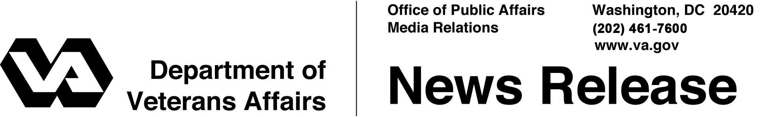
FOR IMMEDIATE RELEASE
January 30, 2014

Federal Agencies Partner to Protect Veterans, Service Members and their Families Using GI Bill Education Benefits
New Online Complaint System Empowers Students, Strengthens Enforcement

WASHINGTON, D.C. – The Departments of Veterans Affairs, Defense, Education and Justice, along with the Consumer Financial Protection Bureau and the Federal Trade Commission announced today the launch of a new online complaint system designed to collect feedback from veterans, service members and their families who are experiencing problems with educational institutions receiving funding from Federal military and veterans educational benefits programs, including benefits programs provided by the Post-9/11 GI Bill and the DoD Military Tuition Assistance Program.
The centralized online reporting system is designed for veterans, service members and eligible dependents to report negative experiences with educational institutions; and gives the federal government the information needed to identify and address unfair, deceptive, and misleading practices and ensure high quality academic and student support services are available for veterans, service members, and their families.
“The online complaint system empowers veterans and their dependents and provides them a direct line to VA and our partner agencies,” said Allison A. Hickey, Under Secretary for Benefits, Department of Veterans Affairs. “The feedback we receive from veterans, service members and their families will help us strengthen enforcement of the ‘Principles of Excellence’ for institutions of higher learning serving veterans and their families to ensure students are receiving the education benefits they have earned and deserve.”
"Our service members and their families now have an easier and efficient way to provide feedback on their civilian educational experiences, which will ensure we have the right information to identify and address any negative practices," said Jessica Wright, Acting Under Secretary of Defense for Personnel and Readiness.
Students can submit a complaint if they believe their school is failing to follow the Principles of Excellence, (i.e. unfair recruiting practices, credit transfer or change in degree requirements) through the centralized online reporting system accessed via the Department of Defense and GI Bill websites. When feedback is received, agencies will contact the school on behalf of the student and work toward a resolution. Complaints and their resolution will be forwarded to the Federal Trade Commission Consumer Sentinel Network, accessible by over 650 federal, state and local law enforcement agencies for use in enhancing and coordinating law enforcement investigations.
Executive Order 13607, signed April 27, 2012, addresses reports of unfair, deceptive or misleading behavior toward Veterans, service members and their families pursuing higher education and directs agencies to establish, implement and promote compliance with “Principles of Excellence” for educational institutions receiving funding from Federal military and veterans educational benefits programs for America’s veterans, service members and eligible dependents, including preventing abusive and deceptive recruiting practices. The new online complaint system is one of a range of tools being implemented by the federal government to ensure that service members, veterans and eligible dependents have access to meaningful information about the cost and quality of educational institutions.
###

