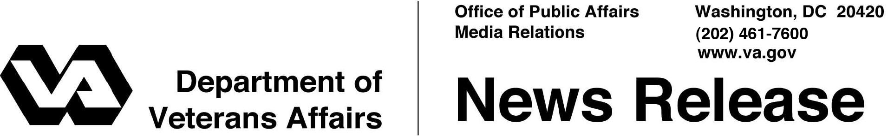

FOR IMMEDIATE RELEASE
May 26, 2011

VA Announces Disaster Assistance After Tornado Outbreaks

Help Available for Veterans in Joplin, Mo.

WASHINGTON – The Department of Veterans Affairs (VA) announced today that special disaster assistance may be available to Veterans with VA-guaranteed home loans who have been affected by recent tornados in Missouri.
“We will do everything we can to help Veterans and their families get through this difficult time,” said Secretary of Veterans Affairs Eric K. Shinseki. “We urge Veterans to use VA resources available to help them recover from this disaster.”
VA strongly encourages mortgage companies not to initiate any new foreclosures in the disaster areas for a period of 90 days. The agency also encourages mortgage companies that service VA-guaranteed home loans to extend every possible forbearance to borrowers who are in distress through no fault of their own. This includes suspension of reporting to credit bureaus and waiving late charges for affected borrowers.
Veterans should contact their insurance company as soon as possible to file claims for losses. At the same time, they need to contact their mortgage companies to let them know their circumstances.
Veterans should also start the FEMA disaster application process as soon as possible by calling 1-800-621-3362. Low interest loans, cash grants, and housing assistance may be available from agencies associated with the disaster recovery effort.
VA has information available on its web site (www.benefits.va.gov/homeloans) that provides basic guidance on options veterans should consider following a major disaster. Veterans may also contact their nearest VA Regional Loan Center at 1-877-827-3702.
For updated information on eligible counties, visit the “Are you a disaster survivor?” section on the FEMA website at http://www.fema.gov/index.shtm.
# # #

