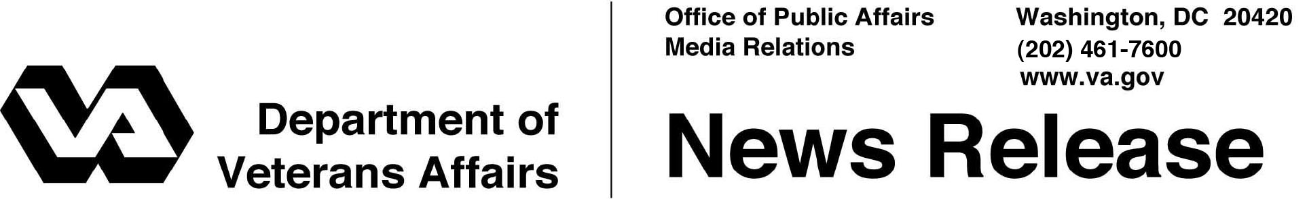

FOR IMMEDIATE RELEASE
January 14, 2013

National Deployment of Paperless Claims Processing System Underway
Major Milestone Achieved in Improving Benefits Delivery

WASHINGTON – The Department of Veterans Affairs announced today the nationwide transition to paperless processing of Veterans’ disability claims at its regional benefits processing offices is underway. VA is aggressively building a strong foundation for its new electronic claims processing system, called Veterans Benefits Management System (VBMS) – a lasting solution that will transform how VA eliminates the backlog in 2015.
“Our approach to claims processing is being modernized to better serve Veterans and address the complex claims our employees are dealing with every day,” said Secretary of Veterans Affairs Eric K. Shinseki. “We continue to transform our claims system to be more responsive through new processes and technology, because taking care of our Veterans and their loved ones is our highest priority.”
As of December 2012, 18 VA regional offices have implemented the new system and are beginning to process newly received compensation claims in an entirely digital format. The VA is on track for full deployment of the system to the remaining 38 regional offices in 2013.
“For our Veterans, VBMS will mean faster, higher-quality and more consistent decisions on claims. We recognize that too many Veterans are waiting too long to get the benefits they have earned, and that is unacceptable. This is a decades-old problem, and we are implementing a robust plan to address it,” said Undersecretary for Benefits Allison A. Hickey. “For our employees, VBMS will be a more user-friendly system that offers better access to decision-level information, rules-based calculators, and automated tools that help them process claims more consistently.”
This marks a major milestone in VA’s transformation of the processes and systems used to deliver benefits to Veterans, their families, and survivors, even while the Veterans Benefits Administration (VBA) has completed a record-breaking 1 million claims per year the last three fiscal years. Critical to VA’s transformation is ending the reliance on the outmoded paper-intensive processes which prevent timely and accurate claims processing. VA is deploying technology solutions which improve access, drive automation, reduce variance, and enable faster and more efficient operations to eliminate the backlog.
The current backlog of claims is the result of increased demand, over a decade of war with many Veterans returning with severe, complex injuries, and increased outreach to Veterans informing them of their benefits. Secretary Shinseki also made important decisions to recognize medical conditions related to Agent Orange service in Southeast Asia, and to simplify the process to file claims for combat PTSD. These decisions expanded access to benefits for hundreds of thousands of Veterans and brought significantly more claims into the system.
VBMS was pilot-tested at select regional offices between 2010 and 2012, with improvements and greater functionality added to system software releases throughout the testing period. In pilot programs, the new system cut the time to process claims nearly in half. The most recent version of VBMS software allows VA claims representatives to:
- establish Veterans’ claims entirely in a digital environment as “e-folders,”
- receive, store, and view Veterans’ submitted claim documents electronically,
- identify and track the evidence VA needs from beneficiaries and other outside sources,
- quickly direct claims electronically among regional offices to better match VA’s workload with available workforce capacity.
The system also enables VA claims processors to access online rules-based calculators and drop-down menus to enhance standardization and accuracy of decisions, for both electronic claims and those received by VA in paper form and uploaded into VBMS. Processors will also use VBMS to generate letters to Veterans concerning their claim status and send requests to private physicians for medical records needed to evaluate claims.
When VBMS is combined with VA’s other Transformation initiatives—including improved claims rater training, cross-functional claims handling teams, and prioritized lanes to speed processing based on type of claim—VA will be positioned to meet Secretary Eric K. Shinseki’s priority goal of processing Veterans’ claims in 125 days or less, at 98 percent accuracy, by the end of 2015.
For more information on VA’s transformation go to http://benefits.va.gov/transformation/
# # #

