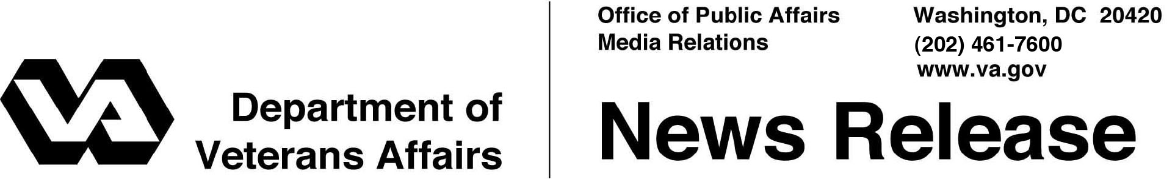

FOR IMMEDIATE RELEASE
January 28, 2013

VA/DoD Continue to Improve Online Access to Benefits Information
New Functionality Added to Online Benefits Portal
WASHINGTON - The Departments of Veterans Affairs and Defense (DoD) just released improvements to the functionality of eBenefits, a joint self-service web portal that provides registered users with secure online information and access to a variety of military and Veterans benefits resources.
“eBenefits is clearly becoming the platform of choice for Veterans seeking access to the numerous benefits they have earned,” said Undersecretary for Benefits Allison A. Hickey. “The increasing capabilities of eBenefits give Veterans and Servicemembers greater flexibility in securing the information they are looking for.”
The latest release, eBenefits 4.3, allows for easy navigation of the online disability compensation claim submission process using interview-style questions and drop-down menus similar to tax-preparation software, instead of a traditional fill-in-the-blank form. The latest release also pre-populates the application with information from a Veteran’s record in VA’s secure database. Veterans can view processing times for each phase of their claim.
Other site improvements include a tool to help determine if a Veteran has eligibility for Vocational Rehabilitation and Employment benefits, a calculator for military reservists to determine retirement benefits, and a search function that identifies a claimant’s appointed Veterans service representative, with links to Google Maps indicating the location of their nearest representative’s office. Servicemembers and Veterans can also access records like Post-9/11 GI Bill enrollment status, VA payment history, and DoD TRICARE health insurance status.
The eBenefits application is a key component of VA’s ongoing transformation to a digital environment for Veterans’ benefits delivery and fully supports VA’s Veterans Relationship Management initiative that provides Veterans with the ability to access information about their benefits anywhere, anytime and empowers them to manage those benefits through self-service capabilities. Additional functionality and features will continue to be added to the site throughout the coming months.
To access eBenefits, Veterans and Servicemembers must obtain a DoD Self-Service Logon (DS Logon), which provides access to several Veterans and military benefits resources using a single username and password. The service is free and may be obtained in person at a VA Regional Office, TRICARE Service Center or online at www.ebenefits.va.gov.
There are currently 2.2 million users with access to eBenefits, and VA is on track to meet the 2013 agency priority goal of 2.5 million users, as outlined for VA on www.Performance.gov.
With the most-recent release, eBenefits has successfully completed 13 consecutive quarterly releases since October 2009 with 47 self-service features enabling Servicemembers and Veterans the ability to download copies of their official VA and military correspondence—to include Veterans civil service preference, service verification, and benefits verification letters; military records; and VA home loan certificates of eligibility, just to name a few.
For more information about VA benefits go to http://www.benefits.va.gov and eBenefits at www.ebenefits.va.gov.

# # #

