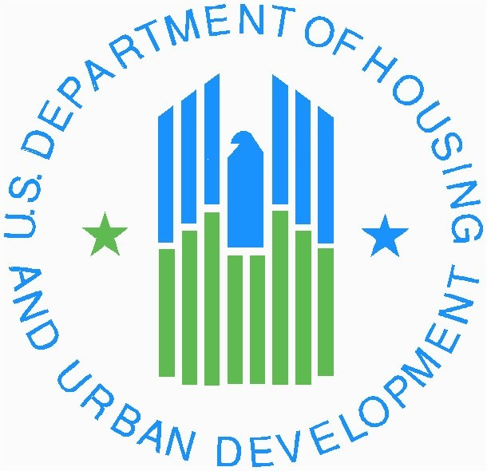
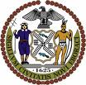
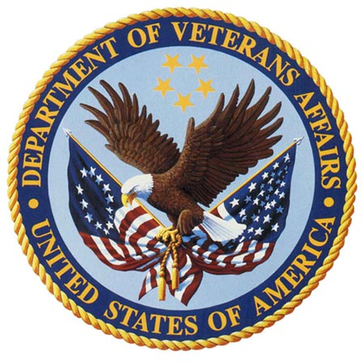

FOR RELEASE
HUD: Donna White (202) 708-0685 Wednesday
VA: Alison Aikele (202) 461-7435 April 16, 2008
Mayor’s Office: Stu Loeser or Dawn Walker (212)788-2958

HUD DEPUTY SECRETARY BERNARDI, VA SECRETARY PEAKE AND MAYOR BLOOMBERG ANNOUNCE HUD AND VA TO PROVIDE PERMANENT HOUSING FOR AN ESTIMATED 10,000 HOMELESS VETERANS
$75 million program to reduce the number of homeless vets nationwide

$9.4 million awarded to New York City to permanently house more than 1,000 homeless veterans and
fulfill recommendations of joint NYC/VA Task Force on ending veteran homelessness

NEW YORK – U.S. Department of Veterans Affairs Secretary James B. Peake and U.S. Housing and Urban Development Deputy Secretary Roy A. Bernardi today announced $75 million to provide permanent supportive housing for an estimated 10,000 homeless veterans nationwide. Bernardi and Peake made the announcement with Mayor Michael R. Bloomberg at a newly renovated housing program for homeless veterans in Queens, and emphasized the Federal and local government’s partnership to house and support America’s homeless veteran population.

New York City will receive approximately $9.4 million to permanently house more than 1,000 homeless veterans. Their program will be administered by the New York City Housing Authority and the Department of Homeless Services.

“We are deeply grateful for the service and sacrifice by our nation’s veterans and we must make every effort to help them as they struggle to avoid a life on the streets,” said Bernardi. “This program is one opportunity to say, ‘Thank You’ and to make certain that we serve them as they once served us.”

“Today, VA, HUD and New York City are strengthening our long-standing partnership on homelessness to achieve a simple vision -- that no one who has served and fought for their country should have to live on the streets,” said Peake. “We hope to build upon this effort soon with another step providing more case managers to support a marked increase in permanent housing units.”

“Ending veteran homelessness is an ambitious goal that is more in reach thanks to this historic federal commitment to provide housing for veterans,” said Mayor Bloomberg. “Our partnership with the VA has already provided homes for hundreds of veterans over the past year and the housing slots being allocated to New York City today will bring new hope to more than 1,000 homeless veterans in our City. It sends a powerful message to the men and women currently fighting for our country overseas – that we do not take their service for granted.”

HUD’s Veterans Affairs Supportive Housing Program (HUD-VASH) will provide local public housing agencies with approximately 10,000 rental assistance vouchers specifically targeted to assist homeless veterans in their area (see attached chart for a local breakdown of homeless veterans to be assisted). In addition, the VA and HUD will link local public housing agencies with VA Medical Centers to provide supportive services and case management to eligible homeless veterans.

HUD will allocate the housing vouchers to local public housing agencies (PHAs) across the country that are specifically targeted to homeless veterans based on a variety of factors, including the number of reported homeless veterans and the proximity of a local VA Medical Center with the capacity to provide case management. New York City and the greater Los Angeles area received the greatest number of vouchers using this criterion.

HUD will provide housing assistance through its Section 8 Housing Choice Voucher (HCV) program which allows participants to rent privately owned housing. The VA will offer eligible homeless veterans clinical and supportive services through its medical centers across the U.S and Puerto Rico. Last year, the VA provided health care to more than 100,000 homeless veterans and other services to over 60,000 veterans in its specialized homeless programs. The Bush Administration’s proposed FY 2009 Budget seeks to double the amount of funding announced today to provide an additional $75 million to support the housing and service needs of an additional 10,000 homeless veterans across America.

Local communities or “Continuums of Care” that receive HUD homeless assistance will work with local VA Medical Centers to identify eligible participants. The VA will then screen homeless veterans to determine their eligibility. Those eligible vets will receive treatment and regular case management to retain the voucher. VA Medical Center case managers will also work closely with local housing agencies to help participants find suitable housing. Participating PHAs will also determine income eligibility in accordance to HUD regulations for the HCV program.

New York City’s Department of Homeless Services will use the 1,000 vouchers, supplemental veterans treatment and case management services announced today to help achieve permanent and sustained housing status for all homeless veterans. In December 2006, the VA and the City of New York reached an historic agreement to address ending veteran homelessness in New York City. Under the agreement, the City vowed to place 100 veterans into permanent housing in 100 days, surpassing the goal with 135 veterans moving during that period, and subsequently succeeded in placing more than 400 veterans into homes of their own in 2007. The VA and the City also convened a joint Task Force that created a strategic plan to end veteran homelessness in New York City. Among the Task Force recommendations were the creation of a jointly operated VA/NYC multi-service center to serve as a one-stop site to access services for homeless veterans, scheduled to open in the Summer of 2008; the creation of a veteran-only SAFE HAVEN as an alternative to the shelter system to open in the Summer/Fall 2008 and veteran-specific, short-term housing site for those working towards permanent housing.

###

HUD is the nation’s housing agency committed to increasing homeownership, particularly among minorities; creating affordable housing opportunities for low-income Americans; and supporting the homeless, elderly, people with disabilities and people living with AIDS. The Department also promotes economic and community development and enforces the nation's fair housing laws. More information about HUD and its programs is available on the Internet at www.hud.gov and espanol.hud.gov.

Secretary James B. Peake, M.D. serves as the chair the U.S. Interagency Council on Homelessness, the federal coordinating body addressing issues of homelessness. Recently, VA announced a reduction of homeless veterans from more than 195,000 to about 154,000. Today, VA supports more than 15,000 beds in transitional housing facilities or in VA residential treatment programs nationwide and recently announced $37 million to fund at least 2,250 new transitional housing beds by giving grants to local providers this year. The Department is the largest federal provider of direct assistance to the homeless, including outreach and case management, treatment, rehabilitation, transitional residential care, therapeutic work and assistance with permanent housing. As part of its homelessness programs, VA also supports special programs for the treatment and rehabilitation of those suffering from mental illness and addictive disorders.

For more information, visit VA’s grant and per diem program Web page at www.va.gov/homeless/page.cfm?pg=3 or contact VA’s grant and per diem program office toll free at 1-877-332-0334, or e-mail VA at homelessvets@mail.va.gov.

State | VA Medical Center Location* | Estimated # of homeless veterans to be assisted
Alaska | Anchorage | 35
Alabama | Birmingham | 105
 | Tuscaloosa | 35
 | Tuskegee | 35
Arkansas | Little Rock | 105
 | Fayetteville | 35
Arizona | Tucson | 70
 | Phoenix | 105
 | Prescott | 35
California | San Francisco | 105
 | Greater Los Angeles | 840
 | Loma Linda | 35
 | Central CA Health Care System | 35
 | Palo Alto | 70
 | Northern CA Health Care System | 35
 | San Diego | 105
 | Long Beach | 70
Colorado | Denver | 175
 | So. Colorado | 35
Connecticut | West Haven | 70
District of Columbia | Washington, DC | 140
Delaware | Wilmington | 35

Florida | Tampa | 105
 | Orlando | 70
 | W. Palm Beach | 105
 | Bay Pines | 105
 | Gainesville | 140
 | Gulf Coast Health Care System | 35
 | Miami | 105
Georgia | Augusta | 35
 | Atlanta | 350
 | Dublin | 35
Hawaii | Honolulu | 70
Iowa | Central Iowa | 35
 | Iowa City | 35
Idaho | Boise | 20
 | Chicago WS | 105
 | Hines | 70
 | N. Chicago | 35
Indiana | Indianapolis | 70
 | N. Indiana | 35
Kansas | Topeka | 35
 | Wichita | 35
 | Leavenworth | 105
Kentucky | Louisville | 70
 | Lexington | 35
Louisiana | Shreveport | 35
 | New Orleans | 140
 | Alexandria | 35
Massachusetts | Boston | 105
 | Northampton | 70
 | Bedford | 70
Maryland | Perry Point | 70
 | Baltimore | 105
Maine | Togus | 35
Michigan | Ann Arbor Health Care System | 70
 | Saginaw | 35
 | Battle Creek | 35
 | Detroit | 105
Minnesota | Minneapolis | 70
Missouri | Kansas City | 70
 | St. Louis | 35
 | Columbia | 35
Mississippi | Jackson | 35
Montana | Montana Health Care System | 35
North Carolina | Asheville | 35
 | Durham | 35
 | Salisbury | 35
North Dakota | Fargo | 35
Nebraska | Omaha | 35
 | Gr. Nebraska | 35
New Hampshire | Manchester | 35
New Jersey | East Orange | 35
 | Lyons | 35

New Mexico | New Mexico Health Care System | 35
Nevada | Sierra Nevada Health Care System | 70
 | Southern Nevada Health Care System | 105
New York | Syracuse | 35
 | Bronx | 385
 | Brooklyn | 455
 | New York | 175
 | Albany | 35
 | Canandaigua | 35
 | Buffalo | 35
 | Montrose | 105
 | Northport | 35
Ohio | Columbus Outpatient Clinic | 35
 | Cleveland | 105
 | Cincinnati | 70
 | Dayton | 35
 | Chillicothe | 35
Oklahoma | Oklahoma City | 35
 | Muskogee | 35
Oregon | Portland | 70
 | Roseburg | 35
 | White City | 35
Pennsylvania | Pittsburgh | 70
 | Philadelphia | 105
 | Butler | 35
 | Coatesville | 105
 | Erie | 35
 | Wilkes-Barre | 35
 | Lebanon | 70
Puerto Rico | San Juan | 20
Rhode Island | Providence ` | 35
South Carolina | Charleston | 70
 | Columbia | 70
South Dakota | Hot Springs | 35
 | Ft. Meade | 35
Tennessee | Memphis | 105
 | Mountain Home | 70
 | Nashville | 70
Texas | San Antonio | 70
 | Central Texas Health Care System | 105
 | El Paso Outpatient Clinic | 35
 | Houston | 385
 | Dallas | 105
Utah | Salt Lake City | 35
Virginia | Hampton | 140
 | Richmond | 35
 | Salem | 35
Vermont | White River Junction | 20
Washington | Seattle | 105
 | American Lake | 35
 | Spokane | 35
 | Walla Walla | 70
Wisconsin | Milwaukee | 70
 | Tomah | 35
West Virginia | Huntington | 35
 | Clarksburg | 35
 | Martinsburg | 35
Wyoming | Cheyenne | 35
 | Sheridan | 35
 | TOTAL | 10,105

* VA Medical Centers’ coverage areas often extend beyond the metropolitan areas in which they are located.

