Introducing the GSA Advantage Purchase Order Portal

What is the GSA Advantage Purchase Order Portal? The “PO Portal” is a new website developed by GSA that allows you to easily view or print your GSA Advantage purchase orders, or you may download your orders in a number of formats including XLS, TXT, XML, or PDF. The PO Portal will also allow you to submit status for your orders back to customers via GSA Advantage.

When will the PO Portal be available for use? On Monday July 14, 2008, we will make GSA Advantage purchase orders available to you via a new website at https://www.poportal.gsa.gov.

How do I access the PO Portal? The PO Portal can only be accessed by the individual you designate. This can be done using the Schedules Input Program (SIP) software or via EDI.

Why do I need to submit an email for each of my order addresses? To ensure that only those individuals you designate can retrieve your orders, we require that you provide us the email address of an authorized individual for each of your order receiving addresses. Only those individuals will be provided access to the PO Portal and will only be able to access orders placed to that address.

What if we have one person who receives orders for several order address? A single individual can receive orders for several order addresses. Provide the same email address for each order address. Since PO Portal accounts are by email address, there would be one PO Portal account for all addresses having the same email.

What if we have several people who need access to one order address? Since PO Portal accounts are by email address, you would need to provide the account User id and password to any individual who you wish to access the account. Suggest you provide a generic email address which can be accessed by several individuals since PO Portal sends a daily email notice to this address listing the previous day’s orders.

How do I submit my order address email(s) using the SIP software? Make sure you have the latest SIP version 7.2e. To determine what version you have, open SIP, click on the tab “About SIP” and check the version. To update SIP, go the Communications tab and click Download SIP upgrade.

If you have not yet submitted an order address email, when you open SIP 7.2e, you will see the following message. This message informs you that an order address email will be required. Click ok.

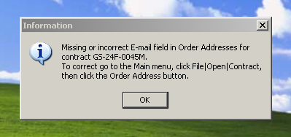

You must provide an email address for each order address. To do this, open SIP and click on File|Open|Contract, then click on the Order Address button.The button looks like this

Click on the Add button to activate the screen below. Once activated, you will need to enter the email address associated with this order address. Please ensure this is a valid email address of the individual who can receive orders and provide status of those orders. You must do this for each of your order addresses.

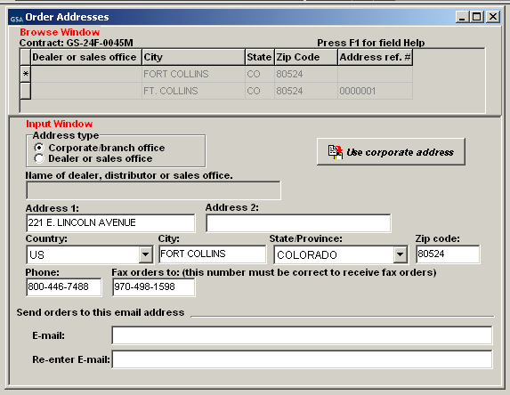

How do I submit my order address email(s) using the SIP import software? For those contractors who use SIP Import, the order address email should be included for each address in the R_EMAIL field of the IREMITOR table.

How do I submit my order address email(s) using EDI? For those contractors who use EDI, the order address email should be included for each address using the EM qualifier of the PER segment. Note: orders will not be sent to the PO Portal for contractors currently receiving orders via EDI or XML however, we will include this email address on the customer’s order confirmation. See more below.

I’m currently using the SIP Order/Status software to download my orders. Will I still be able to use this? Orders will no longer be sent to the SIP Order/Status tool beginning July 14th. You will however, be able to retrieve any orders sent to the SIP Order/Status tool prior to the July 14th cut-over. Although you may still have the software loaded to your PC, we will no longer be sending orders to it. If you have provided an order address email as requested above, you must now get your orders via the PO Portal. If you do not provide an email address, you will begin getting orders via fax. Please note that at some point in the near future we will no longer provide POs via fax, except under emergency conditions where necessary.

After July 14, can I provide status of orders I received previously under the SIP Order/Status tool? No. We will not accept order status from the SIP Order/Status tool beginning July 14.

The SIP Order/Status tool contains my order history. How can I save this? Open the SIP Order/Status tool and click on “Export to File”. This will allow you to save your old purchase order history to your PC. Do this for both “active” and “complete” orders.

I’m currently getting my orders via fax. Will I still get my orders this way? If you have provided an order address email, you must begin using the PO Portal. If you do not provide an email address, you will continue getting orders via fax. Please note that at some point in the near future we will no longer provide POs via fax, except under emergency conditions where necessary.

I’m currently getting my orders via EDI or XML. Will I still get my orders this way? Yes, even if you submit order address emails. If at some point you wish to use the PO Portal instead, please contact the GSA EDI help desk at 703-605-9444 and they can switch you over. Again, orders will not be sent to the PO Portal for contractors currently receiving orders via EDI or XML.

How does the PO Portal work? Authorized individuals who login to the PO Portal may view, print or download orders. Orders appearing are those sent to order addresses having that individual’s email associated with it.

How do I get started? If you have provided an order address email in your SIP or EDI submission, you will get an initial email to register (after July 14th). During registration you will create a user ID and password that will provide you access to the PO Portal.

How do I know if I get an order? Each day you will get an email listing all orders from the previous day (you will not get an email if there are no orders). If desired, you may change your Profile setting in PO Portal to also receive an email notice for each order, or you may simply check the site daily. A link is included in each email taking you to the PO Portal, login is required.

How do I retrieve my orders? Once you login you are taken to the Active POs screen. If you have orders, you will see a link stating “You have 2 new purchase orders! Click here to retrieve”. Once you click the link, the orders will appear on your screen. Clicking the link acknowledges receipt of the order(s). You may then view, print or download your orders.

