Health Benefit Plan Updates

VistA Registration Eligibility and Enrollment (REE) DG*5.3*936

Release Notes
September 2017
Department of Veterans Affairs
Office of Information and Technology (OI&T)

Table of Contents
1 Introduction 1
2 Purpose 1
3 Audience 1
4 This Release 1
4.1 New Features and Functions Added 1
4.2 Enhancements and Modifications to Existing 1
4.3 Known Issues 4
5 Product Documentation 5

Introduction
Patch DG*5.3*936 is being released to support the enhancements for the Enterprise Health Benefits Determination (EHBD) program that focuses on updates for the Enrollment System Modernization (ESM) project, which supports Enrollment System Community Care (ESCC).
DG*5.3*936 is also being released in support of the Enrollment System (ES) 4.6.0 release. Refer to Informational Patch EAS*1*147 (Enrollment Application System) for additional details regarding the ES release.

Purpose
These Release Notes cover the changes to the VistA REE system for this patch release.

Audience
This document targets users and administrators of the VistA REE system and applies to the changes made between this release and any previous release for this software. Therefore, the users and administrators are deemed competent in using existing applications.

This Release
The following sections provide a summary of the new features and functions added, enhancements and modifications to the existing software, and any known issue for VistA REE Patch DG*5.3*936.
The DG*5.3*936 software will be distributed as a PackMan message included with the patch message.

New Features and Functions Added
There are no new features added to VistA REE.

Enhancements and Modifications to Existing
The Health Benefit Plan build components will include an additional field for the Data Dictionary (DD) HEALTH BENEFIT PLAN file (#25.11) and will modify the VistA entries for Health Benefit Plans that are stored or displayed to the users within VistA. Health Benefit Plans also will be added to the Computerized Patient Record System (CPRS) Patient Inquiry screen.
RTC RM #788108 – Assign and/or Unassign Health Benefit Plans
RTC RM #788122 – Send Veterans Choice Information (Health Benefit Plans) to VistA
RTC RM #788124 – View Health Benefit Plans in VistA
RTC RM #788125 – View Veterans Choice Eligibility Information in CPRS
RTC RM #797621 – View Health Benefit Plans in CPRS
List of Updates
- New field COVERAGE CODE field (#.05) is added to HEALTH BENEFIT PLAN file (#25.11). It is added to accommodate Coverage Code information for Health Benefit Plans and it is not visible by any users at this time.
- Six new Health Benefit Plans are getting added to HEALTH BENEFIT PLAN file (#25.11) as part of post installation routine during Patch installation. Below is the list of Health Benefit Plans that are getting added:
- Veteran Plan - Veterans Choice Basic
- Veteran Plan - Veterans Choice Mileage
- Veteran Plan - Veterans Choice Wait Time
- Veteran Plan - VC Unusual and Excessive Burden
- Veteran Plan - Veterans Choice Air, Boat, or Ferry
- Veteran Plan - Military Sexual Trauma
- Modify display screen when using the menu options Patient Inquiry [DG PATIENT INQUIRY], Register a Patient [DG REGISTER PATIENT], Load/Edit Patient Data [DG LOAD PATIENT DATA], Preregister a Patient [DGPRE PRE-REGISTER OPTION] to display Health Benefit Plan names. The Health Benefit Plan names will be the last group displayed on the screen. The system shall display "None" if a Veteran has no assigned Health Benefit Plans. Any updates to the DGPRD patient inquiry screens will automatically update other options that call DGRPD.
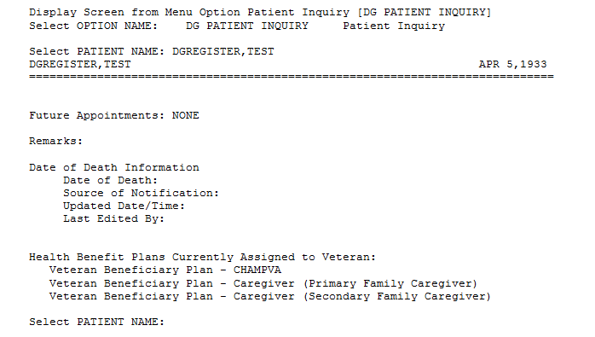

- Add Health Benefit Plans to the Computerized Patient Record System (CPRS) Patient Inquiry screen: The new Community Care Health Benefit Plans will be displayed on the existing Patient Inquiry screen in CPRS.
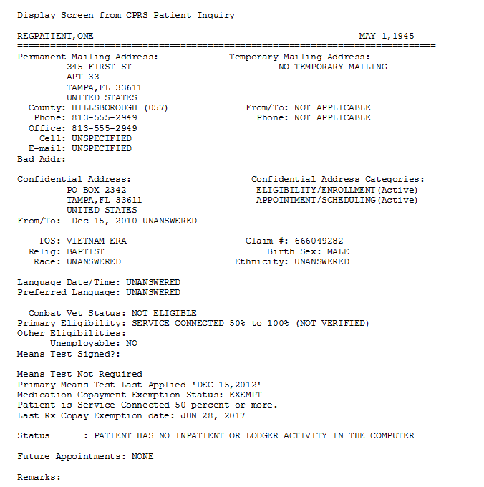
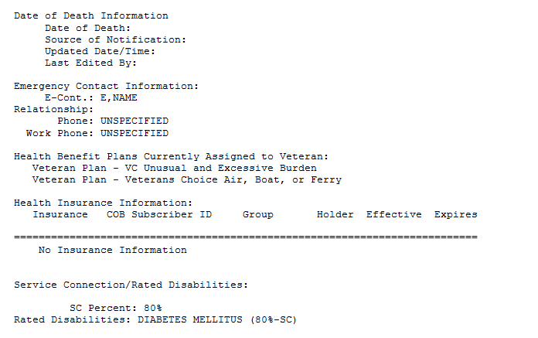

Known Issues
There are no known issues.

Product Documentation
The following documents apply to this release:
Title File Name FTP Mode
Release Notes DG_5_3_936_RN.PDF (binary)
User Manual – Registration Menu DG_5_3_936_REG_UM (binary)
CPRS User Guide: GUI Version updates associated with this patch will be included in the CPRS v31a release.
redacted
Documentation can also be found on the VA Software Documentation Library at:
http://www.va.gov/vdl/

