Enrollment System Modernization (ESM) Phase 2 Veterans Health Information Systems and Technology Architecture (VistA)
Registration, Eligibility & Enrollment (REE)
DG*5.3*1006

Release Notes

March 2020
Department of Veterans Affairs
Office of Information and Technology (OIT)

Table of Contents
Enrollment System Modernization (ESM) Phase 2 Veterans Health Information Systems and Technology Architecture (VistA) Registration, Eligibility & Enrollment (REE) i
Release Notes i
Introduction 1
Purpose. 1
Audience 1
This Release 1
New Features and Functions Added 1
Enhancements and Modifications 1
Defects and Fixes 3
List of Updates 3
Known Issues 8
Product Documentation 8

List of Figures
Figure 1: Eligibility Verification Data, Screen <11> 4
Figure 2: VHAP <11.1> Screen 5
Figure 3: VHAP <11.3> Screen 5
Figure 4: VHAP <11.3.1> Screen 6
Figure 5: VHAP <11.4> Screen 7
Figure 6: Patient Inquiry Option 7

List of Tables
Table 1: DG*5.3*1006 Enhancements and Modifications 2
Table 2: Defects and Fixes in DG*5.3*1006 3

Introduction
The release of Veterans Health Information System and Technology Architecture (VistA) Registration, Eligibility & Enrollment (REE) Registration (DG) patch DG*5.3*1006 supports the enhancements for the Enterprise Health Benefits Determination (EHBD) program that focuses on updates for the Enrollment System Modernization (ESM) Phase 2 project, which supports Enrollment System Community Care (ESCC) and Enrollment System (ES) Sustainment.

Purpose
The Release Notes cover the changes to VistA REE for this release. Patch DG*5.3*1006 is also being released in support of the ES 5.10 release. Refer to Informational Patch EAS*1*186 (Enrollment Application System) for additional details regarding the ES release.

Audience
This document targets users and administrators of VistA REE and applies to the changes made between this release and any previous release for this software.

This Release
This software is being released as a patch (PackMan) message. The PackMan message includes the DG*5.3*1006 patch, which also supports the ES 5.10 release.
The following sections provide a summary of the enhancements and modifications to the existing software for VistA REE with the release of patch DG*5.3*1006.

New Features and Functions Added
There are no new features or functions added to VistA REE for DG*5.3*1006.

Enhancements and Modifications
VistA REE patch DG*5.3*1006 renames Veteran Medical Benefit Plans (VMBPs) as VHA Profiles (VHAPs) to support the Electronic Health Record (EHR) in Cerner's Millennium application. VistA REE ELIGIBILITY VERIFICATION DATA SCREEN <11> and list templates associated with VHAP Screens <11.1>, <11.3>, <11.3.1>, and <11.4> are updated to refer to the plans as "VHA Profiles".
VistA REE Patch DG*5.3*1006 modifies the NAME (#.01) field of the HEALTH BENEFIT PLAN file (#25.11) of 24 VHA Profiles, eliminating non-alphanumeric characters, to allow the profiles to be successfully sent to the Cerner application. The affected VHAPs are detailed in the "Listing of Updates" section of this patch description.
Patch DG*5.3*1006 loads the HEALTH BENEFIT PLAN file (#25.11) to store seven new core VHA Profile names, codes, and short and long descriptions. VistA will accept the new profiles from ES via Health Level Seven (HL7) ORF-Z11/ORU-Z11 messages.
Patch DG*5.3*1006 modifies the VHAP <11.3> and VHAP <11.3.1> screens to display the ASSIGNED DATE AND TIME field (#1) of the CURRENT HEALTH BENEFIT PLAN subfile (#25.01) of the PATIENT file (#2) with both the date and time.
Patch DG*5.3*1006 modifies the help text for the VHAP <11.1> screen so that the response to an entry of "?" displays "Profile name preceded by 'zz' indicates the profile is inactive."
The Patient Inquiry [DG PATIENT INQUIRY] option and Patient Inquiry application program interface (API) (DGRPD) is updated to display "VHA Profiles" instead of "Veteran Medical Benefit Plan". The API DGRPD is called from VistA REE menu options, subscribers to API DGRPD, and other VistA packages.
Integration Control Registration (ICR) 10037 (DGRPD) is updated to display "VHA Profiles" instead of "Veteran Medical Benefit Plan".
ICR 10037 NAME: DGRPD
CUSTODIAL PACKAGE: REGISTRATION
SUBSCRIBING PACKAGE:
USAGE: Supported
Patch DG*5.3*1006 corrects VHAP long descriptions for the following profiles: COMPREHENSIVE EXTENDED CARE SERVICES COPAY EXEMPT, VETERAN EXTENDED CARE SERVICES COPAY EXEMPT, and VETERAN EXTENDED CARE SERVICES COPAY REQ.
Table 1 shows the enhancements and modifications included in the DG*5.3*1006 release as tracked in Rational Team Concert (RTC) Requirements Management (RM).
Table 1: DG*5.3*1006 Enhancements and Modifications
RTC  RM # | Summary
1158673 | Assign VMBP to Individuals with no Veteran Eligibility Code (associated with Employee)
1159224 | VMBP: Plan Name Changes
1162280 | VMBP: Add new and update existing manual plans
1165388 | ES 5.10 Maintain the Enrollment System - VistA View History Date/Time Display Change

Defects and Fixes
Table 2 lists the defects and fixes and corresponding Rational Team Concert (RTC) Change and Configuration Management (CM) numbers included in DG*5.3*1006.
Table 2: Defects and Fixes in DG*5.3*1006
RTC  CM # | Summary
1221614 | Defect: VHAP long descriptions are displaying "=70%" instead of ">=70%" for the following profiles: COMPREHENSIVE EXTENDED CARE SERVICES COPAY EXEMPT, VETERAN EXTENDED CARE SERVICES COPAY EXEMPT, and VETERAN EXTENDED CARE SERVICES COPAY REQ.  Fix: The three VHAP long descriptions are corrected to display ">=70%".

List of Updates
This patch makes the following enhancements to VistA REE:
- Twenty-four existing profiles have been updated to the HEALTH BENEFIT PLAN file (#25.11), eliminating non-alphanumeric characters, in order to support the EHR in Cerner's Millennium application. A pre-install routine included in the build executes the logic to accomplish the profile renames.
  - VETERAN FULL MED BENEFITS TX AND RX COPAY EXMT
  - VETERAN FULL MED BENEFITS TX AND RX COPAY EXMT 6
  - VETERAN FULL MED BENEFITS TX COPAY EXMT AND RX COPAY REQ
  - VETERAN FULL MED BENEFITS TX COPAY EXMT AND RX COPAY REQ 6
  - VETERAN FULL MED BENEFITS TX COPAY REQ AND RX COPAY EXMT 6
  - VETERAN FULL MED BENEFITS TX COPAY REQ AND RX COPAY EXMT 7
  - VETERAN FULL MED BENEFITS TX COPAY REQ AND RX COPAY EXMT 8
  - VETERAN FULL MED BENEFITS TX AND RX COPAY REQ 6
  - VETERAN FULL MED BENEFITS TX AND RX COPAY REQ 8
  - VETERAN FULL MED BENEFITS TX GMT COPAY REQ AND RX COPAY EXMT
  - VETERAN FULL MED BENEFITS TX GMT COPAY REQ AND COPAY EXMT 6
  - VETERAN FULL MED BENEFITS TX GMT COPAY REQ AND RX COPAY REQ
  - VETERAN FULL MED BENEFITS TX GMT AND RX COPAY REQ 6
  - VETERAN RESTRICTED MED BENEFITS
  - NONVETERAN OTHER RESTRICTED MED BENEFITS
  - ACTIVE DUTY AND SHARING AGREEMENTS
  - BENEFICIARY NEWBORN
  - BENEFICIARY CHAMPVA
  - BENEFICIARY SPINA BIFIDA
  - BENEFICIARY CHILDREN OF WOMEN OF VIETNAM VETERANS
  - VETERAN FOREIGN MEDICAL PROGRAM
  - CAREGIVER PRIMARY FAMILY
  - CAREGIVER SECONDARY FAMILY
  - CAREGIVER GENERAL

- Seven new profiles have been added to the HEALTH BENEFIT PLAN file (#25.11). The data is provided in the build with the full data dictionary of the HEALTH BENEFIT PLAN file (#25.11).
  - EMPLOYEE ONLY
  - COMPREHENSIVE EXTENDED CARE SERVICES COPAY EXEMPT
  - VETERAN EXTENDED CARE SERVICES COPAY EXEMPT
  - VETERAN EXTENDED CARE SERVICES COPAY REQ
  - EXTENDED CARE SERVICES HUMANITARIAN
  - ASSISTED REPRODUCTIVE TECHNOLOGY
  - HIGH RISK VETERAN
- Nine existing profiles have been updated in the HEALTH BENEFIT PLAN file (#25.11) so that they are properly displayed based on the profile code being passed to VistA. The data is provided in the build with the full data dictionary of the HEALTH BENEFIT PLAN file (#25.11).
  - VETERAN FOREIGN MEDICAL PROGRAM
  - CAREGIVER GENERAL
  - CAREGIVER PRIMARY FAMILY
  - CAREGIVER SECONDARY FAMILY
  - BENEFICIARY NEWBORN
  - BENEFICIARY CHAMPVA
  - BENEFICIARY CHILDREN OF WOMEN OF VIETNAM VETERANS
  - BENEFICIARY SPINA BIFIDA
  - VETERAN FULL MED BENEFITS TX COPAY EXMT AND RX COPAY REQ 6
- The ELIGIBILITY VERIFICATION DATA SCREEN <11> screen is updated to display "VHA Profiles (VHAP):" instead of "Veteran Medical Benefit Plan (VMBP):".
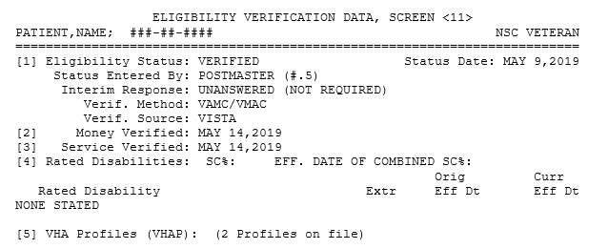
Figure 1: Eligibility Verification Data, Screen <11>

- The list template DGEN HBP PATIENT for the VHAP <11.1> screen is updated so that the header text of the screen reads "VHAP" instead of "VMBP". The profiles are now labeled "Current VHAP" and the VD option is updated to read "View All VHAP Detail".
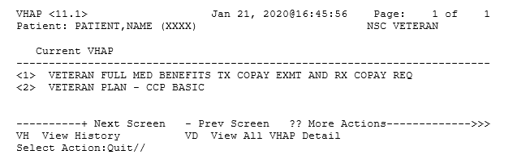
Figure 2: VHAP <11.1> Screen
- The list templates DGEN HBP VIEW for the VHAP <11.3> screen and DGEN HBP VIEWEXP for the VHAP <11.3.1> screen are updated to display the ASSIGNED DATE AND TIME field (#1) of the CURRENT HEALTH BENEFIT PLAN subfile (#25.01) of the PATIENT file (#2) with date and time that will display "VHAP" instead of "VMBP" on the header text of the screens. The column header for the profile name is modified to display “Profile” instead of “Plan Name”. In screen <11.3> the prompt when selecting "EP Expand Entry" is modified to display "Select Profile:" instead of "Select Plan:".
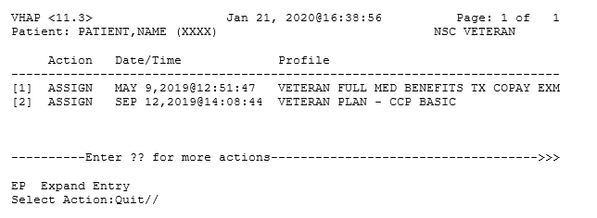
Figure 3: VHAP <11.3> Screen
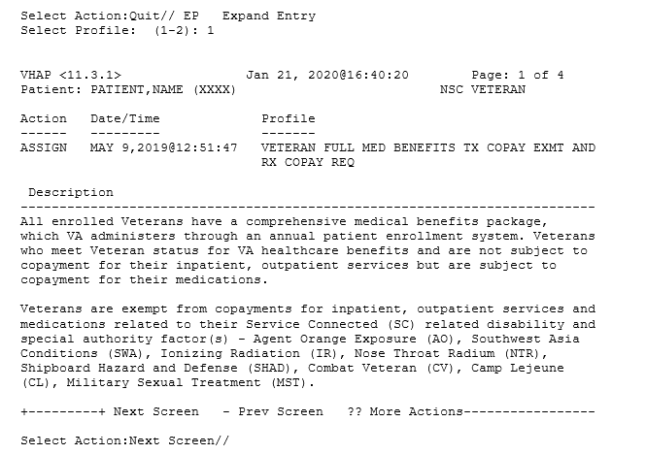
Figure 4: VHAP <11.3.1> Screen

- The list template DGEN HBP DETIAL for the VHAP <11.4> screen is updated so that the header text of the screen reads "VHAP" instead of "VMBP" and the label "VMBP View All Detail" is updated to display "VHAP View All Detail".
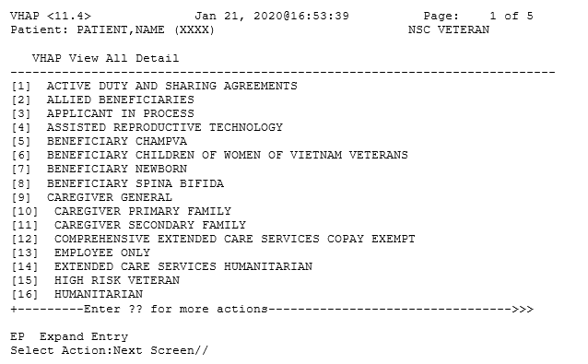
Figure 5: VHAP <11.4> Screen
- In the Patient Inquiry [DG PATIENT INQUIRY] option, the label "Veteran Medical Benefit Plan Currently Assigned to Veteran:" is updated to display "VHA Profiles Currently Assigned to Veteran".
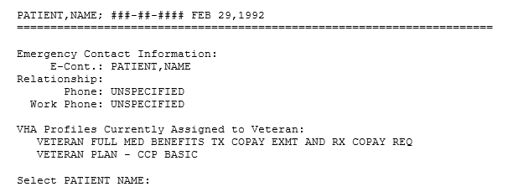
Figure 6: Patient Inquiry Option
Note: The label change is also displayed in external applications and packages that make use of the Patient Inquiry API and Integration Control Registrations (ICRs) #2041, #10037, and #740.
The applications include:
Women’s Health (WV)
Barcode Medication Administration (BCMA)
VISTA IMAGING - CLINICAL DISPLAY
Order Entry Results Reporting
Outpatient Pharmacy Manager (PSO MANAGER)
Computerized Patient Record System (CPRS)
Clinical Information Resource Network (CIRN)
Automated Medical Information Exchange (AMIE)
Regional Office Patient Inquiry (DVBA REG OFF PATIENT INQ)
The following VistA REE menu options also make use of the Patient Inquiry API and reflect the label change:
Collateral Patient Register [DG COLLATERAL PATIENT] option
Load/Edit Patient [DG LOAD PATIENT DATA] option
Register A Patient [DG REGISTER PATIENT] option
- The help text for the VHAP <11.1> screen is updated so that the response to an entry of "?" displays "Profile name preceded by 'zz' indicates the profile is inactive."

Known Issues
No known or open issues were identified in this release.

Product Documentation
The following documents apply to this release:
Title | File Name | FTP Mode
DG*5.3*1006 Release Notes | DG_5_3_P996_RN.PDF | (binary)
User Manual - Registration Menu | PIMS_REG_UM.PDF | (binary)

Sites may retrieve the software and/or documentation directly using Secure File Transfer Protocol (SFTP) from redacted.
Documentation can also be found on the VA Software Documentation Library at: https://www.va.gov/vdl/.

