Add/Edit Address Updates

VistA Registration Eligibility and Enrollment (REE) DG*5.3*925

Release Notes
September 2017
Department of Veterans Affairs
Office of Information and Technology (OI&T)

Table of Contents
1 Introduction 1
2 Purpose 1
3 Audience 1
4 This Release 1
4.1 New Features and Functions Added 1
4.2 Enhancements and Modifications to Existing 1
4.3 List of Updates 2
4.4 Known Issues 5
5 Product Documentation 5

Introduction
Patch DG*5.3*925 is being released to support the enhancements for the Enterprise Health Benefits Determination (EHBD) program that focuses on updates for the Enrollment System Modernization (ESM) project, which supports Enrollment System Community Care (ESCC).
DG*5.3*925 is also being released in support of the Enrollment System (ES) 4.6.0 release. Refer to Informational Patch EAS*1*147 (Enrollment Application System) for additional details regarding the ES release.

Purpose
These Release Notes cover the changes to the VistA REE system for this patch release.

Audience
This document targets users and administrators of the VistA REE system and applies to the changes made between this release and any previous release for this software. Therefore, the users and administrators are deemed competent in using existing applications.

This Release
The following sections provide a summary of the new features and functions added, enhancements and modifications to the existing software, and any known issue for VistA REE Patch DG*5.3*925.
The DG*5.3*925 software will be distributed as a PackMan message included with the patch message.

New Features and Functions Added
There are no new features added to VistA REE.

Enhancements and Modifications to Existing
This portion of the Add/Edit Address Updates build will modify Registration Screens to display the correct address labels.
RTC RM #788099: Add and/or edit residential address in VistA (partial implementation of Business User Story #858263: VistA screen label changes for permanent and temporary addresses)

List of Updates
- The label for "Address" is changed to "Permanent Mailing Address" and the label "Temporary" is changed to "Temporary Mailing Address" on the Patient Inquiry screen shown below in the following options:
Patient Inquiry [DG PATIENT INQUIRY]
Load/Edit Patient Data [DG LOAD PATIENT DATA]
Register a Patient [DG REGISTER PATIENT]
Preregister a Patient [DGPRE PRE-REGISTER OPTION]
REDACTED

- The label "Permanent Address" is changed to "Permanent Mailing Address" and the label "Temporary Address" is changed to "Temporary Mailing Address" on the PATIENT DEMOGRAPHIC DATA, SCREEN <1> in the following options:
View Registration Data [DG REGISTRATION VIEW]
Eligibility Verification [DG ELIGIBILITY VERIFICATION]

REDACTED

- The label for "Temporary Address" is changed to "Temporary Mailing Address" on the screen shown below used to edit the Temporary Address in the following option:
Patient Address Update [DG ADDRESS UPDATE]
REDACTED
- The label for "Permanent Address" is changed to "Permanent Mailing Address" and the question "Do you want to edit the Patient's Address?" has been changed to "Do you want to edit the Patient's Permanent Mailing Address?" on the screen shown below used to edit the patient address after the user responds "Yes" to the "Edit Patient Data?" prompt in the following options:
Load/Edit Patient Data [DG LOAD PATIENT DATA]
Register a Patient [DG REGISTER PATIENT]
Preregister a Patient [DGPRE PRE-REGISTER OPTION]
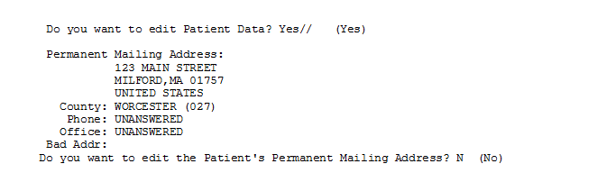

Known Issues
There are no known issues.

Product Documentation
The following documents apply to this release:
Title File Name FTP Mode
Release Notes DG_5_3_925_RN.PDF (binary)
User Manual – Registration Menu DG_5_3_925_REG_UM.PDF (binary)
Redacted
Sites redacted
Documentation can also be found on the VA Software Documentation Library at:
http://www.va.gov/vdl/

