Member ID, Health Benefit Plan, Home Phone, and Future Discharge Date Updates

DG_53_P935.KID
VistA Registration Eligibility and Enrollment (REE) DG*5.3*935
VistA Income Verification Match (IVM)
IVM*2.0*167

Release Notes
January 2018
Department of Veterans Affairs
Office of Information and Technology (OIT)

Table of Contents
1 Introduction 1
2 Purpose 1
3 Audience 1
4 This Release 1
4.1 New Features and Functions Added 1
4.2 Enhancements and Modifications to Existing 2
4.3 Known Issues 6
5 Product Documentation 6

Introduction
The Host file, DG_53_P935.KID, includes patches DG*5.3*935 and IVM*2.0*167. The Host file is being released to support the enhancements for the Enterprise Health Benefits Determination (EHBD) program that focuses on updates for the Enrollment System Modernization (ESM) project, which supports Enrollment System Community Care (ESCC).

Purpose
These Release Notes cover the changes to the Veterans Health Information Systems and Technology Architecture (VistA) Registration, Eligibility & Enrollment (REE) and Income Verification Match (IVM) systems for this release.

Audience
This document targets users and administrators of the VistA REE and IVM systems and applies to the changes made between this release and any previous release for this software. Therefore, the users and administrators are deemed competent in using existing applications.

This Release
This multi-package build is distributed as a host file. The host file DG_53_P935.KID can be obtained from one of the anonymous Secure File Transfer Protocol (SFTP) directories listed in the Software and Documentation Retrieval Instructions section of the patch descriptions.
The following sections provide a summary of the enhancements and modifications to the existing software, and any known issue(s) for VistA REE Patch DG*5.3*935 and VistA IVM Patch IVM*2.0*167.

New Features and Functions Added
There are no new features or functions added to VistA REE or VistA IVM.

Enhancements and Modifications to Existing
The name of a Health Benefit Plan (HBP) is corrected. "Veteran Plan - Veterans Choice Wait Time" is changed to "Veteran Plan - Veterans Choice Wait-Time". A hyphen was added to "Wait-Time".
The Department of Defense (DoD) Electronic Data Interchange Person Identifier (EDIPI) is updated on the VistA system via the Master Veterans Index (MVI). The EDIPI number is retrieved via the VAFCTFU2 Remote Procedure Call. The Member Identifier (ID), also known as EDIPI, will be displayed on the header banner on Registration Screens for the following options. (All menu options below use the same updated header banner.)
Patient Inquiry [DG PATIENT INQUIRY]
Load/Edit Patient Data [DG LOAD PATIENT DATA]
Register a Patient [DG REGISTER PATIENT]
Preregister a Patient [DGPRE PRE-REGISTER OPTION]
View Registration Data [DG REGISTRATION VIEW]
Eligibility Verification [DG ELIGIBILITY VERIFICATION]
Patch IVM*2*167 is being released as a supporting patch for Registration Patch DG*5.3*935. IVM*2*167 contains routine changes to check if a Future Discharge Date (FDD) record exists. An FDD record consists of a Service Branch, Entry Date and Future Discharge Date. If an FDD record exists, it will not be included in the ZMH segment of the ORU-Z07 and ORF-Z07 messages sent from VistA to Enrollment System (ES).
The Military Service Future Discharge Date (FDD) build components include changes to manage, process, and display the FDD record. The record can be manually updated in the Enrollment System (ES) and is read-only in VistA Registration. The FDD record can be received from the military service broker or via an on-line healthcare application. A Veteran can apply for Department of Veterans Affairs (VA) health benefits enrollment before being discharged from the military. The ES is the VA authoritative system for this information. VistA will update the Military Service Episode (MSE) list and the FDD record to match the data provided by ES. The FDD record will not be transmitted from VistA to the ES.
Home Phone Number updates include disabling Home Phone data elements in the IVM Demographics Upload Tool and directly uploading PHONE NUMBER [RESIDENCE] field (#.131), RESIDENCE NUMBER CHANGE DT/TM field (#.1321), RESIDENCE NUMBER CHANGE SITE field (#.1323), and RESIDENCE NUMBER CHANGE SOURCE field (#.1322) to the PATIENT file (#2).
RTC RM #949766: SUS 01.02.02 Maintain VistA
RTC RM #788132: Display Member ID in VistA
RTC RM #788133: View Home Telephone in VistA
RTC RM #773061: Store Future Discharge Date in VistA

List of Updates
- The Member Identifier is displayed between the patient name and the patient Social Security Number (SSN).
- The active Member Identifier is displayed when multiple Member Identifiers are returned from Master Veteran Index (MVI).
- The first inactive Member Identifier returned is displayed when no active Member Identifier is returned.
- The Member Identifier is displayed when one, and only one Member Identifier is returned from MVI.
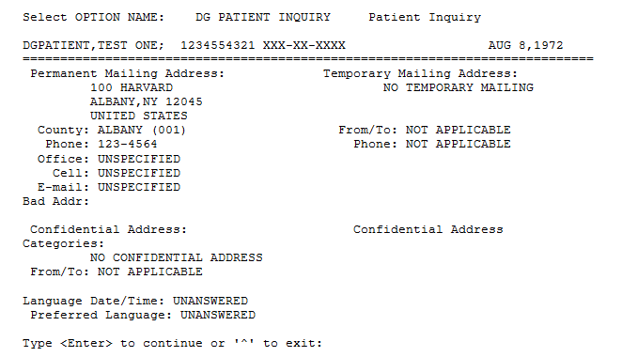
- Update VistA to receive the FDD record in the ZMH segment on the ORU-Z11 or ORF-Z11 Health Level Seven (HL7) message from ES. The FDD MSE received from ES is designated with a Military Service Type of FDD and will contain the Branch of Service, Service Entry Date, and Future Discharge Date data components.
- Update VistA to store the FDD record received from ES.
- VistA will store the FDD record in the existing MILITARY SERVICE EPISODE sub-file (#.3216) of the PATIENT file (#2). The FDD will be stored in the FUTURE DISCHARGE DATE field (#.08) in the MILITARY SERVICE EPISODE sub-file (#.3216) of the PATIENT file (#2).
- The VistA system will remove the military service episode and associated Future Discharge Date when notified by ES that the Future Discharge Date is expired or deleted. The absence of the FDD record ZMH segment on the ORU-Z11 or ORF-Z11 HL7 message from ES will result in the deletion of the FDD record in VistA.
- FDD is an optional field in ES so it will not always be displayed in VistA.
- Update VistA to display the Future Discharge Date when the FDD exists. The FDD will be displayed on the MILITARY SERVICE DATA, SCREEN <6> and MILITARY SERVICE DATA, SCREEN <6.1> screen in the following Menu options.
Load/Edit Patient Data [DG LOAD PATIENT DATA]
Register a Patient [DG REGISTER PATIENT]
View Registration Data [DG REGISTRATION VIEW]
Preregister a Patient [DGPRE PRE-REGISTER OPTION]
Eligibility Verification [DG ELIGIBILITY VERIFICATION]
VistA will display the FDD received from ES and will not perform date validation on the FDD.
- The user will only see FDD displayed on the MILITARY SERVICE DATA, SCREEN <6.1> when inconsistencies exist for the enrollment information group for the following Menu option. The FDD record will display if it exists.
Preregister a Patient [DGPRE PRE-REGISTER OPTION]
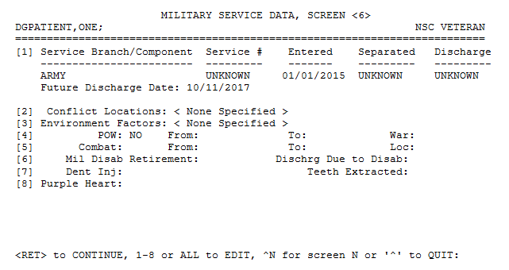
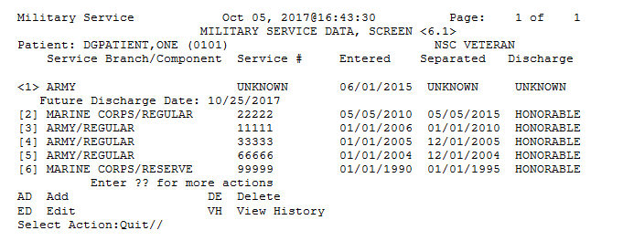
- A VistA user will not be able to add, edit, or delete an FDD record. The FDD record will be locked by VistA when it receives the FDD ZMH segment by storing a one (1) in the DATA LOCKED field (#.07) of the MILITARY SERVICE EPISODE sub-file (#.3216) of the PATIENT file (#2).
- VistA Registration will not send an FDD record to downstream applications. When an associated Future Discharge Date exists (that is not null), the VADPT and VAFHLZMH Application Programming Interface (API) calls will not include the FDD record.
- When adding an MSE in VistA, if the user enters a Service Entry Date or a Service Separation Date that overlaps with an FDD record, an error message will display, stating that an overlap was entered. A screen shot was added to the User Manual - Registration Menu. (Message Text: “Date overlaps with a record that has a Future Discharge Date.”)
- The VADPT Application Programming Interface (API) returns patient-related data. This API was updated to exclude any FDD record. The line tags for this API are SVC^VADPT, 7^VADPT, and 8^VADPT. The Integration Control Registration (ICR) for VADPT is 10061. More details can be found in FORUM, in the documentation of ICR 10061.
- Disable Home Phone data elements in the IVM Demographics Upload tool as the application will not allow VistA to automatically file PHONE NUMBER [RESIDENCE] field (#.131), RESIDENCE NUMBER CHANGE DT/TM field (#.1321), RESIDENCE NUMBER CHANGE SITE field (#.1323) or RESIDENCE NUMBER CHANGE SOURCE field (#.1322) to the PATIENT file (#2) when processing Health Level 7 (HL7) messages from ES.
- Directly upload the Home Phone Data elements PHONE NUMBER [RESIDENCE] field (#.131), RESIDENCE NUMBER CHANGE DT/TM field (#.1321), RESIDENCE NUMBER CHANGE SITE field (#.1323), RESIDENCE NUMBER CHANGE SOURCE field (#.1322) into PATIENT file (#2) when received from ES if the conditions listed below are met:
  - The Change Date/Time of the incoming Home Phone Number is not null.
  - The Change Date/Time of the incoming Home Phone Number from ES is more recent than the VistA Change Date/Time of Home Phone Number.
- Update VistA to exclude the FDD record in the ZMH segment of the ORU/ORF-Z07.

Known Issues
RTC Defect #624366: When manually uploading a phone number via the IVM DEMOGRAPHICS UPLOAD tool in VistA, the tool sets the date/time of the change to the current date/time rather than using the date/time received from ES on the ORU-Z05 message.

Product Documentation
The following documents apply to this release:
Title File Name FTP Mode
Release Notes DG_5_3_P935_KID_RN.PDF (binary)
User Manual – Registration Menu DG_5_3_935_REG_UM.PDF (binary)
PIMS Technical Manual PIMSTM.PDF (binary)
IVM User Manual IVM_2_p167_UM.PDF (binary)
IVM Technical Manual IVM_2_p167_TM.PDF (binary)
Redacted

Documentation can also be found on the VA Software Documentation Library at:
http://www.va.gov/vdl/

