Permanent & Total Disabled Display Updates/
Reason for Closed Application

Registration Eligibility and Enrollment (REE) DG*5.3*940

Release Notes
September 2017
Department of Veterans Affairs
Office of Information and Technology (OI&T)

Table of Contents
1 Introduction 1
2 Purpose 1
3 Audience 1
4 This Release 1
4.1 New Features and Functions Added 1
4.2 Enhancements and Modifications to Existing 1
4.3 Known Issues 6
5 Product Documentation 7

Introduction
Patch DG*5.3*940 is being released to support the enhancements for the Enterprise Health Benefits Determination (EHBD) program that focuses on updates for the Enrollment System Modernization (ESM) project, which supports Enrollment System Community Care (ESCC).
DG*5.3*940 is also being released in support of the Enrollment System (ES) 4.7.0 release. Refer to Informational Patch EAS*1*153 (Enrollment Application System) for additional details regarding the ES release.

Purpose
These Release Notes cover the changes to the VistA REE system for this patch release.

Audience
This document targets users and administrators of the VistA REE system and applies to the changes made between this release and any previous release for this software. Therefore, the users and administrators are deemed competent in using existing applications.

This Release
The following sections provide a summary of the new features and functions added, enhancements and modifications to the existing software, and any known issue for VistA REE Patch DG*5.3*940.
The DG*5.3*940 software will be distributed as a PackMan message included with the patch message.

New Features and Functions Added
There are no new features added to VistA REE.

Enhancements and Modifications to Existing
The DG*5.3*940 software will add the “Permanent and Total (P&T) Disabled” field to the Patient Inquiry Screens in VistA and to the Computerized Patient Record System (CPRS).
Patch 940 will add a new Enrollment Status of “Closed Application” to VistA and create a new field in VistA, “Reason for Closed Application”. The patch will allow VistA to store and display a new Enrollment Status of “Closed Application” and to receive a new field from ES, “Reason for Closed Application” on the Patient Enrollment Screen.
RTC # 788110 – Add Permanent and Total Disabled (P&T) Field to VistA Patient Inquiry
RTC # 773045 – Closed Application (VistA)
RTC # 773046 – View Closed Applications in VistA
List of Updates
This patch makes the following enhancements to the Veterans Health Information Systems and Technology Architecture (VistA):
- The "Permanent & Total Disabled" field will be added to the VistA Patient Inquiry screen in the menu option Patient Inquiry [DG PATIENT INQUIRY]. Routine DGRPD was modified to include the display of the P&T field within the "Other Eligibilities" section. Any updates to the P&T field will be displayed in the field labeled "Permanent & Total Disabled" in the following options:
Register a Patient [DG REGISTER PATIENT]
Load/Edit Patient Data [DG LOAD PATIENT DATA]
Preregister a Patient [DGPRE PRE-REGISTER OPTION]
Display Screen from Menu Option Patient Inquiry [DG PATIENT INQUIRY]:

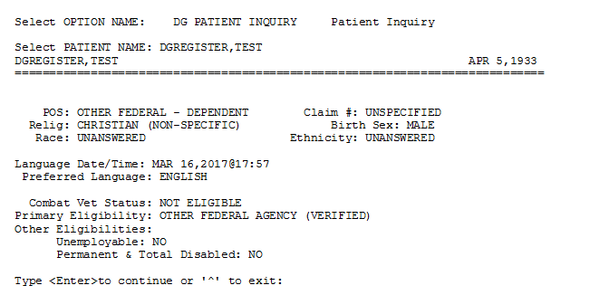
- Computerized Patient Record System (CPRS) Patient Inquiry screen will be updated with the "Permanent & Total Disabled" field with the change indicated in item #1.

Display Screen from Menu CPRS Patient Inquiry:
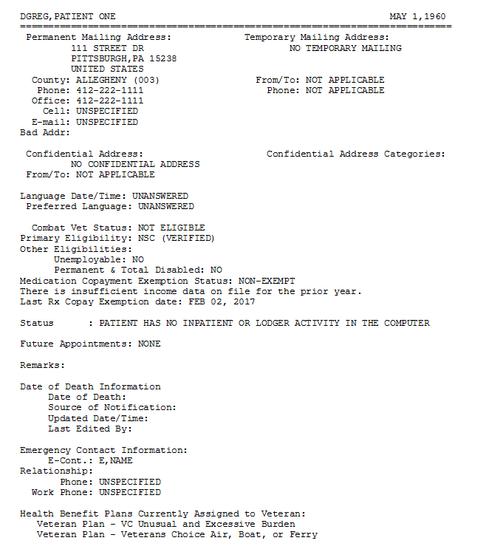

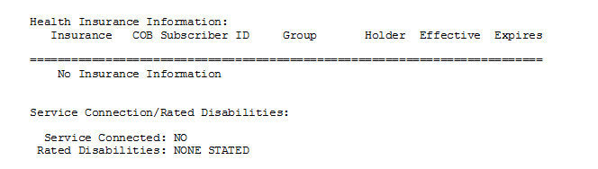
- VistA will receive, store, and display the enrollment status "CLOSED APPLICATION" with "ABANDONED APPLICATION" as the reason for closed application.
- Updated the ENROLLMENT STATUS file (#27.15) with a new entry called "CLOSED APPLICATION".
- A new REASON FOR CLOSED APPLICATION field (#.13) has been added to the PATIENT ENROLLMENT file (#27.11).
  - The new REASON FOR CLOSED APPLICATION field (#.13) is a set of codes with current value of either null or 1 for "ABANDONED APPLICATION".
- The new REASON FOR CLOSED APPLICATION field (#.13) with an ENROLLMENT STATUS of "CLOSED APPLICATION" will be displayed on the following VistA menu option:
Patient Enrollment [DGEN PATIENT ENROLLMENT]

The following is a sample screen capture of the Patient Enrollment option:
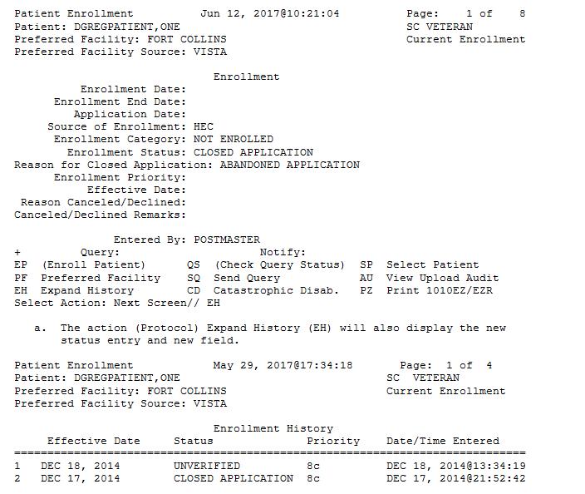

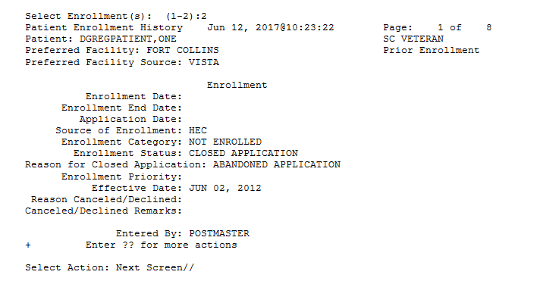
- VistA will receive reason for closed application from the ZEN segment in the ORF/ORU Z11 Health Level 7 (HL7) messages and store the value in the ENROLLMENT STATUS file (#27.11) REASON FOR CLOSED APPLICATION field (#.13).
  - New sequence number 15 has been added to the ZEN segment to accommodate the new field.

Known Issues
There are no known issues.

Product Documentation
The following documents apply to this release:
Title File Name FTP Mode
Release Notes DG_5_3_940_RN.PDF (binary)
User Manual – Registration Menu DG_5_3_940_REG_UM.PDF (binary)
IVM Technical Manual IVM_2_TM_RCA.PDF (binary)
CPRS User Guide: GUI Version updates associated with this patch will be included in the CPRS v31a release.
redacted
Documentation can also be found on the VA Software Documentation Library at:
http://www.va.gov/vdl/

