Address Changes, IVM Demographic Upload Utility and Health Benefit Plan Updates

DG_53_P941.KID
Veterans Health Information Systems and Technology Architecture (VistA)
Registration, Eligibility & Enrollment (REE)

Registration (DG) - DG*5.3*941
Income Verification Match (IVM) - IVM*2.0*164
Enrollment Application System (EAS) - EAS*1.0*151

Release Notes
December 2018
Department of Veterans Affairs
Office of Information and Technology (OIT)

Table of Contents
1 Introduction 1
2 Purpose 1
3 Audience 1
4 This Release 1
4.1 New Features and Functions Added 1
4.2 Enhancements and Modifications to Existing 1
4.2.1 DG*5.3*941 4
4.2.1.1 Part 1: New Address Type of Residential 4
4.2.1.2 Part 2: Determine Non-Residential Address 13
4.2.1.3 Part 3: Patient Address Updates 13
4.2.1.4 Part 4: Add Residential Address to Address Sharing APIs 14
4.2.1.5 Part 5: Address Change Source Fields Updates 14
4.2.1.6 Part 6: Defect – DG Address Update Prompt Labels 15
4.2.1.7 Part 7: Health Benefit Plan Name Corrected 15
4.2.1.8 Part 8: PATIENT File (#2) Address Trigger ADTTM8 15
4.2.1.9 Part 9: Address Fields Converted to Uppercase 16
4.2.2 IVM*2.0*164 16
4.2.3 EAS*1.0*151 17
5 Known Issues 20
6 Product Documentation 20

List of Figures
Figure 1: DG*5.3*941 Updates to Address Change Confirmation Prompts 5
Figure 2: DG*5.3*941 Updates to Address Validation Step 1 6
Figure 3: DG*5.3*941 Updates to Address Validation Step 2 6
Figure 4: DG*5.3*941 Updates to Phone Number Change Prompts 7
Figure 5: DG*5.3*941 Updates to Copy Residential Address to Permanent Mailing Address Prompts 8
Figure 6: DG*5.3*941 Updates to VistA PATIENT DEMOGRAPHIC DATA, SCREEN <1> Groups [1], [4], and [5] 9
Figure 7: DG*5.3*941 Updates to ADDITIONAL PATIENT DEMOGRAPHIC DATA, SCREEN <1.1> Groups [1] – [4] 10
Figure 8: DG*5.3*941 Updates to Copy Residential Address to Permanent Mailing Address Prompts 11
Figure 9: DG*5.3*941 Updates to Copy Permanent Mailing Address to Residential Address Prompts 12
Figure 10: DG*5.3*941 Updates to Temporary Mailing Address Field Prompts 13
Figure 11: DG*5.3*941 Updates to Patient Address Update Menu Option 15
Figure 12: EAS*1.0*151 Updates to Patient Address Field Labels 17
Figure 13: EAS*1.0*151 Updates to View Patient Address Prompts 18
Figure 14: EAS*1.0*151 Updates to Temporary Address Display 19
Figure 15: EAS*1.0*151 Updates to Residential Address Display 19

Introduction
The Host File, DG_53_P941.KID, includes patches DG*5.3*941, IVM*2.0*164, and EAS*1.0*151. The Host File is being released to support the enhancements for the Enterprise Health Benefits Determination (EHBD) program that focuses on updates for the Enrollment System Modernization (ESM) project, which supports Enrollment System Community Care (ESCC).

Purpose
These Release Notes cover the changes to Veterans Health Information Systems and Technology Architecture (VistA) Registration, Eligibility & Enrollment (REE) Registration (DG), Income Verification Match (IVM), and Enrollment Application System (EAS) systems for this release.

Audience
This document targets users and administrators of VistA REE, the DG, IVM, and EAS systems and applies to the changes made between this release and any previous release for this software. Therefore, the users and administrators are deemed competent in using existing applications.

This Release
This multi-package build is distributed as a Host File. The Host File DG_53_P941.KID can be obtained from one of the anonymous Secure File Transfer Protocol (SFTP) directories listed in the Software and Documentation Retrieval Instructions section of the patch descriptions.
The following sections provide a summary of the enhancements and modifications to the existing software for VistA REE patch DG*5.3*941, patch IVM*2.0*164, and patch EAS*1.0*151.

New Features and Functions Added
There are no new features or functions added to VistA REE for DG, IVM, or EAS.

Enhancements and Modifications to Existing
With the installation of patch DG*5.3*941, a new address type of Residential Address can be viewed, added or updated in VistA REE. This address is used by Enrollment and Eligibility to retain the geographic residence of an applicant or patient. It supports the ESCC program's need to determine geographic distance from a treatment facility. A Residential Address street address cannot include a P.O. Box. A new field "Coding Accuracy Support System (CASS) Certified" was added to all address types to store whether postal addresses meet United States Postal Service (USPS) format standards. The CASS Certified field will not be displayed or shared in Address Application Programming Interfaces (APIs). The Residential Address is available for viewing in other VistA packages via Integration Control Registration (ICR) 2041 and 10037. This patch also includes a Health Benefit Plan name change.
VistA can receive from the Enrollment System a new value for the Change Source associated with the Residential Address, Permanent Address, Residential Phone Number, Cellular Phone Number and Email Address. The new value is "VET360" and VistA will accept and store it in the corresponding PATIENT file (#2) field. The value of “VET360” refers to a central repository for patient contact information, which is also used for address validation.
A defect was resolved by revising address type labels on the Patient Address Update [DG ADDRESS UPDATE] Option to be consistent with the changes made with Patch DG*5.3*925.
Patch IVM*2.0*164 modifies the VistA Health Level 7 (HL7) messaging.
VistA Registration will send and receive a new address type of Residential Address to and from the Enrollment System (ES). This address is used by Enrollment and Eligibility to retain the geographic residence of an applicant or patient. It supports the ESCC program's need to determine geographic distance from a treatment facility.
For each address type, VistA Registration will also send and receive the new "Coding Accuracy Support System (CASS) Certified" data element, which is used to indicate whether or not the format of the address was verified by third party software.
The Income Verification Match (IVM) Demographic Upload Utility will include the Permanent Mailing Address CASS Certified field.
Patch EAS*1.0*151 enhances the VistA screen available from menu option View Patient Address [EAS VIEW PATIENT ADDRESS].
A new address type of Residential Address can be viewed. This address is used by Enrollment and Eligibility to retain the geographic residence of an applicant or patient. It supports the ESCC program's need to determine geographic distance from a treatment facility. In addition, the screen labels and prompts are modified.
Enhancements and modifications are tracked in Rational Requirements Management (RM) and Change and Configuration Management (CM) as follows:
RM # 788099 – Add and/or Edit Residential Address in VistA for the following menu options:
Load/Edit Patient Data [DG LOAD PATIENT DATA]
Patient Inquiry [DG PATIENT INQUIRY]
Preregister A Patient [DGPRE PRE-REGISTER OPTION]
Eligibility Verification [DG ELIGIBILITY VERIFICATION]
View Registration Data [DG REGISTRATION VIEW]
Register A Patient [DG REGISTER PATIENT]
Admit A Patient [DG ADMIT PATIENT]
RM # 788101 – Real Time Validation of the Addresses in VistA. The validation and consistency rules are consistent with those used for the Permanent Mailing Address in VistA.
RM # 788103 – Determine Non-Residential Address in VistA by validating if the Residential Address violates the defined Non-Residential Address rules.
RM # 788126 – Communicate Address Changes to VistA Sites: The PATIENT file (#2) includes a new address type of Residential Address and a new CASS Certified field was added for Residential Address (RESIDENTIAL ADDR CASS IND field .1159), Confidential Mailing (CONFIDENTIAL ADDR CASS IND field .14117), Temporary Mailing (TEMPORARY ADDR CASS IND field .12115) and Permanent Mailing (STREET ADDRESS CASS IND field .1118) address types.
RM # 933596 – CR 584192 Modify Health Benefit Plan Name - In the HEALTH BENEFIT PLAN file (#25.11) the name of a Health Benefit Plan (HBP) is corrected. "Veteran Plan - VC Unusual and Excessive Burden" is changed to "Veteran Plan - VC Unusual or Excessive Burden."
RM # 949766 – Maintain VistA by incorporating the following change: In the HEALTH BENEFIT PLAN file (#25.11) the name of a Health Benefit Plan (HBP) is corrected. "Veteran Plan - VC Unusual and Excessive Burden" is changed to "Veteran Plan - VC Unusual or Excessive Burden."
CM # 840104 – During testing a defect was found in which Add/Update Confidential Address from Vista Site1 did not display the correct county name/code in Vista Site2 for County Name = Fairfax and Code = 059. The defect was resolved in version 17 of the IVM*2.0*164 patch, which modifies the code to separate the Confidential Address state pointer from the Residential Address state pointer.

List of Updates

DG*5.3*941

Part 1: New Address Type of Residential
- The PATIENT file (#2) includes a new address type of Residential Address consisting of the following fields:
  - CASS Certified (system-generated and not displayed)
RESIDENTIAL ADDR CASS IND
  - Country
RESIDENTIAL COUNTRY
  - Address Line 1
RESIDENTIAL ADDRESS [LINE 1]
  - Address Line 2
RESIDENTIAL ADDRESS [LINE 2]
  - Address Line 3
RESIDENTIAL ADDRESS [LINE 3]
  - Zip Code (4-Digit Extension)
RESIDENTIAL ZIP+4
  - City
RESIDENTIAL CITY
  - State
RESIDENTIAL STATE
  - County
RESIDENTIAL COUNTY
  - Postal Code
RESIDENTIAL POSTAL CODE
  - Province
RESIDENTIAL PROVINCE
  - Source of Change
RESIDENTIAL ADDR CHANGE SOURCE
  - Site of Change
RESIDENTIAL ADDR CHANGE SITE
  - Last Update (system-generated, view only)
RESIDENTIAL ADDR CHANGE DT/TM
- The following menu options incorporate the Address changes listed below:
Load/Edit Patient Data [DG LOAD PATIENT DATA]
Patient Inquiry [DG PATIENT INQUIRY]
Preregister A Patient [DGPRE PRE-REGISTER OPTION]
Eligibility Verification [DG ELIGIBILITY VERIFICATION]
View Registration Data [DG REGISTRATION VIEW]
Register A Patient [DG REGISTER PATIENT]
Admit A Patient [DG ADMIT PATIENT]
- Validation and consistency rules are consistent with those used for the Permanent Mailing Address unless specified herein.
- When creating or modifying the Residential Address, the fields and prompts are as shown.
  - Country - Required. Defaults to UNITED STATES. Selection limited to the list of countries from the COUNTRY CODE file (#779.004). For an existing address, the Country on-file is displayed.
  - Address Line 1 – Optional, but required for saving. Free Text 3-35 characters.
  - Address Line 2 - Optional. Free Text 3-30 characters.
  - Address Line 3 - Optional. Free Text 3-30 characters.
- VistA uses the selected Country to determine the following fields presented to the user.
  - If Country = UNITED STATES:
    - Zip Code – Optional, but required for saving. Selection must be a valid zip code from ZIP CODE file (#5.11). Once a Zip Code is entered, the State and County will be populated automatically.
    - City – Optional, but required for saving. Selection is derived from the zip code and user may be presented with more than one choice.
  - If Country is not UNITED STATES:
    - City – Optional, but required for saving. Free Text 2-15 characters.
    - Province - Optional. Free Text 1-20 characters.
    - Postal Code - Optional. Free Text 1-10 characters.
- VistA then prompts for the two phone number fields below.
  - Phone Number [RESIDENCE] - Optional. Free Text 4-20 characters.
  - Phone Number [WORK] - Optional. Free Text 4-20 characters.
- VistA then prompts for confirmation to save the changes to the Address fields. The previous residential address fields are displayed along with the updated fields.
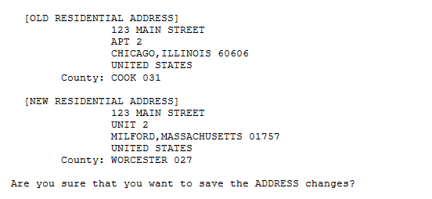
Figure 1: DG*5.3*941 Updates to Address Change Confirmation Prompts
- If the user answers “N”, the changes are discarded.
- If the user answers “Y”, VistA validates the address entered. If the address passes validation, the changes are saved. If the validation fails, VistA rejects the changes, informs the user, and presents the user with a message indicating the validation failure. The validation consists of two steps.
  - The following fields are required and may not be empty.
    - Address Line 1
    - City
    - State (for domestic address only)
    - Zip Code (for domestic address only)
  - The address must be a valid residential address. See Section 4.2.1.2 Part 2: Determine Non-Residential Address.
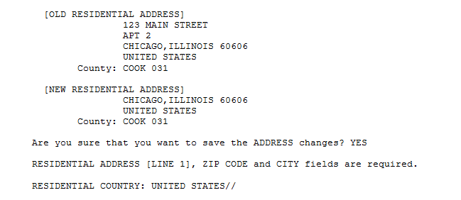
Figure 2: DG*5.3*941 Updates to Address Validation Step 1
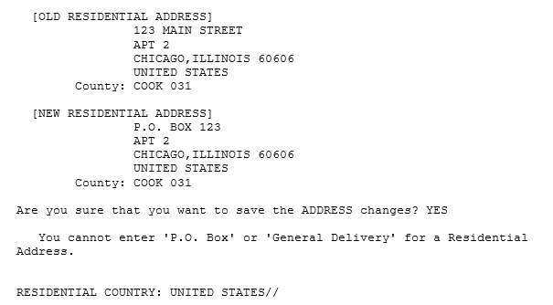
Figure 3: DG*5.3*941 Updates to Address Validation Step 2

- VistA then prompts for confirmation to save the changes to the Phone Number fields. The previous phone number fields are displayed along with the updated phone numbers.
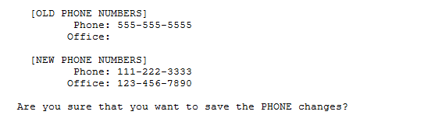
Figure 4: DG*5.3*941 Updates to Phone Number Change Prompts
- If the user answers “Y”, the changes are saved. If the user answers “N”, the changes are discarded.
- After the phone numbers are processed, if the address validation described above had failed, the user is returned to the RESIDENTIAL COUNTRY prompt.
- When the user has completed editing a Residential Address and Phone Number, VistA prompts the user “Copy the Residential Address to the Permanent Mailing Address? NO//”.
  - If the user selects “Yes”, VistA copies the Residential Address fields to the Permanent Mailing Address, displays the Permanent Mailing Address fields, and requests confirmation to update.
  - If the user selects “No”, the copy is cancelled and VistA returns to SCREEN <1.1>.
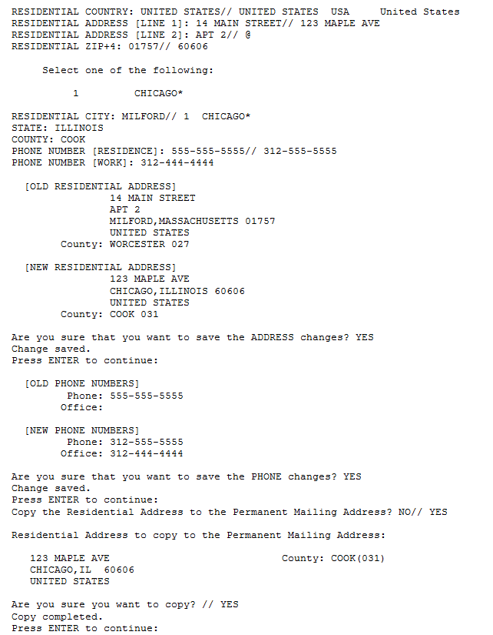
Figure 5: DG*5.3*941 Updates to Copy Residential Address to Permanent Mailing Address Prompts

- The user cannot exit the Residential Address prompts by entering an up carat “^”.
- The Last Update field is system-generated and displayed as view only.
- VistA PATIENT DEMOGRAPHIC DATA, SCREEN <1> is updated as follows:
  - Group [1]: The Phone Number [Residence] and Phone Number [Work] are no longer presented to the user with the Permanent Mailing Address on Registration screens.
  - Group [4]: The Permanent Mailing Address group of fields are removed. The fields 'Cell Phone', 'Pager #' and 'Email Address' are added.
  - Group [5]: The fields 'Language Date/Time' and 'Preferred Language' are added. Temporary Mailing Address fields are removed.
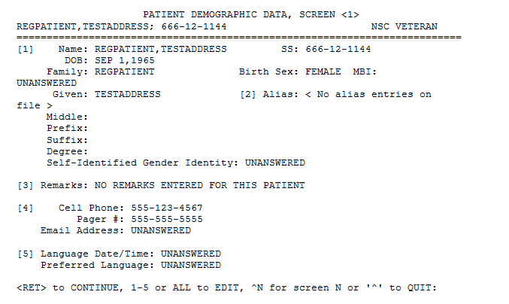
Figure 6: DG*5.3*941 Updates to VistA PATIENT DEMOGRAPHIC DATA,
SCREEN <1> Groups [1], [4], and [5]
- VistA ADDITIONAL PATIENT DEMOGRAPHIC DATA, SCREEN <1.1> is redesigned as follows:
  - Group [1] Residential Address is added with the following fields:
Address Line 1
Address Line 2
Address Line 3
City
State, Zip Code, County - for UNITED STATES address
Province, Postal Code - for foreign address
Country (default equals "United States" for a new address
Phone (Phone Number [Residence])
Office (Phone Number [Work])
  - Group [2] 'Cell Phone', 'Pager #', and 'Email Address' are removed.
  - Group [2] Permanent Mailing Address - is added with the same group of fields as originally presented in SCREEN <1>, group [4], with the removal of the 'Phone:' and 'Office:' fields.
  - Group [3] 'Language Date/Time' and 'Preferred Language' are removed.
  - Group [3] Temporary Mailing Address is added with the same group of fields as originally presented in SCREEN <1>, group [5].
  - Group [4] Confidential Mailing Address is added - same group of fields as originally presented in ADDITIONAL PATIENT DEMOGRAPHIC DATA, SCREEN <1.1>, group [1].
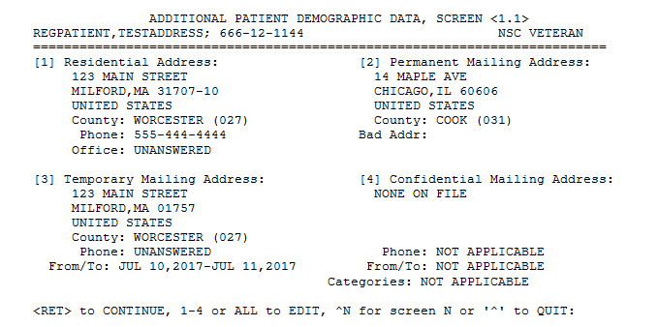
Figure 7: DG*5.3*941 Updates to ADDITIONAL PATIENT DEMOGRAPHIC DATA,
SCREEN <1.1> Groups [1] – [4]
- The Demographic Help Screens for SCREEN <1> and SCREEN <1.1> reflect the changes described above in #16 and #17.

- On the ADDITIONAL PATIENT DEMOGRAPHIC DATA, SCREEN <1.1>, when the user is adding a Permanent Mailing Address that is currently blank and a Residential Address was entered, VistA prompts the user "Copy the Residential Address to the Permanent Mailing Address? NO//".
  - If the user selects "Yes", VistA copies the Residential Address fields to the Permanent Mailing Address, and displays the Permanent Mailing Address fields and requests confirmation to add.
  - If the user selects "No", VistA proceeds by prompting for each Permanent Mailing Address field.
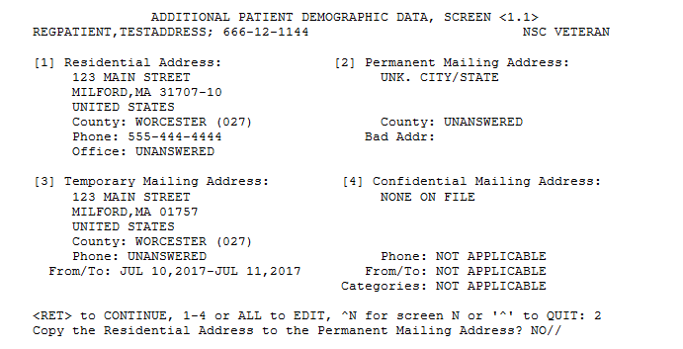
Figure 8: DG*5.3*941 Updates to Copy Residential Address to Permanent Mailing Address Prompts

- On the ADDITIONAL PATIENT DEMOGRAPHIC DATA, SCREEN <1.1>, when the user has edited and saved a Permanent Mailing address and the Permanent Mailing address is an allowable Residential Address (not a P.O. Box or General Delivery and has the required fields) VistA prompts the user "Copy the Permanent Mailing Address to the Residential Address?"
If the user selects "Yes", VistA copies the Permanent Mailing Address fields to the Residential Address, displays the Residential Address fields, and requests confirmation to update.
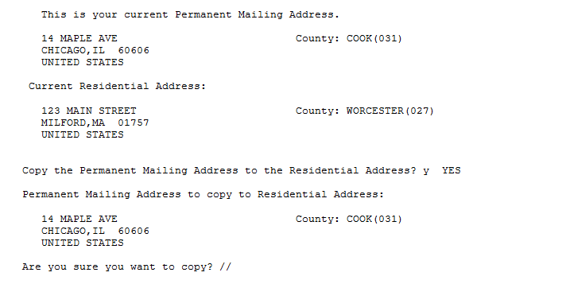
Figure 9: DG*5.3*941 Updates to Copy Permanent Mailing Address to Residential Address Prompts
- A history of Residential address changes is maintained by VistA via VA FileMan auditing.

Part 2: Determine Non-Residential Address
      - VistA prevents a user from saving a Residential Address that is in a non-residential format with General Delivery or P.O. Box. A non-residential address is defined as Address Line 1 starting with any of the following in upper case, lower case, or mixed case (with or without a period):
"Post Office"
"P.O." or "PO"
"General Delivery"
"Box" when immediately followed by a number.
- The user can enter a non-residential address format when:
  - The Veteran's Residential address is Alaska or Hawaii
  - The Veteran resides in one of the United States territories (Guam, American Samoa, CNMI (Mariana Islands), U.S. Virgin Islands, or Philippines)
- If the user attempts to save a Residential Address that violates the non-residential address rules defined above, saving the record is not allowed. The following error message is displayed: "You cannot enter 'P.O. Box' or 'General Delivery' for a Residential Address".

Part 3: Patient Address Updates
      - When editing the Temporary Mailing Address, the prompts for these fields are renamed as follows:
        - TEMP MAILING ADDRESS ACTIVE?:
  - TEMP MAILING ADDRESS START DATE:
  - TEMP MAILING ADDRESS END DATE:
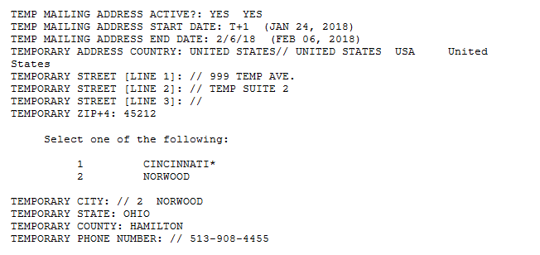
Figure 10: DG*5.3*941 Updates to Temporary Mailing Address Field Prompts
- In the Patient Address Update [DG ADDRESS UPDATE] option, on the screen for editing the Permanent Mailing Address, the 'PHONE NUMBER [RESIDENCE]' and 'PHONE NUMBER [OFFICE]' fields are removed.
- The Patient Inquiry Screen [DG PATIENT INQUIRY] is modified so the first screen mimics the format of SCREEN <1.1>.
  - Residential Address group of fields is added.
  - Permanent Mailing Address, Temporary Mailing Address, and Confidential Mailing Address groups of field are shifted on the screen to mimic the same positions as in SCREEN <1.1>.
  - The Cell phone number and email remain displayed with the Permanent Mailing Address.
- A new CASS Certified field was added for Residential Address (RESIDENTIAL ADDR CASS IND field .1159), Confidential Mailing (CONFIDENTIAL ADDR CASS IND field .14117), Temporary Mailing (TEMPORARY ADDR CASS IND field .12115) and Permanent Mailing (STREET ADDRESS CASS IND field .1118) address types. This new field will be set to "NC" Not Checked when a user enters a new address or edits an existing address.

Part 4: Add Residential Address to Address Sharing APIs
The VADPT routine includes the Residential Address. It now returns the Residential Address with the Patient Address data. This applies to ICR 10061 at entry point “ADD^VADPT”. This provides other VistA packages with the ability to edit the Residential Address, which is planned for a future release.

Part 5: Address Change Source Fields Updates
The Z05 received from the Enrollment System can include any of the following: Residential or Permanent Address, a Residence or Cellular Phone Number or an Email Address. If VistA accepts the update, now the Change Source can contain the value "VET360" and VistA will store "VET360" in the corresponding PATIENT file (#2) Change Source field. The change source fields are:
ADDRESS CHANGE SOURCE (Permanent Address)
RESIDENTIAL ADDR CHANGE SOURCE
RESIDENCE NUMBER CHANGE SOURCE
CELLULAR NUMBER CHANGE SOURCE
EMAIL ADDRESS CHANGE SOURCE

Part 6: Defect – DG Address Update Prompt Labels
On the screen in Registration menu option Patient Address Update [DG ADDRESS UPDATE]:
The labels in the prompt are modified from "Do you want to update the (P)ermanent Address, (T)emporary Address, or (B)oth?" to "Do you want to update the (P)ermanent Mailing Address, (T)emporary Mailing Address, or (B)oth?".
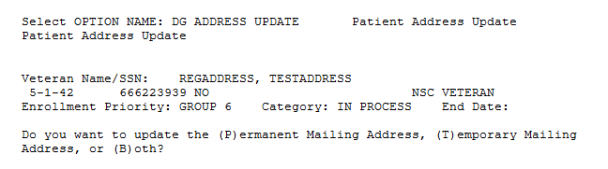
Figure 11: DG*5.3*941 Updates to Patient Address Update Menu Option

Part 7: Health Benefit Plan Name Corrected
In the HEALTH BENEFIT PLAN file (#25.11) the name of a Health Benefit Plan (HBP) is corrected. "Veteran Plan - VC - Unusual and Excessive Burden" is changed to "Veteran Plan - VC - Unusual or Excessive Burden."

Part 8: PATIENT File (#2) Address Trigger ADTTM8
      - When any Residential Address field is changed (see list below), it modifies the Residential Address Change Date and Time field.
RESIDENTIAL ADDR CHANGE DT/TM (#.1158)
RESIDENTIAL ADDRESS [LINE 1]
(#.1151) New
RESIDENTIAL ADDRESS [LINE 2]
(#.1152) New
RESIDENTIAL ADDRESS [LINE 3]
(#.1153) New
RESIDENTIAL CITY
(#.1154) New
RESIDENTIAL STATE
(#.1155) New
RESIDENTIAL ZIP+4
(#.1156) New
RESIDENTIAL COUNTY
(#.1157) New
RESIDENTIAL PROVINCE
(#.11571) New
RESIDENTIAL POSTAL CODE
(#.11572) New
RESIDENTIAL COUNTRY
(#.11573) New
      - Any modification of the Residential Address Change Date and Time field RESIDENTIAL ADDR CHANGE DT/TM (#.1158) triggers the update of the Residential Address Source of Change field RESIDENTIAL ADDR CHANGE SOURCE (#.11582).

Part 9: Address Fields Converted to Uppercase
All address text fields on SCREEN <1.1> are modified to automatically convert the text entered to uppercase. This applies to address lines 1, 2, and 3, City, Province, Postal Code for Residential Address, Permanent Mailing Address, Temporary Mailing Address, and Confidential Mailing Address.

IVM*2.0*164
      - With installation of this patch, VistA receives, stores, and displays Residential Addresses sent by ES.
        - Address changes are received from ES via Z05 HL7 messages, which now include the Residential Address in the PID segment.
  - Logic for Confidential Mailing Address now allows VistA to process Confidential Mailing Address updates when ES is ready to send them. Previously, when a Confidential Mailing Address was updated in ES, a Z05 was sent to VistA, but "site number" logic prevented the address changes from being processed on VistA. The impact of this change will not be apparent until ES begins to send the Confidential Mailing Addresses to VistA.
- When VistA receives a Residential Address type on the Z05 HL7 message from ES, VistA checks the Date/Time last updated:
  - If, and only if, the incoming address is newer, the address is stored in VistA.
  - If the incoming address on the Z05 is older, it is not stored.
  - No other validation is applicable to Residential Address types during the Z05 upload.
- The HL7 message from ES to VistA includes the new CASS Certified field for Permanent Mailing, Temporary Mailing, Confidential Mailing, and Residential Address types in the new ZAV Segment.
  - The new ZAV, Address Verification, segment will be included for each address type included in the Z05 message.
  - The new ZAV, Address Verification, segment will be included for each address type included in the Z07 message.
- The IVM Demographic Upload Utility is modified to include the Permanent Mailing Address CASS Certified field.
When a Permanent Mailing Address is received from ES on the Z05, the associated CASS Certified field will either be uploaded to the IVM Demographic Upload Utility or directly to the PATIENT file (#2) based on the existing rules for processing a Permanent Mailing Address.
- The following menu options allow a Registration user to view, add, or update the Residential Address. If any Residential address field is added or updated, VistA will send the change to ES via the Z07 HL7 message. The new ZAV, Address Verification, segment will be included for each address type included in the Z05 message.
Load/Edit Patient Data [DG LOAD PATIENT DATA]
Patient Inquiry [DG PATIENT INQUIRY]
Preregister A Patient [DGPRE PRE-REGISTER OPTION]
Eligibility Verification [DG ELIGIBILITY VERIFICATION]
Register A Patient [DG REGISTER PATIENT]
Patient Address Update [DG ADDRESS UPDATE]
Admit A Patient [DG ADMIT PATIENT]

EAS*1.0*151
The new address type "Residential Address" can be viewed via the VistA option "View Patient Address" (EAS VIEW PATIENT ADDRESS). This address is used by Enrollment and Eligibility to retain the geographic residence of an applicant or patient. It supports the Enrollment System Community Care (ESCC) program's need to determine geographic distance from a treatment facility.
In addition the screen labels and prompts are modified as follows.
      - The field label for the patient address is modified from "Patient Address" to "Permanent Mailing Address".
- The field label for the date of the patient address change is modified from "Patient Add Change Date" to "Permanent Mailing Add Change Date".
- The field label for the site of the patient address change is modified from "Patient Add Change Site" to "Permanent Mailing Add Change Site".
- The field label for the source of the patient address change is modified from "Patient Add Change Source" to "Permanent Mailing Add Change Source".
REDACTED
Figure 12: EAS*1.0*151 Updates to Patient Address Field Labels

- After displaying the Permanent Mailing Address, the user is prompted for displaying the Confidential Mailing, Temporary Mailing and Residential addresses if they exist in the patient record. This prompt is modified from: "Would you like to see the Confidential and Temporary Addresses? Yes//" to "Would you like to view the Conf Mailing, TempMailing and Residential Addresses? Yes//"
REDACTED
Figure 13: EAS*1.0*151 Updates to View Patient Address Prompts
- The display of the Confidential Address is modified as follows:
  - The field label for the Confidential Address is modified from "Confid Address" to "Confid Mailing Address".
  - The field label for the date of the Confidential Address change is modified from "Confid Add Change Date" to "Confid Mailing Add Change Date".
  - The field label for the site of the Confidential Address change is modified from "Confid Add Change Site" to "Confid Mailing Add Change Site".
  - The field label for the start date of the Confidential Address is modified from "Confid Add Start Date" to "Confid Mailing Add Start Date".
  - The field label for the end date of the Confidential Address is modified from "Confid Add End Date" to "Confid Mailing Add End Date".

- The display of the Temporary Address is modified as follows:
  - The field label for the Temporary Address is modified from "Temp Address" to "Temp Mailing Address".
  - The field label for the date of the Temporary Address change is modified from "Temp Add Change Date" to "Temp Mailing Add Change Date".
  - The field label for the site of the Temporary Address change is modified from "Temp Add Change Site" to "Temp Mailing Add Change Site".
  - The field label for the start date of the Temporary Address is modified from "Temp Add Start Date" to "Temp Mailing Add Start Date".
  - The field label for the end date of the Temporary Address is modified from "Temp Add End Date" to "Temp Mailing Add End Date".
REDACTED
Figure 14: EAS*1.0*151 Updates to Temporary Address Display
- The Residential Address is added to the display if it exists in the patient record. The display of the Residential Address contains the following fields from the PATIENT file (#2):
- RESIDENTIAL ADDRESS LINE 1 (#.1151)
- RESIDENTIAL ADDRESS LINE 2 (#.1152)
- RESIDENTIAL ADDRESS LINE 3 (#.1153)
- RESIDENTIAL ADDRESS CITY (#.1154)
- For United States addresses:
- RESIDENTIAL STATE (#.1155)
- RESIDENTIAL ZIP+4 (#.1156)
- For foreign addresses:
- RESIDENTIAL PROVINCE (#.11571)
- RESIDENTIAL POSTAL CODE (#.11572)
- RESIDENTIAL COUNTRY (#.1153)
- RESIDENTIAL ADDRESS CHANGE SITE (#.11581)
- RESIDENTIAL ADDRESS CHANGE SOURCE (#.11582)
- RESIDENTIAL ADDRESS CHANGE DT/TM (#.1158)
REDACTED
Figure 15: EAS*1.0*151 Updates to Residential Address Display

Known Issues
RTC  CM # | Summary
708863 | PROD: Missing county code error in the ORUZ05 message if a user enters address for US Territories.
721471 | PROD: ES - Temp and Confidential Address Phone number not uploaded in ES when added/updated at a site (ex. ANC10 or Chey3)

Product Documentation
The following documents apply to this release:
Title File Name FTP Mode
Release Notes DG_5_3_P941_KID_RN.PDF (binary)
User Manual – Registration Menu DG_5_3_P941_REG_UM.PDF (binary)
PIMS Technical Manual PIMSTM.PDF (binary)
IVM User Manual IVM_2_P164_UM.PDF (binary)
IVM Technical Manual IVM_2_P164_TM.PDF (binary)
redacted
Documentation can also be found on the VA Software Documentation Library at:
http://www.va.gov/vdl/

