Enrollment System Modernization (ESM) Phase 2

Veterans Health Information Systems and Technology Architecture (VistA)
Registration, Eligibility & Enrollment (REE)

DG*5.3*947

Release Notes
October 2018
Department of Veterans Affairs
Office of Information and Technology (OIT)

Table of Contents
1 Introduction 1
2 Purpose 1
3 Audience 1
4 This Release 1
4.1 New Features and Functions Added 1
4.2 Enhancements and Modifications to Existing 1
5 Known Issues 3
6 Product Documentation 4

Table of Figures
Figure 1: MILITARY SERVICE DATA, SCREEN <6> 3
Figure 2: MILITARY SERVICE DATA, SCREEN <6.1> 3

Introduction
DG*5.3*947 is being released to support the enhancements for the Enterprise Health Benefits Determination (EHBD) program that focuses on updates for the Enrollment System Modernization (ESM) Phase 2 project, which supports Enrollment System Community Care (ESCC).

Purpose
The Release Notes cover the changes to Veterans Health Information Systems and Technology Architecture (VistA) Registration, Eligibility & Enrollment (REE) Registration (DG) systems for this release. DG*5.3*947 is also being released in support of the Enrollment System (ES) 5.3 release. Refer to Informational Patch EAS*1*165 (Enrollment Application System) for additional details regarding the ES release.

Audience
This document targets users and administrators of VistA REE, the DG system and applies to the changes made between this release and any previous release for this software.

This Release
This software is being released as a patch (PackMan) message. The PackMan message includes the DG*5.3*947 patch, which also supports the Enrollment System (ES) 5.3 release.
The following sections provide a summary of the enhancements and modifications to the existing software for VistA REE with the release of patch DG*5.3*947.

New Features and Functions Added
There are no new features or functions added to VistA REE for DG*5.3*947.

Enhancements and Modifications to Existing
The REASON FOR EARLY SEPARATION (#.09) field within the MILITARY SERVICE EPISODE (#.3216) multiple within the PATIENT (#2) file is added in Veterans Health Information System and Technology Architecture (VistA) Registration, Eligibility & Enrollment (REE). The data for this field will be received from ES in ORF-Z11/ORU-Z11 HL7 messages in the ZMH segment. The Reason for Early Separation cannot be edited or deleted by VistA users and will not be sent back to ES in a Z07 message.
Note: DBIA 5783 MILITARY SERVICE EPISODE API - DGMSEUTL includes component GETMSE that returns all records in the MILITARY SERVICE EPISODE (#.3216) multiple within the PATIENT (#2) file in the MSE array. While no modifications were made to this component, the REASON FOR EARLY SEPARATION (#.09) field is included in the returned array.
Enhancements and modifications are tracked in Rational Requirements Manager (RM) as follows:
RM # 958405: Add additional data element “Reason for Early Separation” in the ZMH segment of HL7 message
RM # 958406: Display “Reason for Early Separation” in VistA.
RM # 958407: Display the Help Prompt and Help Prompt Description for “Reason for Early Separation” in VA File Manager.
RM # 958408: Figure 1 Screen Mockup - Military Service Data Screen <6>
RM # 958409: Figure 2 Screen Mockup - Military Service Data Screen <6.1> (Add, Edit, Delete – Scenario 1)
List of Updates
DG*5.3*947 makes the following enhancements to REE:
- The REASON FOR EARLY SEPARATION (#.09) field within the MILITARY SERVICE EPISODE (#.3216) multiple within the PATIENT (#2) file is added.
- The FUTURE DISCHARGE DATE (#.08) field within the MILITARY SERVICE EPISODE (#.3216) multiple within the PATIENT (#2) file is modified to be NONEDITABLE.
- The HL7 interface with ES is modified to include the additional data element of "REASON FOR EARLY SEPARATION" that is associated with each MSE. The ORUZ-11 message contains a new sequence, (#9), in the ZMH segment for the "REASON FOR EARLY SEPARATION".
- MSEs that contain a REASON FOR EARLY SEPARATION will not be included in the ORU-Z07 or ORF-Z07 messages sent to ES.
- The following VistA menu options were modified to display the Reason for Early Separation:
- View Registration Data [DG REGISTRATION VIEW]
- Load/Edit Patient Data [DG LOAD PATIENT DATA]
- Register a Patient [DG REGISTER PATIENT]
- Eligibility Verification [DG ELIGIBILITY VERIFICATION]
- Preregister a Patient [DGPRE PRE-REGISTER OPTION]
- Admit a Patient [DG ADMIT PATIENT]
Note: In the Preregister a Patient [DGPRE PRE-REGISTER OPTION] option, the field is shown only if there are MSE inconsistencies in the record.

- The VistA REE system displays the Reason for Early Separation on the following screens as view-only next to the caption "Early Separation Reason:" (screen mockups below):
- Military Service Data, Screen <6>
- Military Service Data, Screen <6.1>
Figure 1: MILITARY SERVICE DATA, SCREEN <6>
REDACTED
Figure 2: MILITARY SERVICE DATA, SCREEN <6.1>
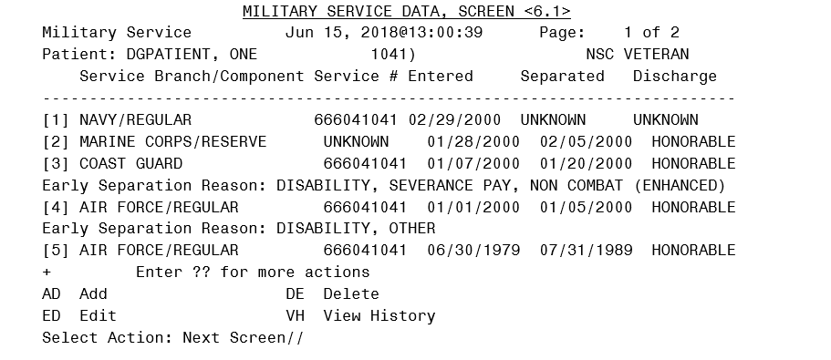
- The VistA REE system does not display the Reason for Early Separation caption if one does not exist for the MSE.
- The following VistA menu options were modified to display the Reason for Early Separation:
  - View Registration Data [DG REGISTRATION VIEW]
  - Load/Edit Patient Data [DG LOAD PATIENT DATA]
  - Register a Patient [DG REGISTER PATIENT]
  - Eligibility Verification [DG ELIGIBILITY VERIFICATION]
  - Preregister a Patient [DGPRE PRE-REGISTER OPTION]
  - Admit a Patient [DG ADMIT PATIENT]
- The VistA REE system does not allow the user to edit an MSE Reason for Early Separation.
- The VistA REE system does not allow the user to delete an MSE Reason for Early Separation.
- When the number of MSEs spans multiple pages on screen <6> or screen <6.1>, the VistA REE system displays all the data elements for each MSE on the same page. The MSE data elements to be displayed together include the following: Branch, Component, Service #, Entered, Separated, Discharge Type, and Future Discharge Date or Reason for Early Separation.

Known Issues
No known issues were identified in this release.

Product Documentation
The following documents apply to this release:
Title File Name FTP Mode
Release Notes DG_5_3_947_RN.PDF (binary)
User Manual – Registration Menu DG_5_3_947_REG_UM.PDF (binary)
Technical Manual – Income
Verification Match IVM_2_TM_RES.PDF (binary)
redacted
Documentation can also be found on the VA Software Documentation Library at:
http://www.va.gov/vdl/

