Enrollment System Modernization (ESM) Phase 2

Veterans Health Information Systems and Technology Architecture (VistA)
Registration, Eligibility & Enrollment (REE)

DG_53_P972.KID
Registration (DG) – DG*5.3*972
Income Verification Match (IVM) – IVM*2.0*183

Release Notes
December 2019
Department of Veterans Affairs
Office of Information and Technology (OIT)

Table of Contents
1 Introduction 1
2 Purpose 1
3 Audience 1
4 This Release 1
4.1 New Features and Functions Added 1
4.2 Enhancements and Modifications 2
4.3 Known Issues 14
5 Product Documentation 14

List of Figures
Figure 1: Help Prompt – CURRENT MOH INDICATOR Field 6
Figure 2: Description – MEDAL OF HONOR INDICATED? Field 7
Figure 3: Patient Enrollment 8
Figure 4: View Upload Audit 9
Figure 5: Patient Inquiry 10
Figure 6: Military Service Data, Screen <6> 11
Figure 7: Eligibility Inquiry for Patient Billing 12

List of Tables
Table 1: DG_53_P972.KID Enhancements and Modifications 13

Introduction
The release of Veterans Health Information System and Technology Architecture (VistA) Registration, Eligibility & Enrollment (REE) Host File DG_53_P972.KID, which includes Registration (DG) patch DG*5.3*972 and Income Verification Match (IVM) patch IVM*2.0*183, supports the enhancements for the Enterprise Health Benefits Determination (EHBD) program that focuses on updates for the Enrollment System Modernization (ESM) Phase 2 project, which supports Enrollment System Community Care (ESCC) and ES Sustainment.

Purpose
The Release Notes cover the changes to VistA REE DG and IVM systems for this release. Host File DG_53_P972.KID, including patches DG*5.3*972 and IVM*2.0*183, is also being released in support of the Enrollment System (ES) 5.5 and 5.7 releases. Refer to Informational Patches EAS*1*173 and EAS*1.0*180 (Enrollment Application System) for additional details regarding the ES releases.

Audience
This document targets users and administrators of VistA REE and applies to the changes made between this release and any previous release for this software.

This Release
This multi-package build is distributed as a Host File. The Host File DG_53_P972.KID can be obtained from one of the anonymous Secure File Transfer Protocol (SFTP) directories listed in the Software and Documentation Retrieval Instructions section of the patch descriptions.
IMPORTANT NOTE: The following patches, which all include functionality for Medal of Honor, will be released concurrently and should be installed in the following order:
- Patch DG*5.3*972, released with patch IVM*2.0*183 in Host File DG_53_P972.KID, ensures Veterans awarded Medal of Honor are placed in Priority Group 1 and are exempt from copayments for health care and medications.
- Patch IVM*2.0*183, released with DG*5.3*972 in Host File DG_53_P972.KID, modifies how VistA determines if an income test is the active current test per Veteran's Financial Assessment (VFA) rules and adds a condition that Medal of Honor recipients are not subject to income testing.
- Patch EAS*1.0*174 ensures VistA users can exempt Veterans awarded Medal of Honor from Long Term Care (LTC) copayments and LTC income testing.
- Integrated Billing (IB) patch IB*2.0*627 will need to be installed directly after EAS*1.0*174 as the full functionality of Medal of Honor will not be apparent until IB*2.0*627 is installed.
The following sections provide a summary of the enhancements and modifications to the existing software for VistA REE with the release of patches DG*5.3*972 and IVM*2.0*183.

New Features and Functions Added
There are no new features or functions added to VistA REE for DG*5.3*972 and IVM*2.0*183.

Enhancements and Modifications
DG*5.3*972
Public Law 114-315, signed into law on December 16, 2016, amends United States Code Title 38 Section 1705 to place Veterans awarded the Medal of Honor into the highest Department of Veterans Affairs (VA) Enrollment Priority group - Enrollment Priority Group 1. Veterans awarded Medal of Honor are currently assigned to Enrollment Priority Group 3.
PL 114-315 amends United States Code Title 38 Section 1710(a), 1710B, and 1722A and exempts Veterans awarded Medal of Honor from copayments for health care, medications, and extended care services.
Additionally, PL 114-315 provides that all Veterans awarded the Medal of Honor currently enrolled for VA hospital care and medical services, and whose Veterans Health Administration (VHA) enrollment records are not currently assigned to Priority Group 1, will have their enrollment record updated to reflect enrollment in Priority Group 1 and exemption from copayments for health care, medications, and extended care services.
ES sends VistA REE an HL7 message (ORU-Z11/ORF-Z11) passing the CURRENT MOH INDICATOR, MOH AWARD DATE, and MOH STATUS DATE. VistA REE receives the data and stores the information in the PATIENT file (#2) and PATIENT ENROLLMENT file (#27.11).
VistA REE calculates the MOH COPAYMENT EXEMPTION DATE based on the MOH AWARD DATE received from ES and the MOH legislation date, December 16, 2016. Refer to PL 114 - 315. This date is displayed in VistA REE for manual billing reconciliation and informational purposes only.
The following VistA REE screens are updated to display a patient's Medal of Honor award indicator without condition, and to display the Medal of Honor award date, status date, and copayment exemption date:
- The VistA REE options that display the MILITARY SERVICE DATA, SCREEN <6> screen
- The option Patient Enrollment [DGEN PATIENT ENROLLMENT] Page 3 screen
- Expand History [DGEN EXPAND HISTORY] action protocol within the Patient Enrollment [DGEN PATIENT ENROLLMENT] option
- View Upload Audit [DGENUP VIEW ELIGIBILTY UPLOAD AUDIT] action protocol within the Patient Enrollment [DGEN PATIENT ENROLLMENT] option
The Eligibility Inquiry for Patient Billing [DG PATIENT ELIGIBILITY INQUIRY] option is updated to display a patient's Medal of Honor award indicator as well as the Medal of Honor award date, status date and copayment exemption date. It is also updated to display a patient’s current Camp Lejeune eligibility.
Integration Control Registration (ICR) 423 ($$AUTOINFO^DGMTCOU1(DFN)) is updated to use the PATIENT file (#2) CURRENT MOH INDICATOR field (#.541) in the auto exemption determination logic to determine if a patient is exempt from Pharmacy Co-Pay.
ICR 423 NAME: DGMTCOU1 - Medication Copay Exemption API
CUSTODIAL PACKAGE: REGISTRATION
SUBSCRIBING PACKAGE: INTEGRATED BILLING
USAGE: Private
ICR 643 ($$BIL^DGMTUB(DFN,IBDT)) is updated to use the PATIENT file (#2) CURRENT MOH INDICATOR field (#.541) in the logic for determining whether a Means Test is required.
ICR 643 NAME: DBIA186
CUSTODIAL PACKAGE: REGISTRATION
SUBSCRIBING PACKAGE: INTEGRATED BILLING
FEE BASIS (only to call entry point $$BIL)
ENROLLMENT APPLICATION SYSTEM
SCHEDULING
USAGE: Controlled Subscription
Patch DG*5.3*972 includes the following enhancements to VistA REE:
- The HL7 interface with ES is modified to include two additional data elements:
  - MOH AWARD DATE. The ORU-Z11/ORF-Z11 message populates sequence #4 component 1 in the ZMH segment.
  - MOH STATUS DATE. The ORU-Z11/ORF-Z11 message populates sequence #4 component 2 in the ZMH segment.
- When VistA receives an HL7 ORU-Z11/ORF-Z11 message, if the Medal of Honor Indicator in the ZMH segment is YES and the patient is not a Veteran, VistA REE returns an error to ES “BAD VALUE, ZMH SEGMENT, SEQ 3, NON VETERAN INELIGIBLE FOR MEDAL OF HONOR” and discontinues processing of the HL7 ORU-Z11/ORF-Z11 message.
- When VistA receives an HL7 ORU-Z11/ORF-Z11 message, the MOH AWARD DATE and MOH STATUS DATE are stored in the following locations:
  - MOH AWARD DATE is stored in the MOH AWARD DATE field (#.542) within the PATIENT file (#2).
  - MOH AWARD DATE is stored in the MOH AWARD DATE field (#50.28) within the PATIENT ENROLLMENT file (#27.11).
  - MOH STATUS DATE is stored in the MOH STATUS DATE field (#.543) within the PATIENT file (#2).
  - MOH STATUS DATE is stored in the MOH STATUS DATE field (#50.29) within the PATIENT ENROLLMENT file (#27.11).
- When VistA receives an HL7 ORU-Z11/ORF-Z11 message, the MOH AWARD DATE and MOH legislation date are used to calculate the MOH COPAYMENT EXEMPTION DATE. Once the MOH COPAYMENT EXEMPTION DATE is calculated, it is stored in the following locations:
  - MOH COPAYMENT EXEMPTION DATE field (#.544) within the PATIENT file (#2)
  - MOH COPAYMENT EXEMPTION DATE field (#50.3) within the PATIENT ENROLLMENT file (#27.11)
  - VistA will not store a future MOH COPAYMENT EXEMPTION DATE.
- The business rules for processing the MOH AWARD DATE and MOH STATUS DATE received in the HL7 ORU-Z11/ORF-Z11 message are as follows:
  - If there is no MOH AWARD DATE sent in the HL7 message, nothing is stored for the MOH AWARD DATE field (#.542) in the PATIENT file (#2) or in the MOH AWARD DATE field (#50.28) within the PATIENT ENROLLMENT file (#27.11). In addition, the MOH COPAYMENT EXEMPTION DATE field (#.544) in the PATIENT file (#2) and the MOH COPAYMENT EXEMPTION DATE field (#50.3) in the PATIENT ENROLLMENT file (#27.11) are null.
  - The MOH AWARD DATE and MOH STATUS DATE data elements are converted to a VA FileMan (FM) date format. The PATIENT file (#2) MOH COPAYMENT EXEMPTION DATE field (#.544) and the PATIENT ENROLLMENT file (#27.11) MOH COPAYMENT EXEMPTION DATE field (#50.3) are calculated as described below:
    - If the MOH AWARD DATE is not null and it is before the legislation date (12/16/2016), then the MOH COPAYMENT EXEMPTION DATE is equal to the legislation date.
    - If the MOH AWARD DATE is the same date as the legislation date (12/16/2016), then the MOH COPAYMENT EXEMPTION DATE is the same as the legislation date.
    - If the MOH AWARD DATE is past the legislation date (12/16/2016), then the MOH COPAYMENT EXEMPTION DATE is the same as the MOH AWARD DATE.
    - If the MOH AWARD DATE is null then the MOH COPAYMENT EXEMPTION DATE is null.
    - If the MOH AWARD DATE is in the future or within 15 years of birth, an error is returned to ES stating: "BAD VALUE, ZMH SEGMENT, SEQ 4, MH AWARD DATE BEFORE BIRTH DATE" as an Application Error (AE).
    - If the MOH AWARD DATE exists but the MOH STATUS DATE does not exist, then an error is returned to ES stating: "BAD VALUE, ZMH SEGMENT, SEQ 4, MH STATUS DATE MISSING" as an AE.
    - VistA will not store a future MOH AWARD DATE or MOH STATUS DATE.
- Priority Group Calculations:
  - If the CURRENT MOH INDICATOR field (#.541) in the PATIENT file (#2) is YES, and the patient is a Veteran, then the patient is placed in Priority Group 1 regardless of other eligibilities. When the patient has a current primary income test for the year and it is a MEANS TEST, the ANNUAL MEANS TEST file (#408.31) STATUS field (#.03) is stored as "NO LONGER REQUIRED". When the primary income test for the year is a CO-PAY EXEMPTION TEST, the STATUS field (#.03) in the ANNUAL MEANS TEST file (#408.31) is stored as "NO LONGER APPLICABLE".
  - If the Current MOH Indicator is NO:
    - The Priority Group is recalculated based on the patient's current eligibility factors. The current primary income test is updated with the previous means test status, which is stored in the STATUS field (#.03) of the ANNUAL MEANS TEST file (#408.31) and in the CURRENT MEANS TEST STATUS field (#.14) of the PATIENT file (#2).
    - The CURRENT MOH INDICATOR field (#.541) in the PATIENT file (#2) is set to and displays as NO. The MOH AWARD DATE field (#.542) in the PATIENT file (#2) and the MOH AWARD DATE field (#50.28) in the PATIENT ENROLLMENT file (#27.11) are set to null and display as blank.
    - The MOH COPAYMENT EXEMPTION DATE field (#.544) in the PATIENT file (#2) and the MOH COPAYMENT EXEMPTION DATE field (#50.3) in the PATIENT ENROLLMENT file (#27.11) are set to null and display as blank.
    - The MOH STATUS DATE field (#.543) in the PATIENT file (#2) and the MOH STATUS DATE field (#50.29) in the PATIENT ENROLLMENT file (#27.11) are set to and display the date received from ES.
  - If the CURRENT MOH INDICATOR field (#.541) in the PATIENT file (#2) is blank or null, the priority group calculation will place the patient in the correct priority group based upon other eligibility factors. The following fields are stored as null and displayed as blank:
    - PATIENT file (#2) CURRENT MOH INDICATOR field (#.541)
    - PATIENT file (#2) MOH AWARD DATE field (#.542)
    - PATIENT file (#2) MOH STATUS DATE field (#.543)
    - PATIENT file (#2) MOH COPAYMENT EXEMPTION DATE field (#.544)
    - PATIENT ENROLLMENT file (#27.11) MOH AWARD DATE field (#50.28)
    - PATIENT ENROLLMENT file (#27.11) MOH STATUS DATE field (#50.29)
    - PATIENT ENROLLMENT file (#27.11) MOH COPAYMENT EXEMPTION DATE field (#50.3)
- Additional updates so Veterans awarded Medal of Honor are not subject to income testing in the Copay Exemption Test User Menu [DG CO-PAY TEST USER MENU] option and the Means Test User Menu [DG MEANS TEST USER MENU] option are as follows:
  - ADD A COPAY EXEMPTION TEST [DG CO-PAY TEST ADD] option: If the CURRENT MOH INDICATOR field (#.541) from the PATIENT file (#2) is YES, the user cannot add a new co-pay exemption test. A new reason for exemption is added for display when a Patient is awarded Medal of Honor: "Patient is awarded Medal of Honor, automatically exempted."
  - EDIT AN EXISTING COPAY EXEMPTION TEST [DG CO-PAY TEST EDIT] option: If the CURRENT MOH INDICATOR field (#.541) from the PATIENT file (#2) is YES, the user cannot edit an existing co-pay exemption test.
  - ADD A NEW MEANS TEST [DG MEANS TEST ADD] option: If the CURRENT MOH INDICATOR field (#.541) from the PATIENT file (#2) is YES, the user cannot add a new means test.
  - EDIT AN EXISTING MEANS TEST [DG MEANS TEST EDIT] option: If the CURRENT MOH INDICATOR field (#.541) from the PATIENT file (#2) is YES, the user cannot edit an existing means test.
- Auditing is turned on for the following PATIENT file (#2) fields:
  - CURRENT MOH INDICATOR field (#.541)
  - MOH AWARD DATE field (#.542)
  - MOH STATUS DATE field (#.543)
  - MOH COPAYMENT EXEMPTION DATE field (#.544)

- The HELP PROMPT text for the CURRENT MOH INDICATOR field (#.541) in the PATIENT file (#2) is updated. The field is read only and can be viewed from the List File Attributes [DILIST] option in the Data Dictionary Utilities [DI DDU], which is located on the VA FileMan [DIUSER] option.
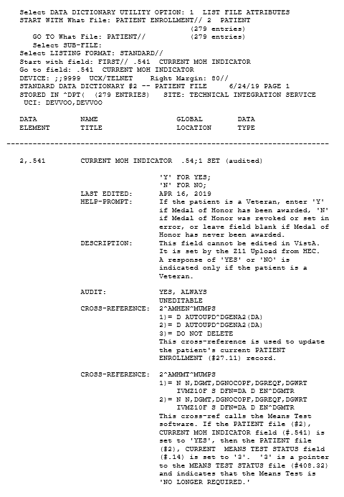
Figure 1: Help Prompt – CURRENT MOH INDICATOR Field
- The HELP PROMPT text for the MEDAL OF HONOR INDICATED? (#50.23) field in the PATIENT ENROLLMENT (#27.11) file is updated.
- The DESCRIPTION text for the MEDAL OF HONOR INDICATED? (#50.23) field in the PATIENT ENROLLMENT (#27.11) file is updated. The field is read only and can be viewed from the List File Attributes [DILIST] option in the Data Dictionary Utilities [DI DDU] [DIUSER] option.
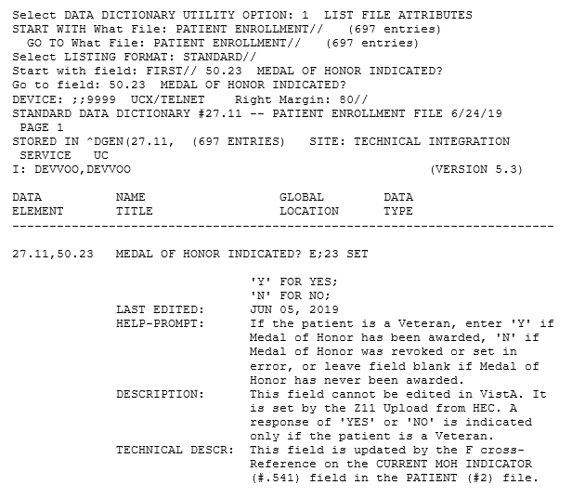
Figure 2: Description – MEDAL OF HONOR INDICATED? Field
- ICR 423 is updated at ($$AUTOINFO^DGMTCOU1(DFN)) to use the PATIENT file (#2) CURRENT MOH INDICATOR field (#.541) in the auto exemption determination logic to determine if a patient is exempt from Pharmacy Co-Pay. It is called by the VistA Integrated Billing (IB) package.
- ICR 643 is updated at ($$BIL^DGMTUB(DFN,DGDT)) to use the PATIENT file (#2) CURRENT MOH INDICATOR field (#.541) in the logic for determining whether a Means Test is required. It is called by the VistA Integrated Billing (IB) package.
- ICN 10147 is referenced at ($$RXST^IBARXEU) to check if Medal of Honor data exists in the VistA Integrated Billing (IB) package.

- Patient Enrollment [DGEN PATIENT ENROLLMENT] option updates:
  - When the CURRENT MOH INDICATOR field (#.541) from the PATIENT file (#2) is populated (not blank or null), the following screens are updated to no longer display “Medal of Honor” and the value of the CURRENT MOH INDICATOR field (#.541) from the PATIENT file (#2):
    - The option Patient Enrollment [DGEN PATIENT ENROLLMENT] Page 2 screen
    - Expand History [DGEN EXPAND HISTORY] action protocol Page 2 screen within the Patient Enrollment [DGEN PATIENT ENROLLMENT] option
  - The option Patient Enrollment [DGEN PATIENT ENROLLMENT] Page 3 screen and Expand History [DGEN EXPAND HISTORY] action protocol Page 3 screen within the Patient Enrollment [DGEN PATIENT ENROLLMENT] option are updated to display:
    - CURRENT MOH INDICATOR field (#.541) from the PATIENT file (#2)
    - MOH AWARD DATE field (#50.28), MOH STATUS DATE field (#50.29), and MOH COPAYMENT EXEMPTION DATE field (#50.3) from the PATIENT ENROLLMENT file (#27.11)
REDACTED
Figure 3: Patient Enrollment
  - Expand History [DGEN EXPAND HISTORY] action protocol Page 3 screen within the Patient Enrollment [DGEN PATIENT ENROLLMENT] option is updated to display the STATUS field (#.03) from the ANNUAL MEANS TEST file (#408.31).
  - View Upload Audit [DGENUP VIEW ELIGIBILTY UPLOAD AUDIT] action protocol Page 2 screen within the Patient Enrollment [DGEN PATIENT ENROLLMENT] option is updated to no longer display the PATIENT file (#2) CURRENT MOH INDICATOR field (#.541).
  - View Upload Audit [DGENUP VIEW ELIGIBILTY UPLOAD AUDIT] action protocol Page 3 screen is updated to:
    - Display the PATIENT file (#2) CURRENT MOH INDICATOR field (#.541) as "MOH".
    - Display the PATIENT ENROLLMENT file (#27.11) MOH AWARD DATE field (#50.28) as "MOHAWRDDATE", the PATIENT ENROLLMENT file (#27.11) MOH STATUS DATE field (#50.29) as "MOHSTATDATE", and the PATIENT ENROLLMENT file (#27.11) MOH COPAYMENT EXEMPTION DATE field (#50.3) as "MOHEXEMPDATE".
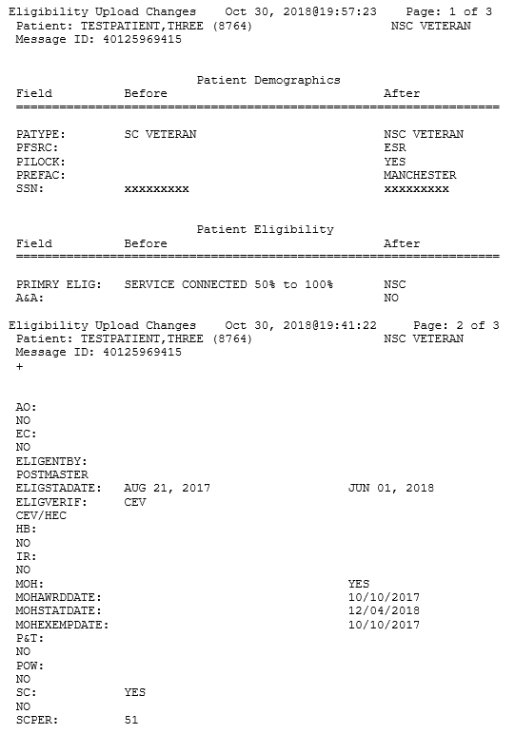
Figure 4: View Upload Audit

- The Patient Inquiry [DG PATIENT INQUIRY] option is updated to suppress the following message so it no longer displays after eligibilities when the Veteran is awarded MOH, had a previous income test, and previously did not decline to provide income information: "There is insufficient income data on file for the prior year." API DGRPD (which is called from VistA REE menu options, subscribers to API DGRPD and other VistA packages) calls the Patient Inquiry [DG PATIENT INQUIRY] option, and reflects the changes listed below, as shown in the following screen capture. The subscribing packages are: Automated Med Info Exchange, Imaging, Women's Health, and Bar Code Med Admin. (Referenced with ICRs 740, 2041, & 10037).
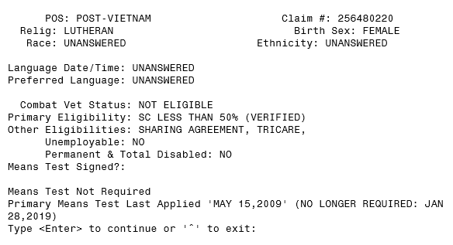
Figure 5: Patient Inquiry

- In VistA REE menu options, the MILITARY SERVICE DATA, SCREEN <6> screen is updated to display the MOH AWARD DATE field (#.542) from the PATIENT file (#2), the MOH STATUS DATE field (#.543) from the PATIENT file (#2), and the MOH COPAYMENT EXEMPTION DATE field (#.544) from the PATIENT file (#2). The CURRENT MOH INDICATOR field (#.541) from the PATIENT file (#2) now displays without condition (prior to the release of this patch, the Medal of Honor indicator only displayed when it was set to “YES”).
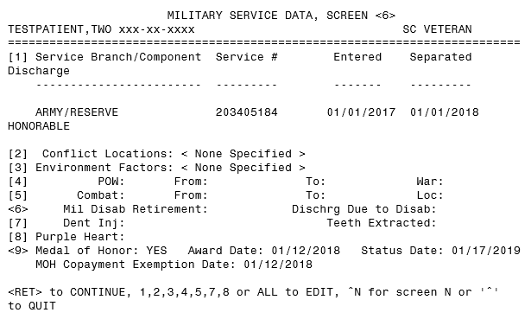
Figure 6: Military Service Data, Screen <6>
- When the PATIENT file (#2) CURRENT MOH INDICATOR field (#.541) is "YES" and the PATIENT file (#2) MOH AWARD DATE field (#.542) is null, the MOH AWARD DATE displays as "UNKNOWN" and the MOH COPAYMENT EXEMPTION DATE displays as "NEEDS DETERMINATION" on the following screens:
  - VistA REE options that display the MILITARY SERVICE DATA, SCREEN <6> screen
  - Patient Enrollment [DGEN PATIENT ENROLLMENT] option
  - Expand History [DGEN EXPAND HISTORY] action protocol within the Patient Enrollment [DGEN PATIENT ENROLLMENT] option
  - View Upload Audit [DGENUP VIEW ELIGIBILTY UPLOAD AUDIT] action protocol within the Patient Enrollment [DGEN PATIENT ENROLLMENT] option
  - Eligibility Inquiry for Patient Billing [DG PATIENT ELIGIBILITY INQUIRY] option

- The Eligibility Inquiry for Patient Billing [DG PATIENT ELIGIBILITY INQUIRY] option is updated as follows:
- The CAMP LEJEUNE ELIGIBILITY INDICATOR field (#.321701) from the PATIENT file (#2) is displayed. Values are YES, NO, or NOT ANSWERED.
- The Medal of Honor fields are added: PATIENT file (#2) CURRENT MOH INDICATOR field (#.541), PATIENT file (#2) MOH AWARD DATE field (#.542), PATIENT file (#2) MOH STATUS DATE field (#.543), and PATIENT file (#2) MOH COPAYMENT EXEMPTION DATE field (#.544).
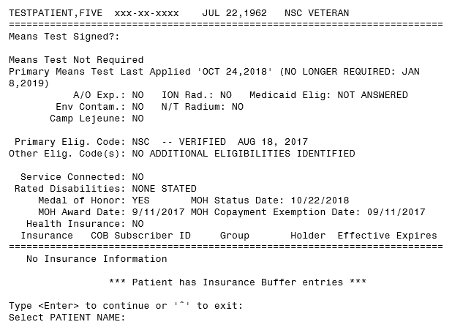
Figure 7: Eligibility Inquiry for Patient Billing
IVM*2.0*183
When a site receives an income test update from the Health Eligibility Center (HEC) (Health Level 7 (HL7) ORU/ORF-Z10 message type), a number of checks are completed on the incoming data before allowing that information to update the site's database. One of the checks is to determine whether the test is a current income test. If an incoming test date is more than 365 days old, the system rejects and does not upload the test if the status is Means Test (MT) Copay Exempt (MT COPAY EXEMPT) or Geographic Means Test (GMT) Copay Required (GMT COPAY REQUIRED).
IVM*2.0*183 modifies how VistA determines if an income test is the active current test per Veteran's Financial Assessment (VFA) rules. Subject to existing criteria, it will also consider the following as current income tests and upload the MT: The received income test has an MT Date greater than or equal to one year prior to the VFA Start Date (VFA Start Date = 1/1/2013), and the MT status is either MT COPAY EXEMPT or GMT COPAY REQUIRED. Note: Rules that determine whether the site has a more current income test and whether the test is active or inactive have not been modified, and may result in rejection of the income test. For example, if there is a 2017 income test on file at the site, and a 2015 income test is received from ES, the incoming test is not a current test, so it will be rejected and will not upload.
VistA users can view the accepted MT in the View a Past Means Test [DG MEANS TEST VIEW TEST] option. Because the test has been accepted, the user will not see messages such as “MEANS TEST REQUIRED” in these scenarios.
An MT will be accepted from the ES when an HL7 ORU/ORF-Z10 message is received at correlated sites using VFA rules to determine if the MT is a current active test. The following criteria are added to that determination:
- The MT Date is greater than or equal to one year prior to the VFA Start Date, the patient is subject to Means Testing, and the patient's MT status is MT COPAY EXEMPT.
OR
- The MT Date is greater than or equal to one year prior to the VFA Start Date, the patient is subject to Means Testing, the patient’s MT status is GMT COPAY REQUIRED, and the patient has agreed to pay the deductible(s).
When ES sends an HL7 ORU/ORF-Z10 message containing the ZMT segment to VistA sites where the Veteran is known, the system will accept and process the income test when the above conditions exist. Previously rejected Z10 messages can also be resent and processed per the above criteria.
An MT received from ES in an HL7 ORU/ORF-Z10 message may not be appropriate for certain patients and may be rejected. Some examples of inappropriate MTs are those for Veterans who are deceased, or those not subject to income testing such as Purple Heart recipients and the catastrophically disabled. Patch IVM*2.0*183 adds a further condition: Medal of Honor recipients. In these cases, the MT is rejected and VistA returns the message “Means Test upload not appropriate for current patient”.
Integration Control Registration (ICR) 7088 ($$OLDMTPF^DGMTU4(TESTDATE)) is added to determine if annual means test date is more than 1 year old.
ICR 7088 NAME: DGMTU4 - Annual means test date determination
CUSTODIAL PACKAGE: REGISTRATION
SUBSCRIBING PACKAGE: INCOME VERIFICATION MATCH
USAGE: Controlled Subscri ENTERED: JUL 11,2019
Table 1 shows the enhancements and modifications included in the DG_53_P972.KID release as tracked in Rational Team Concert (RTC) Requirements Management (RM).
Table 1: DG_53_P972.KID Enhancements and Modifications
RTC  RM # | Summary
883774 | Veterans awarded Medal of Honor should be placed in Priority Group 1 for eligibility and medical benefits
910780 | CR 537984: VistA to accept Means Test from ES when subject to Means Testing
925357 | Within Admissions, Discharge, and Transfer (ADT), when a patient is admitted or transferred the user should be prompted with Camp Lejeune questions
1005709 | Change Request (CR) 745614: VistA REE process and store MOH data
1005711 | CR 745614: If MOH is Yes - Priority Group 1
1005712 | CR 745614: If MOH is Yes - Not subject to Income Testing in VistA REE
1005713 | CR 745614: No Means Test Required based on MOH Award Date
1005714 | CR 745614: If MOH is Yes - Exempt from All Copayments
1005715 | CR 745614: If MOH data is revised - Share information with Integrated Billing
1040377 | CR 844090: VistA REE display Medal of Honor Information
1040378 | CR 844090: VistA REE History of Medal of Honor Award
1040380 | CR 844090: Determine and store the MOH Copayment Exemption Date
1040395 | CR 844090: If MOH is changed, VistA REE shall recalculate Enrollment and Eligibility
1053034 | Maintain VistA Applications for ES 5.5
List of Updates

Known Issues
No known or open issues were identified in this release.

Product Documentation
The following documents apply to this release:
Title File Name FTP Mode
DG_53_P972.KID Release Notes DG_5_3_P972_RN.PDF (binary)
User Manual – Registration Menu PIMS_REG_UM.PDF (binary)
PIMS User Manual – ADT Module ADTBE_UM.PDF (binary)
User Manual – Means Test
Supervisor Menu MTS_UM.PDF (binary)
User Manual – Copay Exemption Test
Supervisor Menu CETS_UM.PDF (binary)
PIMS Technical Manual PIMSTM.PDF (binary)
IVM Technical Manual IVM_2_TM.PDF (binary)
redacted
Documentation can also be found on the VA Software Documentation Library at:
http://www.va.gov/vdl/

