Enrollment System Modernization (ESM) Phase 2

Veterans Health Information Systems and Technology Architecture (VistA)
Registration, Eligibility & Enrollment (REE)

DG_53_P978.KID
Registration (DG) – DG*5.3*978
Income Verification Match (IVM) – IVM*2.0*180

Release Notes
September 2019
Department of Veterans Affairs
Office of Information and Technology (OIT)

Table of Contents
1 Introduction 1
2 Purpose 1
3 Audience 1
4 This Release 1
4.1 New Features and Functions Added 1
4.2 Enhancements and Modifications 1
4.3 Known Issues 10
5 Product Documentation 10

List of Figures
Figure 1: Management Edit Option - Prompt 3
Figure 2: Update Preferred Facility Message 4
Figure 3: Appointment Request Response NO 4
Figure 4: Appointment Request Response YES 5
Figure 5: Tracking Report 6
Figure 6: Call List Option – Detailed Report 7
Figure 7: Audited Fields 8

List of Tables
Table 1: DG*5.3*978 Enhancements and Modifications 2

Introduction
The release of Veterans Health Information System and Technology Architecture (VistA) Registration, Eligibility & Enrollment (REE) Host File DG_53_P978.KID, which includes Registration (DG) patch DG*5.3*978 and Income Verification Match (IVM) patch IVM*2.0*180, supports the enhancements for the Enterprise Health Benefits Determination (EHBD) program that focuses on updates for the Enrollment System Modernization (ESM) Phase 2 project, which supports Enrollment System Community Care (ESCC) and Enrollment System (ES) Sustainment.

Purpose
The Release Notes cover the changes to VistA REE DG and IVM systems for this release. Host File DG_53_P978.KID, including patches DG*5.3*978 and IVM*2.0*180, is also being released in support of the ES 5.6 release. Refer to Informational Patch EAS*1*178 (Enrollment Application System) for additional details regarding the ES release.

Audience
This document targets users and administrators of VistA REE and applies to the changes made between this release and any previous release for this software.

This Release
This multi-package build is distributed as a Host File. The Host File DG_53_P978.KID can be obtained from one of the anonymous Secure File Transfer Protocol (SFTP) directories listed in the Software and Documentation Retrieval Instructions section of the patch descriptions.
The following sections provide a summary of the enhancements and modifications to the existing software for VistA REE with the release of patches DG*5.3*978 and IVM*2.0*180.

New Features and Functions Added
There are no new features or functions added to VistA REE for DG*5.3*978 and IVM*2.0*180.

Enhancements and Modifications
DG*5.3*978
VistA REE currently does not allow a user to request an initial appointment for a newly enrolled Veteran after registration. Welcome To My VA (W2myVA) makes an outbound call from a VA representative in conjunction with the introductory letter and personalized handbook each Veteran receives upon enrollment. If the Veteran requests an appointment during that conversation, the VistA Preferred Facility cannot change the Appointment Request to YES. As a result, the Veteran will not show on the local New Enrollee Appointment Request (NEAR) list to disposition the Veteran's appointment. The Veteran is kept on the W2myVA reports, negatively impacting the W2myVA reporting that captures the total amount of time Veterans wait to be scheduled for an appointment.
Patch DG*5.3*978 provides a mechanism for updating the appointment request field from NO to YES after registration via the Management Edit [DGEN NEACL REQUEST MGT EDIT] option.
The Management Edit Call List [DGEN NEACL MGT RPT1] and Tracking Report [DGEN NEACL MGT RPT2] options are modified, and new fields are added to the database to track the original appointment request and original request date made during registration.
Currently there is no mechanism for a VistA user to add a Veteran to the local NEAR list, unless the user indicates the Veteran wants to be seen by a doctor when completing a VA Form 10-10EZ in ES, VistA, or online. When the New Enrollee makes an appointment request at the W2myVA follow-up phone call, VistA users at the Preferred Facility or an associated Satellite Facility need the ability to change the response from NO to YES. Once the appointment is requested, it places the Veteran on the local NEAR list (Call List [DGEN NEACL MGT RPT1], Call List (background job) [DGEN NEACL MGT RPT1BK] and the Tracking Report [DGEN NEACL MGT RPT2] options). This allows a VistA user to disposition the appointment request in the Management Edit [DGEN NEACL REQUEST MGT EDIT] option. Lack of this functionality impacts accurate reporting of the total amount of time Veterans wait to be scheduled for an appointment.
The Management Edit [DGEN NEACL REQUEST MGT EDIT] option is updated to either present an appointment request prompt to the user or to present the current prompts for dispositioning an appointment request. The Tracking Report [DGEN NEACL MGT RPT2] option is updated to include a new column for the date of the appointment request if the Veteran initially answered YES when completing a VA Form 10-10EZ in ES, VistA, or online. The Call List [DGEN NEACL MGT RPT1] option detailed format includes a new row to display the date of the appointment request if the Veteran initially answered YES when completing a VA Form 10-10EZ in ES, VistA, or online.
The ^XINDEX issue 'Line is longer than 245 bytes' encountered in Primary Developer Review is due to a Kernel Toolkit defect, it is not due to patch DG*5.3*978. Incident INC4991239 was entered and it will be fixed in patch XT*7.3*140.
IVM*2.0*180
Patch DG*5.3*978 provides a mechanism for updating the appointment request field from NO to YES after registration via the Management Edit [DGEN NEACL REQUEST MGT EDIT] option.
When an appointment request is modified, an ORU-Z07 message is triggered to send the appointment request information to ES. This patch modifies the VistA Health Level 7 (HL7) interface with ES to add four additional data elements in the ZIO segment of the ORF/ORU-Z07 message. Of these four new fields, only the appointment request change date/time is inserted into the ZIO segment to provide ES with the date and time the change was made.
Table 1 shows the enhancements and modifications included in the DG*5.3*978 release as tracked in Rational Team Concert (RTC) Requirements Management (RM).
Table 1: DG*5.3*978 Enhancements and Modifications
RTC  RM # | Summary
1002813 | CR 734635: Management Edit Change in VistA
1070951 | ES 5.6.0 Maintain VistA Applications

List of Updates
DG*5.3*978 includes the following enhancements to VistA REE:
- The Management Edit [DGEN NEACL REQUEST MGT EDIT] option is modified as follows:
  - The user is prompted to enter "Does the New Enrollee want an appt. with a VA doctor/provider at [Preferred Facility]?" if the patient has not requested an appointment and if the other conditions defined below in item d are met.
REDACTED
Figure 1: Management Edit Option - Prompt
  - If the user answers YES at this prompt, the Veteran is placed on the NEAR Call List [DGEN NEACL MGT RPT1], Call List (background job) [DGEN NEACL MGT RPT1BK] and NEAR Tracking Report [DGEN NEACL MGT RPT2] options.
  - The response is stored in the APPOINTMENT REQUEST ON 1010EZ field (#1010.159) in the PATIENT File (#2).

  - The conditions that result in displaying "Does the New Enrollee want an appt. with a VA doctor/provider at [Preferred Facility]?" are:
    - The value of the patient's APPOINTMENT REQUEST ON 1010EZ field (#1010.159) in the PATIENT file (#2) is NULL or NO.
    - The patient's ENROLLMENT STATUS field (#.04) in the PATIENT ENROLLMENT file (#27.11) is equal to ENROLLED.
    - The VistA site is a Primary or Satellite Facility of the PREFERRED FACILITY. This is defined as the first three characters of the VistA Site number (STATION NUMBER field (#.04) in the STATION NUMBER (TIME SENSITIVE) file (#389.9)) match the first three characters of the patient's PREFERRED FACILITY field (#27.02) in the PATIENT file (#2). Otherwise the message "Site is not Patient's Preferred Facility. Preferred Facility must be updated." appears.
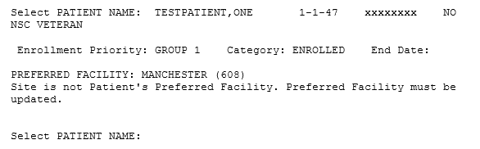
Figure 2: Update Preferred Facility Message
REDACTED
Figure 3: Appointment Request Response NO

  - If the response to "Does the New Enrollee want an appt. with a VA doctor/provider at [Preferred Facility]?" is YES, the system prompts for "Date the Appointment Request Made" and the response is stored in the APPOINTMENT REQUEST DATE field (#1010.1511) in the PATIENT file (#2).
    - The date may not be in the future.
    - The user may press RETURN and is returned to the "Does the New Enrollee want an appt. with a VA doctor/provider at [Preferred Facility]?" prompt.
REDACTED
Figure 4: Appointment Request Response YES
- There are no changes to the Management Edit [DGEN NEACL REQUEST MGT EDIT] option if the Veteran has already requested an appointment in ES, VistA, or online.
- The Tracking Report [DGEN NEACL MGT RPT2] option is modified. The report ("APPT.REQUEST") column now displays the appointment request date whenever the appointment was requested, including from the Management Edit [DGEN NEACL REQUEST MGT EDIT] option. The report includes a new column ("ORIGINAL APPT. REQUEST"). This column is populated with the date the user answered the appointment request question, and does not indicate the Veteran requested an appointment on that date. The Original Appointment Request Date is not used in any other reporting or calculations..
  - Detail and Summary Reports have the report filter labels changed from "APPOINTMENT REQUEST ON 1010EZ START DATE" to "APPOINTMENT REQUEST START DATE" and "APPOINTMENT REQUEST ON 1010EZ END DATE" to "APPOINTMENT REQUEST END DATE".
  - A new column "ORIGINAL APPT. REQUEST" is added to the Detailed Report as the 4th column and displays the ORIGINAL APPOINTMENT REQUEST DATE field (#1010.1513) in the PATIENT file (#2). The date of the Veteran's first response to the "Does the New Enrollee want an appt. with a VA doctor/provider at [Preferred Facility]?" prompt will display in this column.

  - The Detailed Report layout is modified to abbreviate column headings to fit the additional column.
REDACTED
Figure 5: Tracking Report
- The Call List [DGEN NEACL MGT RPT1] option and Call List (background job) [DGEN NEACL MGT RPT1BK] option are modified. The short format and detailed format reports now display the appointment request date whenever the appointment was requested, including from the Management Edit [DGEN NEACL REQUEST MGT EDIT] option. The Detailed Report now displays the date of the appointment request if the Veteran initially answered YES when completing a VA Form 10-10EZ in ES, VistA, or online.

  - The Detailed Report has an additional row "ORIGINAL APPOINTMENT DATE" displaying the ORIGINAL APPT. REQUEST DATE field (#1010.1513) in the PATIENT file (#2). This row is populated with the date the user answered the appointment request question, and does not indicate the Veteran requested an appointment on that date. The Original Appointment Request Date is not used in any other reporting or calculations..
  - The Detailed Report field label "1010EZ APPT. REQUEST DATE:" is changed to "APPT. REQUEST DATE:".
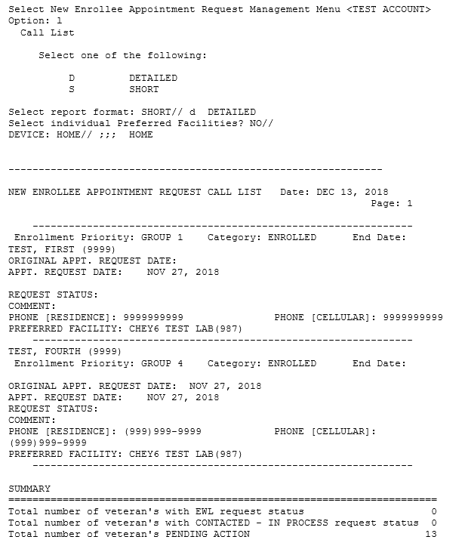
Figure 6: Call List Option – Detailed Report

- Four new fields are added to the PATIENT file (#2) for historical purposes and NEAR List reporting: Call List [DGEN NEACL MGT RPT1], Call List (background job) [DGEN NEACL MGT RPT1BK] and Tracking Report [DGEN NEACL MGT RPT2] options:
  - ORIGINAL APPOINTMENT REQUEST field (#1010.1512)
  - ORIGINAL APPT REQUEST DATE field (#1010.1513)
  - ORIG APPT REQUEST CHG DT/TM field (#1010.1514)
  - APPT REQUEST 1010EZ CHG DT/TM field (#1010.1515)
- The following fields in the PATIENT file (#2) are modified to turn on auditing:
  - APPOINTMENT REQUEST ON 1010EZ field (#1010.159)
  - APPOINTMENT REQUEST DATE field (#1010.1511)
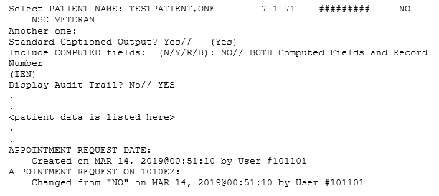
Figure 7: Audited Fields
- The ORIG APPT REQUEST CHG DT/TM field (#1010.1514) in the PATIENT file (#2) will capture the last change date/time of the appointment request or appointment request date (date/time when the ORIGINAL APPOINTMENT REQUEST field (#1010.1512) in the PATIENT file (#2) or ORIG APPT REQUEST DATE field (#1010.1513) in the PATIENT file (#2) is updated).
- Two triggers are added to the APPOINTMENT REQUEST ON 1010EZ field (#1010.159) in the PATIENT file (#2) when the field is updated:
  - The APPT REQUEST 1010EZ CHG DT/TM field (#1010.1515) in the PATIENT file (#2) will capture the date/time when APPOINTMENT REQUEST ON 1010EZ field (#1010.159) in the PATIENT file (#2) is updated.
  - The ORIGINAL APPOINTMENT REQUEST field (#1010.1512) in the PATIENT file (#2) captures the value of the APPOINTMENT REQUEST ON 1010EZ field (#1010.159) in the PATIENT file (#2) the first time that value is set.

- Two triggers are added to the APPOINTMENT REQUEST DATE field (#1010.1511) in the PATIENT file (#2) when the field is updated:
  - The APPT REQUEST 1010EZ CHG DT/TM field (#1010.1515) in the PATIENT file (#2) will capture the date/time when the APPOINTMENT REQUEST DATE field (#1010.1511) in the PATIENT file (#2) is updated.
  - The ORIGINAL APPT REQUEST DATE field (#1010.1513) in the PATIENT file (#2) captures the value of the APPOINTMENT REQUEST DATE field (#1010.1511) in the PATIENT file (#2) the first time that value is set.
- The HL7 interface with ES is modified to add four additional data elements in the ZIO segment of the ORF/ORU-Z11 message.
  - Sequence 7: UPDATE DATE/TIME corresponding to APPT REQUEST 1010EZ CHG DT/TM field (#1010.1515) in the PATIENT file (#2).
  - Sequence 8: ORIGINAL APPOINTMENT REQUEST corresponding to ORIGINAL APPOINTMENT REQUEST field (#1010.1512) in the PATIENT file (#2).
  - Sequence 9: ORIGINAL APPOINTMENT REQUEST DATE corresponding to ORIGINAL APPT REQUEST DATE field (#1010.1513) in the PATIENT file (#2).
  - Sequence 10: UPDATE DATE/TIME corresponding to ORIG APPT REQUEST CHG DT/TM field (#1010.1514) in the PATIENT file (#2).
Note: The ZIO segment includes sequence 5 APPOINTMENT REQUEST ON 1010EZ corresponding to the APPOINTMENT REQUEST ON 1010EZ field (#1010.159) in the PATIENT file (#2) and sequence 6 APPOINTMENT REQUEST DATE corresponding to the APPOINTMENT REQUEST DATE field (#1010.1511).
- When VistA receives an ORF/ORU-Z11 message, the processing of these sequences is as follows:
  - If the ORIGINAL APPOINTMENT REQUEST field (#1010.1512) in the PATIENT file (#2) is empty, sequences 8, 9 and 10 are stored in their corresponding fields.
  - If the date/time in the APPT REQUEST 1010EZ CHG DT/TM field (#1010.1515) in the PATIENT file (#2) is more recent than the date/time in sequence 7, the data in sequences 5, 6, and 7 are not stored in VistA.
  - If the APPOINTMENT REQUEST ON 1010EZ field (#1010.159) in the PATIENT file (#2) is YES and sequence 5 is NO, an Application Error (AE) is sent back to ES.
  - If the APPOINTMENT REQUEST DATE in sequence 6 is a future date, an AE is sent back to ES.
  - Otherwise the data in sequences 5, 6 and 7 are stored in their corresponding fields.
  - If any sequence being filed contains double quotes (""), the corresponding field in VistA is deleted.

IVM*2.0*180 includes the following enhancements to VistA REE:
- The HL7 interface with ES is modified to include four additional data elements in the ZIO segment of the ORF/ORU-Z07 message.
  - Sequence 7: UPDATE DATE/TIME corresponding to APPT REQUEST 1010EZ CHG DT/TM field (#1010.1515) of the PATIENT file (#2).
  - Sequence 8: ORIGINAL APPOINTMENT REQUEST corresponding to ORIGINAL APPOINTMENT REQUEST field (#1010.1512) of the PATIENT file (#2). This field will be blank in the segment.
  - Sequence 9: ORIGINAL APPOINTMENT REQUEST DATE corresponding to ORIGINAL APPT REQUEST DATE field (#1010.1513) of the PATIENT file (#2). This field will be blank in the segment.
  - Sequence 10: UPDATE DATE/TIME corresponding to ORIG APPT REQUEST CHG DT/TM field (#1010.1514) of the PATIENT file (#2). This field will be blank in the segment.
- When the APPOINTMENT REQUEST ON 1010EZ field (#1010.159) or APPOINTMENT REQUEST DATE field (#1010.1511) of the PATIENT file (#2) is modified, VistA REE triggers an ORU-Z07 message to ES. This message is modified to include the APPT REQUEST 1010EZ CHG DT/TM field (#1010.1515) in sequence 7.

Known Issues
No known or open issues were identified in this release.

Product Documentation
The following documents apply to this release:
Title File Name FTP Mode
DG_53_P978.KID Release Notes DG_5_3_P978_RN.PDF (binary)
User Manual - Appointment Menu APPT.PDF (binary)
IVM Technical Manual IVM_2_TM.PDF (binary)
redacted
Documentation can also be found on the VA Software Documentation Library at:
http://www.va.gov/vdl/

