Enrollment System Modernization (ESM) Phase 2

Veterans Health Information Systems and Technology Architecture (VistA)
Registration, Eligibility & Enrollment (REE)

DG_53_P985.KID
Registration (DG) – DG*5.3*985
Income Verification Match (IVM) – IVM*2.0*188

Release Notes
January 2020
Department of Veterans Affairs
Office of Information and Technology (OIT)

Table of Contents
1 Introduction 1
2 Purpose 1
3 Audience 1
4 This Release 1
4.1 New Features and Functions Added 1
4.2 Enhancements and Modifications 2
4.3 Known Issues 9
5 Product Documentation 9

List of Figures
Figure 1: Patient Demographic Data, Screen <1> 4
Figure 2: Patient Demographic Data, Screen <1> Help 4
Figure 3: Patient Inquiry Screen 5
Figure 4: Preferred Name Field Modifications 6
Figure 5: Emergency Contact Data, Screen <3> 8

Introduction
The release of Veterans Health Information System and Technology Architecture (VistA) Registration, Eligibility & Enrollment (REE) Host File DG_53_P985.KID, which includes Registration (DG) patch DG*5.3*985 and Income Verification Match (IVM) patch IVM*2.0*188, supports the enhancements for the Enterprise Health Benefits Determination (EHBD) program that focuses on updates for the Enrollment System Modernization (ESM) Phase 2 project, which supports Enrollment System Community Care (ESCC) and Enrollment System (ES) Sustainment.

Purpose
The Release Notes cover the changes to VistA REE DG and IVM systems for this release. Host File DG_53_P985.KID, including patches DG*5.3*985 and IVM*2.0*188, is also being released in support of the ES 5.9 release. Refer to Informational Patch EAS*1*183 (Enrollment Application System) for additional details regarding the ES release.

Audience
This document targets users and administrators of VistA REE and applies to the changes made between this release and any previous release for this software.

This Release
This multi-package build is distributed as a Host File. The Host File DG_53_P985.KID can be obtained from one of the anonymous Secure File Transfer Protocol (SFTP) directories listed in the Software and Documentation Retrieval Instructions section of the patch descriptions.
The following sections provide a summary of the enhancements and modifications to the existing software for VistA REE with the release of patches DG*5.3*985 and IVM*2.0*188.

New Features and Functions Added
There are no new features or functions added to VistA REE for DG*5.3*985 and IVM*2.0*188.

Enhancements and Modifications
DG*5.3*985
NOTE: The ^XINDEX issue 'Line is longer than 245 bytes' encountered in Primary Developer Review is due to a Kernel Toolkit defect, it is not due to patch DG*5.3*985. Incident INC4991239 was entered and it will be fixed in patch XT*7.3*140.
Compiled list of Errors and Warnings Sep 25, 2019@13:45:22
page 1
|dd2 * * 63 Lines, 2993 Bytes, Checksum:
W !,*7,"The Preferred Name cannot be deleted by the VistA user.
The Patient's First Name may be entered as the Preferred Name. Please contact your facility Master Veteran Index (MVI) Point of Contact (POC) to request they create an MVI Toolkit Request to have this value removed." K X
.2405DEL1+1 S - Line is longer than 245 bytes.
VistA REE users need the ability to enter, edit, and view the Veteran's Preferred Name throughout VistA so that VA staff are able to correctly greet a Veteran during an encounter.
VistA Registration patch DG*5.3*937, released in May 2017, modified VistA by adding the PREFERRED NAME field (#.2405) to the PATIENT file (#2). See the DG*5.3*937 patch description for specific information on how the Preferred Name is shared with MVI. The DG*5.3*985 patch will allow VistA users to enter or edit the Preferred Name using VistA Registration options.
The VistA REE EMERGENCY CONTACT DATA, SCREEN <3> screen does not prompt for a next of kin's phone number when the "ADDRESS SAME AS PATIENT'S?" prompt is answered "YES". Only the next of kin's work phone number prompt displays. VistA users are not able to enter the next of kin's phone number, which may be different from the patient's phone number. VistA REE does not accept/process ES deletions of the fields on the EMERGENCY CONTACT DATA, SCREEN <3> screen. Patch DG*5.3*985 will allow VistA users to enter the primary and secondary next of kin's phone numbers on the EMERGENCY CONTACT DATA, SCREEN <3> screen and will allow VistA to accept and process ES deletion of the fields on the EMERGENCY CONTACT DATA, SCREEN <3> screen received via ORU-Z05 Health Level 7 (HL7) message.
Patch DG*5.3*985 will update the LONG DESCRIPTION (#.04) of the HEALTH BENEFIT PLAN (#25.11) for the plan named VETERAN - FULL MEDICAL BENEFITS TREATMENT & RX COPAY EXEMPT. This is done with the post-install routine.
IVM*2.0*188
The VistA REE EMERGENCY CONTACT DATA, SCREEN <3> screen shows the Emergency Contact data from the PATIENT (#2) file in the following 5 groups:
- Primary Emergency Contact
- Secondary Emergency Contact
- Primary Next of Kin
- Secondary Next of Kin
- Designee
VistA REE receives Emergency Contact details via HL7 messaging from ES. The current functionality is to use this data in VistA REE and Income Verification Match (IVM) packages to add and modify Emergency Contact details in the PATIENT (#2) file only if the incoming Emergency Contact data is newer than the existing data in VistA.
Patch IVM*2.0*188 will modify VistA HL7 messaging and add the ability to delete Emergency Contact details in the PATIENT (#2) file.
The following menu options allow a VistA REE user to view, add or update the Emergency Contact Data:
Load/Edit Patient Data [DG LOAD PATIENT DATA]
Patient Inquiry [DG PATIENT INQUIRY]
Preregister a Patient [DGPRE PRE-REGISTER OPTION]
Eligibility Verification [DG ELIGIBILITY VERIFICATION]
View Registration Data [DG REGISTRATION VIEW]
Register a Patient [DG REGISTER PATIENT]
Admit a Patient [DG ADMIT PATIENT]
Table 1 shows the enhancements and modifications included in the DG_53_P985.KID release as tracked in Rational Team Concert (RTC) Requirements Management (RM).
Table 1: DG_53_P985.KID (DG*5.3*985 and IVM*2.0*188) Enhancements and Modifications
RTC  RM # | Summary
884875 | Enter/Edit Veteran Preferred Name
884877 | View Preferred Name in all Demographics Views
888424 | Receive Emergency Contact Information in VistA
888449 | Receive Next of Kin Information in VistA
List of Updates
DG*5.3*985 makes the following enhancements to VistA REE, which are incorporated in the menu options listed below:
Load/Edit Patient Data [DG LOAD PATIENT DATA]
Patient Inquiry [DG PATIENT INQUIRY]
Preregister a Patient [DGPRE PRE-REGISTER OPTION]
Eligibility Verification [DG ELIGIBILITY VERIFICATION]
View Registration Data [DG REGISTRATION VIEW]
Register a Patient [DG REGISTER PATIENT]
Admit a Patient [DG ADMIT PATIENT]
- The PATIENT DEMOGRAPHIC DATA, SCREEN <1> screen is updated as follows:
  - Group [1]: The fields "SS" and "PSSN Reason" are moved below the "DOB" field.
  - Group [4]: The field "Pager #" is moved up 1 line across from the "Cell Phone" field.
  - Group [6]: A new editable group is added containing the "Preferred Name" field. This field corresponds to the PREFERRED NAME field (#.2405) of the PATIENT file (#2). If there is no value for the "Preferred Name", the text "Not Answered" is displayed.
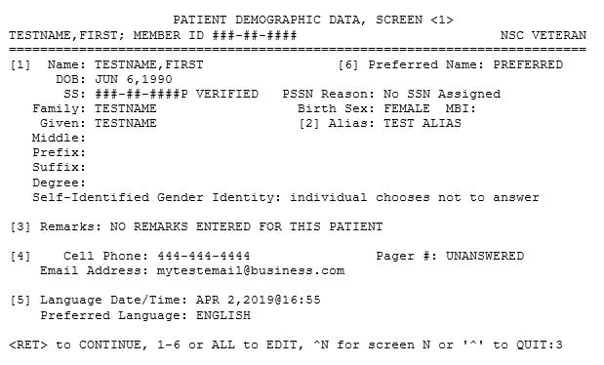
Figure 1: Patient Demographic Data, Screen <1>
- The PATIENT DEMOGRAPHIC DATA, SCREEN <1> HELP screen is updated as follows:
  - Added data group [6] "Preferred Name of Patient"
  - Modified data group [1]: "Sex" is changed to "Birth Sex"
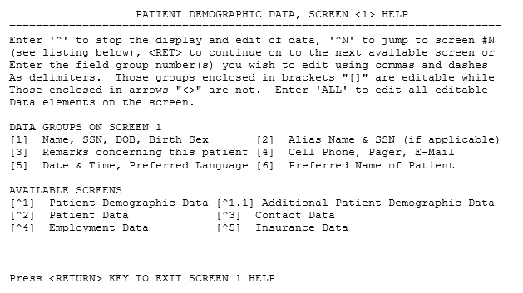
Figure 2: Patient Demographic Data, Screen <1> Help
- The Patient Inquiry Screen [DG PATIENT INQUIRY] is modified as follows:
  - The PREFERRED NAME (#.2405) field is added to the screen banner next to the patient's name and enclosed in parenthesis. If no Preferred Name is defined, this field is not displayed.
  - The remaining fields in the banner (Member ID, SSN, and DOB) are displayed to the right of the Preferred Name, and if the length of these fields exceed 80 characters the fields will wrap to a second line in the banner.
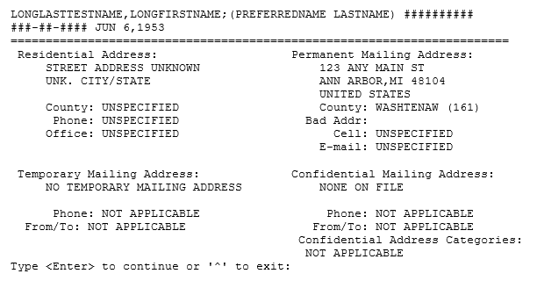
Figure 3: Patient Inquiry Screen

- The PREFERRED NAME field (#.2405) of the PATIENT file (#2) is modified as follows:
  - The field length is changed from 100 to 25 characters
  - The Help Text is updated to reflect the new field length: "Enter the Preferred Name (1-25 alphabetic characters and/or spaces) for how the patient would like to be addressed at the facility. Vulgarities and offensive language are NOT appropriate responses."
  - The text entered is automatically converted to uppercase.
  - Leading, or trailing spaces entered in the text are removed.
  - A DELETE TEST is added to the field in FileMan to prevent the field from being deleted in VistA and FileMan. If the user attempts to delete the value of this field, the following message is displayed: "The Preferred Name cannot be deleted by the VistA user. The Patient's First Name may be entered as the Preferred Name. Please contact your facility MVI POC to request they create an MVI Toolkit Request to have this value removed."
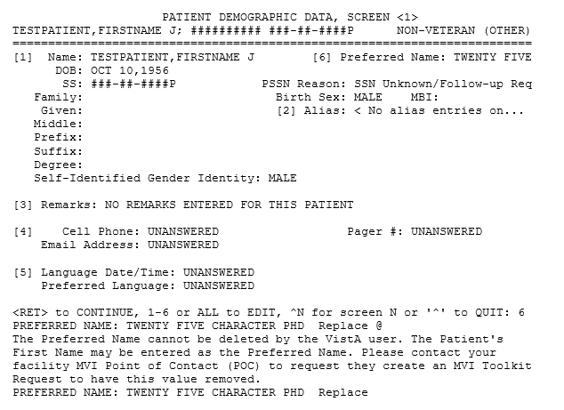
Figure 4: Preferred Name Field Modifications

- When entering or editing the Preferred Name field the following conditions apply:
  - The value entered can be no longer than 25 alphabetical characters or spaces and must contain at least 1 alphabetical character.
  - The value of the Preferred Name, if defined, is presented as the default value.
  - The user may enter a caret "^" to return to the PATIENT DEMOGRAPHIC DATA, SCREEN <1> screen.
  - The field is not required but cannot be deleted once a value is entered.
  - The text entered is converted to uppercase.
  - Leading or trailing spaces are removed from the text.
Note: External applications and packages that make use of the Patient Inquiry Application Programming Interface (API) and Integration Control Registrations (ICRs) #2041, #10037, #6752, and #740 will see the PREFERRED NAME field (#.2405) of the PATIENT file (#2) displayed in the Patient Inquiry screen banner as described in the Listing of Updates #4 above. The applications include:
Womens Health (WV)
Barcode Medication Administration (BCMA)
VistA Imaging - Clinical Display
Order Entry Results Reporting
Outpatient Pharmacy Manager (PSO MANAGER)
Computerized Patient Record System (CPRS)
Clinical Information Resource Network (CIRN)
Automated Medical Information Exchange (AMIE)
Regional Office Patient Inquiry (DVBA REG OFF PATIENT INQ)
The following VistA REE options also display Patient Inquiry API output
Load\Edit Patient [DG LOAD PATIENT DATA]
Register A Patient [DG REGISTER PATIENT]

- VistA users will be prompted for the primary next of kin (NOK) and the secondary next of kin's (NOK-2) phone numbers on the EMERGENCY CONTACT DATA, SCREEN <3> screen when "ADDRESS SAME AS PATIENT'S?" prompt is answered "YES".
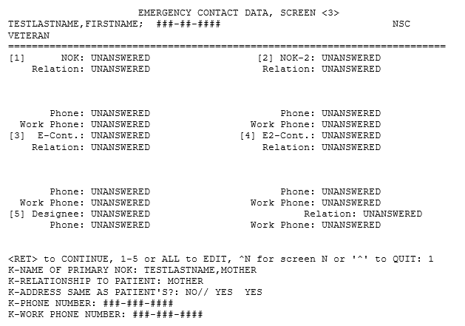
Figure 5: Emergency Contact Data, Screen <3>
- VistA accepts and processes ES deletion of the fields on the EMERGENCY CONTACT DATA, SCREEN <3> screen received via ORU-Z05 HL7 message.
- The following PATIENT file (#2) fields on EMERGENCY CONTACT DATA, SCREEN <3> screen are audited:
K-RELATIONSHIP TO PATIENT(#.212)
K2-NAME OF SECONDARY NOK(#.2191)
K2-RELATIONSHIP TO PATIENT(#.2192)
K2-PHONE NUMBER(#.2199)
E-NAME(#.331)
E-PHONE NUMBER(#.339)
E-RELATIONSHIP TO PATIENT(#.332)
E2-NAME OF SECONDARY CONTACT(#.3311)
E2-RELATIONSHIP TO PATIENT(#.3312)
E2-PHONE NUMBER(#.3319)
D-NAME OF DESIGNEE(#.341)
D-RELATIONSHIP TO PATIENT(#.342)
D-PHONE NUMBER(#.349)

IVM*2.0*188 includes the following enhancements to VistA REE:
With installation of IVM*2.0*188, VistA receives and deletes Emergency Contact data in the PATIENT (#2) file if double quotes are received in the VA-Specific Emergency Contact Segment (ZCT) of the ORU-Z05 HL7 message sent by ES and the date/timestamp received in the ZCT segment is newer than the existing date/timestamp stored in VistA.
- Emergency Contact changes are received from ES via ORU-Z05 HL7 messages, which now include double quotes in the ZCT segment to delete Emergency Contact data in the PATIENT (#2) file.
- VistA now accepts and processes ES deletion of the fields on the EMERGENCY CONTACT DATA, SCREEN <3> screen received via the ORU-Z05 HL7 message.

Known Issues
No known or open issues were identified in this release.

Product Documentation
The following documents apply to this release:
Title File Name FTP Mode
DG_53_P985.KID Release Notes DG_5_3_P985_RN.PDF (binary)
User Manual - Registration Menu PIMS_REG_UM.PDF (binary)
PIMS Technical Manual PIMSTM.PDF (binary)

Redacted
Documentation can also be found on the VA Software Documentation Library at:
http://www.va.gov/vdl/

