Enrollment System Modernization (ESM) Phase 2

Veterans Health Information Systems and Technology Architecture (VistA)
Registration, Eligibility & Enrollment (REE)

DG*5.3*987

Release Notes
October 2019
Department of Veterans Affairs
Office of Information and Technology (OIT)

Table of Contents
1 Introduction 1
2 Purpose 1
3 Audience 1
4 This Release 1
4.1 New Features and Functions Added 1
4.2 Enhancements and Modifications 1
4.3 Defects and Fixes 3
4.4 Known Issues 8
5 Product Documentation 9

List of Figures
Figure 1: ELIGIBILITY VERIFICATION DATA SCREEN <11> 5
Figure 2: VMBP <11.1> Screen 6
Figure 3: VMBP <11.3> Screen 6
Figure 4: VMBP <11.3.1> Screen 7
Figure 5: Patient Inquiry Option 8
Figure 6: "zz" Indicator for Inactive Plans 8

List of Tables
Table 1: DG*5.3*987 Enhancements and Modifications 2
Table 2: Defects and Fixes in DG*5.3*987 3

Introduction
The release of Veterans Health Information System and Technology Architecture (VistA) Registration, Eligibility & Enrollment (REE) Registration (DG) patch DG*5.3*987 supports the enhancements for the Enterprise Health Benefits Determination (EHBD) program that focuses on updates for the Enrollment System Modernization (ESM) Phase 2 project, which supports Enrollment System Community Care (ESCC) and Enrollment System (ES) Sustainment.

Purpose
The Release Notes cover the changes to VistA REE for this release. DG*5.3*987 is also being released in support of the ES 5.8 release. Refer to Informational Patch EAS*1*181 (Enrollment Application System) for additional details regarding the ES release.

Audience
This document targets users and administrators of VistA REE and applies to the changes made between this release and any previous release for this software.

This Release
This software is being released as a patch (PackMan) message. The PackMan message includes the DG*5.3*987 patch, which also supports the ES 5.8 release.
The following sections provide a summary of the enhancements and modifications to the existing software for VistA REE with the release of patch DG*5.3*987.

New Features and Functions Added
There are no new features or functions added to VistA REE for DG*5.3*987.

Enhancements and Modifications
DG*5.3*987 renames Health Benefit Plans (HBPs) as Veteran Medical Benefit Plans (VMBPs) to support the Electronic Health Record (EHR) in Cerner’s Millennium application and adds additional VMBPs to VistA. ES now automatically assigns the correct VMBP(s) to a patient's record based on the patient's traits, such as eligibilities. ES transmits the VMBPs assigned to the patient to VistA REE. VMBPs associated to a patient are displayed in VistA, but cannot be assigned or removed from the patient's record. VistA Registration screens are updated to refer to the plans as either "Veteran Medical Benefit Plan" or "VMBP".
DG*5.3*987 modifies the VistA REE HEALTH BENEFIT PLAN file (#25.11) to store 21 new core VMBP names, codes, and short and long descriptions. VistA will accept the new plans from ES via Health Level Seven (HL7) ORF-Z11/ORU-Z11 messages.
A new VMBP <11.3.1> screen is added to display detailed plan information. VistA REE displays the VMBP <11.3.1> screen when the user selects “Expand Entry” from the View History [DGEN HBP VIEW] action protocol on the VMBP <11.1> screen.
The Patient Inquiry [DG PATIENT INQUIRY] option and Patient Inquiry application program interface (API) (DGRPD) is updated to display "Veteran Medical Benefit Plan" instead of "Health Benefit Plan". The API DGRPD is called from VistA REE menu options, subscribers to API DGRPD, and other VistA packages.
Integration Control Registration (ICR) 10037 (DGRPD) is updated to display "Veteran Medical Benefit Plan" instead of "Health Benefit Plan".
ICR 10037 NAME: DGRPD
CUSTODIAL PACKAGE: REGISTRATION
SUBSCRIBING PACKAGE:
USAGE: Supported
The DG*5.3*987 patch adds a new INACTIVE (#.06) field to the HEALTH BENEFIT PLAN (#25.11) file to allow HBPs to be inactivated in VistA REE. When the INACTIVE (#.06) field is set to YES, then the plan will not be displayed when the user selects the View All HBP Detail [DGEN HBP DETAIL] action protocol to display the HEALTH BENEFIT PLAN <11.4> screen in VistA REE Registration options.
The Maintaining Internal Systems and Strengthening Integrated Outside Networks (MISSION) Act enactment on June 6, 2019 recalculated Veteran's Community Care VMBPs in ES and transmitted the HL7 ORF-Z11/ORU-Z11 messages to VistA. If the message did not transmit successfully, an inactive Veterans Choice plan may display on screens that should display the current VMBP of the Veteran. Plan names preceded by "zz" indicate that the plan is inactive. If an inactive plan is displayed, the user may send an eligibility query by using the SQ Send Query [DGEN SEND ENROLLMENT QUERY] action protocol located in the Patient Enrollment [DGEN PATIENT ENROLLMENT] option. ES will send the VMBPs on file to the requesting site in an ORF-Z11 message. If the ORF-Z11 does not upload successfully, the user should open an incident by calling the Enterprise Service Desk (ESD) at 855-673-4357 or through YourIT and assigning the incident to NTL SUP ADMIN.
DG*5.3*987 also updates the LONG DESCRIPTION (#.04) field in the HEALTH BENEFIT PLAN (#25.11) file for the plan VETERAN PLAN - CCP HARDSHIP DETERMINATION.
DG*5.3*987 converts the text to uppercase in the NAME (#.01) field of the HEALTH BENEFIT PLAN (#25.11) file. HBPs now display in uppercase letters in VistA screens.
Table 1: DG*5.3*987 Enhancements and Modifications
RTC  RM # | Summary
1089726 | VistA VMBP: View VMBP
1089727 | VistA VMBP: Label Change
1089728 | VistA VMBP: Inactivate Plans
1089729 | VistA VMBP: Select Details
1147271 | VMBP: Urgent Care Gap

Defects and Fixes
Table 2 lists the defects and fixes and corresponding Rational Team Concert (RTC) Change and Configuration Management (CM) numbers included in DG*5.3*987 (RM# 1144412: ES 5.7.0 Maintain VistA Applications).
Table 2: Defects and Fixes in DG*5.3*987
RTC  CM # | Summary
572854 | Defect: Inquire to FileMan search in VistA for HBPs are case sensitive - plan names should be UPPERCASE in file #25.11.  Fix: The text of the data in the HEALTH PLAN BENEFIT (#25.11) file in the NAME (#.01) field is converted to upper case text which will allow mixed case lookup for the HBP name in the FileMan INQUIRE TO FILE ENTRIES option.
998188 | Defect: Long description change for plan Veteran Plan - CCP Hardship Determination is needed.  Fix: The long description for the VETERAN PLAN – CCP HARDSHIP DETERMINATION is updated.
List of Updates
This patch includes the following enhancements to VistA REE:
- A new INACTIVE (#.06) field is added to the HEALTH BENEFIT PLAN (#25.11) file to indicate that an HBP is inactivated. When the INACTIVE (#.06) field is set to YES, then the plan will not be displayed when the user selects the View All HBP Detail [DGEN HBP DETAIL] action protocol to display the HEALTH BENEFIT PLAN <11.4> screen in VistA REE Registration options.
If a Veteran was assigned to HBPs that are inactivated, the HBPs will remain on the Veteran's profile so that they may be viewed under "Current Health Benefit Plans" on the HEALTH BENEFIT PLAN <11.1> screen.
Inactivation of Veteran Plans occurs in the HEALTH BENEFIT PLAN (#25.11) file utilizing the new INACTIVE (#.06) field. The INACTIVE (#.06) field is set to YES for the following HBPs:
- VETERAN PLAN - VC UNUSUAL OR EXCESSIVE BURDEN
- VETERAN PLAN - VETERANS CHOICE AIR, BOAT, OR FERRY
- VETERAN PLAN - VETERANS CHOICE BASIC
- VETERAN PLAN - VETERANS CHOICE MILEAGE
- VETERAN PLAN - VETERANS CHOICE WAIT-TIME

- The LONG DESCRIPTION (#.04) field in the HEALTH BENEFIT PLAN (#25.11) file for the VETERAN PLAN - CCP HARDSHIP DETERMINATION plan is updated to the following:
The Veteran must be enrolled in the VA health care system. The Veteran who may meet new MISSION Act access standards (wait time and drive time) may still face an unusual or excessive burden in accessing care at the VA based on:
- Geographical challenges
- Environmental factors such as:
  - Roads that are not accessible to the general public, such as a road through a military base or restricted area
  - Traffic, or
  - Hazardous weather conditions
- A medical condition that impacts the ability to travel
- Meets MISSION Act access standard, but, must travel by air, boat, or ferry
And
- Veteran has received a "COMMUNITY CARE-HARDSHIP DETERMINATION" consult and the consult has not expired then the Veteran will be eligible for Hardship.
- The text of the data in the HEALTH BENEFIT PLAN (#25.11) file in the NAME (#.01) field is converted from mixed case to uppercase. All entries within the file are converted. In the Inquire to File Entries [DIINQUIRE] option, HBP name inquiries are now case insensitive. The conversion is done by a pre-install routine.
HBPs now display in uppercase letters in VistA screens as a result of the case conversion. Registration options/screens that display the Veteran's current HBP(s) are the following:
- Registration options that display HEALTH BENEFIT PLAN <11.1> screen, HEALTH BENEFIT PLAN <11.3> screen, and HEALTH BENEFIT PLAN <11.4> screen.
- The Patient Inquiry [DG PATIENT INQUIRY] option and VistA Packages that call the Patient Inquiry API (DGRPD) display a Veteran's current HBP(s) and this inquiry display is also initially presented in the Registration options such as Register A Patient [DG REGISTER PATIENT] option and Load/Edit Patient Information [DG LOAD PATIENT DATA] option.
- Twenty-one new plans have been added to the HEALTH BENEFIT PLAN file (#25.11). The data is provided in the build with the full data dictionary of the HEALTH BENEFIT PLAN file (#25.11).
  - VETERAN - FULL MEDICAL BENEFITS TREATMENT & RX COPAY EXEMPT
  - VETERAN - FULL MEDICAL BENEFITS TREATMENT COPAY EXEMPT & RX COPAY REQUIRED
  - VETERAN - FULL MEDICAL BENEFITS TREATMENT COPAY REQUIRED & RX COPAY EXEMPT (A)
  - VETERAN - FULL MEDICAL BENEFITS TREATMENT COPAY REQUIRED & RX COPAY EXEMPT (B)
  - VETERAN - FULL MEDICAL BENEFITS TREATMENT COPAY REQUIRED & RX COPAY EXEMPT (C)
  - VETERAN - FULL MEDICAL BENEFITS TREATMENT & RX COPAY REQUIRED (A)
  - VETERAN - FULL MEDICAL BENEFITS TREATMENT & RX COPAY REQUIRED (B)
  - VETERAN - FULL MEDICAL BENEFITS TREATMENT GMT COPAY REQUIRED & RX COPAY EXEMPT (A)
  - VETERAN - FULL MEDICAL BENEFITS TREATMANT GMT COPAY REQUIRED & RX COPAY EXEMPT
  - VETERAN - FULL MEDICAL BENEFITS TREATMENT GMT COPAY REQUIRED & RX COPAY REQUIRED (A)
  - VETERAN - FULL MEDICAL BENEFITS TREATMENT GMT COPAY REQUIRED & RX COPAY REQUIRED
  - VETERAN - RESTRICTED MEDICAL BENEFITS
  - NON-VETERAN - OTHER RESTRICTED MEDICAL BENEFITS
  - RESTRICTED EXAMINATION ONLY
  - HUMANITARIAN
  - APPLICANT IN PROCESS
  - ALLIED BENEFICIARIES
  - OTHER FEDERAL AGENCY
  - ACTIVE DUTY & SHARING AGREEMENTS
  - VETERAN - FULL MEDICAL BENEFITS TREATMENT & RX COPAY EXEMPT (X)
  - VETERAN - FULL MEDICAL BENEFITS TREATMENT COPAY EXEMPT & RX COPAY REQUIRED (Y)
- The ELIGIBILITY VERIFICATION DATA SCREEN <11> screen is updated to display "Veteran Medical Benefit Plan (VMBP):" instead of "Health Benefit Plan:".
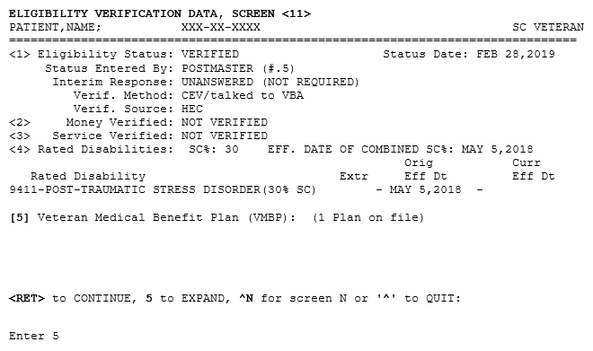
Figure 1: ELIGIBILITY VERIFICATION DATA SCREEN <11>

- The template for the VMBP <11.1> screen is updated so that the header text of the screen reads "VMBP". The plans are now labeled “Current VMBPs:”.
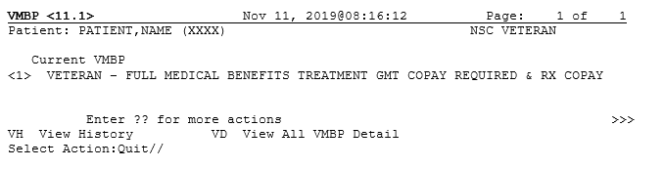
Figure 2: VMBP <11.1> Screen
- The template for the VMBP <11.3> screen is updated so that the header text of the screen reads “VMBP”. In addition, the "ADD" label is changed to read "ASSIGN" and the "DELETE" label is changed to read "UNASSIGN". A new Expand Entry [DGEN HBP VIEWEXP] list template is added to display detailed plan information.
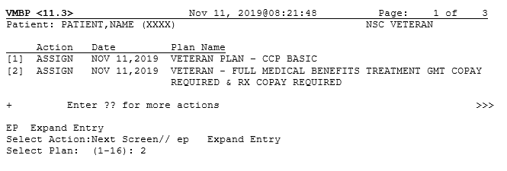
Figure 3: VMBP <11.3> Screen

- A new VMBP <11.3.1> screen is added to display detailed plan information. VistA REE displays the VMBP <11.3.1> screen when the user selects “Expand Entry” from the View History [DGEN HBP VIEW] action protocol on the VMBP <11.3> screen.
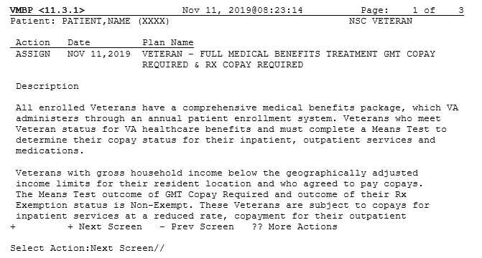
Figure 4: VMBP <11.3.1> Screen
- The template for the VMBP <11.4> screen is updated so that the header text of the screen reads “VMBP” and the label “HBP View All Detail” is updated to display “VMBP View All Detail.”
- In the Patient Inquiry [DG PATIENT INQUIRY] option, the label "Health Benefit Plan Currently Assigned to Veteran:" is updated to display "Veteran Medical Benefit Plan Currently Assigned to Veteran:".
Note: The label change is also displayed in external applications and packages that make use of the Patient Inquiry API; Integration Control Registrations (ICRs) #2041, #10037, and #740; and Remote Procedure Call (RPC) #2089; and reflect the label change. The applications include:
Women’s Health (WV)
Barcode Medication Administration (BCMA)
Vista Imaging - Clinical Display
Order Entry Results Reporting
Outpatient Pharmacy Manager (PSO MANAGER)
Computerized Patient Record System (CPRS)
Clinical Information Resource Network (CIRN)
Automated Medical Information Exchange (AMIE)
Regional Office Patient Inquiry (DVBA REG OFF PATIENT INQ)

The following VistA REE menu options also make use of the Patient Inquiry API and reflect the label change:
Collateral Patient Register [DG COLLATERAL PATIENT] option
Load/Edit Patient [DG LOAD PATIENT DATA] option
Register A Patient [DG REGISTER PATIENT] option
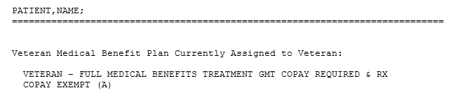
Figure 5: Patient Inquiry Option
- A "zz" indicator is added to the display of any current VMBPs that are inactive. The Veteran's current VMBP(s) are displayed in Registration options that display the updated VMBP <11.1> Screen, and Patient Inquiry [DG PATIENT INQUIRY] option.
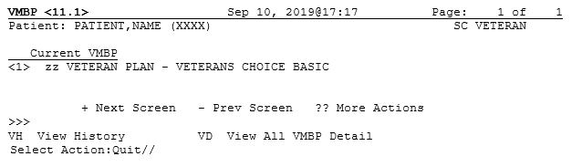
Figure 6: "zz" Indicator for Inactive Plans

Known Issues
No known or open issues were identified in this release.

Product Documentation
The following documents apply to this release:
Title File Name FTP Mode
DG*5.3*987 Release Notes DG_5_3_987_RN.PDF (binary)
User Manual – Registration Menu PIMS_REG_UM.PDF (binary)

Redacted

Documentation can also be found on the VA Software Documentation Library at:
http://www.va.gov/vdl/

