Enrollment System Modernization (ESM) Phase 3

Veterans Health Information Systems and Technology Architecture (VistA)
Registration, Eligibility & Enrollment (REE)

DG_53_P993.KID

Registration (DG) – DG*5.3*993
Income Verification Match (IVM) – IVM*2.0*162 Enrollment Application System (EAS) – EAS*1.0*190

Release Notes
August 2020
Department of Veterans Affairs
Office of Information and Technology (OIT)

Table of Contents
1 Introduction 1
2 Purpose 1
3 Audience 1
4 This Release 1
4.1 New Features and Functions Added 1
4.2 Enhancements and Modifications 1
4.3 Known Issues 17
5 Product Documentation 17

List of Figures
Figure 1: Existing Patient Enrollment Display 6
Figure 2: Self-Reported Registration Only Reason Prompt 7
Figure 3: "Register A Patient" Option Screen 8
Figure 4: "Disposition an Application" Screen 10
Figure 5: Patient Enrollment Screen 11
Figure 6: "Registration Only" Enrollment Screen 12
Figure 7: Link to Patient File Disabled Screen 15

List of Tables
Table 1: DG*5.3*993 Enhancements and Modifications 2

Introduction
The release of Veterans Health Information System and Technology Architecture (VistA) Registration, Eligibility & Enrollment (REE) Host File DG_53_P993.KID includes Registration (DG) patch DG*5.3*993, Income Verification Match (IVM) patch IVM*2.0*162, and Enrollment Application System (EAS) patch EAS*1.0*190. This release supports the enhancements for the Enterprise Health Benefits Determination (EHBD) program. It focuses on updates for the Enrollment System Modernization (ESM) Phase 3 project, which supports Enrollment System Community Care (ESCC) and Enrollment System (ES) Sustainment.

Purpose
The Release Notes cover the changes to VistA REE DG, IVM and EAS systems for this release. DG*5.3*993 is also being released in support of the Enrollment System (ES) 5.12 release. Refer to Informational Patch EAS*1*191 (Enrollment Application System) for additional details regarding the ES release.

Audience
This document targets users and administrators of VistA REE and applies to the changes made between this release and any previous release for this software.

This Release
The software for this patch is being released using a Host File. The Host File is available at the following location REDACTED.
The following sections provide a summary of the enhancements and modifications to the existing software for VistA REE with the release of patches DG*5.3*993, IVM*2.0*162, and EAS*1.0*190.

New Features and Functions Added
There are no new features or functions added to VistA REE for DG*5.3*993, IVM*2.0*162, and EAS*1.0*190.

Enhancements and Modifications
DG*5.3*993
Patch DG*5.3*993 supports the Health Eligibility Center (HEC), which needs to separate registration events from enrollment events. This supports the Veterans Affairs (VA) Office of Inspector General (OIG) recommendation (VA OIG Audit 16-00355-296) #4 - to prevent medical and other registrations from triggering an enrollment application. The anticipated outcome is to allow Veterans, service members, and other nonveterans to register without applying for enrollment for VHA healthcare services.

Currently, in Veterans Health Information System and Technology Architecture (VistA), when patients are added (registered) in VistA for reasons other than enrollment, the Enrollment System (ES) attempts to determine eligibility and enrollment, even if an enrollment application has not been submitted by a Veteran. With patch DG*5.3*993, ES knows whether the person intends to enroll or only to register.

IVM*2.0*162
Registration patch DG*5.3*993 enhanced the existing structure of the Health Level 7 (HL7) VA-Specific Enrollment Status Segment (ZEN) in ORU/ORF-Z11 and ORU/ORF-Z07 in Veterans Health Information System and Technology Architecture (VistA) to receive and send the four additional fields listed below.

- PT APPLIED FOR ENROLLMENT?: The message populates sequence #16 in the ZEN segment.

- REGISTRATION ONLY REASON: The message populates sequence #17 in the ZEN segment.

- REGISTRATION ONLY DATE: The message populates sequence #18 in the ZEN segment.

- SOURCE OF REGISTRATION: The message populates sequence #19 in the ZEN segment.

This patch includes ORU/ORF-Z10 processing changes for Registration Only patients not subject to Means Testing or RX Copay Testing.

Currently, in Veterans Health Information System and Technology Architecture (VistA), when patients are added (registered) in VistA for reasons other than enrollment, the Enrollment System (ES) attempts to determine eligibility and enrollment, even if an enrollment application has not been submitted by a Veteran.

With Host File DG_53_P993.KID, ES will know whether the person intends to enroll or only to register.

EAS*1.0*190
With patch EAS*1.0*190, the action protocol link to the Patient File [EAS EZ LINK TO FILE 2] within the Electronic 10-10EZ Processing [EAS EZ 1010EZ PROCESSING] option has been disabled.
Table 1 shows the enhancements and modifications included in the DG*5.3*993 release as tracked in Rational Team Concert (RTC) Requirements Management (RM).
Table 1: DG*5.3*993 Enhancements and Modifications
RTC  RM # | Summary
1154763 | Option to select Registration Only vs. Full Enrollment in VistA
1154771 | VistA - Provide a Reason for Veteran's Registration with VHA
1154777 | VistA - Capture and Store the Veteran's Registration Date
1154778 | HL7 Messages
1154780 | VistA - Means and Rx Copay Test Not Required
1154784 | Disposition
List of Updates
DG*5.3*993 makes the following enhancements to VistA REE:
- From the Admit a Patient [DG ADMIT PATIENT] option, VistA does not allow new patient records to be added from the "Admit PATIENT" prompt.

  - If the patient entered is not found at the local site, the system no longer prompts "ARE YOU ADDING . . . AS A NEW PATIENT…? No//”.

  - When a user enters a patient's name in double quotes, the system no longer prompts "ARE YOU ADDING . . . AS A NEW PATIENT…? No..”.

  - If the patient entered is not found at the local site, the system now responds with "??" after the patient name. The system displays a new message and the Admit PATIENT prompt is redisplayed.

  - The new message is "Use Register A Patient option to add a new person."

  - In the Admit a Patient [DG ADMIT PATIENT] option, if the user enters ?? at the Admit PATIENT Prompt and then exits by entering a caret '^' from the list of patients at the "Type <Enter> to continue or '^' to exit:" prompt, the system will no longer display a message and will return to the Admit PATIENT prompt.

- From the Load/Edit Patient Data option [DG LOAD PATIENT DATA] option, VistA does not allow a new patient record to be added from the "Select PATIENT NAME" prompt.

  - At the "Select PATIENT NAME:" prompt, if the patient entered is not found at the local site, the system no longer prompts "ARE YOU ADDING . . . AS A NEW PATIENT…? No//”.

  - When a user enters a patient's name in double quotes, the system no longer prompts "ARE YOU ADDING . . . AS A NEW PATIENT…? No//”.

  - If the patient entered is not found at the local site, the system now responds with "??" after the patient name. The system displays a message and the "Select PATIENT NAME:" prompt is redisplayed. The new message is "Use Register A Patient option to add a new person."

  - In the Load/Edit Patient Data [DG LOAD PATIENT DATA] option, if the user enters ?? at the Select PATIENT NAME prompt and if the user exits by entering a caret '^' from the list of patients at the "Type <Enter> to continue or '^' to exit:" prompt, the system shall no longer display a message and will return to the Select PATIENT NAME prompt.

- Four new fields are added to the PATIENT ENROLLMENT file (#27.11).

  - 27.11,.14 PT APPLIED FOR ENROLLMENT? 0;14 SET (audited)

PATIENT APPLIED FOR ENROLLMENT?
'0' FOR NO;
'1' FOR YES;
LAST EDITED: NOV 13, 2019
HELP-PROMPT: Select Y or YES if the patient wants to apply for enrollment for VHA Healthcare benefits. Select N or NO if the patient only wants to register without applying for enrollment.
DESCRIPTION: This field is set to 0 (zero) if the patient did not apply for enrollment (registration only), or 1 if the patient did apply for enrollment.

AUDIT: YES, ALWAYS

  - 27.11,.15 REGISTRATION ONLY REASON 0;15 POINTER TO PATIENT REGISTRATION ONLY REASON file (#408.43) (audited)

LAST EDITED: FEB 04, 2020
HELP-PROMPT: Select a reason for this patient registration.
DESCRIPTION: This field contains the reason for the registration of a patient.

AUDIT: YES, ALWAYS

  - 27.11,.16 REGISTRATION ONLY DATE 0;16 DATE (audited)

INPUT TRANSFORM: S %DT="ESTX" D ^%DT S X=Y K:Y<1 X
LAST EDITED: MAY 01, 2020
HELP-PROMPT: Enter the date and time the patient registered.
DESCRIPTION: This field contains the date and time when the patient was first registered. It can also be blank (null) for any patients that existed prior to the creation of this field.

AUDIT: YES, ALWAYS
NOTES: XXXX--CAN'T BE ALTERED EXCEPT BY
PROGRAMMER

  - 27.11,.17 SOURCE OF REGISTRATION 0;17 SET (audited)

'1' FOR VAMC;
'2' FOR HEC;
'3' FOR HCA;
'4' FOR CARMA;
'5' FOR OTHER;
LAST EDITED: FEB 13, 2020
HELP-PROMPT: Please select the source of registration for the patient.
DESCRIPTION: This field determines the source of registration for the patient.

AUDIT: YES, ALWAYS
SOURCE OF DATA: Q

- One field is modified in the PATIENT ENROLLMENT file (#27.11). In the ENROLLMENT APPLICATION DATE (#.01) field, a TITLE of "APPLICATION DATE" is added and the HELP PROMPT and DESCRIPTION are modified.

27.11,.01 ENROLLMENT APPLICATION DATE 0;1 DATE (Required)

APPLICATION DATE:
INPUT TRANSFORM: S %DT="EPX" D ^%DT S X=Y K:Y<1 X I $D(X)
D H^DGUTL K:X>DGTIME X K DGTIME,DGDATE I
$G(X)>0 D ENRAPP^DGENDD
LAST EDITED: JULY 15, 2020
HELP-PROMPT: Enter the date of the Application for Enrollment or date of Registration (today's date). Enrollment Application Date must not be before 10/1/1996 or patient's DOB, date of Registration is system set.
DESCRIPTION: The date the application/registration was completed. The Enrollment Application date (labeled Application Date) is user entered or set by the Z11 upload from ES for patients who complete the Registration or Enrollment Application i.e., the signature date. The date of the Registration cannot be entered in VistA, it is set by the system during new patient registration to today's date or by the Z11 upload from ES.
Enrollment Application Date:
Must be a date prior or equal to the veterans 'Date of Death'
Must be a precise date, i.e. a day, month and year MUST be included
Cannot be a date prior to the veterans Date of Birth' Cannot be a date in the future
Cannot be a date prior to 10/1/1996

UNEDITABLE
NOTES: XXXX--CAN'T BE ALTERED EXCEPT BY
PROGRAMMER

CROSS-REFERENCE: 27.11^B
1)= S ^DGEN(27.11,"B",$E(X,1,30),DA)=""
2)= K ^DGEN(27.11,"B",$E(X,1,30),DA)

CROSS-REFERENCE: 27.11^AENR01^MUMPS
1)= D E2711^DGRTRIG(DA)
2)= D E2711^DGRTRIG(DA)
3)= DO NOT DELETE
This cross-reference is used to notify HEC of changes that may affect enrollment.

- A new entry is added to the ENROLLMENT STATUS file (#27.15):
ENTRY NUMBER: 25 NAME: REGISTRATION ONLY
ENROLLMENT CATEGORY: NOT ENROLLED
DESCRIPTION: This entry is for patients who do not apply for enrollment for VHA healthcare benefits.

- The new PATIENT REGISTRATION ONLY REASON file (#408.43) is added:

This file contains a list of reasons that can be selected when a user is creating a patient that either does not want to be enrolled for VA care (Registration only) or is a Collateral patient.

DD ACCESS: @
RD ACCESS: @
WR ACCESS: @
DEL ACCESS: @
LAYGO ACCESS: @
AUDIT ACCESS: @

POINTED TO BY: REGISTRATION ONLY REASON field (#.15) of the PATIENT ENROLLMENT File (#27.11)

CROSS REFERENCED BY: REASON(B), CODE(C)

LAST MODIFIED: MAY 8,2020@11:35:31

  - 408.43,.01 REASON 0;1 FREE TEXT (Required)

INPUT TRANSFORM: K:$L(X)>50!($L(X)<3) X
MAXIMUM LENGTH: 50
LAST EDITED: MAY 08, 2020
HELP-PROMPT: Answer must be 3-50 characters in length.
DESCRIPTION: This field contains a patient's self-reported Registration reason.

CROSS-REFERENCE: 408.43^B
1)= S ^DG(408.43,"B",$E(X,1,30),DA)=""
2)= K ^DG(408.43,"B",$E(X,1,30),DA)

  - 408.43,.02 AVAILABILITY 0;2 SET (Required)
'1' FOR REGISTER A PATIENT;
'2' FOR COLLATERAL OF PATIENT;
'3' FOR RECORD CREATED BY HEC;
LAST EDITED: FEB 04, 2020
HELP-PROMPT: Select the availability type for this record.
DESCRIPTION: This field contains values that determine which records can be selected for different processes.

  - 408.43,.03 CODE 0;3 NUMBER (Required)

INPUT TRANSFORM: K:+X'=X!(X>99)!(X<1)!(X?.E1"."1N.N) X
LAST EDITED: MAY 08, 2020
HELP-PROMPT: Type a number between 1 and 99, 0 decimal digits.
DESCRIPTION: This field contains a code for Registration reason.

CROSS-REFERENCE: 408.43^C
1)= S ^DG(408.43,"C",$E(X,1,30),DA)=""
2)= K ^DG(408.43,"C",$E(X,1,30),DA)
This cross-reference allows look-up by Code.

- Three user prompts are moved from the end of the Register a Patient [DG REGISTER PATIENT] option to the beginning, following the prompt "Insurance data retrieval has been initiated." If the patient is a Veteran, the following prompt displays unless the response is already stored as YES:

DO YOU WISH TO ENROLL?

  - If DO YOU WISH TO ENROLL?: is already NO and the Veteran responds YES, the message in the following screen capture appears:

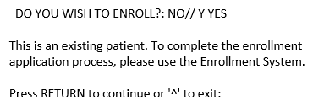
Figure 1: Existing Patient Enrollment Display

  - If the patient answers YES, this prompt follows:

APPLICATION DATE: NOW//

Do you want an appt. with a VA doctor/provider as soon as available?: YES//

Two fields are then populated in the PATIENT file (#2) as follows:

The APPOINTMENT REQUEST ON 1010EZ field (#1010.159) is updated with the answer YES or NO.

The APPOINTMENT REQUEST DATE field (#1010.1511) is set to today's date.

  - For nonveterans and Veterans who do not wish to enroll, this prompt follows unless it has already been populated:
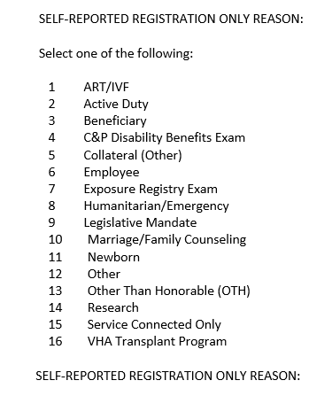
Figure 2: Self-Reported Registration Only Reason Prompt
- In the Register a Patient [DG PATIENT REGISTER] option, if the patient's ENROLLMENT STATUS is REGISTRATION ONLY, then the default values for the following prompts are set as shown:

TYPE OF BENEFIT APPLIED FOR: OUTPATIENT MEDICAL//
TYPE OF CARE APPLIED FOR: ALL OTHER//

- At the end of patient registration when a record is created in the PATIENT ENROLLMENT file (#27.11), the following new fields are populated:

  - If the patient answered YES to the DO YOU WISH TO ENROLL? question, these fields are populated in the PATIENT ENROLLMENT file (#27.11) record:

    - The PT APPLIED FOR ENROLLMENT field (#.14) is set to YES.

    - The REGISTRATION ONLY DATE field (#.16) is set to NOW.

    - The SOURCE OF REGISTRATION field (#.17) is set to 1 (VAMC).

  - If the patient answered NO to the DO YOU WISH TO ENROLL?: question or if the patient is a nonveteran, these fields are populated in the enrollment record:
    - The PT APPLIED FOR ENROLLMENT field (#.14) is set to NO (herein referred to as ENROLL = NO).

    - The REGISTRATION ONLY REASON field (#.15) is set to the value selected by the user above.

    - The REGISTRATION ONLY DATE field (#.16) is set to NOW.

    - The SOURCE OF REGISTRATION field (#.17) is set to 1 (VAMC).

- If the PT APPLIED FOR ENROLLMENT FIELD (#.14) is NO, the Priority Group is null.

- The label "Enrollment Application Date" is changed to "Application Date" at the end of Register A Patient [DG REGISTER PATIENT] option.

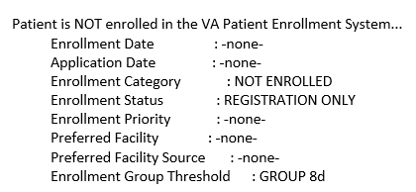
Figure 3: "Register A Patient" Option Screen
- When a new patient is added to the site with the Collateral Patient Register [DG COLLATERAL PATIENT] option, after the system prompts for a "SPONSOR:", this new prompt displays:

SELF-REPORTED REGISTRATION ONLY REASON

Select one of the following:

1 ART/IVF
2 Collateral (Other)
3 Marriage/Family Counseling
4 Newborn
5 VHA Transplant Program

SELF-REPORTED REGISTRATION ONLY REASON

12.1 At the end of the new Collateral patient registration a record is created in the PATIENT ENROLLMENT file (#27.11) and the following fields are populated:

    - The PT APPLIED FOR ENROLLMENT field (#.14) is set to NO.

    - The REGISTRATION ONLY REASON field (#.15) is set to the value selected by the user above.

    - The REGISTRATION ONLY DATE field (#.16) is set to NOW.

    - The SOURCE OF REGISTRATION field (#.17) is set to 1 (VAMC).

- In the Disposition an Application [DG DISPOSITION APPLICATION] option, if the patient's ENROLLMENT STATUS is REGISTRATION ONLY, and "Is the patient to be examined in the medical center today?" was answered "NO", then the default value for the following prompts are set as shown:

STATUS: APPLICATION WITHOUT EXAM//
Select the type of disposition: CANCEL WITHOUT EXAM//

- In the Disposition an Application [DG DISPOSITION APPLICATION] option, if the patient's ENROLLMENT STATUS is REGISTRATION ONLY, and "Is the patient to be examined in the medical center today?" was answered "YES", then the default value for the following prompt is set as shown:

STATUS: 10/10 VISIT//

- The Disposition an Application [DG DISPOSITION APPLICATION] option does NOT display the following prompts if the patient has an enrollment status of REGISTRATION ONLY:

Do you wish to enroll in the VA Patient Enrollment System? YES//

ENROLLMENT APPLICATION DATE:

Do you want an appt. with a VA doctor/provider as soon as available?: YES//

The following screen capture shows the Disposition an Application [DG DISPOSITION APPLICATION] option where the enrollment questions are not asked:
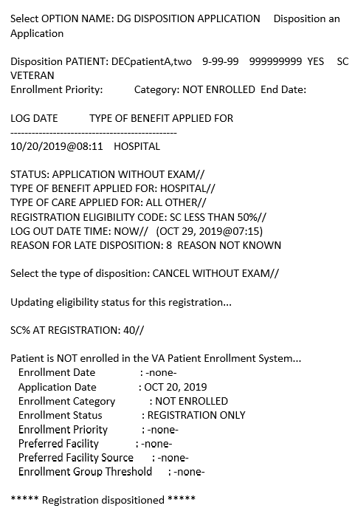
Figure 4: "Disposition an Application" Screen

- The Patient Enrollment [DGEN PATIENT ENROLLMENT] option, Page 1 screen, and Expand History [DGEN EXPAND HISTORY] action protocol Page 1 screen within the Patient Enrollment [DGEN PATIENT ENROLLMENT] option do not display the Enrollment Date and the Enrollment End Date labels and values if the Enrollment Status is REGISTRATION ONLY.
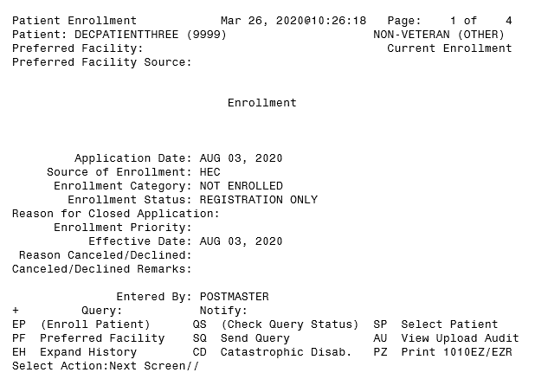
Figure 5: Patient Enrollment Screen
- If the patient answered NO to DO YOU WISH TO ENROLL (ENROLL = NO), the Consistency Check "55 INCOME DATA MISSING" does not appear when consistencies are checked. In addition, the question "Do you wish to return to Screen #9 to enter missing Income Data? is not displayed after the Consistency Check at the end of the following options:
Register a Patient [DG REGISTER PATIENT]
Load/Edit Patient Data [DG LOAD PATIENT DATA]
Preregister a Patient [DGPRE PRE-REGISTER OPTION]
Eligibility Verification [DG ELIGIBILITY VERIFICATION]

- The patient is not subject to a Means Test or RX Copay Exemption Test financial assessment when ENROLL = NO.

18.1 The user is NOT asked if they wish to complete a Means Test in any VistA Registration option

18.2 Prompts and messages related to Means Testing are NOT displayed in any VistA Registration option.

- For a record where ENROLL = NO, from the Preregister a Patient [DGPRE PRE-REGISTER OPTION] option, financial assessment information is NOT displayed after "Other Eligibilities:" and the "[PRE-REGISTER DATE"]".

- For a record that is ENROLL = NO, the Add A New Means Test option [DG MEANS TEST ADD] prevents a user from completing a Means Test. After the patient is selected, the system displays the existing message: "A means test can only be added for patients who require one."

- For a record that is ENROLL = NO, a VistA user is NOT allowed to add a new Copay Exemption Test in [DG CO-PAY TEST ADD] option. The new message "Patient's Enrollment Status is REGISTRATION ONLY" is displayed.

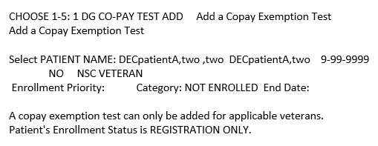
Figure 6: "Registration Only" Enrollment Screen

- With the exception of a death notification for a patient, whenever VistA processing calculates the Priority Group, if the Enrollment Status is Registration Only, the Priority Group remains null and the Enrollment Status remains Registration Only, regardless of eligibility factors. When a patient death notification is received or entered, the Enrollment Status calculation follows the existing process.

- The HL7 interface with ES (ORU/ORF Z11 and ORU/ORF-Z07) is modified to include four additional data elements:

23.1 PT APPLIED FOR ENROLLMENT?. The message populates sequence #16 in the ZEN segment.

23.2 REGISTRATION ONLY REASON. The message populates sequence #17 in the ZEN segment.

23.3 REGISTRATION ONLY DATE. The message populates sequence #18 in the ZEN segment.

23.4 SOURCE OF REGISTRATION. The message populates sequence #19 in the ZEN segment.

- When VistA receives an HL7 ORU-Z11/ORF-Z11 message from ES, the message is rejected in the following conditions:

24.1 PT APPLIED FOR ENROLLMENT in the ZEN segment #16 is NO, patient is a Veteran and the patient applied for enrollment: (Patient Enrollment (#27.11) file PT APPLIED FOR ENROLLMENT (#.14) field is YES).

24.2 ENROLLMENT STATUS is 25 (REGISTRATION ONLY) and REGISTRATION ONLY DATE in the ZEN sequence #18 is not provided.

- When VistA accepts an HL7 ORU-Z11/ORF-Z11 message, the following are stored in PATIENT ENROLLMENT file (#27.11):

25.1 The PT APPLIED FOR ENROLLMENT? at sequence #16 in the ZEN segment is updated in the PT APPLIED FOR ENROLLMENT? field (#.14).

25.2 The REGISTRATION ONLY REASON at sequence #17 in the ZEN segment is updated in the REGISTRATION ONLY REASON field (#.15) after CODE lookup in PATIENT REGISTRATION ONLY REASON file (#408.43).

25.3 The REGISTRATION ONLY DATE at sequence #18 in the ZEN segment is updated in the REGISTRATION ONLY DATE field (#.16).

25.4 The SOURCE OF REGISTRATION at sequence #19 in the ZEN segment is updated in the SOURCE OF REGISTRATION field (#.17).

25.5 If the ENROLLMENT STATUS received is REGISTRATION ONLY and the APPLICATION DATE is not provided, the ENROLLMENT APPLICATION DATE (#.01) field is set equal to the REGISTRATION ONLY DATE from sequence #18 in the ZEN segment.

25.6 If the ENROLLMENT STATUS received is REGISTRATION ONLY and the ENROLLMENT SOURCE is not provided, the SOURCE OF ENROLLMENT (#.03) field is set equal to "HEC".

25.7 If the ENROLLMENT STATUS received is REGISTRATION ONLY and the EFFECTIVE DATE is not provided, the EFFECTIVE APPLICATION DATE (#.08) field is set equal to the REGISTRATION ONLY DATE from sequence #18 in the ZEN segment.

- When VistA sends an HL7 ORU-Z07/ORF-Z07 message, the following are populated from the PATIENT ENROLLMENT file (#27.11):

26.1 The PT APPLIED FOR ENROLLMENT? at sequence #16 in the ZEN segment is populated from the PT APPLIED FOR ENROLLMENT? field (#.14).

26.2 The REGISTRATION ONLY REASON at sequence #17 in the ZEN segment is populated from the CODE of REGISTRATION ONLY REASON field (#.15). The Code is retrieved from the CODE field (#.03) of PATIENT REGISTRATION ONLY REASON file (#408.43).

26.3 The REGISTRATION ONLY DATE at sequence #18 in the ZEN segment is populated from the REGISTRATION ONLY DATE field (#.16).

26.4 The SOURCE OF REGISTRATION at sequence #19 in the ZEN segment is populated from the SOURCE OF REGISTRATION field (#.17).

- The Enroll Patient (EP) action protocol in the Patient Enrollment [DGEN PATIENT ENROLLMENT] option displays a message "Enroll Patient may not be selected at this point.", and no longer prompts non-enrolled Veterans if they wish to enroll for VHA Healthcare.

IVM*2.0*162 includes the following enhancements to VistA REE:

- ORU/ORF-Z10 processing is modified to ensure Registration Only patients are not subject to Means Test and are not subject to RX Copay Test. VistA will reject an ORU/ORF-Z10 with error message "Enrollment Status is Registration Only - not subject to Means Test or RX Copay Test" if it is received for a Registration Only Patient with a Means Test or an RX Copay Test.

EAS*1.0*190 includes the following enhancements to VistA REE:

- The action protocol Link to Patient File [EAS EZ LINK TO FILE 2] within the Electronic 10-10EZ Processing [EAS EZ 1010EZ PROCESSING] option has been disabled.

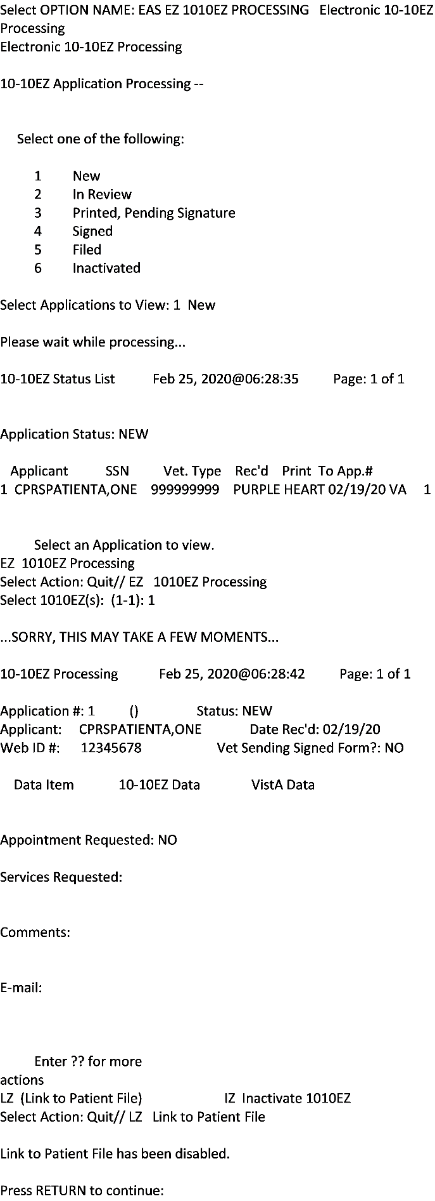
Figure 7: Link to Patient File Disabled Screen

Known Issues
No known or open issues were identified in this release.

Product Documentation
The following documents apply to this release:
Title File Name
DG_53_P993.KID Release Notes DG_5_3_P993_RN.PDF
User Manual - Registration Menu PIMS_REG_UM.PDF
PIMS Technical Manual PIMSTM.PDF
User Manual – ADT Module ADTBE_UM.PDF
IVM Technical Manual IVM_2_TM.PDF
Enrollment Application System User Manual EAS_1_UM.PDF
Enrollment Application System Technical Manual EAS_1_TM.PDF
Documentation can be found on the VA Software Documentation Library (VDL) at: http://www.va.gov/vdl/

