Enrollment System Modernization (ESM) Phase 3

Veterans Health Information Systems and Technology Architecture (VistA)
Registration, Eligibility & Enrollment (REE)

DG_53_P997.KID

Registration (DG) – DG*5.3*997
Income Verification Match (IVM) – IVM*2.0*193

Release Notes
August 2020
Department of Veterans Affairs
Office of Information and Technology (OIT)

Table of Contents
1 Introduction 1
2 Purpose 1
3 Audience 1
4 This Release 1
4.1 New Features and Functions Added 1
4.2 Enhancements and Modifications 1
4.3 Defects and Fixes 3
4.4 Known Issues 15
5 Product Documentation 15

List of Figures
Figure 1: Emergency Contact Data, Screen <3> 5
Figure 2: Emergency Contact Data, Screen <3> (Edit) 7
Figure 3: EMERGENCY CONTACT DATA, SCREEN <3> (Edits Filed) 8
Figure 4: Patient Inquiry 8
Figure 5: ADDITIONAL ELIGIBILITY VERIFICATION DATA, SCREEN <11.5> 9
Figure 6: Caregiver Data <11.5.1> Screen 10
Figure 7: Hardship Determinations – Hardship EXPIRED 11
Figure 8: Hardship Determinations – Hardship YES 12
Figure 9: View a Past Means Test – Hardship Fields 12

List of Tables
Table 1: DG_53_P997.KID (DG*5.3*997 and IVM*2.0*193) Enhancements and Modifications 3
Table 2: Defects and Fixes in DG_53_P997.KID 3

Introduction
The release of Veterans Health Information System and Technology Architecture (VistA) Registration, Eligibility & Enrollment (REE) Host File DG_53_P997.KID includes Registration (DG) patch DG*5.3*997 and Income Verification Match (IVM) patch IVM*2.0*193. This release supports the enhancements for the Enterprise Health Benefits Determination (EHBD) program that focuses on updates for the Enrollment System Modernization (ESM) Phase 3 project, which supports Enrollment System Community Care (ESCC) and Enrollment System (ES) Sustainment.

Purpose
The Release Notes cover the changes to VistA REE DG and IVM systems for this release.

Audience
This document targets users and administrators of VistA REE and applies to the changes made between this release and any previous release for this software.

This Release
***** IMPORTANT *****
These patches are being released with a priority of “EMERGENCY”
and have a 3-day compliance installation requirement.
This multi-package build is distributed as a Host File. Refer to the Software and Documentation Retrieval Instructions section of the patch descriptions for information on obtaining the Host File DG_53_P997.KID and related documentation.
The following sections provide a summary of the enhancements and modifications to the existing software for VistA REE with the release of patches DG*5.3*997 and IVM*2.0*193.

New Features and Functions Added
There are no new features or functions added to VistA REE for DG*5.3*997 and IVM*2.0*193.

Enhancements and Modifications
DG*5.3*997
Patch DG*5.3*997 supports the Health Eligibility Center (HEC), which has a need to provide foreign addresses for a patient's Next of Kin (NOK) and Emergency Contacts. There are five contact types that are modified to allow for foreign addresses: Next of Kin, Next of Kin 2, Emergency Contact, Emergency Contact 2, and Designee.
Patch DG*5.3*997 provides for the viewing, entering, and editing of foreign addresses for the five contact types.
Patch DG*5.3*997 adds foreign address data to the ORU-Z07 Health Level 7 (HL7) message in the ZCT segment sent to ES.
Patch DG*5.3*997 creates two new screens for the display of caregiver-related data: ADDITIONAL ELIGIBILITY VERIFICATION DATA, SCREEN <11.5> and Caregiver Data <11.5.1>. These screens are utilized to populate caregiver-related entries with data that is retrieved via a remote procedure call (RPC) from the Master Patient Index (MPI). The data that is displayed is not stored and is uneditable.
DG*5.3*997 adds two new fields: HARDSHIP EXPIRED (#2.12) field and HARDSHIP EXPIRATION DATE (#2.13) field in the ANNUAL MEANS TEST (#408.31) file. Both fields are uneditable. The HARDSHIP EXPIRED (#2.12) field of the ANNUAL MEANS TEST (#408.31) file is determined based on the HARDSHIP EXPIRATION DATE (#2.13) field of the ANNUAL MEANS TEST (#408.31) file when the Z10 is received from ES.
DG*5.3*997 updates HL7 message structures for the ORU/ORF-Z10 and ORU/ORF-Z07. Sequence 32 of the ZMT segment has been added and is used for the HARDSHIP EXPIRATION DATE (#2.13) field of the ANNUAL MEANS TEST (#408.31) file.
DG*5.3*997 updates the View a Past Means Test [DG MEANS TEST VIEW TEST] option to include HARDSHIP? (#.2) and HARDSHIP EXPIRATION DATE (#2.13) fields of the ANNUAL MEANS TEST (#408.31) file. The HARDSHIP? (#.2) field of the ANNUAL MEANS TEST (#408.31) file will display with a screen display label of Hardship.
DG*5.3*997 updates the Hardships screen to display the HARDSHIP EXPIRATION DATE (#2.13) field of the ANNUAL MEANS TEST (#408.31) file. The screen also displays EXPIRED for the Hardship status when Hardship is expired.
DG*5.3*997 includes updates to prohibit a Hardship from being granted against a means test with a status 'Pending Adjudication'.
DG*5.3*997 sets the HARDSHIP EXPIRATION DATE (#2.13) field of the ANNUAL MEANS TEST (#408.31) file to December 31 of the current year when a Hardship is granted in VistA.
DG*5.3*997 sets the HARDSHIP REVIEW DATE (#.21) field of the ANNUAL MEANS TEST (#408.31) file to 60 days prior to the HARDSHIP EXPIRATION DATE (#2.13) field of the ANNUAL MEANS TEST (#408.31) file. If the current date is 60 days or fewer prior to the HARDSHIP EXPRIATION DATE (#2.13) field of the ANNUAL MEANS TEST (#408.31) file, the system sets the HARDSHIP REVIEW DATE (#.21) field of the ANNUAL MEANS TEST (#408.31) file to the current date when a Hardship is granted in VistA.
DG*5.3*997 updates the Hardship screen to remove the Edit Hardship (EH) and the Delete Hardship (DH) actions from the DGMTH HARDSHIP MENU protocol.
IVM*2.0*193
Patch IVM*2.0*193 populates the VistA Health Level 7 (HL7) ORU-Z07 message to send foreign address data for patient associate contacts to ES. The associates are Next of Kin, Next of Kin 2, Emergency Contact, Emergency Contact 2, and Designee.
Patch IVM*2.0*193 adds 15 entries to the IVM DEMOGRAPHIC UPLOAD FIELDS file (#301.92) which is used to map the HL7 fields to the fields in the VistA database.
Patch IVM*2.0*193 updates the HL7 ORU/ORF-Z10 and the ORU/ORF-Z07 messages with the addition of HARDSHIP EXPIRATION DATE in sequence 32 of the ZMT segment. This data will be stored in the HARDSHIP EXPIRATION DATE (#2.13) field of the ANNUAL MEANS TEST (#408.31) file.

Table 1 shows the enhancements and modifications included in the DG_53_P997.KID release as tracked in Rational Team Concert (RTC) Requirements Management (RM).
Table 1: DG_53_P997.KID (DG*5.3*997 and IVM*2.0*193) Enhancements and Modifications
RTC  RM # | Summary
1164634 | Enter, store and transmit foreign addresses for associates in VistA
1167287 | VHAP: Expire hardships when means test no longer required
1168287 | Notify VistA REE when a Caregiver and Veteran are ready for evaluations
1168288 | Create status for Caregivers
1168289 | Notify ES staff of Caregiver approved status
1168290 | Receive Caregiver information from MPI to VistA REE
1168292 | Push Caregiver VHAPs from ES or VistA to other systems
1168294 | Notify ES/VistA of Caregiver status change in CARMA to “Benefit End”
1168296 | Create ES medical plan for In Process Caregiver
1168297 | Assign the Appropriate VHAP to the Caregiver

Defects and Fixes
Table 2 lists the defects and fixes and corresponding Rational Team Concert (RTC) Change and Configuration Management (CM) numbers / Jira bug identification numbers included in DG_53_P997.KID.
Table 2: Defects and Fixes in DG_53_P997.KID
RTC  CM # /  Jira ID | Summary
RTC CM:  1242011 | Defect: IVM Demographic Upload Fields file (#301.92) may contain different Internal Entry Numbers (IENs) due to installing patch DG*5.3*941 more than once. These IENs should be standard within this file. The error "<UNDEFINED>INIT+31^IVMLDEM3 *Y" may be encountered when running the [IVM UPLOAD DEM] Demographics Upload menu option due to this condition.  Fix: A pre-install routine IVM2193P is run in patch IVM*2.0*193 that checks if patch DG*5.3*941 has been installed more than once. If so, the routine performs a cleanup on the IVM DEMOGRAPHIC UPLOAD FIELDS file (#301.92) file to remove all IENs greater than 150. The IVM DEMOGRAPHIC UPLOAD FIELDS file (#301.92) is replaced by patch IVM*2.0*193 and a code modification is made to prevent the UNDEF error occurring.
Jira:  VES-4084 | Defect: If the connection to VA MPI is unavailable a hard error is received, and the user kicked out of the system.  Fix: When utilizing the VistA Web Service an error trap is set to capture the error when communication is unavailable. The error is logged in the error trap and the user can continue.
List of Updates
DG*5.3*997 makes the following enhancements to VistA REE:
Part 1: NOK/E-Contact/Designee Foreign Address
- Fifteen new fields are added to the PATIENT file (#2) to support foreign addresses.
FIELD NAME GLOBAL DATA
NUMBER TITLE LOCATION TYPE
--------------------------------------------------------------------------
.221 K-COUNTRY .21;12 POINTER TO COUNTRY CODE file (#779.004)
.222 K-PROVINCE .21;13 FREE TEXT (1-20 chars)
.223 K-POSTAL CODE .21;14 FREE TEXT (1-10 chars)
.2101 K2-COUNTRY .211;12 POINTER TO COUNTRY CODE file (#779.004)
.2102 K2-PROVINCE .211;13 FREE TEXT (1-20 chars)
.2103 K2-POSTAL CODE .211;14 FREE TEXT (1-10 chars)
.3306 E-COUNTRY .33;12 POINTER TO COUNTRY CODE file (#779.004)
.3307 E-PROVINCE .33;13 FREE TEXT (1-20 chars)
.3308 E-POSTAL CODE .33;14 FREE TEXT (1-10 chars)
.331012 E2-COUNTRY .331;12 POINTER TO COUNTRY CODE file (#779.004)
.331013 E2-PROVINCE .331;13 FREE TEXT (1-20 chars)
.331014 E2-POSTAL CODE .331;14 FREE TEXT (1-10 chars)
.34012 D-COUNTRY .34;12 POINTER TO COUNTRY CODE file (#779.004)
.34013 D-PROVINCE .34;13 FREE TEXT (1-20 chars)
.34014 D-POSTAL CODE .34;14 FREE TEXT (1-10 chars)
- The HL7 ZCT segment includes foreign address fields in the CONTACT ADDRESS (SEQ 5) portion. The structure contains the Country in component 6. Country is the value from the CODE field (#.01) of the COUNTRY CODE file (#779.004). If no value is in this segment, the default value is “USA”. If Country is not "USA", the Province is placed in component 4, and Postal Code in component 5.
Component Description
1 Street Address 1
2 Street Address 2 & Street Address 3
3 City
4 State or Province
5 Zip Code or Postal Code
6 Country
- Data sharing between VistA and ES is enhanced. Routines VAFHLFNC and VAFHLZCT have been modified to send the foreign address fields in the ZCT segment when sending the Z07 message.
NOTE : While an ORU-Z07 is not being triggered after a Permanent Address is copied into the NOK and NOK-2 address fields, the updating of the PRIMARY NOK CHANGE DATE/TIME and SECONDARY NOK CHANGE DATE/TIME that occurs during the processing of the Permanent Address data will trigger an ORU-Z07.
- The following menu options incorporate the changes to the EMERGENCY CONTACT DATA, SCREEN <3> listed below:
Load/Edit Patient Data [DG LOAD PATIENT DATA]
Preregister a Patient [DGPRE PRE-REGISTER OPTION]
Register a Patient [DG REGISTER PATIENT]
Admit a Patient [DG ADMIT PATIENT]
View Registration Data [DG REGISTRATION VIEW]
Eligibility Verification [DG ELIGIBILITY VERIFICATION]
- The EMERGENCY CONTACT DATA, SCREEN <3> is modified as follows:
  - All address lines are moved over 10 characters to the left.
  - Each associate type displays the Country field at the bottom of the address fields.
  - For a foreign address (i.e., Country is not UNITED STATES), the address displayed shows only the City field below the street address and the Province and Postal Code fields below the City.
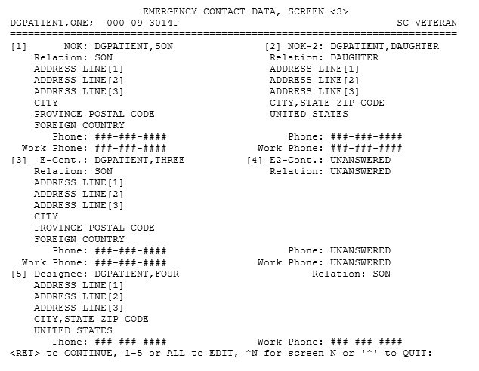
Figure 1: Emergency Contact Data, Screen <3>
- Entering or editing the contact addresses in the EMERGENCY CONTACT DATA, SCREEN <3> is modified as follows:
  - When editing any associate address, the user is first prompted for the COUNTRY. The entry of the COUNTRY follows the same process and validation rules that are enforced in the VistA REE ADDITIONAL PATIENT DEMOGRAPHIC DATA, SCREEN <1.1>.
    - The country defaults to "USA".
    - The country is validated against the COUNTRY CODE file (#779.004).
    - This is a required field, but the user may exit the prompt by entering in the "^" character. This exits the editing process and refreshes the screen.
  - If the country entered is UNITED STATES (USA), the address entry/edit process remains unchanged.
  - If the country entered is not USA:
    - The entry/edit of the Address Lines and City follow the current process.
    - The user is then prompted for the Province.
The field is not required.
The field is Free Text.
The field, if entered, must be between 1-20 characters.
The field may be deleted.
    - The user is then prompted for the Postal Code.
The field is not required.
The field is Free Text.
The field, if entered, must be between 1-10 characters.
The field may be deleted.
  - Note: Data entered into these fields are filed immediately into the database.
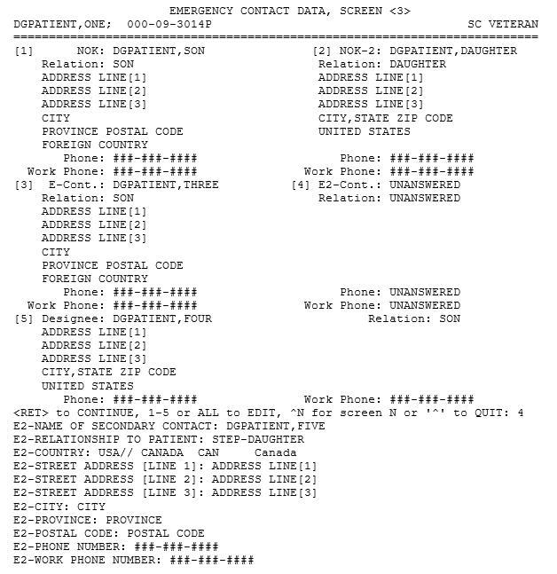
Figure 2: Emergency Contact Data, Screen <3> (Edit)
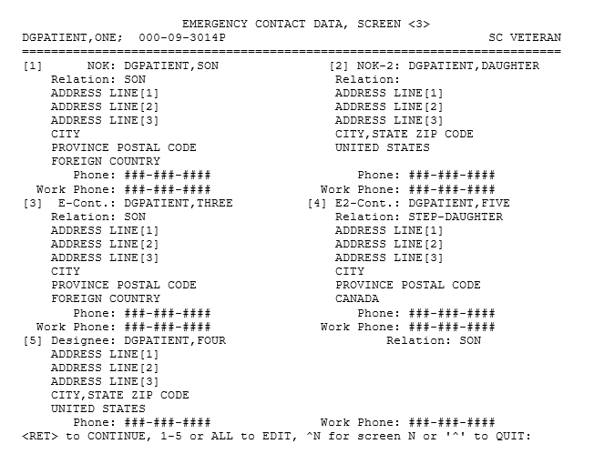
Figure 3: EMERGENCY CONTACT DATA, SCREEN <3> (Edits Filed)
- The Patient Inquiry [DG PATIENT INQUIRY] option is modified as follows:
        - The Emergency Contact Information section (E-Cont. and E2-Cont.) displays the Country field below the address.
        - For a foreign address, the Province and Postal Code are displayed next to the City.
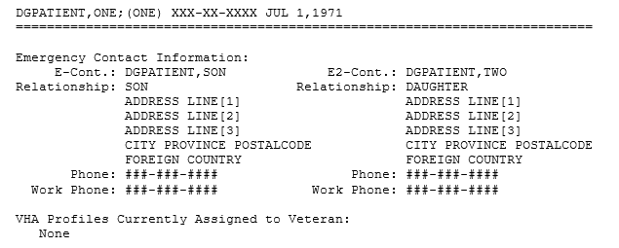
Figure 4: Patient Inquiry

PART 2: Caregiver
- The following menu options incorporate the new screens detailed below:
Load/Edit Patient Data [DG LOAD PATIENT DATA]
Preregister a Patient [DGPRE PRE-REGISTER OPTION]
Register a Patient [DG REGISTER PATIENT]
Admit a Patient [DG ADMIT PATIENT]
View Registration Data [DG REGISTRATION VIEW]
Eligibility Verification [DG ELIGIBILITY VERIFICATION]
NOTE: Caregivers are collaterals. If the SHOW VERIFICATION SCREEN? (#11) field in the TYPE OF PATIENT (#391) file is set to NO for collateral patient types, the display of ELIGIBILITY VERIFICATION DATA, SCREEN <11> and subsequent verification screens is prevented. In order to display caregiver information, sites should ensure that the SHOW VERIFICATION SCREEN? (#11) field in the TYPE OF PATIENT (#391) file is set to YES for collateral patient types.
- The ADDITIONAL ELIGIBILITY VERIFICATION DATA, SCREEN <11.5> is created with a heading of ADDITIONAL ELIGIBILITY VERIFICATION DATA, SCREEN <11.5>. The screen contains a line item label of Caregiver Status Data and a placeholder entry point to display the number of sponsors associated with the caregiver. The number of sponsors displays when the data is retrieved via an RPC from MPI. If there are zero sponsors, the label displays a "0" for the number of entries. If a connection with MPI cannot be established, a warning message is displayed instead of the number of sponsors: (WARNING: MPI CONNECTION NOT AVAILABLE - Systems will be updated automatically when MPI is available. No further action needed to update.).
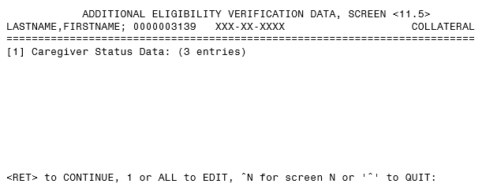
Figure 5: ADDITIONAL ELIGIBILITY VERIFICATION DATA, SCREEN <11.5>

- The Caregiver Data <11.5.1> screen is created with a heading of Caregiver Data <11.5.1>; this screen includes the date, time, and number of pages. The screen contains the column labels of: CAREGIVER'S SPONSOR NAME, L4SSN, SUBTYPE, STATUS, and STATUS DATE. The label descriptions are the following:
Column Label | Description
CAREGIVER'S SPONSOR NAME | The name of the Veteran that the caregiver is providing personal care services, including first name, last name, and middle. The sponsor must be a Veteran.
L4SSN | The last four digits of the sponsor's Social Security Number.
SUBTYPE | The type of caregiver that the sponsor is associated with; one of three types: PRIMARY, SECONDARY, or GENERAL. The Program of Comprehensive Assistance to Family Caregivers (PCAFC) has a Primary Family Caregiver and a Secondary Family Caregiver; the Program of General Caregivers Support Services (PGCSS) has General Family Caregivers.
STATUS | One of five types. Including:  a. In Process: The caregiver will appear in this status until they are approved or denied for the Caregiver program. They will be in this status when the health record is made. During this period, evaluations are being conducted with Caregiver Support Coordinator (CSC)/field staff. A registrant will stay in this status until they are approved or denied for the Caregiver program.  b. Denied: The caregiver applied to participate in the Caregiver program but was denied based on the evaluations conducted by the CSCs.  c. Approved: The caregiver has been approved after completing the training and evaluations in the Computerized Patient Record System (CPRS). They are marked as approved in Caregiver Record Management Application (CARMA).  d. Revoked: A caregiver who has previously been approved for the Caregiver program is removed from the Caregiver program for a reason decided upon by the CSCs staff.  e. Benefit End: A caregiver who was revoked (possibly with a future benefit end date) has reached their benefit end date. CARMA sends this status to trigger the termination of their caregiver VHA Profile (VHAP).
STATUS DATE | The Date that the caregiver "Status" has been applied to the caregiver record. The entry shall be used to display the sponsors in medical record/status date order (descending order).
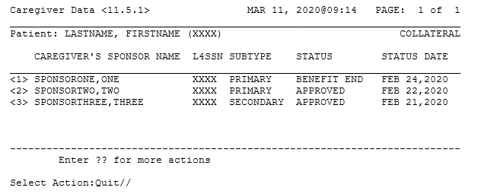
Figure 6: Caregiver Data <11.5.1> Screen
PART 3: Hardship
- When an ORU/ORF-Z10 message is received, sequence 32 of the ZMT segment will populate the HARDSHIP EXPIRATION DATE (#2.13) field of the ANNUAL MEANS TEST (#408.31) file. The value sent is evaluated to determine whether it is a past or future date. If the value evaluates as a date in the past, the HARDSHIP EXPIRED (#2.12) field of the ANNUAL MEANS TEST (#408.31) file is set to 1 (YES). When viewed by a VistA user on the Hardship Determination [DGMTH HARDSHIPS] option, the word "EXPIRED" will display at the "HARDSHIP?:" label. If the value sent is evaluated as a future date, the HARDSHIP EXPIRED (#2.12) field of the ANNUAL MEANS TEST (#408.31) file is set to 0 (NO), and when viewed by a VistA user on the Hardship Determination [DGMTH HARDSHIPS] option, the value displayed at the "HARDSHIP?:" label will be determined by the value in the HARDSHIP? (#.2) field of the ANNUAL MEANS TEST (#408.31) file in accordance with current VistA processing.
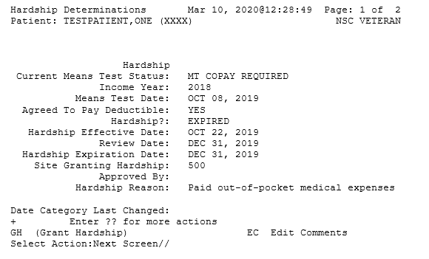
Figure 7: Hardship Determinations – Hardship EXPIRED

- When a Hardship is granted in VistA using the Hardship Determination [DGMTH HARDSHIPS] option and the HARDSHIP EXPIRATION DATE (#2.13) field of the ANNUAL MEANS TEST (#408.31) file is less than 60 days in the future (i.e., Hardship granted after OCT 31), the HARDSHIP REVIEW DATE (#.21) field of the ANNUAL MEANS TEST (#408.31) file will be set to the current date (date the Hardship was granted in VistA).
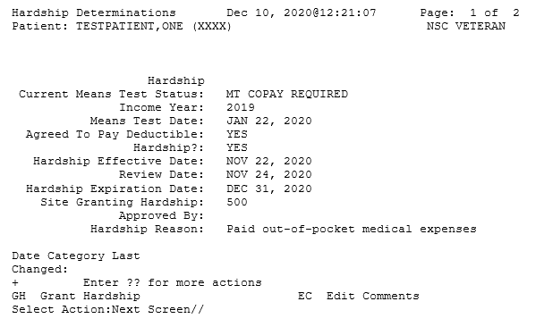
Figure 8: Hardship Determinations – Hardship YES
- The View a Past Means Test [DG MEANS TEST VIEW TEST] option will now include the HARDSHIP? field (#.2) of the ANNUAL MEANS TEST (#408.31) file and the HARDSHIP EXPIRATION DATE (#2.13) field data of the ANNUAL MEANS TEST (#408.31) file on the display. The HARDSHIP? (#.2) field of the ANNUAL MEANS TEST (#408.31) file will display with a screen display label of Hardship.

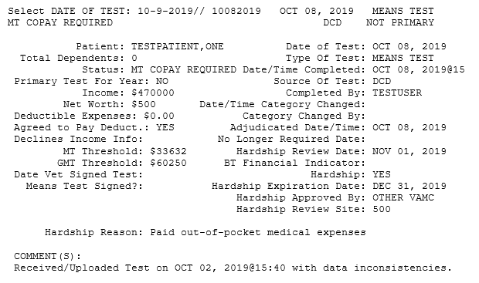
Figure 9: View a Past Means Test – Hardship Fields
IVM*2.0*193 includes the following enhancements to VistA REE:
- The ZCT segment (VA Specific Emergency Contact) includes foreign address data in the CONTACT ADDRESS (SEQ 5). The foreign address fields are in the structure as follows:
  - Component 6 contains the Country Code. The value is the CODE field (#.01) of the COUNTRY CODE file (#779.004).
  - For Country Code not "USA", component 4 contains the Province field.
  - For Country Code not "USA", component 5 contains the Postal Code field.
- The routines responsible for receiving associate address data from ES in the ORU-Z05 HL7 message are modified to receive foreign address data in the ZCT segment and store the data into VistA.
- The HL7 LOCATION field (#.02) in the IVM DEMOGRAPHIC UPLOAD FIELDS file (#301.92) is modified to increase the maximum length to 10 characters.
- Fifteen entries are added to the IVM DEMOGRAPHIC UPLOAD FIELDS file (#301.92). These entries are used to map the address data fields in the ZCT segment to the VistA database fields. The data is provided in the build with the full data dictionary of the IVM DEMOGRAPHIC UPLOAD FIELDS file (#301.92).
DHCP FIELD NAME: K-POSTAL CODE HL7 LOCATION: ZCT055K1F
UPLOADABLE DEMOGRAPHIC FIELD: YES DHCP FILE: PATIENT
DHCP FIELD NUMBER: .223 ADDRESS FIELD?: NO
DHCP LOCATION LOGIC: S DR=.223 D LOOK^IVMPREC9
DHCP OUTPUT LOGIC: S DR=.223 D LOOK^IVMPREC9

DHCP FIELD NAME: K-PROVINCE HL7 LOCATION: ZCT054K1F
UPLOADABLE DEMOGRAPHIC FIELD: YES DHCP FILE: PATIENT
DHCP FIELD NUMBER: .222 ADDRESS FIELD?: NO
DHCP LOCATION LOGIC: S DR=.222 D LOOK^IVMPREC9
DHCP OUTPUT LOGIC: S DR=.222 D LOOK^IVMPREC9

DHCP FIELD NAME: K-COUNTRY HL7 LOCATION: ZCT056K1
UPLOADABLE DEMOGRAPHIC FIELD: YES DHCP FILE: PATIENT
DHCP FIELD NUMBER: .221 ADDRESS FIELD?: NO
DHCP LOCATION LOGIC: S DR=.221 D LOOK^IVMPREC9
DHCP OUTPUT LOGIC: S DR=.221 D LOOK^IVMPREC9

DHCP FIELD NAME: K2-POSTAL CODE HL7 LOCATION: ZCT055K2F
UPLOADABLE DEMOGRAPHIC FIELD: YES DHCP FILE: PATIENT
DHCP FIELD NUMBER: .2103 ADDRESS FIELD?: NO
DHCP LOCATION LOGIC: S DR=.2103 D LOOK^IVMPREC9
DHCP OUTPUT LOGIC: S DR=.2103 D LOOK^IVMPREC9

DHCP FIELD NAME: K2-PROVINCE HL7 LOCATION: ZCT054K2F
UPLOADABLE DEMOGRAPHIC FIELD: YES DHCP FILE: PATIENT
DHCP FIELD NUMBER: .2102 ADDRESS FIELD?: NO
DHCP LOCATION LOGIC: S DR=.2102 D LOOK^IVMPREC9
DHCP OUTPUT LOGIC: S DR=.2102 D LOOK^IVMPREC9

DHCP FIELD NAME: K2-COUNTRY HL7 LOCATION: ZCT056K2
UPLOADABLE DEMOGRAPHIC FIELD: YES DHCP FILE: PATIENT
DHCP FIELD NUMBER: .2101 ADDRESS FIELD?: NO
DHCP LOCATION LOGIC: S DR=.2101 D LOOK^IVMPREC9
DHCP OUTPUT LOGIC: S DR=.2101 D LOOK^IVMPREC9

DHCP FIELD NAME: E-POSTAL CODE HL7 LOCATION: ZCT055E1F
UPLOADABLE DEMOGRAPHIC FIELD: YES DHCP FILE: PATIENT
DHCP FIELD NUMBER: .3308 ADDRESS FIELD?: NO
DHCP LOCATION LOGIC: S DR=.3308 D LOOK^IVMPREC9
DHCP OUTPUT LOGIC: S DR=.3308 D LOOK^IVMPREC9

DHCP FIELD NAME: E-PROVINCE HL7 LOCATION: ZCT054E1F
UPLOADABLE DEMOGRAPHIC FIELD: YES DHCP FILE: PATIENT
DHCP FIELD NUMBER: .3307 ADDRESS FIELD?: NO
DHCP LOCATION LOGIC: S DR=.3307 D LOOK^IVMPREC9
DHCP OUTPUT LOGIC: S DR=.3307 D LOOK^IVMPREC9

DHCP FIELD NAME: E-COUNTRY HL7 LOCATION: ZCT056E1
UPLOADABLE DEMOGRAPHIC FIELD: YES DHCP FILE: PATIENT
DHCP FIELD NUMBER: .3306 ADDRESS FIELD?: NO
DHCP LOCATION LOGIC: S DR=.3306 D LOOK^IVMPREC9
DHCP OUTPUT LOGIC: S DR=.3306 D LOOK^IVMPREC9

DHCP FIELD NAME: E2-POSTAL CODE HL7 LOCATION: ZCT055E2F
UPLOADABLE DEMOGRAPHIC FIELD: YES DHCP FILE: PATIENT
DHCP FIELD NUMBER: .331014 ADDRESS FIELD?: NO
DHCP LOCATION LOGIC: S DR=.331014 D LOOK^IVMPREC9
DHCP OUTPUT LOGIC: S DR=.331014 D LOOK^IVMPREC9

DHCP FIELD NAME: E2-PROVINCE HL7 LOCATION: ZCT054E2F
UPLOADABLE DEMOGRAPHIC FIELD: YES DHCP FILE: PATIENT
DHCP FIELD NUMBER: .331013 ADDRESS FIELD?: NO
DHCP LOCATION LOGIC: S DR=.331013 D LOOK^IVMPREC9
DHCP OUTPUT LOGIC: S DR=.331013 D LOOK^IVMPREC9

DHCP FIELD NAME: E2-COUNTRY HL7 LOCATION: ZCT056E2
UPLOADABLE DEMOGRAPHIC FIELD: YES DHCP FILE: PATIENT
DHCP FIELD NUMBER: .331012 ADDRESS FIELD?: NO
DHCP LOCATION LOGIC: S DR=.331012 D LOOK^IVMPREC9
DHCP OUTPUT LOGIC: S DR=.331012 D LOOK^IVMPREC9

DHCP FIELD NAME: D-POSTAL CODE HL7 LOCATION: ZCT055D1F
UPLOADABLE DEMOGRAPHIC FIELD: YES DHCP FILE: PATIENT
DHCP FIELD NUMBER: .34014 ADDRESS FIELD?: NO
DHCP LOCATION LOGIC: S DR=.34014 D LOOK^IVMPREC9
DHCP OUTPUT LOGIC: S DR=.34014 D LOOK^IVMPREC9

DHCP FIELD NAME: D-PROVINCE HL7 LOCATION: ZCT054D1F
UPLOADABLE DEMOGRAPHIC FIELD: YES DHCP FILE: PATIENT
DHCP FIELD NUMBER: .34013 ADDRESS FIELD?: NO
DHCP LOCATION LOGIC: S DR=.34013 D LOOK^IVMPREC9
DHCP OUTPUT LOGIC: S DR=.34013 D LOOK^IVMPREC9

DHCP FIELD NAME: D-COUNTRY HL7 LOCATION: ZCT056D1
UPLOADABLE DEMOGRAPHIC FIELD: YES DHCP FILE: PATIENT
DHCP FIELD NUMBER: .34012 ADDRESS FIELD?: NO
DHCP LOCATION LOGIC: S DR=.34012 D LOOK^IVMPREC9
DHCP OUTPUT LOGIC: S DR=.34012 D LOOK^IVMPREC9
- With installation of patch IVM*2.0*193, VistA receives and places sequence 32 HARDSHIP EXPIRATION DATE from the HL7 ORU/ORF-Z10 message into the EXPIRATION DATE (#2.13) field of the ANNUAL MEANS TEST (#408.31) file. An ORF/ORU-Z07 message is returned with the HARDSHIP EXPIRATION DATE (#2.13) field of the ANNUAL MEANS TEST (#408.31) file in sequence 32 of the ZMT segment.

Known Issues
No known or open issues were identified in this release.

Product Documentation
The following documents apply to this release:
Title File Name
DG_53_P997.KID Release Notes DG_5_3_P997_RN.PDF
User Manual - Registration Menu PIMS_REG_UM.PDF
PIMS Technical Manual PIMSTM.PDF
User Manual – Means Test
Supervisor Menu MTS_UM.PDF
IVM User Manual IVM_2_UM.PDF
IVM Technical Manual IVM_2_TM.PDF
Documentation can be found on the VA Software Documentation Library (VDL) at: http://www.va.gov/vdl/

