Blind Rehabilitation (BR) Release 5.1.4

Release Notes
July 2023
Document Version 1.0
Department of Veterans Affairs (VA)
Office of Information and Technology (OI&T)

Revision History
Date | Version | Description | Author
07/2023 | 1.0 | Initial Version | Booz Allen Hamilton

Table of Contents
1 Purpose 1
1.1 General Updates 1
1.1.1 Error Messages 1
1.1.2 Print VIST Roster Sorts 2
1.1.3 VIST Roster Summary Report Start Date 3
1.1.4 Edit Blind Patient Date Box 3
1.1.5 VIST Annual Review Page 4
2 JAWS Supported Versions 5

List of Figures
Figure 1: Eye Exam Missing Mandatory Field(s) 1
Figure 2: Date Format Error 2
Figure 3: Data-Only Export 2
Figure 4: Options for Data-Only Export 3
Figure 5: Default Report Start Date 3
Figure 6: Edit Blind Patient Date Box 4
Figure 7: VIST Annual Review Page 4
Figure 8: Supported JAWS Versions 5

Purpose
The Blind Rehabilitation (BR) team has made significant updates to the BR application. This document will summarize the updates made for release 5.1.4 and provide brief instructional text for specific updates.

General Updates
The 5.1.4 release includes Section 508 updates that improve Job Access With Speech (JAWS) reading capabilities. These updates now allow JAWS to read the status notification dialog when a user selects the Select button for a sensitive patient. They also allow JAWS to announce the completion of a patient search. Additionally, JAWS will now be able to assist users in differentiating between patients with identical names when utilizing the Select buttons in the search results table and the Existing Referral Edit buttons.
Release 5.1.4 also includes updates to error messages that add specificity to the respective errors. The Eye Exam missing mandatory fields error message will now specify that the user must enter a valid exam date. The error message for date format now better specifies which field(s) are failing validation. This added specificity will now give more clarity for users utilizing JAWS.
This release will also allow users to perform data-only exports for the reports in the Print VIST Roster Sorts menu. The VIST Roster Summary report start date will now always default as the first day of the current fiscal year. The Edit Blind Patient date box is now labeled “Enrollment Date (MM/DD/YYYY).” Furthermore, the acronym “VIST” on the VIST Annual Review page has been corrected to be read in all caps.
In addition to the aforementioned updates, various potential vulnerabilities identified in the security scan have been remediated.

Error Messages
Figure 1: Eye Exam Missing Mandatory Field(s)
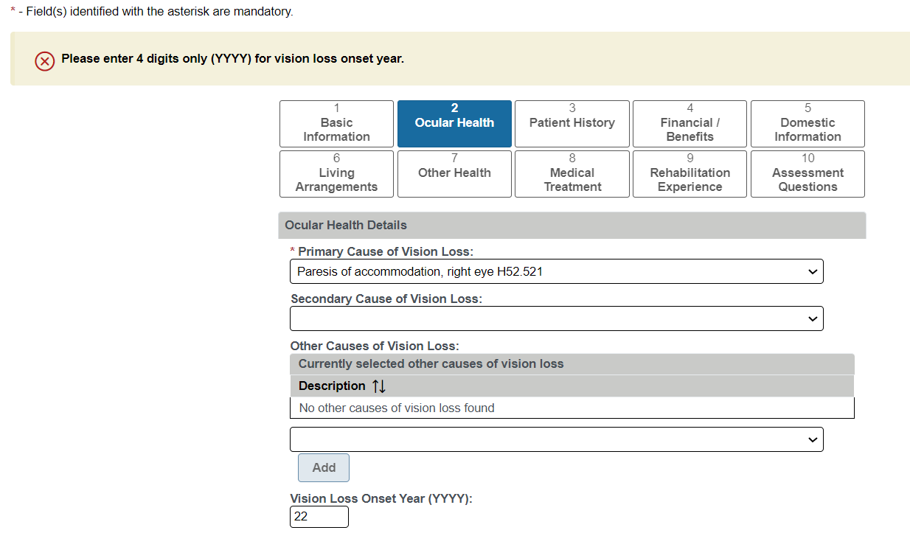
Figure 2: Date Format Error

Print VIST Roster Sorts
Users can now perform data-only exports for the reports in the Print VIST Roster Sorts menu.
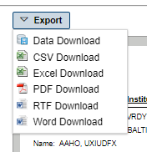
Figure 3: Data-Only Export
The data download will NOT include the cell headers as it does with the other exported formats. Therefore, the data download will include the same information whether the Accessible box is checked or not.
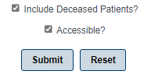
Figure 4: Options for Data-Only Export
Below are examples of column headers that may appear in an exported excel sheet when a user selects the “Include Deceased Patients?” and “Accessible?” options.
- TRUE = The box to include deceased patients is checked, but the patient for that row is not deceased
- FALSE = User did not check the box to include deceased patients
- Date = Date of death if you chose to include deceased patients

VIST Roster Summary Report Start Date
The default start date for the VIST Roster Summary report will be the first day of the current fiscal year.
Figure 5: Default Report Start Date

Edit Blind Patient Date Box
The Edit Blind Patient date box is now labeled “Enrollment Date (MM/DD/YYYY).”
Figure 6: Edit Blind Patient Date Box

VIST Annual Review Page
The VIST Annual Review Page has been corrected to show “VIST” in all caps.

Figure 7: VIST Annual Review Page

JAWS Supported Versions
The supported JAWS versions can be found at the following link: REDACTED
Figure 1 depicts the supported JAWS versions in a table format.
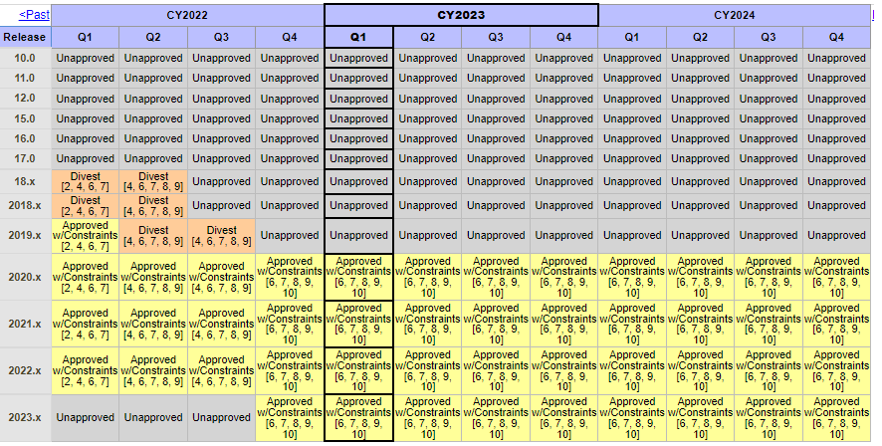
Figure 8: Supported JAWS Versions

