Blind Rehabilitation (BR) Release 5.1.6

Release Notes
February 2023
Document Version 1.0
Department of Veterans Affairs (VA)
Office of Information and Technology (OI&T)

Revision History
Date | Version | Description | Author
02/2023 | 1.0 | Initial Version | Booz Allen Hamilton

Table of Contents
1 Purpose 1
1.1 General Updates 1
1.1.1 Administration Page 1
1.1.2 BR Patient Enter/Edit 1
1.1.3 Create Referrals 3
1.1.4 Modify Referral (Search) 4
1.1.5 Referral Status Save is Read by JAWS 5
1.1.6 JAWS Supported Versions 5
1.1.7 JAWS 2020 Users Workarounds 6
1.1.8 VIST Annual Review 9
1.1.9 Benefits & Services Checklist 9
1.1.10 Letters and Labels 10
1.1.11 Print Individual Records 11
1.1.12 Print Reports 11
1.1.13 Workaround for Referrals Summary Report 11

List of Tables
Figure 1: BR Staff DUZ Code Field 1
Figure 2: Local VistA Site Search 2
Figure 3: Patient Already Selected Dialog 2
Figure 4: Basic Information with Error Messages 3
Figure 5: Enter New Referral for this Patient 4
Figure 6: Referral Types 4
Figure 7: Referrals Found Table 5
Figure 8: Change Referral Status 5
Figure 9: Supported JAWS Versions 6
Figure 10: Save and Continue Button for Registering New Patient 7
Figure 11: Edit Blind Patient Tabs 8
Figure 12: Edit Blind Patient Tabs Link List 8
Figure 13: Error Messages for Blank Required Fields 9
Figure 14: BR Patient Search 9
Figure 15:Enter Benefits and Services Checklist 10
Figure 16: Patient Mailing Labels – Select Patient Criteria 10
Figure 17: Mailing Label Table 10
Figure 18: Patient Mailing Labels – Current List 11
Figure 19: Individual Patient Record 11
Figure 20: Report Data Download 11
Figure 21: Modify Referrals 12
Figure 22: Referrals Found 12

Purpose
The Blind Rehabilitation (BR) team has made significant updates to the BR application. This document will summarize the updates made for release 5.1.6 and provide brief instructional text for specific updates.

General Updates
The System Administrator role has undergone an update which allows them to update a user’s DUZ code. The Patient Search functionality can now be utilized by entering the first initial of a patient’s last name as well as the last four digits of their social security number. When a column sort for Referrals Found is used, and the Edit button is selected, users will now see that patients will match against the data in their respective row. Users will also see that patient records for Additional Medical Treatment Information are displayed correctly. Patient mailing labels will now print correctly on Avery 3x10 label sheets. The VIST Annual Review date on an exported VIST Roster list will be displayed in the correct format. In addition to the forementioned updates, the following new referral types have been added to the application.
- BROS Poly Vision Therapy – 1st Experience
- BROS Poly Vision Therapy – Additional Training
- Vision Therapy – 1st Experience
- Vision Therapy – Additional Training
Changes have also been made for the JAWS screen reader. These improvements include updates towards conveying alert messages and page load completion and the addition of the Alt+K hotkey for the OK button.

Administration Page
System Administrators can now update a user’s DUZ code as depicted in Figure 1.
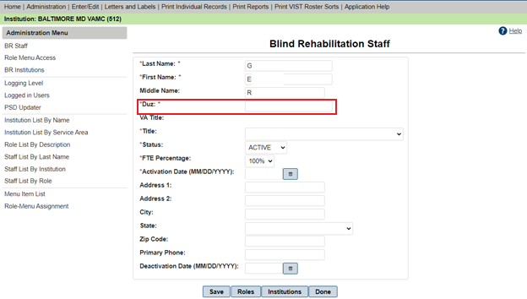
Figure 1: BR Staff DUZ Code Field

BR Patient Enter/Edit
The Patient Search field now has a bolder outline, allowing users to locate the field with more ease.
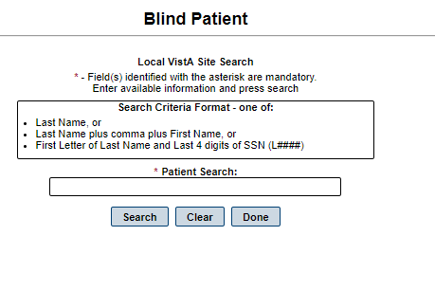
Figure 2: Local VistA Site Search
After searching and selecting a patient, the selected patient appears in the Patient Already Selected dialog. To view the selected patient, click OK. A JAWS user can now utilize the Alt+K hotkey to select the OK button.
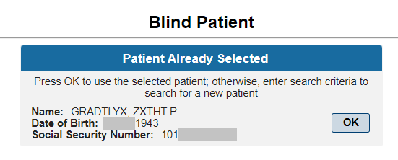
Figure 3: Patient Already Selected Dialog
When the user clicks the Save and Continue button and required fields are left blank, JAWS will read an alert message for every required field left blank as depicted in Figure 13.
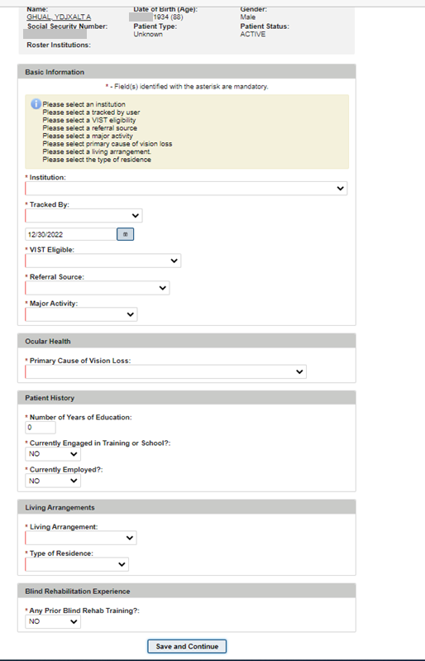
Figure 4: Basic Information with Error Messages

Create Referrals
New referral types are depicted in Figure 5.
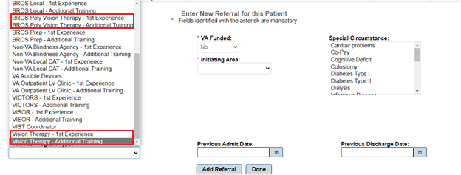
Figure 5: Enter New Referral for this Patient

Modify Referral (Search)
The Modify Referral (Search) reflects the new referral types added as depicted in Figure 6. The referral types will be alphabetized in a future patch.
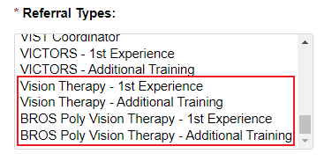
Figure 6: Referral Types
After the list of referrals found is displayed in a table, it is presented in descending order by Created Date. When clicking on the column headers to sort, the Edit button now correctly reflects the data for the row you wish to edit as depicted in Figure 7.
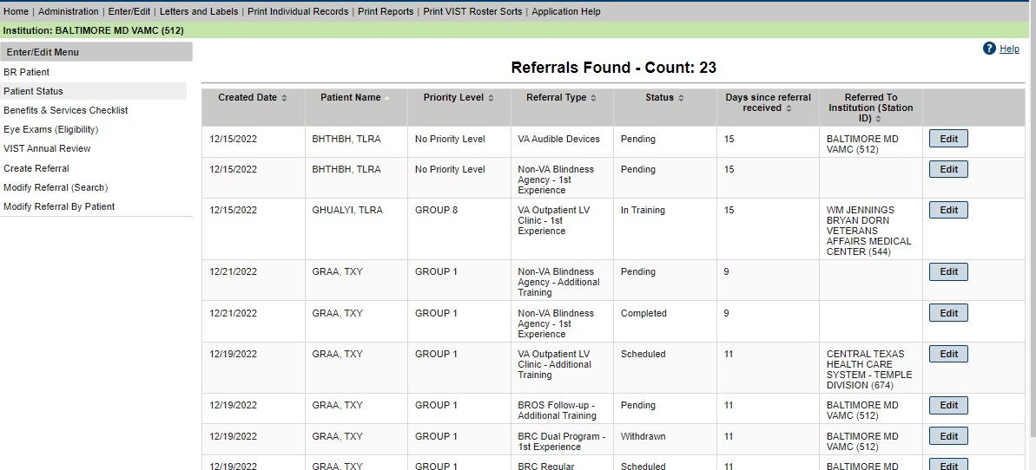
Figure 7: Referrals Found Table

Referral Status Save is Read by JAWS
Changes made to a referral status for the Modify Referral (Search) and Modify Referral By Patient functionalities will produce a message stating that the referral status was saved. This message is now read by JAWS.
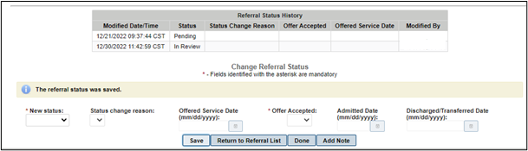
Figure 8: Change Referral Status

JAWS Supported Versions
REDACTED. Figure 9 depicts the supported JAWS versions in a table format.
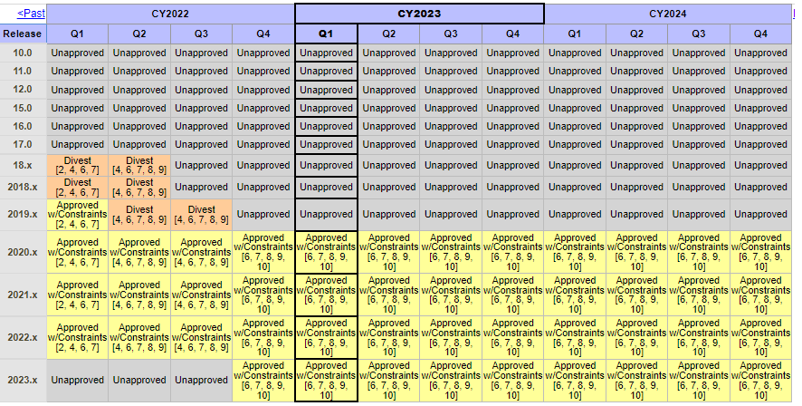
Figure 9: Supported JAWS Versions

JAWS 2020 Users Workarounds
When registering a new patient, JAWS will read error messages when pressing the Enter key on the Save and Continue button. JAWS will not read error messages when utilizing the Alt + S hotkey.
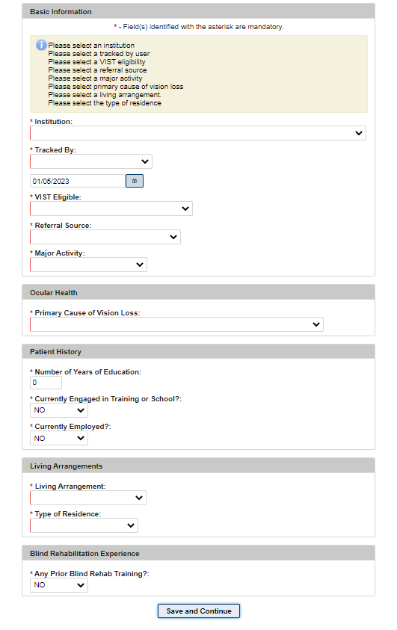
Figure 10: Save and Continue Button for Registering New Patient
Once a new patient has been registered, the Edit Blind Patient section will display boxes numbered 1-10 as depicted in Figure 11. JAWS will read these boxes as Tabs.
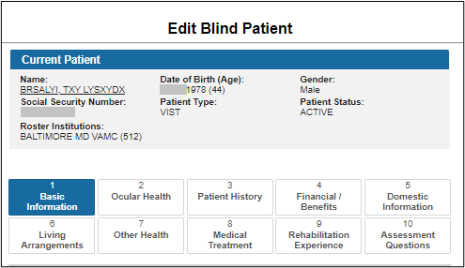
Figure 11: Edit Blind Patient Tabs
Users that have JAWS 2020 or later versions can use the Tab key to navigate through the 10 Edit Blind Patient tabs. The Space bar can be used to select an Edit Blind Patient tab.

Users that have JAWS 2021 or later versions can utilize the appropriate keystrokes to bring up the JAWS links list. JAWS will read the Edit Blind Patient tabs from the links list.

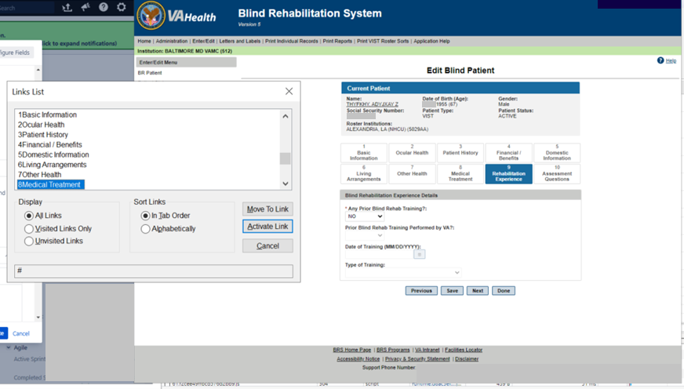
Figure 12: Edit Blind Patient Tabs Link List

VIST Annual Review
When required fields are left blank, JAWS will read an alert message for every required field left blank as depicted in Figure 13.
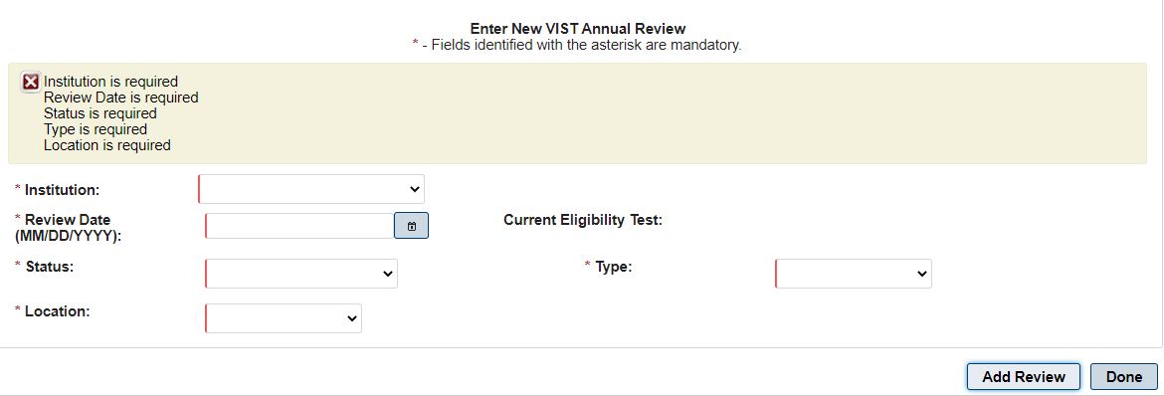
Figure 13: Error Messages for Blank Required Fields
A Patient Search can now be performed with the first initial of the patient’s last name and the last four digits of their social security number as depicted in Figure 14.
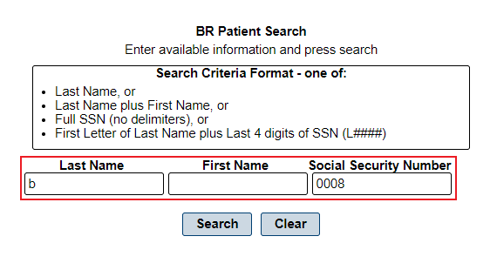
Figure 14: BR Patient Search

Benefits & Services Checklist
The alert message for a successful save for the Benefits and Services Checklist functionality is now announced by JAWS.
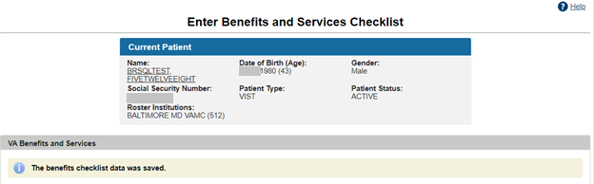
Figure 15:Enter Benefits and Services Checklist

Letters and Labels
- To create a current list, go to Print Patient Mailing Labels and select your desired institution. Click Submit.
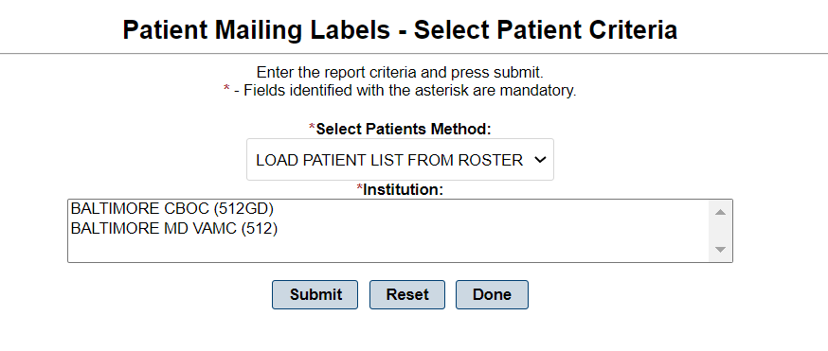
Figure 16: Patient Mailing Labels – Select Patient Criteria
- Click the corresponding Remove button for the labels you do not want as depicted in Figure 17. Once complete, click Continue.
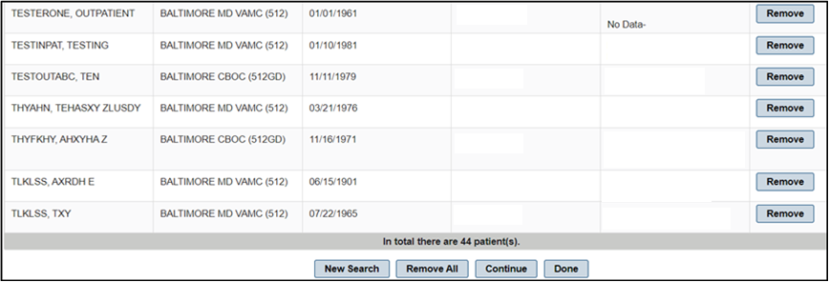
Figure 17: Mailing Label Table
- Go back to Print Patient Mailing Labels. The option to use the list you edited will be available in the Select Patients Method list as depicted in Figure 18.
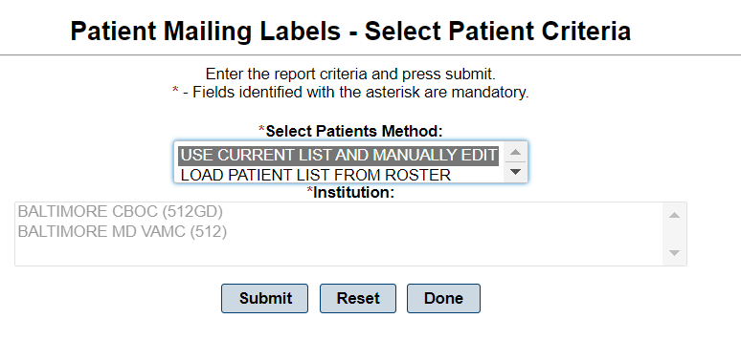
Figure 18: Patient Mailing Labels – Current List
NOTE: The list you created will not exist after you Logout.

The exported PDF file now prints a sheet of 3x10 labels.

Print Individual Records
The display for patient records was updated to remove the Last Medical Exam date.
REDACTED
Figure 19: Individual Patient Record

Print Reports
Exported reports now have the correct date format of MM/DD/YYYY as depicted in Figure 20.
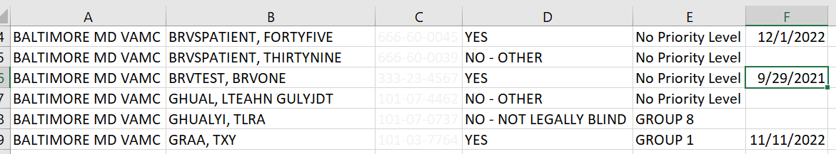
Figure 20: Report Data Download

Workaround for Referrals Summary Report
- Navigate to Enter/Edit then Modify Referral (Search).
- From the Select Institution search type list, select Referrals From your Institution.
- Select All from the Referred To Institutions list.
- Select the desired various referral types.
- Select the desired date range.
The example below shows the referrals to all institutions from 01/01/2022 to 12/30/2022 for BRC referral types, referred from Baltimore VAMC institutions, that were Admitted.
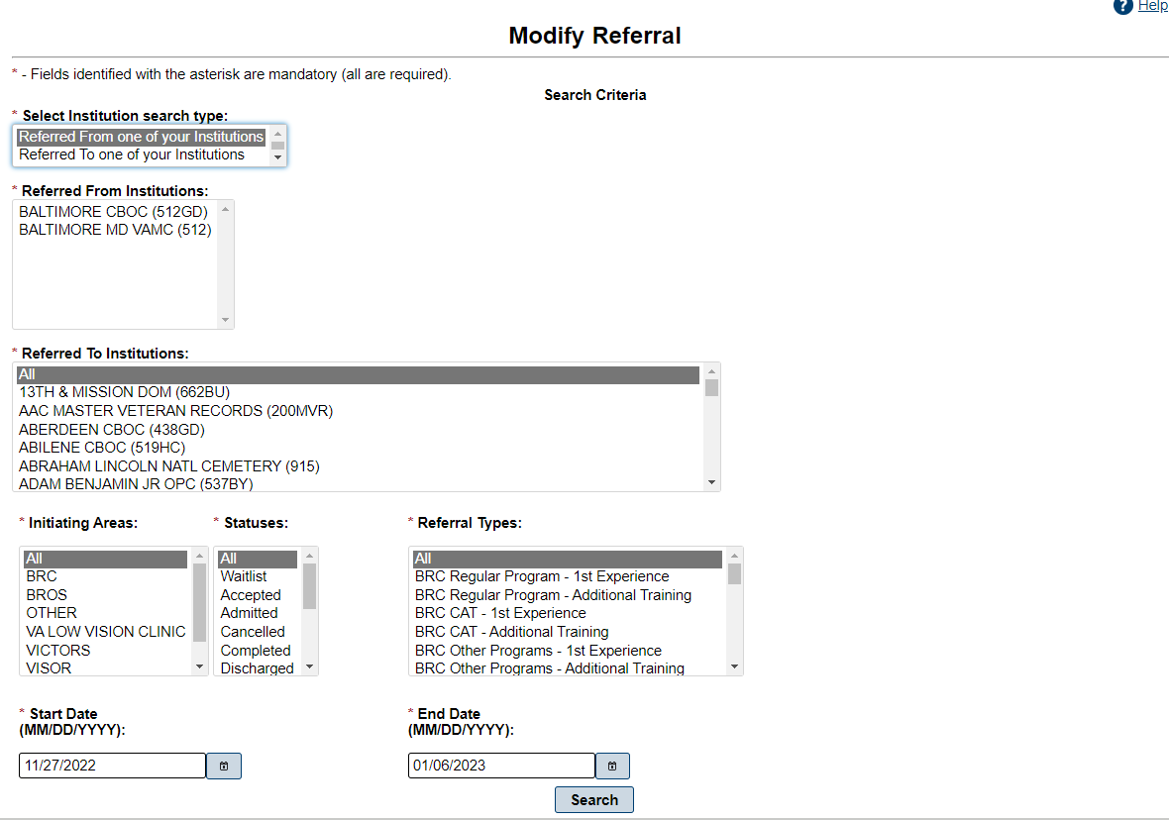
Figure 21: Modify Referrals
The search yielded 6 referrals of BRC type from Baltimore VMAC that were Admitted for 2022.
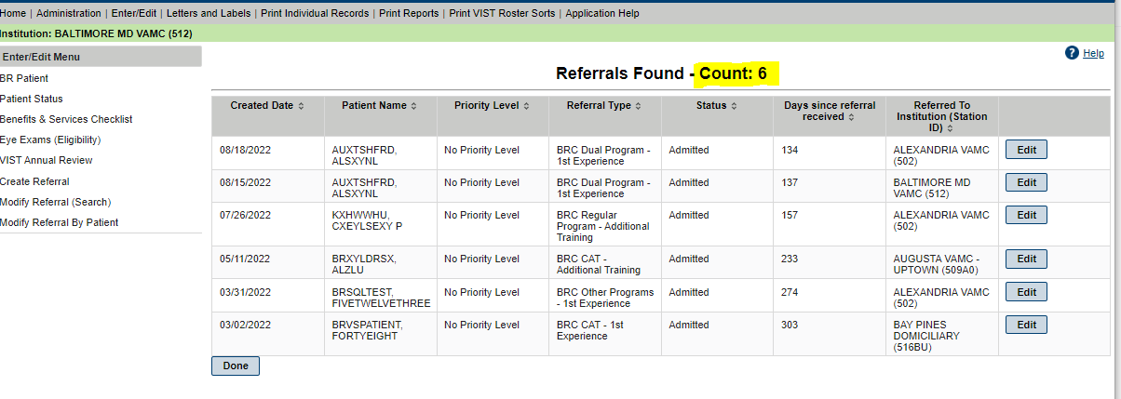
Figure 22: Referrals Found

