Blind Rehabilitation (ANRV)

User Manual
Version 5.1
September 1999 (Version 5.0 VA Release)
August 2022
Department of Veterans Affairs (VA)
Office of Information and Technology (OIT)

Revision History
When updates occur, the Title Page lists the new revised date and this page describes the changes. Bookmarks link the described content changes to its place within manual. There are no bookmarks for format updates. Page numbers change with each update; therefore, they are not included as a reference in the Revision History table.
Date | Version | Description | Author
08/2022 | 5.1 | Updated document to reflect changes feature changes:  The following are the new features and functions added to the BR 5.1 release.  - Two Factor authentication – logon using PIV pin  - A pagination feature was added for search results.  Added additional page information is for preliminary information with these sections:  - Basic Information  - Ocular Health  - Patient History  - Living Arrangements  - Blind Rehabilitation Experience  The following were removed from Administration tab submenu:  - TIU Document Definitions  - MPI Patient Registration  - Patient ICN Lookup  - Patients not registered with MPI  - Visual Acuity Discrepancy  The following submenu items were removed from enter/edit:  - Low Vision Patient  - Education Service Activities  - VARO Claims  - Annual Outcome Survey  - Pre/Post Blind Rehab Survey  - Modify Converted National Waitlist Record VIST Visits  - BRC Clinical Assessments  - Create Treatment Plan  - Modify Treatment Plan  - Enter Non-Treatment Plan Training  - Enter Treatment Plan or Training  The following submenus were removed from print individual records:  - Treatment Plan  - Training History  - Annual Outcome Survey  - Pre/Post Blind Rehab survey  The following submenus were removed from print reports:  - Low Vision Patients Report  - VARO Claim List  - Education & In Service Activities  - VIST Visits Date List  - BRC Pre-Admission By Priority Level  - BRC Workload Monthly Summary  - BRC Workload Monthly Summary By VISN  - BRC Workload Semi-Annual Summary  - BRC Workload Monthly Summary By VISN  - BROS Workload Summary  - BROS Workload Summary By VISN | Booz Allen Hamilton
08/2010 | 5.0.27.6 | Page 7:  • On the Login page the REFRESH button has  been removed. The new login page screen  shot is updated.  Page 24:  • Administrator Menu feature, BR Institutions  New feature is added to Edit BR Institution  page for display and validating against the  active users attached to that institution.  Page 44:  • At the Enter/Edit BR Patient: Basic  Information screen, the Tracked By field dropdown list modified to display the users  with the roles VIST Coordinator, BROS and  Low Vision.  Page 10 & 40:  • VIST Visits Menu item is added under the  Enter/Edit Menu options.  Page 291:  • Page numbers are updated for Index | Project Team
03/2007 | 5.0.26.8 | The following changes have occurred since the  5.0.26.8 version of this document:  Page 8:  • On the Home or Welcome page, under User  Notifications, New referrals and Deceased  Patients can now be viewed by clicking on  the link.  Page 25:  • New Administrator Menu feature, BR  Institutions, displays a list of the names of  existing Blind Rehabilitation Institutions, the  Service Area, and if the Institution's Active  status is set to 'Yes' or 'No.'  Page 28:  • New Administrator Menu feature, Logged In Users is used to display a list and count of all  users logged into the system  Page 29:  • New Administrator Menu feature, Patient  ICN Lookup is used to find a patient by  Identification Control Number (ICN)  Page 37:  • New Administrator Menu report, Menu-Item  List, provides a list of Menu Items  Page 38:  • New Administrator Menu report, Role-Menu  Assignment, provides a list of the available  menu items that have been assigned to each  role  Page 45:  • At the Enter/Edit BR Patient: Basic  Information screen, added the Tracked By  field, which is used to select the person who  is tracking this patient  Page 218:  • New Print Reports Menu report, added the  BRC Pre-Admission by Priority Level report  that provides a list of the requested Report  Fields including an edit link to access Modify  Referral and Note information.  Page 262:  • At the Waitlist Menu, added a BRC Current  Waiting List report that provides a list of  Referrals Waiting by Program Type and  Status.  Page 264:  • New Waitlist Menu report, added the BRC  Historical Waitlist report that provides a list  of Waiting Referrals and the number of  Waiting Referrals with or without details.  Page 266:  • New Waitlist Menu report, added the BRC  Historical Waitlist By VISN report that  provides a list of Waiting Referrals (by  VISN) and the number of Waiting Referrals. | Project Team
11/2006 | 5.0.27.6 | Updated document to V5.0.27.6 | Project Team
07/2006 | 5.0.27.6 | Revision 5 – Updated document to reflect current changes. | Project Team
03/2006 | 5.0.27.6 | Revision 5.x.x.x | Project Team
09/2005 | 5.0 | Updated document V5.0 to remove TIU document definitions.  Updated document V5.0 to reflect current features. | Project Team
08/2005 | 5.0 | Complete revisions. | Project Team
04/2005 | 4.0 | Start revisions from EVS review | Project Team
03/2005 | 4.0 | Draft | Project Team
01/2005 | 4.0 | Start 1.3 Revisions | Project Team
10/2004 | 4.0 | Start 1.2 Revisions | Project Team
07/2004 | 4.0 | V 1.2 – Changes based on V 0.1.11 of the  prototype. | Project Team
05/2004 | 4.0 | V 1.1 – Changes based on V 0.1.6 of the prototype.  V 1.0 – Final approved by SQA  V 0.5 – Revised content based on changes to v 0.1.5 | Project Team
04/2004 | 4.0 | Create Draft  Revised/added content  V 0.4 – Revised content based on SQA feedback.  Added Deceased Patient List Report | Project Team

Table of Contents
Introduction 1
1. Accessibility 2
1.1. Skip to Main Content Option 2
2. Orientation 3
2.1. Recommended Users 3
2.2. Related Manuals 3
2.3. Documentation Retrieval 3
2.4. Standards 3
3. Launching the Software Application 4
3.1. Logging In 4
3.2. Welcome Page 5
3.3. User Notification Page 5
3.4. Logging Out 6
4. Page Layout 7
4.1. Header Menu 7
4.1.1. Home Menu Option 7
4.1.2. Administrator Menu Option 7
4.1.3. Enter/Edit Menu Option 8
4.1.4. Letter and Label Menu Option 8
4.1.5. Print Individual Records Menu Option 8
4.1.6. Print Reports Menu Option 9
4.2. Task Menu 9
4.3. Content Area 9
4.4. Footer 10
4.5. Online Help 10
5. Administrator Menu 11
5.1. BR Staff 11
5.2. Role Menu Access 14
5.3. BR Institutions 15
5.4. Logging Level 16
5.5. Logged-In Users 17
5.6. PSD Updater 18
5.7. Administrator Reports 18
5.7.1. Institution List by Name 18
5.7.2. Institution List by Service Area 19
5.7.3. Role List by Description 20
5.7.4. Staff List by Last Name 21
5.7.5. Staff List by Institution 22
5.7.6. Staff List by Role 23
5.7.7. Menu Item List 24
5.7.8. Role-Menu Assignment 25
6. Entering/Editing Menu 27
6.1. Searching for and Selecting a Patient 27
6.1.1. HealtheVet-VistA Patient Search 27
6.2. Entering/Editing a BR Patient 29
6.2.1. Basic Information 29
6.2.1.1. Ocular Health 31
6.2.1.2. Patient History 33
6.2.2. Financial/Benefits 33
6.2.2.1. Domestic Information 34
6.2.2.2. Living Arrangements 34
6.2.2.3. Other Health 35
6.2.2.4. Medical Treatment 35
6.2.2.5. Blind Rehabilitation Experience 35
6.2.2.6. Assessment Questions 36
6.3. Entering/Editing a Low Vision Patient 37
6.4. Entering/Editing a Patient’s Status 38
6.4.1. Current Patient Status 39
6.4.2. Changing a Patient’s Status 39
6.5. Entering/Editing the Benefits & Services Checklist 40
6.5.1. VA Benefits and Services 41
6.5.2. Non-VA Benefits and Services 42
6.5.3. Local Benefits and Services 44
6.6. Entering/Editing Eye Exams (Eligibility) 44
6.6.1. Existing Eye Exams 45
6.6.2. Enter New Eye Exam 45
6.7. Entering/Editing the VIST Annual Review 46
6.7.1. Existing VIST Annual Reviews 48
6.7.2. Enter New VIST Annual Review 48
6.8. Modifying a Referral (Search) 49
6.9. Modifying a Referral By Patient 53
7. Letter and Labels Menu 57
7.1. Enter/Edit Letters 57
7.2. Print Letters 59
7.3. Print Patient Mailing Labels 60
8. Printing Individual Records Menu 61
8.1. Printing a Patient Record 61
8.2. Printing an Eye Exam (Eligibility) History 61
8.3. Printing a Benefits & Services Checklist 62
8.4. Printing a Referral History 62
8.5. Printing a PCE Problem List 63
9. Printing Reports Menu 64
9.1. Printing Additions to VIST Roster Report 64
9.2. Printing a Deceased Patients List Report 65
9.3. Printing an Inactive VIST Patient Roster Report 66
9.4. Printing a Referral Roster By From Institution 67
9.5. Printing a Referral Roster by To Institution 70
9.6. Printing a Referral Schedule Report 73
9.6.1. Printing a VIST Roster Summary 75
9.6.2. Printing a VIST Roster Summary By VISN 76
9.7. Print VIST Roster Sorts Menu 77
9.7.1. Sort By Residence State 77
9.7.2. Sort By County 78
9.7.3. Sort by City 78
9.7.4. Sort by Zip 79
9.7.5. Sort by Month of Birth 79
9.7.6. Sort by Age 79
9.7.7. Sort by Address/Phone 80
9.7.8. Sort by Primary Cause of Vision Loss 80
9.7.9. Sort by Period of Service 80
9.7.10. Sort by Referral Source 81
9.7.11. Sort by Eye Exam Notes 81
A. Internet Explorer Keyboard Shortcuts 82

List of Tables
Table 1: Document Retrieval Directories 3
Table 2: Keyboard Short Cuts – Viewing and Exploring the Web Pages 82
Table 3: Key Board Short Cuts – Using the Address Bar 83
Table 4: Key Board Short Cuts – Working with Favorites 83
Table 5: Key Board Short Cuts – Editing 83

List of Figures
Figure 1: BR 5.1 Login Screen 4
Figure 2: Welcome Page 5
Figure 3: Logout Screen 6
Figure 4: Administrator Menu Task Menu Options 11
Figure 5: BR Staff 12
Figure 6: Add/Remove Staff Roles 14
Figure 7: Edit Role 15
Figure 8: Edit Blind Rehabilitation Institution 16
Figure 9: Logging Level 17
Figure 10: Successful PSD Updater Screen 18
Figure 11: Institution List by Name Report 19
Figure 12: Institution List by Service Area Report 20
Figure 13: Role List by Description 21
Figure 14: Staff List by Last Name 22
Figure 15: Staff List by Institution 23
Figure 16: Staff List by Role 24
Figure 17: Menu Item List 25
Figure 18: Role-Menu Assignment 26
Figure 19: Patient Search Results 28
Figure 20: Edit Low Vision Patient 37
Figure 21: Patient Search Results 38
Figure 22: Patient Status Change 39
Figure 23: Benefits and Services Options Screen 41
Figure 24: Patient Search Results 47
Figure 25: VITS Annual Review Screen 48
Figure 26: Letters and Labels Menu Task Menu Options Screen Capture 57
Figure 27: Additions to VIST Roster Report 64
Figure 28: VIST Roster Report Print selection 65
Figure 29: Inactive VIST Patient Roster Report 66
Figure 30: Referral Roster by From Institution Report 67
Figure 31: Referral Roster List by to Institution Report 70
Figure 32: Referral Schedule Report 74
Figure 33: VIST Roster Criteria 75
Figure 34: VIST Roster Summary by VISN 76

Introduction
The Blind Rehabilitation Version 5.1 application (BR 5.1) provides enhanced tracking, and reporting, of the BR services provided to Veterans by:
- Visual Impairment Service Teams (VIST) Coordinators
- Blind Rehabilitation Centers (BRCs)
- Blind Rehabilitation Outpatient Specialists (BROS)
- Visual Impairment Services Outpatient Rehabilitation (VISOR) Programs
- Advanced Low Vision Clinic (ALVC) programs (referred to as Visual Impairment Center to Optimize Remaining Sight (VICTORS)
- Intermediate Low Vision Clinic (ILVC) programs (referred to as VA Outpatient LV Clinics)

Intermediate Low Vision Clinic (ILVC) programs (referred to as VA Outpatient LV Clinics) The Blind and Visual Impairment Continuum of Care application provides enhanced tracking, and reporting, of the blind rehabilitation services provided to veterans. Features include Electronic referral process to track patient applications for service, notifications feature to alert users of pending referrals, encounters/progress notes will be automatically created, nationwide centralization of BRVS services data to allow nationwide reporting, ad-hoc reporting capabilities, allows the ability to track BRVS patient care access across institutions, and patients can be referred or transferred to other institutions if they move without having to recreate patient data. The VistA namespace is ANRV.
NOTE: This user manual contains all options for the Blind Rehabilitation web application. Each individual user will see only the options for which he/she has permissions.

Accessibility
BR 5.1 is an accessible web-based application, via a web browser.

Skip to Main Content Option
The Skip to main content option automatically places the cursor into the Content Area to allow screen readers to avoid reading all Header and Task Menu option links. This enables the screen reader to begin reading the first line of content on the page.

Orientation

Recommended Users
The intended audience for BR 5.1 includes:
- Office of Information and Technology/Development, Security, and Operations
- Local Coordinators
- Visual Impairment Service Team (VIST) Coordinators
- Blind Rehabilitation Outpatient Specialist (BROS)
- Blind Rehabilitation Center Staff (BRC)

Related Manuals
- Blind Rehabilitation V. 5.1 Installation/Implementation Guide
- Blind Rehabilitation V. 5.1 Release Notes
- Online Help is available from within the application

Documentation Retrieval
BR documentation can be found on the VA Software Documentation Library (VDL) at: https://www.va.gov/vdl.
Table 1: Document Retrieval Directories
File Name | Description | Retrieval Format
ANRV_5_1_1_CIG.PDF | * Blind Rehabilitation Centralized Server Installation/Implementation Guide | Binary
ANRV_5_1_1_DIBRG.PDF | ** Blind Rehabilitation Deployment,Installation, Back-out and Rollback Guide | Binary
ANRV_5_1_1_RN.PDF | Blind Rehabilitation Release Notes | Binary
ANRV_5_1_1_UM.PDF | Blind Rehabilitation User Manual | Binary
* This Installation Guide is only for Centralized Servers, not to be used at the field VistA site.
** This Installation/Implementation Guide is for field VistA sites.

Standards
Keyboard key names appear in bold type exactly as they appear on a standard keyboard and are enclosed in brackets. For example, the enter key appears as <Enter>.

Launching the Software Application
To launch BR 5.1 web application, click the following URL:
https://vaww.blindrehab.va.gov/
NOTE: You can also add the BR Application web site (URL) to your Favorites list in your Internet Web Browser or create a shortcut on your desktop.
To create a shortcut:
- Right click on your desktop
- Select New then select Shortcut
- Follow the instructions that display in the Create Shortcut dialog box.

Logging In
When you launch BR 5.1, the Login screen displays:
Figure 1: BR 5.1 Login Screen
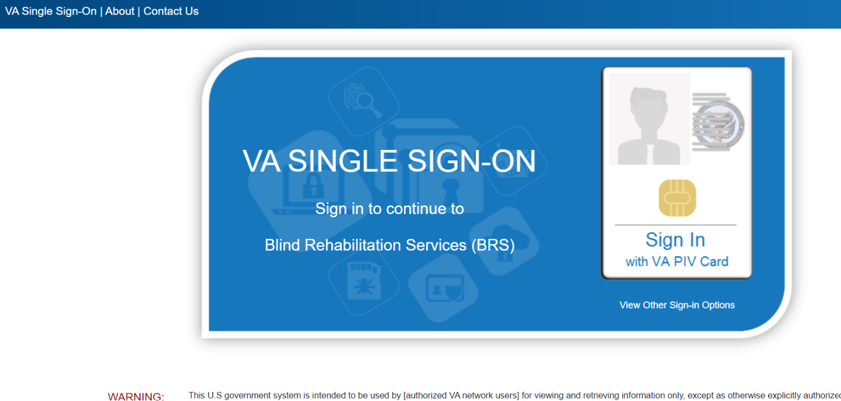
- Click the single sign-on icon.
- Select your authentication Certificate and enter PIN when prompted.
- Not all users will have multiple institutions and will default to their respective institution. If there is a dropdown, Select the institution desired from the drop-down list:
- Click Login to display the Welcome Page.
Figure 2: Welcome Page
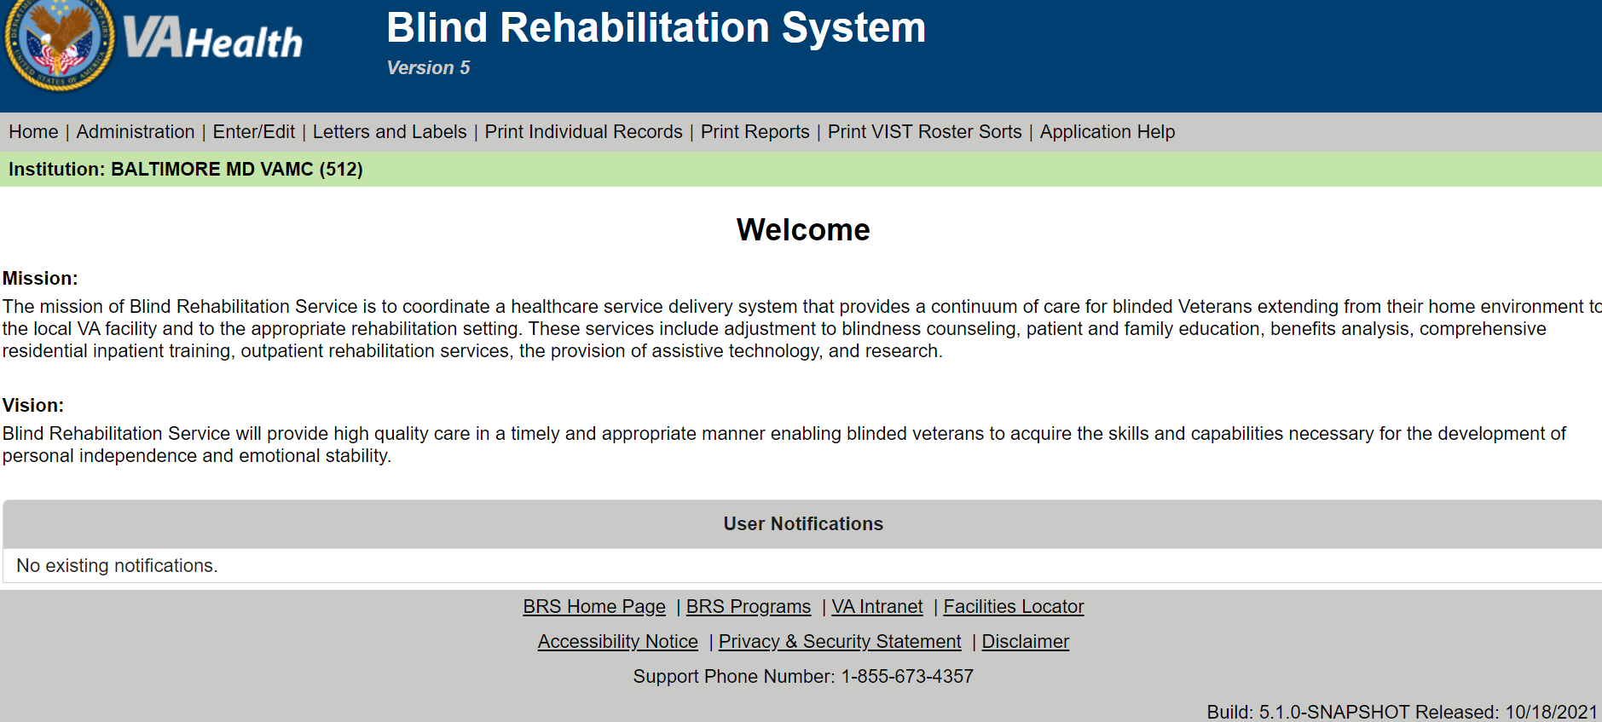

Welcome Page
The Welcome Page is the Home Page and may be referred to as such throughout the Online Help menu and BR System. It is the first page a user will see after logging in. This page contains the Mission and Vision statements and a User Notification section.
If there are New Referrals and/or Deceased Patients a link will display under the User Notification section. Click on either of these links to view information for New Referrals and/or Deceased patients.

User Notification Page
Use this page to view and manage notifications sent to you. After viewing the notification, click the Done button to return to the home page or click the Delete button to remove this notification from your list. Notifications will remain in your list until you delete them.

Logging Out
Click the logout option at the top right corner of the screen to logout of the current user. The Blind Rehabilitation logout screen will appear.
Figure 3: Logout Screen
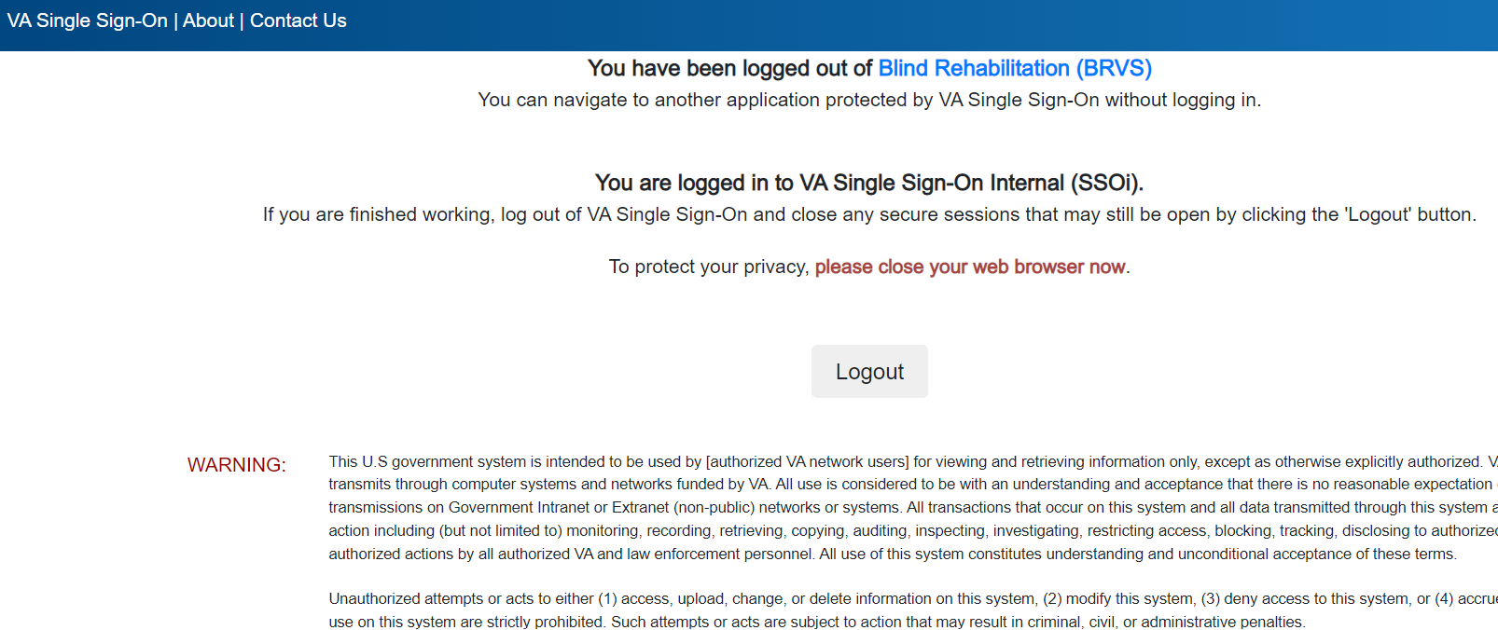

Page Layout
The BR pages are divided into four major sections:
- Header Menu - The horizontal area at the top of the page that displays links to other pages and menus. These links will remain consistent while navigating the BR application.
- Task Menu - The vertical list of links located on the left side of the page. These links are content specific to the Header Menu links.
- Content Area - The area to the right of the Task Menu and below the Header Menu that comprises the center of the page.
- Footer - The area at the bottom on the page, it provides additional links to other related Web sites.

Header Menu
The Header Menu assists you in navigating the BR application by displaying a different set of Task Menu options based on the selected Header Menu option. The options that display on your page will depend on the administrative permissions that have been assigned to you.

Home Menu Option
The Home menu option returns you to the BR Welcome page.

Administrator Menu Option
NOTE: System Administration is performed at the Centralized level. The Menu options in the Administrator Menu are not performed at the local facility. Only Central Administrators will have access to the Administrator Menu Options.
The Administrator Menu option displays the Task Menu options that are available to users assigned the Administrator permissions. The options that display in the Task Menu include:
- BR Staff
- Role Menu Access
- BR Institutions
- Logging Level
- Logged in Users
- PSD Updater
- Institution List by Name
- Institution List by Service Area
- Role List by Description
- Staff List by Last Name
- Staff List by Institution
- Staff List by Role
- Menu Item List
- Role-Menu Assignment

Enter/Edit Menu Option
WARNING: Do not use the Browser Back button in the Enter/Edit functions of the application. This will cause an error and previously entered information will be lost.
The Enter/Edit Options Menu is the default Task Menu. It displays the Task Menu options that are associated with entering and editing patient information. The options that display in the Task Menu include:
- Entering/Editing a BR Patient
- Entering/Editing a Patient’s Status
- Entering/Editing the Benefits & Services Checklist
- Entering/Editing Eye Exams (Eligibility)
- Entering/Editing the VIST Annual Review
- Creating a Referral
- Modifying a Referral (Search)
- Modifying a Referral by Patient

Letter and Label Menu Option
The options that display in the Task Menu include:
- Entering/Editing Letters
- Print Letters
- Print Patient Mailing Labels

Print Individual Records Menu Option
The Print Individual Records Menu option displays the following Task Menu options:
- Patient Record
- Eye Exam (Eligibility) History
- VIST Annual Review History
- Benefits & Services Checklist
- Referral History
- PCE Problem List

Print Reports Menu Option
The Print Reports Menu option displays the following Task Menu options:
- Additions to VIST Roster
- Deceased Patients List
- Inactive VIST Patient Roster
- Referral Roster by From Institution
- Referral Roster by To Institution
- Referral Schedule Report
- VIST Roster List
- VIST Roster Summary
- VIST Roster Summary By VISN

Task Menu
The Task Menu displays vertically along the left margin of the page. Task Menu options display as links to a specific task (or screen). The specific Task Menu options that display, and from which you can select, is controlled by the selected Header Menu.
When you click an option in the Task Menu, except for the Help option, the Content Area will display the page that you will use to perform the selected task.
NOTE: The Help Task Menu option does not affect the Content Area, because the Online Help launches in a secondary browser.

Content Area
The Content Area displays to the right of the Task Menu and under the Header Menu. This area is the primary interface through which you can enter, and view data related to the task that you select from the Task Menu.
NOTE: The Help Task Menu option does not affect the Content Area, because the Online Help launches in a secondary browser.

Footer
The Footer displays horizontally at the bottom of every page and provides a standard set of links to related Web sites.

Online Help
Access Online Help from the Task Menu or from the Help link displayed in the Content Area on some pages.
When you access Online Help from the Task Menu, it will open to the Introduction Help topic from which you can find the topic you want using the Contents, Index, or Search features.
When you access Online Help from the link in the Content Area of a page, it automatically opens to the Help topic associated with the current page.

Administrator Menu
The Administrator Menu option displays the Task Menu options that are available to users with Administrator permissions.
Figure 4: Administrator Menu Task Menu Options
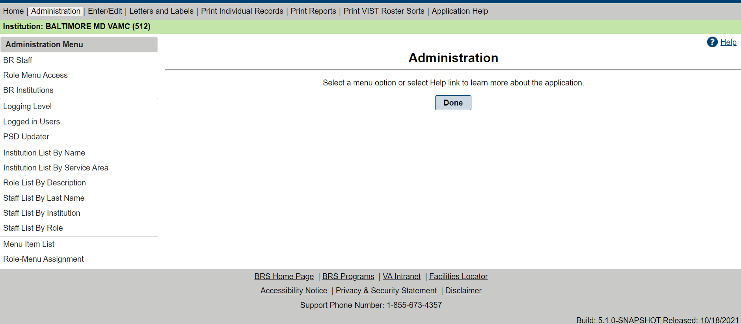
NOTE: System Administration is performed at the Centralized level. The menu options in the Administrator Menu are not performed at the local facility. Only Central Administrators will have access to the Administrator Menu Options.

BR Staff
The BR system allows users with the applicable permissions (such as VIST supervisors and/or IRMs) to enter and edit BR Staff. This information is used to track usage and control access to the BR application.
NOTE: An entry must be present in the New Person file (#200) and/or the USR Class Membership file (#8930.3) before the staff members’ information can be entered in the BR system.
- From the Header Menu, select the Administrator Menu option. From the Task Menu, select the BR Staff link. This will display the Staff Search screen in the content area.
NOTE: The Administrator Menu option will display only if the Administrator Security key is assigned to the user.
Figure 5: BR Staff
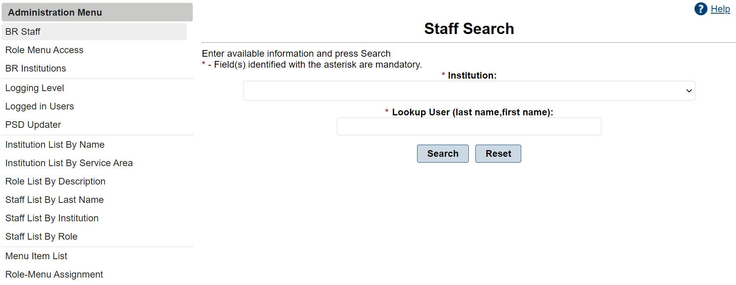
- Select the correct institution from the drop-down list of Institutions. In the Lookup User (last name, first name) field enter at least the first three letters of the staff member’s last name. To narrow the search, type the last name and/or all or part of the first name in the field, and then select the Submit button. The search will return all staff members (display alphabetically by last name) whose names match the information entered. A message displays if no record is found. Select Reset to clear fields.
NOTE: Partial entries must include at least the first three letters of the user’s last name. If less than three letters are used an error message will appear, “Please enter a name of at least 3 characters.”
- Select the Get User button to select the user you want to enter/edit. The staff's details will be displayed.
The selected user’s last name and first name will be pre-populated in the fields provided along with any other previously entered information. If the selected user is already entered in the BR system, you can display any roles and institutions currently assigned to the user by selecting the Roles and Institutions buttons respectively.
- Select the user’s title from the Title drop-down list. Examples include:
- ADMINISTRATIVE
- BLIND REHAB INSTRUCTORS
- CONSULTANT
- IRM SUPPORT USER
- LPN
- MEDICAL SUPPORT ASST.
- NURSING ASSISTANTS
- OCCUPATIONAL THERAPIST
- OPTOMETRIST
- PHYSICIAN
- PHYSICIAN ASST.
- PROGRAM SUPPORT ASST.
- PSYCHOLOGIST
- RECREATION THERAPIST
- REGISTERED NURSES
- RESEARCH
- SECRETARY
- SOCIAL WORKER
- SYSTEM ADMINISTRATOR
- THERAPY ASST.
- TRAINING SPECIALIST
- Use the drop-down list provided to indicate whether the user is active or inactive.
- Select the user’s FTE Percentage from the drop-down list provided. The following selections are available:
- 100%
- 88%
- 75%
- 50%
- 33%
- 25%
- 0%
- Type, or select from the pop-up calendar, the user’s Activation date.
- Type the user’s Address, City, State, Zip Code, and Primary Phone number in the fields provided.
- Type, or select from the pop-up calendar, the user’s Deactivation Date.
- To assign a role to the user, select the Roles button to display the Staff Roles screen.
Select a role to assign to this user. Select multiple roles by holding the Ctrl key when making the selections. When selection is completed, select the Add Selected Roles button below the Available Roles section. The assigned roles display in the Assigned Roles section. To remove an assigned role, first select, and then select the Remove Selected Roles button below the Assigned Roles section. Select Save to save updates and return to the staff's data. Select Done to return to the Welcome Page.
Figure 6: Add/Remove Staff Roles
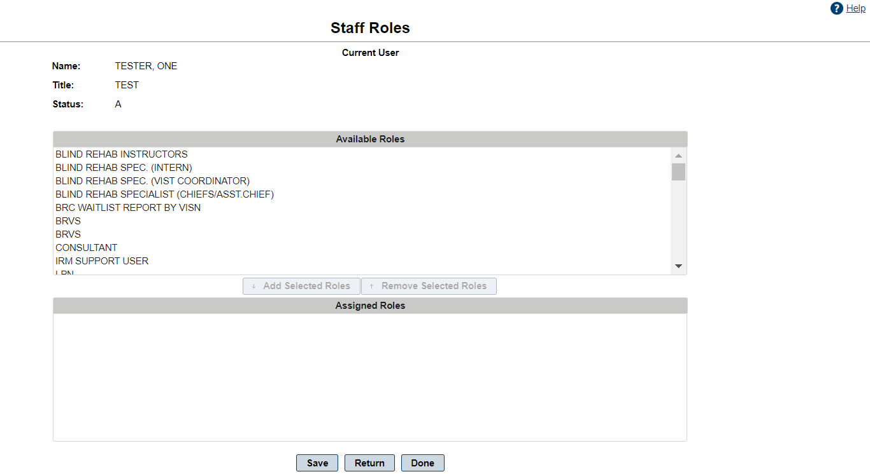
- To assign an institution to the user, select the Institution button to display the Staff Institutions and Service Areas screen:
Select the institution you want to assign to this user. Select multiple institutions by holding the Ctrl key when you make the selections. When selection is completed, select the Add Selected Institutions button below the Available Institutions – Service Area section. The assigned institutions display in the Assigned Institutions – Service Area section. To remove an assigned institution, first select, and then select the Remove Selected Institutions button below the Assigned Institutions – Service Area section. Select Save to save updates and return to the staff's data. Select Done to return to the Welcome Page.
- Select the Save button to save changes.
Information regarding the date when and by whom the user’s record was created and/or modified will be displayed in the Staff Record Create and Last Modification Information section.
- Select Done to return to the Welcome Page.

Role Menu Access
Use the Role Menu Access to assign BR menu items to the different Roles.
- From the Header Menu, select the Administrator Menu option. From the Task Menu, select the Role Menu Access link. This will display the Existing Roles screen in the content area.
NOTE: The Administrator Menu option will display only if the Administrator Security key is assigned to the user.
- To assign or modify the menu items assigned to a specific role, select the Edit button next to the role. This displays the Edit Role screen.
From the Available Menu Items list select the items to be added to the role. Select multiple menu items by pressing and holding down the Ctrl key when you make the selections. When selection is complete, select the Add Selected Menu Items button below the Available Menu Items section. The assigned menu items list in the Assigned Menu Items section. To remove an assigned menu item, first select, and then select the Remove Selected Menu Items button below the Assigned Menu Items section.
Figure 7: Edit Role
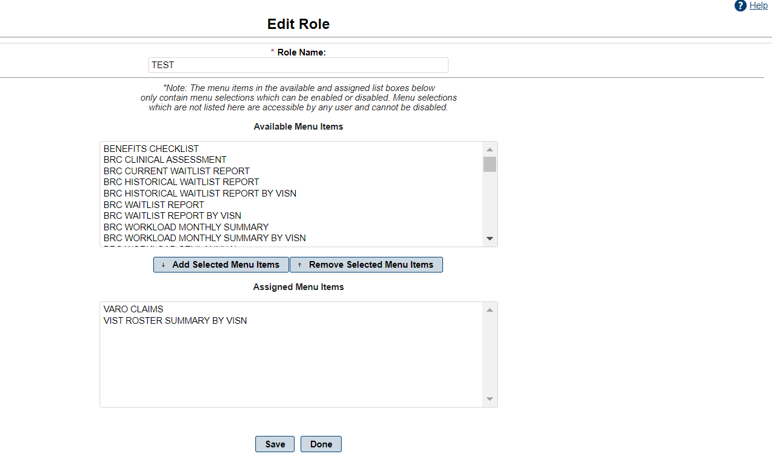
- Select the Save button to save your changes.
- Select Done to return to the Welcome Page.

BR Institutions
This feature displays a list of the existing BR Institutions. Providing the Service Area, Active Status, and Total Number of Active Users
- From the Header Menu, select the Administrator Menu option. From the Task Menu, select the BR Institutions link. This will display the Existing Institutions in the content area.
NOTE: The Administrator Menu option will display only if the Administrator Security key is assigned to the user.
- To change the Active Status, select the Edit button. This displays the Edit Blind Rehabilitation Institution. Under Active Status, select the drop-down arrow and choose yes or no. Select Yes for indicating active or No for indicating inactive.
Figure 8: Edit Blind Rehabilitation Institution
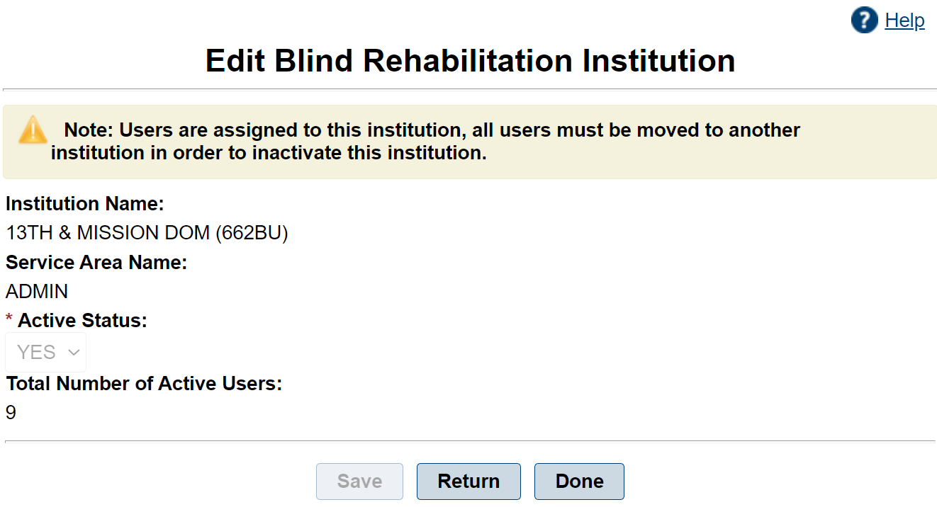
- Select the Save to save your changes.
- Select Return to return to the Existing Institutions page
- Select Done to return to the Welcome Page.

Logging Level
The BR application generates logging events while it runs. These can indicate error conditions, informational messages, or to debug helper output.
- From the Header Menu, select the Administrator Menu option.
NOTE: The Administrator Menu option will display only if the Administrator Security key is assigned to you.
- From the Task Menu, select Logging Level to display the list of Available logging levels in the Content Area.
- To change the Logging Level, select the new level, and then select the Set Logging Level button. The current level will be selected.
Figure 9: Logging Level
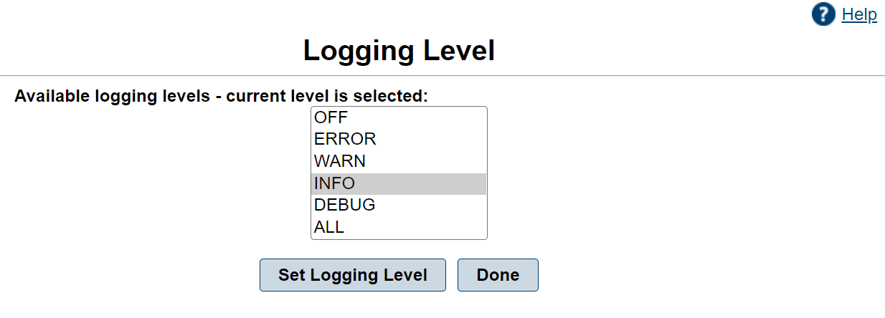
A logging event can be one of the following levels:
- OFF
- ERROR
- WARN
- INFO - (Normal Mode)
- DEBUG
- ALL
Although events of all types are being generated as the application runs, the logging level admin screen determines which level of events is saved into the log file.
- The OFF setting turns off all log events.
- If set to ERROR, only error events are saved.
- If set to WARN, warn and error events are saved.
- If set to INFO, info, warn and error events are saved.
- If set to DEBUG, debug, info, warn and error events are saved.
- The ALL setting is the same as debug for the current time.
DEBUG is a very verbose mode and should only be used to troubleshoot support issues, as it slows down the application. The normal mode in which to run should be INFO.
- Select the Done button to return to the Welcome Page

Logged-In Users
Use this function to display a list and count of all users logged into the system. This functionality also allows the System Administrator to forcibly log a user out.
- From the Header Menu, select the Administrator Menu option.
NOTE: The Administrator Menu option will display only if the Administrator Security key is assigned to you.
- From the Task Menu, select Logged in Users to display the list of and the number of Logged in Users in the Content Area.
- Select the Logout button next to a user to log the user out of the system.
- Select Done to return to the Welcome Page.

PSD Updater
The PSD Updater manually runs the Person Service Demographics (PSD) update for all BR patients. It is used for troubleshooting the overnight PSD update process.
- From the Header Menu, select the Administrator Menu option.
NOTE: The Administrator Menu option will display only if the Administrator Security key is assigned to you.
- From the Task Menu, select PSD Updater to display PSD Updater Management in the Content Area.
- Select Run PSD Updater to start the PSD update process.
- Select Done to return to the Welcome Page.
Figure 10: Successful PSD Updater Screen
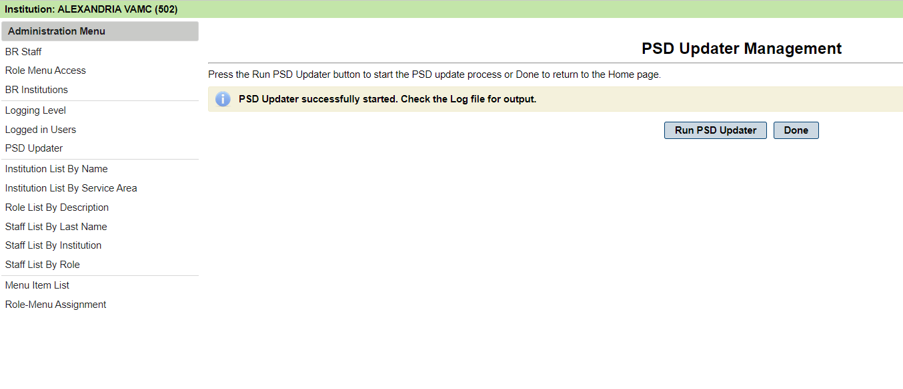

Administrator Reports

Institution List by Name
The Institution List by Name report provides a list of Institutions in alphabetical order by name.
This report contains:
- Institution Name
- Station Number
- City
- State
- VISN
- Report Printed Date
- From the Header Menu, select the Administrator Menu option.
- NOTE: The Administrator Menu option will display only if the Administrator Security key is assigned to you.
- From the Task Menu, select the Institution List by Name link to display the Institution List by Name Report screen in the Content Area.
- Select the Export button and choose the download type (CSV, Excel, PDF, RTF, or Word).
Figure 11: Institution List by Name Report
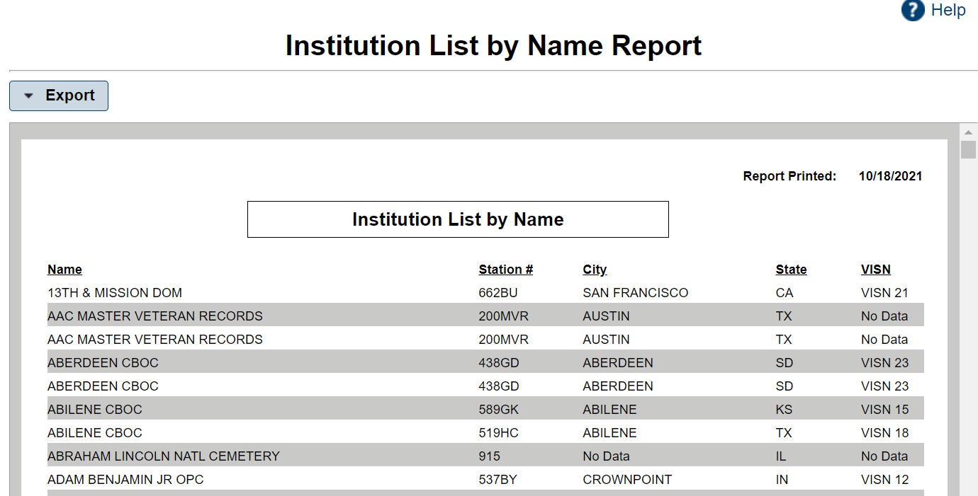

Institution List by Service Area
The Institution List by Service Area report provides a list of Institutions in alphabetical order by Service Area then by Institution Name.
This report contains:
- Institution Name
- Station Number
- City
- State
- VISN
- Total of the Service Area
- Report Printed Date
- From the Header Menu, select the Administrator Menu option.
NOTE: The Administrator Menu option will display only if the Administrator Security key is assigned to you.
- From the Task Menu, select the Institution List by Service Area link to display the Institution List By Service Area Report screen in the Content Area.
- Select the Export button and choose the download type (CSV, Excel, PDF, RTF, or Word).
Figure 12: Institution List by Service Area Report
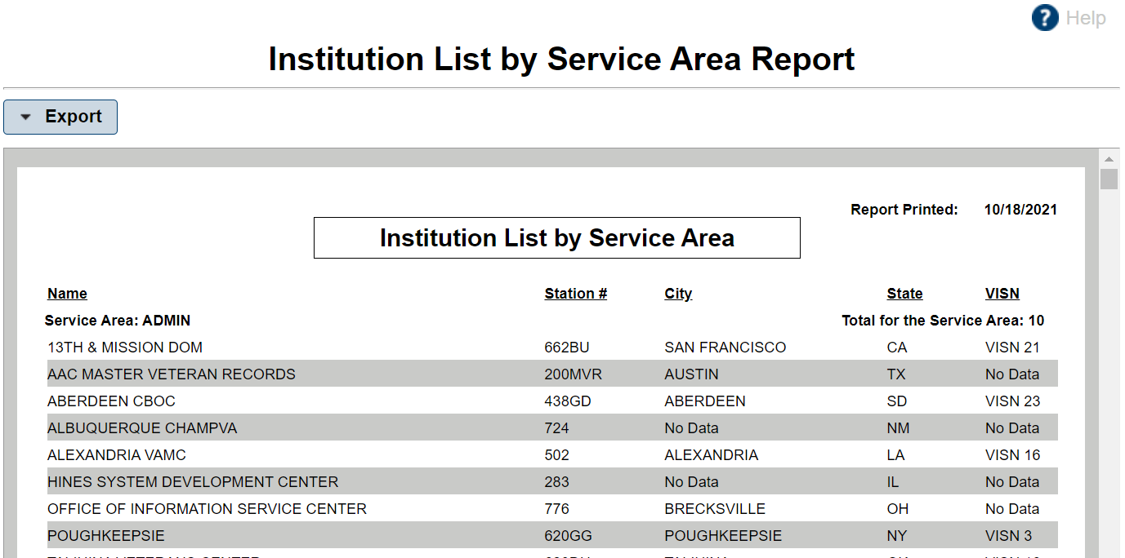

Role List by Description
The Role List by Description report provides a list of Roles in alphabetical order by Description.
This report contains:
- Role Description
- Role Code
- Status
- Report Printed Date
- From the Header Menu, click the Administrator Menu option.
NOTE: The Administrator Menu option will display only if the Administrator Security key is assigned to you.
- From the Task Menu, click the Role List by Description link to display the Role List by Description Report screen in the Content Area.
- Select the Export button and choose the download type (CSV, Excel, PDF, RTF, or Word).
Figure 13: Role List by Description
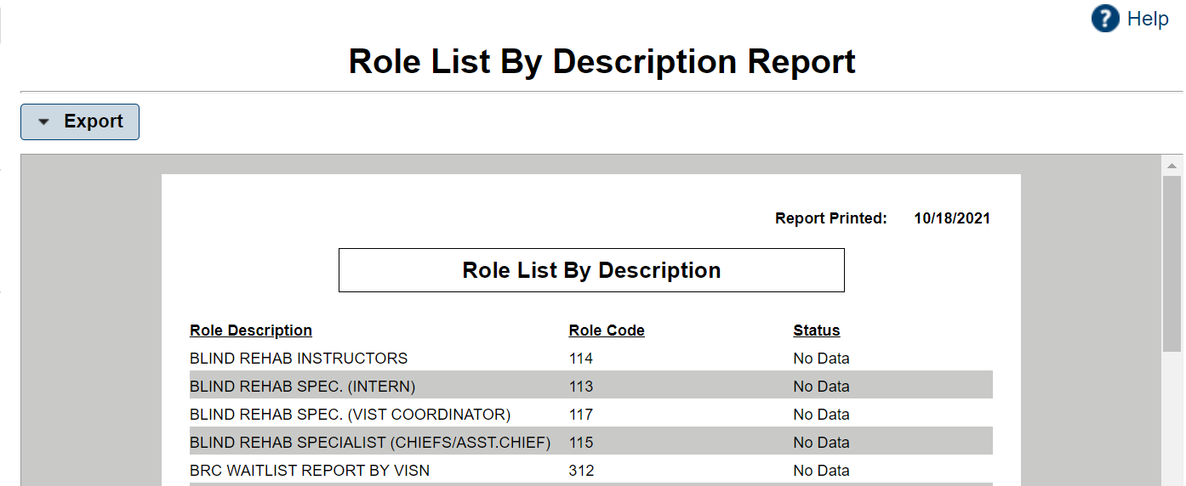

Staff List by Last Name
The Staff List by Last Name report provides a list of Staff members in alphabetical order by last name.
This Report Contains the Staff's:
- Last Name
- First Name
- Title
- Status
- Activation Date
- Deactivation Date
- City
- State
- Report Printed Date
- From the Header Menu, click the Administrator Menu option.
NOTE: The Administrator Menu option will display only if the Administrator Security key is assigned to you.
- From the Task Menu, click the Staff List by Last Name link to display the Staff List by Last Name - Report Criteria screen in the Content Area.
- Select the Export button and choose the download type (CSV, Excel, PDF, RTF, or Word).
Figure 14: Staff List by Last Name
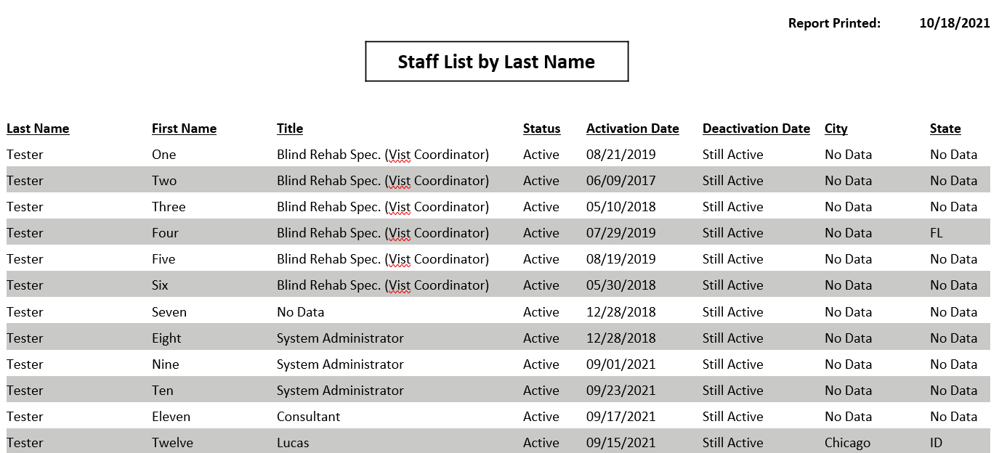

Staff List by Institution
The Staff List by Institution report provides a list of staff members for each institution. List alphabetical first by Institution and then by last name.
This report contains:
- Last Name
- First Name
- Title
- Status
- Activation Date
- Deactivation Date
- City
- State
- Institution Name
- Report Printed Date
- From the Header Menu, click the Administrator Menu option.
NOTE: The Administrator Menu option will display only if the Administrator Security key is assigned to you.
- From the Task Menu, click the Staff List by Institution link to display the Staff List by Institution Report screen in the Content Area.
- Select the Export button and choose the download type (CSV, Excel, PDF, RTF, or Word).
Figure 15: Staff List by Institution
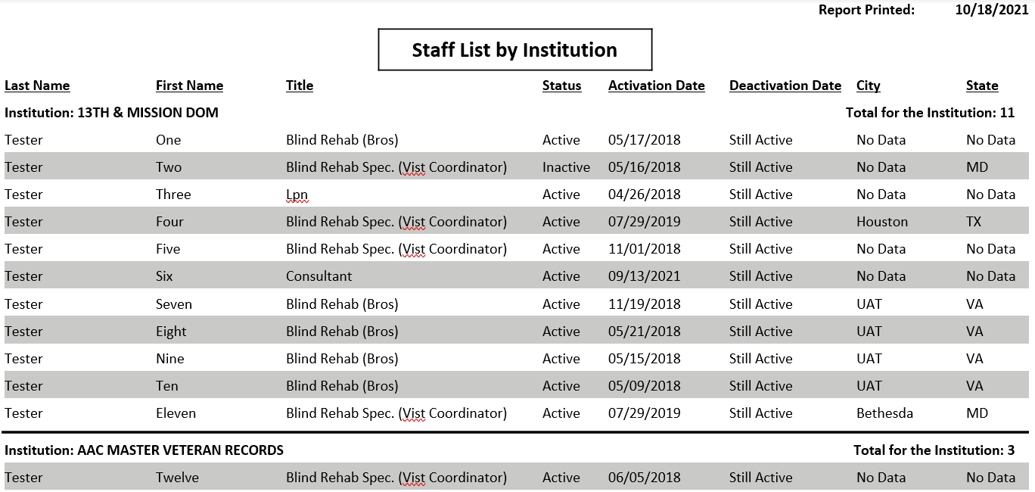

Staff List by Role
The Staff List by Role report provides a list of staff members in alphabetical order first by Role and then by last name.
This report contains:
- Last Name
- First Name
- Title
- Status
- Activation Date
- Deactivation Date
- City
- State
- Role
- Report Printed Date
- From the Header Menu, click the Administrator Menu option.
NOTE: The Administrator Menu option will display only if the Administrator Security key is assigned to you.
- From the Task Menu, click the Staff List by Role link to display the Staff List by Role Report screen in the Content Area.
- Select the Export button and choose the download type (CSV, Excel, PDF, RTF, or Word).
Figure 16: Staff List by Role
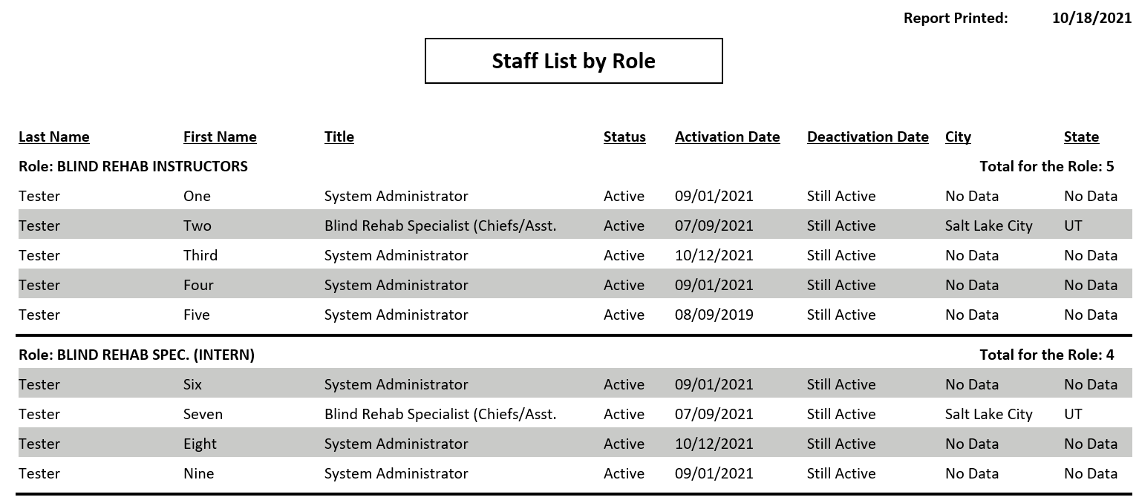

Menu Item List
The Menu Item List report provides a list of Menu Items in alphabetical order by Description.
This report contains:
- Description
- Report Printed Date
- From the Header Menu, click the Administrator Menu option.
NOTE: The Administrator Menu option will display only if the Administrator Security key is assigned to you.
- From the Task Menu, click the Menu Item List link to display the Menu Item List Report screen in the Content Area.
- Select the Export button and choose the download type (CSV, Excel, PDF, RTF, or Word).
Figure 17: Menu Item List
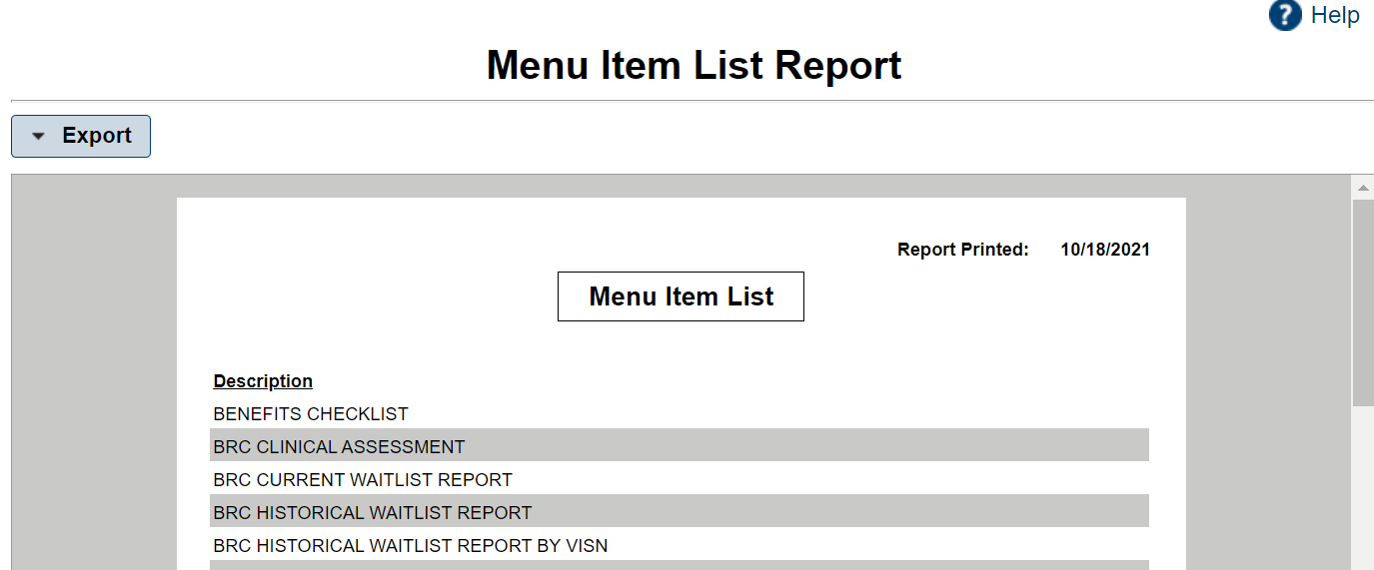

Role-Menu Assignment
The Role-Menu Assignment report provides a list of the available menu items that have been assigned to each role. List alphabetically first by role description and then by menu description. It is used to show what permissions are granted to a user if a role is assigned to them.
This report contains:
- Role Description
- Menu Description
- Reported Printed Date
- From the Header Menu, click the Administrator Menu option.
NOTE: The Administrator Menu option will display only if the Administrator Security key is assigned to you.
- From the Task Menu, click the Role-Menu Assignment link to display the Role-Menu Assignment Report screen in the Content Area.
- Select the Export button and choose the download type (CSV, Excel, PDF, RTF, or Word).
Figure 18: Role-Menu Assignment
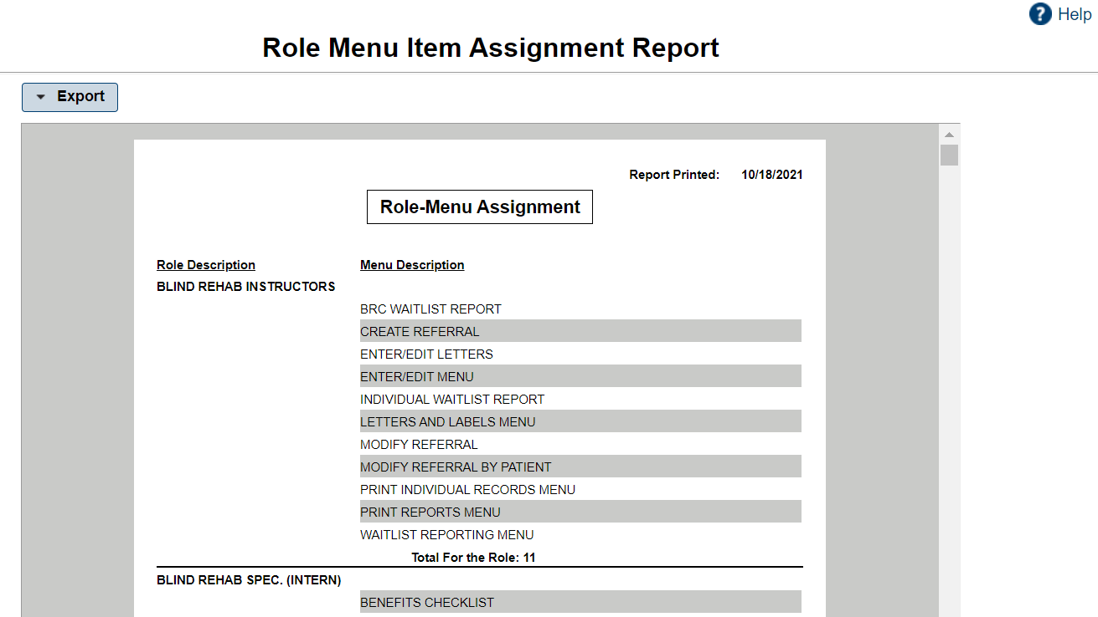

Entering/Editing Menu
WARNING: Do not use the Browser Back button in the Enter/Edit functions of the application. This will cause an error and previously entered information will be lost.

Searching for and Selecting a Patient
You must select a patient prior to performing patient-related tasks. There are two types of patient searches in BR 5.1, the HealtheVet-VistA Patient Search, and the BR Patient Search. The HealtheVet-VistA Patient Search looks in the VistA system (Patient File #2) using the Logged In institution.
The HealtheVet-VistA Patient Search is used to select a patient that is in the VistA system but has not been added to the Blind Rehabilitation application. This search is utilized when selecting the BR Patient under the Enter/Edit Menu.
NOTE: If a user logs into the system and selects a task other than the BR Patient or Low Vision Patient Links under the Enter/Edit Menu, they will get the BR Patient Search, not the HealtheVet-VistA Patient Search and if they are searching for a patient that has not been added to the Blind Rehabilitation application, the patient will not display.

HealtheVet-VistA Patient Search
Select BR Patient under the Enter/Edit Task Menu. The HealtheVet-VistA Patient Search feature displays in the Content Area when a patient is not already selected, and you select one of the following Enter/Edit Task Menu options:
- Entering/Editing a BR Patient
- Entering/Editing a Low Vision Patient
- Type at least the first three letters of the patient’s last name in the Select Patient field and click the Search button. A list of patients displays (in ascending alphabetical order) who match the search criteria. The patients’ records display as separate line items.
Figure 19: Patient Search Results
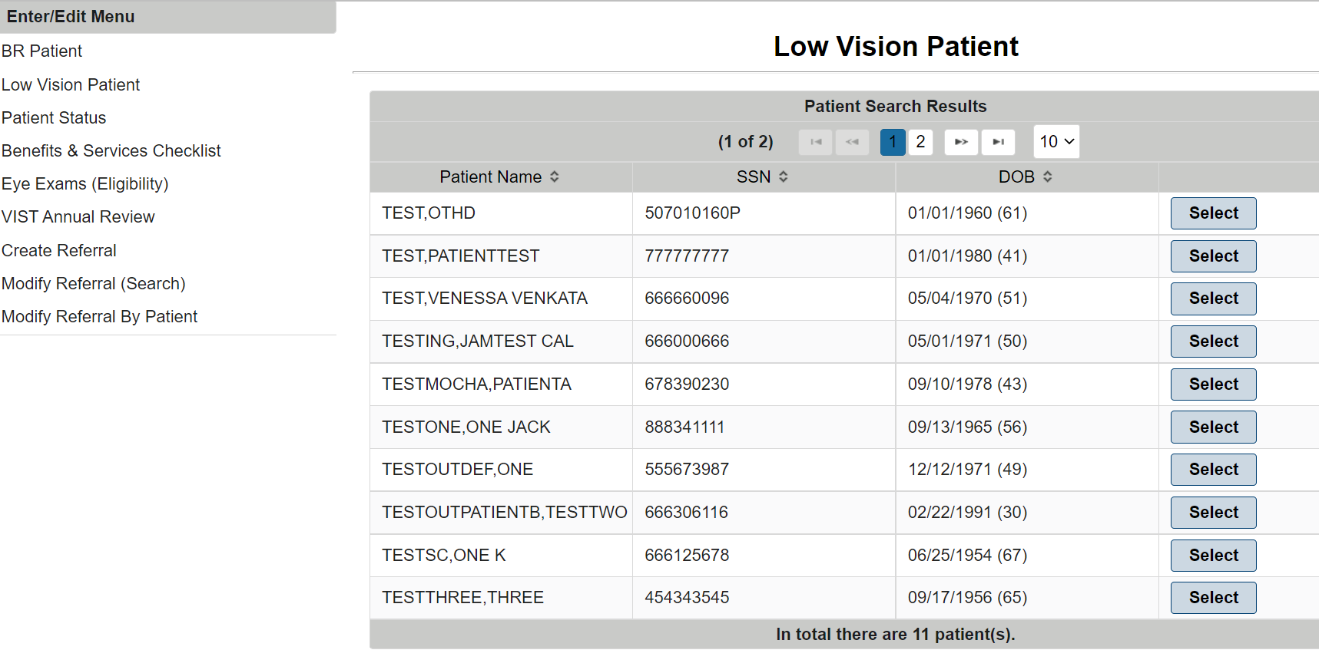
At this point, the system is accessing existing VA patients that have not been added into the BR application. Users also can Search by Input Provider, Ward, Clinic, or Specialty.
- Select the patient whose record you want to access by clicking on the patient’s name.
After selecting your patient, the Patient Lookup Status Notification screen displays. If a patient has any CWAD’s (Crisis Notes, Warning Notes, Allergies, and Directives), these warning messages will appear. There could be multiple notifications screens for you to navigate through, for example, Means Test, Deceased, and Sensitive patient, if applicable.
The selected patient is maintained as the “Current Patient” throughout the subsequent tasks until you select another patient or log off. As you select subsequent tasks from the Task Menu, you are asked if you want to continue with the current patient or select another patient.
The BR Patient Search feature displays in the Content Area when you select one of the Enter/Edit Task Menu options below. If a patient is already selected, that patient’s information displays, and you will be asked if you want to continue with the current patient or select a new patient.
NOTE: The patient you are searching for must exist in the Blind Rehabilitation system.
- Entering/Editing a Patient’s Status
- Entering/Editing the Benefits & Services Checklist
- Entering/Editing Eye Exams (Eligibility)
- Entering/Editing the VIST Annual Review
- Creating a Referral
- Modifying a Referral (Search)
- Modifying a Referral by Patient
- Type the patient’s nine-digit Social Security Number (SSN), or the first letter of the patient’s last name and the last four digits of the patient’s SSN, or the first three letters of the patient’s last name. In addition to the previous search rules, to narrow your search, you can also enter all or part of the patient’s first name. Enter the search data in the fields provided and click the Search button.
- The Patients Found page displays with a list of patients (in ascending alphabetical order) who match the search criteria. The patients’ records display as separate line items.
- From the Patients Found page, select the patient whose record you want to access by clicking the Select button next to the patient’s name.
The selected patient is maintained as the “Current Patient” throughout the subsequent tasks until you select another patient or log off. As you select subsequent tasks from the Task Menu, you are asked if you want to continue with the current patient or select another patient.

Entering/Editing a BR Patient
WARNING: Do not use the Browser Back button in the Enter/Edit functions of the application. This will cause an error and previously entered information will be lost.
NOTE: Some fields are non-editable, display only. This means that the data in the field is defaulted by the system, and it cannot be changed.
- From the Enter/Edit Menu, click BR Patient. The HealtheVet-VistA Patient Search feature displays in the Content Area. Refer to “Searching for and Selecting a Patient” under “Entering/Editing Menu” for instructions on patient selection.

Basic Information
- From the Institution drop-down list, select the institution associated with the patient’s visit.
- From the Tracked By drop-down list, select the person who is tracking this patient (for example, to whom you want to send deceased patient notifications).
- Type, or use the pop-up calendar to select the date on which the patient was enrolled as a BR patient.
- Select the patient’s eligibility for services using the VIST Eligible drop-down list. The following options are available:
- YES
- NO – REVIEWED FOR BRC ATTENDANCE
- NO – OTHER
- NO – NOT LEGALLY BLIND
- INACTIVE
- Select the source from which the referral originated from the Referral Source drop-down list. The following options are available:
- VA EYE CLINIC
- NON – VA EYE CLINIC
- STATE AGENCY
- COMMUNITY AGENCY
- VA STAFF
- VETERANS SERVICE ORGANIZATION
- FAMILY FRIEND
- SELF
- OTHER
- Transfer from another VIST
- VBA Printout
- VBA Staff
- Not known
- DOD
- From the Major Activity drop-down list, select the code that most closely corresponds to the patient’s major activity. The following options are available:
- EMP FOR PAY (The patient is employed for pay)
- ENG IN TRN/SCHOOL (The patient is engaged in training or school program)
- VOL WORK 10HRS/WK (The patient performs volunteer work at least 10 hours per week)
- RETIRED W/APPROP. ACT. (The patient is retired and performs appropriate activities)
- TOO ILL OR TOO DISABLED (The patient is too ill or too disabled to perform activities)
- NO WELL DEFINED ACT. (The patient performs no well-defined activities)
- NOT KNOWN (Major activities are unknown)
The status of the patient’s eligibility displays in the Eligibility (VIST) field.
- Select the category of eligibility as prescribed on the AMIS from the VA Entitlement drop-down list. The following options are available:
- 0% ONLY
- 10% SC THRU SMC
- SC FOR BLINDNESS
- NSC PENSION A&A/HB
- NSC PENSION ONLY
- NSC OTHER ELIGIBILITY
If available, the date of the patient’s last VIST Annual Review displays at the bottom of the Review section. You cannot edit his field.

Ocular Health
- Use the drop-down lists provided to indicate the primary and, if applicable, the secondary cause of the patient’s vision loss. This is a mandatory field. The following options are available:
- APHAKIA 379.31
- CATARACT 366.9
- CEREBOVASCULAR 438.9
- CHORIOID/RETINAL
- CHORIORENTINITIS 363.20
- CORNEAL DISEASE 371.00
- DIABETIC RETINOPATHY (PROLIFERATIVE) 362.02/250.0
- DIABETIC RETINOPATHY, BACKGROUND (NON-PROLIFERATIVE) 362.01/250.50
- GLAUCOMA 365.9
- HEMIANOPSIA; BILATERAL FIELD DEFECTS 368.46
- HISTOPLASMOSIS 115.99
- MACULAR DEGENERATION, WET, EXUDATIVE 362.52
- MACULAR DEGENERATION, DRY, NONEXUDATIVE 362.51
- MACULAR DISEASE NOS 362.50
- NOT APPLICABLE
- OPTIC ATROPHY 377.10
- OPTIC NERVE 377.49
- OTHER EYE DISORDERS 379.8
- RETINAL DETATCHMENT
- RETINAL DISORDER 362.9
- RETINAL VASCULAR OCCLUSION
- RETINITIS PIGMENTOSA 362.74
- SOLAR BURNS
- STARGARDTS 362.75
- TRAUMA 950.9
- UNKNOWN 377.9
- If the patient has another cause of vision loss, select the other cause from the drop-down list provided, and then click the Add Other Cause of Vision Loss button to add the cause to the patient’s record. Multiple causes can be added to the patient’s record.
- Type the onset year of the patient’s vision loss in the field provided.
- Use the drop-down list provided to select the value that best represents the patient’s family history of eye disease. The following options are available:
- APHAKIA
- CATARACT
- CEREBOVASCULAR
- CHORIOID/RETINAL
- CHORIORENTINITIS
- CORNEAL DISEASE
- DIABETIC RETINOPATHY
- GLAUCOMA
- HISTOPLASMOSIS
- MACULAR DEGENERATION
- MACULAR DISEASE
- NOT APPLICABLE
- OPTIC ATROPHY
- OPTIC NERVE
- OTHER
- RETINAL DETATCHMENT
- RETINAL DISORDER
- RETINAL VASCULAR OCCLUSION
- RETINITIS PIGMENTOSA
- TRAUMA
- Use the drop-down list provided to indicate whether the patient uses eye prosthesis.
- If the patient uses eye prosthesis, type or use the pop-up calendar to select the date on which the prosthesis was last replaced.
- Click the Previous to return to the previous screen, the Save button to save the information, the Next button to advance to the next screen, or Done.

Patient History
Use Patient History to capture relevant historic information about the patient.
- Type the number of years of education the patient has completed.
- From the drop-down list provided, indicate whether the patient is currently engaged in training or school. The following options are available:
- YES
- NO
- UNKNOWN
- Use the field provided to type additional education information. The field can accommodate up to 240 characters.
- Use the field provided to type the patient’s work history. The field can accommodate up to 300 characters.
- Use the drop-down list to indicate the patient’s employment status. The following options are available:
- YES
- NO
- UNKNOWN
- Use the field provided to type the patient’s primary occupation. The field can accommodate up to 80 characters.
- Use the drop-down list to indicate whether the patient’s sight loss caused the patient to lose his/her job. The following options are available:
- YES
- NO
- UNKNOWN

Financial/Benefits
Use the fields provided to enter information about the patient’s finances and benefits.
- Type the patient’s monthly household income in the field provided.
- Type the source of the patient’s household income in the field provided. The field can accommodate up to 80 characters.
- Type additional information about the patient’s financial and benefits in the field provided. The field can accommodate up to 10,000 characters.
- Click the Previous to return to the previous screen, the Save button to save the information, the Next button to advance to the next screen, or Done.

Domestic Information
- The system displays the current patient’s marital status.
- If applicable, the system displays spousal information for the current patient in the fields provided.
- If applicable, type the names of the patient’s dependents in the fields provided, and then click the Add Dependent button to add the dependents to the patient’s record. Repeat this step as necessary to add all the patient’s dependents.
- Type any additional information regarding the patient’s marital status in the field provided. The field can accommodate up to 80 characters.

Living Arrangements
- From the drop-down list provided, select the value that best represents the patient’s living arrangements. The following options are available:
- ALONE
- FAMILY
- NURSING HOME
- STATE VETERANS CENTER
- UNKNOWN
- LIVES WITH FRIEND
- BOARD AND CARE
- OTHER
- SPOUSE ONLY
- From the drop-down list provided, select the value that best represents the type of residence in which the patient lives. The following options are available:
- HOUSE
- APARTMENT
- NURSING HOME
- VA DOMICILLIARY
- STATE VETERANS HOME
- BOARD & CARE
- HOMELESS
- OTHER
- NOT KNOWN
- Click the Previous to return to the previous screen, the Save button to save the information, the Next button to advance to the next screen, or Done.

Other Health
In the field provided, type information regarding other health problems the patient may have. The field can accommodate up to 10,000 characters.

Medical Treatment
- Type, or use the pop-up calendar to select the date of the patient’s last medical exam.
- Use the drop-down list provided to indicate whether the VA provided the patient’s previous training.
- Type any additional medical information about the patient in the field provided. The field can accommodate up to 80 characters.

Blind Rehabilitation Experience
- Use the drop-down list provided to indicate whether the patient has received any previous blind rehabilitation training. If Yes is selected the remaining fields will become active and editable.
- If the patient has received previous blind rehabilitation training, use the drop-down list provided to indicate whether the VA provided the patient’s previous training.
- Type, or use the pop-up calendar to select the date of the patient’s previous blind rehabilitation training.
- Use the drop-down list provided to select the type of Blind Rehabilitation training that the patient previously received. The following options are available:
- BRC AUDIBLE DEVICES
- BRC CAT – 1st EXP
- BRC CAT – ADL TRN
- BRC DUAL PROGRAM – 1st EXP
- BRC DUAL PROGRAM – ADL TRN
- BRC Other Programs – 1st EXP
- BRC Other Programs – ADL TRN
- BRC REGULAR PROGRAM – 1st EXP
- BRC REGULAR PROGRAM – ADL TRN
- BROS LOCAL TRAINING – 1st EXP
- BROS LOCAL TRAINING – ADL TRN
- NON-VA BLINDNESS AGENCY – 1ST EXP
- NON-VA BLINDNESS AGENCY – ADL TRN
- NON-VA LOCAL CAT – 1ST EXP
- NON-VA LOCAL CAT – ADL TRN
- VA OUTPATIENT LV CLINIC – 1ST EXP
- VA OUTPATIENT LV CLINIC – ADL TRN
- VISOR – 1ST EXP
- VISOR – ADL TRN
NOTE: EXP means Experience; ADL TRN means Additional Training.
- Click the Previous to return to the previous screen, the Save button to save the information, the Next button to advance to the next screen, or Done.

Assessment Questions
- Type any adjustments to sight loss in the field provided. The field can accommodate up to 10,000 characters.
- Type any living skills assessments or information in the field provided. The field can accommodate up to 10,000 characters.
- Type any orientation and mobility assessments or information in the field provided. The field can accommodate up to 10,000 characters.
- Type any visual skills assessments or information in the field provided. The field can accommodate up to 10,000 characters.
- Type any manual skills assessments or information in the field provided. The field can accommodate up to 10,000 characters.
- Type any computer skills assessments or information in the field provided. The field can accommodate up to 10,000 characters.
- Type any activities, social, or recreational assessments or information in the field provided. The field can accommodate up to 10,000 characters.
- Type any impressions information in the field provided. The field can accommodate up to 10,000 characters.
- Type any veteran goals in the field provided. The field can accommodate up to 10,000 characters.
- Type any appropriateness for blind rehabilitation in the field provided. The field can accommodate up to 10,000 characters.
- Type any plans in the field provided. The field can accommodate up to 10,000 characters.

Entering/Editing a Low Vision Patient
WARNING: Do not use the Browser Back button in the Enter/Edit functions of the application. This will cause an error and previously entered information will be lost.
The Blind Rehabilitation Application provides the functionality to Maintain Low Vision Patients. Maintenance includes Enter, Edit, and Print capabilities. The Enter/Edit capabilities are part of the Clinicians (i.e., Ophthalmologists and Optometrists) Activities, while the Print Low Vision Patient Report is part of the general user activities.
- From the Enter/Edit Menu, click Low Vision Patient. The HealtheVet-VistA Patient Search feature displays in the Content Area. Refer to “Searching for and Selecting a Patient” under “Entering/Editing Menu” for instructions on patient selection.
The Enter/Edit Low Vision Patient page displays for the current patient
Figure 20: Edit Low Vision Patient
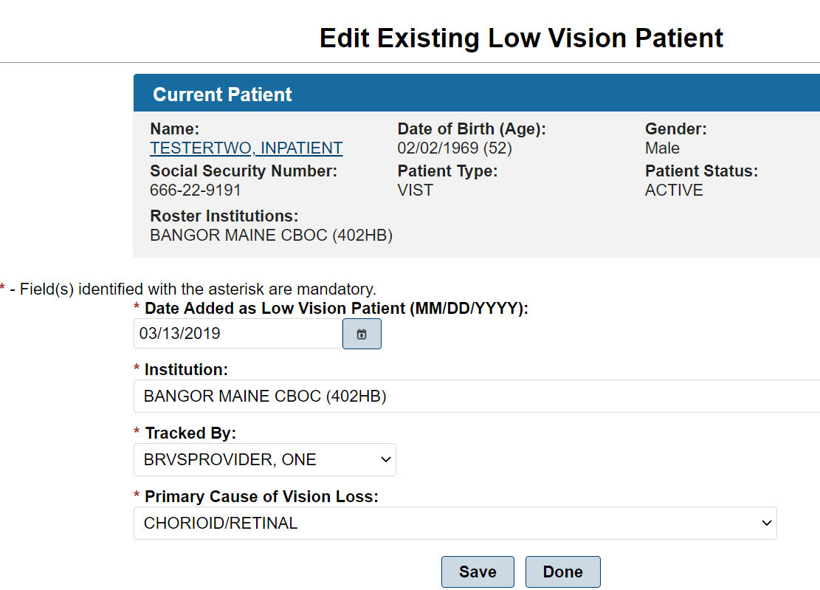
- Type or select from the pop-up calendar the date the patient was added as a Low Vision Patient.
- In the Institution field, click the down arrow and select the correct institution.
- In the Primary Cause of Vision Loss field, click the down arrow and select the primary cause of vision loss.
- Enter or edit the data in the fields, and then click the Save button to save the information you entered. The message: “Patient Successfully Saved” displays.
- Click the Done button to return to the Welcome Page.

Entering/Editing a Patient’s Status
WARNING: Do not use the Browser Back button in the Enter/Edit functions of the application. This will cause an error and previously entered information will be lost.
The Enter/Edit Patient Status page allows you to assign a status of Inactive to a patient. You can also reassign a status of Active to a patient.
From the Task Menu, click the Patient Status link.
If a patient is already selected, you will be asked if you want to continue with the current patient or select another patient.
To select another patient, type the patient’s nine-digit Social Security Number (SSN), or the first letter of the patient’s last name and the last four digits of the patient’s SSN, or the first three letters of the patient’s last name. In addition to the previous search rules, to narrow your search, you can also enter all or part of the patient’s first name. Enter the search data in the fields provided. and click the Search button.
- The Patients Found page displays with a list of patients (in ascending alphabetical order) who match the search criteria. The patients’ records display as separate line items.
Figure 21: Patient Search Results
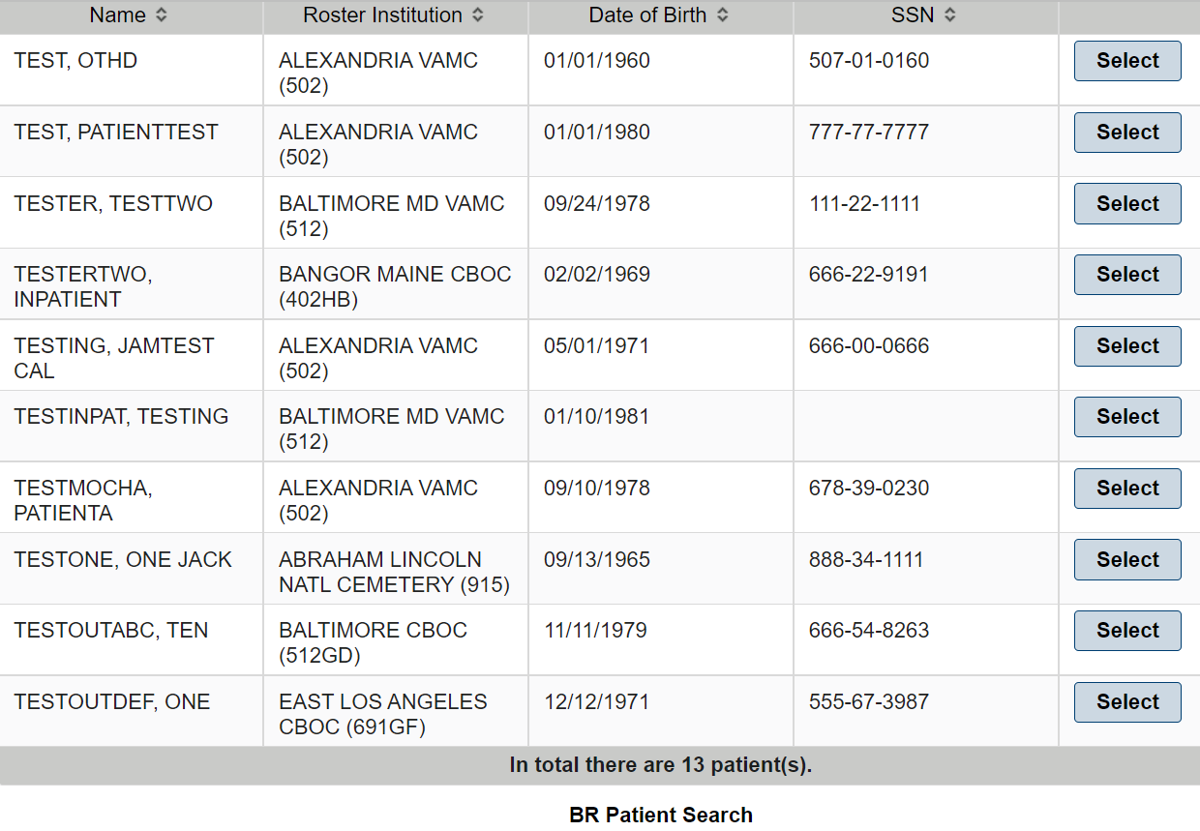
- From the Patients Found page, select the patient whose record you want to access by clicking on the Select button next to the patient’s name.
The Patient Status page displays the following sections:
- Current Patient information
- Current Patient Status
- Inactivate/Activate Patient
NOTE: The patient’s status can be Active or Inactive. If the patient’s status is active, this section will allow you to inactive the patient. If the patient’s status is inactive, this section will allow you to activate the patient.
Figure 22: Patient Status Change
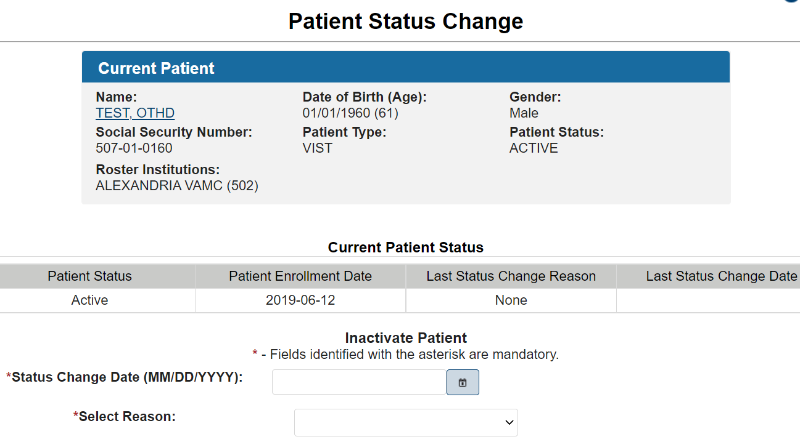

Current Patient Status
The Current Patient status section displays the patient’s status, either Active or Inactive, the date, and the reason the patient’s status was changed to Inactive.

Changing a Patient’s Status
If the current patient’s status is “Active,” you can change the patient’s status to “Inactive.” If the current patient’s status is “Inactive,” you can change the patient’s status to “Active.”
- Type, or select from the pop-up calendar the effective date of the patient’s change of status.
- If you are changing the patient’s status from “Active” to “Inactive,” you will need to select one of the following reasons from the drop-down list provided:
- Other/Deceased (not confirmed)
- No longer legally blind
- Not Eligible for VA Healthcare
- Unable to locate
NOTE: The Select Reason drop-down list does not display when changing a patient’s status from “Inactive” to “Active.”
- Click the Activate/Inactivate Patient Status button to change the patient’s status
- Click the Done button to return to the Welcome Page.

Entering/Editing the Benefits & Services Checklist
WARNING: Do not use the Browser Back button in the Enter/Edit functions of the application. This will cause an error and previously entered information will be lost.
Use Benefits & Services Checklist to enter the patient’s current benefits. This includes VA, Non-VA, and Local benefits.
- From the Enter/Edit Menu, click Benefits & Services Checklist.
If a patient is already selected, you are asked if you want to continue with the current patient or select another patient.
To continue with the current patient, click OK.
To select a different patient, to select another patient, type the patient’s nine-digit Social Security Number (SSN), or the first letter of the patient’s last name and the last four digits of the patient’s SSN, or the first three letters of the patient’s last name. In addition to the previous search rules, to narrow your search, you can also enter all or part of the patient’s first name. Enter the search data in the fields provided. and click the Search button.
- The Patients Found page displays with a list of patients (in ascending alphabetical order) who match the search criteria. The patients’ records display as separate line items.
- From the Patients Found page, select the patient whose record you want to access by clicking on the Select button next to the patient’s name to display the Edit Benefits and Services Checklist screen. If you are editing for this patient, their current benefits default in the fields. The Current Patient information displays in the upper part of the screen.
Figure 23: Benefits and Services Options Screen
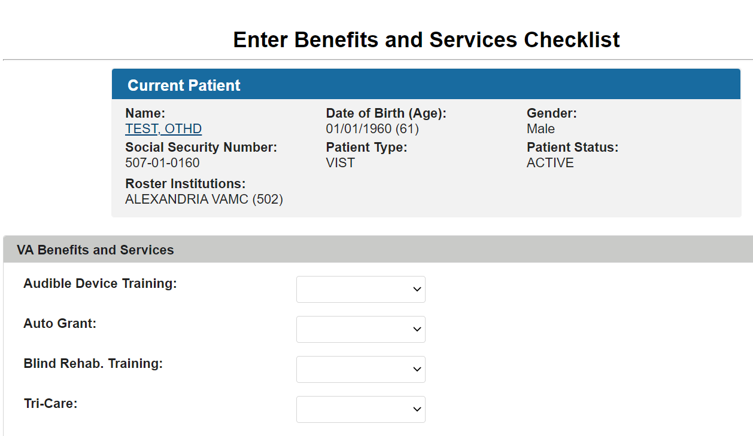
There are three sections to this screen:
- VA Benefits and Services
- Non- VA Benefits and Services
- Local Benefits and Services

VA Benefits and Services
At each field, click the down arrow to display the drop-down list of choices. Each field in this section has the following choices from which to select:
- Declined
- Not Available
- Not Eligible
- Pending
- Yes
- Audible Device Training allows you to note if the Veteran has exercised his/her right to an Audible Device. From the drop-down list, select whether the Veteran has used or is eligible for the Audible Device.
- Auto Grant denotes if the Veteran has exercised his/her right to an Auto Grant. From the drop-down list, select whether the Veteran has used or is eligible for the Auto Grant.
- Blind Rehab Training allows you to note if the Veteran has attended or declined blind rehabilitation services. You may also indicate if the Veteran has a pending application for blind rehab.
- Tri-care allows you to indicate if the Veteran/family is eligible for Tri-care. You may also indicate if an application is pending for Tri-care.
- CHAMPVA allows you to indicate if the Veteran/family is eligible for CHAMPVA. You can also indicate if an application is pending for CHAMPVA.
- Clothing Allowance allows you to indicate if the Veteran is eligible for the clothing allowance. You can also indicate if an application for the clothing allowance is pending approval by PSAS.
- Education –VA Response allows you to indicate if the Veteran/family has taken advantage of the Education benefit. You may also note if an application is pending.
- Fee Basis indicates a Veteran's eligibility for and status with Fee Basis services.
- HISA indicates if the Veteran has eligibility for and/or used the HISA grant.
- Insurance – SDVI indicates if the Veteran has insurance.
- Insurance – Waive Premium indicates whether the Veteran is eligible for and has applied for a waiver of the premiums for the SDVI Life Insurance.
- Prosthetics describes if the Veteran is eligible for prosthetic items.
- SAH- 801 (a) is the structural alteration to housing program administered by the VARO. This field allows you to enter the Veteran's use and eligibility for this grant.
- SAH – 801 (b) is the structural alteration to housing program administered by the VARO. This field allows you to enter the Veteran's use and eligibility for this grant.
- Vocational Rehabilitation denotes if the Veteran has participated in the VA vocational rehabilitation program.
- VIST Annual Review allows you to enter information regarding the Veteran's participation in the annual VIST review in your program.

Non-VA Benefits and Services
At each field, click the down arrow to display the drop-down list of choices. Each field in this section has the following choices from which to select:
- Declined
- Not Available
- Not Eligible
- Pending
- Yes
At each field, select the correct choice.
- Identification Card
NOTE: The AFB form of identification is no longer available. Individuals should apply at their state motor vehicle offices for non-driver identification cards that serve the same purpose and provide legal identification comparable to the sighted person's driver’s license.
- Blinded Veterans Association - This is the Congressional chartered service organization established for blind Veterans. Although originally established for SC Veterans, over the years the BVA has amended its bylaws and now allows all NSC Veterans with vision problems to join as equal members with a few significant exceptions including the necessity to be a SC Veteran for blindness in order to stand for the offices of President and Vice President of the organization.
- Commissary and Exchange – These are privileges granted to SC Veterans rated 100%. A blind Veteran may also select a sighted companion who will be admitted with a letter of proof by the eligible Veteran.
- National Consumer Group - These are the principal advocacy organizations of and for the blind. The American Council of the Blind, the National Federation of the Blind and the Guide Dog Users, Inc. are among the major organizations.
- Free Postage - This is the provision by which a blind person may send large print, Braille and taped materials free of postage to a person requiring these media.
- Phone Directory Assistance - This is the service available in most areas of the country enabling a blind customer to be waived of information charges on their residential phone. You must apply for this service with both your local and long-distance carrier.
- Dog Guide Training - There are approximately 16 schools across the country that provide selection of, matching with and training in the use of guide dogs for legally blind persons.
- Hadley School for The Blind - This is an international correspondence school providing courses in many subject areas. Instructional materials are provided in Braille, large print and tape formats.
- Disabled Parking Placard - This is a privilege granted to eligible disabled persons that will allow them to park in designated handicapped parking spaces or to park free of meter charges or to remain in time-restricted parking spaces beyond the posted limit with the display of the placard or with disabled license tags on the car. The disabled person may but does not need to be the driver, so a blind person may obtain disabled tags or the placard for use in a vehicle he/she owns or in which he/she rides.
- Income Tax Deduction - This is a provision in the IRS code that enables a legally blind person to take an extra amount in deductions from their long form tax return. In the past, this was a full dependent's deduction but was reduced in the IRS reforms of 1993 and is currently approximately $600.
- National Parks Admission Permit - This is a life-long permit a disabled person may obtain at any National Park that will entitle them and any companions accompanying them in the same vehicle free admission to National parks.
- Radio Reading Service - This is a service available in many parts of the country that provides materials such as the local paper and current publication read over a closed-circuit radio receiver for which a special receiver must be obtained from the service.
- Learning Ally - This is a service that provides text and professional materials recorded on tape.
- Social Security - The Social Security Administration has several benefits that a blind person may be eligible for including SSI and SSDI. For blind persons receiving SSDI, the earning limit for gainful employment is higher than for other disabled persons; currently it is $1000 a month.
- Talking Books - This is a service available from the National Library Service, Library of Congress that provides recorded books for persons unable to read regular print. The NLS program also provides books and magazines in Braille.
- Voting Rights - A blind or visually impaired person has the right to be accompanied by the person of their choice into the voting booth to assist them in casting their vote. There are slight variations in some jurisdictions with respect to what forms of identification the escort must provide.

Local Benefits and Services
There are a variety of local programs, services and benefits from which a blind or visually impaired Veteran may benefit. These vary widely throughout the country, and it is important to be familiar with those in your area in order to provide blind Veterans the greatest array of services.
At each local program, benefit and/or service field, click the down arrow to display the drop-down list of choices. Each field in this section has the following choices from which to select:
- Declined
- Not Available
- Not Eligible
- Pending
- Yes
When all data is selected, click the Save button. The system displays the following message:
“Benefits & Services Checklist successfully saved”
Click the Done button to return to the Welcome Page.

Entering/Editing Eye Exams (Eligibility)
WARNING: Do not use the Browser Back button in the Enter/Edit functions of the application. This will cause an error and previously entered information will be lost.
- From the Task Menu, click the Eye Exams (for Eligibility) link.
If a patient is already selected, you will be asked if you want to continue with the current patient or select another patient.
- Type the patient’s nine-digit Social Security Number (SSN), or the first letter of the patient’s last name and the last four digits of the patient’s SSN, or the first three letters of the patient’s last name in the fields provided and click the Search button.
- The Patients Found page displays with a list of patients (in ascending alphabetical order) who match the search criteria. The patients’ records display as separate line items.
- From the Patients Found page, select the patient whose record you want to access by clicking on the Select button next to the patient’s name.
The Eye Exams (Eligibility) page displays. The Eye Exams (Eligibility) page allows you to view and enter information about the patient’s eye exams. The page displays the following sections:
- Current Patient information
- Existing Eye Exams
- Enter New Eye Exam

Existing Eye Exams
This section displays the results of the patient’s previous eye exams. The results list chronologically in ascending order. You can select an existing eye exam to edit by clicking the Edit Exam button located to the right of the existing exam.
NOTE: The procedure to edit an exam is the same as the procedure to enter a new eye exam.

Enter New Eye Exam
This section allows you to enter eye exam information for the selected patient.
- From the drop-down list provided, select the Institution in which the exam occurred.
- Type, or select from the pop-up calendar, the date of the patient’s eye exam.
- In the Performed by VA? field, select the correct option. Choices are NO, YES, or UNKNOWN.
- Use the drop-down lists provided to select the visual acuity for the patient’s right and left eyes. The following options are available:
- NO LIGHT PERCEPTION
- LIGHT PERCEPTION ONLY / HAND MOTION
- 1/200 UP TO AND INCLUDING 5/200
- 6/200 UP TO AND INCLUDING 20/200
- 20/70 UP TO AND INCLUDING 20/190
- 20/40 UP TO AND INCLUDING 20/60
- 20/30 OR BETTER
- UNKNOWN
- Use the drop-down lists provided to select the field of vision for the patient’s right and left eyes. The following options are available:
- 5 DEGREES OR LESS
- 6 TO 20 DEGREES
- 21 TO 30 DEGREES
- >30 DEGREES
- NOT APPLICABLE
- UNKNOWN
- Use the drop-down lists provided to select the Legal Blindness/Visual Impairment Status (Primary). The following options are available:
- Field < or = 10 degrees or 20/500-20/1000
- Field < or = 20 degrees or 20/200-20/400
- Field < or = 5 degrees or HM at < or = 10’ or count fingers < 3’ or 20/1000
- Impairment level not further specified, blindness, one eye
- Legal blindness (general U.S. definition)
- Near normal, 20/30-20/70 unspec. Visual disturbance
- Normal vision; 20/25 or better; unspec. Disorder of refraction or accommodation
- Not legal blindness; 20/70-20/160
- One eye: total impairment; other eye: near normal vision
- One eye: total impairment; other eye: not specified
- Orthoptic Training
- Totally blind, NLP or LPO
- Type any relevant notes in the text box provided. The field can accommodate up to 320 characters.
- Click the Add Eye Exam button to add the claim to the list of existing eye exams.
- Repeat steps 1 through 7 until all exams are entered, and then click the Done button to return to the Welcome Page.

Entering/Editing the VIST Annual Review
WARNING: Do not use the Browser Back button in the Enter/Edit functions of the application. This will cause an error and previously entered information will be lost.
The VIST Annual Reviews page allows you to view and enter information about the patient’s annual VIST reviews. Each patient is contacted annually to check his or her status and to ensure that further care, if needed, is provided. VIST Annual Review information is used for reporting purposes.
- From the Task Menu, click VIST Annual Review.
If a patient is already selected, you will be asked if you want to continue with the current patient or select another patient.
- Type the patient’s nine-digit Social Security Number (SSN), or the first letter of the patient’s last name and the last four digits of the patient’s SSN, or the first three letters of the patient’s last name in the fields provided and click the Search button.
- The Patients Found page displays with a list of patients (in ascending alphabetical order) who match the search criteria. The patients’ records display as separate line items.
Figure 24: Patient Search Results
- From the Patients Found page, select the patient whose record you want to access by clicking on the Select button next to the patient’s name.
The VIST Annual Review page displays for the current patient.
The VIST Annual Reviews page displays the following sections:
- Current Patient information
- Existing VIST Annual Reviews
- Enter New VIST Annual Review
Figure 25: VITS Annual Review Screen
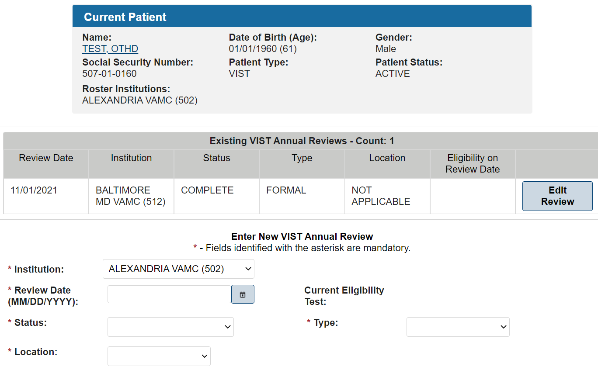

Existing VIST Annual Reviews
This section displays information about the patient’s previous VIST annual reviews. The reviews list chronologically in ascending order. You can select an existing Annual Review to edit by clicking the Edit Review button located to the right of the existing review.
NOTE: The procedure to edit a review is the same as the procedure to enter a new VIST Annual Review.

Enter New VIST Annual Review
- Select the Institution in which the review occurred from the drop-down list provided.
- Type, or use the pop-up calendar to select the date of the VIST review.
- Select the status of the patient’s review using the Status of Review drop-down list. This field is mandatory when a review date is entered. The following options are available:
- COMPLETE
- DECLINED
- NO SHOW
- COULD NOT CONTACT
- Select the type of the patient’s review using the Type of Review drop-down list. This field is mandatory when a review date is entered. The following options are available:
- FORMAL – The patient is brought into the facility and has all required procedures performed during of one day.
- COMPONENT – The required procedures are performed over the course of several days.
- Select the location where the VIST review was performed. The following options are available:
- HOME
- OFFICE
- TELEPHONE
- OTHER
- Click the Add Review button to add the review to the list of existing VIST Annual Reviews.
- Click the Done button to return to the Welcome Page.

Modifying a Referral (Search)
WARNING: Do not use the Browser Back button in the Enter/Edit functions of the application. This will cause an error and previously entered information will be lost.
This Blind Rehabilitation (BR) application menu option provides the functionality necessary to edit and update existing referrals or to cancel inactive referrals.
- From the Enter/Edit Menu, click Modify Referral (Search) to display the Referral Search screen.
- Use the following fields to search for, and then modify a referral:
- Select Institution Search Type:
- Select one of the following search types:
- Referred From one of your Institutions
Use this type to search for referrals from your institution. Selecting this search type causes the option list in the Referred from Institutions field below to display the institutions from which that referral may have been sent. Use the Referred to Institutions field to select all the institutions to which that referral may have been sent or you can select a specific institution to which that referral may have been sent.
Referred To one of your Institutions
Use this type to search for referrals to your institutions. Selecting this search type causes the option list in the Referred to Institutions field below to display the institutions to which that referral may have been sent. Use the Referred from Institutions field to select all the institutions from which that referral may have been sent or you can select a specific institution from which that referral may have been sent.
Referred from Institutions:
Select the institution that initiated the referral. Default value is all. If the user selects the referral to option, the user will only be able to cancel an existing referral with a pending status or submit an incomplete referral.
Referred to Institutions:
Select the institution to which the referral was sent. The user will select this option to finish processing a referral. This will also be the option to finish referrals they initiated (For example, to resolve referrals to outside agency. This would be a case where the same person initiating would resolve. The Referral From & To Institutions would be the same in this situation.)
Initiating Areas:
Select the area initiating the referral. Options include:
- VIST
- BRC
- BROS
Statuses:
Select one or more referral statuses. Options include:
- Pending
- Accepted
- Offered
- Scheduled
- Complete
- Cancelled
- Withdrawn
Referral Types
Select all, one, or several referral types. Options include:
- All
- BRC Regular Program – 1st EXP
- BRC Regular Program – ADL TRN
- BRC CAT – 1st EXP
- BRC CAT – ADL TRN
- BRC Other Programs – 1st EXP
- BRC Other Programs – ADL TRN
- BRC Dual Program – 1st EXP
- BRC Dual Program – ADL TRN
- BRC Audible Devices
- BROS Local Training – 1st EXP
- BROS Local Training ADL TRN
- VA Outpatient LV Clinic – 1st EXP
- VA Out patient LV Clinic – ADL TRN
- VISOR – 1st EXP
- VISOR – ADL TRN
- Non-VA Blindness Agency – 1st EXP
- Non-VA Blindness Agency – ADL TRN
- Non-VA Local CAT – 1st EXP
- Non-VA Local CAT – ADL TRN
- Not accepted for BR Training.
- Other VIST Coordinator
NOTE: EXP means Experience; ADL TRN means Additional Training.
Start Date (MM/DD/YYYY)
Enter the Start Date (MM/DD/YYYY) for the referral or click the icon next to the field and select from a calendar.
End Date (MM/DD/YYYY)
Enter the End Date (MM/DD/YYYY) for the referral or click the icon next to the field and select from a calendar.
- Select data in the fields, and then click the Search button.
The system displays a list of appropriate referrals from which the user may select for editing. The list contains the Created Date, Patient Name, Priority Level, Referral Type, Status, Days Since Referral Received, and Referred to Institution (Station ID). The list can be resorted (in ascending or descending order) by column heading; just select the column by which you want to sort the list.
NOTE: If the referral is finished the following message displays: ‘This referral is finished and cannot be modified’
New Status:
Select the appropriate status. Choices for Non-BRC referrals include:
- In Review
- Accepted
- Offered
- Scheduled
- Completed
- Cancelled
- Withdrawn
Choices for BRC Referrals include:
- In Review
- Accepted
- Offered
- Scheduled
- Discharged
- Cancelled
- Withdrawn
Status Definitions
Select In Review if you are in the process of reviewing the referral to determine acceptance.
Select Accepted if the referral has been approved. This means the application review process is completed and the application is approved.
Select Offered if the patient has been offered a date of service.
If Offered Status is selected, select the Offer Accepted value of Yes if the patient accepts the date of service offered. Select a value of No if the patient does not accept the date of service offered. This date must be on or after the ‘Referral Date.’ Once you enter data in this field, it becomes a non-editable field.
If the Offered Accepted is Yes, the system automatically sets the referral to a Scheduled Status for the current date.
If the Offered date is not accepted, additional dates of service may be offered. This is only available if the patient does not accept the first admission offer. Enter the additional service dates the patient is offered. This date must be on or after the ‘Referral Date’. Once you enter data in this field, it becomes a non-editable field.
Once the Offered date is accepted, the system automatically sets the status to Schedule for the current date.
For a Non-BRC Referral: Select Completed Status, after the patient receives the services.
For a BRC Referral: The system sets the Admission Status automatically when the date the patient is admitted into the BRC for training is received from MAS. This field automatically updates if/when the patient is admitted to the MAS system.
NOTE: If the system is unable to determine the Admission Date, a notification is sent to the appropriate institution for the user to select the admission date from a list of available dates pulled from MAS.
For a BRC Referral: The system sets the Discharge Status automatically when the date the patient is discharged from the BRC after completing the training is received from MAS. A discharge date is not allowed without an admission date. The discharge date cannot be before the admission date. This field automatically updates if/when the patient is discharged within the MAS system.
NOTE: If the system is unable to determine the Discharge Date, a notification is sent to the appropriate institution for the user to select the discharge date from a list of available dates pulled from MAS.
Select Cancelled status if the BRC denies services to the patient. You must also select the appropriate reason. Once the Cancelled status is selected, the referral remains in a cancelled status and is not editable. Options include:
- Medical Unstable
- Visual Status
- Psychological Status
- Personal Status
- Not Eligible for VA Care
- Deceased
- Referred to VIST
- Referred to BROS
- Enter data in the fields and click Save. To select another Referral, click Return to Referral List. To add a note to the referral, click Add Note. The system will display an Existing Notes box and a New Note box which is interactive so you can enter a new note.
When complete, click Save Note. To cancel, click Cancel Note. Click Done to return to the Welcome page.

Modifying a Referral By Patient
WARNING: Do not use the Browser Back button in the Enter/Edit functions of the application. This will cause an error and previously entered information will be lost.
The Blind Rehabilitation (BR) application provides the functionality necessary to modify/update existing referrals for a specific patient. In addition, the BR application will provide historical referral information. As referrals are updated, the users will be able to review the history to see the status and number of referrals over time for a given patient
- From the Enter/Edit Menu, click Modify Referral By Patient. If a patient is already selected, you are asked if you want to continue with the current patient or select another patient. To continue with the current patient, click OK.
- To select a different patient, type the patient’s nine-digit Social Security Number (SSN), or the first letter of the patient’s last name and the last four digits of the patient’s SSN, or the first three letters of the patient’s last name in the fields provided and click the Search button.
- The Patients Found page displays with a list of patients (in ascending alphabetical order) who match the search criteria. The patients’ records display as separate line items.
- From the Patients Found page, select the patient whose record you want to access by clicking on the Select button next to the patient’s name. The system displays a list of referrals from which you can select, and then modify the referral status.
The list contains the Referral Number, Created Date, Patient Name, Referral Type, Status, Referred to Institution (Station ID), Initiating Area, and Special Consideration.
- To edit the status of a specific referral, click the Edit Referral button to display the edit screen with details of the referral. Details include referral information, referral number, and the referral status history.
The following fields display for editing:
New Status:
Select the appropriate status. Choices for Non-BRC referrals include:
- In Review
- Accepted
- Offered
- Scheduled
- Completed
- Cancelled
- Withdrawn
- In Training

Choices for BRC Referrals include:
- In Review
- Accepted
- Offered
- Scheduled
- Discharged
- Cancelled
- Withdrawn
Status Definitions
Select In Review if you are in the process of reviewing the referral to determine acceptance.
Select Accepted if the referral has been approved. This means the application review process is completed and the application is approved.
Select Offered if the patient has been offered a date of service.
If Offered Status is selected, select the Offer Accepted value of Yes if the patient accepts the date of service offered. Select a value of No if the patient does not accept the date of service offered. This date must be on or after the ‘Referral Date.’ Once you enter data in this field, it becomes a non-editable field.
If the Offered Accepted is Yes, the system automatically sets the referral to a Scheduled Status for the current date.
If the Offered date is not accepted, additional dates of service may be offered. This is only available if the patient does not accept the first admission offer. Enter the additional service dates the patient is offered. This date must be on or after the ‘Referral Date’. Once you enter data in this field, it becomes a non-editable field.
Once the Offered date is accepted, the system automatically sets the status to Schedule for the current date.
For a Non-BRC Referral: Select Completed Status, after the patient receives the services.
For a BRC Referral: The system sets the Admission Status automatically when the date the patient is admitted into the BRC for training is received from MAS. This field automatically updates if/when the patient is admitted to the MAS system.
NOTE: If the system is unable to determine the Admission Date, a notification is sent to the appropriate institution for the user to select the admission date from a list of available dates pulled from MAS.
For a BRC Referral: The system sets the Discharge Status automatically when the date the patient is discharged from the BRC after completing the training is received from MAS. A discharge date is not allowed without an admission date. The discharge date cannot be before the admission date. This field automatically updates if/when the patient is discharged within the MAS system.
NOTE: If the system is unable to determine the Discharge Date, a notification is sent to the appropriate institution for the user to select the discharge date from a list of available dates pulled from MAS.
Select Cancelled status if the BRC denies services to the patient. You must also select the appropriate reason. Once the Cancelled status is selected, the referral remains in a cancelled status and is not editable. Options include:
- Medical Unstable
- Visual Status
- Psychological Status
- Personal Status
- Not Eligible for VA Care
- Deceased
- Referred to VIST
- Referred to BROS
Select Withdrawn status if the patient declines to receive services. You must also select the appropriate reason. Once the Withdrawn status is selected, the referral remains in a cancelled status and is not editable. Choices for Status Change Reasons include:
- Medical Unstable
- Visual Status
- Psychological Status
- Personal Status
- Not Eligible for VA Care
- Deceased
- Referred to VIST
- Referred to BROS
- Enter data in the fields and click Save. To add a note to the referral, click Add Note. The system will display an Existing Notes box (if there are existing notes) and a New Note box which is interactive, so you can enter a new note. When complete, click Save Note. To cancel, click Cancel. To select another Referral, click Return to Referral List. Click Done to return to the Welcome page.

Letter and Labels Menu
The Letter and Labels Menu link is accessible from the Header Menu.
This menu provides options to edit letters, print letters, and print mailing labels as necessary for patients.
Select the Done link in the Content Area to return to the Welcome Page.
Figure 26: Letters and Labels Menu Task Menu Options Screen Capture

Enter/Edit Letters
Navigation
Select the Enter/Edit Letters link from the Task Menu to display the Letters – Search Criteria in the Content Area:
- Search: Select the Institution, and then click Search to display the list of existing letters for that institution.
Select Add Letter to Enter New Letter
Select Done to return to the Welcome Page
- Add Letter: Select the Institution, and then click Add Letter to Enter New Letter
- Reset: Select Reset to deselect an institution
- Done: Select Done to return to the Welcome Page
Editing an Existing Letter
- Select the institution, and then click Search to display the list of Existing Letters for that institution. From the Existing Letters section click the Edit button next to the letter to be edited. The letter displays for editing.
- The data within the less than (<) and greater than (>) signs has to be replaced. Delete the directional signs (< and >) when entering specific data.
For Example:
|Todays Date|
|PatientFirstName| |PatientMiddleName| |PatientLastName|
|PatientAddressLine1|
|PatientAddressLine2|
|PatientAddressLine3|
|PatientCity|, |PatientState| |PatientZip|
When Printed Becomes:
December 07, 2005
Three VISTpatient
123 Anystreet
Anycity, Anystate, 12345
- The Data Fields are located to the right of the Letter Text area. Highlight desired data field and copy and paste into the letter. Include the vertical lines ( | ) before and after data field text, the data value for that field will be substituted, for the selected institution, when the letter is printed.
- When complete, select Save. To print the letter, refer to Printing a Letter later in this section.
NOTE: When a letter is edited, the text entered remains until that letter is edited again.
Enter a New Letter
- From the Letters - Search Criteria screen select the Institution and click the Add Letter button to display the Enter New Letter screen.
- Enter the letter name in the Letter Name field.
- Add desired data fields. The Data Fields are located to the right of the Letter Text area. Highlight desired data field and copy and paste into the letter. Include the vertical lines ( | ) before and after data field text, the data value for that field will be substituted, for the selected institution, when the letter is printed.
- Enter the text of the letter.
- When complete, click Save. The Letters screen displays the list of existing letters, including the letter just created.
NOTE: When a letter is edited, the text entered remains until that letter is edited again.
- To print the letter, refer to Printing a Letter later in this section.
- Select Cancel to return to the Letter - Search Criteria page.
- Select Done to return to the Welcome Page.
Printing a Letter
- Select the Institution, and then click Search to display the list of Existing Letters for that institution.
- From the Existing Letters screen, click the Print button to the right of the letter needing to be printed. The Letters – Select Patient Criteria screen displays.
- Use the Select Patients Method field to display (and edit) a list of currently selected patients or to load from a roster for the specific selected institution. If the Select Patients Method is to ‘LOAD PATIENT LIST FROM ROSTER,’ the list of available institutions is displayed. Choose one or more institutions from which to select patients.
NOTE: To select multiple institutions, hold the <Ctrl> key down while making the selections.
- Select Submit to display the Currently Selected Patients
  - To remove patients from the list, select the patient name (to select multiple, hold the <Ctrl> key down while making the selections) and select Remove All.
  - When the list is complete, click the Continue button to display the Print BR Letter Criteria screen. The name of the letter you are printing displays.
  - Enter the desired font size and click the Print button. If you change the size of the font, you can click the Reset button to return to the default font.
  - The letter displays on the screen. To print the letter, use the appropriate printing option available.
- Select Reset to clear selections
- Select Done to return to the Welcome Page

Print Letters
From the Task Menu select Print Letters to display the Letters - Search Criteria screen.
- Select the Institution, and then select Search to display the list of Existing Letters for that institution.
- From the Existing Letters screen, select the Print button to the right of the letter needing to be printed. The Letters – Select Patient Criteria screen displays.
- Use the Select Patients Method field to display (and edit) a list of currently selected patients or to load from a roster for the specific selected institution. If the Select Patients Method is to ‘LOAD PATIENT LIST FROM ROSTER,’ the list of available institutions is displayed. Choose one or more institutions from which to select patients.
NOTE: To select multiple institutions, hold the <Ctrl> key down while making the selections.
- Select Submit to display the Currently Selected Patients
  - To remove patients from the list, select the patient name (to select multiple, hold the <Ctrl> key down while making the selections) and select Remove All.
  - When the list is complete, select the Continue button to display the Print BR Letter Criteria screen. The name of the letter you are printing displays.
  - Enter the desired font size and select the Print button. Select the Reset button to return to the default font.
  - The letter displays on the screen. To print the letter, use the appropriate printing option available.
- Select Reset to clear selections.
- Select Done to return to the Welcome Page.

Print Patient Mailing Labels
From the Task Menu, click Print Patient Mailing Labels to display the Patient Mailing Labels - Select Patient Criteria screen.
- Select the institution, and then click Submit to display the list of existing patients for that institution.
- Use the Select Patients Method field to display (and edit) a list of currently selected patients or to load from a roster for the specific selected institution.
- After you display a list of patients you have the option to remove any patient to which you do not want to send the letter by clicking the Remove button next to the patient's name.
- When the list is complete, click the Continue button to display the Patient Mailing Labels Criteria screen.
- Label Sort Order: Click the down arrow to specify the sorting order of the patient list. The options are: LAST NAME (default setting), CITY, COUNTY, and STATE.
- Label Type: Use this field to determine the size of the label. You can print 30 (default setting) or 14 labels per sheet.
- Click the Submit button to generate the labels.
- To generate the labels in Adobe Acrobat format for printing, click the Printer icon and follow the directions on the screen.

Printing Individual Records Menu
These menu options contain the functionality to print the individual records for a specific patient.

Printing a Patient Record
Use this menu option to print the record for a specific patient.
- From the Header Menu, click the Print Individual Patient Records Menu option.
- From the Task menu, click the Patient Record menu option. If a current patient is already selected, you will be asked if you want to continue with the current patient or select another patient. Click the OK button to continue with the current patient.
- To select a different patient, type the patient’s nine-digit Social Security Number (SSN), or the first letter of the patient’s last name and the last four digits of the patient’s SSN, or the first three letters of the patient’s last name in the fields provided and click the Search button.
- The Patients Found page displays with a list of patients (in ascending alphabetical order) who match the search criteria. The patients’ records display as separate line items.
- From the Patients Found page, select the patient whose record you want to access by clicking on the Select Button next to the patient’s name. The Patient Record for the selected patient displays. To print the Patient Record, use the appropriate printing option available. Click the Home button to return to the Welcome Page.

Printing an Eye Exam (Eligibility) History
Use this menu option to print the patient’s eye exam (eligibility) history record.
- From the Header Menu, click the Print Individual Patient Records Menu option.
- From the Task menu, click the Eye Exam (Eligibility) History menu option. If a current patient is already selected, you will be asked if you want to continue with the current patient or select another patient. Click the OK button to continue with the current patient.
- To select a different patient, type the patient’s nine-digit Social Security Number (SSN), or the first letter of the patient’s last name and the last four digits of the patient’s SSN, or the first three letters of the patient’s last name in the fields provided and click the Search button.
- The Patients Found page displays with a list of patients (in ascending alphabetical order) who match the search criteria. The patients’ records display as separate line items.
- From the Patients Found page, select the patient whose record you want to access by clicking on the Select Button next to the patient’s name. The Individual Eye (Eligibility) History - Report Criteria screen displays. The Current Patient information displays in the upper part of the screen.
- Enter the Start Date (MM/DD/YYYY) for the record or click the calendar icon to select the date.
- Enter the End Date (MM/DD/YYYY) for the record or click the calendar icon to select the date.
- To generate the report in Adobe Acrobat format for printing, click the Export dropdown button and choose the file type to save the report.

Printing a Benefits & Services Checklist
Use this menu option to print the patient’s Benefits & Services Checklist record.
- From the Header Menu, click the Print Individual Patient Records Menu option.
- From the Task menu, click the Benefits & Services Checklist menu option. If a current patient is already selected, you will be asked if you want to continue with the current patient or select another patient. Click the OK button to continue with the current patient.
- To select a different patient, type the patient’s nine-digit+- Social Security Number (SSN), or the first letter of the patient’s last name and the last four digits of the patient’s SSN, or the first three letters of the patient’s last name in the fields provided and click the Search button.
- The Patients Found page displays with a list of patients (in ascending alphabetical order) who match the search criteria. The patients’ records display as separate line items.
- From the Patients Found page, select the patient whose record you want to access by clicking on the Select Button next to the patient’s name. The Individual Benefits & Services Checklist displays for the selected patient. To print the record, use the appropriate printing option available. Click the Home button to return to the Welcome Page.

Printing a Referral History
Use this menu option to print the patient’s Referral History record.
- From the Header Menu, click the Print Individual Patient Records Menu option.
- From the Task menu, click the Referral History menu option. If a current patient is already selected, you will be asked if you want to continue with the current patient or select another patient. Click the OK button to continue with the current patient.
- To select a different patient, type the patient’s nine-digit Social Security Number (SSN), or the first letter of the patient’s last name and the last four digits of the patient’s SSN, or the first three letters of the patient’s last name in the fields provided and click the Search button.
- The Patients Found page displays with a list of patients (in ascending alphabetical order) who match the search criteria. The patients’ records display as separate line items.
- From the Patients Found page, select the patient whose record you want to access by clicking on the Select Button next to the patient’s name. The Individual Referral History - Report Criteria screen displays. The Current Patient information displays in the upper part of the screen.
- Enter the Start Date (MM/DD/YYYY) for the record or click the calendar icon to select the date.
- Enter the End Date (MM/DD/YYYY) for the record or click the calendar icon to select the date.
- To generate the report in Adobe Acrobat format for printing, click the Export dropdown button and choose the file type to save the report.

Printing a PCE Problem List
Use this menu option to print the Patient Care Encounter (PCE) file.
- From the Header Menu, click the Print Individual Patient Records Menu option.
- From the Task menu, click the PCE Problem List menu option. If a current patient is already selected, you will be asked if you want to continue with the current patient or select another patient. Click the OK button to continue with the current patient.
- To select a different patient, type the patient’s nine-digit Social Security Number (SSN), or the first letter of the patient’s last name and the last four digits of the patient’s SSN, or the first three letters of the patient’s last name in the fields provided and click the Search button.
- The Patients Found page displays with a list of patients (in ascending alphabetical order) who match the search criteria. The patients’ records display as separate line items.
- From the Patients Found page, select the patient whose record you want to access by clicking on the Select Button next to the patient’s name. The PCE Problem List screen displays. The Current Patient information displays in the upper part of the screen.
- Click the down arrow and select the institution from the list that displays.
- Click the down arrow and select the status. Options are:
- All
- Active
- Inactive
- Enter data in the fields and click Submit. The PCE Problem List for the selected patient displays. To print the record, use the appropriate printing option available.

Printing Reports Menu
The Blind Rehabilitation application offers reporting capability that is easy to use. This feature has numerous report options.
- From the Header Menu, click the Print Reports Menu option.
- From the list of available reports displayed in the Task Menu, select the report you want to run.
- The criteria selection page for the selected report will display in the Content Area.
Because each report has unique reporting criteria, each BR report will have a unique page from which you can select the criteria and parameters and generate the report. Descriptions of each of the available BR reports are provided in the following sections.

Printing Additions to VIST Roster Report
The Additions to VIST Roster report provides a list of patients added to the VIST Roster during the specified report period.
Figure 27: Additions to VIST Roster Report
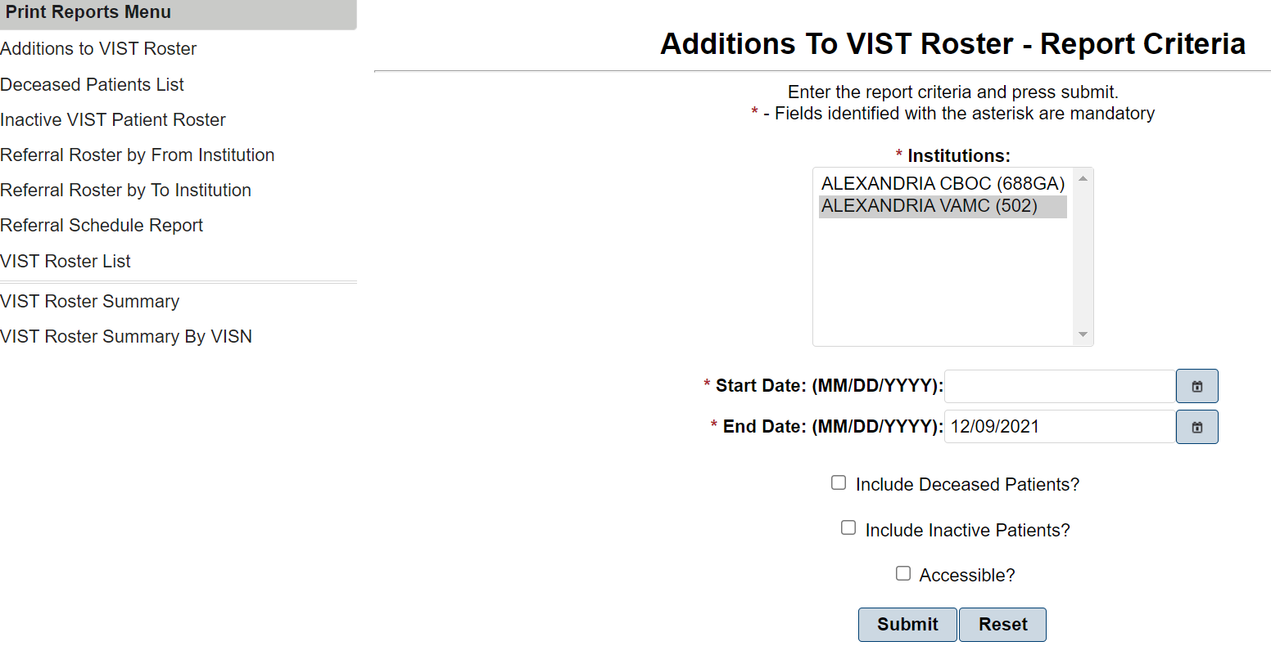
- Select one or more or all the Institutions from which you want to report. The Institutions list alphabetically in ascending order.
- Enter the Start Date (MM/DD/YYYY) for the report or click the icon next to the field and select from a calendar. This date will determine how far back the system will search for patients in the selected institution(s).
- Enter the End Date (MM/DD/YYYY) for the report or click the icon next to the field and select from a calendar. This date will usually be the current date.
- If applicable, place a check in the Include Deceased Patients checkbox to include deceased patients that have been added to the VIST Roster.
- If applicable, place a check in the Accessible? checkbox field to indicate that you want the report 508 compliant.
- Click the Submit button to generate the report, or click the Reset button to clear the selected criteria and start over.
The Additions to VIST Roster report displays the enrollment date, patient name, SSN, VIST Eligibility, referral source, and if applicable, the date of death of patients by institution. To generate the report in Adobe Acrobat format for printing, click the Export dropdown button and choose the file type to save the report.
Figure 28: VIST Roster Report Print selection
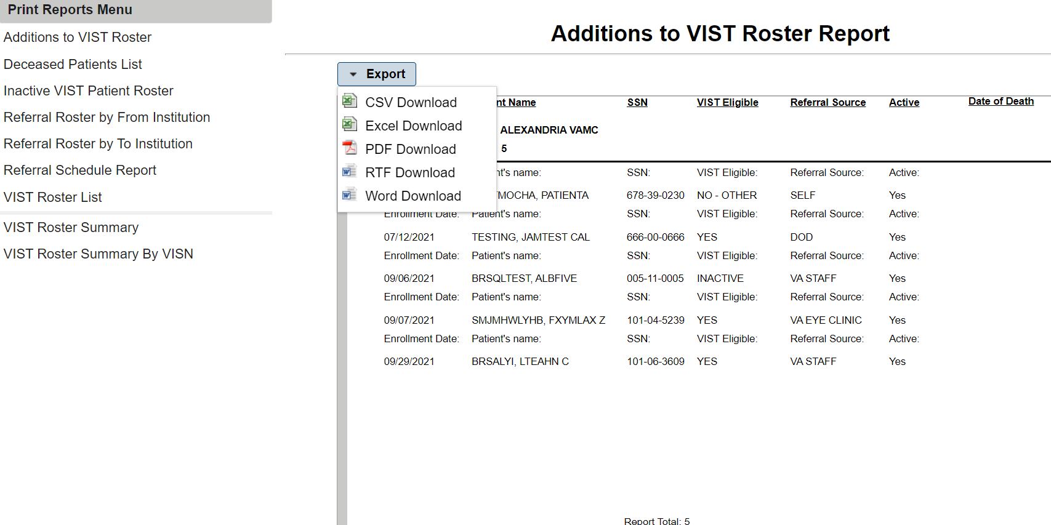

Printing a Deceased Patients List Report
The Deceased Patients List report provides a list of patients who have died since the last time the report was run. The BR Patients are updated with deceased dates appropriately.
- Select one or more or all of the Institutions from which you want to report for deceased patients. The institutions list alphabetically in ascending order by name.
- Enter the Start Date (MM/DD/YYYY) for the report or click the icon next to the field and select from a calendar. This date will determine how far back the system will search for patients in the selected institution(s).
- Enter the End Date (MM/DD/YYYY) for the report or click the icon next to the field and select from a calendar. This date will usually be the current date.
- If applicable, place a check in the Accessible? checkbox field to indicate that you want the report 508 compliant.
- Click the Submit button to generate the report, or click the Reset button to clear the selected criteria and start over.
The Deceased Patient List report displays the Patient Name, SSNs, and Date of Death of deceased patients. The report displays subtotals of deceased patients by each selected institution and a total for all institutions. To generate the report in Adobe Acrobat format for printing, click the Export dropdown button and choose the file type to save the report.

Printing an Inactive VIST Patient Roster Report
The Inactive VIST Patient Roster report provides a list of patients that have been assigned an “Inactive” status.
Figure 29: Inactive VIST Patient Roster Report
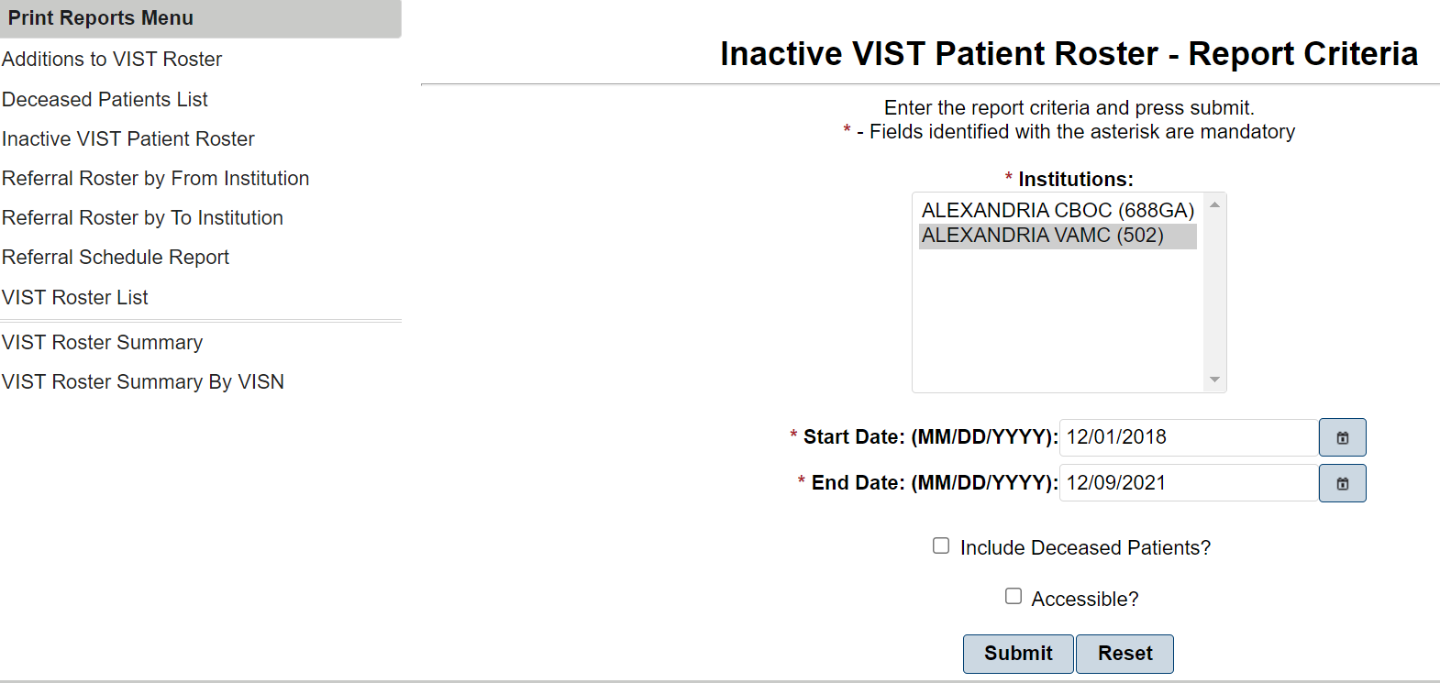
- Select one or more or all of the Institutions from which you want to report. The institutions list alphabetically in ascending order by name.
- Enter the Start Date (MM/DD/YYYY) for the report or click the icon next to the field and select from a calendar. This date will determine how far back the system will search for patients in the selected institution(s).
- Enter the End Date (MM/DD/YYYY) for the report or click the icon next to the field and select from a calendar. This date will usually be the current date.
- If applicable, place a check in the Include Deceased Patients checkbox to include deceased patients on the report.
- If applicable, place a check in the Accessible? checkbox field to indicate that you want the report 508 compliant.
- Click the Submit button to generate the report, or click the Reset button to clear the selected criteria and start over.

Printing a Referral Roster By From Institution
This menu option provides you with a printout of referrals for blind rehabilitation based on the referral schedule. You have the choice of how far back in time (i.e., one day, one month, one year, two years, etc.) from which to retrieve information for the report results.
Figure 30: Referral Roster by From Institution Report
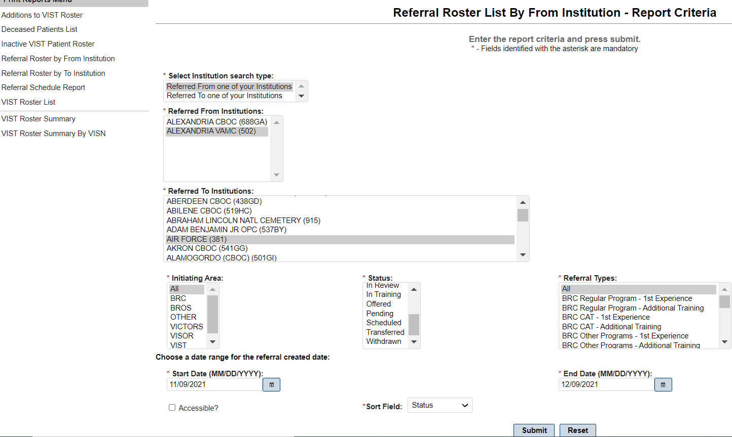
- From the Print Reports Menu, click Referral Schedule Report to display the Referral Schedule Report– Report Criteria screen.
- Use the following fields to search for a referral:
Select Institution Search Type:
Select one of the following search types:
Referred From one of your Institutions
Use this type to search for referrals from your institution. Selecting this search type causes the option list in the Referred from Institutions field below to display the institutions from which that referral may have been sent. Use the Referred to Institutions field to select all of the institutions to which that referral may have been sent or you can select a specific institution to which that referral may have been sent.
Referred To one of your Institutions
Use this type to search for referrals to your institutions. Selecting this search type causes the option list in the Referred To Institutions field below to display the institutions to which that referral may have been sent. Use the Referred From Institutions field to select all of the institutions from which that referral may have been sent or you can select a specific institution from which that referral may have been sent.
Referred From Institutions:
Select the institution(s) that initiated the referral.
Referred To Institutions:
Select the institution(s) to which the referral is sent.
Initiating Areas:
Initiating Areas:
Select the area initiating the referral. Options include:
- All
- BRC
- BROS
- OTHER
- VICTORS
- VISOR
- VIST
Select the area initiating the referral. Options include:
- Scheduled
- Admitted
- Cancelled
- Completed
- Discharged
- In Training
- Completed
- Transferred
- Withdrawn
NOTE: To simplify the selection when trying to identify specific Waitlist related information, selecting Waitlist causes the program to automatically select the appropriate statuses (Pending, In Review, and Accepted) that identify individuals on the waitlist based on the waitlist records with these statuses.
Referral Types
Select all, one, or several referral types. Options include:
- All
- BRC CAT – 1st Experience
- BRC CAT – Additional Training
- BRC Dual Program – 1st Experience
- BRC Dual Program – Additional Training
- BRC Other Programs – 1st Experience
- BRC Other Programs – Additional Training
- BRC Regular Program – 1st Experience
- BRC Regular Program – Additional Training
- BROS Follow-up – 1st Experience
- BROS Follow-up – Additional Training
- BROS Local – 1st Experience
- BROS Local – Additional Training
- BROS Prep – 1st Experience
- BROS Prep – Additional Training
- Non-VA Blindness Agency – 1st Experience
- Non-VA Blindness Agency – Additional Training
- Non-VA Local CAT – 1st Experience
- Non-VA Local CAT – Additional Training
- VA Audible Devices
- VA Outpatient LV Clinic – 1st Experience
- VA Outpatient LV Clinic – Additional Training
- VICTORS – 1st Experience
- VICTORS – Additional Training
- VISOR – 1st Experience
- VISOR – Additional Training
- VIST Coordinator
- Enter the Start Date (MM/DD/YYYY) for the report or click the icon next to the field and select from a calendar. This date will determine how far back the system will search for patients in the selected institution(s).
- Enter the End Date (MM/DD/YYYY) for the report or click the icon next to the field and select from a calendar. This date will usually be the current date.
- If applicable, place a check in the Accessible? checkbox field to indicate that you want the report 508 compliant.
- Select data in the fields, and then click the Submit button.
The report displays the schedule. The list contains the Referral Date, Created By, Patient Name, SSN, Initiating Area, Status, Referral Type, Referred from Institution (Station ID), Admit/Discharge/Offered Service Dates, and Special Circumstances. To generate the report in Adobe Acrobat format for printing, click the Export dropdown button and choose the file type to save the report.

Printing a Referral Roster by To Institution
This menu option provides you with a printout of referrals for blind rehabilitation based on the date of referral. You have the choice of how far back in time (i.e., one day, one month, one year, two years, etc.) from which to retrieve information for the report results.
Figure 31: Referral Roster List by to Institution Report
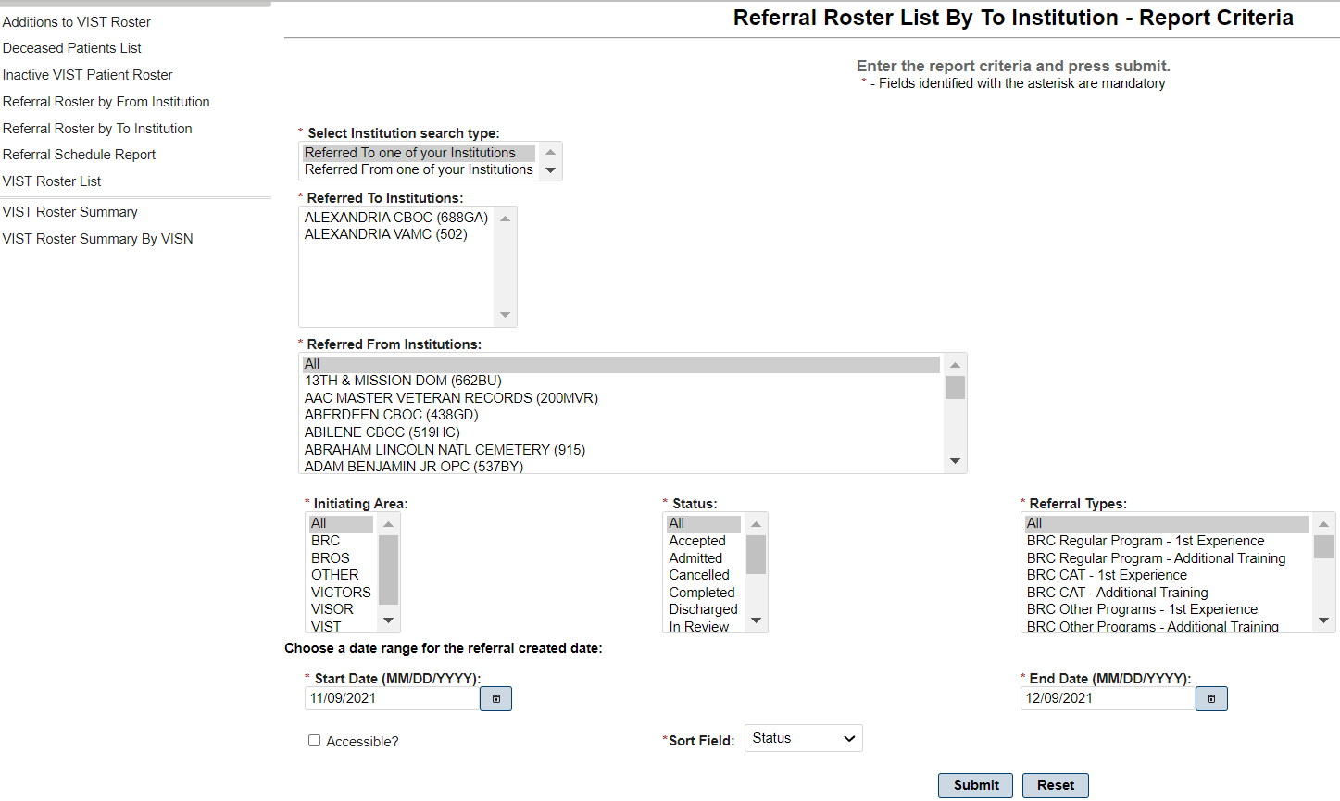
- From the Print Reports Menu, click Referral Roster by To Institution to display the Referral Roster List – Report Criteria screen.
- Use the following fields to search for a referral:
Select Institution Search Type:
Select one of the following search types:
- Referred From one of your Institutions
  - Use this type to search for referrals from your institution. Selecting this search type causes the option list in the Referred From Institutions field below to display the institutions from which that referral may have been sent. Use the Referred To Institutions field to select all of the institutions to which that referral may have been sent or you can select a specific institution to which that referral may have been sent.
- Referred To one of your Institutions
  - Use this type to search for referrals to your institutions. Selecting this search type causes the option list in the Referred To Institutions field below to display the institutions to which that referral may have been sent. Use the Referred From Institutions field to select all of the institutions from which that referral may have been sent or you can select a specific institution from which that referral may have been sent.
- Referred From Institutions:
  - Select the institution(s) that initiated the referral.
- Referred To Institutions:
  - Select the institution(s) to which the referral is sent.

Initiating Areas:
Select the area initiating the referral. Options include:
- All
- Waitlist
- Accepted
- Admitted
- Cancelled
- Completed
- Discharged
- In Review
- In Training
- Offered
- Pending
- Scheduled
- Transferred
- Withdrawn
Statuses:
Select one or more referral statuses. Options include:
- All
- Waitlist
- Discharged
- Offered
- In Review
- Completed
- Admitted
- Accepted
- Withdrawn
- Cancelled
- Scheduled
- Pending

NOTE: In an effort to simplify the selection when trying to identify specific Waitlist related information, selecting Waitlist causes the program to automatically select the appropriate statuses (Pending, In Review, and Accepted) that identify individuals on the waitlist based on the waitlist records with these statuses.
Referral Types:
Select all, one, or several referral types. Options include:
- All
- BRC CAT – 1st Experience
- BRC CAT – Additional Training
- BRC Dual Program – 1st Experience
- BRC Dual Program – Additional Training
- BRC Other Programs – 1st Experience
- BRC Other Programs – Additional Training
- BRC Regular Program – 1st Experience
- BRC Regular Program – Additional Training
- BROS Follow-up – 1st Experience
- BROS Follow-up – Additional Training
- BROS Local – 1st Experience
- BROS Local – Additional Training
- BROS Prep – 1st Experience
- BROS Prep – Additional Training
- Non-VA Blindness Agency – 1st Experience
- Non-VA Blindness Agency – Additional Training
- Non-VA Local CAT – 1st Experience
- Non-VA Local CAT – Additional Training
- VA Audible Devices
- VA Outpatient LV Clinic – 1st Experience
- VA Outpatient LV Clinic – Additional Training
- VICTORS – 1st Experience
- VICTORS – Additional Training
- VISOR – 1st Experience
- VISOR – Additional Training
- VIST Coordinator
NOTE: EXP means Experience; ADL TRN means Additional Training.

  - Enter the Start Date (MM/DD/YYYY) for the report or click the icon next to the field and select from a calendar. This date will determine how far back the system will search for patients in the selected institution(s).

  - Enter the End Date (MM/DD/YYYY) for the report or click the icon next to the field and select from a calendar. This date will usually be the current date.

- If applicable, place a check in the Accessible? checkbox field to indicate that you want the report 508 compliant.

- Select data in the fields, and then click the Submit button.

The report displays the list of referrals. The list contains the Referral Number, Created Date, Patient Name, Referral Type, Status, Referred to Institution (Station ID), Initiating Area, and Special Consideration. To generate the report in Adobe Acrobat format for printing, click the Export dropdown button and choose the file type to save the report.

Printing a Referral Schedule Report
This menu option provides you with a printout of referrals for blind rehabilitation based on the referral schedule. You have the choice of how far back in time (i.e., one day, one month, one year, two years, etc.) from which to retrieve information for the report results.
Figure 32: Referral Schedule Report
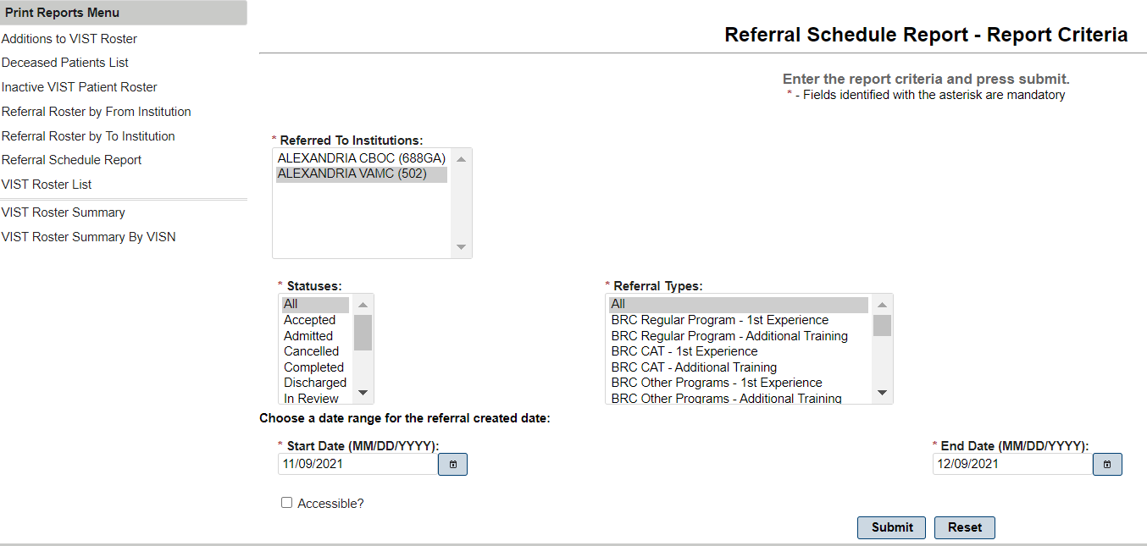
- From the Print Reports Menu, click Referral Schedule Report to display the Referral Schedule Report– Report Criteria screen
- Use the following fields to search for a referral:
Referred To Institutions:
Select the institution(s) that you want to include in the report.
Statuses:
Select one or more referral statuses. Options include:
- All
- Scheduled
- Admitted
- Cancelled
- Completed
- Discharged
- In Training
- Completed
- Transferred
- Withdrawn

Referral Types
Select all, one, or several referral types. Options include:
- All
- BRC CAT – 1st Experience
- BRC CAT – Additional Training
- BRC Dual Program – 1st Experience
- BRC Dual Program – Additional Training
- BRC Other Programs – 1st Experience
- BRC Other Programs – Additional Training
- BRC Regular Program – 1st Experience
- BRC Regular Program – Additional Training
- Enter the Start Date (MM/DD/YYYY) for the report or click the icon next to the field and select from a calendar. This date will determine how far back the system will search for patients in the selected institution(s).
- Enter the End Date (MM/DD/YYYY) for the report or click the icon next to the field and select from a calendar. This date will usually be the current date.
- If applicable, place a check in the Accessible? checkbox field to indicate that you want the report 508 compliant.
- Select data in the fields, and then click the Submit button.
The report displays the schedule. The list contains the Referral Date, Created By, Patient Name, SSN, Initiating Area, Status, Referral Type, Referred from Institution (Station ID), Admit/Discharge/Offered Service Dates, and Special Circumstances. To generate the report in Adobe Acrobat format for printing, click the Export dropdown button and choose the file type to save the report.

Printing a VIST Roster Summary
The VIST Roster Summary Report provides all VIST Roster summary information that occurred within the chosen dates. The report sorts by date.
Figure 33: VIST Roster Criteria
- From the Print Reports Menu, click VIST Roster Summary to display the VIST Roster Summary – Report Criteria screen.
- Select one or more or all the Institutions from which you want to report. The institutions list alphabetically in ascending order by name.
- Enter the Start Date (MM/DD/YYYY) for the report or click the icon next to the field and select from a calendar. This date will determine how far back the system will search for patients in the selected institution(s).
- Enter the End Date (MM/DD/YYYY) for the report or click the icon next to the field and select from a calendar. This date will usually be the current date.
- Click the Submit button to generate the report, or click the Reset button to clear the selected criteria and start over.
The report displays for each selected applicable institution. To generate the report in Adobe Acrobat format for printing, click the Export dropdown button and choose the file type to save the report.

Printing a VIST Roster Summary By VISN
The VIST Roster Summary Report by VISN (Veterans Integrated Service Network) provides all VIST Roster summary information that occurred within the chosen dates for the selected VISN(s). The report sorts by date.
Figure 34: VIST Roster Summary by VISN
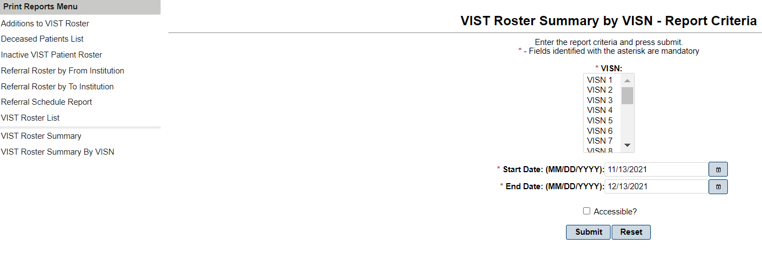
- From the Print Reports Menu, click VIST Roster Summary by VISN to display the VIST Roster Summary by VISN – Report Criteria screen.
- Select one or more or all the VISN(s) from which you want to report. They list in ascending order.
- Enter the Start Date (MM/DD/YYYY) for the report or click the icon next to the field and select from a calendar. This date will determine how far back the system will search for patients in the selected institution(s).
- Enter the End Date (MM/DD/YYYY) for the report or click the icon next to the field and select from a calendar. This date will usually be the current date.
- Click the Submit button to generate the report, or click the Reset button to clear the selected criteria and start over.
The VIST Roster Summary By VISN report displays. To generate the report in Adobe Acrobat format for printing, click the Printer icon and follow the directions on the screen.

Print VIST Roster Sorts Menu
This menu option displays a menu of sort options. Use to select the sort criteria for the VIST Roster before you generate each report. Each of these menu options generates a VIST Roster sorted by the specific option you select.
- Select the Print VIST Roster Sorts Menu to display the following sort menu options:
- Sort By Residence State
- Sort By County
- Sort By City
- Sort By Zip
- Sort By Month of Birth
- Sort By Age
- Sort Address/Phone
- Sort By Primary Cause of Vision Loss
- Sort By Period of Service
- Sort By Referral source
- Sort By eye Exam Notes

Sort By Residence State
- Select one or more or all the Institutions from which you want to report. The institutions list alphabetically in ascending order by name.
- In the States field, select the appropriate State.
- If applicable, place a check in the Include Deceased Patients checkbox to include deceased patients that have been added to the VIST Roster.
- If applicable, place a check in the Accessible? checkbox field to indicate that you want the report 508 compliant.
- Click the Submit button to generate the report, or click the Reset button to clear the selected criteria and start over.
- The Sort by State report displays. To generate the report in Adobe Acrobat format for printing, click the Export dropdown button and choose the file type to save the report.

Sort By County
- Select one or more or all of the Institutions from which you want to report. The institutions list alphabetically in ascending order by name.
- In the County to Use field, select ALL or SELECTED.
- If you choose ALL, when you click Submit to generate the report the Selected Counties field defaults to ALL.
- If you choose SELECTED, the County to Add field becomes available to use and you must enter the Counties:
- Enter the desired County in the County to Add field, and then click ADD. This will add the County to the Selected Counties field and make it available for selection when running the report.
- If applicable, place a check in the Include Deceased Patients checkbox to include deceased patients that have been added to the VIST Roster.
- If applicable, place a check in the Accessible? checkbox field to indicate that you want the report 508 compliant.
- Click the Submit button to generate the report, or click the Reset button to clear the selected criteria and start over.
The Sort by County report displays. To generate the report in Adobe Acrobat format for printing, click the Export dropdown button and choose the file type to save the report.

Sort by City
- Select one or more or all the Institutions from which you want to report. The institutions list alphabetically in ascending order by name.
- In the City to Use field, select All or SELECTED.
- If you choose ALL, when you click Submit to generate the report, the Selected Cities field defaults to ALL.
- If you choose SELECTED, the City to Add field becomes available to use and you must enter the Cities:
- Enter the desired City in the City to Add field, and then click ADD. This will add the City to the Selected City field and make it available for selection when running the report.
- If applicable, place a check in the Include Deceased Patients checkbox to include deceased patients that have been added to the VIST Roster.
- If applicable, place a check in the Accessible? checkbox field to indicate that you want the report 508 compliant.
- Click the Submit button to generate the report, or click the Reset button to clear the selected criteria and start over.
The Sort by City report displays. To generate the report in Adobe Acrobat format for printing, click the Export dropdown button and choose the file type to save the report.

Sort by Zip
- Select one or more or all the Institutions from which you want to report. The institutions list alphabetically in ascending order by name.
- In the Zip Codes to Use field, select All or SELECTED.
- If you choose ALL, when you click Submit to generate the report, the Selected Zip codes field defaults to ALL.
- If you choose SELECTED, the Zip code to Add field becomes available to use and you must enter the zip codes:
- Enter the desired zip code in the Zip code to Add field, and then click ADD. This will add the Zip code to the Selected Zip code field and make it available for selection when running the report.
- If applicable, place a check in the Include Deceased Patients checkbox to include deceased patients that have been added to the VIST Roster.
- If applicable, place a check in the Accessible? checkbox field to indicate that you want the report 508 compliant.
- Click the Submit button to generate the report, or click the Reset button to clear the selected criteria and start over.
The Sort by Zip Code report displays. To generate the report in Adobe Acrobat format for printing, click the Export dropdown button and choose the file type to save the report.

Sort by Month of Birth
- Select one or more or all the Institutions from which you want to report. The institutions list alphabetically in ascending order by name.
- Click the down arrow to select the starting month in the Birth Month Start field.
- Click the down arrow to select the ending month in the Birth Month End field.
- If applicable, place a check in the Include Deceased Patients checkbox to include deceased patients that have been added to the VIST Roster.

Sort by Age
- Select one or more or all the Institutions from which you want to report. The institutions list alphabetically in ascending order by name.
- Click the down arrow to select the start age in the Start Age field.
- Click the down arrow to select the end age in the End Age field.
- If applicable, place a check in the Include Deceased Patients checkbox to include deceased patients that have been added to the VIST Roster.
- If applicable, place a check in the Accessible? checkbox field to indicate that you want the report 508 compliant.
- Click the Submit button to generate the report, or click the Reset button to clear the selected criteria and start over.
The Sort by Age report displays. To generate the report in Adobe Acrobat format for printing, click the Export dropdown button and choose the file type to save the report.

Sort by Address/Phone
- Select one or more or all the Institutions from which you want to report. The institutions list alphabetically in ascending order by name.
- If applicable, place a check in the Include Deceased Patients checkbox to include deceased patients that have been added to the VIST Roster.
- If applicable, place a check in the Accessible? checkbox field to indicate that you want the report 508 compliant.
- Click the Submit button to generate the report, or click the Reset button to clear the selected criteria and start over.
The Sort by Address/Phone report displays. To generate the report in Adobe Acrobat format for printing, click the Export dropdown button and choose the file type to save the report.

Sort by Primary Cause of Vision Loss
- Select one or more or all the Institutions from which you want to report. The institutions list alphabetically in ascending order by name.
- If applicable, place a check in the Include Deceased Patients checkbox to include deceased patients that have been added to the VIST Roster.
- If applicable, place a check in the Accessible? checkbox field to indicate that you want the report 508 compliant.
- Click the Submit button to generate the report, or click the Reset button to clear the selected criteria and start over.
The Sort by Primary Cause of Vision Loss report displays. To generate the report in Adobe Acrobat format for printing, click the Export dropdown button and choose the file type to save the report.

Sort by Period of Service
- Select one or more or all the Institutions from which you want to report. The institutions list alphabetically in ascending order by name.
- If applicable, place a check in the Include Deceased Patients checkbox to include deceased patients that have been added to the VIST Roster.
- If applicable, place a check in the Accessible? checkbox field to indicate that you want the report 508 compliant.
- Click the Submit button to generate the report, or click the Reset button to clear the selected criteria and start over.
The Sort by Period of Service report displays. To generate the report in Adobe Acrobat format for printing, click the Export dropdown button and choose the file type to save the report.

Sort by Referral Source
- Select one or more or all the Institutions from which you want to report. The institutions list alphabetically in ascending order by name.
- If applicable, place a check in the Include Deceased Patients checkbox to include deceased patients that have been added to the VIST Roster.
- If applicable, place a check in the Accessible? checkbox field to indicate that you want the report 508 compliant.
- Click the Submit button to generate the report, or click the Reset button to clear the selected criteria and start over.
The Sort by Referral Source report displays. To generate the report in Adobe Acrobat format for printing, click the Export dropdown button and choose the file type to save the report.

Sort by Eye Exam Notes
- Select one or more or all the Institutions from which you want to report. The institutions list alphabetically in ascending order by name.
- If applicable, place a check in the Include Deceased Patients checkbox to include deceased patients that have been added to the VIST Roster.
- If applicable, place a check in the Accessible? checkbox field to indicate that you want the report 508 compliant.
- Click the Submit button to generate the report, or click the Reset button to clear the selected criteria and start over.
The Sort by Eye Exam Notes report displays. To generate the report in Adobe Acrobat format for printing, click the Export dropdown button and choose the file type to save the report.

Internet Explorer Keyboard Shortcuts
You can use shortcut keys to view and explore web pages, use the address bar, work with favorites, and edit.
Table 2: Keyboard Short Cuts – Viewing and Exploring the Web Pages
Short Cut Keys | Action Preformed
F1 | Display the Internet Explorer Help, or when in a dialog box, display context helps on an item
F11 | Toggle between Full Screen and regular view of the browser window
TAB | Move forward through the items on a Web page, the Address bar, and the Links bar
SHIFT+TAB | Move back through the items on a Web page, the Address bar, and the Links bar
ALT+HOME | Go to your Home page
ALT+RIGHT ARROW | Go to the next page
ALT+LEFT ARROW | Go to the previous page
ALT+LEFT BACKSPACE | Go to the previous page
SHIFT+F10 | Display a shortcut menu for a link
CTRL+TAB or F6 | Move forward between frames
SHIFT+CTRL+TAB | Move back between frames
UP ARROW | Scroll toward the beginning of a document
DOWN ARROW | Scroll toward the end of a document
PAGE UP | Scroll toward the beginning of a document in larger increments
PAGE DOWN | Scroll toward the end of a document in larger increments
HOME | Move to the beginning of a document
END | Move to the end of a document
CTRL+F | Find on this page
F5 | Refresh the current Web page only if the time stamp for the Web version and your locally stored version are different
CTRL+R | Refresh the current Web page only if the time stamp for the Web version and your locally stored version are different
CTRL+F5 | Refresh the current Web page, even if the time stamp for the Web version and your locally stored version are the same
ESC | Stop downloading a page
CTRL+O | Go to a new location
CTRL+L | Go to a new location
CTRL+N | Open a new window
CTRL+W | Close the current window
CTRL+S | Save the current page
CTRL+P | Print the current page or active frame
ENTER | Activate a selected link
CTRL+E | Open Search in Explorer bar
CTRL+I | Open Favorites in Explorer bar
CTRL+H | Open History in Explorer bar
CTRL+click | In History or Favorites bars, open multiple folders
Table 3: Key Board Short Cuts – Using the Address Bar
Short Cut Keys | Action Preformed
ALT+D | Select the text in the Address bar
F4 | Display the Address bar history
CTRL+LEFT ARROW | When in the Address bar, move the cursor left to the next logical break (. or /)
CTRL+RIGHT ARROW | When in the Address bar, move the cursor right to the next logical break (. or /)
CTRL+ENTER | Add "www." To the beginning and ".com" to the end of the text typed in the Address bar
UP ARROW | Move forward through the list of AutoComplete matches
DOWN ARROW | Move back through the list of AutoComplete matches
Table 4: Key Board Short Cuts – Working with Favorites
Short Cut Keys | Action Preformed
CTRL+D | Add the current page to your favorites
CTRL+B | Open the Organize Favorites dialog box
ALT+UP ARROW | Move selected item up in the Favorites list in the Organize Favorites dialog box
ALT+DOWN ARROW | Move selected item down in the Favorites list in the Organize Favorites dialog box
Table 5: Key Board Short Cuts – Editing
Short Cut Keys | Action Preformed
CTRL+X | Remove the selected items and copy them to the Clipboard
CTRL+C | Copy the selected items to the Clipboard
CTRL+V | Insert the contents of the Clipboard at the selected location
CTRL+A | Select all items on the current Web page

