CPRS List Manager

Bulk Parameter Editor for Notifications

User Guide
February 2020
Department of Veterans Affairs
Office of Information and Technology (OIT)

Revision History
NOTE: The revision history cycle begins once changes or enhancements are requested after the document has been baselined.
Place latest revisions at top of table.
Date | Revision | Description | Author
02/2020 | 1.0 | Initial version | BPEN Team
Table of Contents
1. Introduction 1
1.1. Bulk Parameter Editor for Notifications 1
2. Parameter Manager — The List Manager Interface 4
2.1. Parameter Manager — List Manager Interface Actions 4
3. Entity Management — The List Manager Interface 6
3.1. List Manager Interface Actions 6
3.2. Adding Entities to the List Automatically 6
3.3. Example of the Existing Method of Parameter Editing 7
3.4. Enable/Disable Notifications -- Processing Flag (PARAMETER): 8
3.5. Entity Management 10
3.5.1. New Entity List 12
4. Display the Notifications a User can Receive [NEW] 15
5. Alert Tracking Reports 19
5.1. Report Descriptions: 19
5.2. Summary Report 20
5.3. Top 10 Report 21
5.4. Filtered Report 24
5.5. Alert Tracking Report (CSV Format) 27
6. Report Menu for Alerts 31

Table of Figures
Figure 1: Notification Mgmt Menu. 2
Figure 2: Bulk Parameter Editor Menu. 3
Figure 3: Entity Selection screen 3
Figure 4: Set Default Recipient(s) for Notification 4
Figure 5: Parameter Manager: List Manager Interface. 4
Figure 6: Entity Management — List Manager Interface. 6
Figure 7: Example of Existing Method of Parameter Editing. 7
Figure 9:Processing flag Displaying Available Levels. 8
Figure 10: Processing Flag, Entity: User. 9
Figure 11: List Manager Display for Entity Management. 10
Figure 12: Adding Multiple Users to the Entity List. 11
Figure 13: Enter NEW PERSON screen. 11
Figure 14: Add Users to Entity List. 12
Figure 15:Example of changing the instance Value. 13
Figure 16: Editing Instance Values. 14
Figure 17: Results of updating all Instances to Enabled. 14
Figure 18: Bulk Parameter Editor Menu. 15
Figure 19: Condensed Notification List Report. 16
Figure 20: Detailed Notification List Report. 17
Figure 21: Basic Notification List Report. 18
Figure 22: Bulk Parameter Editor Menu. 19
Figure 23: Alert Tracking Reports Menu 19
Figure 24: Alert Tracking report (VistA) 20
Figure 25: Notification Data [SUMMARY] Report 21
Figure 26: Bulk Parameter Editor Menu. 22
Figure 27: Alert Tracking Reports Menu 22
Figure 28: Alert Tracking report (VistA) 22
Figure 29: Top 10 Report (Descending Order) 23
Figure 30: Bulk Parameter Editor Menu. 24
Figure 31: Alert Tracking Reports Menu 24
Figure 32: Alert Tracking report (VistA) 25
Figure 33: Filtered Report 26
Figure 34: Bulk Parameter Editor Menu. 27
Figure 35: Alert Tracking Reports Menu 27
Figure 36: Alert Tracking Report (CSV Format Prompts. 28
Figure 37: Example of Alert Tracking Report (CSV Format) – Data sent to Device. 29
Figure 38: Example of email message for report sent to Outlook. 30
Figure 39: Example of capturing the data in the email. 30

Introduction
The Bulk Parameter Editor for Notifications (BPEN) is a new List Manager option distributed in patch OR*3.0*500. It allows users to view and edit multiple Order Entry Results Reporting (OERR)/CPRS notification parameter settings simultaneously.
It utilizes naming conventions and editing of Kernel Parameters. Refer to the Kernel Parameters Tools Supplement for additional information to understand parameter management.
Definitions from the Kernel Developer’s Guide:
- Parameter: The actual name under which values are stored
- Entity: A level at which you can define a parameter
- Instance: Used when more than one value may be assigned to a given entity/parameter combination
- Value: Assigned to every parameter for the entities allowed in the parameter definition

NOTE: Using a number pad for entering numbers is not recommended.

OR*3.0*518 provides new reporting functionality to assist with the identification of high-volume View Alerts, enabling assessment of data and consideration of trends that may benefit from change. OR*3.0*518 introduces new menu option, Alert Tracking Reports, which is available on the Bulk Parameter Editor for Notifications menu.

Bulk Parameter Editor for Notifications
A new menu option is located on the “Notification Mgmt Menu” [ORB NOT COORD MENU] entitled “Bulk Parameter Editor for Notifications” [ORB3 LM 1 MAIN MENU].

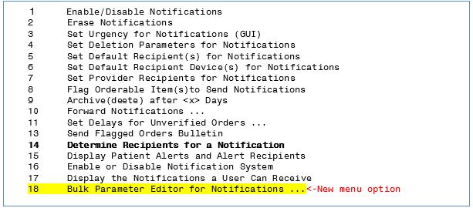
Figure 1: Notification Mgmt Menu.
- Select 18 to display the Bulk Parameter Editor for Notifications.
This new Bulk Parameter Editor Menu displays 18 new Notification options:

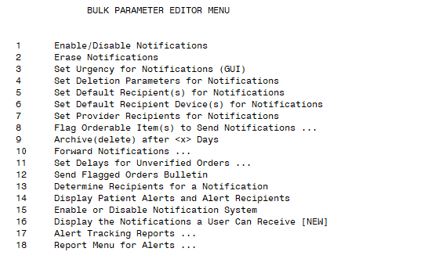
Figure 2: Bulk Parameter Editor Menu.
NOTE: In reference to the Notifications Mgmt Menu and the Bulk Parameter Editor Menu options, although some menu options appear to be duplicates, they are not the same:
- Notifications Mgmt Menu: Options on this menu are used to turn notifications on or off for a single provider.
- Bulk Parameter Editor Menu: Options on this menu allow users to view and edit multiple notification parameter settings simultaneously.

- Select 1- Enable/Disable Notifications to display the Entity Selection screen (for more information, refer to Section 3.3).
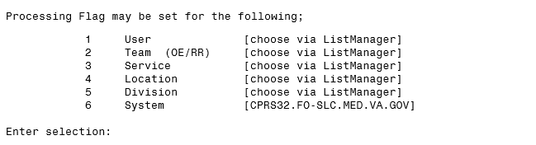
Figure 3: Entity Selection screen

- Set Default Recipient(s) for Notification:
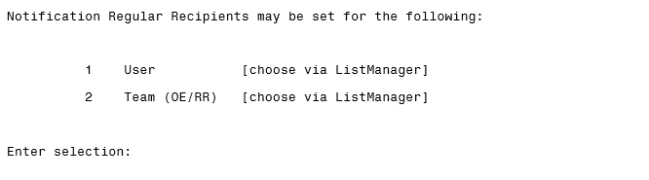
Figure 4: Set Default Recipient(s) for Notification

Parameter Manager — The List Manager Interface
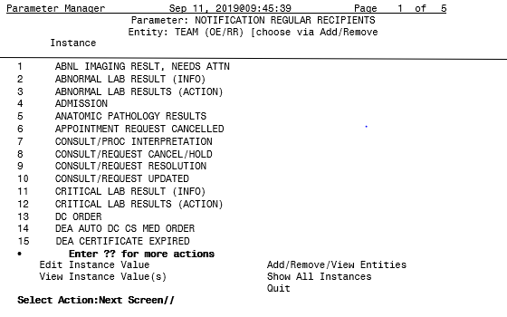
Figure 5: Parameter Manager: List Manager Interface.

Parameter Manager — List Manager Interface Actions
Edit Instance Value: Allows one to all* instances in the list to be edited. The appropriate values are automatically available for selection when editing an instance value.
This action is the default List Manager action. To select many instances (>76), enter EDIT, and then enter a range (3-8) or list of numbers (3,6,8-10).
View Instance Value(S): Displays all the current ENTITIES and the values currently set for the INSTANCE.
Add/Remove/View Entities: Starts the Entity Management List Manager application.
Show All Instances: Displays all instance values of a SINGLE ENTITY type such as SYSTEM level.

Entity Management — The List Manager Interface
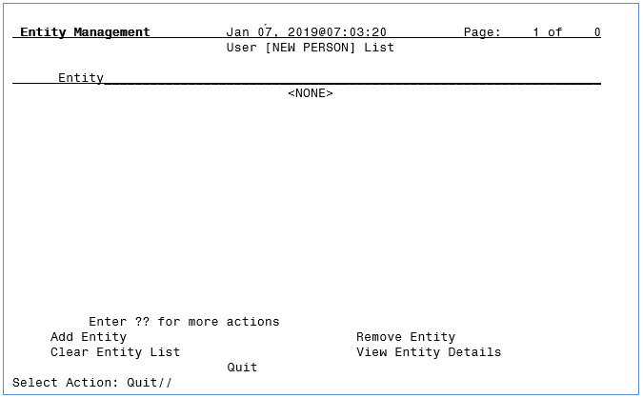
Figure 6: Entity Management — List Manager Interface.

List Manager Interface Actions
Add Entity: Allows entities to be added from the appropriate file to the list for editing. All entities in the list are edited simultaneously from the Parameter Manager. Press <ENTER> to finish adding entries.
Remove Entity: Allows entities to be removed from the list for editing. One or more entries may be removed at a time.
Clear Entity List: Removes all entities from the list at one time.
View Entity Details: Displays all the current INSTANCE(S) and the values currently set for the ENTITY.
Quit: Exits the Entity Management List Manager interface.

Adding Entities to the List Automatically
When editing a PARAMETER at the ENTITY level for the USER/NEW PERSON file, there is additional functionality to make bulk editing of users and Notification Parameters easier:
- At the Parameter Manager, select VIEW INSTANCE VALUE(S) to see all the current values for an instance. At the end of the page, you will be prompted:
Press <ENTER> to continue, ‘A’, ‘S’, or ‘^’ to exit
- Entering a “?” and pressing <ENTER> will display the help text:
Press <ENTER> to continue displaying the list.
Press '^' to exit displaying the list.
Selecting 'A' will add ALL of the users in this list as ENTITIES.
Selecting 'S' will add SOME of the users based on the selected parameter value.
- Entering ‘A’ and pressing <ENTER> will add ALL entities that have a value set for the instance to automatically be added to the ENTITY MANAGER LIST for editing.
- Entering ‘S’ and pressing <ENTER> will then prompt for a parameter value. All entities with the selected value will automatically be added to the ENTITY MANAGER LIST for editing.
- Once ‘A’ or ‘S’ have been selected (with a value as needed), you will automatically be taken to the ENTITY MANAGEMENT application displaying the current list.
IMPORTANT NOTE: This action only ADDS entities to the list. Entities already on the list will remain.

Example of the Existing Method of Parameter Editing
Parameter=Processing Flag
Entity=User (CPRS,PROVIDER)
Instance=Notification (ABNL IMAGING RESLT, NEEDS ATTN)
Value=Enabled
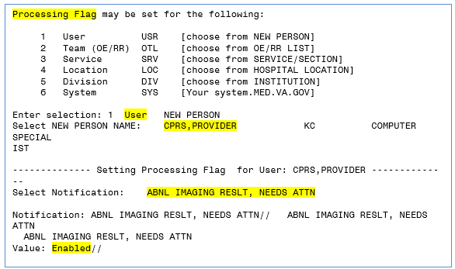
Figure 7: Example of Existing Method of Parameter Editing.
NOTE: Using the existing method allows only ONE user to be edited for ONE Notification. The BPEN walkthrough will edit the same Notification [ABNL IMAGING RESLT, NEEDS ATTN] below.

Enable/Disable Notifications -- Processing Flag (PARAMETER):
Once a Notification Parameter has been selected for editing, the desired Entity level must be selected. There are up to 6 levels available for a Notification Parameter. The available levels will be shown for each Notification Parameter.
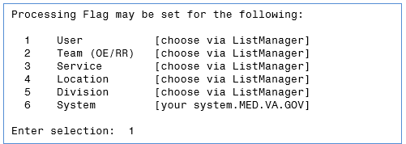
Figure 9:Processing flag Displaying Available Levels.
- When a level displays [choose via ListManager], it indicates that the Notification Parameter ENTITY may be set for one or more INSTANCES at a time. This is the main new feature of the BPEN.
- Levels that display a value, typically the “System” level, indicate that only a single ENTITY may be edited at a time.
- Once a level has been selected, the main Parameter Manager screen displays via List Manager.

NOTE: Observe the current Parameter [PROCESSING FLAG] and Entity [USER] displayed in the title area of the display. Entities must be added via another List Manager display before any Processing Flag values may be edited. In this example, the entities needed are USERS.
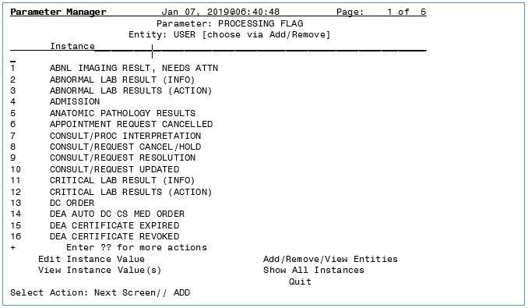
Figure 10: Processing Flag, Entity: User.
- Entering ADD/REMOVE/VIEW ENTITIES navigates to another List Manager display for Entity Management.

Entity Management
Figure 11: List Manager Display for Entity Management.
Currently, the list is empty:
- To ADD ENTITY, you may add a group of users to the ENTITY list by Team, Service, Division or All active users.
- If you select Team, Service, or Division, you will be prompted to enter the name of a Team, Service or Division, and the names associated with the ENTITY will be added to the list automatically.
- You may add multiple Teams or Divisions. Each time you enter a new ENTITY, the names will be added to the list automatically and you will return to the Entity Management List Manager interface.
- If you choose All, all active CPRS users will be added to the list automatically, you will return to the Entity Management List Manager interface, and all the names will be listed.
- You may add more users, by selecting add Entity.

The example below demonstrates addition of multiple users based on selection of a Service.
- After you select ‘S,’ and then enter the name of the SERVICE/SECTION, all the names of the users associated with the SERVICE/SECTION will be added automatically to the Entity List and you will be returned to the Entity List.
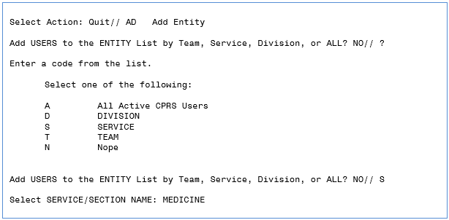
Figure 12: Adding Multiple Users to the Entity List.
- If you enter NO to the “Add USERS to the ENTITY List by Team, Service, Division, or ALL? NO//,” you will proceed to “Enter NEW PERSON:” and may add one or more NEW PERSON names to the entity list.

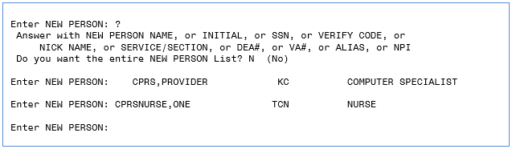
Figure 13: Enter NEW PERSON screen.

New Entity List
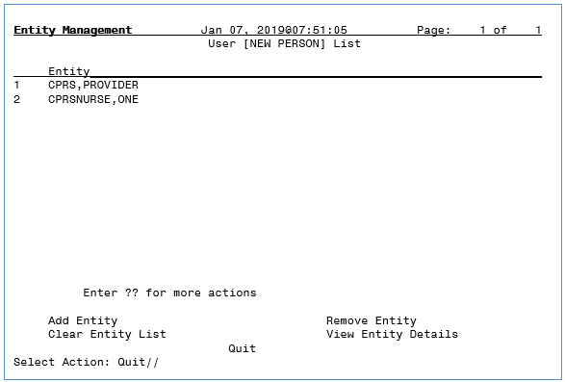
Figure 14: Add Users to Entity List.
IMPORTANT NOTE: Add as many users to the list as desired.
When you “Quit,” you will return to the Parameter Manager List Manager interface.
The next steps display the new functionality of the Bulk Parameter Editor for Notifications (BPEN).

- Enter EDIT to change the instance value of the users from the ENTITY list.
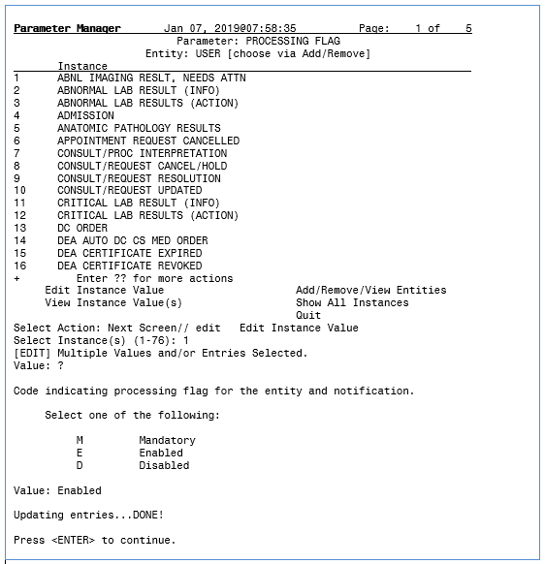
Figure 15:Example of changing the instance Value.
In the example above, note that only Instance 1 (ABNL IMAGING RESLT, NEEDS ATTN) was selected and the value was ENABLED. Both users from the ENTITY List Manager application had their Notification Parameter edited to ENABLED.

IMPORTANT NOTE: ALL instance values in the list may be edited at one time. Instead of entering just 1, you may enter any number of instances in a list or range of numbers or both. Example: 1-5,9,15-20

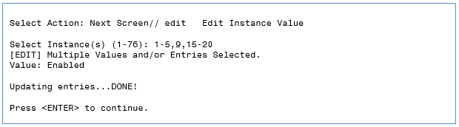
Figure 16: Editing Instance Values.
- To see the results, go back to ADD/REMOVE VIEW ENTITIES. Enter VIEW ENTITY DETAILS and select 1.
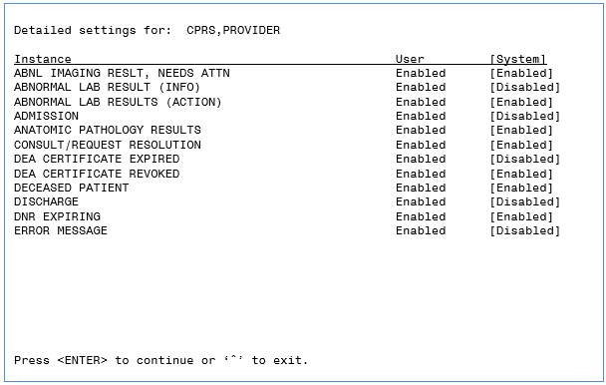
Figure 17: Results of updating all Instances to Enabled.
All 12 Instances (Notification Parameters) have been updated at once to Enabled from selecting 1-5,9,15-20 for the selected users in the Entity Management List.

IMPORTANT NOTE: You may compare the USER setting values to the SYSTEM setting values. When you change the value of a setting for an Entity, only the values for that Entity will be changed. In the above example, only the setting values were changed for the USER level Entity.

Display the Notifications a User can Receive [NEW]
A new option, Display the Notifications a User can Receive [New], has been added to the Bulk Parameter Editor for Notifications menu option. It was added to evaluate notifications sent to a user. It provides details that are NOT included in the ‘Display the Notifications a User Can Receive’ option on the Coordinators Notification Mgmt Menu.
The new option evaluates all Teams and Divisions as well as User, System and Package. Location is not evaluated by either this option or the original option. The new option prompts for a user/recipient then processes each notification to determine if and why the user will receive the notification. This information is then displayed. The precedence hierarchy is determined based on the Notification Processing Matrix (in APPENDIX B) of the CPRS Technical Manual updated January 2020).
The report may be displayed in three formats: Condensed, Detailed or Basic Report.
Figure 18: Bulk Parameter Editor Menu.

Enter the name of the USER to display their notification list. There are three report formats: Condensed, Detailed, or Basic Report. Select Condensed. At the DEVICE: HOME// prompt, you may enter a device or host file. If you want to display the report without page breaks, enter ;9999.

Condensed Report below displays the name of the Notifications, Status and Why the user is receiving the Notification.

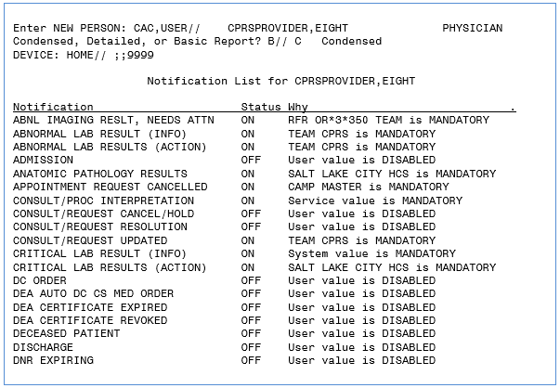
Figure 19: Condensed Notification List Report.

Detailed Report displays All ENTITIES regardless of whether a Processing Flag value is assigned.

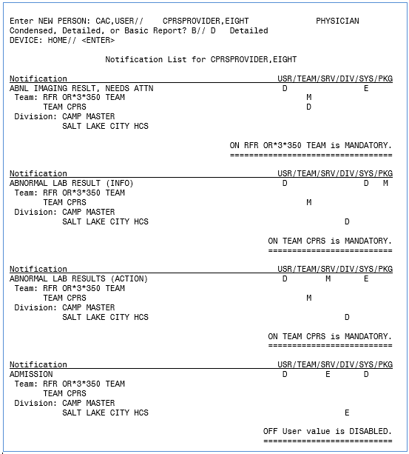
Figure 20: Detailed Notification List Report.

Basic Report displays only the ENTITIES assigned a Processing Flag.

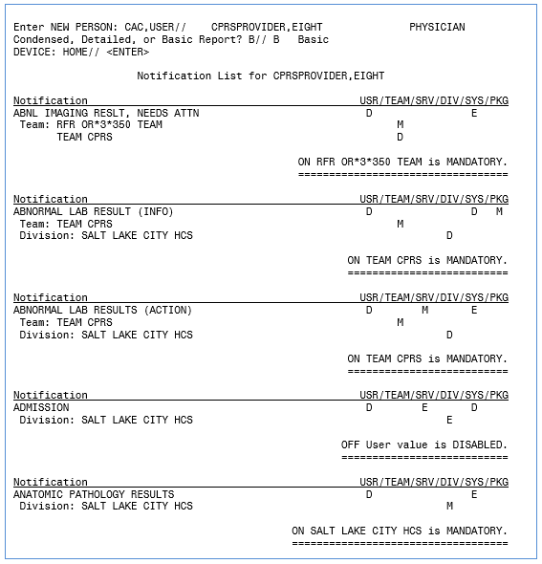
Figure 21: Basic Notification List Report.

Alert Tracking Reports

Report Descriptions:
The Alert Tracking Report (VistA) introduces three new VistA reports:
- Two predefined reports—based on date range:
- SUMMARY Report: Displays total counts by Notification, Recipient, Title, Service, Division, Location.
- TOP 10 Report: Displays total counts for the top ten entries with the greatest counts: Notifications, Recipients, Titles, Services, Divisions, Locations.
- One customizable report—based on date range:
- FILTERED Report: Displays Notifications and total counts sorted by one or more filters: Notification, Recipient, Title, Service, Division, Location.

- From the Notification Mgmt Menu, select 18 Bulk Parameter Editor for Notifications.

Figure 22: Bulk Parameter Editor Menu.
- From the Bulk Parameter Editor Menu, select 17 Alert Tracking Reports
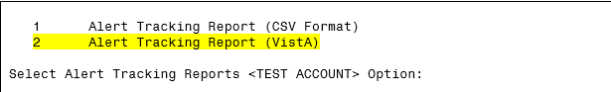
Figure 23: Alert Tracking Reports Menu

NOTE: Alert Tracking Report (CSV Format) was distributed and documented for OR*3.0*500. OR*3.0*518 renamed the option to differentiate it from the new Alert Tracking Report (VistA).

- Select 2 Alert Tracking Report (VistA)
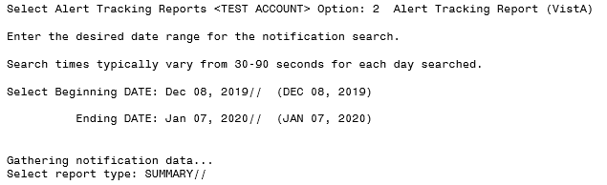
Figure 24: Alert Tracking report (VistA)

Summary Report
This report displays total counts by Notification, Recipient, Title, Service, Division, and Location.
- Refer to Figure 24 and perform the following (Do NOT use the numeric keypad 0-9):
  - Enter a Beginning Date; the default date is one month prior to today.
  - Enter an Ending Date; the default date is today’s date.
  - Note that search times will vary according to the number of days searched.
  - Select SUMMARY as the report type; SUMMARY is the default report.
  - Enter ;;9999 at the DEVICE prompt so the report will display without page breaks. The DEVICE prompt is a standard device prompt so you may enter other devices such as a host file or a spooler. This report can also be logged to a text file.

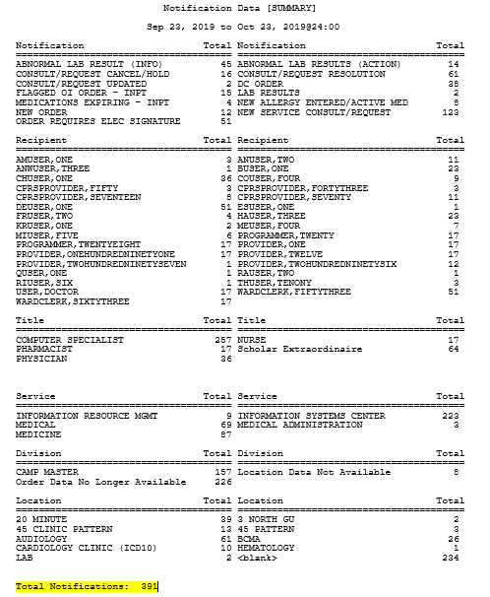
Figure 25: Notification Data [SUMMARY] Report

Top 10 Report
This report displays total counts for the top ten entries with the greatest counts: Notifications, Recipients, Titles, Services, Divisions, and Locations.
- From the Bulk Parameter Editor Menu, select 17 Alert Tracking Reports
Figure 26: Bulk Parameter Editor Menu.
Figure 27: Alert Tracking Reports Menu
- Select 2 Alert Tracking Report (VistA)
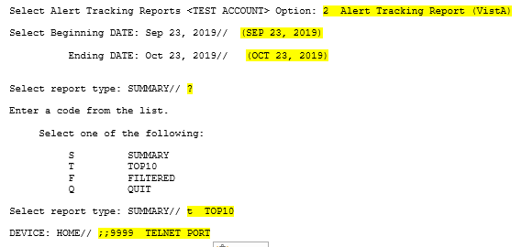
Figure 28: Alert Tracking report (VistA)
- Refer to Figure 28 and perform the following (Do NOT use the numeric keypad 0-9):
- Enter a Beginning Date; the default date is one month prior to today.
- Enter an Ending Date; the default date is today’s date.
- Note that search times will vary according to the number of days searched.
- Select TOP 10 as the report type. Enter a “?” for selection choices.
- Enter ;;9999 at the DEVICE prompt so the report will display without page breaks. The DEVICE prompt is a standard device prompt so you may enter other devices such as a host file or a spooler. You could also log this report to a text file.
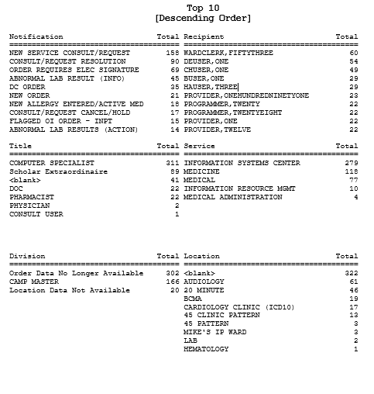
Figure 29: Top 10 Report (Descending Order)

Filtered Report
This report displays notifications and total counts sorted by one or more filters: Notification, Recipient, Title, Service, Division, Location.
- From the Bulk Parameter Editor Menu, select 17 Alert Tracking Reports
Figure 30: Bulk Parameter Editor Menu.
Figure 31: Alert Tracking Reports Menu

- Select 2 Alert Tracking Report (VistA)
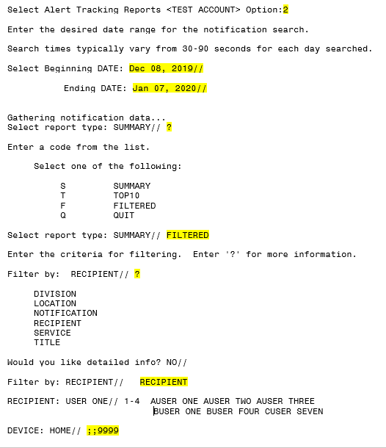
Figure 32: Alert Tracking report (VistA)
- Refer to Figure 32 and perform the following (Do NOT use the numeric keypad 0-9):
- Enter a Beginning Date; the default date is a month prior to today.
- Enter an Ending Date; the default date is today’s date.
- Note that search times will vary according to the number of days searched.
- Enter a “?” for selection choices. Select FILTERED as the report type.Enter a “?” to display the filtering options. You may enter one or more filters separated by a comma, e.g., r,n,s. In the example below, one filter was selected: RECIPIENT.
NOTE: The filter with the greatest number of notifications for their type will be the default filter.
You will be prompted to select an entry for each selected filter. You may enter one or more entries. For example, entering a “?” will display a numbered list of selection choices. You may enter a range of numbers (1-2), individual numbers separated by a comma (1,5,7-10), part of the last names separated by a comma (bak,def,crum) or “all.” After you enter the selection for each filter, all of the items for the selected filter will display.
Enter ;;9999 at the DEVICE: HOME// prompt so the report will display without page breaks. The DEVICE prompt is a standard device prompt so you may enter other devices such as a host file or a spooler. You could also log this report to a text file.
The FILTERED report below is a very simple report with one selected filter, Recipient.
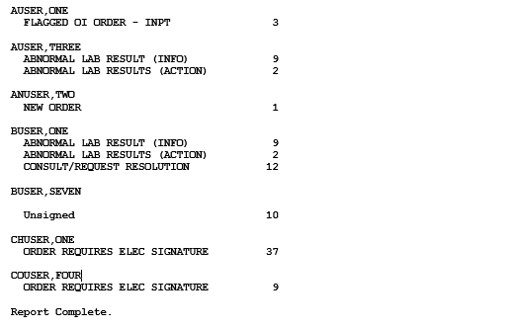
Figure 33: Filtered Report
The first row displays the name of the recipient; subsequent rows are indented and display each Notification associated with the recipient. The total Notification Count displays to the right of the Notification

Alert Tracking Report (CSV Format)
- From the Bulk Parameter Editor Menu, select 17 Alert Tracking Reports.
Figure 34: Bulk Parameter Editor Menu.
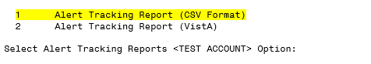
Figure 35: Alert Tracking Reports Menu
- Select 1 Alert Tracking Report (CSV Format).
NOTE: The Alert Tracking Report (CSV Format) option prompts for report start and end dates and may be sent to a device or host file, a mail message, or both. The 30 day default date range might take more than an hour and impact system resources, where the same trends may be seen over 7 days. Consider running lengthy reports after hours, or printing to a spooler.
.

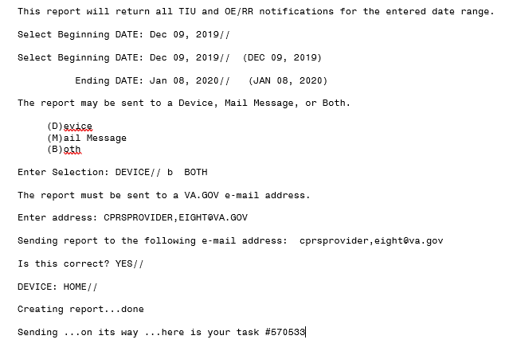
Figure 36: Alert Tracking Report (CSV Format Prompts.
Whether you send the data to a device or an email message, it can be uploaded into an excel spreadsheet and further manipulated via pivot tables.
If you send the data to a device or a host file, it will look like the example on the next page (Figure 37).

NOTE:
- You may set up your terminal and device to display 255 characters to avoid line-wrapping
- You may also capture the report into a file by setting up a logging file, Starting the logging after entering the device parameters: DEVICE: 0;255;9999 and then Stopping the logging after the report prints to the screen
- Upload the data into an excel spreadsheet using one of the training examples on the View Alert Pulse
- Each data field is delimited by a coma
- If a data field is blank (see first line of data below), there will be two comas
- If the order or note associated with the alert has been deleted, the DIVISION [LOCATION] data field will display: Data No Longer Available

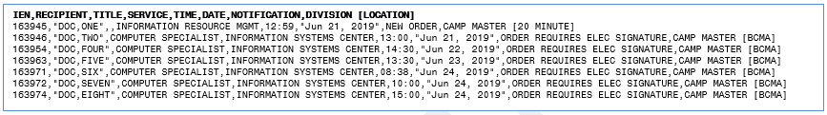
Figure 37: Example of Alert Tracking Report (CSV Format) – Data sent to Device.

Mail Message: If you send the report to an OUTLOOK email message, the screen capture below is what you will see in the email message.
- Place your cursor on the blue line and click on Restore Line Breaks.
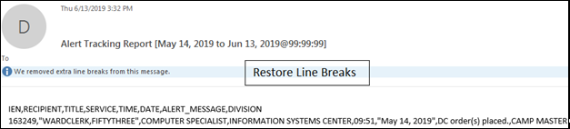
Figure 38: Example of email message for report sent to Outlook.
If you want to upload this data to a spreadsheet, click on select all and copy.
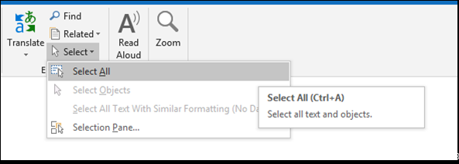
Figure 39: Example of capturing the data in the email.

- Paste the copied report into Notepad
- Save the text file where you can retrieve it easily.
- To import the text file into Excel, refer to the training:
https://www.vapulse.va.gov/docs/DOC-229793

Report Menu for Alerts
The Report Menu for Alerts [XQAL REPORTS MENU] was added to the Bulk Parameter Editor for Notifications menu option for ease of access. This is a Kernel menu option and includes five options that provide useful functionality for trouble-shooting View Alerts.
For additional information about the Report Menu for Alert functionality, refer to the Kernel 8.0 and Kernel Toolkit 7.3 Technical Manual, Section 5.3.1 Kernel, and then search for the desired Report Menu option. Included below is a list of the five options accessible on the Report Menu for Alerts [XQAL REPORTS MENU].
- Critical Alerts Count Report [XQAL CRITICAL ALERT COUNT]
- List Alerts for a user from a specified date [XQAL ALERT LIST FROM DATE]
- Patient Alert List for specified date [XQAL PATIENT ALERT LIST]
- User Alerts Count Report [XQAL USER ALERTS COUNT]
- View data for Alert Tracking file entry [XQAL VIEW ALERT TRACKING ENTRY]

