Update _2_0_290

Clinical Reminders

VA-TELECRITICAL CARE NOTE

Install Guide

July 2022

Product Development
Office of Information Technology
Department of Veterans Affairs

Table of Contents
Introduction 1
Install Details 3
Install Example 4
Post Installation 7

Introduction
In 2020 the Tele-ICU based in Cincinnati and the Tele-ICU based in Minneapolis began the process of merging and becoming a national program called TeleCritical Care (TeleCC). Each of the Tele-ICU programs began as a separate VISN program, so there are two different Tele-ICU CPRS notes in use. This National CPRS note will take the place of the local CPRS notes that are currently in use, for we are now one national program, TeleCritical Care. Please note that this note template is only to be used by TeleCC clinicians.

Sites that do not provide inpatient services should install this update but will not need to set up the note title.

UPDATE_2_0_290 contains 1 Reminder Exchange entry:
UPDATE_2_0_290 VA-TELECRITICAL CARE NOTE

The exchange file contains the following components:

TIU TEMPLATE FIELD
IC/BLANK LINE 74 CHARACTERS T DIALOG USE
TEXT (1-30 CHAR)
WP 1 LINE
DATE & TIME
TELE CC NUR PN OUTCOME OTHER
EB 20/240
TELE-CC NUR PN CHECK ALL APPLY
TELE CC COMMUNICATION BY
VA-TELECRITICAL CARE FAMILY MEMBER
WP 2 LINE
VA-TELCRITICAL CARE DOC CODE STATUS
VA-TELCRITICAL CARE LST NOTE
TEXT (1-30 CHAR) REQ
VA-TELE CC NUTR EXPLAIN
DATE

HEALTH FACTORS
VA-REMINDER UPDATES [C]
VA-UPDATE_2_0_290
VA-TELE-CC PROVIDER/NURSING NOTE [C]
VA-TELE CC NURSE CRITICAL LAB VALUE NOTIFICATION
VA-TELE CC NUR INTERACTION CALL >1HR
VA-TELE CC NUR INTERACTION CALL 46-60 MIN
VA-TELE CC NUR INTERACTION CALL 31-45 MIN
VA-TELE CC NUR INTERACTION CALL 16-30 MIN
VA-TELE CC NUR INTERACTION CALL 11-15 MIN
VA-TELE CC NUR INTERACTION CALL 6-10 MIN
VA-TELE CC NUR INTERACTION CALL 1-5 MIN
VA-TELE CC NURSE OUTCOME/EVALUATION THERAPY ADJUSTED
VA-TELE CC NURSE OUTCOME/EVALUATION NO CARE PLAN CHANGES
VA-TELE CC NURSE OUTCOME/EVALUATION OTHER
VA-TELE CC NURSE OUTCOME/EVALUATION TELE CC ASSISTANCE DECLINED
VA-TELE CC NURSE OUTCOME/EVALUATION PATIENT STATUS IMPROVED
VA-TELE CC NURSE OUTCOME/EVALUATION TELE CC PHYSICIAN NOTIFIED
VA-TELE CC NURSE OUTCOME/EVALUTION INCREASED OBSERVATION
VA-TELE CC NURSE OUTCOME/EVALUATION BEDSIDE PHYSICIAN NOTIFIED
VA-TELE CC NURSE OUTCOME/EVALUATION BEDSIDE RN NOTIFIED
VA-TELE CC NURSE PN INTERACTION PATIENT/FAMILY EDUCATION
VA-TELE CC NURSE PN INTERACTION OTHER
VA-TELE CC NURSE PN INTERACTION WITNESS/2ND SIGN ON MED AND TX
VA-TELE CC NURSE PN INTERACTION EVALUATE PATIENT
VA-TELE CC NURSE PN INTERACTION TROUBLESHOOT
VA-TELE CC NURSE PN INTERACTION MANAGE TREATMENT/THERAPY
VA-TELE CC NURSE PN INTERACTION ANALYZE/INTERPRET RESULTS
VA-TELE CC NURSE PN INTERACTION CONSULTATION NURSE TO NURSE
VA-TELE CC NURSE PN INTERACTION ASSIST W CPR/RAPID RESPONSE
VA-TELE CC NUR TR ROUND
VA-TELE CC NUR TR CALLS/E-ALERT
VA-TELE CC NUR TR ELERT
VA-TELE CC NUR TR ARRHYTHMIA
VA-TELE CC NUR TR ALERT
VA-TELE CC VERBAL AGREEMENT PT/FAM OPTED OUT TELE CC VIDEO
VA-TELE CC VERBAL AGREEMT VM UNABLE OBTAIN CALL CC WHEN PT READY
VA-TELE CC VERBAL STAFF BEDSIDE
VA-TELE CC VERBAL STAFF TO FAMILY
VA-TELE CC VERBAL AGREEMNT VIDEO MONIT OBTAIN BY TELE CC FROM PT
VA-TELE CC NURSE ADMISSION PT ADMITTED TO TELE CRITICAL CARE
VA-TELE CC NURSE NOTE
VA-TELE CC PROVIDER TIME >60 MINS
VA-TELE CC PROVIDER TIME 51-60 MINS
VA-TELE CC PROVIDER TIME 41-50 MINS
VA-TELE CC PROVIDER TIME 31-40 MINS
VA-TELE CC PROVIDER TIME 21-30 MINS
VA-TELE CC PROVIDER TIME 11-20 MINS
VA-TELE CC PROVIDER TIME 6-10 MINS
VA-TELE CC PROVIDER TIME 1-5 MINS
VA-TELE CC PROVIDER NOT PLACED BY TELE CC NO
VA-TELE CC PROVIDER ORDERS PLACED BY TELE CC YES
VA-SUICIDE SAFETY PLAN [C]
VA-TELE CC PROVIDER INTERACTION CHANGE PT CARE DECLINED ASSIST
VA-TELE CC PROVIDER INTERACTION CHANGE PATIENT CARE NO
VA-TELE CC PROVIDER INTERACTION CHANGE PATIENT CARE YES
VA-TELE CC PROVIDER COMMUNICATION W SITE PHY TO HEALTH CARE TEAM
VA-TELE CC PROVIDER COMMUNICATION W SITE PHYSICIAN TO NURSE
VA-TELE CC PROVIDER COMMUNICATION W SITE PHYSICIAN TO RESIDENT
VA-TELE CC PROVIDER COMMUNICATION W SITE PHYSICIAN TO PROVIDER
VA-TELE CC PROVIDER COMMUNICATION W SITE PHYSICIAN TO PHYSICIAN
VA-TELE CC PROVIDER COMMUNICATION W SITE APRN TO HEALTHCARE TEAM
VA-TELE CC PROVIDER COMMUNICATION W SITE APRN TO NURSE
VA-TELE CC PROVIDER COMMUNICATION W SITE APRN TO RESIDENT
VA-TELE CC PROVIDER COMMUNICATION W SITE APRN TO PROVIDER
VA-TELE CC PROVIDER COMMUNICATION W SITE APRN TO PHYSICIAN
VA-TELE CC PRO COMMUNICATION YES
VA-TELE CC PROVIDER COMMUNICATION W SITE DEFERRED
VA-TELE CC PRO COMM INITIATED BY PRIMARY
VA-TELE CC PRO COMM INITIATED BY TELE
VA-TELE PRO CRITICAL LAB CALL
VA-TELE CC PRO CRITICAL TRANSFER
VA-TELE CC PRO CRITICAL ARRHYTHMIA
VA-TELE CC PRO CRITICAL RESPIRATORY
VA-TELE CC PRO CRITICAL SEVERE HYPOTENSION
VA-TELE CC PROVIDER CRITICAL SEVERE HTN OR ACS OR ANGINA
VA-TELE CC PROVIDER CRITICAL CARDIOPULMONARY ARREST
VA-TELE CC PRO CRITICAL ASSESS CHANGE
VA-TELE CC PRO CRITICAL NOTE
VA-TELE CC PRO ACUTE NOTES FAMILY END
VA-TELE CC PRO ACUTE NOTES FAMILY UPDATE
VA-TELE CC PRO ACUTE NOTES FAMILY
VA-TELE CC PRO ACUTE NOTES ASSESS LAB
VA-TELE CC PRO ACUTE NOTES ASSESS HEMOD
VA-TELE CC PROVIDER ACUTE NOTES ASSESS CHANGE RESP SUPPORT
VA-TELE CC PRO ACUTE NOTES ASSESS
VA-TELE CC PRO ACUTE NOTES
VA-TELE CC PRO RT ORD LINE/TUBE
VA-TELE CC PRO ADMISSION REVIEW
VA-TELE CC PRO BEST PR VENT
VA-TELE CC PRO BEST PR SUP
VA-TELE CC PRO BEST PR SEPSIS
VA-TELE CC PRO BEST PR SED
VA-TELE CC PRO BEST PR GLUCOSE
VA-TELE CC PRO BEST PR DVT
VA-TELE CC PRO BEST PRACTICES
VA-TELE CC PRO ROUTINE ORDER
VA-TELE CC PROVIDER MULTIDISCIPLINARTY ROUND NOTE
VA-TELE CC PROVIDER ROUTINE NOTE
VA-TELE CC PROVIDER

REMINDER SPONSOR
OFFICE OF SPECIALTY CARE SERVICES

REMINDER TERM
VA-REMINDER UPDATE_2_0_290

REMINDER DIALOG
VA-TELECRITICAL CARE NOTE

Install Details

This update is being distributed as a web host file. The address for the host file is: https://REDACTED/UPDATE_2_0_290.PRD

The file will be installed using Reminder Exchange, programmer access is not required.

Installation:
=============
This update can be loaded with users on the system. Installation will take less than 5 minutes.

Install Example
To Load the exchange file, use LWH. The URL is https://REDACTED/UPDATE_2_0_290.PRD

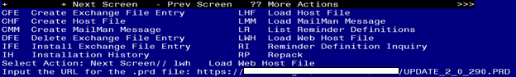

If you use LWH and it works, you will see something like this message. Make sure the file was loaded successfully.
Search and locate an entry titled UPDATE_2_0_290 VA-TELECRITICAL CARE NOTE in reminder exchange.
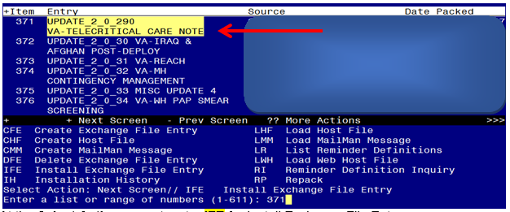

At the Select Action prompt, enter IFE for Install Exchange File Entry
Enter the number that corresponds with your entry titled UPDATE_2_0_290 VA-TELECRITICAL CARE NOTE (in this example it is entry 369, it will vary by site) that is dated 07/05/2022.

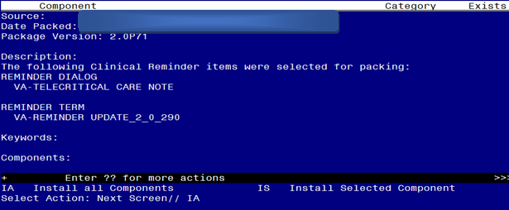
At the Select Action prompt, type IA for Install all Components and hit enter.
For all new entries in any category you will choose I to Install
Skip any items in any category you are prompted to overwrite

You will then be prompted to install the dialog component.
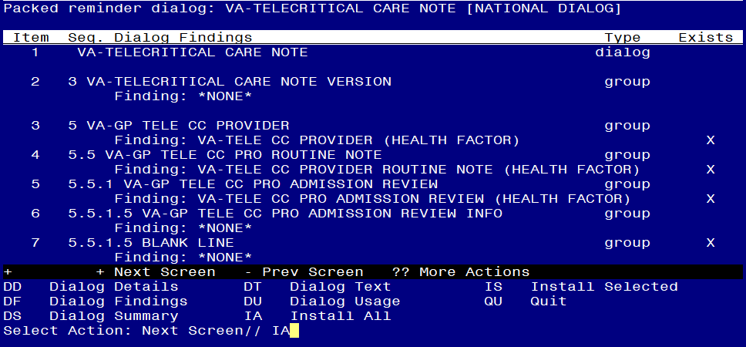
At the Select Action prompt, type IA to install the dialog – VA-TELECRITICAL CARE NOTE
Install reminder dialog and all components with no further changes: Y//ES

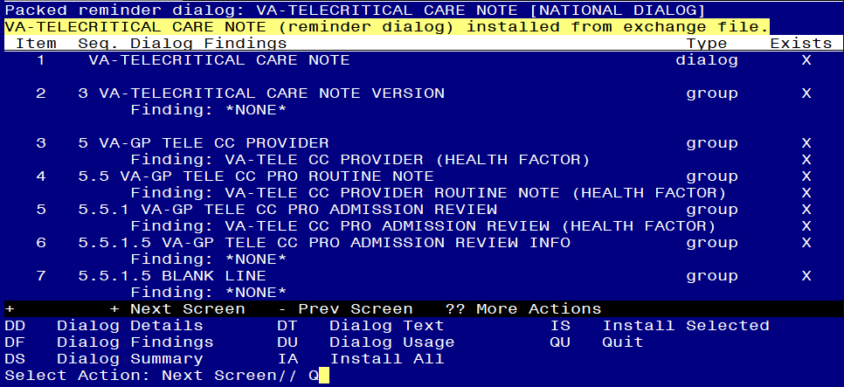
When the dialog has completed installation, you will then be returned to this screen. At the Select Action prompt, type Q.

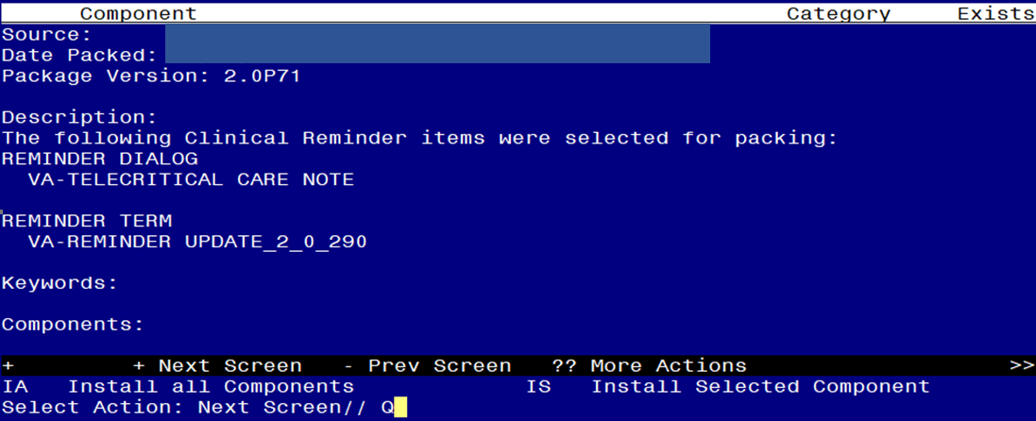
You will then be returned to this screen. At the Select Action prompt, type Q.

Install complete.

Post Installation

THE POST INSTALL STEPS ARE ONLY NECESSARY FOR SITES THAT PROVIDE INPATIENT SERVICES.

- Setup of Note Title.

The note title to create to associate with this template is: TELECRITICAL CARE NOTE
VHA Enterprise Standard Title: TELEHEALTH NOTE

You can add these to your document class where telehealth progress notes are located.

Note: Comprehensive information on Creating new Document Classes and Titles can be found beginning on page 54 of the TIU/ASU Implementation Guide at the following link: http://www.va.gov/vdl/documents/Clinical/CPRS-Text_Integration_Utility_(TIU)/tiuim.pdf

If your site has any notes with one of these titles, you should INACTIVATE these note titles. ONLY the new title will be used:
TELE ICU NOTE
TELE-ICU NOTE
TELE ICU ED/ACUTE CARE NOTE
Tele ICU Progress Note
Tele-ICU Education and Consent STL
Tele-ICU Nursing Note

- Make the Dialog templates available to be attached to a Personal or Shared templates or to be able to attach the dialog to a progress note title.
Select Reminder Managers Menu <TEST ACCOUNT> Option: CP CPRS Reminder Configuration
CA Add/Edit Reminder Categories
CL CPRS Lookup Categories
CS CPRS Cover Sheet Reminder List
MH Mental Health Dialogs Active
PN Progress Note Headers
RA Reminder GUI Resolution Active
TIU TIU Template Reminder Dialog Parameter
DEVL Evaluate Coversheet List on Dialog Finish
DL Default Outside Location
PT Position Reminder Text at Cursor
LINK Link Reminder Dialog to Template
TEST CPRS Coversheet Time Test
NP New Reminder Parameters
GEC GEC Status Check Active
WH WH Print Now Active
Select CPRS Reminder Configuration <TEST ACCOUNT> Option: TIU TIU Template Reminder Dialog Parameter
Reminder Dialogs allowed as Templates may be set for the following:
1 User USR [choose from NEW PERSON]
3 Service SRV [choose from SERVICE/SECTION]
4 Division DIV [SALT LAKE CITY]
5 System SYS [NATREM.FO-SLC.MED.VA.GOV]
Enter selection: 5 Choose the appropriate number for your site. Your site may do this by System or other levels. The example below uses SYSTEM level.
Setting Reminder Dialogs allowed as Templates for System: NATREM.FO-SLC.MED.VA.GOV
Select Display Sequence: ?
388 VA-COVID-19 TELEPHONE FOLLOW-UP
389 VA-SRA-CONSULT RESPONSE (D)
When you type a question mark above, you will see the list of #’s (with dialogs) that are already taken. Choose a number NOT on this list. For this example, 390 is not present so I will use 390.
Select Display Sequence: 390
Are you adding 390 as a new Display Sequence? Yes// YES
Display Sequence: 390// <Enter> 390
Clinical Reminder Dialog: VA-TELECRITICAL CARE NOTE reminder dialog NATIONAL
...OK? Yes// <Enter> (Yes)

- Associate the reminder dialogs with the note title in CPRS
- In CPRS, open the Template Editor, expand Document Titles, select the appropriate folder (if applicable), then click New Template (top right-hand corner).
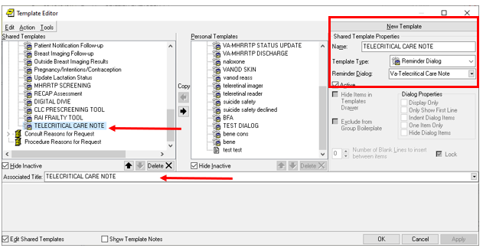

Type in the following information:
Name: TELECRITICAL CARE NOTE
Template Type: Reminder Dialog
Reminder Dialog: VA-TELECRITICAL CARE NOTE
Next, type in the Associated Title name TELECRITICAL CARE NOTE –– then click Apply.

