

**Update _2_0_243**

Clinical Reminders

TBI SCREENING UPDATE

Install Guide

**January 2022**

Product Development

Office of Information Technology

Department of Veterans Affairs

Table of Contents

Introduction 1

Pre-Install 2

Install Details 5

Install Example 5

Post Installation 9

# Introduction

VHA Directive 1184 establishes policy on the TBI screening and evaluation process and  is being revised to focus on “post-9/11” Veterans from “Operation Enduring Freedom (OEF), Operation Iraqi Freedom (OIF) and Operation New Dawn (OND)”.  This revised policy requires changes to the TBI Clinical Reminder in CPRS to focus on “post-9/11” deployment related injuries.  All Veterans with a service separation date after 9/11/2001 are required to be screened for possible deployment related TBI.  Veterans with a positive TBI screen must be offered a Comprehensive TBI Evaluation (CTBIE) to address symptoms and develop an individualized care plan for their deployment related injuries.  Veterans with possible TBI related symptoms not related to post 9/11 deployment would not have a positive TBI screen but should be referred to Polytrauma providers for a comprehensive evaluation and development of an individualized care plan.

The cohort logic is being updated to include any patient that is a Veteran and has a service separation date of later than 09/11/2001.

The dialog is updated to remove the question about where the patient served and replace it with a question about post 09/11 deployment.

Before, the template first asked about what conflicts the Veteran served in and then it expanded and asked about prior diagnosis:

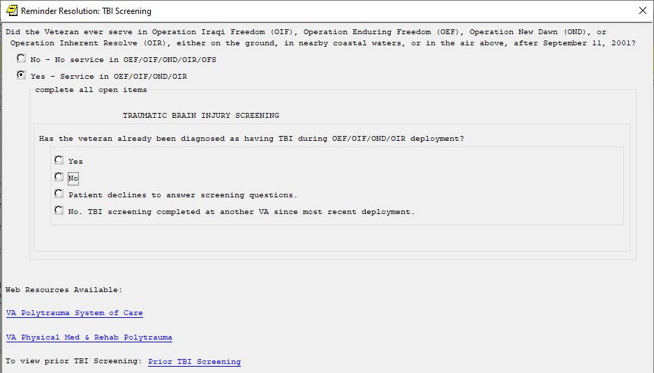

A no response then asked the nested questions 1-4:

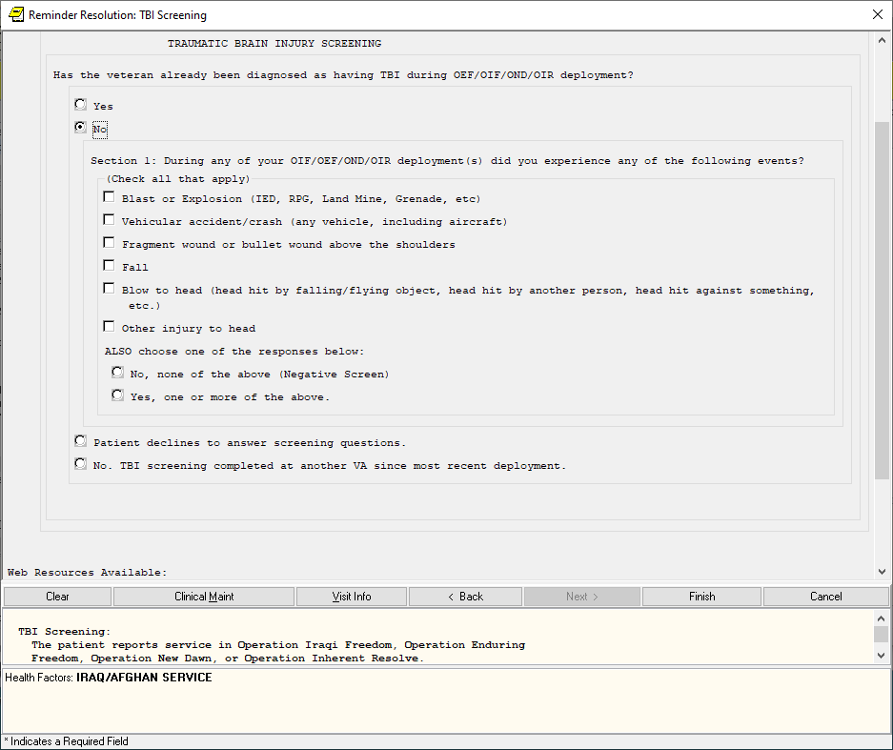

After: Dialog asks if Veteran was deployed is support of post 09/11 actions and then expands:

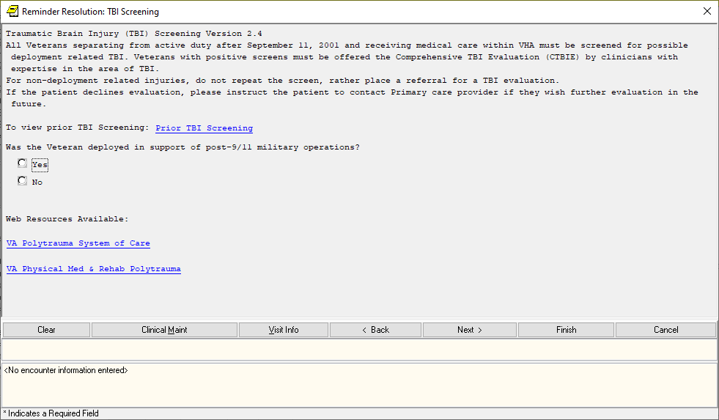

UPDATE_2_0_243 contains 1 Reminder Exchange entry:

UPDATE_2_0_243 VA-TBI SCREENING UPDATE

**The exchange file contains the following components:**

**TIU TEMPLATE FIELD**

VA-TBI SCR/HIST RPT

VA-TBI PRIOR SCREEN RESULTS

VA-VAMC LOCATIONS

VA-DATE COMBO Y/M

BLANK TEXT FIELD FOR DIALOGS

VA-TBI PMR POLYTRAUMA

VA-TBI POLYTRAUMA

**HEALTH FACTORS**

VA-REMINDER UPDATES [C]

VA-UPDATE_2_0_243

TBI-SECTIONS [C]

VA-TBI NO DEPLOYMENT

TBI-SCREENED PREVIOUSLY

TBI-PT REFUSAL

TBI SOURCE [C]

TBI-OTHER INJURY TO HEAD

TBI-BLOW TO HEAD

TBI RESULTS [C]

TBI-HEAD INJURY

TBI-CONCUSSION

TBI SYMPTOMS [C]

TBI-SLEEP PROBLEMS

TBI CURRENT SYMPTOMS [C]

TBI-CURRENT SLEEP PROBLEM

TBI-REFERRALS [C]

TBI-REFERRAL DECLINED

TBI-REFERRAL SENT

TBI-SECTION IV - YES

TBI-SECTION IV - NO

TBI-CURRENT HEADACHES

TBI-CURRENT IRRITABILITY

TBI-CURRENT VISUAL PROBLEMS

TBI-CURRENT DIZZINESS

TBI-CURRENT MEMORY PROBLEMS

TBI-SECTION III - YES

TBI-SECTION III - NO

TBI-VISUAL PROBLEMS

TBI-IRRITABILITY

TBI-MEMORY PROBLEMS

TBI-DIZZINESS

TBI-HEADACHES

TBI-SECTION II - YES

TBI-SECTION II - NO

TBI-UNCONSCIOUS

TBI-NO MEMORY OF INJURY

TBI-DAZED/CONFUSED

TBI-SECTION I - YES

TBI-SECTION I - NO

TBI-BLAST

TBI-FALL

TBI-VEHICULAR

TBI-FRAGMENT/BULLET

TBI-PREVIOUS TBI DX

IRAQ/AFGHANISTAN [C]

IRAQ/AFGHAN SERVICE

NO IRAQ/AFGHAN SERVICE

**REMINDER SPONSOR**

OFFICE OF PATIENT CARE SERVICES

OFFICE OF QUALITY & PERFORMANCE

OFFICE OF PUBLIC HEALTH AND ENVIRONMENTAL HAZARDS

**REMINDER TERM**

VA-REMINDER UPDATE_2_0_243

VA-COMBAT VET

VA-TBI-PT REFUSAL

VA-TBI-PREVIOUS TBI DX

VA-IRAQ/AFGHAN SERVICE

VA-IRAQ/AFGHAN SERVICE NO

VA-TBI SCREENING COMPLETED SCREENING RESOLUTIONS

VA-ACTIVE DUTY

VA-IRAQ/AFGHAN PERIOD OF SERVICE

**REMINDER DEFINITION**

VA-TBI SCREENING

**REMINDER DIALOG**

VA-TBI SCREENING

# Pre-Install

1. **Find TBI Referral orders currently in use.**

* Using the Vista Menu, Reminder Dialog Manager, DI- Reminder Dialog, change view to Element view and Inq/Print the reminder dialog element **VA-PDIQ POLYTRAUMA CONSULT**. You will need to identify the local order used as an additional finding and add this order back post install.
* Using the Vista Menu, Reminder Dialog Manager, DI- Reminder Dialog, change view to Element view and Inq/Print the reminder dialog element **VA-TBI OI CONSULT FOR KNOWN TBI**. You will need to identify the local order used as an additional finding and add this order back post install.

# Install Details

This update is being distributed as a web host file. The address for the host file is: https://REDACTED/UPDATE_2_0_243.PRD

The file will be installed using Reminder Exchange, programmer access is not required.

Installation:

=============

This update can be loaded with users on the system. Installation will take less than 2 minutes.

# Install Example

To Load the exchange file, use LWH. The URL is https://REDACTED/UPDATE_2_0_243.PRD

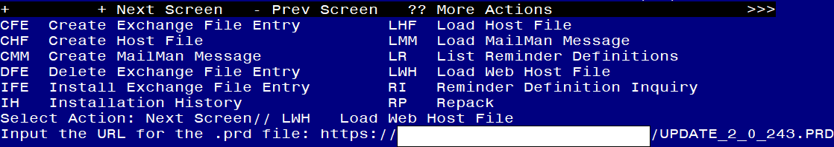

If you use LWH and it works, you will see something like this message. Make sure the file was loaded successfully.

Terminal window screen shot of the message displaying the URL of the file that was successfully loaded.  Part of the URL has been redacted as it is a VA only internal web site URL.

Search and locate an entry titled **UPDATE_2_0_243 VA-TBI SCREENING UPDATE** in reminder exchange.

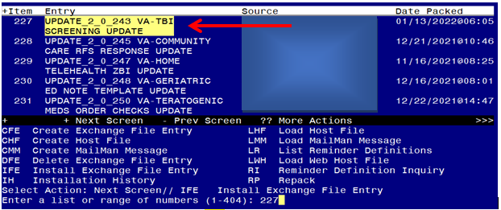

At the **Select Action** prompt, enter **IFE** for Install Exchange File Entry

Enter the number that corresponds with your entry titled **UPDATE_2_0_243 VA-TBI SCREENING UPDATE** (in this example it is entry 227, it will vary *by site)* that is dated 01/13/2021.

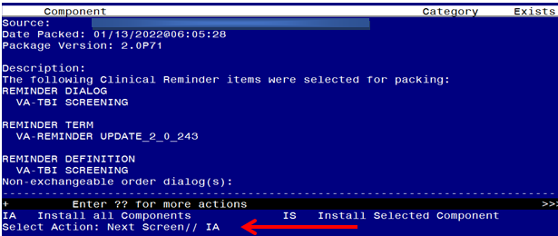

At the **Select Action** prompt, type **IA** for Install all Components and hit enter.

**For all new entries in any category you will choose I to Install**

**Skip any Health Factors that you are prompted to Overwrite.**

**Merge any Reminder Terms that exist but are different**

**OVERWRITE the reminder definition**

You will then be prompted to install the first dialog component. You will choose IA to install all even though some items will already have an X to indicate they exist.

**For VA-TBI SCREENING: 
Screen shot of the terminal window showing a list of elements, groups and dialogs with the text with IA for "Install All" entered at the "Select Action:" Prompt.  The correct entries to make after this entry are described in the text.**

At the **Select Action** prompt, type **IA** to install the dialog – **VA-TBI SCREENING**

**YOU WILL SEE THESE PROMPTS:**

FINDING entry Q.ECOE TEMP OI FOR POLYTRAUMA CONSULT does not exist.

Select one of the following:

D Delete

P Replace with an existing entry

Q Quit the install

Enter response: P Replace with an existing entry

Select ORDER DIALOG NAME: enter your local order dialog for polytrauma consult here

FINDING entry Q.ECOE TEMP OI FOR KNOWN TBI does not exist.

Select one of the following:

D Delete

P Replace with an existing entry

Q Quit the install

Enter response: P Replace with an existing entry

Select ORDER DIALOG NAME: enter your local order dialog for TBI consult here

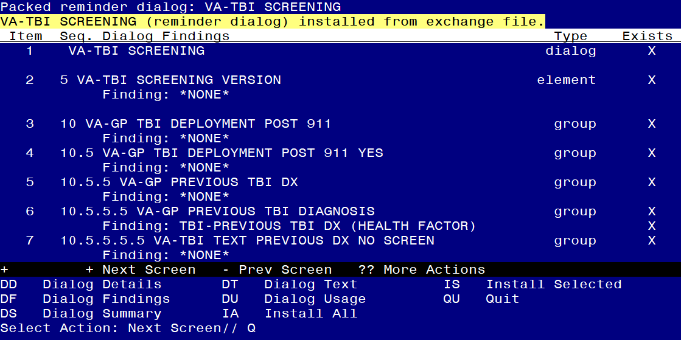

When the dialog has completed installation, you will then be returned to this screen. At the **Select Action** prompt, type **Q.**

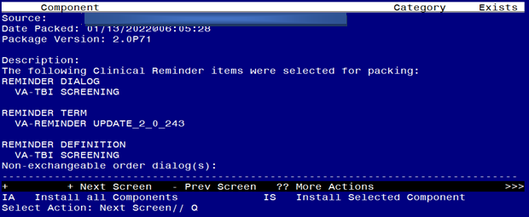

You will then be returned to this screen. At the **Select Action** prompt, type **Q.**

Install complete.

# Post Installation

1. **Add/Review TBI Referral identified in pre-install to reminder dialog.** Using the Vista Menu, Reminder Dialog Manager, DI- Reminder Dialog, change view to element view edit the reminder dialog element **VA-PDIQ POLYTRAUMA CONSULT**, confirm that the quick order identified in the pre-install is an additional finding and add it if it is not.
2. **Add/Review TBI Referral identified in pre-install to reminder dialog.** Using the Vista Menu, Reminder Dialog Manager, DI- Reminder Dialog, change view to element view edit the reminder dialog element **VA-TBI OI CONSULT FOR KNOWN TBI**, confirm the quick order identified in the pre-install is an additional finding and add it if it is not.
3. **Open the TBI reminder** on a test patient and confirm the version number displayed at the top of the screen is 2.4.
4. **Inquire into the reminder definition VA-TBI SCREENING** and confirm the cohort logic matches what is shown below:

**Customized PATIENT COHORT LOGIC to see if the Reminder applies to a patient:**

**FI(10)&FI(1)&'(FI(11)&FF(5))**