Update _2_0_246

Clinical Reminders

VA-ONC CLINICAL PATHWAYS – LUNG CANCER
Install Guide

May 2022

Product Development
Office of Information Technology
Department of Veterans Affairs

Table of Contents
Introduction 1
Pre-Install 10
Install Details 11
Install Example 11
Post Installation 19

Introduction
This update is for Lung Cancer Clinical Pathways. Clinical pathways standardize evidence-based practices to ensure high quality, cost-effective care for patients at each point in their care plan. The Lung Clinical pathways templates will be used to document treatment decisions related to lung cancer. These templates were developed by the National Oncology Program Office in collaboration with an interdisciplinary team of subject matter experts, with the support of national program offices such as medical oncology, radiation oncology, surgery, pathology, and pharmacy. These templates will be used by all members of a Veteran’s Oncology care team to document a treatment decision.

The purpose of these templates is to collect data on Clinical pathways utilization and will facilitate continuous process improvement efforts, which may result in a change to provider practice, local processes, or a change to the Clinical pathway recommendations. Recommendations are based upon national guidelines, published literature, and institutional experience with efficacy, toxicity and cost.

VHA Directive 1415 requires that all sites use the National Oncology templates. If your site does not provide oncology services, the site must request a waiver to exempt it from the requirement to use the National Oncology templates. The waiver can be requested by emailing REDACTED.

UPDATE_2_0_246 contains 1 Reminder Exchange entry:
UPDATE_2_0_246 VA-ONC CLINICAL PATHWAYS – LUNG CANCER

The exchange file contains the following components:

REMINDER GENERAL FINDINGS
VIEW PROGRESS NOTE TEXT

TIU TEMPLATE FIELD
VA-ONC INSTRUCTIONS ON/OFF PATHWAY
VA-ONC OFF REASON TXT
VA-ONC TREATMENT REASON
VA-ONC CLINICAL TRIAL
VA-ONC LUNG PATHWAYS
VA-ONC NEITHER ON/OFF
VA-ONC CONFIRMATION TEXT
VA-ONC NPOP SHAREPOINT

HEALTH FACTORS
VA-REMINDER UPDATES [C]
VA-UPDATE_2_0_246
VA-ONC PRCA MOLECULAR TESTING PATHWAY [C]
VA-ONC PRCA GERM CGP CONSENT FUTURE DATE
VA-ONC PRCA TISSUE SUFFICIENCY UNKNOWN
VA-ONC PRCA CGP ORDER FUTURE DATE
VA-ONC PRCA PRETEST CONSENT: OFF PATH
VA-ONC PRCA PRETEST CONSENT: ON PATH
VA-ONC PRCA GERM CGP PT DECLINE: ON PATH
VA-ONC PRCA GERM CGP ORDER: OFF PATH
VA-ONC PRCA GERM CGP ORDER: ON PATH
VA-ONC PRCA TISSUE SUFFICIENT: OFF PATH
VA-ONC PRCA REASSESS: ON PATH
VA-ONC PRCA LIQUID BIOPSY: ON PATH
VA-ONC PRCA REPEAT BIOPSY: ON PATH
VA-ONC PRCA TISSUE SUFFICIENT: ON PATH
VA-ONC PRCA CGP ORDER: ON PATH
VA-ONC PRCA CGP ORDER: OFF PATH
ONCOLOGY (ONC) LUNG CANCER TREATMENTS [C]
ONC LUNG PALLIATIVE REFERRAL
VA-ONC LUNG SCLC RELAPSE PATHWAY [C]
VA-ONC LUNG SCLC RELAPSE >6M OFF PATH RSN
VA-ONC LUNG SCLC RELAPSE >6M OFF PATH TX
VA-ONC LUNG SCLC RELAPSE >6M CARBO+ETO
VA-ONC LUNG SCLC RELAPSE >6M CLINICAL TRIAL
VA-ONC LUNG SCLC RELAPSE PS 3-4 OFF PATH RSN
VA-ONC LUNG SCLC RELAPSE PS 3-4 OFF PATH TX
VA-ONC LUNG SCLC RELAPSE PS 3-4 REFER HOSPICE
VA-ONC LUNG SCLC RELAPSE PS 3-4 CLINICAL TRIAL
VA-ONC LUNG SCLC RELAPSE PS 0-1-2 OFF PATHWAY RSN
VA-ONC LUNG SCLC RELAPSE PS 0-1-2 OFF PATHWAY TX
VA-ONC LUNG SCLC RELAPSE PS 0-1-2 LURBINECTEDIN
VA-ONC LUNG SCLC RELAPSE PS 0-1-2 CLINICAL TRIAL
VA-ONC LUNG SCLC RELAPSE >6M CARBO+ETO+ATEZ
VA-ONC LUNG SCLC EXTENSIVE STAGE CLINICAL PATHWAY [C]
VA-ONC LUNG SCLC EXT SUB NO PROG OFF PATH RSN
VA-ONC LUNG SCLC EXT SUB NO PROG OFF PATH TX
VA-ONC LUNG SCLC EXT SUB NO PROG MAIN ATEZO
VA-ONC LUNG SCLC EXT SUB NO PROG CLINICAL TRIAL
VA-ONC LUNG SCLC EXT INI IMMUNO OFF PATH RSN
VA-ONC LUNG SCLC EXT INI IMMUNO OFF PATH TX
VA-ONC LUNG SCLC EXT INI IMMUNO REFER HOSPICE
VA-ONC LUNG SCLC EXT INI IMMUNO CLINICAL TRIAL
VA-ONC LUNG SCLC EXT INI CHEMO OFF PATH RSN
VA-ONC LUNG SCLC EXT INI CHEMO OFF PATH TX
VA-ONC LUNG SCLC EXT INI CHEMO CARBO+ETO
VA-ONC LUNG SCLC EXT INI CHEMO CLINICAL TRIAL
VA-ONC LUNG SCLC EXT INI CHEMO/IMMUNO OFF PATH RSN
VA-ONC LUNG SCLC EXT INI CHEMO/IMMUNO OFF PATH TX
VA-ONC LUNG SCLC EXT INI CHEMO/IMMUNO CARBO+ETO+ATEZO
VA-ONC LUNG SCLC EXT INI CHEMO/IMMUNO CLINICAL TRIAL
VA-ONC LUNG SCLC EXT SYMPTOM METS OFF PATH RSN
VA-ONC LUNG SCLC EXT SYMPTOM METS OFF PATH TX
VA-ONC LUNG SCLC EXT SYMPTOM METS CLINICAL TRIAL
VA-ONC LUNG SCLC EXT SYMPTOM METS REFER RAD ONC
VA-ONC LUNG SCLC LIMITED STAGE 1ST LINE PATHWAY [C]
VA-ONC LUNG SCLC LIMITED SUB PS3-4 OFF PATH RSN
VA-ONC LUNG SCLC LIMITED SUB PS3-4 OFF PATH TX
VA-ONC LUNG SCLC LIMITED SUB PS3-4 MRI SURVEILLANCE
VA-ONC LUNG SCLC LIMITED SUB PS3-4 CLINICAL TRIAL
VA-ONC LUNG SCLC LIMITED SUB NO PROG OFF PATH RSN
VA-ONC LUNG SCLC LIMITED SUB NO PROG OFF PATH TX
VA-ONC LUNG SCLC LIMITED SUB NO PROG REFER RAD ONC
VA-ONC LUNG SCLC LIMITED SUB NO PROG CLINICAL TRIAL
VA-ONC LUNG SCLC LIMITED INITIAL OFF PATH RSN
VA-ONC LUNG SCLC LIMITED INITIAL OFF PATH TX
VA-ONC LUNG SCLC LIMITED INITIAL CIS+ETO+CHEST RAD
VA-ONC LUNG SCLC LIMITED INITIAL CLINICAL TRIAL
VA-ONC LUNG SCLC INCIDENTAL DISCOVERY PATHWAY [C]
VA-ONC LUNG SCLC INCIDENTAL INCOMPLETE RESECT OFF PATH RSN
VA-ONC LUNG SCLC INCIDENTAL INCOMPLETE RESECT OFF PATH TX
VA-ONC LUNG SCLC INCIDENTAL INCOMPLETE RESECT CIS+ETO+RAD
VA-ONC LUNG SCLC INCIDENTAL INCOMPLETE RESECT CLINICAL TRIAL
VA-ONC LUNG SCLC INCIDENTAL COMPLETE RESECT OFF PATH RSN
VA-ONC LUNG SCLC INCIDENTAL COMPLETE RESECT OFF PATH TX
VA-ONC LUNG SCLC INCIDENTAL COMPLETE RESECT CIS+ETO
VA-ONC LUNG SCLC INCIDENTAL COMPLETE RESECT CLINICAL TRIAL
VA-ONC LUNG SQUAMOUS RELAPSE PATHWAY [C]
VA-ONC LUNG SQR 2ND IMMUNO AMEN RAD OFF PATH REASON
VA-ONC LUNG SQR 3RD LINE NOT AMEN RAD OFF PATH REASON
VA-ONC LUNG SQR 3RD LINE NOT AMEN RAD OFF PATH TX
VA-ONC LUNG SQR 3RD LINE NOT AMEN RAD REFER PALL CARE
VA-ONC LUNG SQR 3RD LINE NOT AMEN RAD CLINICAL TRIAL
VA-ONC LUNG SQR 3RD LINE AMEN RAD OFF PATH REASON
VA-ONC LUNG SQR 3RD LINE AMEN RAD OFF PATH TX
VA-ONC LUNG SQR 3RD LINE AMEN RAD REFER RAD ONC
VA-ONC LUNG SQR 3RD LINE AMEN RAD CLINICAL TRIAL
VA-ONC LUNG SQR 2ND IMMUNO NOT AMEN RAD OFF PATH REASON
VA-ONC LUNG SQR 2ND IMMUNO NOT AMEN RAD OFF PATH TX
VA-ONC LUNG SQR 2ND IMMUNO NOT AMEN RAD CARBO+PACLITAXEL
VA-ONC LUNG SQR 2ND IMMUNO NOT AMEN RAD CLINICAL TRIAL
VA-ONC LUNG SQR 2ND IMMUNO AMEN RAD OFF PATH TX
VA-ONC LUNG SQR 2ND IMMUNO AMEN RAD REFER RAD ONC
VA-ONC LUNG SQR 2ND IMMUNO AMEN RAD CLINICAL TRIAL
VA-ONC LUNG SQR 2ND CHEMO+/-IMMUNO NOT AMEN RAD OFF PATH RSN
VA-ONC LUNG SQR 2ND CHEMO+/-IMMUNO NOT AMEN RAD OFF PATH TX
VA-ONC LUNG SQR 2ND CHEMO+/-IMMUNO NOT AMEN RAD DOCETAXEL
VA-ONC LUNG SQR 2ND CHEMO+/-IMMUNO NOT AMEN RAD CLINICAL TRIAL
VA-ONC LUNG SQR 2ND CHEMO+/-IMMUNO AMEN RAD OFF PATH REASON
VA-ONC LUNG SQR 2ND CHEMO+/-IMMUNO AMEN RAD OFF PATH TX
VA-ONC LUNG SQR 2ND CHEMO+/-IMMUNO AMEN RAD REFER RAD ONC
VA-ONC LUNG SQR 2ND CHEMO+/-IMMUNO AMEN RAD CLINICAL TRIAL
VA-ONC LUNG NSCLC STAGE IVA M1B/M1A PATHWAY [C]
VA-ONC LUNG IVA M1B/M1A AMEN DEF TX OFF PATHWAY REASON
VA-ONC LUNG IVA M1B/M1A AMEN DEF TX OFF PATHWAY TX
VA-ONC LUNG IVA M1B/M1A AMEN DEF TX REFER RAD ONC/ONC/SURG
VA-ONC LUNG IVA M1B/M1A AMEN DEF TX CLINICAL TRIAL
VA-ONC LUNG NON-SQUAMOUS RELAPSE PATHWAY [C]
VA-ONC LUNG NSR 2ND CHEMO+/-IMMUNO EGFR EXON 20 INS MOBOCERTINIB
VA-ONC LUNG NSR 2ND S/P IMMUNO PROG EGFREX20 MOBOCERTINIB
VA-ONC LUNG NSR 2ND CHEMO+/-IMMUNO HER2 OFF PATH RSN
VA-ONC LUNG NSR 2ND CHEMO+/-IMMUNO HER2 OFF PATH TX
VA-ONC LUNG NSR 2ND CHEMO+/-IMMUNO HER2 TRASTUZUMAB
VA-ONC LUNG NSR 2ND CHEMO+/-IMMUNO HER2 CLINICAL TRIAL
VA-ONC LUNG NSR 2ND S/P IMMUNO PROG HER2 OFF PATH RSN
VA-ONC LUNG NSR 2ND S/P IMMUNO PROG HER2 OFF PATH TX
VA-ONC LUNG NSR 2ND S/P IMMUNO PROG HER2 TRASTUZUMAB
VA-ONC LUNG NSR 2ND S/P IMMUNO PROG HER2 CLINICAL TRIAL
VA-ONC LUNG NSR 2ND CHEMO+/-IMMUNO KRAS G12 SOTORASIB
VA-ONC LUNG NSR 2ND S/P IMMUNO PROG NO KRASG12/EGFREX20 OFF RSN
VA-ONC LUNG NSR 2ND S/P IMMUNO PROG NO KRASG12/EGFRX20 OFF TX
VA-ONC LUNG NSR 2ND S/P IMMUNO PROG NO KRASG12/EGFREX20 DOC
VA-ONC LUNG NSR 2ND S/P IMMUNO PROG NO KRASG12/EGFREX20 CLIN TR
VA-ONC LUNG NSR 2ND S/P IMMUNO PROG EGFREX20 OFF PATH REASON
VA-ONC LUNG NSR 2ND S/P IMMUNO PROG EGFREX20 OFF PATH TREATMENT
VA-ONC LUNG NSR 2ND S/P IMMUNO PROG EGFREX20 AMIVANTAMAB
VA-ONC LUNG NSR 2ND S/P IMMUNO PROG EGFREX20 CLIN TRIAL
VA-ONC LUNG NSR 2ND CHEMO+/-IMMUNO NO KRASG12/EGFREX20 OFF RSN
VA-ONC LUNG NSR 2ND CHEMO+/-IMMUNO NO KRASG12/EGFREX20 OFF TX
VA-ONC LUNG NSR 2ND CHEMO+/-IMMUNO NO KRASG12/EGFREX20 DOCETAXEL
VA-ONC LUNG NSR 2ND CHEMO+/-IMMUNO NO KRASG12/EGFREX20 CLIN TR
VA-ONC LUNG NSR 2ND S/P IMMUNO PROG KRAS G12C OFF PATH RSN
VA-ONC LUNG NSR 2ND IMMUNO ALONE OFF PATHWAY REASON
VA-ONC LUNG NSR 2ND CHEMO+/-IMMUNO EGFR EXON 20 INS OFF PATH RSN
VA-ONC LUNG NSR 3RD LINE PREV DOCETAXEL OFF PATHWAY REASON
VA-ONC LUNG NSR 3RD LINE NO PREV DOCE TX OFF PATH REASON
VA-ONC LUNG NSR 2ND CHEMO+/-IMMUNO KRAS G12 OFF PATH REASON
VA-ONC LUNG NSR 3RD LINE PREV DOCETAXEL OFF PATHWAY TX
VA-ONC LUNG NSR 3RD LINE PREV DOCETAXEL REFER TO HOSPICE
VA-ONC LUNG NSR 3RD LINE PREV DOCETAXEL CLINICAL TRIAL
VA-ONC LUNG NSR 3RD LINE NO PREV DOCE TX OFF PATH TX
VA-ONC LUNG NSR 3RD LINE NO PREV DOCE TX DOCETAXEL
VA-ONC LUNG NSR 3RD LINE NO PREV DOCE TX CLINICAL TRIAL
VA-ONC LUNG NSR 2ND S/P IMMUNO PROG KRAS G12C OFF PATH TX
VA-ONC LUNG NSR 2ND S/P IMMUNO PROG KRAS G12C SOTORASIB
VA-ONC LUNG NSR 2ND S/P IMMUNO PROG KRAS G12C CLIN TRIAL
VA-ONC LUNG NSR 2ND IMMUNO ALONE OFF PATHWAY TX
VA-ONC LUNG NSR 2ND IMMUNO ALONE CARBOPLATIN+PEMET REXED
VA-ONC LUNG NSR 2ND CHEMO+/-IMMUNO EGFR EXON 20 INS OFF PATH TX
VA-ONC LUNG NSR 2ND IMMUNO ALONE CLINICAL TRIAL
VA-ONC LUNG NSR 2ND CHEMO+/-IMMUNO EGFR EXON 20 INS CLIN TRIAL
VA-ONC LUNG NSR 2ND CHEMO+/-IMMUNO KRAS G12 OFF PATH TX
VA-ONC LUNG NSR 2ND CHEMO+/-IMMUNO EGFR EXON 20 INS AMIVANTAMAB
VA-ONC LUNG NSR 2ND CHEMO+/-IMMUNO KRAS G12 CLINICAL TRIAL
VA-ONC LUNG IVA/IVB MUTATION NEGATIVE PATHWAY [C]
VA-ONC LUNG IVA/IVB NEG MUT PDL1>=50 CHEMO PEMBROLIZUMAB ALONE
VA-ONC LUNG IVA/IVB NEG MUT NO IMMUNO OFF PATHWAY TX
VA-ONC LUNG IVA/IVB NEG MUT NO IMMUNO CLINICAL TRIAL
VA-ONC LUNG IVA/IVB NEG MUT NO IMMUNO OFF PATHWAY REASON
VA-ONC LUNG IVA/IVB NEG MUT NO IMMUNO CARBO+PEM
VA-ONC LUNG IVA/IVB NEG MUT PDL1>=50 CHEMO OFF PATHWAY REASON
VA-ONC LUNG IVA/IVB NEG MUT PDL1>1 NO CHEMO OFF PATHWAY REASON
VA-ONC LUNG IVA/IVB NEG MUT PDL1<50 CHEMO OFF PATHWAY REASON
VA-ONC LUNG IVA/IVB NEG MUT PDL1>1 NO CHEMO OFF PATHWAY TX
VA-ONC LUNG IVA/IVB NEG MUT PDL1>1 NO CHEMO PEMBRO ALONE
VA-ONC LUNG IVA/IVB NEG MUT PDL1>=50 CHEMO OFF PATHWAY TX
VA-ONC LUNG IVA/IVB NEG MUT PDL1>=50 CHEMO CLINICAL TRIAL
VA-ONC LUNG IVA/IVB NEG MUT PDL1>1 NO CHEMO CLINICAL TRIAL
VA-ONC LUNG IVA/IVB NEG MUT PDL1>=50 CHEMO PEMBRO+CARBO+PEMETREX
VA-ONC LUNG IVA/IVB NEG MUT PDL1<50 CHEMO OFF PATHWAY TX
VA-ONC LUNG IVA/IVB NEG MUT PDL1<50 CHEMO PEMBRO+CARBO+PEMETREX
VA-ONC LUNG IVA/IVB NEG MUT PDL1<50 CHEMO CLINICAL TRIAL
VA-ONC LUNG IVA/IVB MUTATION POSITIVE PATHWAY [C]
VA-ONC LUNG IVA/IVB SUB POS MUT EGFR 19/21 L858R OFF PATH REASON
VA-ONC LUNG IVA/IVB SUB POS MUT EGFR 19/21 L858R OFF PATH TX
VA-ONC LUNG IVA/IVB SUB POS MUT EGFR 19/21 L858R DOCETAXEL
VA-ONC LUNG IVA/IVB SUB POS MUT EGFR 19/21 L858R CLINICAL TRIAL
VA-ONC LUNG IVA/IVB SUB POS MUT ALL OTHER MUT OFF PATHWAY RSN
VA-ONC LUNG IVA/IVB SUB POS MUT ALK GENE FUSION OFF PATHWAY RSN
VA-ONC LUNG IVA/IVB 2ND POS MUT ALL OTHER MUT OFF PATHWAY REASON
VA-ONC LUNG IVA/IVB 2ND POS MUT EXON19/21 L858R OFF PATHWAY RSN
VA-ONC LUNG IVA/IVB 2ND POS MUT ALK GENE FUSION OFF PATHWAY RSN
VA-ONC LUNG IVA/IVB 1ST POS MUT ROS1 GENE FUSION OFF PATHWAY RSN
VA-ONC LUNG IVA/IVB 1ST POS MUT RET REARRANGE OFF PATHWAY REASON
VA-ONC LUNG IVA/IVB 1ST POS MUT NTRK GENE FUSION OFF PATHWAY RSN
VA-ONC LUNG IVA/IVB 1ST POS MUT MET EXON 14 SKIP OFF PATHWAY RSN
VA-ONC LUNG IVA/IVB 1ST POS MUT EGFR 19/21 L858R OFF PATHWAY RSN
VA-ONC LUNG IVA/IVB 1ST POS MUT BRAF V600E OFF PATHWAY REASON
VA-ONC LUNG IVA/IVB 1ST POS MUT ALK GENE FUSION OFF PATHWAY RSN
VA-ONC LUNG IVA/IVB 1ST POS MUT NTRK GENE FUSION ENTRECTINIB
VA-ONC LUNG IVA/IVB SUB POS MUT ALL OTHER MUT OFF PATHWAY TX
VA-ONC LUNG IVA/IVB SUB POS MUT ALL OTHER MUT DOCETAXEL
VA-ONC LUNG IVA/IVB SUB POS MUT ALL OTHER MUT CLINICAL TRIAL
VA-ONC LUNG IVA/IVB SUB POS MUT ALK GENE FUSION OFF PATHWAY TX
VA-ONC LUNG IVA/IVB SUB POS MUT ALK GENE FUSION DOCETAXEL
VA-ONC LUNG IVA/IVB SUB POS MUT ALK GENE FUSION CARBO+PEM+/-CI
VA-ONC LUNG IVA/IVB SUB POS MUT ALK GENE FUSION CLINICAL TRIAL
VA-ONC LUNG IVA/IVB 2ND POS MUT ALL OTHER MUT OFF PATHWAY TX
VA-ONC LUNG IVA/IVB 2ND POS MUT ALL OTHER MUT CARBO+PEM+/-CI
VA-ONC LUNG IVA/IVB 2ND POS MUT ALL OTHER MUT CLINICAL TRIAL
VA-ONC LUNG IVA/IVB 2ND POS MUT ALK GENE FUSION OFF PATHWAY TX
VA-ONC LUNG IVA/IVB 2ND POS MUT ALK GENE FUSION LORLATINIB
VA-ONC LUNG IVA/IVB 2ND POS MUT ALK GENE FUSION CLINICAL TRIAL
VA-ONC LUNG IVA/IVB 2ND POS MUT EXON19/21 L858R OFF PATHWAY TX
VA-ONC LUNG IVA/IVB 2ND POS MUT EXON19/21 L858R CARBO+PEM+/-CI
VA-ONC LUNG IVA/IVB 2ND POS MUT EXON19/21 L858R CLINICAL TRIAL
VA-ONC LUNG IVA/IVB 1ST POS MUT NON STANDARD NPOP CONSULT
VA-ONC LUNG IVA/IVB 1ST POS MUT NTRK GENE FUSION OFF PATHWAY TX
VA-ONC LUNG IVA/IVB 1ST POS MUT NTRK GENE FUSION CLINICAL TRIAL
VA-ONC LUNG IVA/IVB 1ST POS MUT BRAF V600E OFF PATHWAY TX
VA-ONC LUNG IVA/IVB 1ST POS MUT BRAF V600E DABRAFENIB+TRAMETINIB
VA-ONC LUNG IVA/IVB 1ST POS MUT BRAF V600E CLINICAL TRIAL
VA-ONC LUNG IVA/IVB 1ST POS MUT ROS1 GENE FUSION OFF PATHWAY TX
VA-ONC LUNG IVA/IVB 1ST POS MUT ROS1 GENE FUSION ENTRECTINIB
VA-ONC LUNG IVA/IVB 1ST POS MUT ROS1 GENE FUSION CLINICAL TRIAL
VA-ONC LUNG IVA/IVB 1ST POS MUT RET REARRANGE OFF PATHWAY TX
VA-ONC LUNG IVA/IVB 1ST POS MUT RET REARRANGE SELPERCATNIB
VA-ONC LUNG IVA/IVB 1ST POS MUT RET REARRANGE CLINICAL TRIAL
VA-ONC LUNG IVA/IVB 1ST POS MUT MET EXON 14 SKIP OFF PATHWAY TX
VA-ONC LUNG IVA/IVB 1ST POS MUT MET EXON 14 SKIP CAPMATINIB
VA-ONC LUNG IVA/IVB 1ST POS MUT MET EXON 14 SKIP CLINICAL TRIAL
VA-ONC LUNG IVA/IVB 1ST POS MUT ALK GENE FUSION OFF PATHWAY TX
VA-ONC LUNG IVA/IVB 1ST POS MUT ALK GENE FUSION ALECTINIB
VA-ONC LUNG IVA/IVB 1ST POS MUT ALK GENE FUSION CLINICAL TRIAL
VA-ONC LUNG IVA/IVB 1ST POS MUT EGFR 19/21 L858R OFF PATHWAY TX
VA-ONC LUNG IVA/IVB 1ST POS MUT EGFR 19/21 L858R OSIMERTINIB
VA-ONC LUNG IVA/IVB 1ST POS MUT EGFR 19/21 L858R CLINICAL TRIAL
VA-ONC LUNG SQUAMOUS STAGE IVB PATHWAY [C]
VA-ONC LUNG SQUIVB PDL1 >=50% PEM ALONE
VA-ONC LUNG SQUIVB NO IMMUNO\NO CHEMO OFF PATH REASON
VA-ONC LUNG SQUIVB NO IMMUNO\NO CHEMO OFF PATH TX
VA-ONC LUNG SQUIVB NO IMMUNO\NO CHEMO REFER HOSPICE
VA-ONC LUNG SQUIVB NO IMMUNO\NO CHEMO CLINICAL TRIAL
VA-ONC LUNG SQUIVB PD-L1>=1% IMMUNO ONLY OFF PATH REASON
VA-ONC LUNG SQUIVB PD-L1>=1% IMMUNO ONLY OFF PATH TX
VA-ONC LUNG SQUIVB PD-L1>=1% IMMUNO ONLY PEMBRO
VA-ONC LUNG SQUIVB PD-L1>=1% IMMUNO ONLY CLINICAL TRIAL
VA-ONC LUNG SQUIVB CHEMO ONLY OFF PATH REASON
VA-ONC LUNG SQUIVB CHEMO ONLY OFF PATH TX
VA-ONC LUNG SQUIVB CHEMO ONLY CARBO+PAC
VA-ONC LUNG SQUIVB CHEMO ONLY CLINICAL TRIAL
VA-ONC LUNG SQUIVB PDL1 >=50% OFF PATHWAY REASON
VA-ONC LUNG SQUIVB PDL1 >=50% OFF PATHWAY TX
VA-ONC LUNG SQUIVB PDL1 >=50% PEM+CARBO+PAC +PEM MAIN
VA-ONC LUNG SQUIVB PDL1 >=50% CLINICAL TRIAL
VA-ONC LUNG SQUIVB PDL1 0-49% OFF PATHWAY REASON
VA-ONC LUNG SQUIVB PDL1 0-49% OFF PATHWAY TX
VA-ONC LUNG SQUIVB PDL1 0-49% PEM+CARBO+PAC
VA-ONC LUNG SQUIVB PDL1 0-49% CLINICAL TRIAL
VA-ONC LUNG SQUIVB NO SMOKE/MIXED/SMALL/CLIN IND MOLECULAR TEST
VA-ONC LUNG SQUIVB SYMPTOMATIC REFER RAD ONC
VA-ONC LUNG METASTATIC NSCLC MOLECULAR TESTING [C]
VA-ONC LUNG TISSUE SUFFICIENCY UNKNOWN
VA-ONC LUNG CGP ORDER FUTURE DATE
VA-ONC LUNG PD-L1 ORDER FUTURE DATE
VA-ONC LUNG LIQUID BIOPSY: ON PATH
VA-ONC LUNG TISSUE SUFFICIENT: OFF PATH
VA-ONC LUNG REASSESS: ON PATH
VA-ONC LUNG REPEAT BIOPSY: ON PATH
VA-ONC LUNG TISSUE SUFFICIENT: ON PATH
VA-ONC LUNG CGP ORDER: OFF PATH
VA-ONC LUNG CGP ORDER: ON PATH
VA-ONC LUNG PD-L1 ORDER: OFF PATH
VA-ONC LUNG PD-L1 ORDER: ON PATH
VA-ONC LUNG NSCLC STAGE III UNRESECTABLE CLINICAL PATHWAY [C]
VA-ONC LUNG NSCLC III UNRESECT S/P CHEMO OFF PATH RSN
VA-ONC LUNG NSCLC III UNRESECT S/P CHEMO OFF PATH TX
VA-ONC LUNG NSCLC III UNRESECT S/P CHEMO SURVEILLANCE
VA-ONC LUNG NSCLC III UNRESECT S/P CHEMO CLINICAL TRIAL
VA-ONC LUNG NSCLC III UNRESECT SUB NO IMMUNO OFF PATH RSN
VA-ONC LUNG NSCLC III UNRESECT SUB NO IMMUNO OFF PATH TX
VA-ONC LUNG NSCLC III UNRESECT SUB NO IMMUNO SURVEILLANCE
VA-ONC LUNG NSCLC III UNRESECT SUB NO IMMUNO CLIN TRIAL
VA-ONC LUNG NSCLC III UNRESECT SUB IMMUNO OFF PATH RSN
VA-ONC LUNG NSCLC III UNRESECT SUB IMMUNO OFF PATH TX
VA-ONC LUNG NSCLC III UNRESECT SUB IMMUNO DURVALUMAB
VA-ONC LUNG NSCLC III UNRESECT SUB IMMUNO CLIN TRIAL
VA-ONC LUNG NSCLC III UNRESECT INI SQU OFF PATH RSN
VA-ONC LUNG NSCLC III UNRESECT INI SQU OFF PATH TX
VA-ONC LUNG NSCLC III UNRESECT INI SQU CARBO+PAC+RAD
VA-ONC LUNG NSCLC III UNRESECT INI SQU CLINICAL TRIAL
VA-ONC LUNG NSCLC III UNRESECT INI NSQ OFF PATH RSN
VA-ONC LUNG NSCLC III UNRESECT INI NSQ OFF PATH TX
VA-ONC LUNG NSCLC III UNRESECT INI NSQ CARBO+PEM+RAD
VA-ONC LUNG NSCLC III UNRESECT INI NSQ CLINICAL TRIAL
VA-ONC LUNG NSCLC III UNRESECT INI CON RAD OFF PATH RSN
VA-ONC LUNG NSCLC III UNRESECT INI CON RAD OFF PATH TX
VA-ONC LUNG NSCLC III UNRESECT INI CON RAD CARBO+PAC+RAD
VA-ONC LUNG NSCLC III UNRESECT INI CON RAD CLINICAL TRIAL
VA-ONC LUNG PANCOAST CLINICAL PATHWAY [C]
VA-ONC LUNG PAN NO SURG/YES CON CIS/ETO OFF PATH RSN
VA-ONC LUNG PAN NO SURG/YES CON CIS/ETO OFF PATH TX
VA-ONC LUNG PAN NO SURG/YES CON CIS/ETO ARBO+PAC+RAD+DURVALUMAB
VA-ONC LUNG PAN NO SURG/YES CON CIS/ETO CLINICAL TRIAL
VA-ONC LUNG PAN NO SURG/NO CON CIS/ETO OFF PATH RSN
VA-ONC LUNG PAN NO SURG/NO CON CIS/ETO OFF PATH TX
VA-ONC LUNG PAN NO SURG/NO CON CIS/ETO +RAD+DURVALUMAB
VA-ONC LUNG PAN SURG/YES CON CIS/ETO OFF PATH RSN
VA-ONC LUNG PAN NO SURG/NO CON CIS/ETO CLINICAL TRIAL
VA-ONC LUNG PAN SURG/YES CON CIS/ETO OFF PATH TX
VA-ONC LUNG PAN SURG/YES CON CIS/ETO CARBO+PAC+RAD+SURG
VA-ONC LUNG PAN SURG/YES CON CIS/ETO CLINICAL TRIAL
VA-ONC LUNG PAN SURG/NO CON CIS/ETO OFF PATH RSN
VA-ONC LUNG PAN SURG/NO CON CIS/ETO OFF PATH TX
VA-ONC LUNG PAN SURG/NO CON CIS/ETO +RAD+SURG
VA-ONC LUNG PAN SURG/NO CON CIS/ETO CLINICAL TRIAL
VA-ONC LUNG NSCLC IIIA CLINICAL PATHWAY [C]
VA-ONC LUNG NSCLC IIIA R1/R2 NO RRS OFF PATH RSN
VA-ONC LUNG NSCLC IIIA R1/R2 NO RRS OFF PATH TX
VA-ONC LUNG NSCLC IIIA R1/R2 NO RRS REF RADONC
VA-ONC LUNG NSCLC IIIA R1/R2 NO RRS CLIN TRIAL
VA-ONC LUNG NSCLC IIIA R1/R2 RRS OFF PATH RSN
VA-ONC LUNG NSCLC IIIA R1/R2 RRS OFF PATH TX
VA-ONC LUNG NSCLC IIIA R1/R2 RRS RERESECT
VA-ONC LUNG NSCLC IIIA R1/R2 RRS CLIN TRIAL
VA-ONC LUNG NSCLC IIIA R0 OFF PATH RSN
VA-ONC LUNG NSCLC IIIA R0 OFF PATH TX
VA-ONC LUNG NSCLC IIIA R0 SURVEILLANCE
VA-ONC LUNG NSCLC IIIA R0 CLIN TRIAL
VA-ONC LUNG NSCLC IIIA NO PROG OFF PATH RSN
VA-ONC LUNG NSCLC IIIA NO PROG OFF PATH TX
VA-ONC LUNG NSCLC IIIA NO PROG SURGERY
VA-ONC LUNG NSCLC IIIA NO PROG CLIN TRIAL
VA-ONC LUNG NSCLC IIIA INITIAL TX SQU OFF PATH RSN
VA-ONC LUNG NSCLC IIIA INITIAL TX SQU OFF PATH TX
VA-ONC LUNG NSCLC IIIA INITIAL TX SQU CIS+DOCETAXEL
VA-ONC LUNG NSCLC IIIA INITIAL TX SQU CLIN TRIAL
VA-ONC LUNG NSCLC IIIA INITIAL TX NSQ OFF PATH RSN
VA-ONC LUNG NSCLC IIIA INITIAL TX NSQ OFF PATH TX
VA-ONC LUNG NSCLC IIIA INITIAL TX NSQ CIS+PEMETREXED
VA-ONC LUNG NSCLC IIIA INITIAL TX NSQ CLIN TRIAL
VA-ONC LUNG NSCLC IIA/IIB CLINICAL PATHWAY [C]
VA-ONC LUNG NSCLC IIA/IIB R1/R2 NO RRS SQU OFF PATH RSN
VA-ONC LUNG NSCLC IIA/IIB POST RESECT SQU OFF PATH RSN
VA-ONC LUNG NSCLC IIA/IIB POST RESECT SQU OFF PATH TX
VA-ONC LUNG NSCLC IIA/IIB POST RESECT SQU CIS+DOC+REF RAD ONC
VA-ONC LUNG NSCLC IIA/IIB POST RESECT SQU CLINICAL TRIAL
VA-ONC LUNG NSCLC IIA/IIB POST RESECT NSQ OFF PATH RSN
VA-ONC LUNG NSCLC IIA/IIB POST RESECT NSQ OFF PATH TX
VA-ONC LUNG NSCLC IIA/IIB POST RESECT NSQ CIS+PEME+REF RAD ONC
VA-ONC LUNG NSCLC IIA/IIB POST RESECT NSQ CLINICAL TRIAL
VA-ONC LUNG NSCLC IIA/IIB R1/R2 NO RRS SQU OFF PATH TX
VA-ONC LUNG NSCLC IIA/IIB R1/R2 NO RRS SQU CIS+DOC+RAD ONC
VA-ONC LUNG NSCLC IIA/IIB R1/R2 NO RRS SQU CLIN TRIAL
VA-ONC LUNG NSCLC IIA/IIB R1/R2 NO RRS NSQ OFF PATH RSN
VA-ONC LUNG NSCLC IIA/IIB R1/R2 NO RRS NSQ OFF PATH TX
VA-ONC LUNG NSCLC IIA/IIB R1/R2 NO RRS NSQ CIS+PEME+RAD ONC
VA-ONC LUNG NSCLC IIA/IIB R1/R2 NO RRS NSQ CLIN TRIAL
VA-ONC LUNG NSCLC IIA/IIB R1/R2 RRS OFF PATH RSN
VA-ONC LUNG NSCLC IIA/IIB R1/R2 RRS OFF PATH TX
VA-ONC LUNG NSCLC IIA/IIB R1/R2 RRS RERESECT
VA-ONC LUNG NSCLC IIA/IIB R1/R2 RRS CLIN TRIAL
VA-ONC LUNG NSCLC IIA/IIB R0 SQU OFF PATH RSN
VA-ONC LUNG NSCLC IIA/IIB R0 SQU OFF PATH TX
VA-ONC LUNG NSCLC IIA/IIB R0 SQU CLIN TRIAL
VA-ONC LUNG NSCLC IIA/IIB R0 NSQ OFF PATH RSN
VA-ONC LUNG NSCLC IIA/IIB R0 NSQ OFF PATH TX
VA-ONC LUNG NSCLC IIA/IIB R0 NSQ CIS+PEME
VA-ONC LUNG NSCLC IIA/IIB R0 SQU CIS+DOCE
VA-ONC LUNG NSCLC IIA/IIB R0 NSQ CLIN TRIAL
VA-ONC LUNG NSCLC IIA/IIB NO SURG OFF PATH RSN
VA-ONC LUNG NSCLC IIA/IIB NO SURG OFF PATH TX
VA-ONC LUNG NSCLC IIA/IIB NO SURG REF ONC/RAD ONC
VA-ONC LUNG NSCLC IIA/IIB NO SURG CLIN TRIAL
VA-ONC LUNG NSCLC IIA/IIB SURG OFF PATH RSN
VA-ONC LUNG NSCLC IIA/IIB SURG OFF PATH TX
VA-ONC LUNG NSCLC IIA/IIB SURG RESECTION
VA-ONC LUNG NSCLC IIA/IIB SURG CLINICAL TRIAL
VA-ONC LUNG NSCLC STAGE IA/IB PATHWAY[C]
VA-ONC LUNG NSCLC PATH IB NEG MARG CLIN TRIAL
VA-ONC LUNG NSCLC PATH IB POS MARG NO RERESECT OFF PATH RSN
VA-ONC LUNG NSCLC PATH IB POS MARG NO RERESECT OFF PATH TX
VA-ONC LUNG NSCLC PATH IB POS MARG NO RERESECT REF RAD ONC
VA-ONC LUNG NSCLC PATH IB POS MARG NO RERESECT CLINICAL TRIAL
VA-ONC LUNG NSCLC PATH IB POS MARG RERESECT OFF PATH RSN
VA-ONC LUNG NSCLC PATH IB POS MARG RERESECT OFF PATH TX
VA-ONC LUNG NSCLC PATH IB POS MARG RERESECT
VA-ONC LUNG NSCLC PATH IB POS MARG RERESECT CLIN TRIAL
VA-ONC LUNG NSCLC PATH IB NEG MARG OFF PATHWAY RSN
VA-ONC LUNG NSCLC PATH IB NEG MARG OFF PATHWAY TX
VA-ONC LUNG NSCLC PATH IB NEG MARG SURVEILLANCE
VA-ONC LUNG NSCLC PATH IB NEG MARG CLINICAL TRIAL
VA-ONC LUNG NSCLC PATH IA POS MARG NO RERESECT OFF PATH RSN
VA-ONC LUNG NSCLC PATH IA POS MARG NO RERESECT OFF PATH TX
VA-ONC LUNG NSCLC PATH IA POS MARG NO RERESECT REF RAD ONC
VA-ONC LUNG NSCLC PATH IA POS MARG NO RERESECT CLINICAL TRIAL
VA-ONC LUNG NSCLC PATH IA POS MARG RERESECT OFF PATH RSN
VA-ONC LUNG NSCLC PATH IA POS MARG RERESECT OFF PATH TX
VA-ONC LUNG NSCLC PATH IA POS MARG RERESECT
VA-ONC LUNG NSCLC PATH IA POS MARG RERESECT CLIN TRIAL
VA-ONC LUNG NSCLC PATH IA NEG MARGINS OFF PATH RSN
VA-ONC LUNG NSCLC PATH IA NEG MARGINS OFF PATH TX
VA-ONC LUNG NSCLC PATH IA NEG MARGINS SURVEILLANCE
VA-ONC LUNG NSCLC PATH IA NEG MARGINS CLIN TRIAL
VA-ONC LUNG NSCLC IA/IB SURG NO OFF PATH RSN
VA-ONC LUNG NSCLC IA/IB SURG NO OFF PATH TX
VA-ONC LUNG NSCLC IA/IB SURG NO REF RAD ONC
VA-ONC LUNG NSCLC IA/IB SURG NO CLIN TRIAL
VA-ONC LUNG NSCLC IA/IB SURG OFF PATH RSN
VA-ONC LUNG NSCLC IA/IB SURG OFF PATH TX
VA-ONC LUNG NSCLC IA/IB SURG LOBECTOMY
VA-ONC LUNG NSCLC IA/IB SURG CLIN TRIAL
VA-ONCOLOGY PATHWAYS [C]
VA-ONC LUNG SCLC RELAPSE PATHWAY
VA-ONC LUNG SCLC LIMITED STAGE 1ST LINE PATHWAY
VA-ONC LUNG SCLC EXTENSIVE STAGE CLINICAL PATHWAY
VA-ONC LUNG SCLC INCIDENTAL DISCOVERY PATHWAY
VA-ONC LUNG SQUAMOUS RELAPSE PATHWAY
VA-ONC LUNG NON-SQUAMOUS RELAPSE PATHWAY
VA-ONC LUNG NSCLC STAGE III UNRESECTABLE CLINICAL PATHWAY
VA-ONC LUNG PANCOAST CLINICAL PATHWAY
VA-ONC LUNG NSCLC IIIA CLINICAL PATHWAY
VA-ONC LUNG NSCLC IIA/IIB CLINICAL PATHWAY
VA-ONC LUNG NSCLC STAGE IA/IB PATHWAY
VA-ONC LUNG SQUAMOUS STAGE IVB PATHWAY
VA-ONC LUNG IVA/IVB MUTATION NEGATIVE PATHWAY
VA-ONC LUNG IVA/IVB MUTATION POSITIVE PATHWAY
VA-ONC LUNG NSCLC STAGE IVA M1B/M1A PATHWAY
VA-ONC LUNG MOLECULAR TESTING

REMINDER TERM
VA-REMINDER UPDATE_2_0_246

HEALTH SUMMARY TYPE
VA-ONCOLOGY PATHWAYS (HS)
VA-ONCOLOGY PATHWAYS LUNG (HS)

HEALTH SUMMARY OBJECTS
VA-ONCOLOGY PATHWAYS (TIU)
VA-ONCOLOGY PATHWAYS LUNG (TIU)

TIU DOCUMENT DEFINITION
VA-ONCOLOGY PATHWAYS
VA-ONCOLOGY PATHWAYS LUNG

REMINDER DIALOG
VA-ONCOLOGY LUNG SCLC PATHWAYS
VA-ONCOLOGY LUNG RELAPSE PATHWAYS
VA-ONCOLOGY LUNG LOCALLY ADVANCED PATHWAYS
VA-ONCOLOGY LUNG EARLY STAGE PATHWAYS
VA-ONCOLOGY LUNG FIRST LINE METS STAGE IV PATHWAYS
VA-ONCOLOGY LUNG PATHWAY

Pre-Install

Using the Vista Menu, Reminder Dialog Manager, DI- Reminder Dialog, change view to element view, inquire into the following reminder dialog elements and identify any quick orders or menus that have been added as an additional finding. You site may have not added any orders to these items. The orders identified will need to be added back post install.

VA-EL ONC LUNG ON PDL1
VA-EL ONC LUNG PTHWY NGS ON
VA-EL ONC LUNG ON PATHWAY TISSUE SUFF
VA-EL ONC LUNG PATHWAY REPEAT BIOPSY
VA-EL ONC LUNG PTHWY LIQUID BIOPSY

Install Details

This update is being distributed as a web host file. The address for the host file is: https://REDACTED /UPDATE_2_0_246.PRD
The file will be installed using Reminder Exchange, programmer access is not required.

Installation:
=============
This update can be loaded with users on the system. Installation will take less than 20 minutes.

Install Example
To Load the Web Host File. Navigate to Reminder exchange in Vista
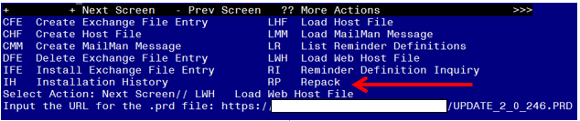
At the Select Action: prompt, enter LWH for Load Web Host File
At the Input the url for the .prd file: prompt, type the following web address:
https://REDACTED/UPDATE_2_0_246.PRD
You should see a message at the top of your screen that the file successfully loaded.

Search and locate an entry titled UPDATE_2_0_246 VA-ONC CLINICAL PATHWAYS – LUNG CANCER in reminder exchange.
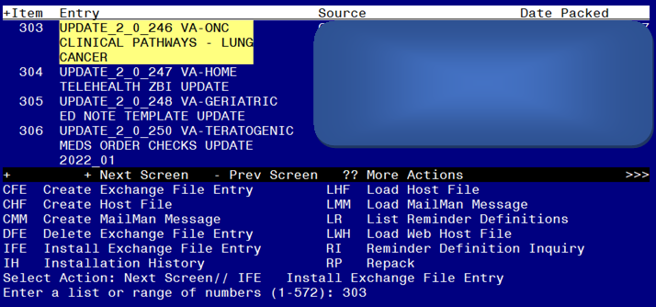

At the Select Action prompt, enter IFE for Install Exchange File Entry
Enter the number that corresponds with your entry UPDATE_2_0_246 VA-ONC CLINICAL PATHWAYS – LUNG CANCER (in this example it is entry 303. It will vary by site). The date of the exchange file should be 04/19/2022.

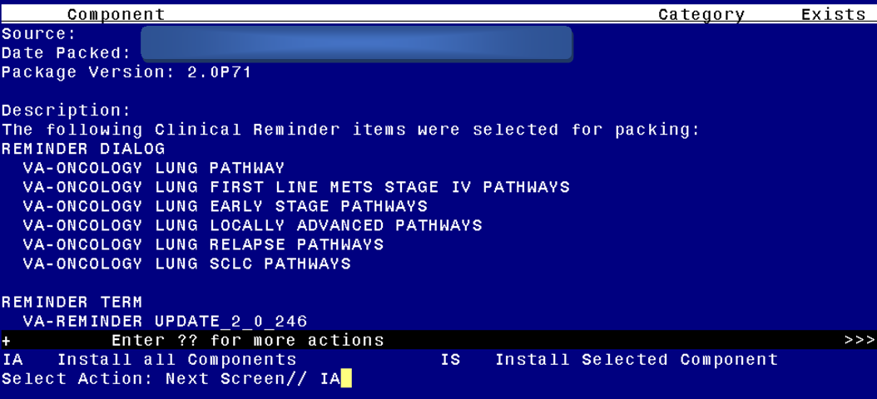
At the Select Action prompt, type IA for Install all Components and hit enter.
Select Action: Next Screen// IA Install all Components
You will see several prompts, for all new entries you will choose I to Install.
If you are prompted to overwrite any entries, you will choose O to Overwrite.
You will be prompted to install the FIRST reminder dialog component (VA-ONCOLOGY LUNG SCLC PATHWAYS). You will choose to install all even though some components may have an X to indicate that they exist.
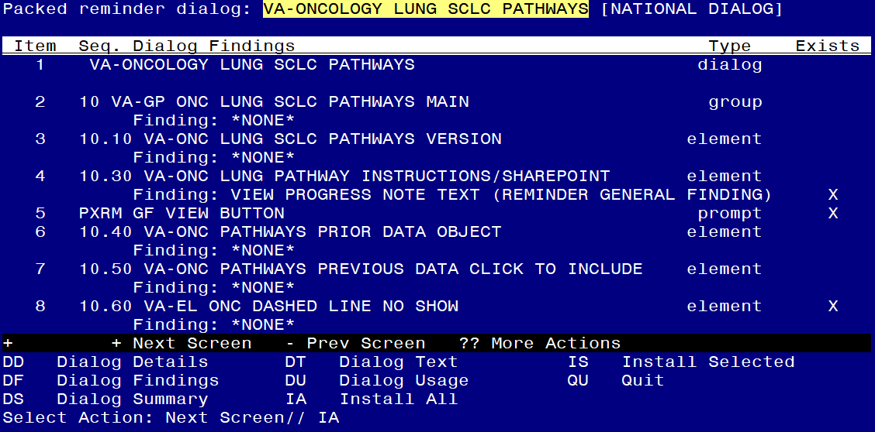

At the Select Action prompt, type IA to install the dialog: VA-ONCOLOGY LUNG SCLC PATHWAYS
Select Action: Next Screen// IA Install All
Install reminder dialog and all components with no further changes: Y// Yes

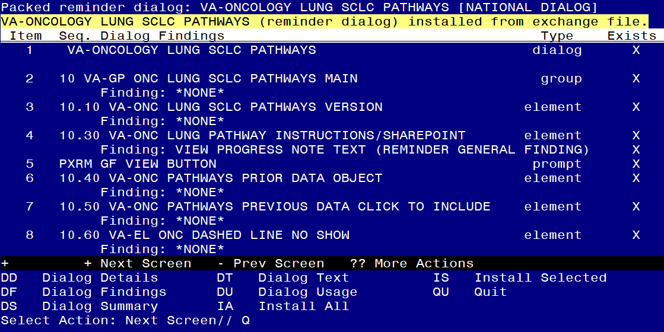

After completing this dialog install, you will type Q.
You will be prompted to install the next reminder dialog component (VA-ONCOLOGY LUNG RELAPSE PATHWAYS). You will choose to install all even though some components may have an X to indicate that they exist.

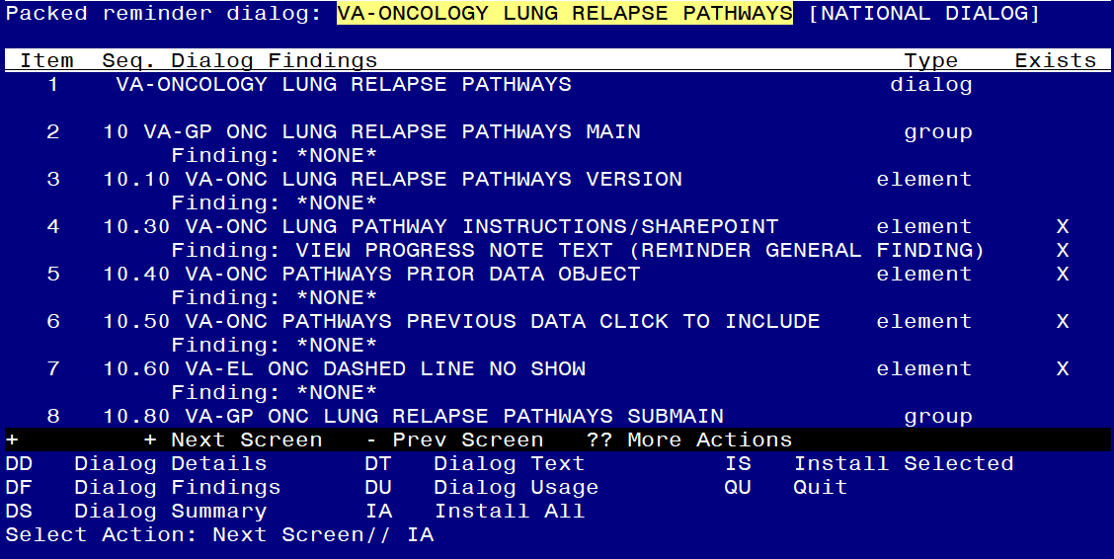
At the Select Action prompt, type IA to install the dialog VA-ONCOLOGY LUNG RELAPSE PATHWAYS
Select Action: Next Screen// IA Install All
Install reminder dialog and all components with no further changes: Y// Yes

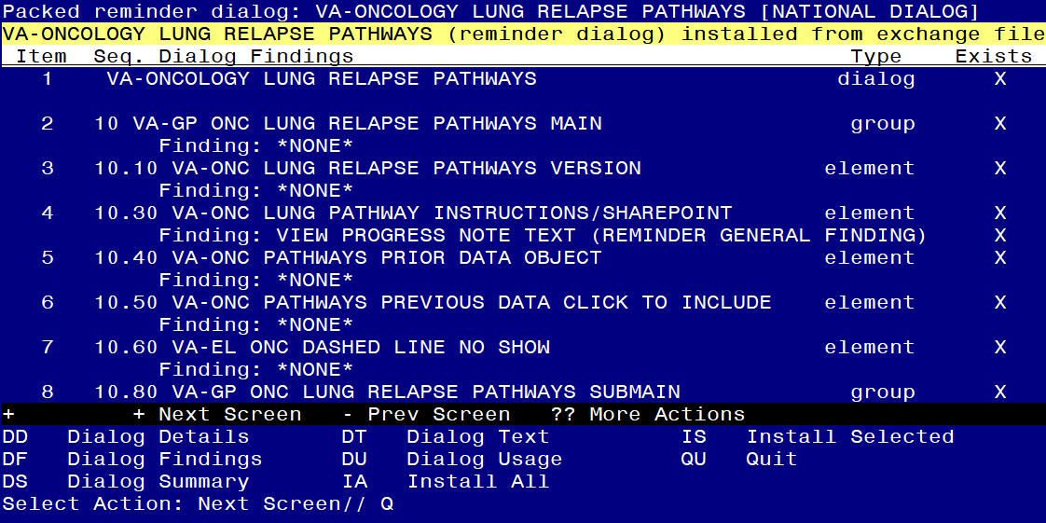

After completing this dialog install, you will type Q.
You will be prompted to install the next reminder dialog component (VA-ONCOLOGY LUNG LOCALLY ADVANCED PATHWAYS). You will choose to install all even though some components may have an X to indicate that they exist.
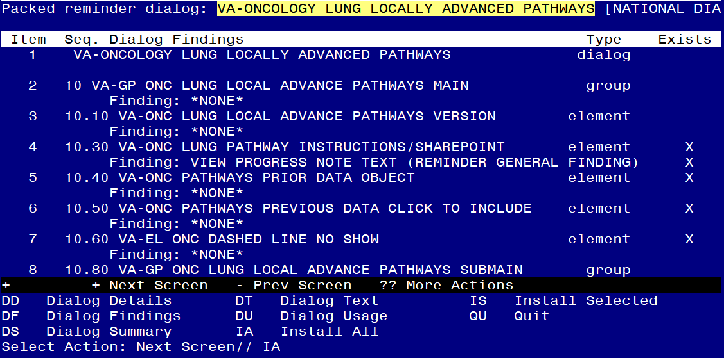
At the Select Action prompt, type IA to install the dialog: VA-ONCOLOGY LUNG LOCALLY ADVANCED PATHWAYS
Select Action: Next Screen// IA Install All
Install reminder dialog and all components with no further changes: Y// Yes
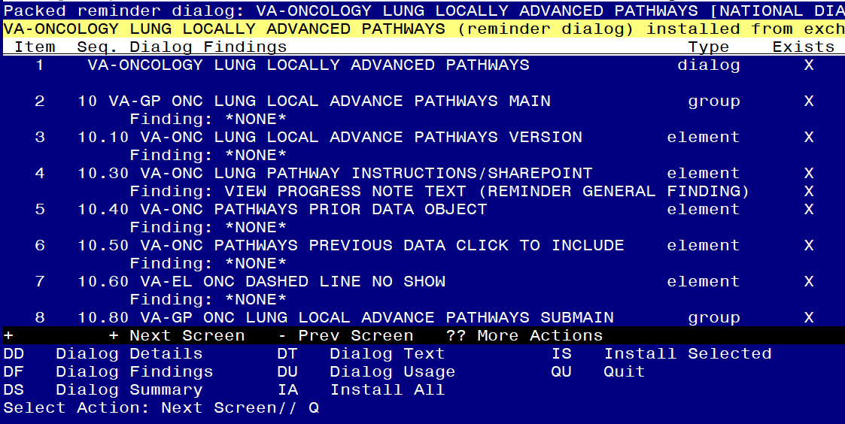

After completing this dialog install, you will type Q.

You will be prompted to install the next reminder dialog component (VA-ONCOLOGY LUNG EARLY STAGE PATHWAYS). You will choose to install all even though some components may have an X to indicate that they exist.
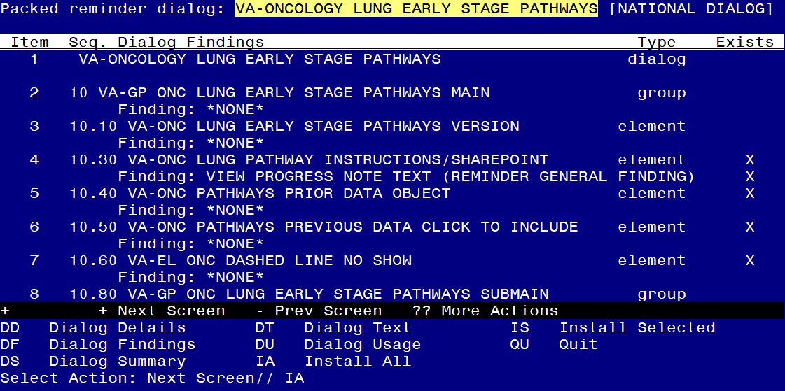
At the Select Action prompt, type IA to install the dialog: VA-ONCOLOGY LUNG EARLY STAGE PATHWAYS
Select Action: Next Screen// IA Install All
Install reminder dialog and all components with no further changes: Y// Yes
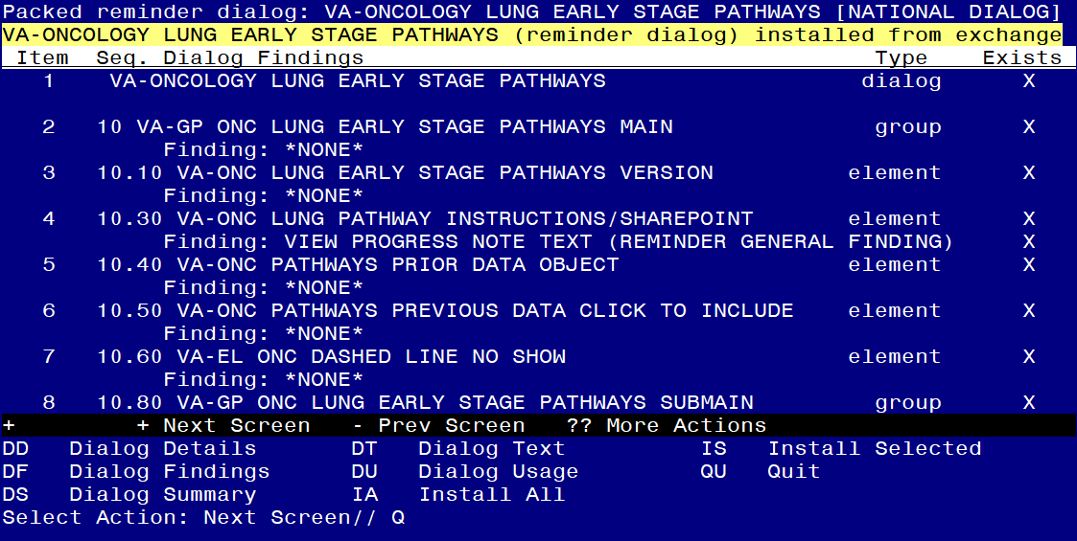

After completing this dialog install, you will type Q.

You will be prompted to install the next reminder dialog component (VA-ONCOLOGY LUNG FIRST LINE METS STAGE IV PATHWAYS). You will choose to install all even though some components may have an X to indicate that they exist.

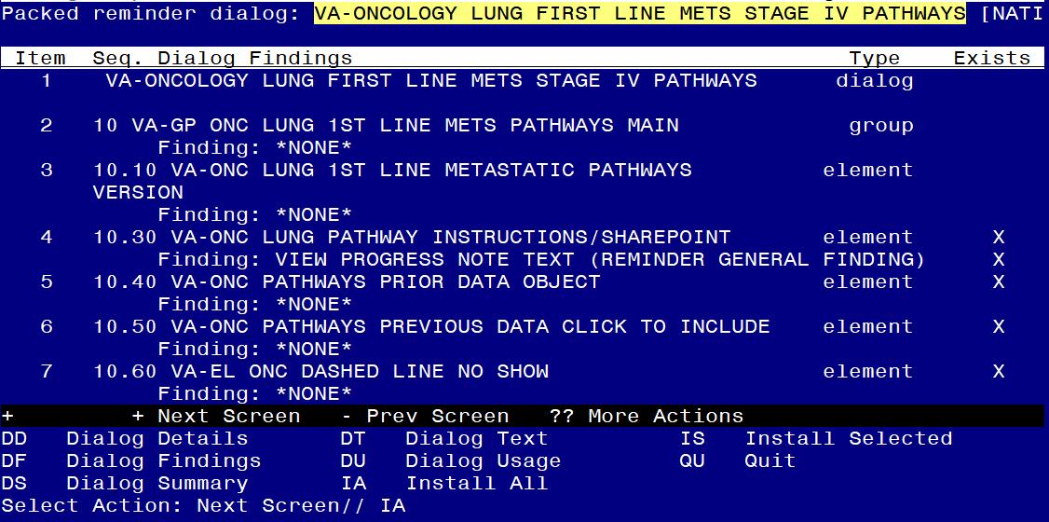
At the Select Action prompt, type IA to install the dialog VA-ONCOLOGY LUNG FIRST LINE METS STAGE IV PATHWAYS
Select Action: Next Screen// IA Install All
Install reminder dialog and all components with no further changes: Y// Yes

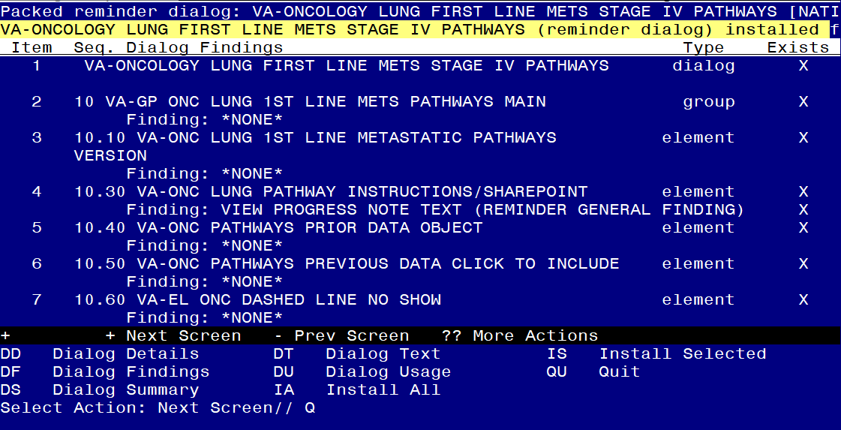

After completing this dialog install, you will type Q.
You will be prompted to install the next reminder dialog component (VA-ONCOLOGY LUNG PATHWAY). You will choose to install all even though some components may have an X to indicate that they exist.
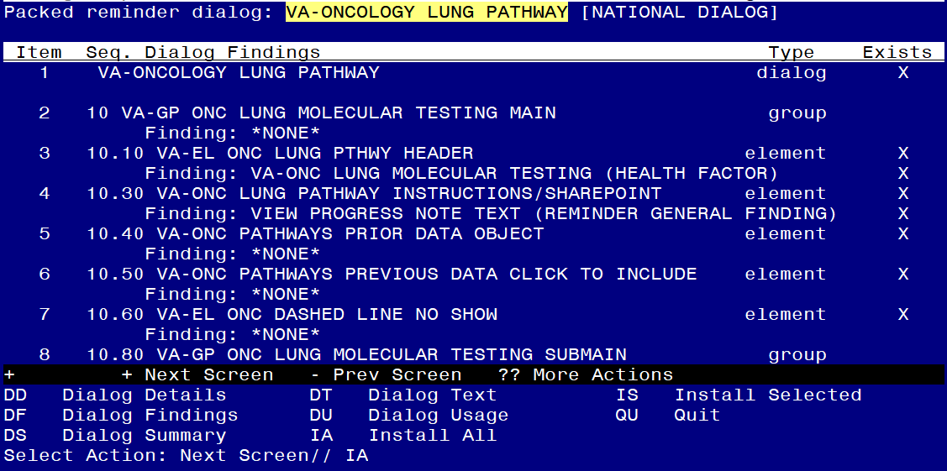
At the Select Action prompt, type IA to install the dialog VA-ONCOLOGY LUNG PATHWAY
Select Action: Next Screen// IA Install All
Install reminder dialog and all components with no further changes: Y// Yes
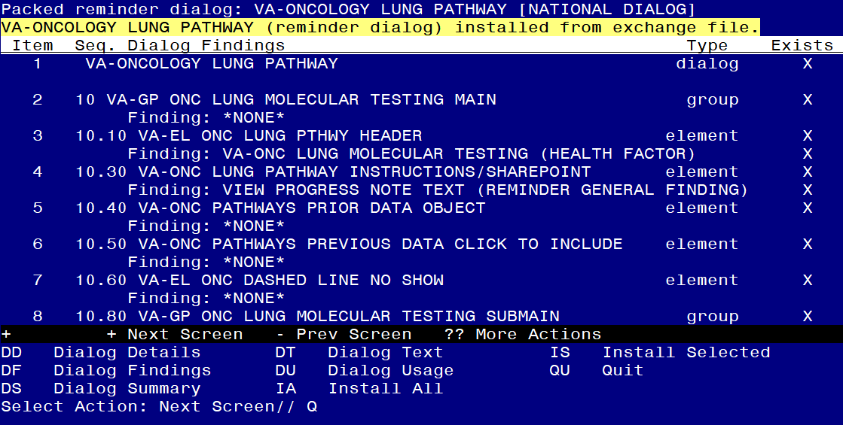

After completing this dialog install, you will type Q.

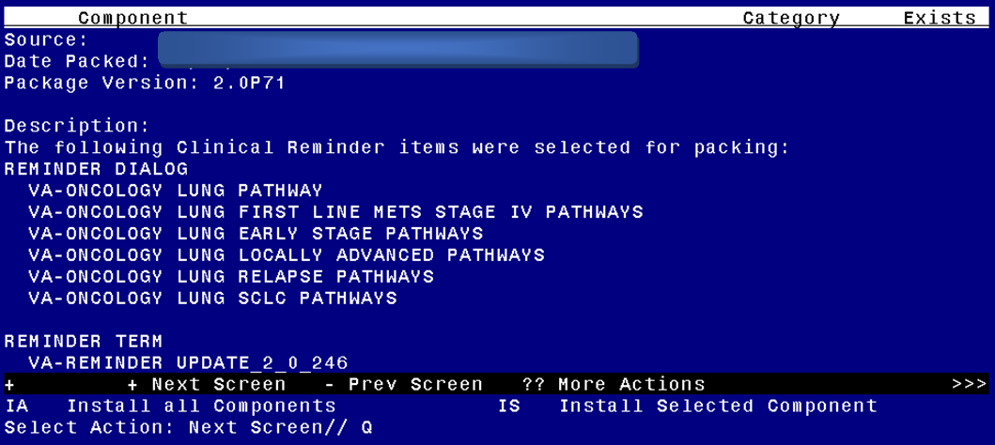
You will then be returned to this screen. At the Select Action prompt, type Q.

Install complete.

Post Installation

- Setup of Note Titles.

The note titles to create to associate with this template are:
ONCOLOGY-EARLY STAGE LUNG CANCER PATHWAYS
ONCOLOGY-LOCALLY ADVANCED LUNG CANCER PATHWAYS
ONCOLOGY-FIRST LINE STAGE IV METASTATIC LUNG CANCER PATHWAYS
ONCOLOGY-LUNG CANCER RELAPSE PATHWAYS
ONCOLOGY-SMALL CELL LUNG CANCER PATHWAYS

VHA Enterprise Standard Title: HEMATOLOGY AND ONCOLOGY NOTE

You should already have a note title created named ONCOLOGY-LUNG MOLECULAR TESTING PATHWAY

You can add these to your document class where progress notes used by Oncology are located. They should not be in your consult document class.

Note: Comprehensive information on Creating new Document Classes and Titles can be found beginning on page 54 of the TIU/ASU Implementation Guide at the following link: http://www.va.gov/vdl/documents/Clinical/CPRS-Text_Integration_Utility_(TIU)/tiuim.pdf

- Make the Dialog template available to be attached to a Personal or Shared template or to be able to attach the dialog to a progress note title. (You can use the LINK feature in this menu for steps 2 and 3 if you choose to)
Select Reminder Managers Menu <TEST ACCOUNT> Option: CP CPRS Reminder Configuration
CA Add/Edit Reminder Categories
CL CPRS Lookup Categories
CS CPRS Cover Sheet Reminder List
MH Mental Health Dialogs Active
PN Progress Note Headers
RA Reminder GUI Resolution Active
TIU TIU Template Reminder Dialog Parameter
DEVL Evaluate Coversheet List on Dialog Finish
DL Default Outside Location
PT Position Reminder Text at Cursor
LINK Link Reminder Dialog to Template
TEST CPRS Coversheet Time Test
NP New Reminder Parameters
GEC GEC Status Check Active
WH WH Print Now Active
Select CPRS Reminder Configuration <TEST ACCOUNT> Option: TIU TIU Template Reminder Dialog Parameter
Reminder Dialogs allowed as Templates may be set for the following:

1 User USR [choose from NEW PERSON]
3 Service SRV [choose from SERVICE/SECTION]
4 Division DIV [SALT LAKE CITY]
5 System SYS [NATREM.FO-SLC.MED.VA.GOV]
Enter selection: 5 Choose the appropriate number for your site. Your site may do this by System or other levels. The example below uses SYSTEM level.
Setting Reminder Dialogs allowed as Templates for System: NATREM.FO-SLC.MED.VA.GOV
Select Display Sequence: ?
388 VA-COVID-19 TELEPHONE FOLLOW-UP
389 VA-SRA-CONSULT RESPONSE (D)
When you type a question mark above, you will see the list of #’s (with dialogs) that are already taken. Choose a number NOT on this list. For this example, 390 is not present so I will use 390.
Select Display Sequence: 390
Are you adding 390 as a new Display Sequence? Yes// YES
Display Sequence: 390// <Enter> 390
Clinical Reminder Dialog: VA-ONCOLOGY LUNG EARLY STAGE PATHWAYS reminder dialog NATIONAL
...OK? Yes// <Enter> (Yes)

Select Display Sequence: 391
Are you adding 391 as a new Display Sequence? Yes// YES
Display Sequence: 391// <Enter> 391
Clinical Reminder Dialog: VA-ONCOLOGY LUNG LOCALLY ADVANCED PATHWAYS
reminder dialog NATIONAL
...OK? Yes// <Enter> (Yes)
Select Display Sequence: 392
Are you adding 392 as a new Display Sequence? Yes// YES
Display Sequence: 392// <Enter> 392
Clinical Reminder Dialog: VA-ONCOLOGY LUNG FIRST LINE METS STAGE IV PATHWAYS
reminder dialog NATIONAL
...OK? Yes// <Enter> (Yes)

Select Display Sequence: 393
Are you adding 393 as a new Display Sequence? Yes// YES
Display Sequence: 393// <Enter> 393
Clinical Reminder Dialog: VA-ONCOLOGY LUNG RELAPSE PATHWAYS
reminder dialog NATIONAL
...OK? Yes// <Enter> (Yes)

Select Display Sequence: 394
Are you adding 394 as a new Display Sequence? Yes// YES
Display Sequence: 394// <Enter> 394
Clinical Reminder Dialog: VA-ONCOLOGY LUNG SCLC PATHWAYS
reminder dialog NATIONAL
...OK? Yes// <Enter> (Yes)

3. Associate the reminder dialogs with the note title in CPRS. In addition to connecting to the note titles, you should also add these to a shared template folder for your oncology service.

- In CPRS, open the Template Editor, expand Document Titles, select the appropriate folder (if applicable), then click New Template (top right-hand corner).

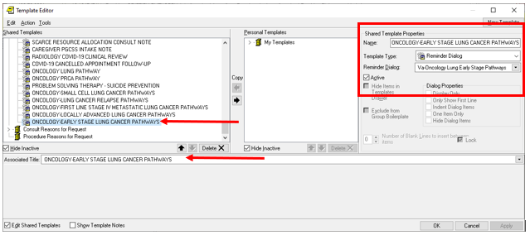

Type in the following information:
Name: ONCOLOGY-EARLY STAGE LUNG CANCER PATHWAYS
Template Type: Reminder Dialog
Reminder Dialog: VA-ONCOLOGY LUNG EARLY STAGE PATHWAYS

Next, type in the Associated Title name – ONCOLOGY-EARLY STAGE LUNG CANCER PATHWAYS – then click Apply.

- In CPRS, open the Template Editor, expand Document Titles, select the appropriate folder (if applicable), then click New Template (top right-hand corner).

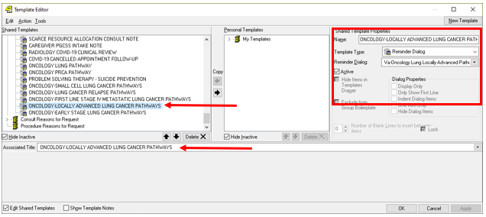

Type in the following information:
Name: ONCOLOGY-LOCALLY ADVANCED LUNG CANCER PATHWAYS
Template Type: Reminder Dialog
Reminder Dialog VA-ONCOLOGY LUNG LOCALLY ADVANCED PATHWAYS

Next, type in the Associated Title name – ONCOLOGY-LOCALLY ADVANCED LUNG CANCER PATHWAYS– then click Apply.
- In CPRS, open the Template Editor, expand Document Titles, select the appropriate folder (if applicable), then click New Template (top right-hand corner).

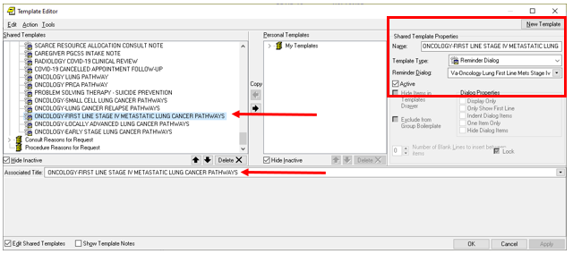

Type in the following information:
Name: ONCOLOGY-FIRST LINE STAGE IV METASTATIC LUNG CANCER PATHWAYS
Template Type: Reminder Dialog
Reminder Dialog: VA-ONCOLOGY LUNG FIRST LINE METS STAGE IV PATHWAYS

Next, type in the Associated Title name – ONCOLOGY-FIRST LINE STAGE IV METASTATIC LUNG CANCER PATHWAYS – then click Apply.

- In CPRS, open the Template Editor, expand Document Titles, select the appropriate folder (if applicable), then click New Template (top right-hand corner).

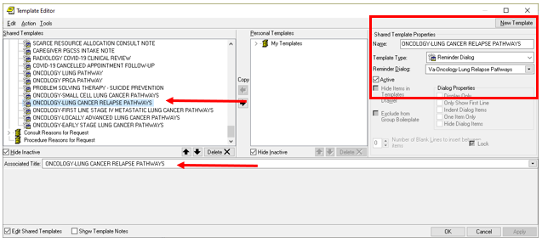

Type in the following information:
Name: ONCOLOGY-LUNG CANCER RELAPSE PATHWAYS
Template Type: Reminder Dialog
Reminder Dialog: VA-ONCOLOGY LUNG RELAPSE PATHWAYS
Next, type in the Associated Title name – ONCOLOGY-LUNG CANCER RELAPSE PATHWAYS– then click Apply.

- In CPRS, open the Template Editor, expand Document Titles, select the appropriate folder (if applicable), then click New Template (top right-hand corner).
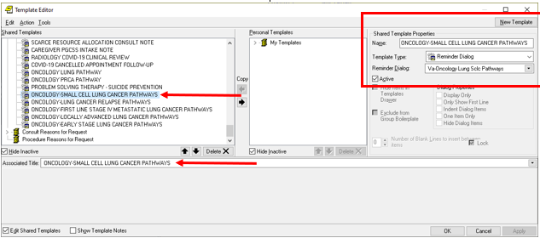

Type in the following information:
Name: ONCOLOGY-SMALL CELL LUNG CANCER PATHWAYS
Template Type: Reminder Dialog
Reminder Dialog: VA-ONCOLOGY LUNG SCLC PATHWAYS

Next, type in the Associated Title name – ONCOLOGY-SMALL CELL LUNG CANCER PATHWAYS – then click Apply.

- Disable element –If your site does not have the precision oncology IFC available, you can disable this element: VAL-ONC LUNG IVB POS 1ST OTHER.
There are 111 sites that have this consult. If the site would like the consult, contact REDACTED.

- Enable specific elements – Review with your oncologist to see if they would like only lung pathway health factors to display or all pathway health factors to display in the template.
- Released enabled local elements: These elements have an object that is only for lung pathway health factors. If your Oncologists only want lung pathway health factors to show in the pathway templates, you do not have to do anything else.
VA-ONC LUNG PATHWAYS PRIOR DATA OBJECT
VA-ONC LUNG PATHWAYS PREVIOUS DATA CLICK TO INCLUDE
|VA-ONCOLOGY PATHWAYS LUNG| is being released with the lung pathway health factors.

- Released disabled local elements: These elements have an object that is for all pathway health factors. If your Oncologists want all pathway health factors to show in the pathway templates, you need to enable these elements.
VA-ONC PATHWAYS PRIOR DATA OBJECT (Disabled)
VA-ONC PATHWAYS PREVIOUS DATA CLICK TO INCLUDE (Disabled)
And disable these elements:
VA-ONC LUNG PATHWAYS PRIOR DATA OBJECT
VA-ONC LUNG PATHWAYS PREVIOUS DATA CLICK TO INCLUDE

|VA-ONCOLOGY PATHWAYS| is being released with the lung pathway health factors and the prostate molecular testing health factors mapped.

- Add orders to the reminder dialog. (OPTIONAL)
Within the templates, there are multiple places where you can add a consult orders or a menu to order consults. Review with your local oncology service to see if they would like these orders added to the dialogs.
Using the Vista Menu, Reminder Dialog Manager, DI- Reminder Dialog, change view to element view edit the following reminder dialog elements, adding your quick order or menu containing the items indicated as an additional finding to these elements:

Element | Finding
Template: VA-ONCOLOGY LUNG EARLY STAGE
Pathway: NSCLC Clinical Stage IA and IB
VA-ONC LUNG IA/IB SURG NO REFER RAD ONC | Map Radiation Oncology consult
VA-ONC LUNG IA/IB PATH IA POS NON RESECT REFER RAD ONC | Map Radiation Oncology consult
VA-ONC LUNG IA/IB PATH IB POS NO RESECT REFER RAD ONC | Map Radiation Oncology consult
Pathway: NCLC Clinical Stage IIA, IIB and Resectable IIIA Excluding Single Level N2 and Pancoast Tumors
VA-ONC LUNG IIA/IIB NOT SURG CAND REFER RAD AND ONC | Map Radiation Oncology consult/Oncology consult-order menu
VA-ONC LUNG IIA/IIB PATH R1/R2 NSQ NON RESECT CIS+PEME | Map Radiation Oncology consult
VA-ONC LUNG IIA/IIB PATH R1/R2 SQU NON RESECT CIS+DOC | Map Radiation Oncology consult
VA-ONC LUNG IIA/IIB PATH R1/R2 NSQ POST CIS+PEME | Map Radiation Oncology consult
VA-ONC LUNG IIA/IIB PATH R1/R2 SQU POST CIS+DOC | Map Radiation Oncology consult
Pathway: NSCLC Clinical Stage IIIA Resectable Single Level N2, T2a-T2b, and T3
VA-ONC LUNG IIIA R1/R2 RE-RESECT NOT CAND REFER RAD ONC | Map Radiation Oncology consult
Template: VA-ONCOLOGY LUNG LOCALLY ADVANCED PATHWAYS
Pathway: Pancoast Tumors T4N1 and T4N0
VA-ONC LUNG PANCOAST SURG CAND CIS+ETOP SURGERY | Map Radiation Oncology consult/Surgery consult-order menu
VA-ONC LUNG PANCOAST SURG NO CIS+ETOP CARBO+PAC | Map Radiation Oncology consult/Surgery consult-order menu
VA-ONC LUNG PANCOAST NO SURG CIS+ETOP DURVALUMAB | Map Radiation Oncology consult
VA-ONC LUNG PANCOAST NO SURG NO CIS+ETOP CARBO+PAC | Map Radiation Oncology consult
Pathway: NSCLC Stage III Unresectable Multiple Level N2, Bulky N2, Any N3, Any T4 due to Tumor Invasion into Adjacent Structure First Line
VA-ONC LUNG III CON RAD YES 1ST CARBO+PAC W/RAD | Map Radiation Oncology consult
VA-ONC LUNG III CON RAD NO NSQ CARBO+PEME | Map Radiation Oncology consult
VA-ONC LUNG III CON RAD NO SQU CARBO+PAC | Map Radiation Oncology consult
Template: VA-ONCLOGY LUNG FIRST LINE METS STAGE IV PATHWAYS
Pathway: NSCLC Stage IVA M1b Single Extrathoracic Site (Oligometastatic Disease) or M1a due to a Contralateral Nodule at Presentation
VA-ONC LUNG REFER TO PALLIATIVE CARE | Map Palliative Care consult
VA-ONC LUNG M1B AMEN REFER | Map Radiation Oncology consult/Rad Onc/Surgery consult-order menu
Pathway: NSCLC Stage IVA Due to Pericardial/Pleural Effusion and IVB Mutation Positive
VAL-ONC LUNG IVB POS 1ST OTHER | Map Precision Oncology consult
Pathway: Squamous Stage IVB First Line
VA-ONC LUNG SQUIVB SYMPTOMATIC | Map Radiation Oncology consult
VA-ONC LUNG SQUIVB NO CHEMO/IMMUNO HOSPICE | Map Hospice consult
Template: VA-ONCOLOGY LUNG RELAPSE PATHWAYS
Pathway: Non-Squamous Relapse
VA-ONC LUNG NSR 3RD LINE YES DOCETAXEL REFER HOSPICE | Map Hospice consult
Pathway: Squamous Relapse
VA-ONC LUNG SQR 2ND LINE CHEMO/IMMUNO AMEN RAD REFER RAD ONC | Map Radiation Oncology consult
VA-ONC LUNG SQR 2ND LINE IMMUNO AMEN REFER RAD ONC | Map Radiation Oncology consult
VA-ONC LUNG SQR 3RD LINE PROG AMEN LOCAL THERAPY | Map Radiation Oncology consult
VA-ONC LUNG SQR 3RD LINE PROG NOT AMEN PALL CARE | Map Palliative Care consult
Template: VA-ONCOLOGY LUNG SCLC PATHWAYS
Pathway: SCLC Incidental Discovery Resected
VA-ONC LUNG SCLC INC INCOMP RESECT CIS+ETO+RAD | Map Radiation Oncology consult
Pathway: SCLC Limited Stage First Line
VA-ONC LUNG SCLC LIMIT INITIAL CIS+ETO W/RAD | Map Radiation Oncology consult
VA-ONC LUNG SCLC LIMIT SUB PS3-4 NO RAD ONC | Map Radiation Oncology consult
VA-ONC LUNG SCLC LIMIT SUB PS3-4 SURVEILLANCE | Map MRI quick order/Radiology order menu
Pathway: SCLC Extensive Stage First Line
VA-ONC LUNG SCLC EXT SYMPTOMATIC | Map Radiation Oncology consult
VA-ONC LUNG SCLC EXT IMMUNO ONLY REFER HOSPICE | Map Hospice consult
VA-ONC LUNG SCLC RELAPSE <6M PS 3-4 REFER HOSPICE | Map Hospice consult
Pathway: SCLC Relapse
VA-ONC LUNG SCLC RELAPSE SYMPTOMATIC | Map Radiation Oncology consult
VA-ONC LUNG SCLC RELAPSE <6M PS 3-4 REFER HOSPICE | Map Hospice consult
Template: VA-ONCOLOGY LUNG PATHWAY | These may have been previously mapped
Pathway: Metastatic NSCLC Molecular Testing
VA-EL ONC LUNG ON PDL1 | Map PD-L1 order
VA-EL ONC LUNG PTHWY NGS ON | Map Tumor Genomic testing order
VA-EL ONC LUNG PTHWY LIQUID BIOPSY | Map order for liquid biopsy

