

**Update _2_0_247**

Clinical Reminders

VA-HOME TELEHEALTH ZARIT UPDATE

Install Guide

**November 2021**

Product Development

Office of Information Technology

Department of Veterans Affairs

Table of Contents

Introduction 1

Install Details 3

Install Example 3

Post Installation 8

# Introduction

The Office of Connected Care/Telehealth Services, in collaboration with the Office of Social Work and the Intimate Partner Violence Assistance Program have decided to inactivate the reminder dialog group VA-GP HT GAREGIVER RISK SCREEN MAIN (CB) that is part of the following templates:

* VA-HT ASSESSMENT TREAMENT PLAN TEMPLATE
* VA-HT CAREGIVER ASSESSMENT TEMPLATE
* VA-HT PERIODIC EVALUATION

This reminder dialog group contains the Zarit Burden Interview (ZBI) mental health instrument. The stakeholders above determined that the presence of this instrument in a Veteran record could pose a potential safety risk as it can indicate domestic violence. Inactivating the group will make the section in the templates no longer viewable/selectable.

The associated cover-sheet reminder triggered by the ZBI, VA-HT CAREGIVER RISK ASSESSMENT, is also being inactivated.

1. Before (prompting section in the VA-HT ASSESSMENT TREAMENT PLAN TEMPLATE)

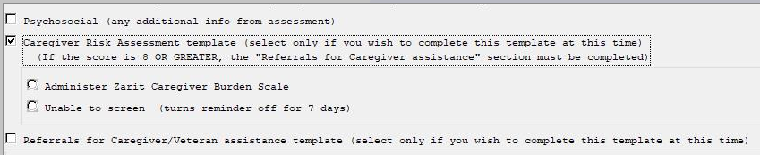

After, that option no longer displays (with the reminder dialog group inactivated)



1. Before (prompting section in the VA-HT CAREGIVER ASSESSMENT TEMPLATE)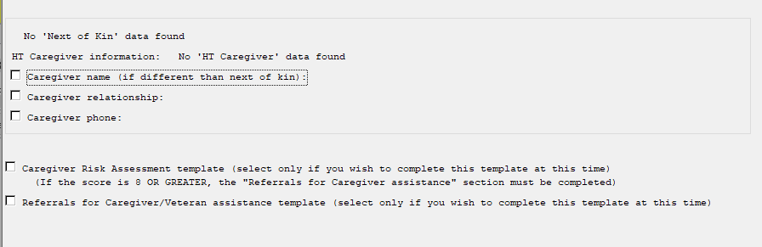

After, that option no longer displays (with the reminder dialog group inactivated)

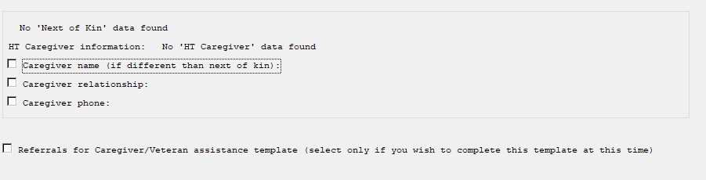

1. Before (prompting section in the VA-HT PERIODIC EVALUATION)

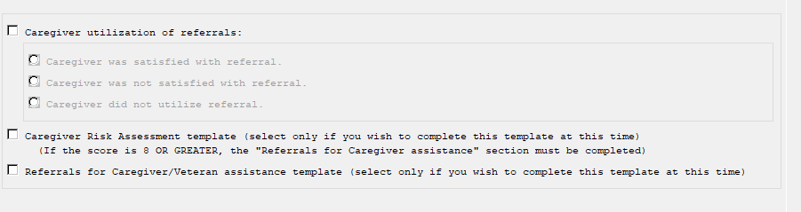

After, that option no longer displays (with the reminder dialog group inactivated)

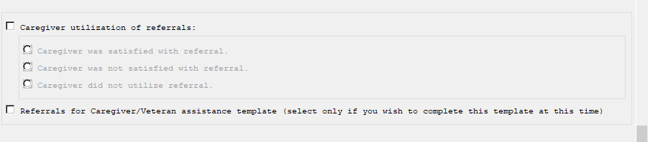

UPDATE_2_0_247 contains 1 Reminder Exchange entry:

UPDATE_2_0_247 VA-HOME TELEHEALTH ZARIT UPDATE

**The exchange file contains the following components:**

**HEALTH FACTORS**

VA-REMINDER UPDATES [C]

VA-UPDATE_2_0_247

HT CAREGIVER RISK ASSESSMENT SCREEN [C

HT UNABLE TO SCREEN CAREGIVER

HT CAREGIVER ASSESSMENT SCREEN COMPLET

HT (HOME TELEHEALTH) [C]

HT ENROLLMENT-START DATE

HT DISCHARGE [C]

HT DISCHARGE-HAS MET GOALS

HT DISCHARGE-PT/CG REQUEST DC SERVICES

HT DISCHARGE-UNABLE TO OPERATE DEVICES

HT DISCHARGE-RELOCATED OUT OF SVC AREA

HT DISCHARGE-ADMITTED TO NURSING HOME

HT DISCHARGE-NO VA PRIMARY CARE SVCS

HT DISCHARGE-PHONE,ELECT SVCS UNAVAIL

HT DISCHARGE-REFERRED TO HOSPICE

HT DISCHARGE-PATIENT IS DECEASED

HT DISCHARGE-PROLONGED HOSPITALIZATION

HT DISCHARGE-PROVIDER REQUESTS DC

HT DISCHARGE-NO RESPONSE TO PROGRAM

HT CONTINUUM OF CARE (CCF) [C]

HT CCF UNPAID CAREGIVER-YES

**REMINDER SPONSOR**

VHA OFFICE OF CONNECTED CARE (10P8)

**REMINDER TERM**

VA-REMINDER UPDATE_2_0_247

VA-HT ENROLLMENT-START DATE

VA-HT CAREGIVER RISK ASSESSMENT DONE

VA-HT DISCHARGE REASONS

VA-HT UNABLE TO SCREEN CAREGIVER

VA-HT CCF UNPAID CAREGIVER-YES

**REMINDER DEFINITION**

VA-HT CAREGIVER RISK ASSESSMENT

**REMINDER DIALOG**

VA-GP HT CAREGIVER RISK SCREEN MAIN (CB)

VA-HT CAREGIVER RISK ASSESSMENT

# Install Details

This update is being distributed as a web host file. The address for the host file is: https://Redacted/UPDATE_2_0_247.PRD

The file will be installed using Reminder Exchange, programmer access is not required.

Installation:

=============

This update can be loaded with users on the system. Installation will take less than 2 minutes.

# Install Example

To Load the exchange file, use LWH. The URL is

https://REDACTED /UPDATE_2_0_247.PRD

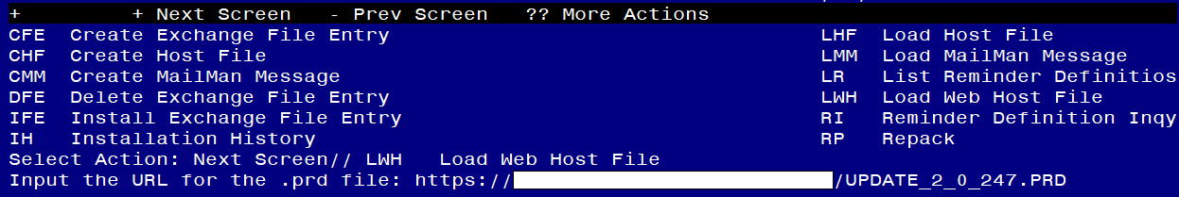

If you use LWH and it works, you will see something like this message. Make sure the file was loaded successfully.

Terminal window screen shot of the message displaying the URL of the file that was successfully loaded.  Part of the URL has been redacted as it is a VA only internal web site URL.

Search and locate an entry titled **UPDATE_2_0_247 VA-HOME TELEHEALTH ZARIT UPDATE** in reminder exchange.

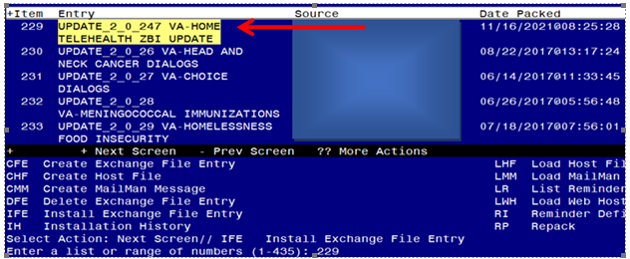

At the **Select Action** prompt, enter **IFE** for Install Exchange File Entry

Enter the number that corresponds with your entry titled **UPDATE_2_0_247 VA-HOME TELEHEALTH ZARIT UPDATE** *(in this example it is entry 229, it will vary by site)* that is dated 11/16/2021.

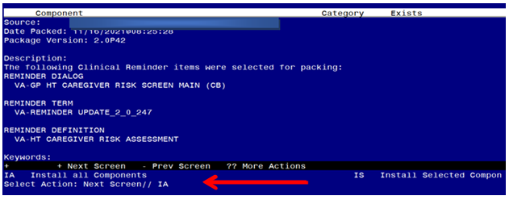

At the **Select Action** prompt, type **IA** for Install all Components and hit enter.

**For all new entries in any category you will choose I to Install**

**Skip any Health Factors that that exist but are different**

**Skip any Reminder Terms that exist but are different**

**OVERWRITE the reminder definition**

You will then be prompted to install the first dialog component. You will choose IA to install all even though some items will already have an X to indicate they exist.

Regarding the VA-GP HT CAREGIVER RISK SCREEN MAIN (CB) Group
Screen shot of the terminal window showing a list of elements, groups and dialogs with the text with IA for "Install All" entered at the "Select Action:" Prompt.  The correct entry is described in the text.

At the **Select Action** prompt, type **IA** to install the dialog – **VA-GP HT CAREGIVER RISK SCREEN MAIN (CB)**

Regarding the VA-GP HT CAREGIVER RISK SCREEN MAIN (CB)
Screen shot of the last of the list of elements, groups and dialogs that needed to be installed with a Q for quit entered at the "Select Action:" prompt because they now all exist.  

When the dialog has completed installation, you will then be returned to this screen. At the **Select Action** prompt, type **Q.**

You will then be prompted to install the next dialog component. You will choose IA to install all even though some items will already have an X to indicate they exist.

Regarding the VA-HT CAREGIVER RISK ASSESSMENT (reminder dialog)
Screen shot of the terminal window showing a list of elements, groups and dialogs with the text with IA for "Install All" entered at the "Select Action:" Prompt.  The correct entry is described in the text.

At the **Select Action** prompt, type **IA** to install the dialog – **VA-HT CAREGIVER RISK ASSESSMENT**

Regarding the VA-HT CAREGIVER RISK ASSESSMENT (reminder dialog)
Screen shot of the last of the list of elements, groups and dialogs that needed to be installed with a Q for quit entered at the "Select Action:" prompt because they now all exist.  

When the dialog has completed installation, you will then be returned to this screen. At the **Select Action** prompt, type **Q.**

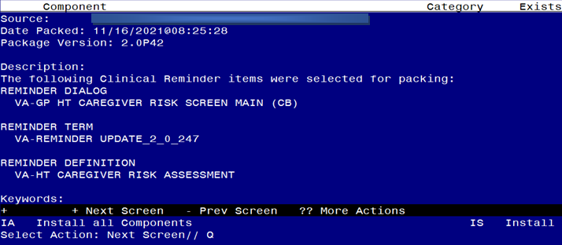

You will then be returned to this screen. At the **Select Action** prompt, type **Q.**

Install complete.

# Post Installation

1. Using the Vista Menu, Reminder Definition Management, RI- Inquire about Reminder Definition, **Inquire into the reminder definition** VA-HT CAREGIVER RISK ASSESSMENT and confirm that it is now INACTIVE:

-----------------------------------------------------------------

VA-HT CAREGIVER RISK ASSESSMENT No. XX

-----------------------------------------------------------------

INACTIVE

Print Name: ZZHT Caregiver Risk Assessment

1. Using the Vista Menu, Reminder Dialog Manager, DI- Reminder Dialog, change view to Group view and Inq/Print the reminder dialog group **VA-GP HT CAREGIVER RISK SCREEN MAIN (CB)**. The status below the name should show as DISABLE AND DO NOT SEND MESSAGE (depending on your screen settings, you may only see part of the message as shown below).

REMINDER DIALOG INQUIRY

--------------------------------------------------------------------

NUMBER: xxxx

Name: VA-GP HT CAREGIVER RISK SCREEN MAI

DISABLE AN