Update _2_0_248

Clinical Reminders

VA-GERIATRIC ED NOTE TEMPLATE UPDATE
Install Guide

January 2022

Product Development
Office of Information Technology
Department of Veterans Affairs

Table of Contents
Introduction 1
Install Details 3
Install Example 4
Post Installation 8

Introduction
The National ED and Geriatrics group released the Geriatric Emergency Department Note Template (Clinical Reminder Update_2_0_227) on September 16, 2021. The following changes are needed based on feedback from the field after implementation.

Summary of Changes:

1. Corrected placement of one of the health factors- VA-GERI ED ISAR HELP REG.

2. Upon opening each screen there is the option to Defer or Perform. This was in response to all of the questions needing to be answered prior to Defer being selected in the last version.

3. Health factors added to several options.

4. Free text boxes were added throughout.

5. Re-sequenced the local orders placeholder. This was in response to the scoring and place order being mutually exclusive

For questions, contact Danielle Cosentino (REDACTED).

UPDATE_2_0_248 contains 1 Reminder Exchange entry:
UPDATE_2_0_248 VA-GERIATRIC ED NOTE TEMPLATE UPDATE

The exchange file contains the following components:

TIU TEMPLATE FIELD
WP LONG
WORD PROCESSING (REQUIRED)
BLANK SPACE1
TEXT (1-10 CHAR) REQ

HEALTH FACTORS
VA-REMINDER UPDATES [C]
VA-UPDATE_2_0_248
VA-GERI ED COG IMP SCREEN [C]
VA-GERI ED CIS NEGATIVE INDICATE LOW LIKELIHOOD OF DEMENTIA
VA-GERI ED CIS POSITIVE INDICATE HIGH LIKELIHOOD OF DEMENTIA
VA-GERI ED CIS CLOCK-2
VA-GERI ED CIS CLOCK-0
VA-GERI ED CIS RECALL-3
VA-GERI ED CIS RECALL-2
VA-GERI ED CIS RECALL-1
VA-GERI ED CIS RECALL-0
VA-GERI ED CIS DEFER
VA-GERI ED SCREENING TIME [C]
VA-GERI ED SCREENING TIME > 20
VA-GERI ED SCREENING TIME 16-20
VA-GERI ED SCREENING TIME 10-15
VA-GERI ED SCREENING TIME < 10
VA-GERI ED ISAR SCORE [C]
VA-GERI ED ISAR SCORE-6
VA-GERI ED ISAR SCORE-5
VA-GERI ED ISAR SCORE-4
VA-GERI ED ISAR SCORE-3
VA-GERI ED ISAR SCORE-2
VA-GERI ED ISAR SCORE-1
VA-GERI ED ISAR SCORE-0
VA-GERI ED ISAR REPORTS MORE THAN 3 MEDS DAILY
VA-GERI ED ISAR REPORTS MEMORY PROBLEM
VA-GERI ED ISAR REPORTS VISION PROBLEM
VA-GERI ED ISAR HOSP
VA-GERI ED ISAR HELP MORE
VA-GERI ED ISAR HELP REG
VA-GERI ED ISAR DEFER
VA-GERI ED DELIRIUM SCREEN [C]
VA-GERI ED BCAM FEATURE 1-NO
VA-GERI ED BCAM FEATURE 3-YES
VA-GERI ED BCAM FEATURE 4-NO
VA-GERI ED BCAM FEATURE 4-YES
VA-GERI ED BCAM FEATURE 3-NO
VA-GERI ED BCAM FEATURE 2-YES
VA-GERI ED BCAM FEATURE 2-NO
VA-GERI ED BCAM FEATURE 1-YES
VA-GERI ED BCAM DEFER
VA-GERI ED DTS POSITIVE
VA-GERI ED DTS NEGATIVE
VA-GERI ED DTS DEFER
VA-GERI ED STEADI FALL SCREEN [C]
VA-GERI ED STEADI FALL SCREEN NEG
VA-GERI ED STEADI FALL SCREEN POS
VA-GERI ED STEADI WORRIES ABOUT FALLING
VA-GERI ED STEADI FEELS UNSTEADY STAND OR WALK
VA-GERI ED STEADI FALL PAST YEAR
VA-GERI ED STEADI FALL SCREEN DEFER
VA-GERI ED CGB SCORE [C]
VA-GERI ED CGB SCORE 13-16
VA-GERI ED CGB SCORE 9-12
VA-GERI ED CGB SCORE 5-8
VA-GERI ED CGB SCORE 0-4
VA-GERI ED CGB DEFER
VA-GERI ED KATZ ADLS [C]
VA-GERI ED KATZ ADLS 6 INDEP
VA-GERI ED KATZ ADLS 5 INDEP
VA-GERI ED KATZ ADLS 4 INDEP
VA-GERI ED KATZ ADLS 3 INDEP
VA-GERI ED KATZ ADLS 2 INDEP
VA-GERI ED KATZ ADLS 1 INDEP
VA-GERI ED KATZ ADLS ZERO INDEP
VA-GERI ED KATZ ADLS FEEDING DEPENDENT
VA-GERI ED KATZ ADLS FEEDING INDEP
VA-GERI ED KATZ ADLS CONTINENCE DEPENDENT
VA-GERI ED KATZ ADLS CONTINENCE COMPLETE SELF CONTROL
VA-GERI ED KATZ ADLS TRANSFERRING DEPENDENT
VA-GERI ED KATZ ADLS TRANSFERRING INDEP
VA-GERI ED KATZ ADLS TOILETING DEPENDENT
VA-GERI ED KATZ ADLS TOILETING INDEP
VA-GERI ED KATZ ADLS DRESSING DEPENDENT
VA-GERI ED KATZ ADLS DRESSING INDEP
VA-GERI ED KATZ ADLS BATHING DEPENDENT
VA-GERI ED KATZ ADLS BATHING INDEP
VA-GERI ED KATZ ADLS DEFER

REMINDER SPONSOR
CAREGIVER SUPPORT PROGRAM

REMINDER TERM
VA-REMINDER UPDATE_2_0_248

REMINDER DIALOG
VA-GERIATRIC ED NOTE

Install Details

This update is being distributed as a web host file. The address for the host file is: https://REDACTED/docs/UPDATE_2_0_248.PRD
The file will be installed using Reminder Exchange, programmer access is not required.

Installation:
=============
This update can be loaded with users on the system. Installation will take less than 5 minutes.

Pre-Install

- You should have installed update 227 prior to installing this update.
Link to 227 install guide redacted. It may be at https://www.va.gov/vdl
or https://foia-vista.worldvista.org/Patches_By_Application/PXRM-CLINICAL%20REMINDERS/PRD-Files/Documents/Update_2_0_227_IG-508.pdf

- Identify Referral orders currently in use.
- Using the Vista Menu, Reminder Dialog Manager, DI- Reminder Dialog, change view to Group view and Inq/Print the reminder dialog groups listed below. You will need to identify the local order used as an additional finding and if the dialog group was enabled. This step was optional and your site may not have enabled or added orders to these groups.

VAL-GP ISAR ORDERS
VAL-GP DTS ORDERS
VAL-GP BCAM ORDERS
VAL-GP MINI ORDERS
VAL-GP KATZ ORDERS
VAL-GP STEADI ORDERS
VAL-GP CAREGIVER ORDERS

Install Example
To Load the Web Host File. Navigate to Reminder exchange in Vista

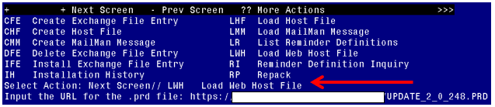
At the Select Action: prompt, enter LWH for Load Web Host File
At the Input the url for the .prd file: prompt, type the following web address:
https://vaww.va.gov/reminders/docs/UPDATE_2_0_248.PRD
You should see a message at the top of your screen that the file successfully loaded.

Search and locate an entry titled UPDATE_2_0_248 VA-GERIATRIC ED NOTE TEMPLATE UPDATE in reminder exchange.

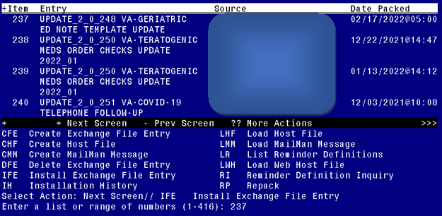

At the Select Action prompt, enter IFE for Install Exchange File Entry
Enter the number that corresponds with your entry UPDATE_2_0_248 VA-GERIATRIC ED NOTE TEMPLATE UPDATE (in this example it is entry 237. It will vary by site). The date of the exchange file should be 02/17/2022.

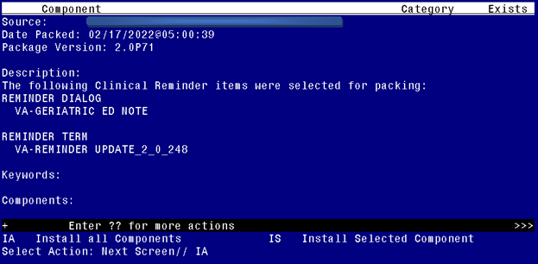

At the Select Action prompt, type IA for Install all Components and hit enter.
Select Action: Next Screen// IA Install all Components
You will see several prompts:
For all new entries you will choose I to Install
If you are prompted to overwrite any components, choose S to Skip.
You will be promped to install the reminder dialog component (VA-GERIATRIC ED NOTE). You will choose to install all even though some components may have an X to indicate that they exist.
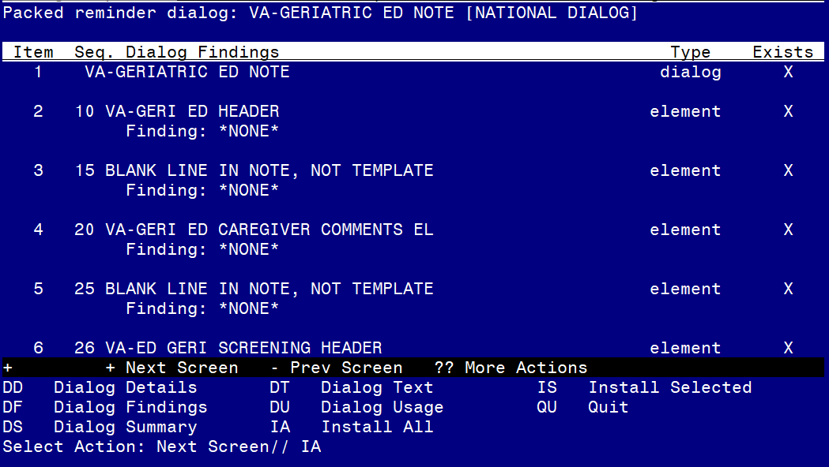

At the Select Action prompt, type IA to install the dialog: VA-GERIATRIC ED NOTE
Select Action: Next Screen// IA Install All
Install reminder dialog and all components with no further changes: Y// Yes

After completing this dialog install, you will type Q.
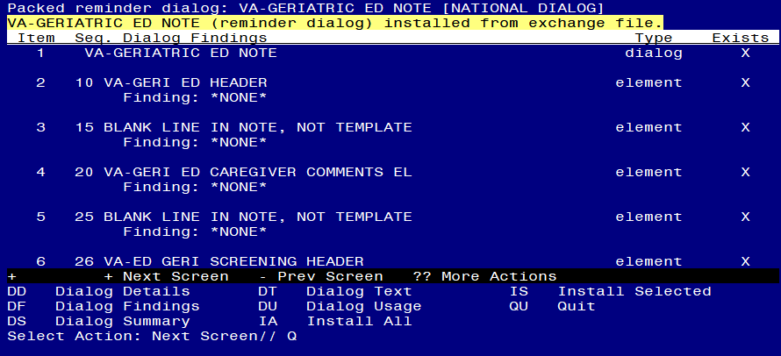

Select Action: Next Screen// Q

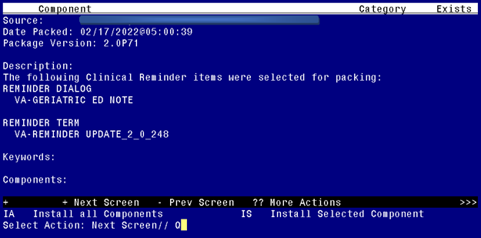
You will then be returned to this screen. At the Select Action prompt, type Q.

Install complete.

Post Installation

The post install ONLY needs to be completed at facilities participating in the GERI_ED program. If your site IS NOT one of the listed sites, no post install setup is needed. For the sites listed below, please complete the post install set-up:

VA ACEP Accredited Geriatric ED or Applicant | City, State | Facility Number
Ann Arbor VA Medical Center | Ann Arbor, MI | 506
Baltimore VA Medical Center | Baltimore, MD | 512
Biloxi VA Medical Center | Biloxi, MS | 520
Buffalo VA Medical Center | Buffalo, NY | 528
Fresno VA Medical Center | Central California | 570
Ralph H Johnson VA Medical Center | Charleston, SC | 534
Jesse Brown VA Medical Center | Chicago, IL | 537
Cincinnati VA Medical Center | Cincinnati, OH | 539
Louis Stokes Cleveland VA Medical Center | Cleveland, OH | 541
Wm. Jennings Bryan Dorn VA Medical Center | Columbia, SC | 544
Dallas VA Medical Center | Dallas, TX | 549
Atlanta VA Medical Center | Decatur, GA | 508
Rocky Mountain Regional VA Medical Center | Denver, CO | 554
Des Moines VA Medical Center | Des Moines, IA | 636A6
John D. Dingell VA Medical Center | Detroit, MI | 553
Durham VA Health Care System | Durham, NC | 558
Fayetteville VA Medical Center (Veterans HCS of the Ozarks) | Fayetteville, AR | 564
Fayetteville VA Medical Center (VA Coastal HCS) | Fayetteville, NC | 565
Grand Junction VA Medical Center | Grand Junction, CO | 575
Michael E. DeBakey VA Medical Center | Houston, TX | 580
Richard L Roudebush VA Medical Center | Indianapolis, IN | 583
GV Sonny Montgomery VA Medical Center | Jackson, MS | 586
Kansas City VA Medical Center | Kansas City, MO | 589
John L. McClellan Memorial Veterans Hospital | Little Rock, AR | 598
Tibor Rubin VA Medical Center | Long Beach, CA | 600
West Los Angeles VA Medical Center | Los Angeles, CA | 691
Robley Rex VA Medical Center | Louisville, KY | 603
William S. Middleton Memorial Veterans Hospital | Madison, WI | 607
Memphis VA Medical Center | Memphis, TN | 614
New Orleans VA Medical Center | New Orleans, LA | 629
Omaha VA Medical Center | Omaha, NE | 636
Palo Alto VA Medical Center | Palo Alto, CA | 640
Carl T. Hayden VA Medical Center | Phoenix, AZ | 644
Alexandria VA Medical Center | Pineville, LA | 502
Pittsburgh VA Medical Center | Pittsburg, PA | 646
Northern Arizona VA Health Care System | Prescott, AZ | 649
Reno VA Medical Center | Reno, NV | 654
Hunter Holmes McGuire VA Medical Center | Richmond, VA | 652
VA Boston HCS | Roxbury, MA | 523
George E Whalen Veterans Affairs Medical Center | Salt Lake City, UT | 660
Audie L Murphy Veteran's Hospital San Antonio TX | San Antonio, TX | 671
San Diego VA Medical Center | San Diego, CA | 664
San Francisco VA Medical Center | San Francisco, CA | 662
Seattle VA Medical Center | Seattle, WA | 663
Overton Brooks VA Medical Center | Shreveport, LA | 667
John Cochran Veterans Hospital - St Louis | St. Louis, MO | 657
Syracuse VA Medical Center | Syracuse, NY | 528A7
Togus VA Medical Center | Togus, ME | 402
Topeka VA Medical Center | Topeka, KS | 677
Tucson VA Medical Center | Tucson, AZ | 678
West Haven VA Medical Center | West Haven, CT | 689
West Palm Beach VA Medical Center | West Palm Beach, FL | 548
White River Junction VA Medical Center | White River Junction, VT | 405

- Using the pre-install inquiry, add local orders/enable reminder dialog groups for referrals – OPTIONAL
Each screening tool has the option to add local orders for referrals if needed. There is a reminder dialog group located at the end of each screen. The purpose of these reminder dialog groups is to allow local editing and addition of consults or other orderable items in response to the screen result. Your site should determine what if any referral options should be offered based on positive screens.

The reminder dialog groups below are currently not disabled, If you do not need these options enabled, you can edit them and disable. The dialog text can be modified as needed.
VAL-GP ISAR ORDERS
VAL-GP DTS ORDERS
VAL-GP BCAM ORDERS
VAL-GP MINI ORDERS
VAL-GP KATZ ORDERS
VAL-GP STEADI ORDERS
VAL-GP CAREGIVER ORDERS

- There is an option on the deferral options to document the reason for deferral. This element is enabled but can be disabled at your site if you do not want your users to enter a reason why, you can disable the reminder dialog element VAL-DEFER TEXT.

