Update_2_0_249

Clinical Reminders

VA-STRENGTH AT HOME TEMPLATES

Install Guide

June 2022

Product Development
Office of Information Technology
Department of Veterans Affairs

Table of Contents
Introduction 1
Install Details 5
Install Example 5
Post Installation 11

Introduction
The Strength at Home dialogs will be utilized by Clinicians (usually Licensed Clinical Social Workers, Psychologists, or Licensed Mental Health Counselors) to deliver the Strength at Home Group therapy intervention, which is an evidenced based practice to reduce the use of IPV in intimate relationships. Notes will be used to document:
- Any inquiry about Strength at Home (SAH)- RHS Strength at Home-V General Note.
- Assessment of Veteran who wishes to engage in the SAH program- RHS Strength at Home-V Intake Assessment Note.
- Group visits 1-12 (RHS Strength at Home-V Group Note).
- The Post Treatment Assessment Summary once a Veteran is done interacting with the program (RHS strength at Home-V Post Treatment Assessment Note).
Please note that frequency of note usage depends on the amount of SAH service delivery in response to Veteran demand. For example, some sites have 3 or 4 groups being conducted at the same time while others only do 1 group at a time.

UPDATE_2_0_249 contains 1 Reminder Exchange entry:
UPDATE_2_0_249 VA-STRENGTH AT HOME TEMPLATES

The exchange file contains the following components:

TIU TEMPLATE FIELD
GEN WORD PROCESSING
GEN WORD PROCESSING REQ
COMMENT (TEXT)
VA-WORD
OTHER NON-VA
OTHER TEXT
TEXT (1-60 CHAR)
TEXT (1-4)
GEN WORD PROCESSING LARGE
COMMENT OPTIONAL
VA-SAH CALLER TYPE
VA-SAH CALL TYPE NOTE
DATE
VA-SAH IA MS COG
VA-SAH IA MS INSIGHT
VA-SAH IA MS TC
VA-SAH IA MS TP
VA-SAH IA MS AFFECT
VA-SAH IA MS MOOD
VA-SAH IA MS SPEECH
VA-SAH IA MS BEHAVIOR
VA-SAH IA MS APPEARANCE
VA-SAH IA HEAD INJURY TEXT
YES -OR- NO
VA-SAH IA CURRENT MH TX
YES/NO/NA
VA-SAH IA OTHER MILITARY HX

HEALTH FACTORS
VA-REMINDER UPDATES [C]
VA-UPDATE_2_0_249
VA-IPVAP/SAH [C]
VA-IPVAP/SAH VPA VET DID NOT COMPLETE POST SURVEY
VA-IPVAP/SAH VPA IPV USE DENIED
VA-IPVAP/SAH VPA IPV EXP 3 MO TYPE IV ENDORSED
VA-IPVAP/SAH VPA IPV EXP 3 MO TYPE III ENDORSED
VA-IPVAP/SAH VPA IPV EXP 3 MO TYPE II ENDORSED
VA-IPVAP/SAH VPA IPV EXP 3 MO TYPE I ENDORSED
VA-IPVAP/SAH VPA IPV USE TYPE IV ENDORSED
VA-IPVAP/SAH VPA IPV USE TYPE III ENDORSED
VA-IPVAP/SAH VPA IPV USE TYPE II ENDORSED
VA-IPVAP/SAH VPA IPV USE TYPE I ENDORSED
VA-IPVAP/SAH VPA AUDIT C SCORE
VA-IPVAP/SAH VPA PCL SCORE
VA-IPVAP/SAH VPA IPSVS DOES NOT ENDORSE
VA-IPVAP/SAH VPA IPSVS ENDORSES
VA-IPVAP/SAH VPA COMP < 9 SESSIONS
VA-IPVAP/SAH VPA COMP 9-11 SESSIONS
VA-IPVAP/SAH VPA COMP 12 SESSIONS
VA-IPVAP/SAH VPA TRACKING NUMBER
VA-IPVAP/SAH VPA VET NOT JUSTICE INVOLVED
VA-IPVAP/SAH VPA VET JUSTICE INVOLVED
VA-IPVAP/SAH VPA END DATE
VA-IPVAP/SAH VPA START DATE
VA-IPVAP/SAH PTN CONTACT NEVER
VA-IPVAP/SAH PTN CONTACT <1 X MONTH
VA-IPVAP/SAH PTN CONTACT 1-3 X MONTH
VA-IPVAP/SAH PTN CONTACT 1-2 X WEEK
VA-IPVAP/SAH PTN CONTACT 3-5 X WEEK
VA-IPVAP/SAH PTN CONTACT DAILY
VA-IPVAP/SAH VET DOES NOT HAVE CHLDRN
VA-IPVAP/SAH VET HAS CHLDRN
VA-IPVAP/SAH REL OTHER
VA-IPVAP/SAH REL SINGLE
VA-IPVAP/SAH REL WIDOWED
VA-IPVAP/SAH REL ENGAGED
VA-IPVAP/SAH REL DATING
VA-IPVAP/SAH REL DIVORCED
VA-IPVAP/SAH REL SEPARATED
VA-IPVAP/SAH REL MARRIED
VA-IPVAP/SAH NOT ENROLLED
VA-IPVAP/SAH ENROLLED IN NEXT COURSE
VA-IPVAP/SAH PCL SCORE
VA-IPVAP/SAH IPV EXP LFT TYPE IV ENDORSED
VA-IPVAP/SAH IPV EXP LFT TYPE III ENDORSED
VA-IPVAP/SAH IPV EXP LFT TYPE II ENDORSED
VA-IPVAP/SAH IPV EXP LFT TYPE I ENDORSED
VA-IPVAP/SAH IPV EXP 3 MO TYPE IV ENDORSED
VA-IPVAP/SAH IPV EXP 3 MO TYPE III ENDORSED
VA-IPVAP/SAH IPV EXP 3 MO TYPE II ENDORSED
VA-IPVAP/SAH IPV EXP 3 MO TYPE I ENDORSED
VA-IPVAP/SAH IPV USE LFT TYPE IV ENDORSED
VA-IPVAP/SAH IPV USE LFT TYPE III ENDORSED
VA-IPVAP/SAH IPV USE LFT TYPE II ENDORSED
VA-IPVAP/SAH IPV USE LFT TYPE I ENDORSED
VA-IPVAP/SAH IPV USE 3 MO TYPE IV ENDORSED
VA-IPVAP/SAH IPV USE 3 MO TYPE III ENDORSED
VA-IPVAP/SAH IPV USE 3 MO TYPE II ENDORSED
VA-IPVAP/SAH IPV USE 3 MO TYPE I ENDORSED
VA-IPVAP/SAH AUDIT C SCORE
VA-IPVAP/SAH IPSVS DOES NOT ENDORSE
VA-IPVAP/SAH IPSVS ENDORSES
VA-IPVAP/SAH LEG NOT JUSTICE INVOLVED
VA-IPVAP/SAH LEG JUSTICE INVOLVED
VA-IPVAP/SAH EMP STATUS NOT IMPACTED IPV
VA-IPVAP/SAH EMP STATUS IMPACTED IPV
VA-IPVAP/SAH EMP OTHER
VA-IPVAP/SAH EMP DISABLED
VA-IPVAP/SAH EMP STUDENT
VA-IPVAP/SAH EMP RETIRED
VA-IPVAP/SAH EMP FULL TIME
VA-IPVAP/SAH EMP PART TIME
VA-IPVAP/SAH EMP NOT EMP
VA-IPVAP/SAH EDU OTHER
VA-IPVAP/SAH EDU DOCTORAL PROGRAM
VA-IPVAP/SAH EDU GRAD DEGREE
VA-IPVAP/SAH EDU SOME GRAD SCHL
VA-IPVAP/SAH EDU COLL GRAD
VA-IPVAP/SAH EDU SOME COLL/TRADE SCHL
VA-IPVAP/SAH EDU HS GRAD
VA-IPVAP/SAH EDU < HS
VA-IPVAP/SAH HSG TYPE OTH
VA-IPVAP/SAH HSG TYPE NH
VA-IPVAP/SAH HSG TYPE ALF
VA-IPVAP/SAH HSG TYPE HUD
VA-IPVAP/SAH HSG TYPE HUDVASH
VA-IPVAP/SAH HSG TYPE GPD
VA-IPVAP/SAH HSG TYPE WITH FAM
VA-IPVAP/SAH HSG TYPE RENTS
VA-IPVAP/SAH HSG TYPE OWNS HOME
VA-IPVAP/SAH HSG OTH
VA-IPVAP/SAH HSG UNSTBL
VA-IPVAP/SAH HSG STBL
VA-IPVAP/SAH DISCHARGE RANK
VA-IPVAP/SAH SVC CON UNK
VA-IPVAP/SAH SVC CON NO
VA-IPVAP/SAH SVC CON YES
VA-IPVAP/SAH MILITARY SERVICE ERA
VA-IPVAP/SAH BRANCH OF SERVICE
VA-IPVAP/SAH SVC UT NONE
VA-IPVAP/SAH SVC UT VET CNTR
VA-IPVAP/SAH SVC UT MED AX
VA-IPVAP/SAH SVC UT MED INAX
VA-IPVAP/SAH SVC UT VR
VA-IPVAP/SAH SVC UT GI
VA-IPVAP/SAH HIGHEST RANK
VA-IPVAP/SAH REFERRAL OTHER
VA-IPVAP/SAH REFERRAL VJO
VA-IPVAP/SAH REFERRAL JUSTICE SYSTEM
VA-IPVAP/SAH REFERRAL SELF
VA-IPVAP/SAH REFERRAL CLINICIAN

REMINDER SPONSOR
SOCIAL WORK/CASE MANAGEMENT – INTIMATE PARTNER VIOLENCE ASSISTANCE PROGRAM

REMINDER TERM
VA-REMINDER UPDATE_2_0_249

TIU DOCUMENT DEFINITION
PATIENT SEX
PATIENT ETHNICITY
PATIENT RACE
PATIENT AGE

REMINDER DIALOG
VA-SAH GROUP NOTE
VA-SAH GENERAL NOTE
VA-SAH POST TREATMENT ASSESSMENT NOTE
VA-SAH INTAKE ASSESSMENT NOTE

Install Details

This update is being distributed as a web host file. The address for the host file is Redacted/UPDATE_2_0_249.PRD

The file will be installed using Reminder Exchange, programmer access is not required.

Installation:
=============
This update can be loaded with users on the system. Installation will take less than 15 minutes.

Install Example
To Load the Web Host File. Navigate to Reminder exchange in Vista
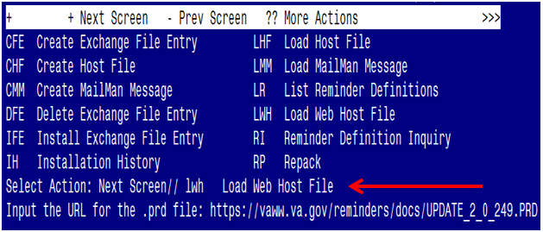

At the Select Action: prompt, enter LWH for Load Web Host File
At the Input the url for the .prd file: prompt, type the following web address:

https://REDACTED/UPDATE_2_0_249.PRD

You should see a message at the top of your screen that the file successfully loaded.

Search for and locate the reminder exchange entry titled:
UPDATE_2_0_249 VA-STRENGTH AT HOME TEMPLATES

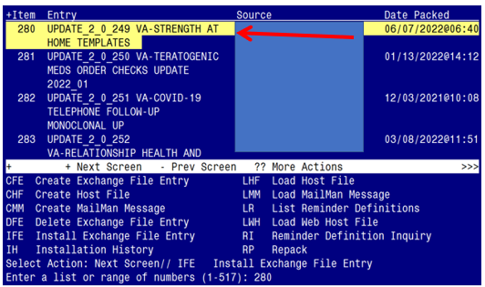

At the Select Action prompt, enter IFE for Install Exchange File Entry
Enter the number that corresponds with your entry titled UPDATE_2_0_249 VA-STRENGTH AT HOME TEMPLATES (in this example it is entry 280, it will vary by site). The exchange file date should be 06/07/2022@06:40.

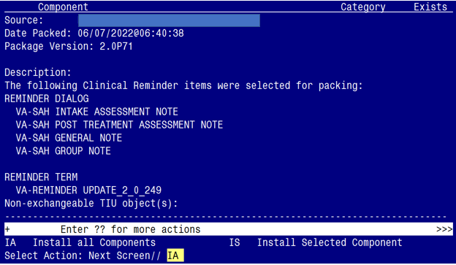

At the Select Action prompt, type IA for Install all Components and hit enter.
Select Action: Next Screen// IA Install all Components
You will see several prompts:
- For all new components, you will choose I to Install
- For any existing components, you will choose O to Overwrite
You will be promped to install the 1st dialog component:

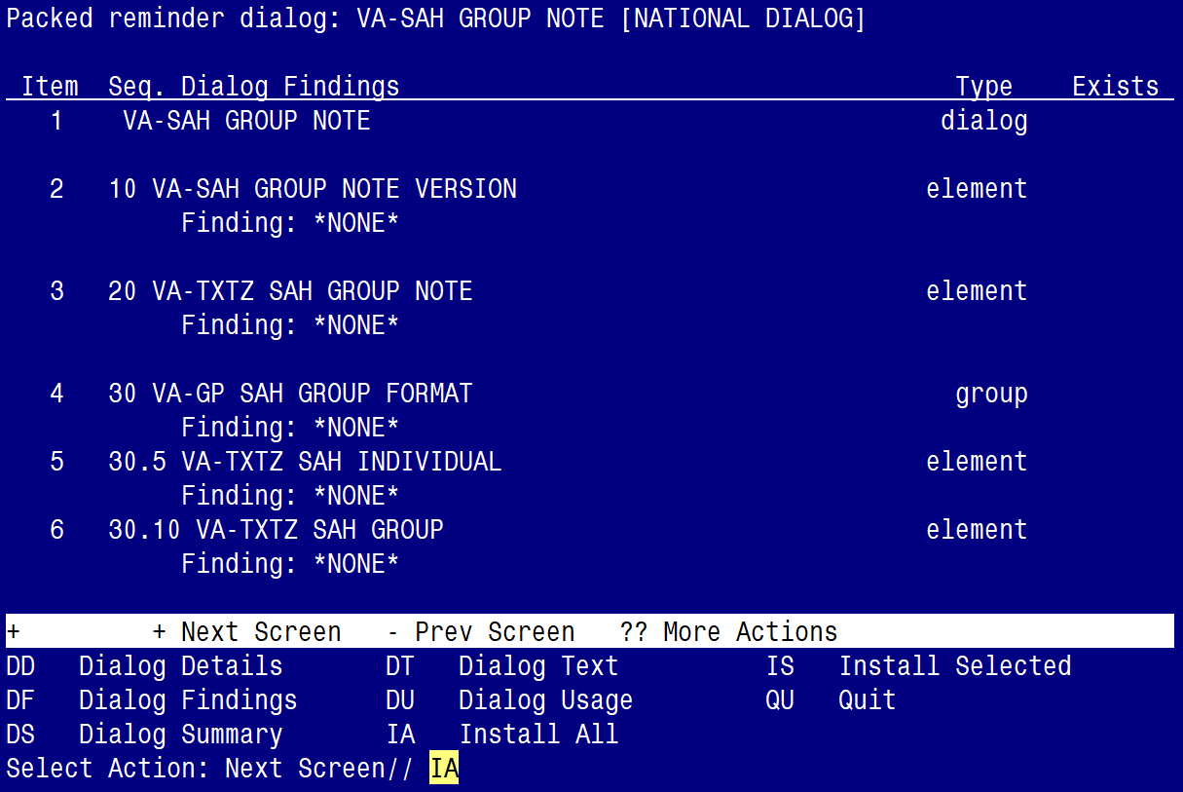

At the Select Action prompt, type IA to install the dialog – VA-SAH GROUP NOTE
Select Action: Next Screen// IA Install All
Install reminder dialog and all components with no further changes: Y// YES

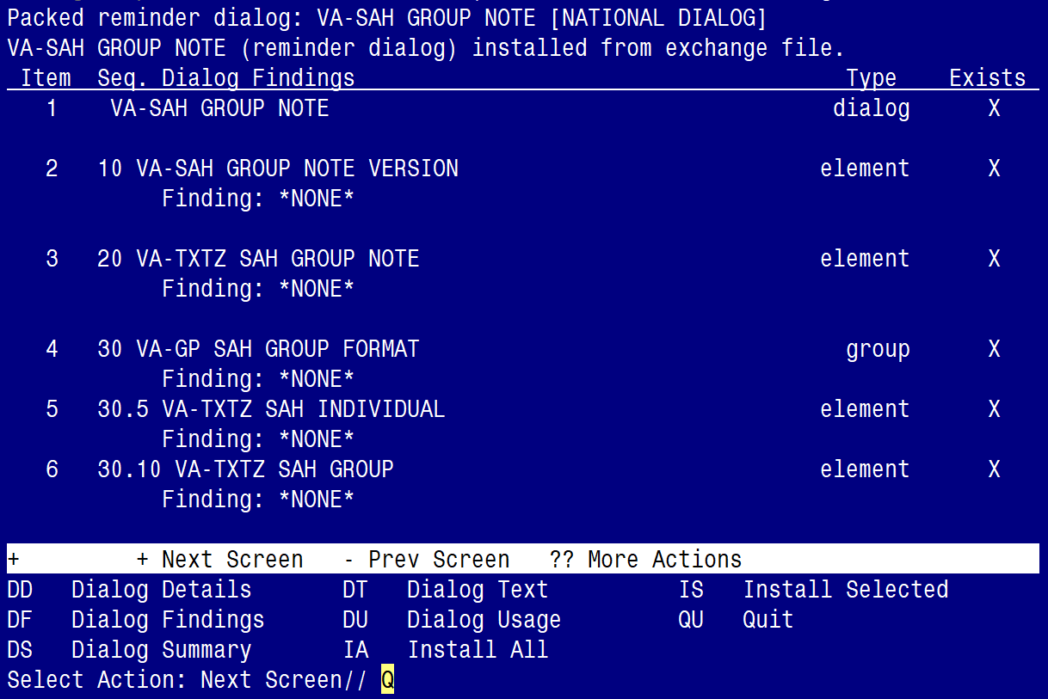

When the dialog has completed installation, you will then be returned to this screen. At the Select Action prompt, type Q.
You will be promped to install the 2nd dialog component:

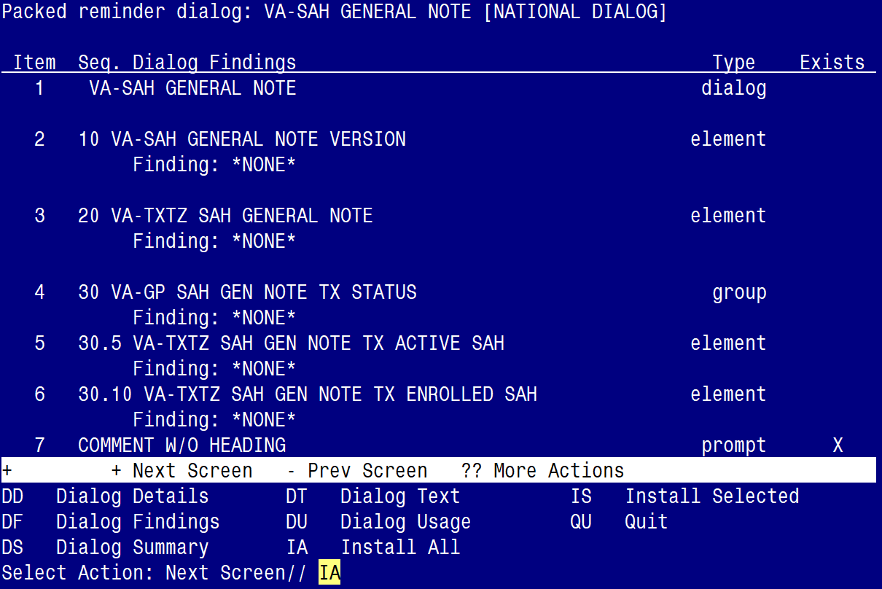

At the Select Action prompt, type IA to install the dialog – VA-SAH GENERAL NOTE
Select Action: Next Screen// IA Install All
Install reminder dialog and all components with no further changes: Y// YES

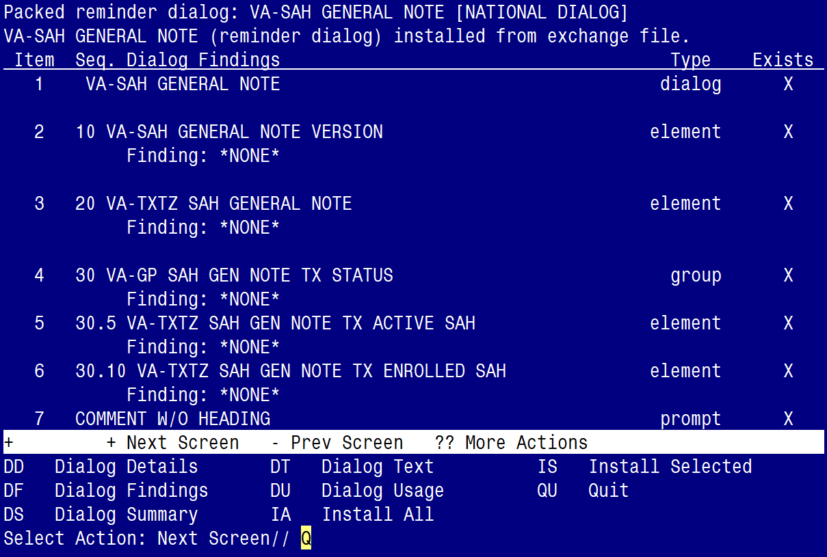

When the dialog has completed installation, you will then be returned to this screen. At the Select Action prompt, type Q.

You will be promped to install the 3rd dialog component:

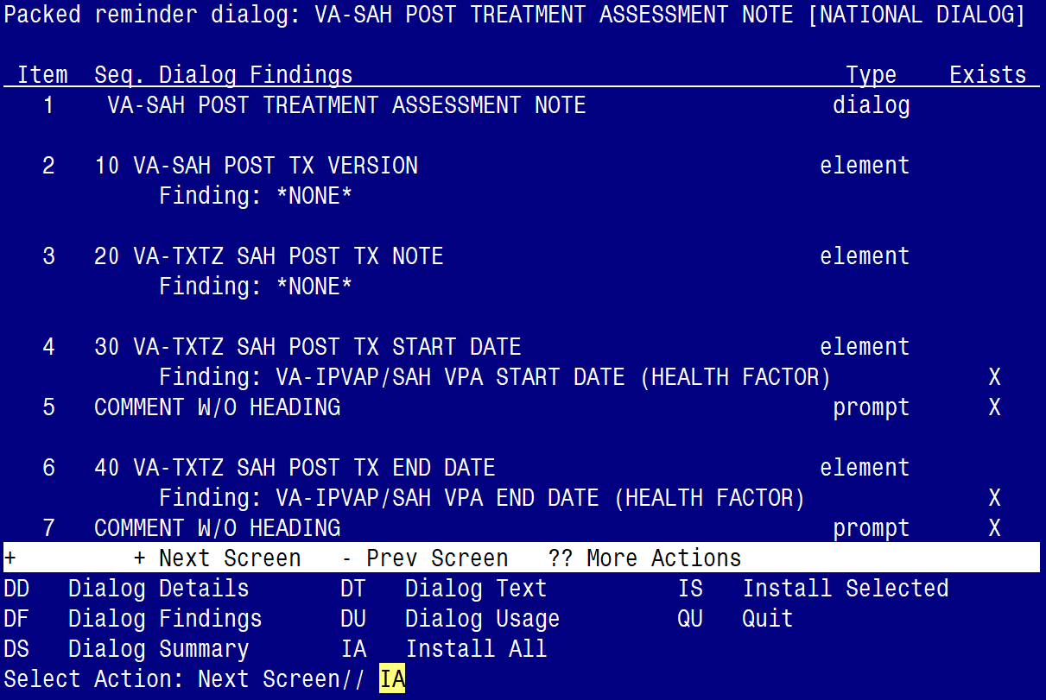

At the Select Action prompt, type IA to install the dialog – VA-SAH POST TREATMENT ASSESSMENT NOTE
Select Action: Next Screen// IA Install All
Install reminder dialog and all components with no further changes: Y// ES

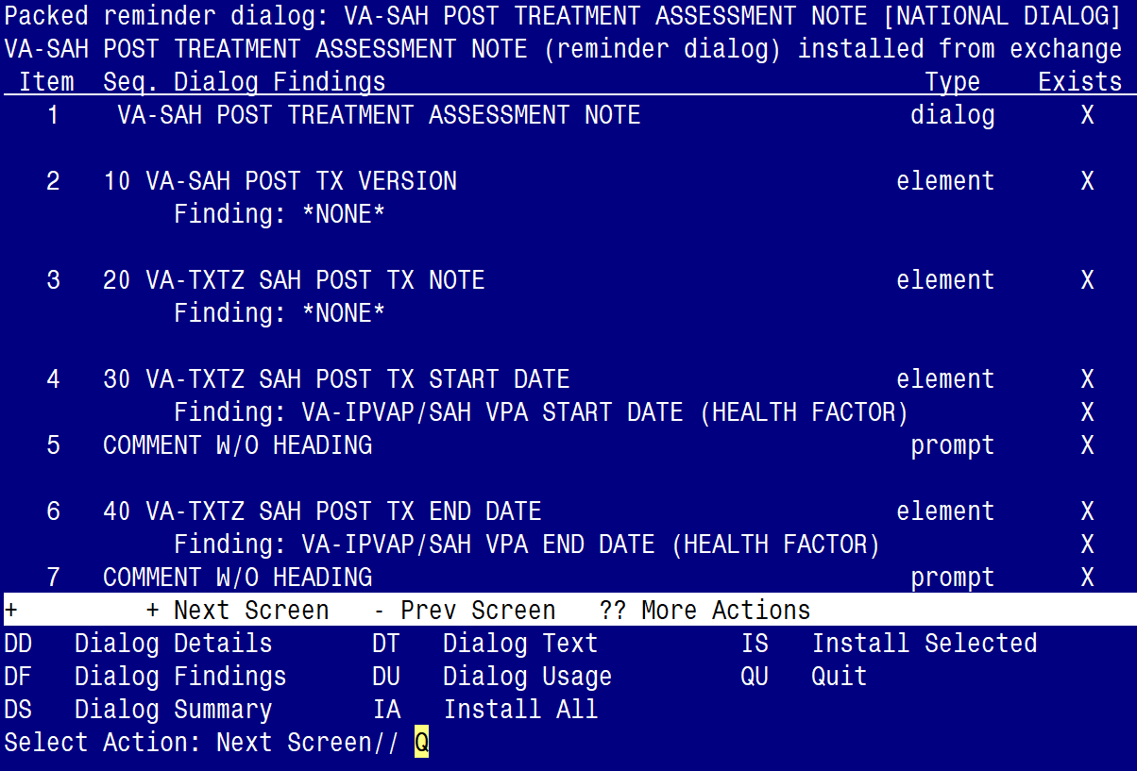

When the dialog has completed installation, you will then be returned to this screen. At the Select Action prompt, type Q.
You will be promped to install the 4th dialog component:

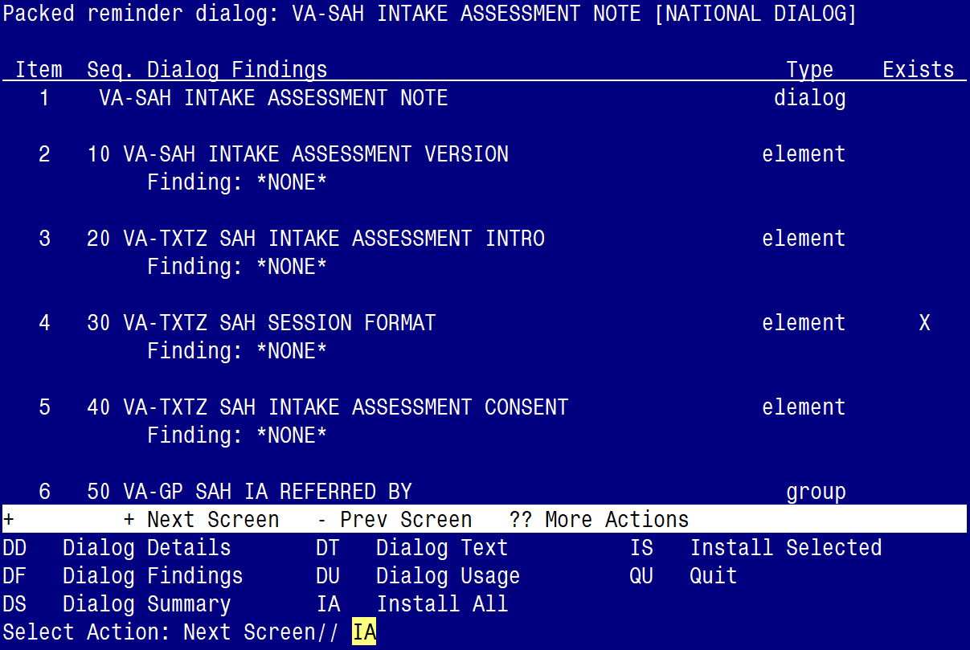

At the Select Action prompt, type IA to install the dialog – VA-SAH INTAKE ASSESSMENT NOTE
Select Action: Next Screen// IA Install All
Install reminder dialog and all components with no further changes: Y// ES

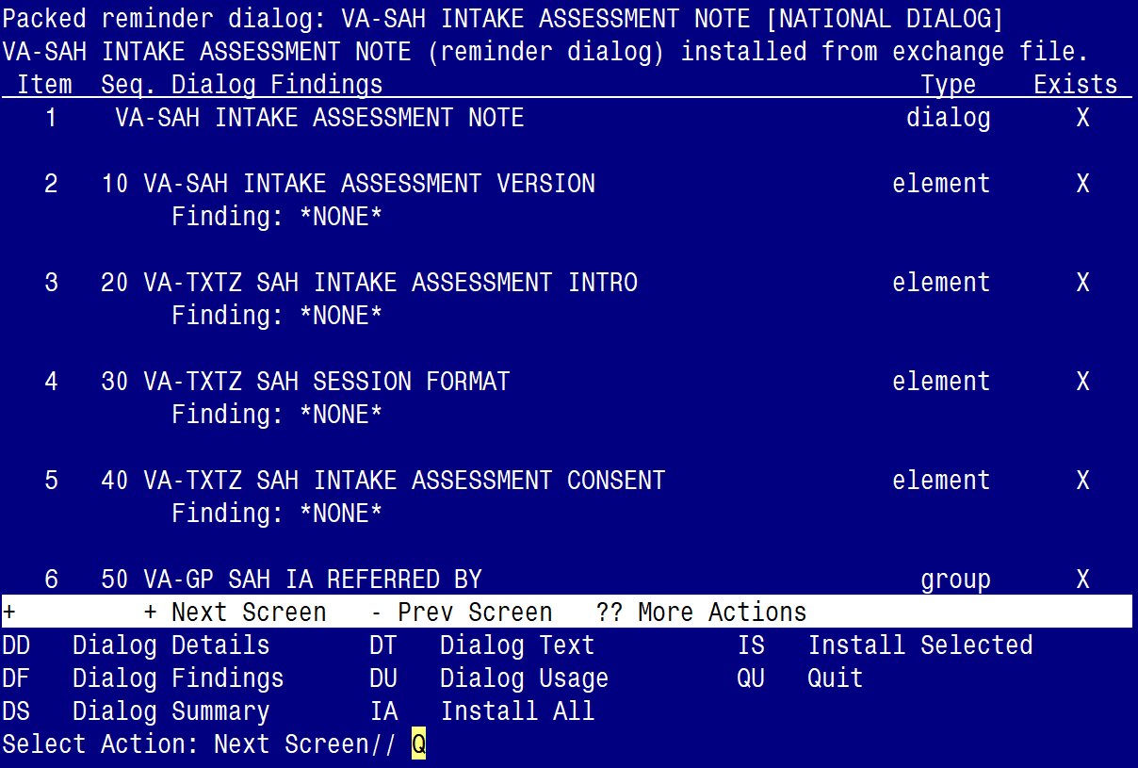

When the dialog has completed installation, you will then be returned to this screen. At the Select Action prompt, type Q.

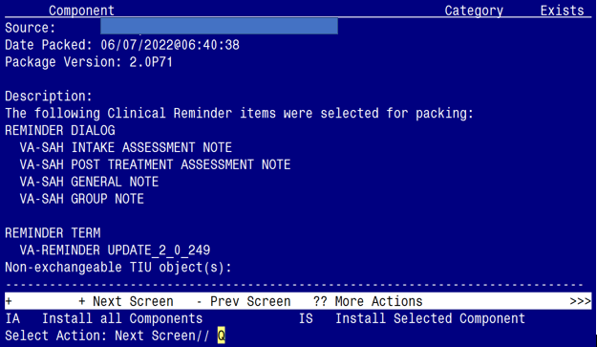

You will be returned to this screen. Type Q to quit.
Install Completed

Post Installation

- Make the Dialogs able to be attached to a Personal/Shared templates or to progress note titles.

From the Reminders Manager Menu:
Select Reminder Managers Menu Option: CP CPRS Reminder Configuration
CA Add/Edit Reminder Categories
CL CPRS Lookup Categories
CS CPRS Cover Sheet Reminder List
MH Mental Health Dialogs Active
PN Progress Note Headers
RA Reminder GUI Resolution Active
TIU TIU Template Reminder Dialog Parameter
DL Default Outside Location
PT Position Reminder Text at Cursor
Select CPRS Reminder Configuration Option: TIU TIU Template Reminder Dialog Parameter
Reminder Dialogs allowed as Templates may be set for the following:
1 User USR [choose from NEW PERSON]
3 Service SRV [choose from SERVICE/SECTION]
4 Division DIV [choose from INSTITUTION]
5 System SYS [NATREM.FO-SLC.MED.VA.GOV]
Enter selection: 5 Choose the appropriate number for your site. Your site may do this by System or other levels. The example below uses SYSTEM level

Setting Reminder Dialogs allowed as Templates for System:
Select Display Sequence: ?

148 VA-VETERANS CHOICE NOTE
149 VA-TBI SCREENING
When you type a question mark above, you will see the list of #’s (with dialogs) that are already taken. Choose a number NOT on this list. For this example, looking above I see the number 150 is not present, so I will use 150.

Select Display Sequence: 150
Are you adding 150 as a new Display Sequence? Yes// Y YES
Display Sequence: 150// <Enter> 150
Clinical Reminder Dialog: type in the name of the dialog
VA-SAH INTAKE ASSESSMENT NOTE then <enter>
reminder dialog NATIONAL
OK? Yes// <Enter> (Yes)
Select Display Sequence: 151
Are you adding 151 as a new Display Sequence? Yes// Y YES
Display Sequence: 151// <Enter> 151
Clinical Reminder Dialog: type in the name of the dialog
VA-SAH POST TREATMENT ASSESSMENT NOTE then <enter>
reminder dialog NATIONAL
OK? Yes// <Enter> (Yes)
Select Display Sequence: 152
Are you adding 153 as a new Display Sequence? Yes// Y YES
Display Sequence: 153// <Enter> 152
Clinical Reminder Dialog: type in the name of the dialog
VA-SAH GENERAL NOTE then <enter>
reminder dialog NATIONAL
OK? Yes// <Enter> (Yes)
Select Display Sequence: 153
Are you adding 155 as a new Display Sequence? Yes// Y YES
Display Sequence: 155// <Enter> 155
Clinical Reminder Dialog: type in the name of the dialog
VA-SAH GROUP NOTE then <enter>
reminder dialog NATIONAL
OK? Yes// <Enter> (Yes)

- Setup of specific Note titles.
You will need to create four new note titles for these templates, as follows:

RHS STRENGTH AT HOME-V INTAKE ASSESSMENT NOTE
RHS STRENGTH AT HOME-V POST TREATMENT ASSESSMENT NOTE
RHS STRENGTH AT HOME-V GENERAL NOTE
RHS STRENGTH AT HOME-V GROUP NOTE

You can place them in the same category as your other social work notes.

All the note titles above are to be mapped to the following VHA Enterprise Standard Title: SOCIAL WORK NOTE

Note: Comprehensive information on Creating Document Definitions can be found beginning on page 47 of the TIU/ASU Implementation Guide

- Associate the new reminder dialogs with the note titles in CPRS
To do this, go to Template Editor, then Document Titles, select the appropriate folder (if applicable), and choose New Template (top right-hand corner).

- Type in the following information:
Name: RHS STRENGTH AT HOME-V INTAKE ASSESSMENT NOTE
Template Type: Reminder Dialog
Reminder Dialog: VA-SAH INTAKE ASSESSMENT NOTE

Next, type in the Associated Title, which in this case is RHS STRENGTH AT HOME-V INTAKE ASSESSMENT NOTE and hit Apply.

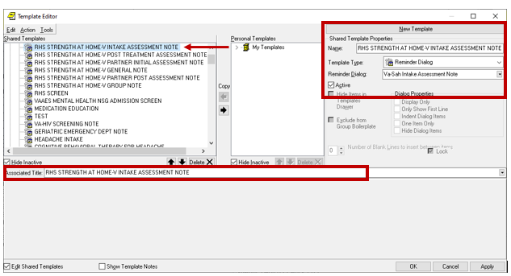

- Name: RHS STRENGTH AT HOME-V POST TREATMENT ASSESSMENT NOTE
Template Type: Reminder Dialog
Reminder Dialog: VA-SAH POST TREATMENT ASSESSMENT NOTE
Associated Title: RHS STRENGTH AT HOME-V POST TREATMENT ASSESSMENT NOTE

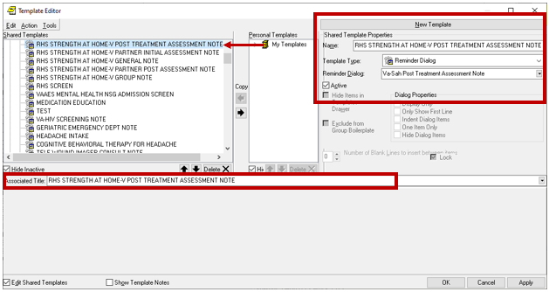

- Name: RHS STRENGTH AT HOME-V GENERAL NOTE
Template Type: Reminder Dialog
Reminder Dialog: VA-SAH GENERAL NOTE
Associated Title: RHS STRENGTH AT HOME-V GENERAL NOTE

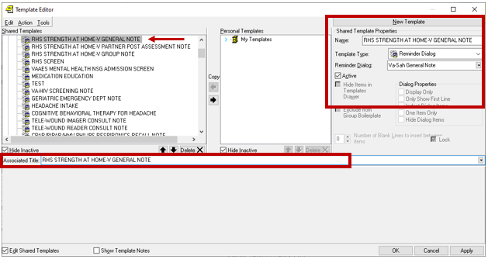

- Name: RHS STRENGTH AT HOME-V GROUP NOTE
Template Type: Reminder Dialog
Reminder Dialog: VA-SAH GROUP NOTE
Associated Title: RHS STRENGTH AT HOME-V GROUP NOTE

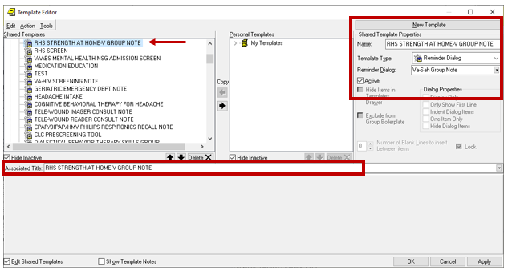

- Add your sites Patient Telephone and Patient Address object the following ELEMENTS:

Element: VAL-TH VVC TELEPHONE TRIAGE CONTACT PHONE OBJECT
Text: *PHONE OBJECT HERE*

Element: VAL-TH VVC TELEPHONE TRIAGE PATIENT LOCATION HOME
Text: Home *PATIENT ADDRESS OBJECT HERE*

- Confirm all four (highlighted) patient data objects (PDOs)are mapped to the ELEMENT below. If not, add your local PDOs to each of the four options.

Element: VAL-TXTZ SAH IA DEMOGRAPHIC
Text: Age: |PATIENT AGE|
Race: |PATIENT RACE|
Ethnicity: |PATIENT ETHNICITY|
Biological sex: |PATIENT SEX|

