Update _2_0_250

Clinical Reminders

TERATOGENIC MEDICATIONS UPDATE 2022_01

Install Guide

January 2022

Product Development
Office of Information Technology
Department of Veterans Affairs

Table of Contents
Introduction 1
Install Details 2
Installation: 4
Install Example 4
Post-Install Set-up Instructions 8

Introduction

UPDATE_2_0_250 contains 1 Reminder Exchange entry: UPDATE_2_0_250 VA-TERATOGENIC MEDS ORDER CHECKSUPDATE 2022_01

The Teratogenic Medications Order Check Interim Solution was originally released as VistA patch PXRM*2*22 in July 2012. The interim solution is intended to have regular updates for clinical content, primarily to add newly approved medications that have a noted risk during pregnancy and that warrant an order check. This update, UPDATE_2_0_250 represents the fifth such update.

Below are the changes:
- Component
RULE: VA-WH HIRISK MEDS (EXTREME RISK) NO PREG DOC RULE
RULE: VA-WH HIRISK MEDS (EXTREME RISK) NOT PREG RULE

Action
Increasing severity to ‘HIGH’ for all EXTREME RISK TDrug Order Checks

- Component
RULE: VA-WH HIRISK MEDS (EXTREME RISK) PREG RULE
RULE: VA-WH HIRISK MEDS (MODERATE/HIGH RISK) PREG RULE
RULE: VA-WH HIRISK IMAGING (MRI) PREG RULE
RULE: VA-WH HIRISK IMAGING (NON MRI) PREG RULE

Action
Updating order check text to indicate need to document counseling

- Component
GROUP: VA-WH HIRISK MEDICATIONS (MODERATE/HIGH RISK) GROUP

Action
Drug DG.CHLORPHENIRAMINE/IBUPROFEN/PSEUDOEPHEDRINE should not have been in this list – the ibuprofen component suggests it needs only be in the VA-WH HIRISK MEDICATIONS (MOD/HIGH RISK DURING PREGNANCY) GROUP

Drug DG.DICLOFENAC need not be in this list either.

Add new entries

- Component
GROUP: VA-WH HIRISK MEDICATIONS (MOD/HIGH RISK DURING PREGNANCY) GROUP

Action
Add DG.DISULFIRAM per EMAIL “DDI request and request to add med to pregnancy list”

Add 14 statin entries

Add new entries

- Component
GROUP: VA-WH HIRISK MEDICATIONS (EXTREME RISK) GROUP

Action
Remove 14 statin entries – they are moving to pregnancy group

GROUP: VA-WH HIRISK MEDICATIONS (LACTATION LEVEL 1) GROUP

Action
Add 5 new entries

Install Details

This update is being distributed as a web host file. The address for the host file is: https://Redacted /UPDATE_2_0_250.PRD

The following reminder content is included in this UPDATE:

REMINDER GENERAL FINDINGS
LACTATION END DATE
PATIENT IS NOT LACTATING
PATIENT IS LACTATING
WH-LACTATION DATA SOURCE
CLEAR ALL FOR ALL USER
LACTATION CLEAR SMART DATA
LACTATION ALERT ID
WH-TD LACTATION EDIT RECORD

HEALTH FACTORS
WH PAP SMEAR [C]
WH HYSTERECTOMY W/CERVIX REMOVED
VA-REMINDER UPDATES [C]
VA-UPDATE_2_0_250

REMINDER SPONSOR
WOMEN VETERANS HEALTH PROGRAM
OFFICE OF NURSING INFORMATICS
VHA NATIONAL CENTER FOR HEALTH PROMOTION AND DISEASE PREVENTION (NCP) AND VHA OFFICE OF WOMEN'S HEALTH

REMINDER TAXONOMY
VA-WH TUBAL REANASTOMOSIS (TAXONOMY)
VA-WH TUBAL LIGATION CODES (TAXONOMY)
VA-WH HYSTERECTOMY W/CERVIX REMOVED
VA-WH TERATOGENIC MEDICATIONS EXCLUSIONS TAXONOMY

REMINDER TERM
VA-WH TUBAL REANASTOMOSIS (TERM)
VA-WH TUBAL LIGATION CODES (TERM)
VA-WH HIRISK LACTATING EXPIRED DOC
VA-WH LACTATION ALERT
VA-WH HIRISK LACTATING CURRENT DOC
VA-REMINDER UPDATE_2_0_250

REMINDER DEFINITION
VA-WH HIRISK ORDER CHECK - PREGNANT
VA-WH MEDICALLY UNABLE TO CONCEIVE
VA-WH HIRISK ORDER CHECK - NOT PREGNANT
VA-WH HIRISK ORDER CHECK - NO PREG DOC
VA-WH UPDATE LACTATION STATUS
VA-WH HIRISK ORDER CHECK - LACTATING
VA-WH PREGNANCY AND LACTATION DATA ENTRY ALLOWED
VA-WH BL LACTATION ADD END DATE
VA-WH BL POTENTIALLY UNSAFE ORDERS
VA-WH BL LACTATION STATUS DOCUMENTATION
VA-WH BL LACTATION EDIT END DATE

HEALTH SUMMARY TYPE
VA-WH LACTATION STATUS

HEALTH SUMMARY OBJECTS
VA-WH LACTATION STATUS (TIU)

TIU DOCUMENT DEFINITION
VA-WH LACTATION STATUS

REMINDER ORDER CHECK RULES
VA-WH HIRISK IMAGING (NON MRI) PREG RULE
VA-WH HIRISK IMAGING (MRI) PREG RULE
VA-WH HIRISK MEDS (MODERATE/HIGH RISK) PREG RULE
VA-WH HIRISK MEDS (EXTREME RISK) PREG RULE
VA-WH HIRISK MEDS (EXTREME RISK) NOT PREG RULE
VA-WH HIRISK MEDS (EXTREME RISK) NO PREG DOC RULE
VA-WH HIRISK MEDS (LACT 1) EXPIRED DOC RULE
VA-WH HIRISK MEDS (LACT 1) RULE
VA-WH HIRISK MEDS (MODERATE/HIGH RISK) NO PREG DOC RULE
VA-WH HIRISK MEDS (MODERATE/HIGH RISK) NOT PREG RULE

REMINDER ORDER CHECK ITEMS GROUP
VA-WH HIRISK MEDICATIONS (LACTATION LEVEL 1) GROUP
VA-WH HIRISK MEDICATIONS (EXTREME RISK) GROUP
VA-WH HIRISK MEDICATIONS (MOD/HIGH RISK DURING PREGNANCY) GROUP
VA-WH HIRISK MEDICATIONS (MODERATE/HIGH RISK) GROUP

The file will be installed using Reminder Exchange, programmer access is not required.

Installation:
This update can be loaded with users on the system. Installation
will take less than five minutes.

Install Example

To Load the Web Host File. Navigate to Reminder exchange in Vista
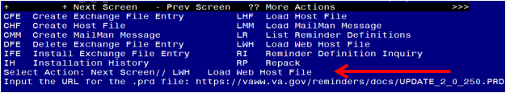
At the Select Action: prompt, enter LWH for Load Web Host File
At the Input the url for the .prd file: prompt, type the following web address:
https://Redacted/UPDATE_2_0_250.PRD
You should see a message at the top of your screen that the file successfully loaded.

Navigate to the exchange entry named UPDATE_2_0_250 VA-TERATOGENIC MEDS ORDER CHECKSUPDATE 2022_01
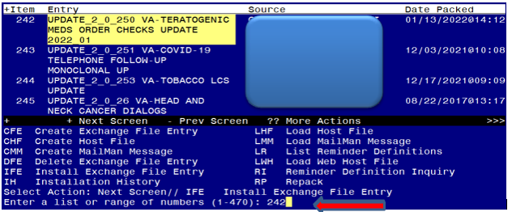
At the Select Action prompt, enter IFE for Install Exchange File Entry
Enter the number that corresponds with your entry UPDATE_2_0_250 VA-TERATOGENIC MEDS ORDER CHECKS UPDATE 2022_01 (in this example it is entry 242, it will vary by site, The exchange date should be 01/13/2022).

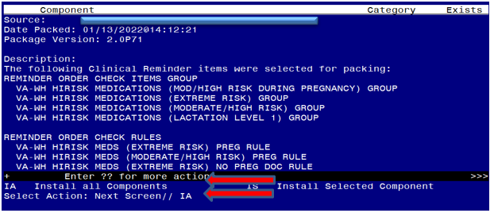
At the Select Action prompt, type IA for Install all Components and hit enter.
Any items that are NEW in any categories, you should INSTALL
If you are prompted to overwrite any reminder general findings, you should choose SKIP
If you are prompted to overwrite any health factors, you should choose SKIP - You will install the new health factor
If you are prompted to overwrite any reminder sponsor, you should choose SKIP
If you are prompted to overwrite any reminder taxonomies, you should choose SKIP
If you are prompted to overwrite any reminder terms, you should choose SKIP – You will install the new term
If you are prompted to overwrite any reminder definitions, you should choose SKIP
If you are prompted to overwrite any health summary types, you should choose SKIP
If you are prompted to overwrite any health summary objects, you should choose SKIP
If you are prompted to overwrite any TIU DOCUMENT DEFINITIONS, you should choose SKIP
If you are prompted to overwrite any REMINDER ORDER CHECK RULES, you should choose Overwrite
If you are prompted to overwrite any REMINDER ORDER CHECK ITEMS GROUP, you should choose Overwrite
If you are installing in your test account, during installation you may get prompted to delete or replace drugs that do not exist in your test account. You can choose delete. This is because test account drug files do not get updated like production system files do.

You will be prompted to install the reminder dialog component, you do not need to install this dialog, choose Q to quit.
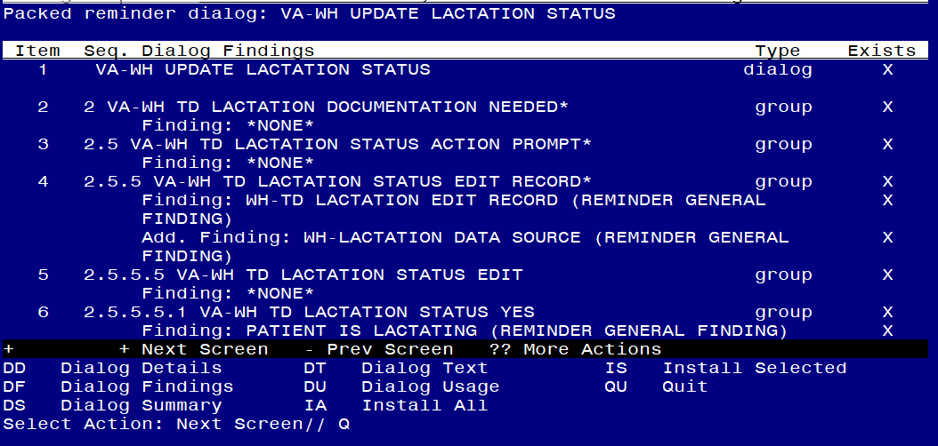
At the Select Action prompt, type Q.

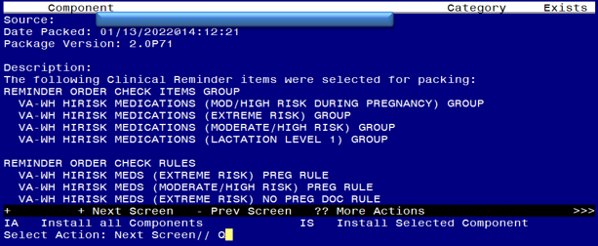
You will then be returned to this screen. At the Select Action prompt, type Q.

Install Complete

Post-Install Set-up Instructions

Activate the Reminder Order Check Rules
The installation of CLINICAL REMINDER UPDATE_2_0_250 will require the STATUS of the following Reminder Order Check Rules shown below be changed to PROD. Shown below are the steps to make this change if yours does not show that PROD status.

VA-WH HIRISK IMAGING (NON MRI) PREG RULE
VA-WH HIRISK IMAGING (MRI) PREG RULE
VA-WH HIRISK MEDS (MODERATE/HIGH RISK) PREG RULE
VA-WH HIRISK MEDS (EXTREME RISK) PREG RULE
VA-WH HIRISK MEDS (EXTREME RISK) NOT PREG RULE
VA-WH HIRISK MEDS (EXTREME RISK) NO PREG DOC RULE
VA-WH HIRISK MEDS (LACT 1) EXPIRED DOC RULE
VA-WH HIRISK MEDS (LACT 1) RULE
VA-WH HIRISK MEDS (MODERATE/HIGH RISK) NO PREG DOC RULE
VA-WH HIRISK MEDS (MODERATE/HIGH RISK) NOT PREG RULE

The option represented here is Add/Edit Reminder Order Check Rule [PXRM ORDER CHECK RULE EDIT].

Select Reminder Order Check Menu <TEST ACCOUNT> Option: RE Add/Edit Reminder Order Check Rule
Select Reminder Order Check Rule by one of the following:

N: ORDER CHECK RULE NAME
R: REMINDER DEFINITION
T: REMINDER TERM
Q: QUIT

Select Reminder Order Check Rule by: (N/R/T/Q): N// <ENTER>
ORDER CHECK RULE NAME
Select Reminder Order Check Rule: VA-WH HIRISK MEDS (EXTREME RISK) NOT PREG RULE
RULE NAME: VA-WH HIRISK MEDS (EXTREME RISK) NOT PREG RULE
DISPLAY NAME: Known or Potential Teratogen (EXTREME Risk-to-Benefit Ratio)
STATUS: PROD

CLASS: NATIONAL
SPONSOR: WOMEN VETERANS HEALTH PROGRAM
REVIEW DATE:
_____________________________________________________________
I=INACTIVE, P=PRODUCTION, T=TESTING

Repeat for all the listed Reminder Order Check Rules –
**All 10 LISTED need to be changed to a status of PROD post install.

VA-WH HIRISK IMAGING (NON MRI) PREG RULE
VA-WH HIRISK IMAGING (MRI) PREG RULE
VA-WH HIRISK MEDS (MODERATE/HIGH RISK) PREG RULE
VA-WH HIRISK MEDS (EXTREME RISK) PREG RULE
VA-WH HIRISK MEDS (EXTREME RISK) NOT PREG RULE
VA-WH HIRISK MEDS (EXTREME RISK) NO PREG DOC RULE
VA-WH HIRISK MEDS (LACT 1) EXPIRED DOC RULE
VA-WH HIRISK MEDS (LACT 1) RULE
VA-WH HIRISK MEDS (MODERATE/HIGH RISK) NO PREG DOC RULE
VA-WH HIRISK MEDS (MODERATE/HIGH RISK) NOT PREG RULE

