Update_2_0_254

Clinical Reminders

VA-WH GONORRHEA AND CHLAMYDIA STI SCREENING

Install Guide

April 2022

Product Development
Office of Information Technology
Department of Veterans Affairs

Table of Contents
Introduction 1
Install Details 3
Install Example 3
Post Installation 7

Introduction

Gonorrhea (GC) and Chlamydia (CT) infections are on the rise in the US with over 500,000 reported cases of GC and 1.8 million cases of CT in 2018, representing a 63% increase of GC between 1991 and 2018 and the most number of reported CT infections ever. Data from the VHA has matched the trends of the US, with a substantial increase in infections between 2009 and 2019 among women Veterans. These infections in females have serious sequelae, including pelvic inflammatory disease, chronic pelvic pain, infertility, and ectopic pregnancies, making it critical that infections are identified and treated. Per VHA guidance, GC/CT screening is recommended for all sexually active women (birth sex female) ages 24 and younger. Despite this guidance, screening rates within VHA are suboptimal with only 22.6% of women under age 25 being screened in 2019. The goal of this clinical reminder is to improve compliance with VHA guidance around GC/CT screening, with an aim towards reducing series consequences of untreated infections in our female Veteran population.

Per VHA guidelines, screening is recommended for Gonorrhea and
Chlamydia infections in:

1) All sexually active women ages 24 years and younger
2) Sexually active women ages 25 years and older who are at risk of
infection (history of previous or coexisting sexually transmitted
infections (STI); new or multiple sexual partners; sexual partner with
concurrent sexual partners; sexual partner with an STI; inconsistent
condom use; exchanging sex for money or drugs; drug use).

Redacted URL for the detailed Guideline listed above.

Screening is targeted to birth sex female to prevent sequelae including
pelvic inflammatory disease and subsequent infertility, ectopic
pregnancy, and chronic pelvic pain.

++ This clinical reminder does not address women 25 and older who will
require separate risk assessments with their healthcare team. ++

Nucleic acid amplification (NAAT) is the preferred method for screening
for both Gonorrhea and Chlamydia, and can be performed on endocervical,
vaginal, and urine specimens.

Clinic-based self-collection may be used.

Female is determined by the birth sex field in Vista.

UPDATE_2_0_254 contains 1 Reminder Exchange entry:
UPDATE_2_0_254 VA-WH GONORRHEA AND CHLAMYDIA STI SCREENING

The exchange file contains the following components:

REMINDER GENERAL FINDINGS
TICKLER REMINDER COMMENT
TICKLER REMINDER

TIU TEMPLATE FIELD
TIU TEMPLATE FIELD

HEALTH FACTORS
VA-REMINDER UPDATES
VA-UPDATE_2_0_254
VA-WH GONORRHEA AND CHLAMYDIA STI SCREEN [C]
VA-WH GONORRHEA AND CHLAMYDIA STI SCREEN NOT INDICATED OTHER
VA-WH GONORRHEA AND CHLAMYDIA STI SCREEN BIRTH SEX NOT FEMALE
VA-WH GONORRHEA AND CHLAMYDIA STI SCREEN NO RISK FACTORS
VA-WH GONORRHEA AND CHLAMYDIA STI SCREEN DEFER
VA-WH GONORRHEA AND CHLAMYDIA STI SCREEN PATIENT DECLINED
VA-WH GONORRHEA AND CHLAMYDIA STI SCREEN COMPLETED PREVIOUSLY
VA-WH GONORRHEA AND CHLAMYDIA STI SCREEN COMPLETED
VA-WH GONORRHEA AND CHLAMYDIA STI SCREEN NOT SEXUALLY ACTIVE 12M

REMINDER SPONSOR
WOMEN VETERANS HEALTH PROGRAM

REMINDER TERM
VA-REMINDER UPDATE_2_0_254
VA-WH GONORRHEA AND CHLAMYDIA STI SCREEN LAB RESULTS
VA-WH GONORRHEA AND CHLAMYDIA STI SCREEN NOT INDICATED
VA-WH GONORRHEA AND CHLAMYDIA STI SCREEN DEFER
VA-WH GONORRHEA AND CHLAMYDIA STI SCREEN PATIENT DECLINED
VA-WH GONORRHEA AND CHLAMYDIA STI SCREEN COMPLETED PREVIOUSLY
VA-WH GONORRHEA AND CHLAMYDIA STI SCREEN ORDER TEST
VA-WH GONORRHEA AND CHLAMYDIA STI SCREEN COMPLETED
VA-WH GONORRHEA AND CHLAMYDIA STI SCREEN NOT SEXUALLY ACTIVE 12M

REMINDER DEFINITION
VA-WH GONORRHEA AND CHLAMYDIA STI SCREENING

REMINDER DIALOG
VA-WH GONORRHEA AND CHLAMYDIA STI SCREENING

Install Details

This update is being distributed as a web host file. The address for the host file is: https://Redacted/UPDATE_2_0_254.PRD

The file will be installed using Reminder Exchange, programmer access is not required.
Installation:
=============
This update can be loaded with users on the system. Installation will take less than 5 minutes.

Install Example
To Load the Web Host File. Navigate to Reminder exchange in Vista
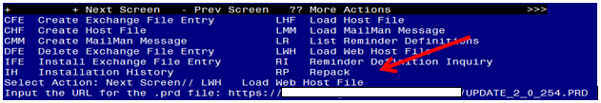

At the Select Action: prompt, enter LWH for Load Web Host File
At the Input the url for the .prd file: prompt, type the following web address:
https://Redacted/UPDATE_2_0_254.PRD

You should see a message at the top of your screen that the file successfully loaded.

Search for and locate the reminder exchange entry titled UPDATE_2_0_254 VA-WH GONORRHEA AND CHLAMYDIA STI SCREENING. 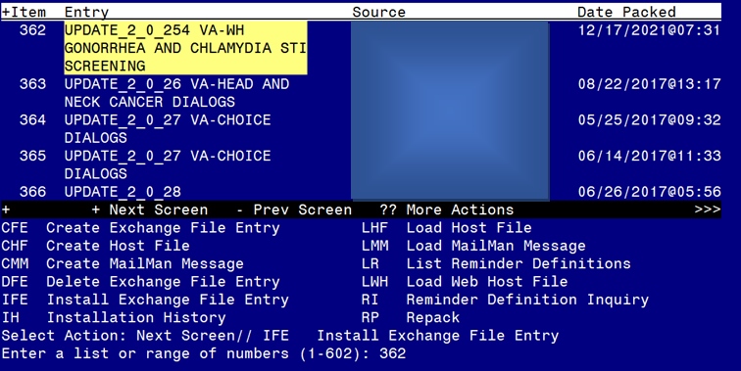

At the Select Action prompt, enter IFE for Install Exchange File Entry
Enter the number that corresponds with your entry titled UPDATE_2_0_254 VA-WH GONORRHEA AND CHLAMYDIA STI SCREENING (in this example it is entry 362, it will vary by site) The date on the exchange file should be 12/17/2021.

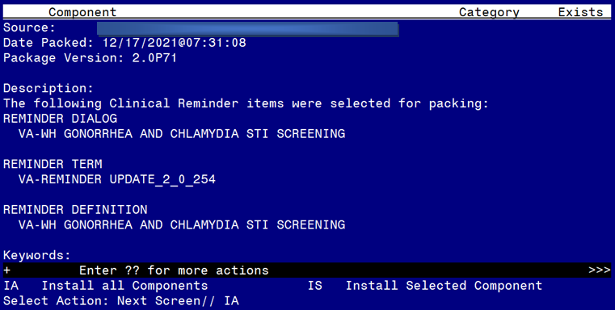
At the Select Action prompt, type IA for Install all Components and hit enter.
Select Action: Next Screen// IA Install all Components

During the installation, you will see several prompts:
Install all new components
SKIP any existing components that you are prompted to overwrite
You will be promped to install the dialog component:
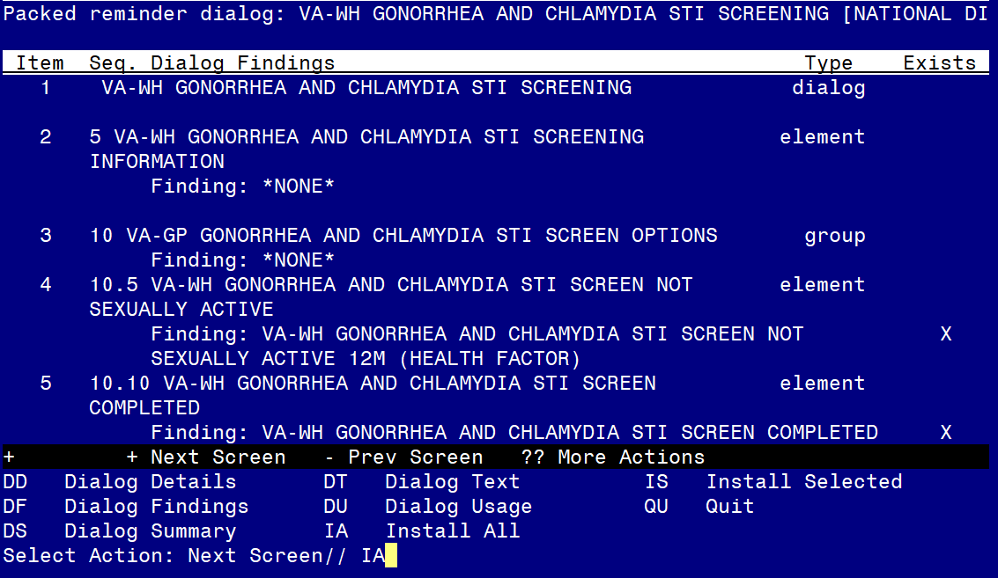
At the Select Action prompt, type IA to install the dialog – VA-WH GONORRHEA AND CHLAMYDIA STI SCREENING
Select Action: Next Screen// IA Install All
Install reminder dialog and all components with no further changes: Y// ES
When you see this prompt, hit enter to link the dialog to the reminder definition:
Reminder Dialog VA-WH GONORRHEA AND CHLAMYDIA STI SCREENING is not linked to a reminder.
Select Reminder to Link: VA-WH GONORRHEA AND CHLAMYDIA STI SCREENING// HIT ENTER HERE TO LINK
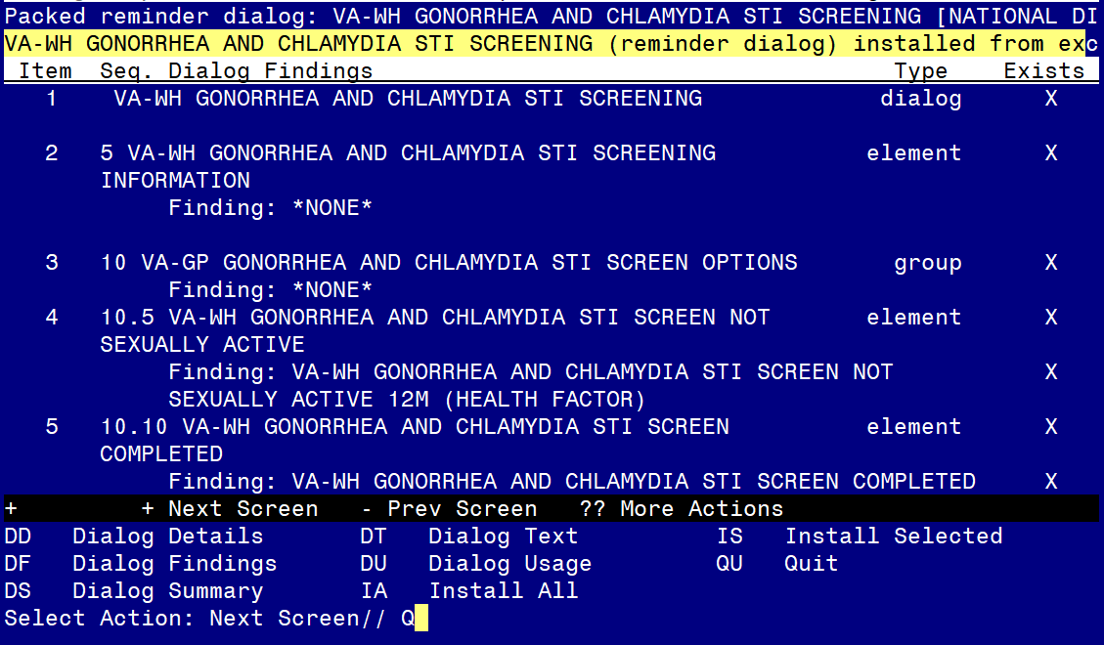
When the dialog has completed installation, you will then be returned to this screen. At the Select Action prompt, type Q.

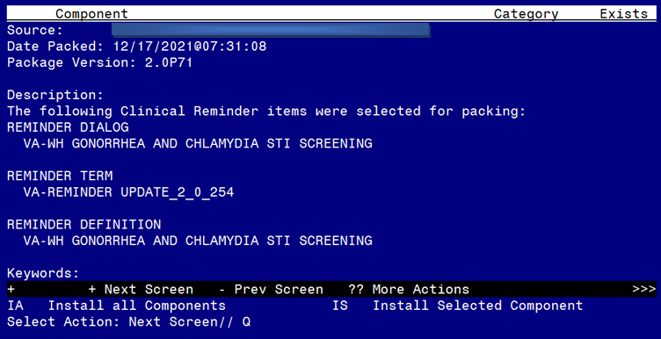

You will be returned to this screen. Type Q to quit.
Install Completed

Post Installation

- Add Order to the reminder dialog
Add your local quick order for Gonorrhea and Chlamydia screening as an additional finding to the element: VA-WH GONORRHEA AND CHLAMYDIA STI SCREEN ORDER TEST.

- Add your local lab tests that represent Gonorrhea and Chlamydia Screening to the reminder term VA-WH GONORRHEA AND CHLAMYDIA STI SCREEN LAB RESULTS, these findings should be LT (lab test) findings. If you are not sure what tests to add, please confer with your local lab Ad Pac.

- Add your local orderable item that represent an order for Gonorrhea and Chlamydia Screening to the reminder term VA-WH GONORRHEA AND CHLAMYDIA STI SCREEN ORDER TEST, these findings should be OI (orderable item) findings. If you are not sure what tests to add, please confer with your local lab Ad Pac.

- Add this reminder to the cover sheet for the appropriate users. The print name is Gonorrhea and Chlamydia STI Screening.

- Notify users of this reminder that they need to have the notification Scheduled Alert set to On.
  - The tickler alert option in the template will send the user an alert for the date/time that they specify.
  - To receive this alert, the scheduled alert notification must be enabled

