Update _2_0_255

Clinical Reminders

VA-RPS Health Factors

Install Guide

January 2022

Product Development
Office of Information Technology
Department of Veterans Affairs

Table of Contents
Introduction 1
Install Details 2
Install Example 2
Post Installation 5

Introduction

Unique treatment modalities, such as equine or animal therapy, adaptive sports, and creative arts, are commonly used for the physical and mental rehabilitation of Veterans. Tracking these treatment modalities allows for accurate assessment of their utilization and impact across the VHA network. Multiple providers across multiple disciplines may also implement their treatments, and visibility to these services will help direct Veteran care. As leadership better visualizes how these programs are being utilized across the network, noting trends in successful programming, leadership will be able to formulate future recommendations and guidance related to treatment plans.

This update contains 32 new health factors that represent these treatment modalities. Your facility can use these health factors to add to local encounter forms for the clinics used or add to local reminder dialog templates used to document these treatments.

UPDATE_2_0_255 contains 1 Reminder Exchange entry:
UPDATE_2_0_255 VA-RPS HEALTH FACTORS

The exchange file contains the following components:

HEALTH FACTORS
VA-RPS SERVICES [C]
VA-RPS-E-SPORTS-FIRST VISIT CMPLT
VA-RPS-GARDENING-FIRST VISIT CMPLT
VA-RPS-ART THERAPY-FIRST VISIT CMPLT
VA-RPS-AGRITHERAPY-FIRST VISIT CMPLT
VA-RPS-E-SPORTS-SUBSEQUENT VISIT CMPLT
VA-RPS-MUSIC THERAPY-FIRST VISIT CMPLT
VA-RPS-DANCE THERAPY-FIRST VISIT CMPLT
VA-RPS-DRAMA THERAPY-FIRST VISIT CMPLT
VA-RPS-GARDENING-SUBSEQUENT VISIT CMPLT
VA-RPS-VIRTUAL REALITY-FIRST VISIT CMPLT
VA-RPS-ADAPTIVE SPORTS-FIRST VISIT CMPLT
VA-RPS-ART THERAPY-SUBSEQUENT VISIT CMPLT
VA-RPS-AGRITHERAPY-SUBSEQUENT VISIT CMPLT
VA-RPS-MUSIC THERAPY-SUBSEQUENT VISIT CMPLT
VA-RPS-DANCE THERAPY-SUBSEQUENT VISIT CMPLT
VA-RPS-DRAMA THERAPY-SUBSEQUENT VISIT CMPLT
VA-RPS-RECREATION THERAPY-FIRST VISIT CMPLT
VA-RPS-VIRTUAL REALITY-SUBSEQUENT VISIT CMPLT
VA-RPS-ADAPTIVE SPORTS-SUBSEQUENT VISIT CMPLT
VA-RPS-HORTICULTURE THERAPY-FIRST VISIT CMPLT
VA-RPS-RECREATION THERAPY-SUBSEQUENT VISIT CMPLT
VA-RPS-ANIMAL ASSISTED THERAPY-FIRST VISIT CMPLT
VA-RPS-HORTICULTURE THERAPY-SUBSEQUENT VISIT CMPLT
VA-RPS-ANIMAL ASSISTED ACTIVITIES-FIRST VISIT CMPLT
VA-RPS-ANIMAL ASSISTED THERAPY-SUBSEQUENT VISIT CMPLT
VA-RPS-EQUINE ASSISTED SVCS-THERAPY-FIRST VISIT CMPLT
VA-RPS-EQUINE ASSISTED SVCS-LEARNING-FIRST VISIT CMPLT
VA-RPS-ANIMAL ASSISTED ACTIVITIES-SUBSEQUENT VISIT CMPLT
VA-RPS-EQUINE ASSISTED SVCS-THERAPY-SUBSEQUENT VISIT CMPLT
VA-RPS-EQUINE ASSISTED SVCS-HORSEMANSHIP-FIRST VISIT CMPLT
VA-RPS-EQUINE ASSISTED SVCS-LEARNING-SUBSEQUENT VISIT CMPLT
VA-RPS-EQUINE ASSISTED SVCS-HORSEMANSHIP-SUBSEQUENT VISIT CMPLT
VA-REMINDER UPDATES [C]
VA-UPDATE_2_0_255

REMINDER SPONSOR
OFFICE OF REHABILITATION AND PROSTHETIC SERVICES

REMINDER TERM
VA-RPS HEALTH FACTORS
VA-REMINDER UPDATE_2_0_255

Install Details
This update is being distributed as a web host file. The address for the host file is: https://REDACTED/UPDATE_2_0_255.PRD
The file will be installed using Reminder Exchange, programmer access is not required.

Installation:
=============
This update can be loaded with users on the system. Installation will take less than 2 minutes.

Install Example
To Load the exchange file, use LWH. The URL is https://REDACTED/UPDATE_2_0_255.PRD

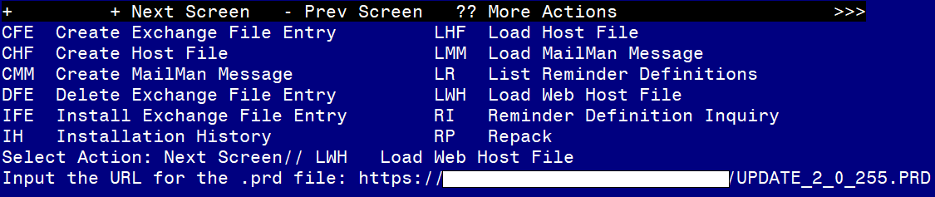

You should see a message that the file was loaded successfully.
Search and locate an entry titled UPDATE_2_0_255 VA-RPS HEALTH FACTORS in reminder exchange.
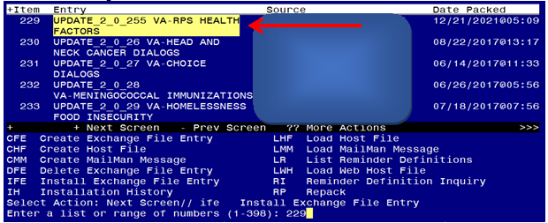
At the Select Action prompt, enter IFE for Install Exchange File Entry

Enter the number that corresponds with your entry titled UPDATE_2_0_255 VA-RPS HEALTH FACTORS (in this example it is entry 229, it will vary by site) that is dated 12/21/2021.
THIS NEXT STEP IS NEW – PLEASE PAY CLOSE ATTENTION BEFORE YOU INSTALL ALL COMPONENTS, YOU NEED TO INSTALL SELECT THE NEW REMINDER SPONSOR ENTRY ONLY (ITEM 36):
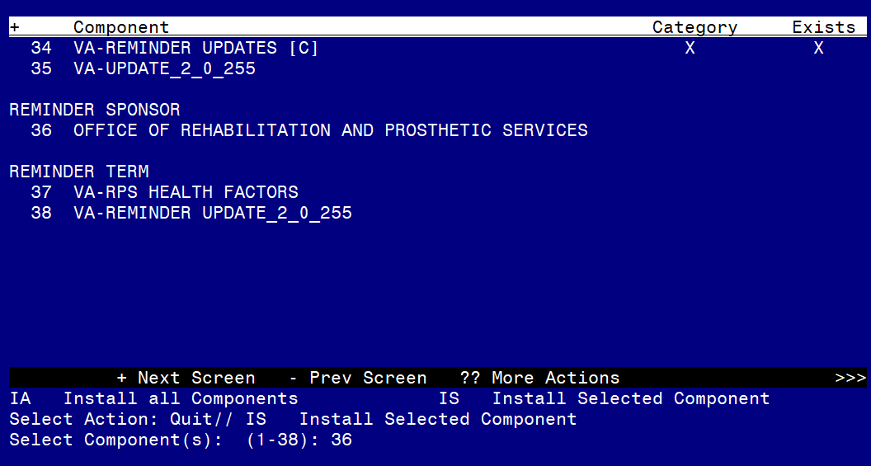
Select Action: Quit// IS Install Selected Component
Select Component(s): (1-38): 36
REMINDER SPONSOR entry OFFICE OF REHABILITATION AND PROSTHETIC SERVICES is NEW,what do you want to do?
Select one of the following:
C Create a new entry by copying to a new name
I Install
Q Quit the install
S Skip, do not install this entry
Enter response: I// nstall
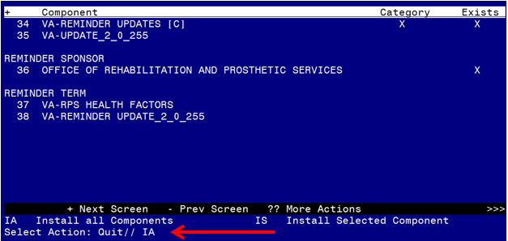
At the Select Action prompt, type IA for Install all Components and hit enter.
For all new entries in any category you will choose I to Install
Skip any items in any category you are prompted to overwrite

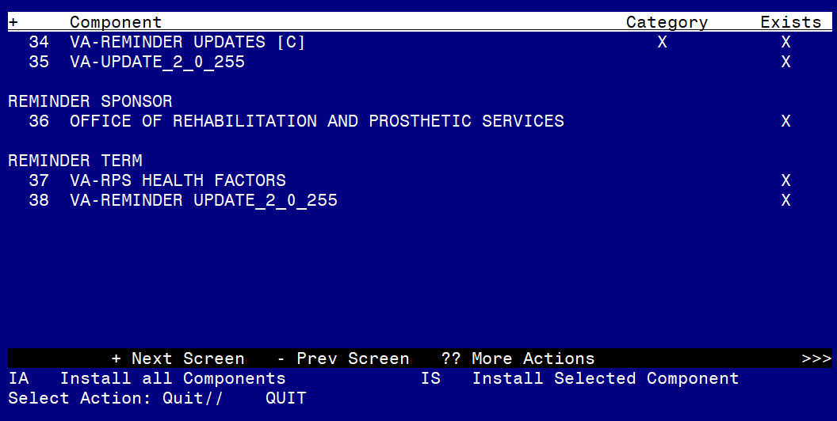
You will then be returned to this screen. At the Select Action prompt, type Q.

Install complete.

Post Installation

There are no post installation steps required.

