Update _2_0_256

Clinical Reminders

VA-MEDICATION EDUCATION REVIEW TEMPLATE
Install Guide

February 2022

Product Development
Office of Information Technology
Department of Veterans Affairs

Table of Contents
Introduction 1
Install Details 2
Install Example 2
Post Installation 6

Introduction
Background/Purpose:
- The 2019 Office of Inspector General (OIG) Comprehensive Healthcare Inspection Program (CHIP) identified an opportunity to improve the provision of patient and/or caregiver education specific to newly prescribed medications, assessment of patient and/or caregiver understanding of the education provided, and the reconciliation of patient medications.
- A national Medication Information Management Task Force (MIMTF) was chartered to develop, pilot, and recommend a mandatory education template on newly prescribed medications that includes the assessment of patient/caregiver understanding, enabling success at-home with their new medications.
- OIG VHA CHIP for 2019 Medication Information Management (MIM) Response to Recommendations 24 and 25 (002).pdf
- In addition, The Joint Commission requires that clinicians educate patients and families about the safe and effective use of medications and evaluate patient/caregiver understanding of the education provided.
- The provision of clear, understandable medication education by all clinicians is critical to ensure that patients have the information that they need to manage their health at home.
- This documentation template was developed to support and standardize these patient education requirements.

Utilization:
- This template is recommended to be embedded in facilities current reminder dialog templates used for medication reconciliation/documentation related to medication information management.
- If the facilities do not have reminder dialogs, it can be used as a stand-alone in the shared template folder.
- This dialog does not replace any teratogenic medication education documentation at sites.

UPDATE_2_0_256 contains 1 Reminder Exchange entry:
UPDATE_2_0_256 VA-MEDICATION EDUCATION REVIEW TEMPLATE

The exchange file contains the following components:

HEALTH FACTORS
VA-REMINDER UPDATES [C]
VA-UPDATE_2_0_256
VA-VA-MIMTF EDU PATIENT LEVEL OF UNDERSTANDING [C]
VA-VA-MIMTF PATIENT UNABLE TO UNDERSTAND/MANAGE MEDICATIONS
VA-VA-MIMTF PATIENT UNDERSTANDING OTHER
VA-VA-MIMTF PATIENT UNDERSTANDING NEEDS PRACTICE/SUPERVISION
VA-VA-MIMTF PATIENT UNDERSTANDING NEEDS FURTHER TEACHING
VA-VA-MIMTF PATIENT DEMONSTRATED UNDERSTANDING
VA-VA-MIMTF PATIENT VERBALIZED UNDERSTANDING
VA-VA-MIMTF EDU TYPE OF EDUCATION PROVIDED [C]
VA-VA-MIMTF EDUCATION PROVIDED IN OTHER FORMAT
VA-VA-MIMTF VIDEO EDUCATION PROVIDED
VA-VA-MIMTF DEMONSTRATED EDUCATION PROVIDED
VA-VA-MIMTF WRITTEN EDUCATIONAL MATERIALS PROVIDED
VA-VA-MIMTF VERBAL EDUCATION PROVIDED
VA-MIMTF INDIVIDUAL(S) EDUCATED [C]
VA-MIMTF OTHER INDIVIDUAL(S) EDUCATED ABOUT MEDICATION(S)
VA-MIMTF HEALTHCARE AIDE EDUCATED ABOUT MEDICATION(S)
VA-MIMTF CAREGIVER EDUCATED ABOUT MEDICATION(S)
VA-MIMTF PATIENT EDUCATED ABOUT MEDICATION(S)
VA-MIMTF MEDICATION EDUCATION [C]
VA-MIMTF EDUCATION ON CHANGED MEDICATION(S) PROVIDED
VA-MIMTF EDUCATION ON NEW MEDICATION(S) PROVIDED
VA-MIMTF MEDICATION EDUC PROVIDED
VA-MIMTF MEDICATION EDUCATION NOT PERFORMED - OTHER
VA-MIMTF PATIENT/CAREGIVER DECLINE/UNABLE
VA-MIMTF MEDS EDUC NOT PROVIDED-NO CHANGES TO MEDS THIS ENCTR

REMINDER TERM
VA-REMINDER UPDATE_2_0_256

REMINDER DIALOG
VA-MEDICATION EDUCATION REVIEW TEMPLATE

Install Details

This update is being distributed as a web host file. The address for the host file is: https://REDACTED/UPDATE_2_0_256.PRD
The file will be installed using Reminder Exchange, programmer access is not required.

Installation:
=============
This update can be loaded with users on the system. Installation will take less than 5 minutes.

Install Example
To Load the Web Host File. Navigate to Reminder exchange in Vista
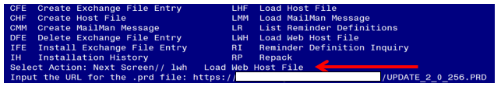

At the Select Action: prompt, enter LWH for Load Web Host File
At the Input the url for the .prd file: prompt, type the following web address:
https://REDACTED /UPDATE_2_0_256.PRD
You should see a message at the top of your screen that the file successfully loaded.

Search and locate an entry titled UPDATE_2_0_256 VA-MEDICATION EDUCATION REVIEW TEMPLATE in reminder exchange.

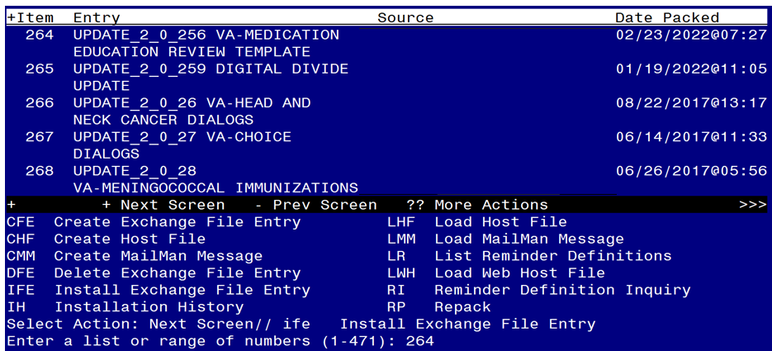
At the Select Action prompt, enter IFE for Install Exchange File Entry
Enter the number that corresponds with your entry UPDATE_2_0_256 VA-MEDICATION EDUCATION REVIEW TEMPLATE (in this example it is entry 264. It will vary by site). The date of the exchange file should be 02/23/2022.

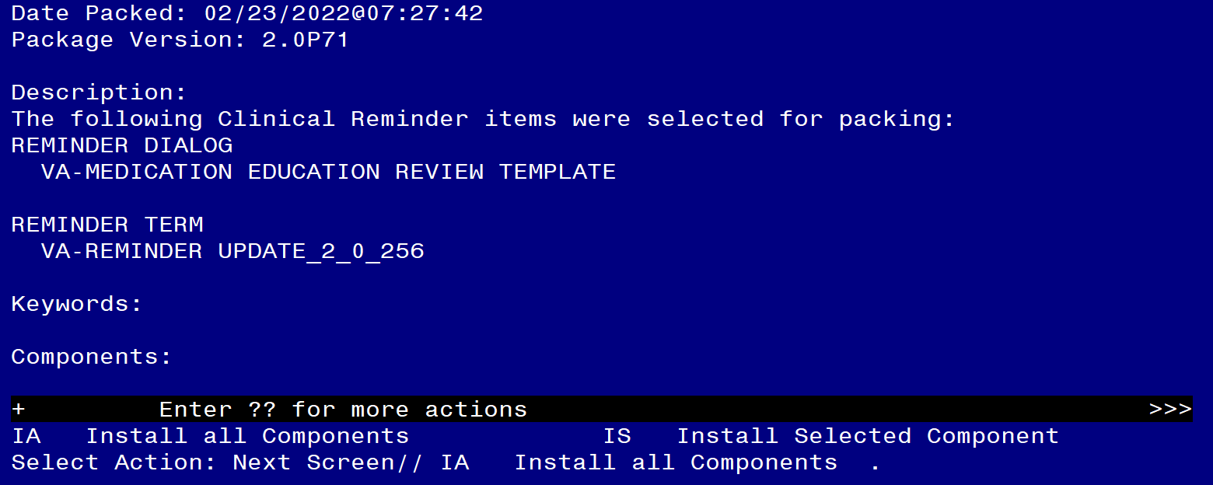

At the Select Action prompt, type IA for Install all Components and hit enter.
Select Action: Next Screen// IA Install all Components
You will see several prompts:
For all new entries you will choose I to Install
If you are prompted to overwrite any components, choose S to Skip.

You will be promped to install the reminder dialog component (VA-MEDICATION EDUCATION REVIEW TEMPLATE). You will choose to install all even though some components may have an X to indicate that they exist.
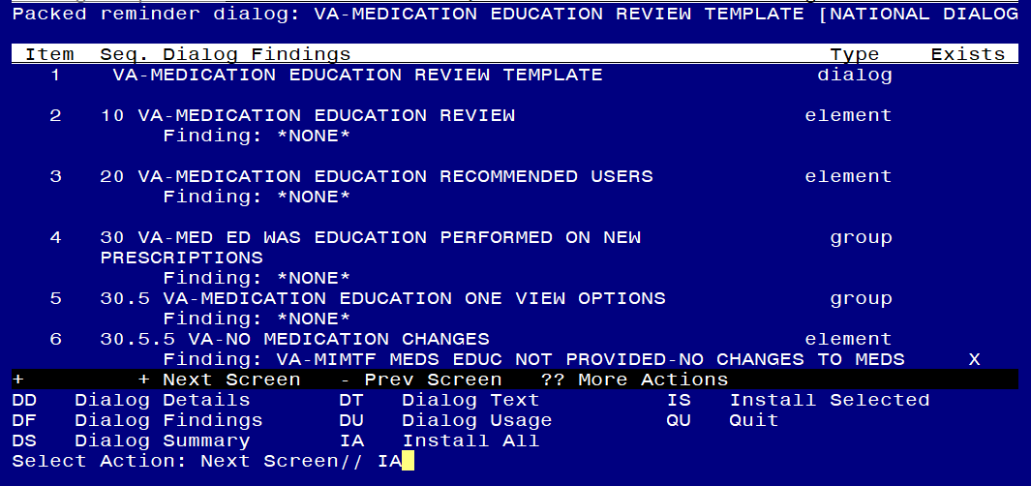

At the Select Action prompt, type IA to install the dialog: VA-MEDICATION EDUCATION REVIEW TEMPLATE
Select Action: Next Screen// IA Install All
Install reminder dialog and all components with no further changes: Y// Yes

After completing this dialog install, you will type Q.
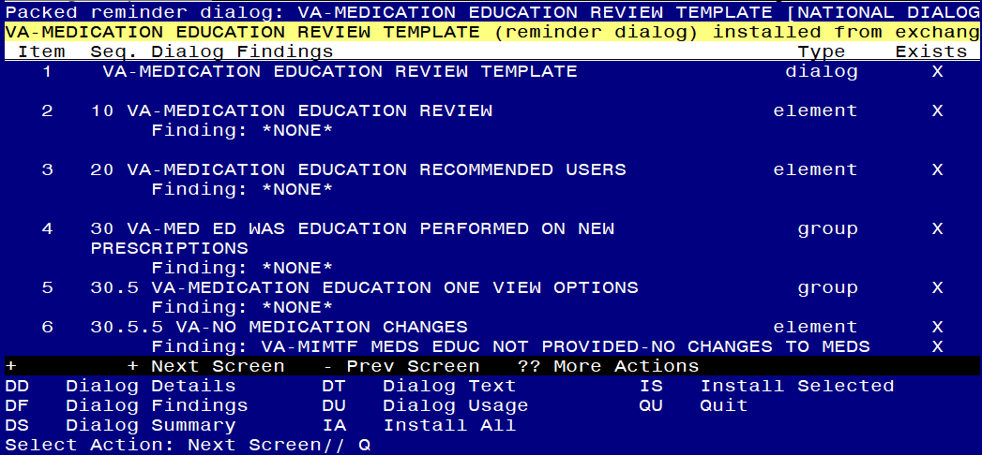

Select Action: Next Screen// Q

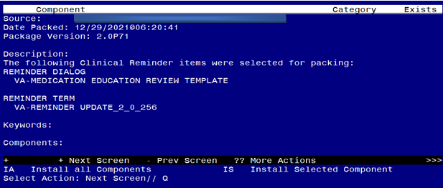
You will then be returned to this screen. At the Select Action prompt, type Q.

Install complete.

Post Installation

The recommended method for deploying this dialog is to embed the parent reminder group in existing local medication reconciliation dialogs as an additional option. Coordinate local deployment method with appropriate local staff.

- Update local reminder dialogs (recommended strategy of deployment).

Insert VA-MED ED WAS EDUCATION PERFORMED ON NEW PRESCRIPTIONS reminder group in local medication reconciliation/documentation reminder dialog(s) related to medication management.

Below is an example of how to embed the national reminder group into an existing local dialog.

- This is an example of a local dialog regarding medication education. The site has decided the first option should be replaced with the national reminder group from this update, VA-MED ED WAS EDUCATION PERFORMED ON NEW PRESCRIPTIONS.

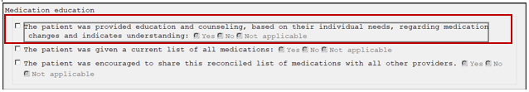

- Using the REMINDER DIALOG MANAGEMENT menu, select the REMINDER DIALOGS option and find the local dialog.

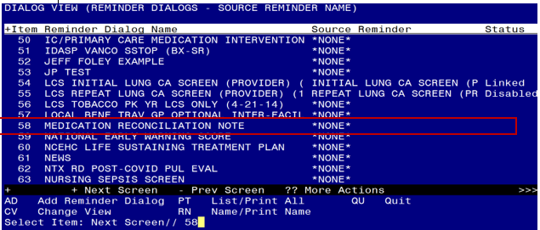

- Identify the group that the national group should be added. In this example, the MEDICATION EDUCATION AND COUNSELING local element will be replaced by the VA-MED ED WAS EDUCATION PERFORMED ON NEW PRESCRIPTIONS national group.

- Open the parent group where the national group should be placed. In this example the parent group is the MEDICATION EDUCATION HEADER group, which is Item 1.

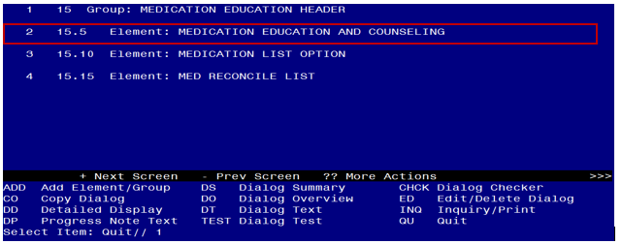

- Edit the group. Enter through the options until the Select SEQUENCE: option.

Select Dialog Element Action: Edit
NAME: MEDICATION EDUCATION HEADER
DISABLE:
CLASS: LOCAL//
SPONSOR:
REVIEW DATE:
RESOLUTION TYPE:
ORDERABLE ITEM:
FINDING ITEM:
Additional findings: none
Select ADDITIONAL FINDING:
GROUP CAPTION:
PUT A BOX AROUND THE GROUP: YES//
SHARE COMMON PROMPTS:
MULTIPLE SELECTION:
HIDE/SHOW GROUP: SHOW//
GROUP HEADER DIALOG TEXT:
Medication education
Edit? NO//
GROUP HEADER ALTERNATE P/N TEXT:
Edit? NO//
EXCLUDE FROM PROGRESS NOTE:
SUPPRESS CHECKBOX: SUPPRESS//
NUMBER OF INDENTS: 2//
INDENT PROGRESS NOTE TEXT: INDENT//
Select SEQUENCE: 15// ? Enter a ? to see the items in the group.
Answer with COMPONENTS SEQUENCE, or ITEM
Choose from:
5 MEDICATION EDUCATION AND COUNSELING
10 MEDICATION LIST OPTION
15 MED RECONCILE LIST

You may enter a new COMPONENTS, if you wish
Type a Number between .1 and 999.9, 1 Decimal Digit

Select SEQUENCE: 15// 5 Enter the item number of the element/group to be replaced. If adding the national group and not replacing, then enter a new sequence number corresponding to the location in the dialog where the new national group should display.

Select SEQUENCE: 5 MEDICATION EDUCATION AND COUNSELING
SEQUENCE: 5//
DIALOG ELEMENT: MEDICATION EDUCATION AND COUNSELING
// VA-MED ED WAS EDUCATION PERFORMED ON NEW PRESCRIPTIONS
...OK? Yes Enter the national group name to replace the existing local element.

- View the updated dialog in VistA. The national group is now added to the local dialog.

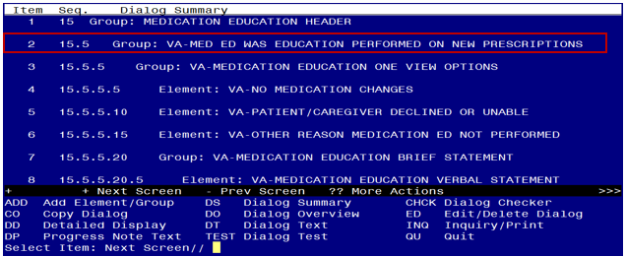

- Refresh the reminder dialogs in CPRS and verify the dialog is accurate.

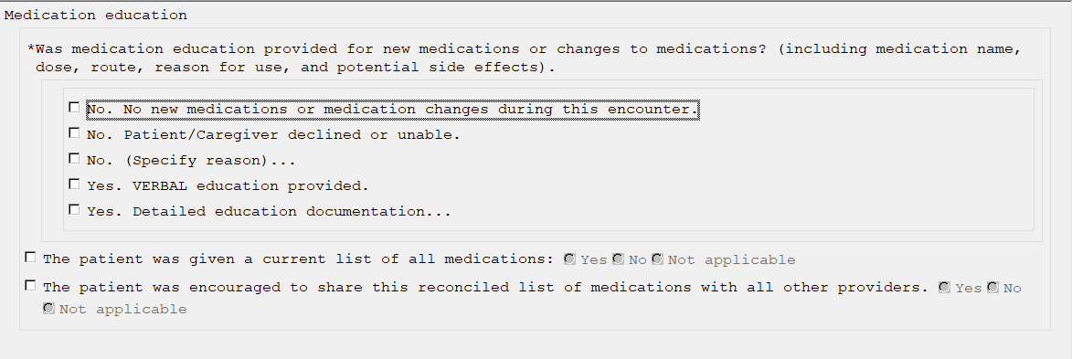

- Make the Dialog template available to be attached to a Personal or Shared template or to be able to attach the dialog to a progress note title (optional).

Select Reminder Managers Menu <TEST ACCOUNT> Option: CP CPRS Reminder Configuration
CA Add/Edit Reminder Categories
CL CPRS Lookup Categories
CS CPRS Cover Sheet Reminder List
MH Mental Health Dialogs Active
PN Progress Note Headers
RA Reminder GUI Resolution Active
TIU TIU Template Reminder Dialog Parameter
DEVL Evaluate Coversheet List on Dialog Finish
DL Default Outside Location
PT Position Reminder Text at Cursor
LINK Link Reminder Dialog to Template
TEST CPRS Coversheet Time Test
NP New Reminder Parameters
GEC GEC Status Check Active
WH WH Print Now Active
Select CPRS Reminder Configuration <TEST ACCOUNT> Option: TIU

Reminder Dialogs allowed as Templates may be set for the following:
1 User USR [choose from NEW PERSON]
3 Service SRV [choose from SERVICE/SECTION]
4 Division DIV [SALT LAKE CITY]
5 System SYS [NATREM.FO-SLC.MED.VA.GOV]
Enter selection: 5 Choose the appropriate number for your site. Your site may do this by System or other levels. This example uses SYSTEM level.

Select Display Sequence: ?
388 VA-COVID-19 TELEPHONE FOLLOW-UP
389 VA-SRA-CONSULT RESPONSE (D)
When you type a question mark above, you will see the list of #’s (with dialogs) that are already taken. Choose a number NOT on this list. For this example, 390 is not present so I will use 390.
Select Display Sequence: 390
Are you adding 390 as a new Display Sequence? Yes// YES
Display Sequence: 390// <Enter>
Clinical Reminder Dialog: VA-MEDICATION EDUCATION REVIEW TEMPLATE
Enter the name of the reminder dialog.

...OK? Yes// <Enter> (Yes)

- Setup of Note Title (not recommended).
  - Set up in shared template folder is recommended if not embedded in local templates

The note title to create to associate with this template is: MEDICATION EDUCATION REVIEW

VHA Enterprise Standard Title: EDUCATION NOTE

You can add this to your document class where Multiuse/Education templates are located.

Note: Information on Creating new Document Classes and Titles can be found on page 54 of the TIU/ASU Implementation Guide at the following link: http://www.va.gov/vdl/documents/Clinical/CPRS-Text_Integration_Utility_(TIU)/tiuim.pdf

- Associate the reminder dialog with the note title in CPRS (not recommended).

In CPRS, open the Template Editor, expand Document Titles, select the appropriate folder (if applicable), then click New Template (top right-hand corner).

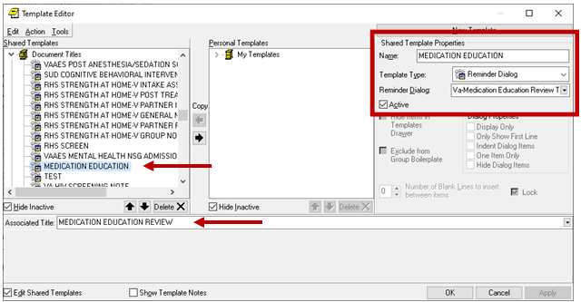

Type in the following information:
Name: MEDICATION EDUCATION
Template Type: Reminder Dialog
Reminder Dialog: VA-MEDICATION EDUCATION REVIEW TEMPLATE

Next, type in the Associated Title: MEDICATION EDUCATION REVIEW –– then click Apply.

