Update _2_0_257

Clinical Reminders

VA-WHS NADA ACUPUNCTURE/ACUPRESSURE
Install Guide

April 2022

Product Development
Office of Information Technology
Department of Veterans Affairs

Table of Contents
Introduction 1
Install Details 3
Install Example 3
Post Installation 6

Introduction
The templated will be used by clinicians who are trained and privileged or scoped to perform the National Acupuncture Detoxification Association (NADA) acupuncture protocol. It should be used when the protocol is used to treat patients. Clinicians may include licensed acupuncturists, physicians, advance practice providers and chiropractors, plus any trained specifically in the NADA protocol.

UPDATE_2_0_257 contains 1 Reminder Exchange entry:
UPDATE_2_0_257 VA-WHS NADA ACUPUNCTURE/ACUPRESSURE

The exchange file contains the following components:

TIU TEMPLATE FIELD
WORD PROCESSING (REQUIRED)11

HEALTH FACTORS
VA-REMINDER UPDATES [C]
VA-UPDATE_2_0_257
VA-NADA ACUPUNCTURE/ACUPRESSURE [C]
VA-NADA WELL-BEING ASSESSMENT
VA-NADA CONVENTIONAL BIOMED DX
VA-NADA INTERVENTION-ADVERSE EVENT
VA-NADA INTERVENTION-NO ADVERSE EVENT
VA-NADA 2ND INTERVENTION POINTS-LUNG LEFT
VA-NADA 2ND INTERVENTION POINTS-LUNG RIGHT
VA-NADA 2ND INTERVENTION POINTS-LUNG BILAT
VA-NADA 2ND INTERVENTION POINTS-LIVER LEFT
VA-NADA 2ND INTERVENTION POINTS-LIVER RIGHT
VA-NADA 2ND INTERVENTION POINTS-LIVER BILAT
VA-NADA 2ND INTERVENTION POINTS-KIDNEY LEFT
VA-NADA 2ND INTERVENTION POINTS-KIDNEY RIGHT
VA-NADA 2ND INTERVENTION POINTS-KIDNEY BILAT
VA-NADA 2ND INTERVENTION POINTS-SHEN MEN LEFT
VA-NADA 2ND INTERVENTION POINTS-SHEN MEN RIGHT
VA-NADA 2ND INTERVENTION POINTS-SHEN MEN BILAT
VA-NADA 2ND INTERVENTION POINTS-SYMPATHETIC LEFT
VA-NADA 2ND INTERVENTION POINTS-SYMPATHETIC RIGHT
VA-NADA 2ND INTERVENTION POINTS-SYMPATHETIC BILAT
VA-NADA 2ND INTERVENTION 10 POINTS USED
VA-NADA 2ND INTERVENTION-OTHER
VA-NADA 2ND INTERVENTION PRESS TACK NEEDLES
VA-NADA 2ND INTERVENTION EAR PELLETS/BEADS
VA-NADA 2ND INTERVENTION EAR MAGNETS
VA-NADA 2ND INTERVENTION EAR SEEDS
VA-NADA 1ST INTERVENTION TIME >/= 21 MIN
VA-NADA 1ST INTERVENTION TIME </= 20 MIN
VA-NADA 1ST INTERVENTION POINTS-LUNG LEFT
VA-NADA 1ST INTERVENTION POINTS-LUNG RIGHT
VA-NADA 1ST INTERVENTION POINTS-LUNG BILAT
VA-NADA 1ST INTERVENTION POINTS-LIVER LEFT
VA-NADA 1ST INTERVENTION POINTS-LIVER RIGHT
VA-NADA 1ST INTERVENTION POINTS-LIVER BILAT
VA-NADA 1ST INTERVENTION POINTS-KIDNEY LEFT
VA-NADA 1ST INTERVENTION POINTS-KIDNEY RIGHT
VA-NADA 1ST INTERVENTION POINTS-KIDNEY BILAT
VA-NADA 1ST INTERVENTION POINTS-SHEN MEN LEFT
VA-NADA 1ST INTERVENTION POINTS-SHEN MEN RIGHT
VA-NADA 1ST INTERVENTION POINTS-SHEN MEN BILAT
VA-NADA 1ST INTERVENTION POINTS-SYMPATHETIC LEFT
VA-NADA 1ST INTERVENTION POINTS-SYMPATHETIC RIGHT
VA-NADA 1ST INTERVENTION POINTS-SYMPATHETIC BILAT
VA-NADA 1ST INTERVENTION 10 POINTS USED
VA-NADA 1ST INTERVENTION ACUPUNCTURE NEEDLES
VA-NADA 1ST INTERVENTION-OTHER
VA-NADA 1ST INTERVENTION PRESS TACK NEEDLES
VA-NADA 1ST INTERVENTION EAR PELLETS/BEADS
VA-NADA 1ST INTERVENTION EAR MAGNETS
VA-NADA 1ST INTERVENTION EAR SEEDS
VA-NADA SUBJ OTHER
VA-NADA SUBJ WELL-BEING
VA-NADA SUBJ STRESS
VA-NADA SUBJ PAIN
VA-NADA SUBJ SLEEP DISORDERS
VA-NADA SUBJ TRAUMA/PTSD
VA-NADA SUBJ SUD VISIT
VA-NADA SUBJ MH VISIT
VA-NADA INDIVIDUAL SESSION
VA-NADA GROUP SESSION
VA-NADA RETURN VISIT
VA-NADA INITIAL VISIT

REMINDER SPONSOR
WHOLE HEALTH

REMINDER TAXONOMY
VA-NADA ACUPRESSURE PROCEDURE
VA-NADA ACUPUNCTURE PROCEDURE

REMINDER TERM
VA-REMINDER UPDATE_2_0_257

REMINDER DIALOG
VA-WHS NADA ACUPUNCTURE/ACUPRESSURE

Install Details
This update is being distributed as a web host file. The address for the host file is: https://Redacted/UPDATE_2_0_257.PRD
The file will be installed using Reminder Exchange, programmer access is not required.
Installation:
=============
This update can be loaded with users on the system. Installation will take less than 5 minutes.

Install Example
To Load the Web Host File. Navigate to Reminder exchange in Vista
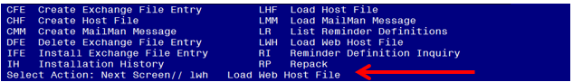

At the Select Action: prompt, enter LWH for Load Web Host File
At the Input the url for the .prd file: prompt, type the following web address:
https://REDACTED/UPDATE_2_0_257.PRD

You should see a message at the top of your screen that the file successfully loaded.

Search and locate an entry titled UPDATE_2_0_257 VA-WHS NADA ACUPUNCTURE/ACUPRESSURE in reminder exchange.

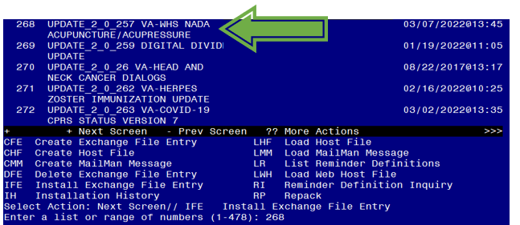
At the Select Action prompt, enter IFE for Install Exchange File Entry

Enter the number that corresponds with your entry UPDATE_2_0_257 VA-WHS NADA ACUPUNCTURE/ACUPRESSURE (in this example it is entry 268. It will vary by site). The date of the exchange file should be 03/07/2022.

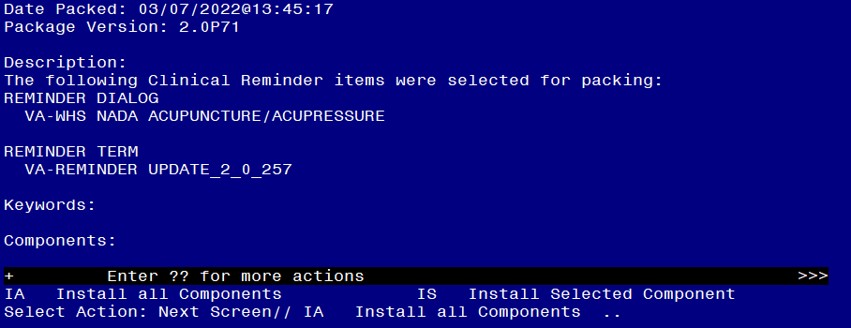

At the Select Action prompt, type IA for Install all Components and hit enter.
Select Action: Next Screen// IA Install all Components
You will see several prompts, for all new entries you will choose I to Install
For components that already exists but the packed component is different, choose S to Skip.

You will be promped to install the reminder dialog component (VA-WHS NADA ACUPUNCTURE/ACUPRESSURE). You will choose to install all even though some components may have an X to indicate that they exist.
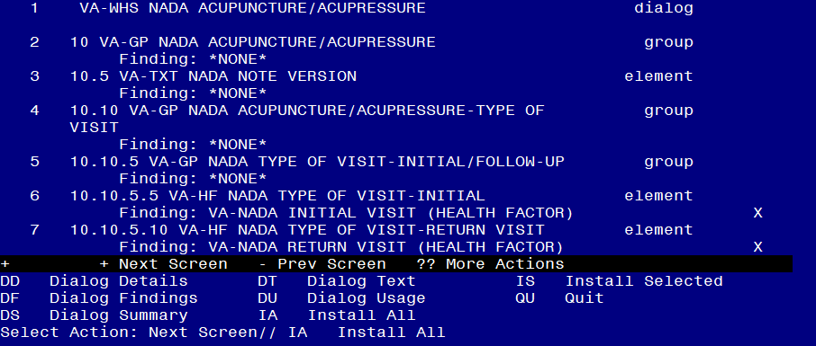
At the Select Action prompt, type IA to install the dialog: VA-WHS NADA ACUPUNCTURE/ACUPRESSURE
Select Action: Next Screen// IA Install All
Install reminder dialog and all components with no further changes: Y// Yes
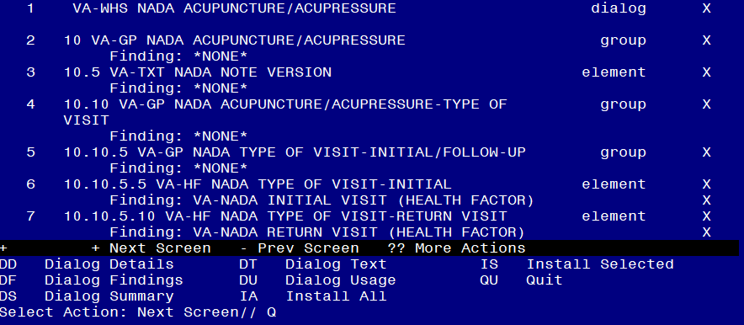

After completing this dialog install, you will type Q.

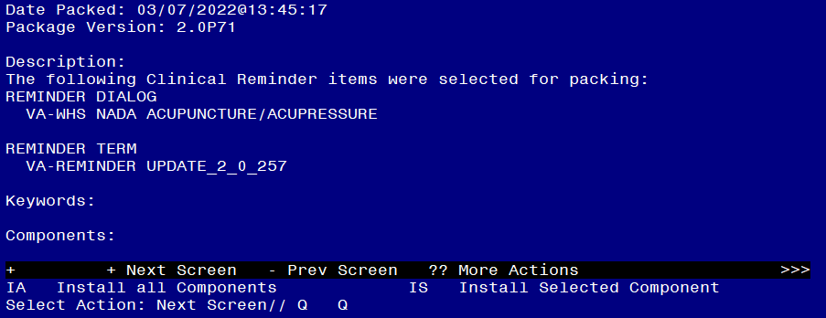
You will then be returned to this screen. At the Select Action prompt, type Q.

Install complete.

Post Installation

- Make the Dialog template available to be attached to a Personal or Shared template or to be able to attach the dialog to a progress note title.

Select Reminder Managers Menu <TEST ACCOUNT> Option: CP CPRS Reminder Configuration
CA Add/Edit Reminder Categories
CL CPRS Lookup Categories
CS CPRS Cover Sheet Reminder List
MH Mental Health Dialogs Active
PN Progress Note Headers
RA Reminder GUI Resolution Active
TIU TIU Template Reminder Dialog Parameter
DEVL Evaluate Coversheet List on Dialog Finish
DL Default Outside Location
PT Position Reminder Text at Cursor
LINK Link Reminder Dialog to Template
TEST CPRS Coversheet Time Test
NP New Reminder Parameters
GEC GEC Status Check Active
WH WH Print Now Active
Select CPRS Reminder Configuration <TEST ACCOUNT> Option: TIU TIU Template Reminder Dialog Parameter

Reminder Dialogs allowed as Templates may be set for the following:

1 User USR [choose from NEW PERSON]
3 Service SRV [choose from SERVICE/SECTION]
4 Division DIV [SALT LAKE CITY]
5 System SYS [NATREM.FO-SLC.MED.VA.GOV]

Enter selection: 5 Choose the appropriate number for your site. Your site may do this by System or other levels. The example below uses SYSTEM level.

Setting Reminder Dialogs allowed as Templates for System: NATREM.FO-SLC.MED.VA.GOV
Select Display Sequence: ?

388 VA-COVID-19 TELEPHONE FOLLOW-UP
389 VA-SRA-CONSULT RESPONSE (D)

When you type a question mark above, you will see the list of #’s (with dialogs) that are already taken. Choose a number NOT on this list. For this example, 390 is not present so I will use 390.

Select Display Sequence: 390
Are you adding 390 as a new Display Sequence? Yes// YES

Display Sequence: 390// <Enter> 390
Clinical Reminder Dialog: VA-WHS NADA ACUPUNCTURE/ACUPRESSURE reminder dialog NATIONAL
...OK? Yes// <Enter> (Yes)

- Setup of Note Title.

The note title to create to associate with this template is: NADA ACUPUNCTURE/ACUPRESSURE NOTE

VHA Enterprise Standard Title: INTEGRATIVE HEALTH NOTE

You can add this to your document class where whole health notes are located.

Note: Comprehensive information on Creating new Document Classes and Titles can be found beginning on page 54 of the TIU/ASU Implementation Guide at the following link: http://www.va.gov/vdl/documents/Clinical/CPRS-Text_Integration_Utility_(TIU)/tiuim.pdf

- Associate the reminder dialog with the note title in CPRS

In CPRS, open the Template Editor, expand Document Titles, select the appropriate folder (if applicable), then click New Template (top right-hand corner).

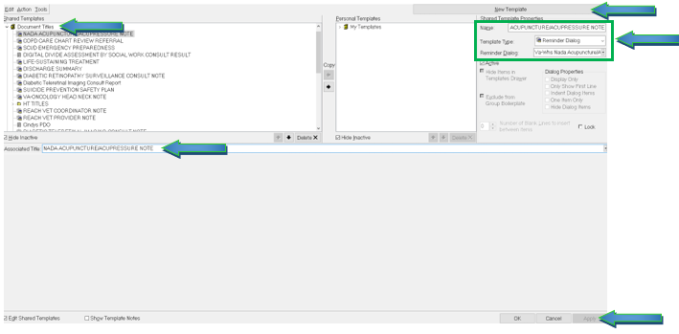

Type in the following information:
Name: NADA ACUPUNCTURE/ACUPRESSURE NOTE
Template Type: Reminder Dialog
Reminder Dialog: VA-WHS NADA ACUPUNCTURE/ACUPRESSURE

Next, type in the Associated Title name – NADA ACUPUNCTURE/ACUPRESSURE NOTE – then click Apply.

- Associate the reminder dialog with a shared template in CPRS (if applicable)

In CPRS, open the Template Editor, expand Shared Templates, select the appropriate folder (if applicable), then click New Template (top right-hand corner).

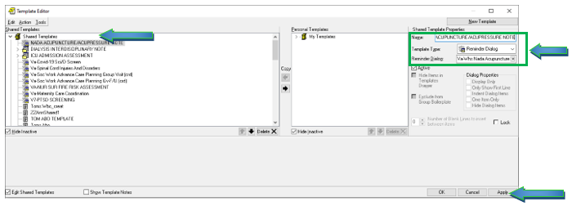

Type in the following information:
Name: NADA ACUPUNCTURE/ACUPRESSURE NOTE
Template Type: Reminder Dialog
Reminder Dialog: VA-WHS NADA ACUPUNCTURE/ACUPRESSURE

Click Apply, then OK.

