Update_2_0_258

Clinical Reminders

VA-MISC Update 16

Install Guide

March 2022

Product Development
Office of Information Technology
Department of Veterans Affairs

Table of Contents
Introduction 1
Pre-Installation 14
Install Details 15
Install Example 15
Post Installation 22

Introduction
This update contains minor spelling corrections and other changes/edits to existing clinical reminder content, a full list of the changes can be found here:

MISC_UPDATE_16_CHANGES

UPDATE_2_0_258 contains 1 Reminder Exchange entry:
UPDATE_2_0_258 VA-MISC UPDATE 16

The exchange file contains the following components:

ROUTINE
PXRMCALT
PXRMCDEF
PXRMCWH
PXRMPDEM

VA GENERIC
BENDROFLUMETHIAZIDE/NADOLOL
EPINEPHRINE/LIDOCAINE
DOPAMINE
RITODRINE
QUININE
ERYTHROMYCIN
PROBUCOL
DESIPRAMINE
HYDRALAZINE/HYDROCHLOROTHIAZIDE
AMANTADINE
PSEUDOEPHEDRINE
HYDROCHLOROTHIAZIDE/PROPRANOLOL
PIMOZIDE
DOBUTAMINE
TAMOXIFEN
FENFLURAMINE
TERBUTALINE
HYDROCHLOROTHIAZIDE/METOPROLOL
APOMORPHINE
COCAINE
NORTRIPTYLINE
HYDROXYCHLOROQUINE
PHENYLEPHRINE
NOREPINEPHRINE
ISOPROTERENOL
CHLOROQUINE/PRIMAQUINE
CHLOROQUINE
CLOZAPINE (SANDOZ)
MIDOSTAURIN
VALBENAZINE
CLOZAPINE (AUROBINDO)
CLOZAPINE (ACCORD)
DEUTETRABENAZINE
RIBOCICLIB
NUSINERSEN
METHYLPHENIDATE
FORMOTEROL/GLYCOPYRROLATE
PIMAVANSERIN
CLOZAPINE (ACTAVIS)
NECITUMUMAB
OSIMERTINIB
TIPIRACIL/TRIFLURIDINE
OLODATEROL/TIOTROPIUM
IVABRADINE
DONEPEZIL/MEMANTINE
PANOBINOSTAT
LENVATINIB
QUINIDINE
ATAZANAVIR/COBICISTAT
DIPHENHYDRAMINE/NAPROXEN
ELIGLUSTAT
OLODATEROL
DROXIDOPA
CERITINIB
HYDROCODONE
LEUPROLIDE/NORETHINDRONE
CLOZAPINE (VERSACLOZ)
PHENTERMINE
AMPHETAMINE RESIN COMPLEX
FLUTICASONE/VILANTEROL
DABRAFENIB
BEDAQUILINE
PASIREOTIDE
CABOZANTINIB
MIRABEGRON
BOSUTINIB
PHENTERMINE/TOPIRAMATE
CRIZOTINIB
VEMURAFENIB
DOMPERIDONE
EZOGABINE
INDACATEROL
RILPIVIRINE
TELAPREVIR
VANDETANIB
FAMOTIDINE/IBUPROFEN
ALISKIREN/AMLODIPINE/HYDROCHLOROTHIAZIDE
ERIBULIN
FINGOLIMOD
AMLODIPINE/HYDROCHLOROTHIAZIDE/OLMESARTAN
ESOMEPRAZOLE/NAPROXEN
FORMOTEROL/MOMETASONE
TELAVANCIN
PAZOPANIB
ROMIDEPSIN
ASENAPINE
DRONEDARONE
HALOPERIDOL
AMLODIPINE/HYDROCHLOROTHIAZIDE/VALSARTAN
ILOPERIDONE
DEGARELIX
TETRABENAZINE
ALISKIREN/HYDROCHLOROTHIAZIDE
BENDAMUSTINE
NILOTINIB
DIPHENHYDRAMINE/IBUPROFEN
ARFORMOTEROL
LISDEXAMFETAMINE
LAPATINIB
PALIPERIDONE
VORINOSTAT
POSACONAZOLE
OMEPRAZOLE/SODIUM BICARBONATE
EFAVIRENZ/EMTRICITABINE/TENOFOVIR
DASATINIB
SUNITINIB
RANOLAZINE
SORAFENIB
CLOZAPINE (TEVA)
CLOZAPINE (FAZACLO)
EPROSARTAN/HYDROCHLOROTHIAZIDE
SOLIFENACIN
HYDROCHLOROTHIAZIDE/TELMISARTAN
TELITHROMYCIN
LANSOPRAZOLE/NAPROXEN
DIPHENHYDRAMINE/PHENYLEPHRINE
HYDROCHLOROTHIAZIDE/OLMESARTAN
FLUOXETINE/OLANZAPINE
CLOZAPINE (CARACO)
AMIODARONE
VARDENAFIL
PALONOSETRON
ATAZANAVIR
ALFUZOSIN
BORTEZOMIB
GEMIFLOXACIN
TRIMIPRAMINE
BUPRENORPHINE/NALOXONE
ARIPIPRAZOLE
ATOMOXETINE
ESCITALOPRAM
OXALIPLATIN
VORICONAZOLE
PERFLUTREN
DEXMETHYLPHENIDATE
CLOZAPINE (CLOZARIL)
CLOZAPINE (UDL)
CLOZAPINE (MYLAN)
CLOZAPINE (IVAX)
PROMETHAZINE/PSEUDOEPHEDRINE
FORMOTEROL
ESOMEPRAZOLE
GALANTAMINE
ZIPRASIDONE
OXYTOCIN
CANDESARTAN/HYDROCHLOROTHIAZIDE
FOSINOPRIL/HYDROCHLOROTHIAZIDE
ARSENIC
MIFEPRISTONE
DEXMEDETOMIDINE
PANTOPRAZOLE
DOFETILIDE
HYDROCHLOROTHIAZIDE/QUINAPRIL
EPINEPHRINE
EPIRUBICIN
GATIFLOXACIN
MOXIFLOXACIN
LOPERAMIDE/SIMETHICONE
LEVALBUTEROL
HYDROCHLOROTHIAZIDE/IRBESARTAN
CILOSTAZOL
EFAVIRENZ
CITALOPRAM
HALOFANTRINE
TOLTERODINE
CAPECITABINE
HYDROCHLOROTHIAZIDE/VALSARTAN
SIBUTRAMINE
TOREMIFENE
GREPAFLOXACIN
HYDROCODONE/IBUPROFEN
HYDROCHLOROTHIAZIDE/MOEXIPRIL
DOLASETRON
QUETIAPINE
ANAGRELIDE
ALBUTEROL/IPRATROPIUM
TIZANIDINE
NELFINAVIR
DONEPEZIL
LEVOFLOXACIN
MIDODRINE
OLANZAPINE
SPARFLOXACIN
MIRTAZAPINE
LITHIUM
RITONAVIR
DEXTROAMPHETAMINE
IBUTILIDE
SAQUINAVIR
BISOPROLOL/HYDROCHLOROTHIAZIDE
BENAZEPRIL/HYDROCHLOROTHIAZIDE
EPHEDRINE
MOEXIPRIL
SEVOFLURANE
LANSOPRAZOLE
HYDROCHLOROTHIAZIDE/LOSARTAN
FLUVOXAMINE
SALMETEROL
TACROLIMUS
GRANISETRON
TORSEMIDE
VENLAFAXINE
RISPERIDONE
PIPERACILLIN/TAZOBACTAM
CISAPRIDE
LEVOMETHADYL
FELBAMATE
FAMOTIDINE
DIPHENHYDRAMINE/TRIPELENNAMINE
AMILORIDE/HYDROCHLOROTHIAZIDE
AMITRIPTYLINE/PERPHENAZINE
HYDROCHLOROTHIAZIDE/TIMOLOL
ITRACONAZOLE
SOTALOL
PAROXETINE
HYDROCHLOROTHIAZIDE/RESERPINE
AZITHROMYCIN
SERTRALINE
CLARITHROMYCIN
METOCLOPRAMIDE
HYDROCHLOROTHIAZIDE/TRIAMTERENE
HYDROCHLOROTHIAZIDE/METHYLDOPA
HYDRALAZINE/HYDROCHLOROTHIAZIDE/RESERPINE
DIPHENHYDRAMINE/PSEUDOEPHEDRINE
THIORIDAZINE
HYDROCHLOROTHIAZIDE
HYDROCHLOROTHIAZIDE/SPIRONOLACTONE
ENALAPRIL/HYDROCHLOROTHIAZIDE
HYDROXYZINE
OFLOXACIN
ONDANSETRON
ISRADIPINE
BEPRIDIL
CIPROFLOXACIN/DEXTROSE
DIPHENHYDRAMINE
IMIPRAMINE
CHLORPROMAZINE
PROMETHAZINE
NORFLOXACIN
PROPOFOL
FLUCONAZOLE
CLOMIPRAMINE
DOXEPIN
CLOZAPINE
HYDROCHLOROTHIAZIDE/LABETALOL
QUININE SULFATE/VITAMIN E
DISOPYRAMIDE
OMEPRAZOLE
METRONIDAZOLE
HYDROCHLOROTHIAZIDE/LISINOPRIL
FLUOXETINE
ASTEMIZOLE
FUROSEMIDE
NICARDIPINE
CIPROFLOXACIN
TERFENADINE
SULFAMETHIZOLE/TRIMETHOPRIM
EPINEPHRINE/LIDOCAINE/POVIDONE
EPINEPHRINE/LIDOCAINE/POVIDONE/SODIUM CHLORIDE
EPINEPHRINE/LIDOCAINE/SODIUM CHLORIDE
DROPERIDOL/FENTANYL
EPINEPHRINE,RACEMIC
LITHIUM CARBONATE/SODIUM CHLORIDE
LOPERAMIDE
DIPHENHYDRAMINE/GUAIFENESIN/MENTHOL/SODIUM CITRATE
PHENYLPROPANOLAMINE
EPINEPHRINE/ZINC PHENOLSULFONATE
EPINEPHRINE/ZINC CHLORIDE
CHLORAL HYDRATE/SALICYLIC ACID
EPINEPHRINE/PILOCARPINE
MESORIDAZINE BESYLATE
METOCLOPRAMIDE/SODIUM CHLORIDE
DROPERIDOL
PENTAMIDINE ISETHIONATE
IBOGAINE
LEUPROLIDE
AMPHETAMINE
METRONIDAZOLE/SODIUM CHLORIDE
AMITRIPTYLINE
EPINEPHRINE/ETIDOCAINE
EPINEPHRINE/PRILOCAINE
BUPRENORPHINE
AMITRIPTYLINE/CHLORDIAZEPOXIDE
CHLORAL HYDRATE
METHADONE
BENDROFLUMETHIAZIDE
AMPHETAMINE/DEXTROAMPHETAMINE
BENDROFLUMETHIAZIDE/POTASSIUM CHLORIDE
ISOPROTERENOL/PHENYLEPHRINE
FLECAINIDE
TRAZODONE
ALBUTEROL
PERPHENAZINE
GUANETHIDINE/HYDROCHLOROTHIAZIDE
METAPROTERENOL
PAPAVERINE
AMPHOTERICIN B/TETRACYCLINE
INDAPAMIDE
ERYTHROMYCIN/SULFISOXAZOLE
PROCAINAMIDE
DESERPIDINE/HYDROCHLOROTHIAZIDE
AMPHOTERICIN B
ISOPROTERENOL/SODIUM CHLORIDE
METHAMPHETAMINE
CAPTOPRIL/HYDROCHLOROTHIAZIDE

VA PRODUCT
KENTOCONAZOLE 200MG TAB

ORDERABLE ITEMS
LST DNR EXCEPT
LST DNR – DO NOT RESUSCITATE

REMINDER GENERAL FINDINGS
VIEW PROGRESS NOTE TEXT
WH PROCEDURE ACTION COMMENT
RADIOLOGY REPORT RECEIVED

TIU TEMPLATE FIELD
VA-RAI SCORE TEXT
WWW RAI FRAILTY
TEXT (6 CHAR)
VA SP 3 LINES
VA-OSP WARNING SIGNS
VA SP 3 LINES R
VA-OSP PRIOR ATTEMPTS
IM VIS HPV URL
IM VIS HPV9 DT
VA-OSP VHB URL
VA-OSP EDIT 40 R IND
VA-OSP CITY ST
VA-OSP STREET ADD
TEXT (1-60 CHAR)
TEXT (1-10 CHAR)
VA-LST WORD PROCESS 2 LINES REQ
VA-LST DNR OR DNAR
ACP QUALIFICATION GUIDELINES
ACP ELIGIBILITY STEPS
LIFELINESUPPORT.ORG
PBM HEPLISAV-B TRAVEL RECOMMEND
PBM HEPLISAV-B LIST OF COUNTRIES
VA-PSAS EDIT 50
VA-PSAS DATE(R)
VA-PSAS WORD 2 LINES
VA-PSAS HISA SC BENEFIT INFO (DISPLAY)
VA-PSAS YES/NO(R)
NCP INFLUENZA IMMUNIZATION GUIDANCE
WH US SPR LINK
WH US MEC LINK
VA-WH MAMMOGRAM GUIDANCE
IM VIS HBV DT
IM VIS HAV DT

EXAM
TRR EXAM OTH ASSESS-U/A
TRR EXAM OTH ASSESS-ABN
TRR EXAM OTH ASSESS-NORM
TRR EXAM OPTC NRV-NORMAL
TRR EXAM OPTC NRV-ABN
TRR EXAM OPTC NRV-U/A
TRR EXAM MACULA-U/A
TRR EXAM MACULA-ABN
TRR EXAM MACULA-NORMAL
TRR DM EXAM RTNOPTY-U/A
TRR DM EXAM RTNOPTY-ABN
TRR DM EXAM RTNOPTY-NORMAL

HEALTH FACTORS
VA-REMINDER UPDATES [C]
VA-UPDATE_2_0_258
VA-RAI FRAILTY TOOL [C]
VA-RAI FRAILTY SCORE
VA-RAI FRAILTY SCORE WITHOUT CANCER
VA-SUICIDE RISK ASSESSMENT [C]
VA-HISTORY OF SUICIDE ATTEMPTS NO
VA-SUICIDE ACTION ONE ON ONE
VA-SUICIDE ACTION RESIDENT OTHER
VA-SUICIDE ACTION SAFETY PLAN RT
VA-SUICIDE ACTION INCREASE ROUNDING RT
VA-SUICIDE ACTION SYMPTOM MONITORING
VA-SUICIDE ACTION REVIEW PERSONAL ITEMS
VA-SUICIDE ACTION INCREASE THERAPY
VA-SUICIDE ACTION RECOVERY BUDDY
VA-SUICIDE ACTION LIMIT POV ACCESS
VA-SUICIDE ACTION REVIEW PASSES
VA-SUICIDE ACTION ADMISSION BEDROOM ASSE
VA-SUICIDE ACTION ADMISSION BEDROOM MONI
VA-SUICIDE ACTION REQUIRE CHECK IN
VA-SUICIDE ACTION DEPENDENT MEDS MANAGE
VA-SUICIDE ACTION MONITOR UDS
VA-SUICIDE ACTION VOLUNTARY HOSPITAL
VA-SUICIDE ACTION INVOLUNTARY HOSPITAL
VA-SUICIDE WARNING SIGNS [C]
VA-SUICIDE WARN UNKNOWN
VA-SUICIDE WARN INCREASED ISOLATION
VA-SUICIDE WARN DIRECT OTHER
VA-SUICIDE WARN IND SUBSTANCE ABUSE
VA-SUICIDE WARN IND RECKLESS
VA-SUICIDE WARN IND SLEEP DISTURBANCES
VA-SUICIDE WARN IND HOPELESSNESS
VA-SUICIDE WARN IND ANXIETY
VA-SUICIDE WARN DIRECT COMMUNICATION
VA-SUICIDE WARN IND GUILT
VA-SUICIDE WARN DIRECT SEEK ACCESS
VA-SUICIDE WARN DIRECT PREPARATIONS
VA-SUICIDE WARN IND ANGER
VA-SUICIDE WARN NONE
VA-SUICIDE RISK FACTORS [C]
VA-SUICIDE RISK HX OF SUICIDE ATTEMPT
VA-UNKNOWN HISTORY OF SUICIDE ATTEMPTS
VA-SUICIDE ATT MOST RECENT LETHAL UNKN
VA-LETHAL EVENT 7 DAYS DISCHARGE YES
VA-LETHAL EVENT 7 DAYS DISCHARGE UNK
VA-LETHAL EVENT 7 DAYS DISCHARGE NO
VA-LETHAL EVENT STATUS CONTRACT BED
VA-LETHAL EVENT STATUS CLC
VA-LETHAL EVENT STATUS RRTP
VA-LETHAL EVENT LOCATION VA PROPERTY UNK
VA-LETHAL EVENT LOCATION VA PROPERTY YES
VA-LETHAL EVENT LOCATION VA PROPERTY NO
VA-LETHAL EVENT STATUS UNK
VA-LETHAL EVENT STATUS OTHER
VA-LETHAL EVENT STATUS INPATIENT
VA-LETHAL EVENT STATUS OUTPATIENT
VA-SUICIDE HELP UNKNOWN
VA-SUICIDE HELP OTHER LETHAL
VA-SUICIDE HELP OP MH LETHAL
VA-SUICIDE HELP OP MED LETHAL
VA-SUICIDE HELP HOSPITAL LETHAL
VA-SUICIDE HELP NONE LETHAL
VA-SUICIDE ATT LETHAL INJURY UNKNOWN
VA-SUICIDE ATT LETHAL INJURY
VA-SUICIDE ATT LETHAL NO INJURY
VA-SUICIDE ATT LETHAL INTERRUPTED UNKNWN
VA-SUICIDE ATT LETHAL INTERRUPTED OTHER
VA-SUICIDE ATT LETHAL INTERRUPTED SELF
VA-SUICIDE ATT LETHAL NOT INTERRUPTED
VA-SUICIDE ATT LETHAL SUFFOCATION
VA-SUICIDE ATT LETHAL STABBED CUT SELF
VA-SUICIDE LETHAL ATT OVERDOSE
VA-SUICIDE ATT LETHAL JUMP IN FO AUTO/TR
VA-SUICIDE ATT LETHAL JUMPING FR HEIGHT
VA-SUICIDE ATT LETHAL INJURY BY OTHER
VA-SUICIDE ATT LETHAL POISON CHEMICAL
VA-SUICIDE LETHAL ATT HANG OTHER
VA-SUICIDE LETHAL ATT FIREARM
VA-SUICIDE ATT LETHAL AUTO OTHER
VA-SUICIDE ATT LETHAL CARBON MONOXIDE
VA-SUICIDE ATT LETHAL DROWNING
VA-SUICIDE ATT LETHAL OTHER NOT PROVIDED
VA-SUICIDE ATT LETHAL OTHER METHOD
VA-SUICIDE ATT MOST LETHAL DOC SBOR NO
VA-SUICIDE ATT MOST LETHAL DOC SBOR
VA-SUICIDE PRIOR ATTEMPT DATE LETHAL
VA-SUICIDE ATTEMPT MOST RECENT LETHAL NO
VA-SUICIDE ATTEMPT MOST RECENT LETHAL
VA-SUICIDE BEHAVIOR AND OVERDOSE REPORT [C]
VA-SBOR EVENT 7 DAYS DISCHARGE YES
VA-SBOR EVENT 7 DAYS DISCHARGE UNK
VA-SBOR EVENT 7 DAYS DISCHARGE NO
VA-SBOR EVENT STATUS CONTRACT BED
VA-SBOR EVENT STATUS CLC
VA-SBOR EVENT STATUS RRTP
VA-SBOR EVENT LOCATION VA PROPERTY UNK
VA-SBOR EVENT LOCATION VA PROPERTY YES
VA-SBOR EVENT LOCATION VA PROPERTY NO
VA-SBOR EVENT STATUS UNK
VA-SBOR EVENT STATUS OTHER
VA-SBOR EVENT STATUS INPATIENT
VA-SBOR EVENT STATUS OUTPATIENT
VA-SUICIDE HELP OP MH
VA-SUICIDE HELP OP MED
VA-SUICIDE HELP HOSPITAL
VA-SUICIDE HELP OTHER
VA-SUICIDE HELP NONE
VA-SUICIDE ATTEMPT INJURY UNKNOWN
VA-SUICIDE ATTEMPT INJURY
VA-SUICIDE ATTEMPT NO INJURY
VA-SUICIDE ATTEMPT INTERRUPTED UNKNOWN
VA-SUICIDE ATTEMPT INTERRUPTED BY OTHER
VA-SUICIDE ATTEMPT INTERRUPTED BY SELF
VA-SUICIDE ATTEMPT NOT INTERRUPTED
VA-SUICIDE ATTEMPT SUFFOCATION
VA-SUICIDE ATTEMPT STABBED CUT SELF
VA-SUICIDE ATTEMPT OVERDOSE
VA-SUICIDE ATTEMPT JUMP IN FO AUTO/TRAIN
VA-SUICIDE ATTEMPT JUMPING FROM HEIGHT
VA-SUICIDE ATTEMPT INJURY BY OTHER
VA-SUICIDE ATTEMPT POISON CHEMICAL
VA-SUICIDE ATT HANG OTHER
VA-SUICIDE ATT FIREARM
VA-SUICIDE ATTEMPT AUTO OTHER
VA-SUICIDE ATTEMPT CARBON MONOXIDE
VA-SUICIDE ATTEMPT DROWNING
VA-SUICIDE ATTEMPT OTHER NOT PROVIDED
VA-SUICIDE ATTEMPT OTHER METHOD
VA-SBOR DOESNT EXIST MOST RECENT ATTEMPT
VA-SBOR EXISTS FOR MOST RECENT ATTEMPT
VA-SUICIDE PRIOR ATTEMPT DATE
VA-SUICIDE ATTEMPT NUMBER
VA-HISTORY OF SUICIDE ATTEMPTS YES
VA-SUICIDE SAFETY PLAN [C]
VA-SP EMERG CONTACT NEEDS UPDATE
VA-SP EMERG CONTACT ARE UP-TO-DATE
VA-SP REFUSED SAFETY PLANNING
VA-VAAES LINE [C]
VA-VAAES PICC INSERT PREP DRAPE
VA-VAAES PICC INSERT PREP MASK
VA-VAAES PICC INSERT PREP GOWN
VA-VAAES PICC INSERT PREP STERILE GLOVES
VA-VAAES PICC INSERT PREP CAP
VA-VAAES PICC INSERTION PREP OTHER
VA-VAAES PICC INSERTION PREP ANTIMIC
VA-VAAES PICC INSERTION PREP CHLOR
VA-VAAES PICC INSERT PREP HAND HYGIENE
ETHICS-RESUSCITATION [C]
ETHICS-DNAR/DNR-EXCEPT
ETHICS-CPR-FULL CODE
ETHICS-DNAR/DNR
REMINDER FACTORS [C]
VA-HEMOGLOBIN A1C OUTSIDE LAB
VA-TRR CATEGORY-NON DM EYE EXAM [C]
VA-TRR OTH ASSESS UNABLE TO ASSESS
VA-TRR OTH ASSESS EXAM ABNORMAL
VA-TRR OTH ASSESS EXAM NORMAL
VA-TRR OPTIC NRV EXAM NORMAL
VA-TRR OPTIC NRV EXAM ABNORMAL
VA-TRR OPTIC NRV EXAM UNABLE TO ASSES
VA-TRR MACULA EXAM UNABLE TO ASSESS
VA-TRR MACULA EXAM ABNORMAL
VA-TRR MACULA EXAM NORMAL
VA-TRR CATEGORY-DM EYE EXAM [C]
VA-TRR DM RETINOP EXAM UNABLE TO ASSESS
VA-TRR DM RETINOP EXAM ABNORMAL
VA-TRR DM RETINOP EXAM NORMAL
VA-EYE CARE AT-RISK SCREEN [C]
VA-OUTSIDE EYE AT-RISK SCREEN
HYPERTENSION [C]
VA-HTN SELF-RECORDED DIASTOLIC BLOOD PRESSURE
VA-HTN SELF-RECORDED SYSTOLIC BLOOD PRESSURE
HTN SELF-RECORDED BP
VA-PHP [C]
VA-PHP MAP
HTN REFERRED OTHER
WH MAMMOGRAM [C]
WH SMART OUTSIDE REPORT INFO
TELE URGENT CARE [C]
TELE URGENT TYPE CHAT HF
TELE URGENT TYPE PHONE HF
TELE URGENT TYPE VIDEO HF
REFUSED ULTRASOUND FOR AAA
IMAGING [C]
OUTSIDE SCREENING FOR AAA
AAA SCREENING AND F/U [C]
OUTSIDE OR PRIOR IMAGING FOR AAA SCREEN
AAA SCREENING CONFIRMED AS COMPLETE
IMAGING FOR AAA N/A CURRENTLY
IMAGING FOR AAA N/A PERMANENTLY
OUTSIDE AAA REPAIR
TOBACCO [C]
FORMER SMOKER - <100 LIFETIME CIGARETTES
HISTORY OF SMOKING
PREVIOUS SMOKER
CURRENT SMOKER

REMINDER SPONSOR
WOMEN VETERANS HEALTH PROGRAM
MENTAL HEALTH SERVICES
OFFICE OF MENTAL HEALTH SERVICES
OFFICE OF NURSING INFORMATICS
OFFICE OF NURSING SERVICE
NATIONAL CENTER FOR ETHICS IN HEALTH CARE
OFFICE OF TELEHEALTH SERVICES STORE AND FORWARD TELEHEALTH
NATIONAL CENTER FOR HEALTH PROMOTION AND DISEASE PREVENTION (NCP)
NATIONAL CLINICAL REMINDER COMMITTEE
VA NATIONAL CENTER FOR HEALTH PROMOTION AND DISEASE PREVENTION (NCP)
OFFICE OF PATIENT CARE SERVICES
OFFICE OF PUBLIC HEALTH AND ENVIRONMENTAL HAZARDS

REMINDER COMPUTED FINDING
VA-WH NEXT PROCEDURE
VA-REMINDER DEFINITION
VA-SMART PROCESSING ALERT DATA
VA-SEX
VA-DATE OF BIRTH

REMINDER TAXONOMY
VA-LONG QT SYNDROME (TAXONOMY)
TRI EX DM RETINOPATHY U/A
VA-TRI DM1/DM2 NO RETINOPATHY NO MACULAR EDEMA R/L
VA-IMAGING FOR AAA (NON-SPECIFIC)
VA-IMAGING FOR AAA (SPECIFIC)
VA-TERMINAL CANCER PATIENTS
VA-ABD AORTIC ANEURYSM
VA-TOBACCO USE

REMINDER TERM
VA-LONG QT SYNDROME (TERM)
VA-REMINDER UPDATE_2_0_258
VA-WH NEXT BREAST PROCEDURE
VA-LST DNR EXCEPT ACTIVE ORDERS
VA-LST DNR ACTIVE ORDER
VA-LST ACTIVE DNR ORDER BRANCHING LOGIC
VA-WH MAMMOGRAM ALERT FOR MALE
VA-PATIENT IS MALE
VA-REFUSED IMAGING FOR AAA SCREEN
VA-IMAGING FOR AAA ORDERABLE ITEMS
VA-IMAGING FOR AAA (RAD NON-SPECIFIC PROC)
VA-OUTSIDE SCREENING FOR AAA
VA-IMAGING CONFIRMED AS ADEQUATE FOR AAA SCREENING
VA-IMAGING FOR AAA (CPT NON-SPECIFIC PROC)
VA-IMAGING FOR AAA (RAD SPECIFIC PROC)
VA-AAA SCREENING NOT APPLICABLE
VA-AAA DX/AAA REPAIR CPT
VA-SMOKING HX <100 LIFETIME CIGARETTES
VA-SMOKING HISTORY

REMINDER DEFINITION
VA-LIFE SUSTAINING TREATMENT BRANCHING LOGIC
VA-AAA SCREENING

REMINDER ORDER CHECK RULES
VA-LONG QT SYNDROME (RULE)

REMINDER ORDER CHECK ITEMS GROUP
VA-QT PROLONGING MEDICATIONS (GROUP)

REMINDER DIALOG
VA-GP MISC UPDATE 16

Pre-Installation

Prior to installing this Update:

- Check Reminder Exchange Install History (IH) and ensure your facility has installed the following (previously released) Updates:

  - UPDATE_2_0_158 VA-TELE URGENT CARE NOTE
  - UPDATE_2_0_162 VA-PERSONAL HEALTH INVENTORY
  - UPDATE_2_0_166 VA-HYPERTENSION REMINDER UPDATE
  - UPDATE_2_0_182 VA-OSP SAFETY PLAN UPDATE
  - UPDATE_2_0_185 VA-LIFE SUSTAINING TREATMENT UPDATE
  - UPDATE_2_0_210 VA-WH MAMMOGRAM SCREENING REMINDER UPDATE
  - UPDATE_2_0_211 VA-INFLUENZA REMINDER UPDATE
  - UPDATE_2_0_212 VA-AES SHIFT ASSESSMENT BUNDLE
  - UPDATE_2_0_217 VA-TELERETINOPATHY REMINDER UPDATES
  - UPDATE_2_0_221 VA-RAI FRAILTY TEMPLATE
  - UPDATE_2_0_236 VA-PROSTHETICS TEMPLATES

- From the Reminder Dialog Management menu, Inquire/Print (INQ) and capture/save the following GROUP:

  - VAL-HTN REFERRAL OTHER
(Note: This group may (or may not) be set to ‘disabled’ in your system)

The INQ capture is needed when addressing item #1 in the Post-Installation steps.

- Identify the generic orders mapped to the following element and group. These generic orders must be remapped IMMEDIATELY after installation.
From the Reminder Dialog Management menu, Inquire/Print (INQ) and capture/save the generic orders mapped:

  - Group: VA-LST DNR (E)
  - Group: VA-LST DNR EXCEPT 2 (G)

The INQ capture is needed when addressing item #2 in the Post-Installation steps.

Install Details

This update is being distributed as a web host file. The address for the host file is: https://REDACTED/UPDATE_2_0_258.PRD

The file will be installed using Reminder Exchange, programmer access is not required.

Installation:
=============
This update can be loaded with users on the system. Installation will take less than 15 minutes.

Install Example
To Load the Web Host File. Navigate to Reminder exchange in Vista
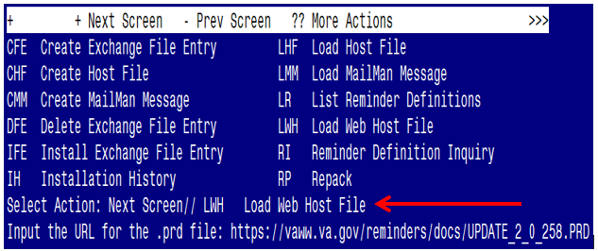

At the Select Action: prompt, enter LWH for Load Web Host File
At the Input the url for the .prd file: prompt, type the following web address:
https://Redacted /UPDATE_2_0_258.PRD
You should see a message at the top of your screen that the file successfully loaded.

Search for and locate the reminder exchange entry titled UPDATE_2_0_258 VA-MISC UPDATE 16.
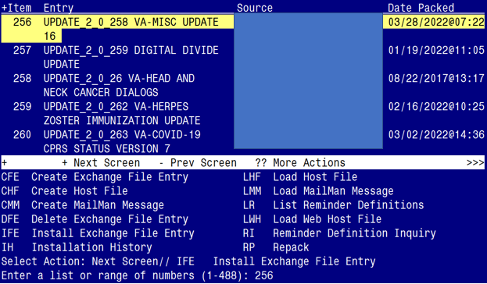

At the Select Action prompt, enter IFE for Install Exchange File Entry
Enter the number that corresponds with your entry titled UPDATE_2_0_258 VA-MISC UPDATE 16 (in this example it is entry 256, it will vary by site). The exchange file date should be 03/28/2022@07:22.

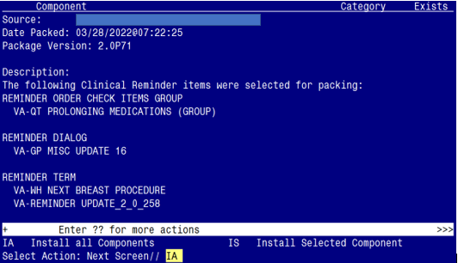

At the Select Action prompt, type IA for Install all Components and hit enter.
Select Action: Next Screen// IA Install all Components

Life-Sustaining Treatment (LST) orderable items:
- Some sites do not have the nationally standardized naming convention for their LST orderable items.

- If you see the following prompts during installation, replace the national orderable item with the local one by selecting P for replace.
Finding OI.LST DNR EXCEPT does not exist, what do you want to do?
Select one of the following:
D Delete
P Replace with an existing entry
Q Quit the install

Enter response: P Replace with an existing entry
Select ORDERABLE ITEMS NAME: LOCAL LST DNR EXCEPT
(Enter name of your site’s local orderable item used in the generic order linked to the VA-LST DNR EXCEPT 2 (G) group.)

Finding OI.LST DNR EXCEPT does not exist, what do you want to do?

Select one of the following:
D Delete
P Replace with an existing entry
Q Quit the install

Enter response: P Replace with an existing entry
Select ORDERABLE ITEMS NAME: LOCAL LST DNR EXCEPT
(Enter name of your site’s local orderable item used in the generic order linked to the VA-LST DNR EXCEPT 2 (G) group.)

Finding OI.LST DNR - DO NOT RESUSCITATE does not exist, what do you want to do?

Select one of the following:
D Delete
P Replace with an existing entry
Q Quit the install

Enter response: P Replace with an existing entry
Select ORDERABLE ITEMS NAME: LOCAL LST DNR - DO NOT RESUSCITATE (Enter name of your site’s local orderable item used in the generic order linked to the VA-LST DNR (E) element.)

You will see several prompts:

1 - For all new components, you will choose I to Install

2 - For most existing components, you will choose O to Overwrite.

3 - For any existing reminder terms (related to AAA Screen), you will choose S to Skip, if prompted. The Reminder Term prompts you may see are as follows:

REMINDER TERM entry named VA-IMAGING FOR AAA (RAD NON-SPECIFIC PROC) already exists but the packed component is different, what do you want to do?

Select one of the following:
C Create a new entry by copying to a new name
O Overwrite the current entry
U Update
Q Quit the install
S Skip, do not install this entry

Enter response: O// Skip, do not install this entry.....
REMINDER TERM entry named VA-IMAGING FOR AAA (RAD SPECIFIC PROC) already exists but the packed component is different, what do you want to do?

Select one of the following:
C Create a new entry by copying to a new name
O Overwrite the current entry
U Update
Q Quit the install
S Skip, do not install this entry

Enter response: O// Skip, do not install this entry.....

REMINDER TERM entry named VA-IMAGING FOR AAA (CPT NON-SPECIFIC PROC) already exists but the packed component is different, what do you want to do?

Select one of the following:
C Create a new entry by copying to a new name
O Overwrite the current entry
U Update
Q Quit the install
S Skip, do not install this entry

Enter response: O// Skip, do not install this entry.....

REMINDER TERM entry named VA-OUTSIDE SCREENING FOR AAA already exists but the packed component is different, what do you want to do?

Select one of the following:
C Create a new entry by copying to a new name
O Overwrite the current entry
U Update
Q Quit the install
S Skip, do not install this entry

Enter response: O// Skip, do not install this entry.....

REMINDER TERM entry named VA-IMAGING FOR AAA ORDERABLE ITEMS already exists but the packed component is different, what do you want to do?

Select one of the following:
C Create a new entry by copying to a new name
O Overwrite the current entry
U Update
Q Quit the install
S Skip, do not install this entry

Enter response: O// Skip, do not install this entry.....

REMINDER TERM entry named VA-SMOKING HISTORY already exists but the packed component is different, what do you want to do?
Select one of the following:

C Create a new entry by copying to a new name
O Overwrite the current entry
U Update
Q Quit the install
S Skip, do not install this entry

Enter response: O// Skip, do not install this entry.....

REMINDER TERM entry named VA-SMOKING HX <100 LIFETIME CIGARETTES already exists but the packed component is different, what do you want to do?
Select one of the following:

C Create a new entry by copying to a new name
O Overwrite the current entry
U Update
Q Quit the install
S Skip, do not install this entry

Enter response: O// Skip, do not install this entry.....

4 - For the following taxonomies, you will choose S to Skip … if prompted

REMINDER TAXONOMY entry named VA-IMAGING FOR AAA (NON-SPECIFIC)
already exists but the packed component is different, what do you want to do?

Select one of the following:
C Create a new entry by copying to a new name
O Overwrite the current entry
U Update
Q Quit the install
S Skip, do not install this entry

Enter response: O// Skip, do not install this entry.....

REMINDER TAXONOMY entry named VA-IMAGING FOR AAA (SPECIFIC)
already exists but the packed component is different, what do you want to do?

Select one of the following:
C Create a new entry by copying to a new name
O Overwrite the current entry
U Update
Q Quit the install
S Skip, do not install this entry

Enter response: O// Skip, do not install this entry.....

5- For the following Reminder Order Check Rule, you will choose S to Skip … if prompted

REMINDER ORDER CHECK RULES entry named VA-LONG QT SYNDROME (RULE)
already exists but the packed component is different, what do you
want to do?

Select one of the following:

C Create a new entry by copying to a new name
O Overwrite the current entry
U Update
Q Quit the install
S Skip, do not install this entry

Enter response: O// Skip, do not install this entry.....

You will then be promped to install the dialog component:

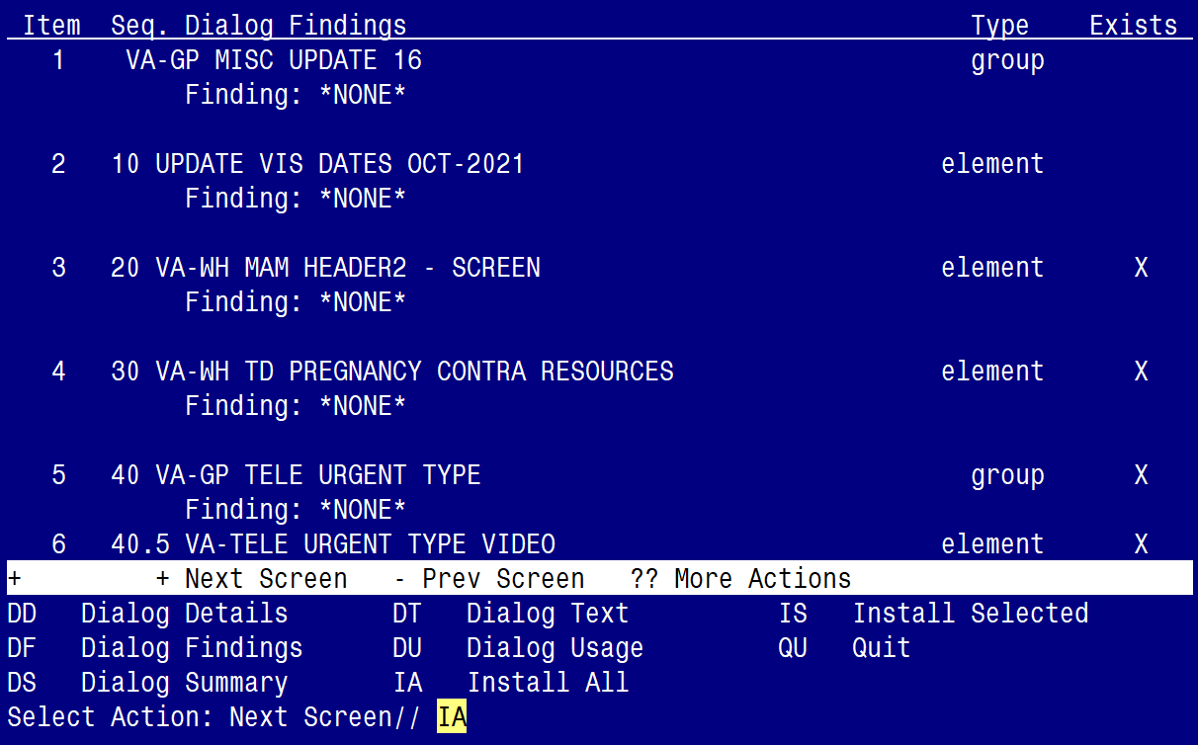

At the Select Action prompt, type IA to install the dialog – VA-GP MISC UPDATE 16
Select Action: Next Screen// IA Install All
Install reminder dialog and all components with no further changes: Y// ES

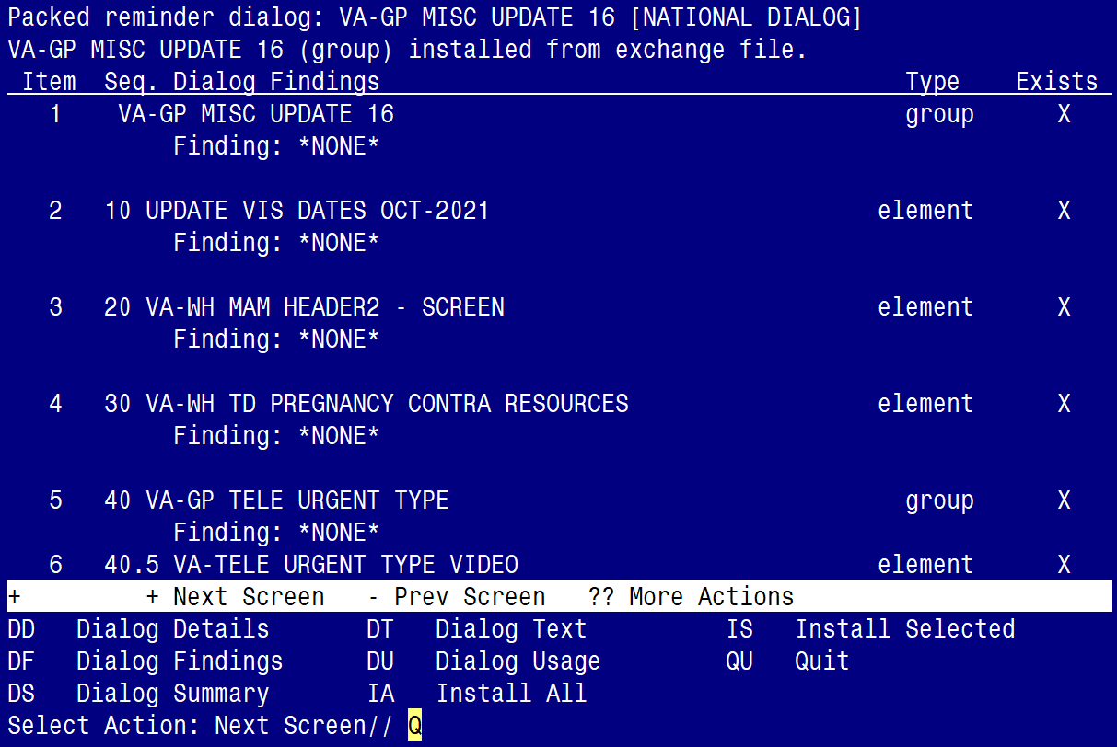

When the dialog has completed installation, you will then be returned to this screen. At the Select Action prompt, type Q.

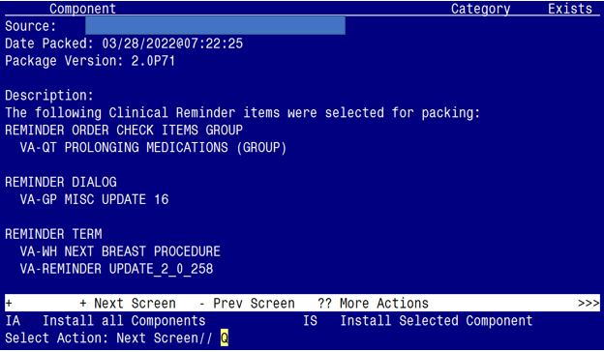

You will be returned to this screen. Type Q to quit.
Install Completed

Post Installation

- Refer to the Inquire/Print (INQ) you saved during the Pre-Installation steps for the following GROUP:

  - VAL-HTN REFERRAL OTHER

To minimize local configuration, post-install, this group is now represented by the element name VAL-HTN REFERRAL OTHER CONSULT. If you had the above group enabled previously and had a local order mapped to the Additional Finding Item, you will need to re-add that same local order to the additional finding Item in the element below:

  - VAL-HTN REFERRAL OTHER CONSULT
(Take Note: Make sure you ‘enable’ this element)

- Refer to the Inquire/Print (INQ) you saved during the Pre-Installation steps to remap generic orders.

Do not overwrite the health factor in the FINDING ITEM field.

Remap the generic orders identified in pre-installation to the ADDITIONAL FINDING field in following groups:

  - In the Reminder Dialog Management menu, Navigate to the Reminder Dialog Group view.

  - VA-LST DNR (E) group order remapping (it is now a group, not an element)
Current dialog group name: VA-LST DNR (E)

FINDING ITEM: ETHICS-DNAR/DNR//
Select ADDITIONAL FINDINGS: Q.OR LST DNR (Enter “Q.”, then the name of the generic order.)

Searching for a ORDER DIALOG, (pointed-to by ADDITIONAL FINDINGS)
OR LST DNR ...OK? Yes// Yes
Editing Finding Number: 1
ADDITIONAL FINDINGS: OR LST DNR

  - VA-LST DNR EXCEPT 2 (G) group order remapping
Current dialog group name: VA-LST DNR EXCEPT 2 (G)

FINDING ITEM: ETHICS-DNAR/DNR//
Select ADDITIONAL FINDINGS: Q.OR LST DNR EXCEPT (Enter “Q.”, then the name of the generic order.)

Searching for a ORDER DIALOG, (pointed-to by ADDITIONAL FINDINGS)
OR LST DNR EXCEPT ...OK? Yes// Yes
Editing Finding Number: 1
ADDITIONAL FINDINGS: OR LST DNR EXCEPT

- Reminder Order Check Rule: VA-LONG QT SYNDROME (RULE)

Ensure the “Status” is set to PRODUCTION. If not edit from Inactive to Production

BEFORE:
RULE NAME: VA-LONG QT SYNDROME (RULE)
DISPLAY NAME: ISSUE: Patient with documented long QT syndrome
STATUS: INAC <<< change to PRODUCTION

CLASS: NATIONAL
SPONSOR:
REVIEW DATE:
___________________________________________________________________________
I=INACTIVE, P=PRODUCTION, T=TESTING

AFTER:
RULE NAME: VA-LONG QT SYNDROME (RULE)
DISPLAY NAME: ISSUE: Patient with documented long QT syndrome
STATUS: PROD

CLASS: NATIONAL
SPONSOR:
REVIEW DATE:
___________________________________________________________________________
I=INACTIVE, P=PRODUCTION, T=TESTING

