

**Update_2_0_263**

Clinical Reminders

VA-COVID-19 CPRS STATUS VERSION 7

Install Guide

**March 2022**

Product Development

Office of Information Technology

Department of Veterans Affairs

**Table of Contents**

Introduction 1

Install Details 2

Install Example 4

Post Installation 12

# Introduction

Banner VERSION 7 changes

1. Based on feedback from the field and clinical and lab subject matter expert input an adjustment is being made to the COVID-19 Banner logic. Sites that use PCR tests that can have a result of “Presumptive Positive” have not been able to see this on the banner. This update will provide three options for this result if it is the most recent test. These options will display for 14 days or until a more recent PCR test is resulted.

The 3 possible options for display if the test was done in the past 14 days:

   a. Presumptive Positive

   b. Presumptive Positive      PCR test pending collection:

               c.  Presumptive Positive      PCR test collected, results pending:

Example of (a)



If a PCR is pending and not received in the lab – as in b.  above.



                If a PCR is collected by lab but no results are available – as in c. above



Once the PCR is resulted, then that result is what will display instead of the presumptive positive.

2. New CDC guidance recommends that immunocompromised (IC) patients not be removed from isolation without clinical evaluation or 2 negative tests (PCR/NAAT or Antigen). Even though the banner makes NO recommendations for infection control precautions, the concern was raised that automatically converting ‘POSITIVE’ to ‘Prior Positive’ for any IC patient could result in a failure to follow necessary precautions.

The banner will now remain in the ‘POSITIVE’ status for any Immunocompromised patient after a positive test until either: 1) there are 2 negative tests (PCR/NAAT or Antigen) or 2) there is clinical evaluation and an indication that infection has clinically resolved.

A reminder definition is also part of this release. Running a reminder report on this definition will give you the patients for whom the banner will turn POSITIVE with version 7 of the banner and who previously had another status showing.

**UPDATE_2_0_263 contains 1 Reminder Exchange entry:**

UPDATE_2_0_263 VA-COVID-19 CPRS STATUS VERSION 7

**The exchange file contains the following components:**

**HEALTH FACTORS**

1 VA-REMINDER UPDATES [C]

2 VA-UPDATE_2_0_263

3 VA-COVID-19 [C]

4 VA-COVID-19 UNK OUTSIDE LAB TEST NEG

5 VA-COVID-19 NON PCR AG LAB OUTSIDE NEG

6 VA-COVID-19 PCR LAB OUTSIDE NEGATIVE

7 VA-COVID-19 UNK OUTSIDE LAB TEST POS

8 VA-COVID-19 NON PCR AG LAB OUTSIDE POS

9 VA-COVID-19 NO LONGER SUSPECTED

10 VA-COVID-19 INCORRECT PRIOR POSITIVE PCR

11 VA-COVID-19 RESOLVED

12 VA-COVID-19 SUSPECTED

13 VA-COVID-19 OUTSIDE PCR SPEC COLLECTED

14 VA-COVID-19 PCR LAB OUTSIDE POSITIVE

15 VA-COVID-19 LAB OUTSIDE POSITIVE

**REMINDER SPONSOR**

16 NATIONAL CLINICAL REMINDER COMMITTEE

17 NATIONAL CENTER FOR HEALTH PROMOTION AND DISEASE

PREVENTION (NCP)

18 VA NATIONAL CENTER FOR HEALTH PROMOTION AND

DISEASE PREVENTION (NCP)

19 POPULATION HEALTH

20 OFFICE OF PATIENT CARE SERVICES

**REMINDER COMPUTED FINDINGS**

VA-REMINDER DEFINITION

VA-DATE OF DEATH

**REMINDER TAXONOMY**

21 VA-IMMUNOCOMPROMISED FOR COVID-19 ADDL DOSE

22 VA-HIV INFECTION

23 LONG TERM SYSTEMIC STEROID

24 VA-PNEUMOC DZ RISK - CHEMOTHERAPY

25 VA-COVID-19 SNOMED CODES

**REMINDER TERM**

26 VA-REMINDER UPDATE_2_0_263

27 VA-COVID-19 OUTSIDE RESULTS NEGATIVE PCR & AG

28 VA-COVID-19 PCR/AG LAB RESULTS

29 VA-CD4 COUNT

30 VA-STEROID PREDN EQUIV 5-6.6MG

31 VA-STEROID PREDN EQUIV 6.6-9MG

32 VA-STEROID PREDN EQUIV 10-19MG

33 VA-STEROID PREDN EQUIV >=20MG

34 VA-CHEMO/IMMUNOSUPPRESSIVE DRUGS

35 VA-IMMUNOCOMPROMISED FOR COVID-19 BANNER

36 VA-COVID-19 PCR LAB RESULTS PRESUMP POSITIVE

37 VA-COVID-19 AG LAB RESULTS POSITIVE HF

38 VA-COVID-19 AG LAB RESULTS POSITIVE

39 VA-COVID-19 RELATED ORDERABLE ITEMS FOR BANNER

DISPLAY

40 VA-SARS-COV-2 VACCINES

41 VA-COVID-19 PROB LIST DX

42 VA-COVID-19 PCR LAB ORDERS

43 VA-COVID-19 CLINICAL INFO

44 VA-COVID-19 OUTSIDE RESULTS

45 VA-COVID-19 PRESUMED

46 VA-COVID-19 ANTIBODY LAB TEST

47 VA-COVID-19 NO LONGER PRESUMED

48 VA-COVID-19 INCORRECT PRIOR POSITIVE PCR RESULT

49 VA-COVID-19 PCR LAB RESULTS POSITIVE

50 VA-COVID-19 OUTSIDE PCR LAB POSITIVE

51 VA-COVID-19 OUTSIDE PCR SPECIMEN COLLECTED

52 VA-COVID-19 RECOVERED

53 VA-COVID-19 OUTSIDE PCR LAB NEGATIVE

54 VA-COVID-19 PCR LAB RESULTS NEGATIVE

**REMINDER DEFINITION**

55 VAL-IMMUNOCOMPROMISING DRUGS/LABS/DX FOR COVID-19

56 VA-COVID-19 CPRS STATUS

57 VAL-COVID-19 POS, IC, NO TESTING x2 OR CLIN EVAL

# Install Details

This update is being distributed as a web host file. The address for the host file is:

**https://REDACTED/UPDATE_2_0_263.PRD**

The file will be installed using Reminder Exchange, programmer access is not required.

Installation:

=============

This update can be loaded with users on the system. Installation will take less than 5 minutes.

# Pre-Install

Using the Vista menu, Reminder Term management, Term Inquiry, inquire and save the following reminder terms for reference post install. If you follow the install guide closely, your mapping should be preserved.

1. **VA-COVID-19 PCR LAB RESULTS NEGATIVE**
2. **VA-COVID-19 PCR LAB RESULTS POSITIVE**
3. **VA-COVID-19 PCR LAB ORDERS**
4. **VA-COVID-19 PCR/AG LAB RESULTS**
5. **VA-COVID-19 ANTIBODY LAB TEST**
6. **VA-COVID-19 AG LAB RESULTS POSITIVE**

# Install Example

To Load the Web Host File. Navigate to Reminder exchange in Vista

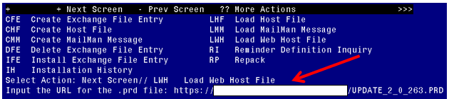

At the **Select Action:** prompt, enter **LWH** for Load Web Host File

At the **Input the url for the .prd file:** prompt, type the following web address:

**https://REDACTED/UPDATE_2_0_263.PRD**

You should see a message at the top of your screen that the file successfully loaded.

Terminal window screen shot of the message displaying the URL of the file that was successfully loaded.  Part of the URL has been redacted as it is a VA only internal web site URL.

Search for and locate the reminder exchange entry titled UPDATE_2_0_263 VA-COVID-19 CPRS STATUS VERSION 7.

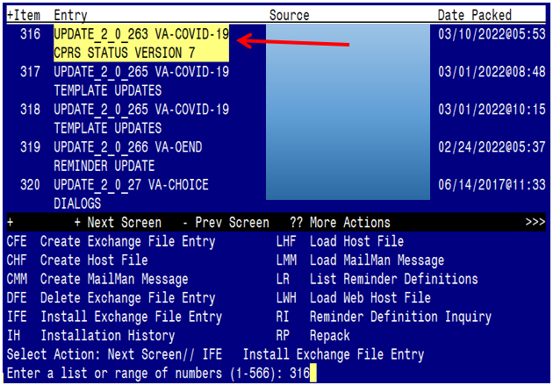

At the **Select Action** prompt, enter **IFE** for Install Exchange File Entry

Enter the number that corresponds with your entry titled **UPDATE_2_0_263 VA-COVID-19 CPRS STATUS VERSION 7**  *(in this example it is entry 316, it will vary by site)* The date on the exchange file should be 03/10/2022.

**Do not INSTALL ALL. Follow the screen shots below to only install selected items.**

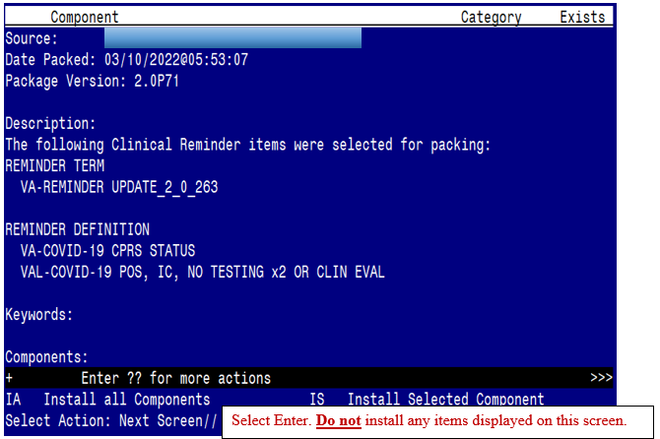

At the **Select Action** prompt, select enter to move to the next screen.

Continue to hit enter at the **Select Action** prompt until you get to the Health Factor Section. These Health Factor Components will have numbers next to them.

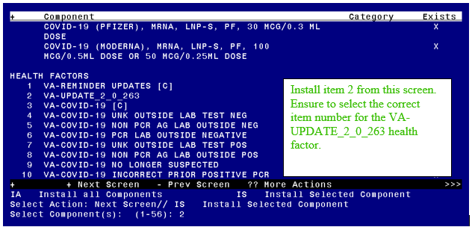

At the **Select Action** prompt, type IS for install selected Component, you will install component 2

Select Action: Next Screen// IS Install Selected Component

Select Component(s): (1-56): 2

HEALTH FACTORS entry VA-UPDATE_2_0_263 is NEW,

what do you want to do?

Select one of the following:

C Create a new entry by copying to a new name

I Install

Q Quit the install

S Skip, do not install this entry

Enter response: I// nstall

At the **Select Action** prompt, select enter to move to the next screen.

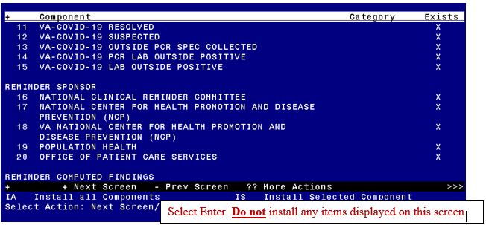

At the **Select Action** prompt, select enter to move to the next screen.

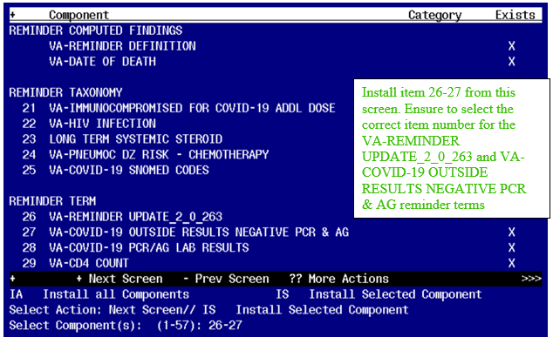

Select Action: Next Screen// IS Install Selected Component

Select Component(s): (1-56): 26-27

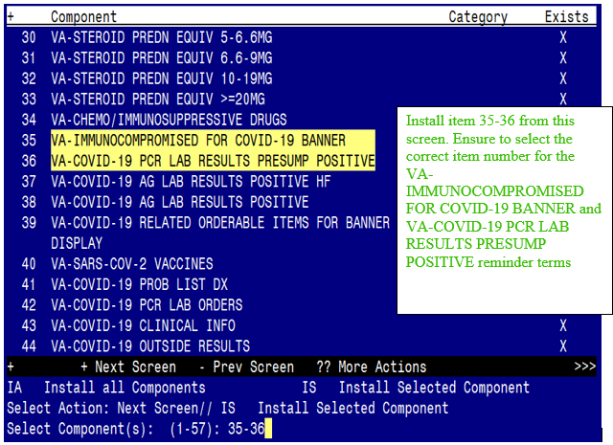

Select Action: Next Screen// IS Install Selected Component

Select Component(s): (1-56): 35-36

At the **Select Action** prompt, select enter to move to the next screen.

REMINDER TERM entry VA-IMMUNOCOMPROMISED FOR COVID-19 BANNER is NEW,what do you want to do?

Select one of the following:

C Create a new entry by copying to a new name

I Install

Q Quit the install

S Skip, do not install this entry

Enter response: I// nstall

REMINDER TERM entry VA-COVID-19 PCR LAB RESULTS PRESUMP POSITIVE is NEW,what do you want to do?

Select one of the following:

C Create a new entry by copying to a new name

I Install

Q Quit the install

S Skip, do not install this entry

Enter response: I// nstall

At the **Select Action** prompt, select enter to move to the next screen.

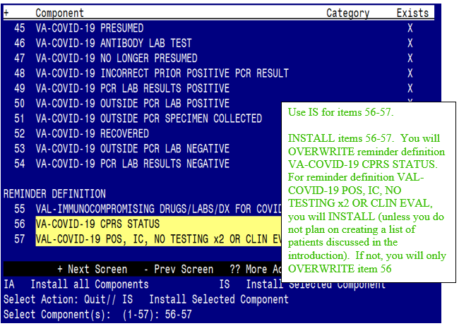

REMINDER DEFINITION entry VA-COVID-19 CPRS STATUS exists, but the packed component is different

what do you want to do?

Select one of the following:

C Create a new entry by copying to a new name

Q Quit the install

S Skip, do not install this entry

O Overwrite

Enter response: O// Overwrite

REMINDER DEFINITION entry VAL-COVID-19 POS, IC, NO TESTING x2 OR CLIN EVAL is NEW,

what do you want to do?

Select one of the following:

C Create a new entry by copying to a new name

I Install

Q Quit the install

S Skip, do not install this entry

Enter response: I// nstall

You will be returned to this screen. Type Q to quit.

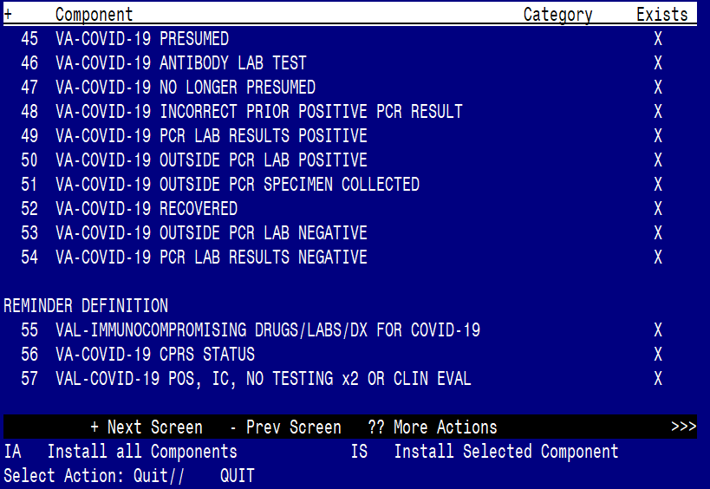

Install Completed

# Post Installation

Review the following terms from the pre-install and edit to add your local items if needed, if you only installed the components in the install instructions, no changes should be needed:

1. **VA-COVID-19 PCR LAB RESULTS NEGATIVE**

This term should only contain lab test (LT) findings for COVID-19 PCR lab tests

1. **VA-COVID-19 PCR LAB RESULTS POSITIVE**

This term should only contain lab test (LT) findings for COVID-19 PCR lab tests

1. **VA-COVID-19 PCR LAB ORDERS**

This term should only contain orderable items (OI) findings for COVID-19 PCR lab test orderable items

1. **VA-COVID-19 PCR/AG LAB RESULTS**

This term should only contain lab test (LT) findings for COVID-19 PCR and COVID-19 Antigen lab tests

1. **VA-COVID-19 ANTIBODY LAB TEST**

This term should only contain lab test (LT) findings for COVID-19 ANTIBODY Tests

1. **VA-COVID-19 AG LAB RESULTS POSITIVE**

This term should only contain lab test (LT) findings for COVID-19 antigen tests

There IS ONE new reminder term that can be mapped

1. **VA-COVID-19 PCR LAB RESULTS PRESUMP POSITIVE**

Add your local lab test (LT) findings for COVID-19 tests that can have a result of PRESUMPTIVE POSITIVE.

You will need to check with your Laboratory AdPac and confirm what tests IF ANY need to be mapped here. Not all sites have COVID-19 PCR laboratory tests that include a result of PRESUMPTIVE POSITIVE.