Update _2_0_264

Clinical Reminders

VA-SMART DIALOG AND MAMMOGRAM REMINDER UPDATE

Install Guide

June 2022

Product Development
Office of Information Technology
Department of Veterans Affairs

Table of Contents
Introduction 1
Install Details 11
Install Example 12
Post Installation 16

Introduction
Several revisions have been made to the VA-WH SMART BREAST IMAGING FOLLOW-UP reminder dialog and the VA-WH MAMMOGRAM SCREENING reminder definition.

- The VA-WH NEXT BREAST PROCEDURE reminder term CONDITION has been updated. A Beginning Date/Time of 10.1.2020 has also been added to prevent the term from inappropriately evaluating procedures completed before the SMART functionality was deployed in CPRS 31b.
- The following reminder terms have been moved from the reminder resolution and added to the reminder cohort logic as exclusions. These findings were not temporarily resolving the reminder correctly in conjunction with the Custom Due Date finding. Now, during the deferral and order period, the reminder will be N/A. It will come due again after the temporary resolution time has passed.
  - VA-MAMMOGRAM SCREEN DEFER
  - VA-WH MAMMOGRAM ORDER
  - VA-WH BREAST CARE ORDER HEALTH FACTOR
- New finding FOUND TEXT has been added to display in the clinical maintenance to assist local staff understand temporary logic.
  - If the VA-BREAST CARE ORDER HEALTH FACTOR term is true, the following will display in clinical maintenance:
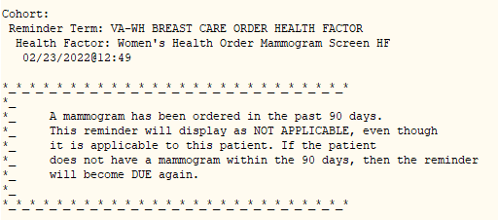

  - If the VA-WH MAMMOGRAM SCREEN NOT INDICATED term is true, the following will display in clinical maintenance:
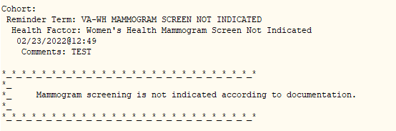

  - If the VA-WH MAMMOGRAM SCREEN DEFER term is true, the following will display in clinical maintenance:
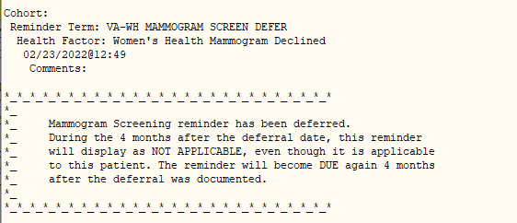

  - If the VA-WH MAMMOGRAM ORDER term is true, the following will display in clinical maintenance:
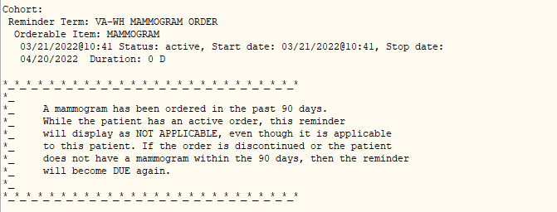

- Two incorrect URLs have been removed from the Mammogram Screening reference information.
- Corrected an error that caused the reminder to be not applicable on patients <40 yo who had a mammogram and a new screening date documented in the VA-WH SMART BREAST IMAGING FOLLOW-UP note.
- Branching logic has been added to the VA-WH MAMMOGRAM SCREENING reminder dialog to hide the “Change the frequency of mammograms for this patient” option if the VA-WH NEXT BREAST PROCEDURE reminder term is true. This indicates a future screening recommendation has been documented using the SMART dialog since CPRS 31b implementation. Once the mammogram reminder due date has been set using SMART, then the original frequency change options in the mammogram screening dialog do not impact the reminder logic.
- The option to document “Patient breast images are normal” has been revised to “Patient breast images are benign/normal”.
Before:

After:

UPDATE_2_0_264 contains 1 Reminder Exchange entry:
VA-SMART DIALOG AND MAMMOGRAM REMINDER UPDATE

- Corrected an error occurring when a user selected ‘no action required’ under the next steps section.
- Corrected a reminder resolution error occurring when a user selected “Other” in the Diagnostics options section.
- A new general finding is included that will ensure the date a procedure report was received in SMART will be stored.
- The “Written Report Available” section has been revised to ensure required fields are easier to complete.
- A new section has been added to document breast density per the imaging report.
- Options for documenting outside Breast Tomosynthesis procedures have been added.

Before:
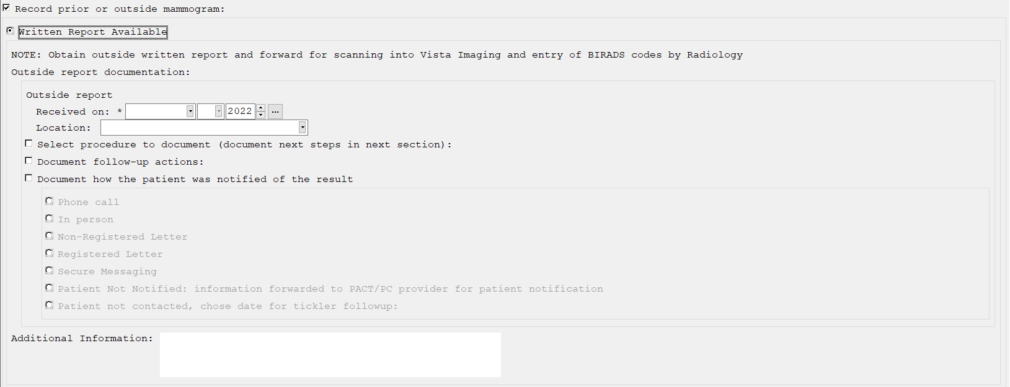

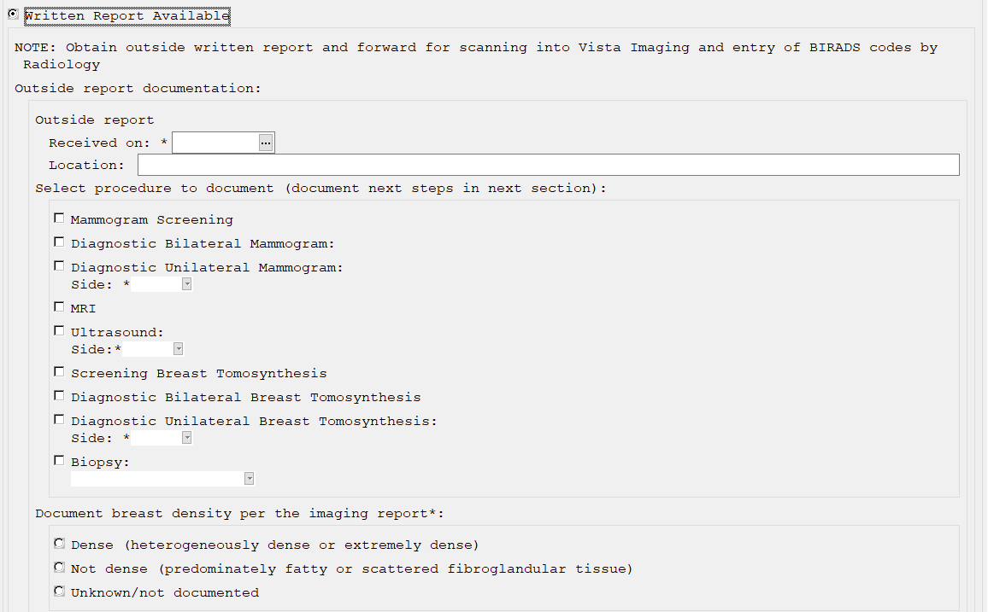After:

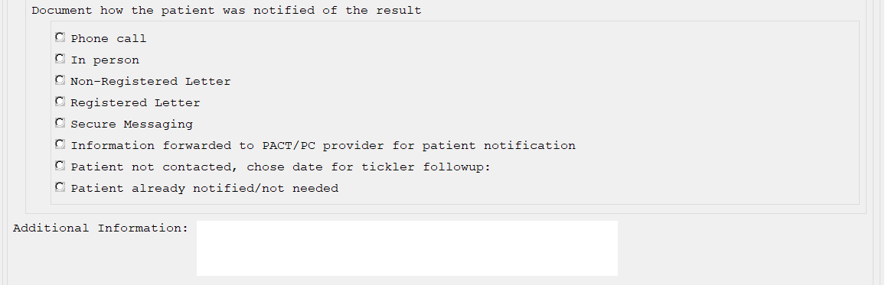

The exchange file contains the following components:

TEMPLATE FIELDS
SMART WORD 40X4
VA-WH SMART OUTSIDE OTHER
VA-WH SMART ULTRASOUND TYPE
VA-WH SMART UNILAT TYPE
BLANK TEXT FIELD FOR DIALOGS
VA-WH MAMMOGRAM GUIDANCE

GENERAL FINDINGS
TICKLER REMINDER COMMENT
TICKLER REMINDER
FOLLOW UP WITH PATIENT COMMENT
FOLLOW UP WITH PATIENT
WH PROCEDURE ACTION COMMENT
RADIOLOGY REPORT RECEIVED
NOTIFICATION NOT NEEDED
EMAIL CONTACTED
SECURE MESSAGING
LETTER REGISTERED CONTACTED
LETTER (CERTIFIED)
LETTER CONTACTED
LETTER
WHO CONTACTED
IN PERSON
PHONE CALL
BREAST CARE CASCADE NAME
CLOSE CASCADE BREAST CARE
BR CLOSE AND FOLLOW COMPLETE
BR CLOSED PROCEDURE
BREAST REFER FOR BIOPSY
BIOPSY
WV NOTIFICATION PATIENT
OBTAIN PRIOR FILMS
BREAST OBTAIN PRIOR FILMS
BREAST BIOPSY ALREADY OBTAIN
BIOPSY ALREADY OBTAINED
BREAST CURRENTLY UNDER TREATMENT
CURRENTLY UNDER TREATMENT
CONSULT
BREAST CONSULT
BREAST REFER TO ONCOLOGIST
REFER TO ONCOLOGIST
BREAST REFER TO SURGEON
REFER TO SURGEON
IMAGE COMMENT
BREAST NEED MRI
RETURN FOR MRI
BREAST NEED ULTRASOUND
RETURN FOR ULTRASOUND
BREAST NEED MAMMOGRAM
RETURN FOR MAMMOGRAM
BR NO NEXT TREATMENT DATE
BR NO NEXT TREATMENT
WH PATIENT
BREAST next MAM 2Y
AGE BASED SCREENING
BREAST next MAM 1Y
BREAST next MAM AT START AGE
MAMMOGRAM SCREENING 2Y
MAMMOGRAM SCREENING 1Y
BREAST UNSATISFACTORY RESULT
BR UNSATISFACTORY RESULT
BREAST ABNORMAL RESULT
BR ABNORMAL RESULT
BREAST NORMAL RESULT
BR NEM RESULT
BI-RAD 6 RESULT
BI-RAD 6
BI-RAD 5 RESULT
BI-RAD 5
BI-RAD 4 RESULT
BI-RAD 4
BI-RAD 3 RESULT
BI-RAD 3
BI-RAD 2 RESULT
BI-RAD 2
BI-RAD 1 RESULT
BI-RAD 1
BI-RAD 0 RESULT
BI-RAD 0
BREAST UNSATISFACTORY DENSE RESULT
BREAST ABNORMAL DENSE RESULT
BREAST NORMAL DENSE RESULT
BI-RAD 6 DENSE RESULT
BI-RAD 5 DENSE RESULT
BI-RAD 4 DENSE RESULT
BI-RAD 3 DENSE RESULT
BI-RAD 2 DENSE RESULT
BI-RAD 1 DENSE RESULT
BI-RAD 0 DENSE RESULT
BREAST TOMOSYNTHESIS UNILAT REPORT
BR OUTSIDE REPORT PROCEDURE DATE
BR OUTSIDE ACCESSION
BREAST TOMOSYNTHESIS BILAT REPORT
BREAST TOMOSYNTHESIS SCREENING REPORT
OUTSIDE ULTRASOUND
OUTSIDE MRI
OUTSIDE MAMMOGRAM DX UNILAT
OUTSIDE MAMMOGRAM DX BILAT
MAMMOGRAM SCREENING REPORT
OUTSIDE REPORT
VIEW PROGRESS NOTE TEXT
ALERT ID
CLEAR ONE
WV DIAGNOSIS
WV PROCEDURE ACCESS
MAMMOGRAM TEST
VIEW LAST THREE BR TRMTS
VIEW EPISODE
SMART BI-RAD ALERT
CLEAR OTHER ALERTS ID
CLEAR ALL FOR PROVIDER
BR NEXT DUE AT AGE
BR MAMMOGRAM SCREENING NEXT TRMT

HEALTH FACTORS
VA-REMINDER UPDATES [C]
VA-UPDATE_2_0_264
WH MAMMOGRAM [C]
WH ORDER MAMMOGRAM SCREEN HF
WH OUTSIDE INCOMPLETE MAMMOGRAM
WH OUTSIDE ABNL MAMMOGRAM
WH OUTSIDE NORMAL MAMMOGRAM
VA-WH BREAST RESULT BIRAD 6
VA-WH BREAST RESULT BIRAD 5
VA-WH BREAST RESULT BIRAD 4
VA-WH BREAST RESULT BIRAD 3
VA-WH BREAST RESULT BIRAD 2
VA-WH BREAST RESULT BIRAD 1
VA-WH BREAST RESULT BIRAD 0
VA-WH BREAST OTHER
VA-WH MAMMOGRAM DX UNILATERAL
VA-WH MAMMOGRAM DX BILATERAL
VA-WH MAMMOGRAM SCREENING
WH SMART OUTSIDE REPORT INFO
WH MAMMOGRAM SCREEN NOT INDICATED
WH BR CA SCREEN N/A 5 YRS-COMORBIDITIES
WH BR CA SCREEN N/A 5 YRS-LE<5YRS
VA LIFE EXPECTANCY [C]
VA LIMITED LIFE EXPECTANCY
WH BILATERAL MASTECTOMY
WH MAMMOGRAM SCREEN FREQ - 1Y
WH MAMMOGRAM SCREEN FREQ - 6M
WH MAMMOGRAM DEFERRED
VA-WH BR CA 40-44 WANTS SCREENING
VA-WH BR CA 40-44 BEGIN AGE 45
WH MAMMOGRAM SCREEN FREQ - 2Y
WH MAMMOGRAM DECLINED
WH BR CA 40-49 WANTS SCREENING
WH MAMMOGRAM SCREEN FREQ - 4M
VA-WH BR CA DEFER 1Y
VA-WH BR CA DEFER 6M
REMINDER FACTORS [C]
INACTIVATE BREAST CANCER SCREEN
WH ORDER MAMMOGRAM UNILAT HF
WH ORDER MAMMOGRAM BILAT HF
WH MAMMOGRAM OUTSIDE

REMINDER SPONSOR
OFFICE OF PUBLIC HEALTH AND ENVIRONMENTAL HAZARDS AND THE WOMEN
VETERANS HEALTH STRATEGIC HEALTH CARE GROUP
VHA NATIONAL CENTER FOR HEALTH PROMOTION AND DISEASE PREVENTION (NCP)
AND VHA OFFICE OF WOMEN'S HEALTH
NATIONAL CENTER FOR HEALTH PROMOTION AND DISEASE PREVENTION

REMINDER TAXONOMY
VA-MASTECTOMY
VA-BREAST TUMOR
VA-TERMINAL CANCER PATIENTS
VA-MAMMOGRAM/SCREEN
VA-WH BILATERAL MASTECTOMY

REMINDER TERM
VA-REMINDER UPDATE_2_0_264
VA-WH BL ACTIVE BREAST IMAGE ALERT DATA
VA-WH OPEN PROCEDURES PER CASCADE
VA-WH BL BR ACTIVE ALERT ID
VA-PATIENT IS MALE
VA-WH MAMMOGRAM ALERT FOR MALE
VA-WH BL BR BI-RAD 6
VA-WH BL BR BI-RAD 5
VA-WH BL BR BI-RAD 4
VA-WH BL BR BI-RAD 3
VA-WH BL BR BI-RAD 0
VA-WH BL BR BI-RAD 2
VA-WH BL BR BI-RAD 1
VA-AGE >74
VA-BL AGE>74
VA-WH AGE BETWEEN 55 AND 74
VA-WH AGE BETWEEN 45 AND 54
VA-WH MAMMOGRAM AGE<55
VA-WH OPEN BR PROCEDURES WITH BIRAD CODES
VA-WH OPEN BR PROCEDURES WITHOUT BIRAD CODES AND DENSE
VA-WH OPEN BR PROCEDURES WITH BIRAD CODES DENSE
VA-WH BL GET BREAST IMAGES
VA-WH BL BREAST CASCADE EXIST
VA-WH NEXT BREAST PROCEDURE
VA-AGE >39&<45
VA-WH CHAMP VA PATIENT
VA-WH BR CA 40-44 WANTS SCREEN TERM
VA-WH BR CA 40-44 BEGIN AGE 45
VA-WH MAMMOGRAM ORDER
VA-WH HX BREAST CANCER/ABNORMAL MAM
VA-WH MAMMOGRAM SCREEN FREQ - 2Y
VA-WH MAMMOGRAM SCREEN FREQ - 1Y
VA-WH MAMMOGRAM SCREEN FREQ - 6M
VA-WH MAMMOGRAM SCREEN FREQ - 4M
VA-WH MAMMOGRAM UNSATISFACTORY IN RAD/WH PKG
VA-WH MAMMOGRAM SCREEN DEFER
VA-WH MAMMOGRAM SCREEN NOT INDICATED
VA-WH BREAST CARE ORDER HEALTH FACTOR
VA-WH MAMMOGRAM SCREEN DONE
VA-WH MAMMOGRAM SCREEN IN RAD PKG
VA-WH MAMMOGRAM SCREEN IN WH PKG
VA-TERMINAL CANCER PATIENT
VA-WH BILATERAL MASTECTOMY

REMINDER DEFINITIONS
VA-WH BL BR ALERT WITH NO OPEN PROCEDURE
VA-WH OPEN BREAST PROCEDURES PER CASCADE
VA-WH MAMMOGRAM SCREENING

REMINDER DIALOG
VA-WH SMART BREAST IMAGING FOLLOW-UP
VA-WH MAMMOGRAM SCREENING

Pre-Installation Steps
- Record the orders mapped to the VA-WH SMART BREAST IMAGING FOLLOW-UP reminder dialog. The site will need to re-map these orders to the reminder dialog during the install.
  - Identify the order dialog mapped to the group VA-WH BR ADDITIONAL IMAGING. This order dialog will be used to replace the Q.BREAST TREATMENT MENU during the installation.
  - Identify the order dialog mapped to the element VA-WH BR CONSULT. This order dialog will be used to replace the Q.GMRCOR CONSULT during the installation.
- Record the order dialog mapped (if one is mapped) to the VA-WH GP ORDERS - MAMMOGRAM SCREEN reminder group.
- Create a copy of the reminder inquiry output for the VA-WH MAMMOGRAM SCREENING reminder using either CPRS or VistA. Use this copy to confirm all local mapping for reminder terms are correct after post-installation.

Install Details
This update is being distributed as a web host file. The address for the host file is: https://REDACTED/UPDATE_2_0_264.PRD
The file will be installed using Reminder Exchange, programmer access is not required.
Installation:
=============
This update can be loaded with users on the system. Installation will take less than 5 minutes.

Install Example
To Load the Web Host File. Navigate to Reminder exchange in Vista
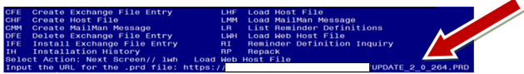

At the Select Action: prompt, enter LWH for Load Web Host File
At the Input the url for the .prd file: prompt, type the following web address:
https://vaww.va.gov/reminders/docs/UPDATE_2_0_264.PRD

You should see a message at the top of your screen that the file successfully loaded.

Search and locate an entry titled UPDATE_2_0_264 VA-SMART DIALOG AND MAMMOGRAM REMINDER UPDATE in reminder exchange.
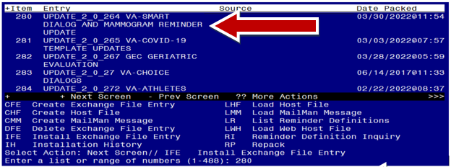

At the Select Action prompt, enter IFE for Install Exchange File Entry

Enter the number that corresponds with your entry UPDATE_2_0_264 VA-SMART DIALOG AND MAMMOGRAM REMINDER UPDATE (in this example it is entry 280. It will vary by site). The date of the exchange file should be 03/30/2022.

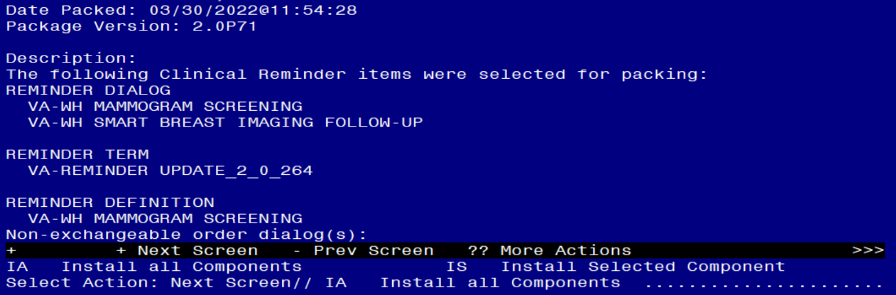

At the Select Action prompt, type IA for Install all Components and hit enter.
Select Action: Next Screen// IA Install all Components

- For all new entries, choose Install

- For REMINDER DIALOG LINK TYPE entries that exist, but the packed component is different, OVERWRITE.

- For TERMS and TAXONOMIES that exist, but the packed component is different SKIP, except the following term. Overwrite this term if asked:
- VA-WH NEXT BREAST PROCEDURE

- For REMINDER DEFINITIONS that exist, but the packed component is different OVERWRITE.

You will be promped to install the reminder dialog component (VA-WH SMART BREAST IMAGING FOLLOW-UP). You will choose to install all even though some components may have an X to indicate that they exist.
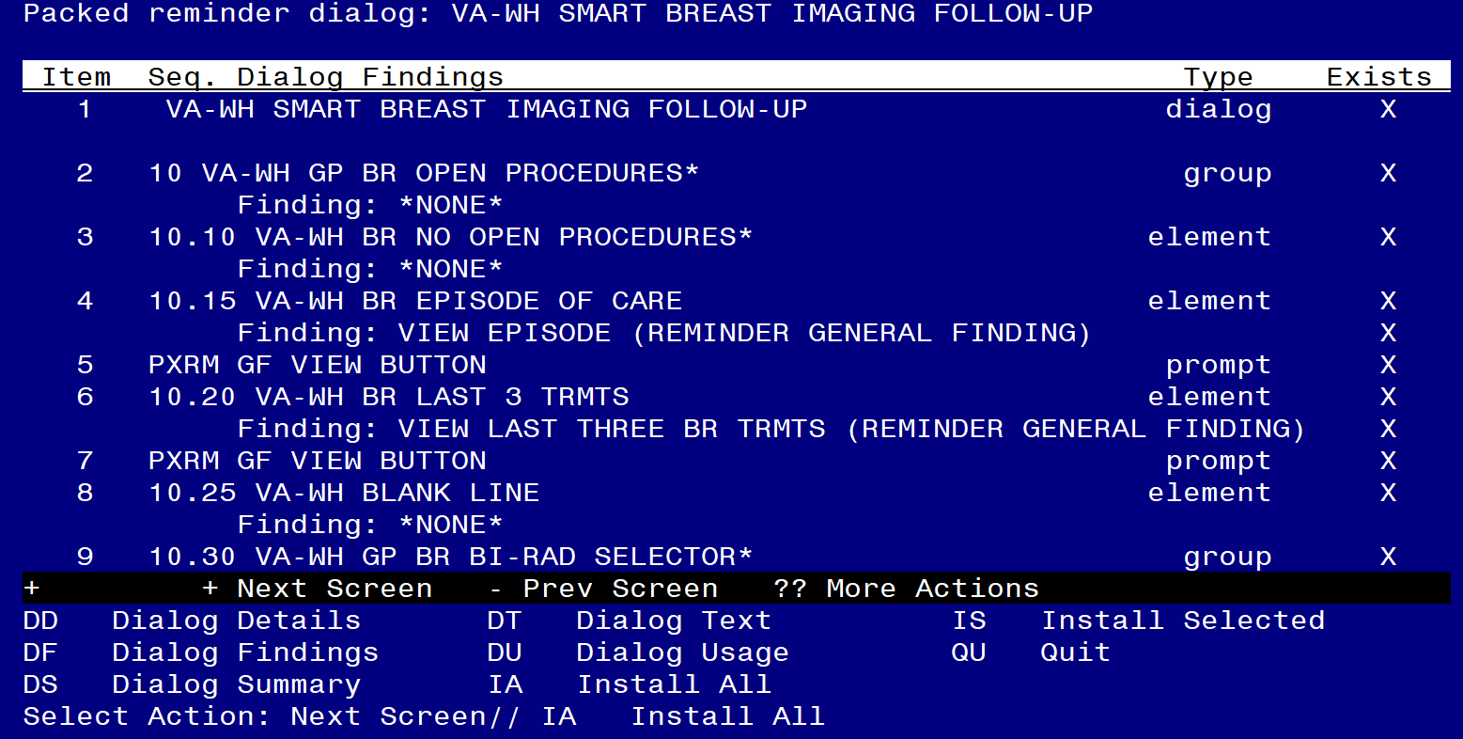
At the Select Action prompt, type IA to install the dialog: VA-WH SMART BREAST IMAGING FOLLOW-UP).
Select Action: Next Screen// IA Install All
Install reminder dialog and all components with no further changes: Y// Yes

FINDING entry Q.BREAST TREATMENT MENU does not exist.

Enter a code from the list.

Select one of the following:

D Delete
P Replace with an existing entry
Q Quit the install

Enter response: P
Select ORDER DIALOG NAME: Enter local breast treatment menu identified in Pre-Installation steps.

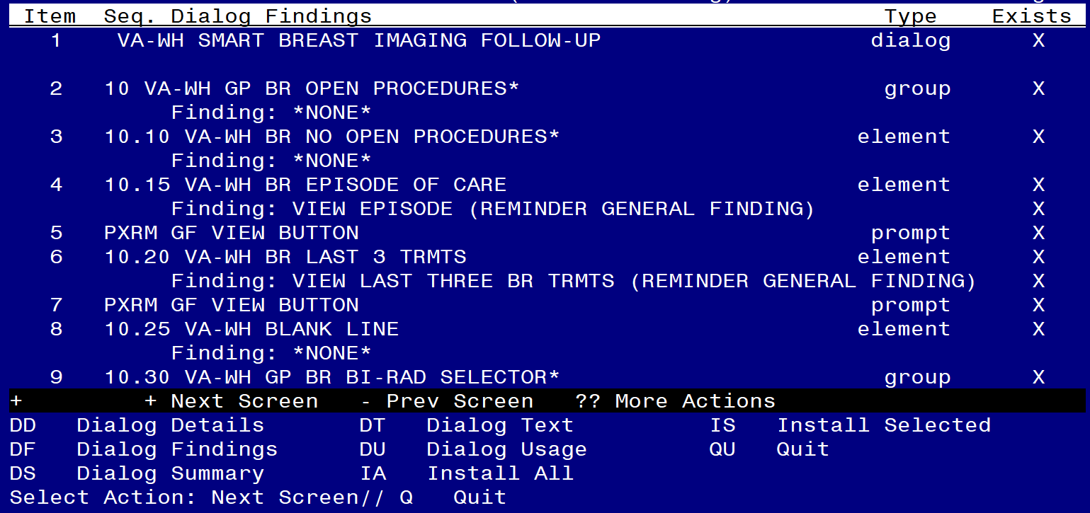

After completing this dialog install, you will type Q.

You will be promped to install the reminder dialog component (VA-WH MAMMOGRAM SCREENING) You will choose to install all even though some components may have an X to indicate that they exist.
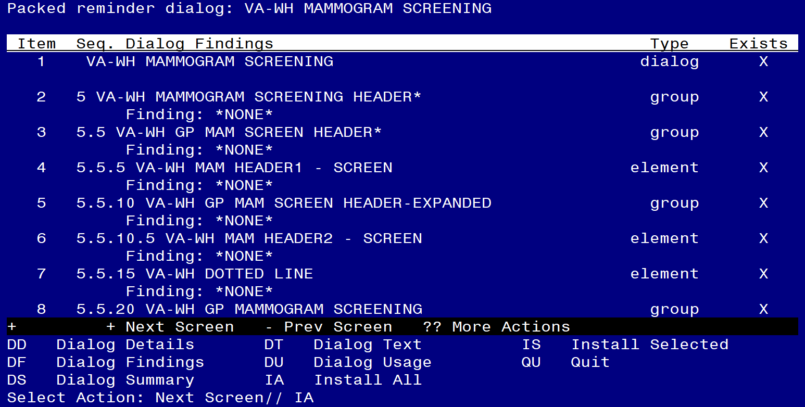
At the Select Action prompt, type IA to install the dialog: VA-WH MAMMOGRAM SCREENING).
Select Action: Next Screen// IA Install All
Install reminder dialog and all components with no further changes: Y// Yes

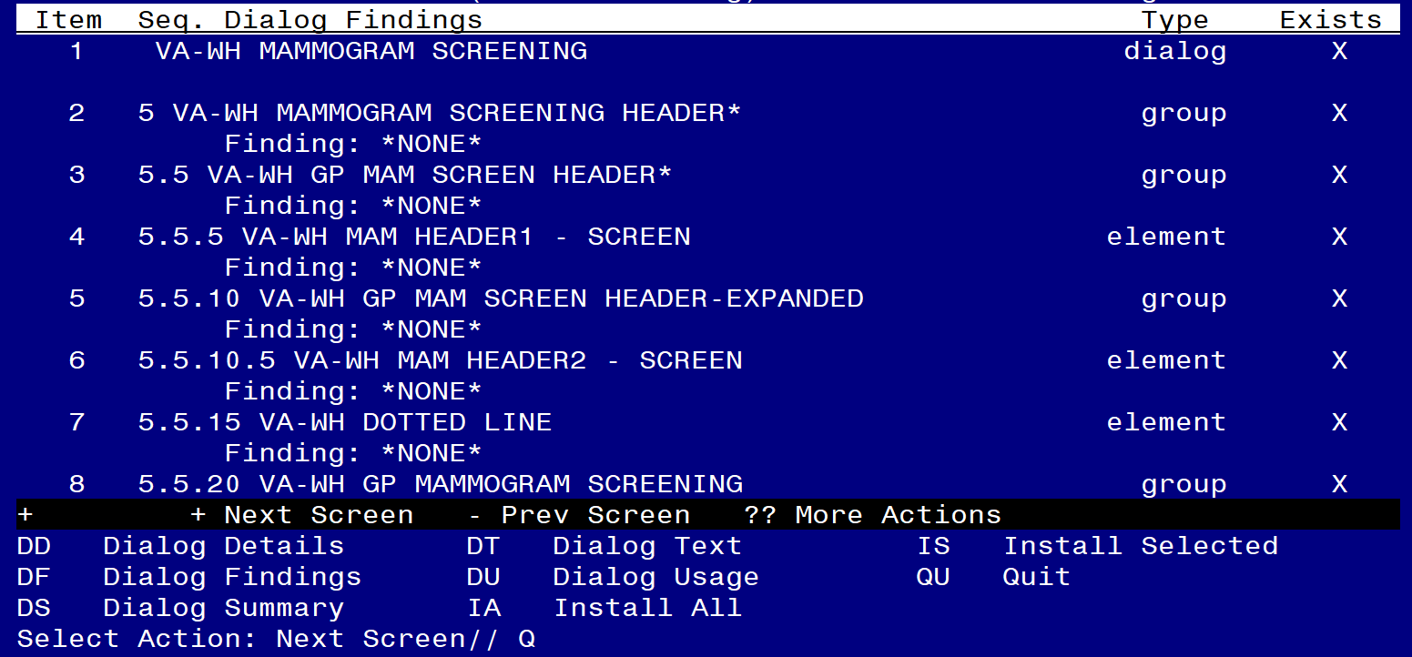

After completing this dialog install, you will type Q.

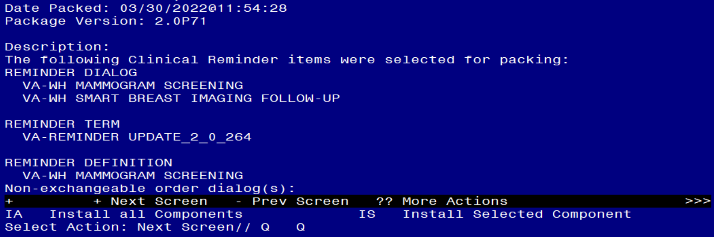

You will then be returned to this screen. At the Select Action prompt, type Q.

Install complete.

Post Installation

- Map the order dialog identified in the pre-installation to the VA-WH GP ORDERS - MAMMOGRAM SCREEN reminder group.

NAME: VA-WH GP ORDERS - MAMMOGRAM SCREEN
DISABLE:
CLASS: LOCAL//
SPONSOR: WOMEN VETERANS HEALTH PROGRAM
REVIEW DATE:
RESOLUTION TYPE:
ORDERABLE ITEM:
FINDING ITEM: Add order dialog here.

- Using the reminder inquiry output from the pre-installation step, compare all reminder terms in the VA-WH MAMMOGRAM SCREENING reminder definition to confirm all local mapping is correct.

- Confirm all local orders are mapped correctly in the VA-WH SMART BREAST IMAGING FOLLOW-UP reminder dialog.

