Update _2_0_265

Clinical Reminders

VA-COVID-19 TEMPLATE UPDATES
Install Guide

March 2022

Product Development
Office of Information Technology
Department of Veterans Affairs

Table of Contents
Introduction 1
Pre-Install 5
Install Details 6
Install Example 7
Post Installation 14

Introduction

DESCRIPTION:

Based on updated CDC guidance, feedback from the field and working with clinical leadership updates have been made to the following COVID-19 templates.

VA-COVID-19 DISCHARGE TEMPLATE
Updated isolation criteria for positive options and guidance for quarantine for negative options
VA-COVID-19 TELEPHONE FOLLOW-UP
Removed monoclonal antibodies
Added branching logic if patient had been screened that day, does not require symptom screen unless the user would like to complete it
updated isolation criteria for positive options and guidance for quarantine for negative options
VA-COVID-19 PROVIDER FOLLOW-UP
Re-organized medical history to be alphabetical
Updated social determinants section
Re-organized so that labs and imaging fall before the assessment
Positive assessment options of mild, moderate and severe disease no longer expand
In discharge home options - updated isolation criteria for positive options and guidance for quarantine for negative options
VA-COVID-19 RETURN TO WORK
Simplified options.
VA-COVID-19 STATUS ADJUSTMENT
Updated isolation/quarantine guidance under clinical status section
VA-SCREENING COVID
If positive screen, added two new fields, one for date symptoms began and one for date of exposure at least one is required
This screen is embedded in the ED triage note and the SCI template
VA-COVID-19 CLC SCREEN
If positive screen, added two new fields, one for date symptoms began and one for date of exposure at least one is required

UPDATE_2_0_265 contains 1 Reminder Exchange entry:
UPDATE_2_0_265 VA-COVID-19 TEMPLATE UPDATES

The exchange file contains the following components:
REMINDER GENERAL FINDINGS
VIEW PROGRESS NOTE TEXT

TIU TEMPLATE FIELD
VA-BLANK
VA-CDC UP TO DATE VACCINES
VA-CDC QUARANTINE ISOLATION
HYPERLINK COVID-19 PREVENT SPREAD
HYPERLINK COVID-19 PATIENT EDU
HYPERLINK COVID-19 CARE AT HOME
HYPERLINK COVID-19 DISP NONHOSP PT
HYPERLINK COVID-19 HOW TO PROTECT SELF
VA-COVID TEST RESULTS PHONE INFORMATION
VA-CRC SOCIAL
VA-WORD
VA-PPE TYPE PROVIDER
TEXT (1-10 CHAR) REQ
VA-COVID 19 CDC SYMPTOMS
VA-COVID SYMPTOM TEXT
VA-COVID IM STATUS
OTHER NON-VA
OTHER TEXT
VA-TIME SPENT
DATE
WORD PROC 70X5
ADDITIONAL INFO (DISP ONLY)
VA-CDC IF YOU ARE SICK

HEALTH FACTORS
VA-REMINDER UPDATES [C]
VA-UPDATE_2_0_265
VA-COVID-19 [C]
VA-COVID-19 DC TEST NEGATIVE
VA-COVID-19 DC SUSPECTED FALSE NEGATIVE
VA-COVID-19 DC TEST POSITIVE
VA-COVID-19 DC TEST PENDING RESULTS
VA-COVID-19 DC SUSPECTED, NO TEST
VA-COVID-19 RESIDENTIAL LIVING
VA-COVID-19 HOUSEHOLD CONTACT
VA-COVID-19 HEALTH CARE WORKER
VA-COVID-19 PLAN ADMISSION
VA-COVID-19 PLAN TRANSFER
VA-COVID-19 PLAN REMAIN HOME
VA-COVID-19 PLAN REFERRAL
VA-COVID-19 OUTSIDE PCR SPEC COLLECTED
VA-COVID-19 NON PCR AG LAB OUTSIDE NEG
VA-COVID-19 UNK OUTSIDE LAB TEST NEG
VA-COVID-19 PCR LAB OUTSIDE NEGATIVE
VA-COVID-19 NON PCR AG LAB OUTSIDE POS
VA-COVID-19 UNK OUTSIDE LAB TEST POS
VA-COVID-19 PCR LAB OUTSIDE POSITIVE
VA-COVID-19 SUSPECTED SEVERE
VA-COVID-19 SUSPECTED MILD
VA-COVID-19 SUSPECTED MODERATE
VA-COVID-19 SUSPECTED
VA-COVID-19 SCREENED LOW SUSPICION
VA-COVID-19 FE COUGH DURING INTERVIEW
VA-COVID-19 FE LOOKS ILL
VA COVID-19 FE NO RESPIRATORY DIFFICULTY
VA-COVID-19 FE CYANOSIS
VA-COVID-19 FE ACCESSORY MUSC RESP
VA-COVID-19 FE RESP DISTRESS
VA-COVID-19 FE ALERT
VA-COVID-19 ROS OTHER
VA-COVID-19 ROS GI
VA-COVID-19 ROS CV
VA-COVID-19 ROS RESP
VA-COVID-19 ROS ENT
VA-COVID-19 ROS GENERAL
VA-COVID-19 MED HX PREGNANCY
VA-COVID-19 MED HX HOMELESSNESS
VA-COVID-19 MED HX OBESITY
VA-COVID-19 MED HX BREASTFEEDING
VA-COVID-19 MED HX OTHER
VA-COVID-19 MED HX CANCER
VA-COVID-19 MED HX HTN
VA-COVID-19 MED HX IMMUNOCOMPROMISED
VA-COVID-19 MED HX LIVER DISEASE
VA-COVID-19 MED HX ESRD
VA-COVID-19 MED HX DIABETES
VA-COVID-19 MED HX HEART DISEASE
VA-COVID-19 MED HX LUNG DISEASE
VA-COVID-19 MED HX AGE
VA-COVID-19 VISIT TYPE PHONE
VA-COVID-19 VISIT TYPE F2F
VA-TRAVEL SCREEN [C]
VA-EXPOSURE TO COVID NO
VA-EXPOSURE TO COVID YES
VA-HOME MONITORING BLOOD PRESSURE
VA-HOME MONITORING PULSE OX
VA-HOME MONITORING TEMP
VA-COVID-19 FOLLOW UP PC
VA-COVID-19 PLAN OTHER FOLLOW UP
VA-COVID-19 PLAN SECURE MESSAGE
VA-COVID-19 PLAN ANNIE AP FOLLOW UP
VA-COVID-19 PLAN CONTINUE CALLS
VA-COVID-19 PLAN PROVIDE PREVENTION INFO
VA-COVID-19 PLAN CONTACT VA NURSE LINE
VA-COVID-19 UNABLE TO CARE FOR SELF HOME
VA-COVID-19 CAN CARE FOR SELF AT HOME
VA-COVID-19 NO SYMPTOMS
VA-SYMPTOM VOMITING
VA-SYMPTOM SORE THROAT
VA-SYMPTOM SHORTNESS OF BREATH
VA-SYMPTOM RUNNY NOSE
VA-SYMPTOM NAUSEA
VA-SYMPTOM MUSCLE PAIN
VA-SYMPTOM LOSS OF TASTE OR SMELL
VA-SYMPTOM HEADACHE
VA-SYMPTOM FEVER
VA-SYMPTOM FATIGUE
VA-SYMPTOM DIARRHEA
VA-SYMPTOM COUGH
VA-SYMPTOM CHILLS
VA-EXPOSURE TO FEVER/RESP ILL 14D
VA-EXPOSURE TO FEVER/RESP ILL 14D NO
VA-COVID-19 UNABLE TO LEAVE MESSAGE
VA-COVID-19 UNABLE TO REACH PATIENT
VA-COVID-19 EXPOSURE DATE
VA-COVID-19 SYMPTOM ONSET DATE
VA-COVID SCREEN POSITIVE
VA-COVID-19 RESOLVED
VA-COVID-19 NO LONGER SUSPECTED

REMINDER SPONSOR
OFFICE OF EMERGENCY MEDICINE
OFFICE OF NURSING SERVICE

REMINDER TERM
VA-REMINDER UPDATE_2_0_265
VA-SEX MALE
VA-BL COVID SCREEN COMPLETE TODAY

HEALTH SUMMARY TYPE
VA-COVID-19 EXPOSURE
COVID19 LAB RESULTS

HEALTH SUMMARY OBJECTS
VA-COVID-19 EXPOSURE (TIU)
COVID19 LAB RESULTS (TIU)

TIU DOCUMENT DEFINITION
VA-COVID-19 EXPOSURE
COVID19 LAB RESULTS

REMINDER DIALOG
VA-COVID-19 DISCHARGE INSTRUCTIONS
VA-COVID-19 PROVIDER FOLLOW-UP
VA-COVID-19 TELEPHONE FOLLOW-UP
VA-COVID-19 FEB 2022 UPDATE

Pre-Install

Using the Vista menu Reminder Dialog Manager, Reminder Dialog, change your view to GROUP and choose inquire/print for the following reminder dialog groups:
GROUPS:
VAL-COVID-19 PENDING LOCAL INFORMATION - this dialog group was sent out disabled, you may have enabled it and added additional local content.
VAL-COVID 19 RESULTS NEGATIVE LOCAL INFORMATION – this dialog group was sent out disabled, you may have enabled it and added additional local content.
VAL-COVID-19 PREVENTION LOCAL INFORMATION - this dialog group was sent out disabled, you may have enabled it and added additional local content.
VAL-COVID-19 POSITIVE LOCAL INFORMATION - this dialog group was sent out disabled, you may have enabled it and added additional local content.
VAL-GP COVID-19 FOLLOW-UP PLAN EDUCATION- this dialog group was sent with standard components, your site may have added additional items.
VAL-GP COVID ASSESSMENT LAB TESTS - this dialog group was sent with standard components, your site may have added additional items.

ELEMENTS
VAL-TH VVC TELEPHONE TRIAGE CONTACT PHONE OBJECT - This element should have your local object for the patient phone number
VAL-TH VVC TELEPHONE TRIAGE PATIENT LOCATION HOME - This element should have your local object for patient address
VAL-COVID-19 FOLLOW-UP PLAN ANNIE - Your site could have disabled this element
VAL-COVID-19 FOLLOW-UP PLAN ED NURSE HOTLINE - This element should contain your local contact information
VAL-COVID PATIENT INFORMATION - This element contains data objects for patient name and patient age, you may have replaced them locally.
VAL-COVID ALLERGY AND MEDICATIONS - This element should contain your local object for medication
VAL-COVID FOCUSED EXAM TEMP - This element has a data object for temperature, you may have replaced it with a local object
VAL-COVID PLAN DISCHARGE HOME FOLLOW UP - This element has information on virtual care, you may have added additional text to this element.
VAL-COVID-19 DIRECTIONS TO PACT - This element contains instructions to add PACT team as an additional signer, you may have added additional text to this element.
VAL-COVID PROVIDER NOTE - This is an element you may have used to add additional local information to the VA-COVID-19 PROVIDER FOLLOW-UP note.

This TIU template field contains information on how patients can access lab results. Review and save for reference post install:

VA-COVID TEST RESULTS PHONE INFORMATION

Save this info for the post install, it will make adding information back post -install easier if your site has made local edits. Not all sites will have made local edits to every one of these dialog groups/elements.

Install Details

Installation:
=============
This update can be loaded with users on the system. Installation will take less than 30 minutes. You will need to allow additional time for the pre and post install steps.

This update is being distributed as a web host file. The address for the host file is:
https://REDACTED /UPDATE_2_0_265.PRD

The file will be installed using Reminder Exchange, programmer access is not required.

If you install in your test account, because your test account does not have the COVID immunizations in the immunization file, you may get prompted to replace the immunization finding or you may get an error.

Install Example

To Load the Web Host File. Navigate to Reminder exchange in Vista
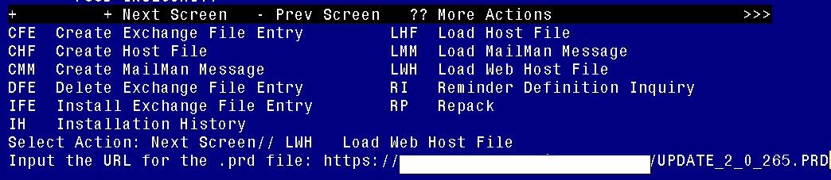
At the Select Action: prompt, enter LWH for Load Web Host File
At the Input the url for the .prd file: prompt, type the following web address:
https://REDACTED/UPDATE_2_0_265.PRD
You should see a message at the top of your screen that the file loaded successfully
Search and locate an entry titled UPDATE_2_0_265 VA-COVID-19 TEMPLATE UPDATES in reminder exchange. 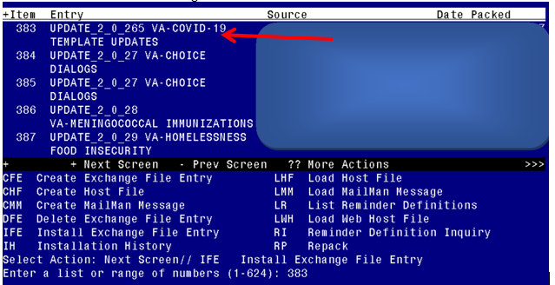
At the Select Action prompt, enter IFE for Install Exchange File Entry
Enter the number that corresponds with your entry UPDATE_2_0_265 VA-COVID-19 TEMPLATE UPDATES (in this example it is entry 383 it will vary by site). The date of the exchange file should be 03/03/2022.

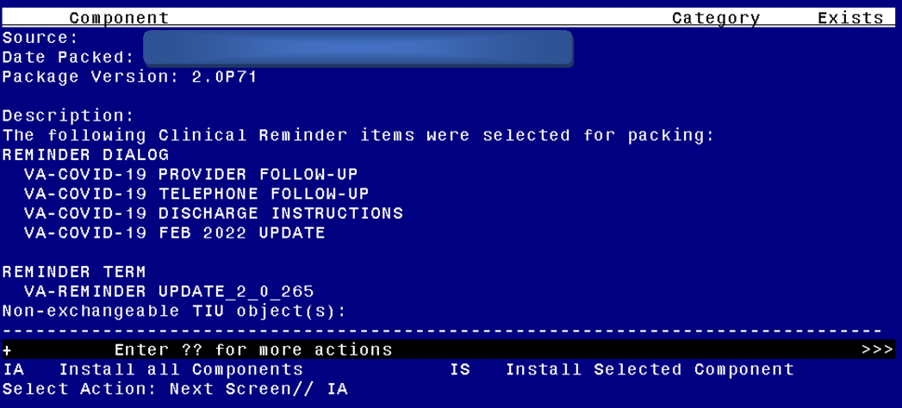
At the Select Action prompt, type IA for Install all Components and hit enter.
Select Action: Next Screen// IA Install all Components
You will see several prompts, for all new entries you will choose I to Install
For components that already exists but the packed component is different, you will choose S to Skip with one exception, if you are prompted to overwrite the reminder term VA-BL COVID SCREEN COMPLETE TODAY you should overwrite.
REMINDER TERM entry named VA-BL COVID SCREEN COMPLETE TODAY already
exists but the packed component is different, what do you want to do?
Select one of the following:
C Create a new entry by copying to a new name
M Merge findings
O Overwrite the current entry
U Update
Q Quit the install
S Skip, do not install this entry
Enter response: O// verwrite the current entry
Are you sure you want to overwrite? N// y YES

You will be prompted to install the FIRST reminder dialog component – You will choose to install all even though some components may have an X to indicate that they exist.
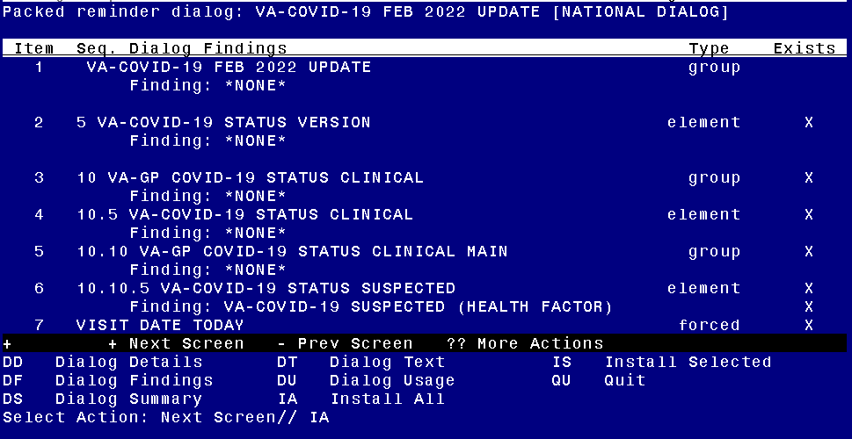

At the Select Action prompt, type IA to install the dialog – VA-COVID-19 FEB 2022 UPDATE
Select Action: Next Screen// IA Install All
Install reminder dialog and all components with no further changes: Y// Yes
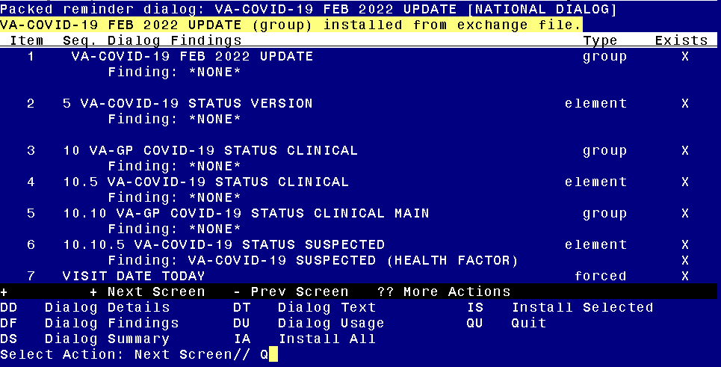

After completing this dialog install, you will type Q.

You will be prompted to install the next reminder dialog component – You will choose to install all even though some components may have an X to indicate that they exist.
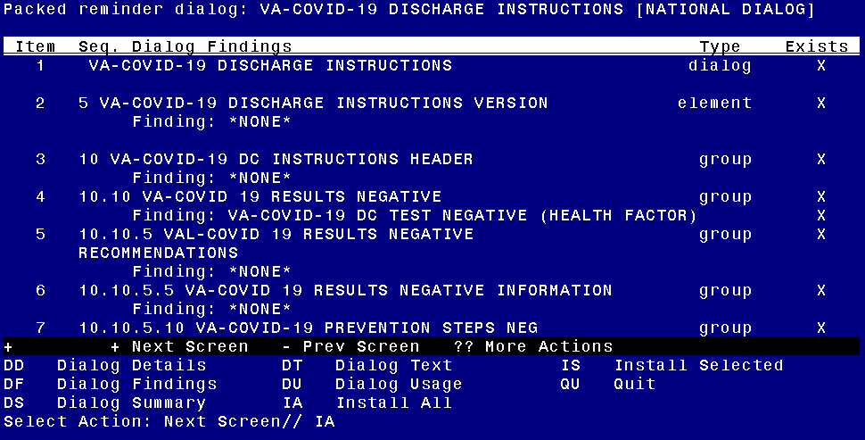

At the Select Action prompt, type IA to install the dialog –VA-COVID-19 DISCHARGE INSTRUCTIONS
Select Action: Next Screen// IA Install All
Install reminder dialog and all components with no further changes: Y// Yes

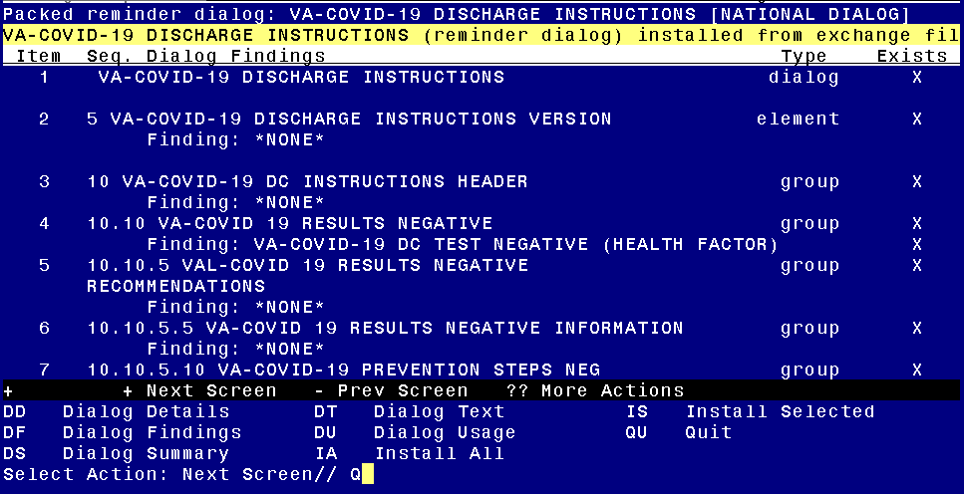

After completing this dialog install, you will type Q.
You will be prompted to install the next reminder dialog component – You will choose to install all even though some components may have an X to indicate that they exist.
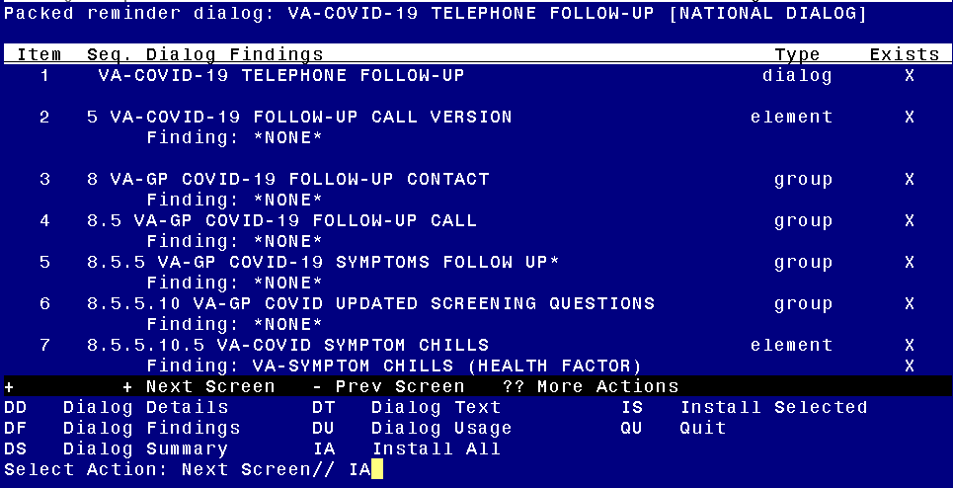

At the Select Action prompt, type IA to install the dialog – VA-COVID-19 TELEPHONE FOLLOW-UP
Select Action: Next Screen// IA Install All
Install reminder dialog and all components with no further changes: Y// Yes

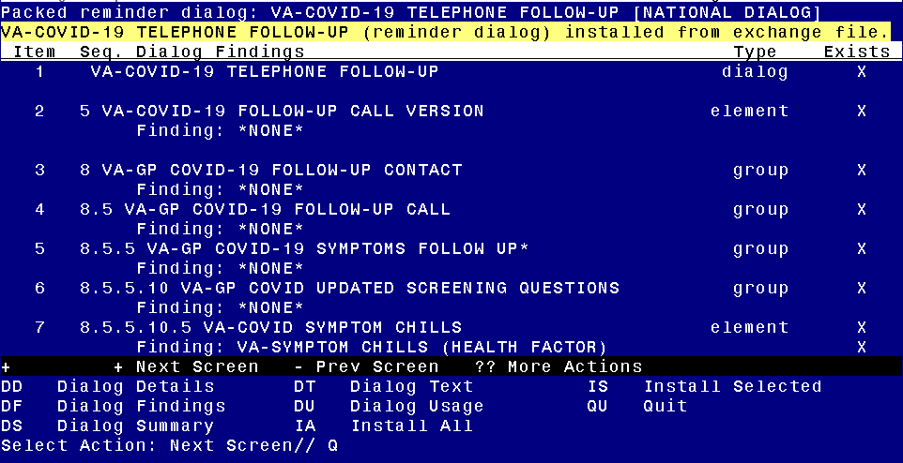

After completing this dialog install, you will type Q.

You will be prompted to install the LAST reminder dialog component – You will choose to install all even though some components may have an X to indicate that they exist.
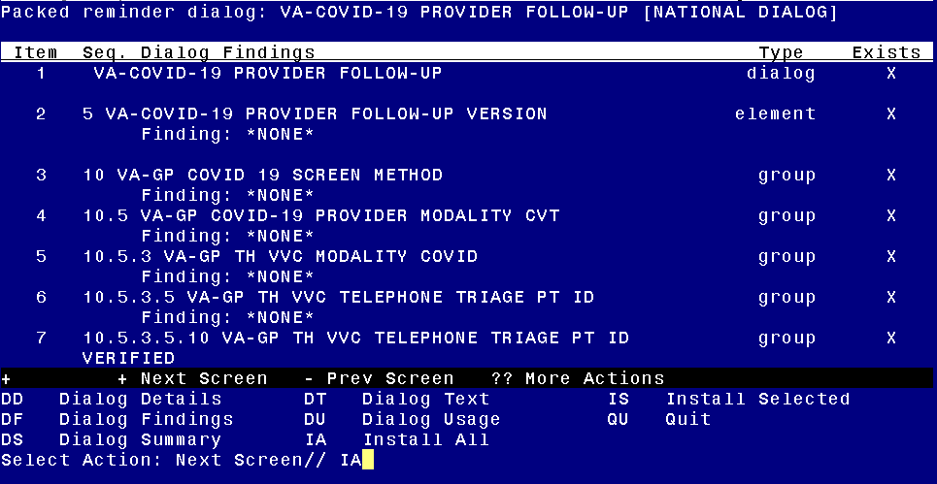

At the Select Action prompt, type IA to install the dialog – VA-COVID-19 PROVIDER FOLLOW-UP
Select Action: Next Screen// IA Install All
Install reminder dialog and all components with no further changes: Y// Yes

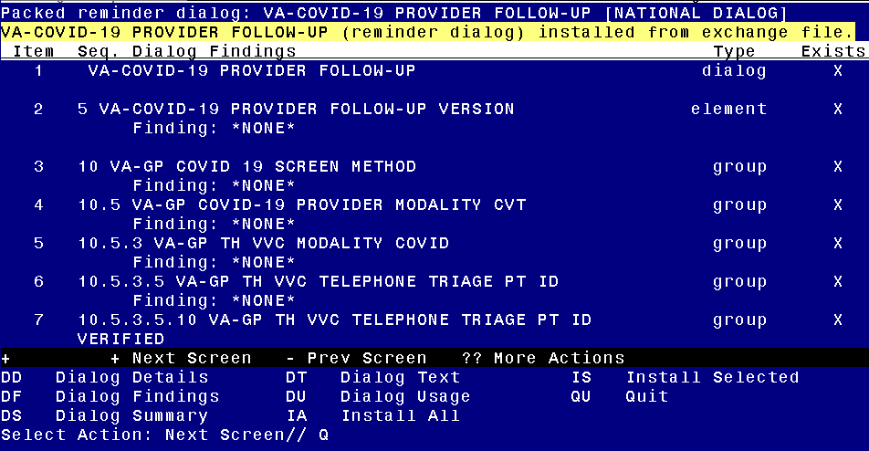

After completing this dialog install, you will type Q.

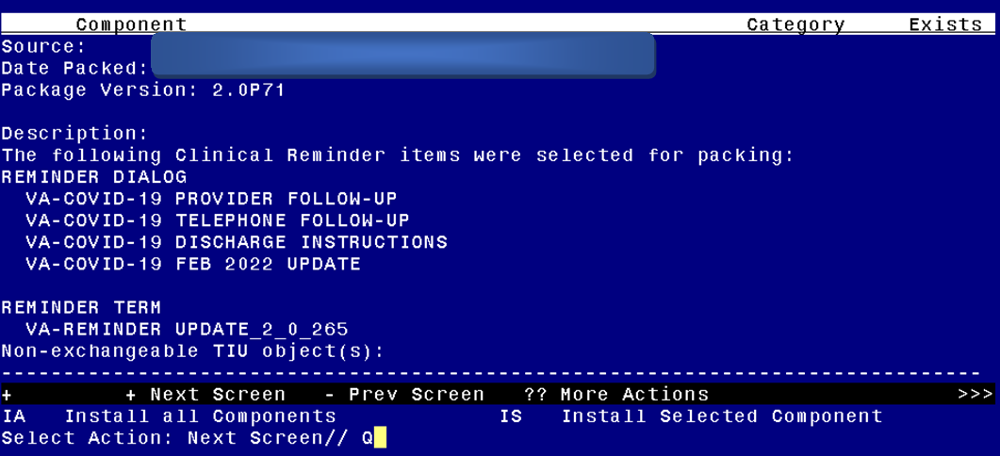
You will then be returned to this screen. At the Select Action prompt, type Q.

Install complete.

Post Installation

- Open the COVID-19 Screen Template (VA-SCREEN COVID) and confirm the version is 9.1
- Open the COVID-19 Screen Template (VA-COVID-19 CLC SCREEN) and confirm the version is 5.1
- Open the COVID-19 Provider Screen Template (VA-COVID-19 PROVIDER FOLLOW-UP) and confirm the version is 5.1
- Open the COVID-19 Telephone Follow-Up (VA-COVID-19 TELEPHONE FOLLOW-UP) and confirm the version is 8.1
- Open the COVID-19 Discharge Template (VA-COVID-19 DISCHARGE INSTRUCTIONS) and confirm the version is 5.1
- Open the COVID-19 Status Adjustment Template (VA-COVID-19 STATUS ADJUSTMENTS) and confirm the version is 5.1
- Open the COVID-19 Return to Work Template (VA-COVID-19 RETURN TO WORK) and confirm the version is 3.1
- Add local content to reminder dialog groups and elements if needed.
Review the pre-install for these items and edit to make any local changes.
- If you had made changes to the below items before, you will need to re-do any local modifications to the following groups.
- If your pre-install inquiry matches the post install review, no changes are needed.
- Some items will require that you enter your local data objects, those are specified below.
GROUPS:
VAL-COVID-19 PENDING LOCAL INFORMATION - if in the pre-install you had enabled and added local information, add that information back and re-enable this group.
VAL-COVID 19 RESULTS NEGATIVE LOCAL INFORMATION - if in the pre-install you had enabled and added local information, add that information back and re-enable this group.
VAL-COVID-19 PREVENTION LOCAL INFORMATION - if in the pre-install you had enabled and added local information, add that information back and re-enable this group.
VAL-COVID-19 POSITIVE LOCAL INFORMATION - if in the pre-install you had enabled and added local information, add that information back and re-enable this group.
VAL-GP COVID ASSESSMENT LAB TESTS – we have added a new sequence to this group but you can add back any additional local items you previously had, do not remove any sequences
VAL-GP COVID-19 FOLLOW-UP PLAN EDUCATION - this dialog group was sent with standard components; your site may have added additional items. If in the pre-install you have additional items, you may add them back.

ELEMENTS
VAL-TH VVC TELEPHONE TRIAGE CONTACT PHONE OBJECT – replace the dialog text *PHONE OBJECT HERE* with your local object that represents the patient phone number
VAL-TH VVC TELEPHONE TRIAGE PATIENT LOCATION HOME – replace the dialog text *PATIENT ADDRESS OBJECT HERE* with your local object that represents the patient phone number
VAL-COVID-19 FOLLOW-UP PLAN ANNIE - Your site could have disabled this element, compare with your pre-install and make changes if needed.
VAL-COVID-19 FOLLOW-UP PLAN ED NURSE HOTLINE -This element should contain your local contact information compare with your pre-install and make changes if needed.
VAL-COVID PATIENT INFORMATION- This element has data objects for patient name and patient age, you may have replaced them locally, compare with your pre-install and make changes if needed.
VAL-COVID ALLERGY AND MEDICATIONS - replace the dialog text ***local medication object to be added here for
display only*** with your local object for current patient medications.
VAL-COVID FOCUSED EXAM TEMP- This element has data objects for patient temperature, you may have replaced it locally, compare with your pre-install and make changes if needed.
VAL-COVID PLAN DISCHARGE HOME FOLLOW UP- replace the dialog text **SITE SPECIFIC INFO CAN BE ADDED HERE** with any local information you had added.
VAL-COVID-19 DIRECTIONS TO PACT- This element contains instructions to add PACT team as an additional signer, you may have added additional text to this element, compare with your pre-install and make changes if needed.
VAL-COVID PROVIDER NOTE - This is an element you may have used to add additional local information to the VA-COVID-19 PROVIDER FOLLOW-UP note, compare with your pre-install and make changes if needed.

In addition to the items identified in the pre-install the following items also should be edited:
VAL-COVID-19 PREVENTION INFORMATION NOT TESTED PN – replace the alternate progress note text **ADD LOCAL INFO FOR TESTING** with your site local information for how Veterans can get tested for COVID-19.
VAL-COVID RACE ETHNICITY CONFIRM NO - replace the dialog text *******local info here**** with information on who the Veteran should contact at your site to get the race and ethnicity changed in the medical record if it is incorrectly listed.

This TIU template field contains information on how patients can access lab results. Review the pre install and make any needed changes:

VA-COVID TEST RESULTS PHONE INFORMATION

This TIU template field should contain information about your site, please make sure it is updated appropriately.

VA COVID SITE NAME

