Update _2_0_267

Clinical Reminders

VA-GEC GERIATRIC EVALUATION
Install Guide

May 2022

Product Development
Office of Information Technology
Department of Veterans Affairs

Table of Contents
Introduction 1
Install Details 1
Install Example 2
Post Installation 5

Introduction
The Geriatric Evaluation Note Template is for geriatric providers (MD, DO, NP, PA) conducting one of two types of geriatric evaluations: Geriatric Consultation or Comprehensive Geriatric Assessment. Geriatric Evaluations are mandated for inclusion in the VA health care benefits package. This note includes metrics that align with demonstrating compliance with The Public Law. The template has been designed to abstract data for quality and performance improvement. The dialog allows facilities to add local templates for evaluation and management documentation completion or to add to existing templates and aligns with current efforts being built into the new Federal Electronic Health Record.

UPDATE_2_0_267 contains 1 Reminder Exchange entry:
UPDATE_2_0_267 GEC GERIATRIC EVALUATION

The exchange file contains the following components:

TIU TEMPLATE FIELD
BLANK SPACE1

HEALTH FACTORS
VA-REMINDER UPDATES [C]
VA-UPDATE_2_0_267
VA-GEC EVALUATION [C]
VA-GEC GERIATRIC FOLLOW-UP ASSESSMENT
VA-GEC GERIATRIC EVALUATION COMPREHENSIVE GERIATRIC ASSESSMENT
VA-GEC GERIATRIC EVALUATION SINGLE GERIATRIC PROVIDER CONSMENT
VA-GEC GERIATRIC EVALUATION NOTE

REMINDER SPONSOR
OFFICE OF GERIATRIC EXTENDED CARE

REMINDER TERM
VA-REMINDER UPDATE_2_0_267

REMINDER DIALOG
VA-GEC GERIATRIC EVALUATION NATIONAL NOTE

Install Details
This update is being distributed as a web host file. The address for the host file is: https://REDACTED/UPDATE_2_0_267.PRD
The file will be installed using Reminder Exchange, programmer access is not required.

Installation:
=============
This update can be loaded with users on the system. Installation will take less than 5 minutes.

Install Example
To Load the Web Host File. Navigate to Reminder exchange in Vista
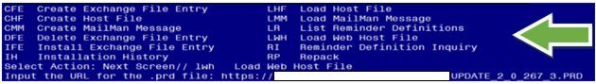

At the Select Action: prompt, enter LWH for Load Web Host File
At the Input the url for the .prd file: prompt, type the following web address:
https://REDACTED/UPDATE_2_0_267.PRD

You should see a message at the top of your screen that the file successfully loaded.

Search and locate an entry titled UPDATE_2_0_267 GEC GERIATRIC EVALUATION in reminder exchange.
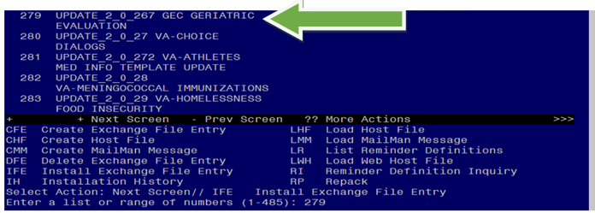

At the Select Action prompt, enter IFE for Install Exchange File Entry

Enter the number that corresponds with your entry UPDATE_2_0_267 VA-GEC GERIATRIC EVALUATION (in this example it is entry 279. It will vary by site). The date of the exchange file should be 03/28/2022.

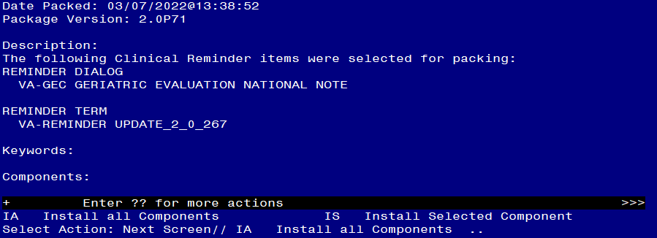

At the Select Action prompt, type IA for Install all Components and hit enter.
Select Action: Next Screen// IA Install all Components
You will see several prompts, for all new entries you will choose I to Install
For components that already exists but the packed component is different, choose S to Skip.

You will be promped to install the reminder dialog component (VA-GEC GERIATRIC EVALUATION). You will choose to install all even though some components may have an X to indicate that they exist.
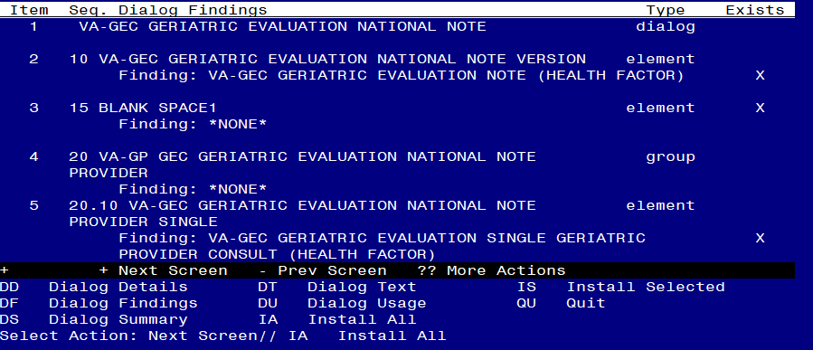
At the Select Action prompt, type IA to install the dialog: VA-GEC GERIATRIC EVALUATION).
Select Action: Next Screen// IA Install All
Install reminder dialog and all components with no further changes: Y// Yes
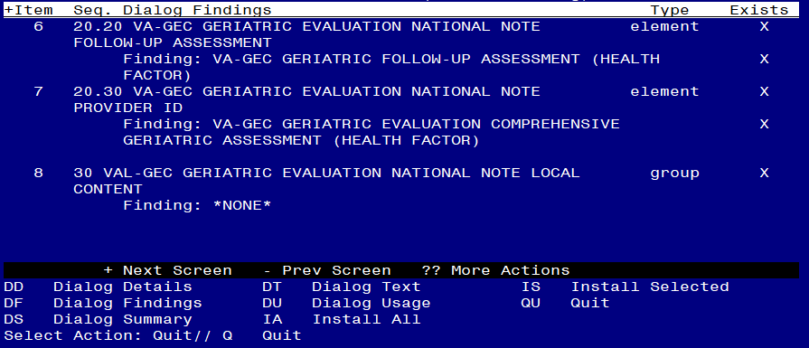

After completing this dialog install, you will type Q.

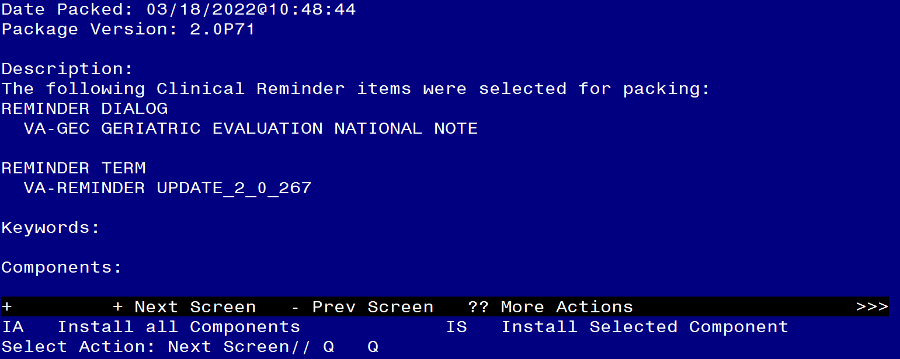
You will then be returned to this screen. At the Select Action prompt, type Q.

Install complete.

Post Installation

- The use of the VA-GEC GERIATRIC EVALUATION NATIONAL NOTE content is mandatory; however, the implementation method is a local decision. The dialog can be embedded into existing local geriatric evaluation dialogs or local content can be added to this dialog. Coordinate with local GEC staff.

  - To add to local dialogs: Embed the VA-GP GEC GERIATRIC EVALUATION NATIONAL NOTE PROVIDER reminder dialog group into any existing GEC Geriatric reminder dialog.

OR

  - To add local content to this dialog: Add appropriate local content (groups and elements) to the VAL-GEC GERIATRIC EVALUATION NATIONAL NOTE LOCAL CONTENT reminder group (if needed).
    - This method requires creating the note title described below and attaching the national dialog.

- Make the Dialog template available to be attached to a Personal or Shared template or to be able to attach the dialog to a progress note title.

Select Reminder Managers Menu <TEST ACCOUNT> Option: CP CPRS Reminder Configuration
CA Add/Edit Reminder Categories
CL CPRS Lookup Categories
CS CPRS Cover Sheet Reminder List
MH Mental Health Dialogs Active
PN Progress Note Headers
RA Reminder GUI Resolution Active
TIU TIU Template Reminder Dialog Parameter
DEVL Evaluate Coversheet List on Dialog Finish
DL Default Outside Location
PT Position Reminder Text at Cursor
LINK Link Reminder Dialog to Template
TEST CPRS Coversheet Time Test
NP New Reminder Parameters
GEC GEC Status Check Active
WH WH Print Now Active
Select CPRS Reminder Configuration <TEST ACCOUNT> Option: TIU TIU Template Reminder Dialog Parameter

Reminder Dialogs allowed as Templates may be set for the following:

1 User USR [choose from NEW PERSON]
3 Service SRV [choose from SERVICE/SECTION]
4 Division DIV [SALT LAKE CITY]
5 System SYS [NATREM.FO-SLC.MED.VA.GOV]

Enter selection: 5 Choose the appropriate number for your site. Your site may do this by System or other levels. The example below uses SYSTEM level.

Setting Reminder Dialogs allowed as Templates for System: NATREM.FO-SLC.MED.VA.GOV
Select Display Sequence: ?

388 VA-COVID-19 TELEPHONE FOLLOW-UP
389 VA-SRA-CONSULT RESPONSE (D)

When you type a question mark above, you will see the list of #’s (with dialogs) that are already taken. Choose a number NOT on this list. For this example, 390 is not present so I will use 390.

Select Display Sequence: 390
Are you adding 390 as a new Display Sequence? Yes// YES

Display Sequence: 390// <Enter> 390
Clinical Reminder Dialog: VA-GEC GERIATRIC EVALUATION NATIONAL NOTE
reminder dialog NATIONAL
...OK? Yes// <Enter>

- Setup of Note Title.

The note title to create to associate with this template is: GERIATRIC EVALUATION NOTE (Sites can revise the title if needed).

VHA Enterprise Standard Title: GERIATRIC MEDICINE NOTE

You can add this to your document class where whole health notes are located.

Note: Comprehensive information on Creating new Document Classes and Titles can be found beginning on page 54 of the TIU/ASU Implementation Guide at the following link: http://www.va.gov/vdl/documents/Clinical/CPRS-Text_Integration_Utility_(TIU)/tiuim.pdf

- Associate the reminder dialog with the note title in CPRS

In CPRS, open the Template Editor, expand Document Titles, select the appropriate folder (if applicable), then click New Template (top right-hand corner).

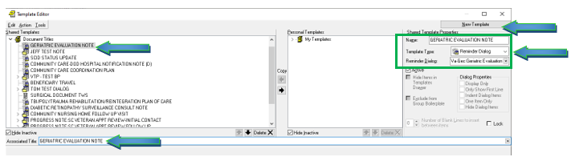

Type in the following information:
Name: GERIATRIC EVALUATION NOTE
Template Type: Reminder Dialog
Reminder Dialog: VA-GEC GERIATRIC EVALUATION NATIONAL NOTE

Next, type in the Associated Title name – GERIATRIC MEDICINE NOTE – then click Apply.

- Sites may also want to add this dialog to a shared template folder (optional).

In CPRS, open the Template Editor, select Edit Shared Templates, select Shared Templates, select the appropriate folder, then click New Template (top right-hand corner).

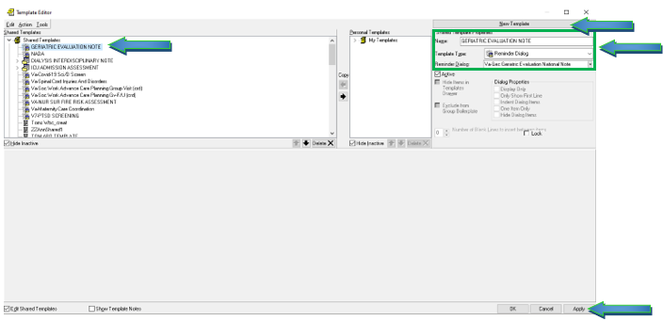
Type in the following information:
Name: GERIATRIC EVALUATION NOTE
Template Type: Reminder Dialog
Reminder Dialog: VA-GEC GERIATRIC EVALUATION NATIONAL NOTE

Next, type in the Associated Title name – GERIATRIC EVALUATION NOTE – then click Apply.

