Update_2_0_268

Clinical Reminders

Cognitive Behavioral Interventions for Substance Use Disorder

Install Guide

June 2022

Product Development
Office of Information Technology
Department of Veterans Affairs

Table of Contents
Introduction 1
Pre-Install 1
Install Details 2
Install Example 2
Post Installation 7

Introduction
The template will help identify the provision of evidence-based cognitive-behavioral interventions (CBIs) to treat substance use disorder (SUD). This will assist the Psychoactive Drug Safety Initiative (PDSI) in its effort to monitor evidence-based treatment for stimulant use disorder (StimUD), which is implicated in the growing crisis of overdose deaths and for which no FDA-approved medications are presently available.

By helping identify the delivery of evidence-based CBIs to treat Veterans with substance use disorder including, but not limited to, StimUD, the data yielded by the template can inform targeted efforts to increase access to these life-saving, evidence-based interventions, i.e. by training more clinicians at sites where utilization lags.

Although CBIs are one of the two evidence-based means of treating StimUD to which VA is seeking to expand Veteran access (the other being Contingency Management which has an extant template), there is no mechanism for monitoring their provision and using those data to inform training and quality control efforts.

Group Notes may be an option for documenting information for patients. Users will have to determine whether they should use Group Notes or not. There is education about using Group Notes along with the template being distributed with this update. The education will be in the same folder as this install guide.

UPDATE_2_0_268 contains 1 Reminder Exchange entry:
UPDATE_2_0_268 VA-MH CB-SUD EVIDENCE BASED INTERVENTIONS

The exchange file contains the following components:
HEALTH FACTORS
1 VA-REMINDER UPDATES [C]
2 VA-UPDATE_2_0_268
3 VA-MH CB-SUD TEMPLATE [C]
4 VA-MH CB-SUD INDIV OR GRP SESSION BY OTHERWISE
TRAINED
5 VA-MH CB CSG-SUD GRP SESSION BY VA TRAINED PROVID
OR EQUIV
6 VA-MH CB-SUD INDIV SESSION BY VA TRAINED LIP OR
EQUIV

REMINDER SPONSOR
7 OFFICE OF MENTAL HEALTH SERVICES
8 MENTAL HEALTH SERVICES

REMINDER TERM
9 VA-REMINDER UPDATE_2_0_268

REMINDER DIALOG

10 VA-MH CB-SUD EVIDENCE BASED INTERVENTIONS

Pre-Install
- Make sure you have installed Update_2_0_88 Opioid Use Disorder Buprenorphine Initiation and Update_2_0_72 VA-Opioid Use Disorder Assessment prior to installing this Update.

Also, before you install this update, use the action INQ (Inquiry/Print) to print and save the existing dialog for the following items. This will ensure the local modifications to these items are easier to complete when you address the Post-Install steps.

- In Reminder Dialog Manager > Reminder Dialogs > Change your view to Dialog Elements.
  - Use the action INQ (Inquiry/Print) to print and save the existing content for the following element: VAL-MH OUD PDMP LINK. If you previously added a hyperlink TXML field to this element, you’ll have it saved for re-adding it during the Post-Install steps.

- In Reminder Dialog Manager > Reminder Dialogs > Change your view to Dialog Elements.
  - Use the action INQ (Inquiry/Print) to print and save the existing content for the following element: VAL-MH OUD ASSESS NALOXONE ORDERED. If you previously added a Naloxone quick order to this element, you’ll have it saved for re-adding it during the Post-Install steps.

Install Details

This update is being distributed as a web host file. The address for the host file is: https://Redacted/UPDATE_2_0_268.PRD

The file will be installed using Reminder Exchange, programmer access is not required.

Installation:
=============
This update can be loaded with users on the system. Installation will take less than 10 minutes.

Install Example
To Load the Web Host File. Navigate to Reminder exchange in Vista
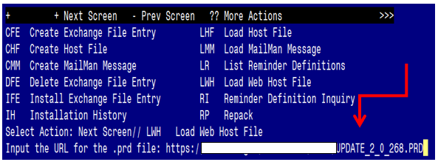

At the Select Action: prompt, enter LWH for Load Web Host File
At the Input the url for the .prd file: prompt, type the following web address:
https://vaww.va.gov/reminders/docs/UPDATE_2_0_268.PRD

You should see a message at the top of your screen that the file successfully loaded.

Search and locate an entry titled UPDATE_2_0_268 VA-MH CB-SUD EVIDENCE BASED INTERVENTIONS in reminder exchange

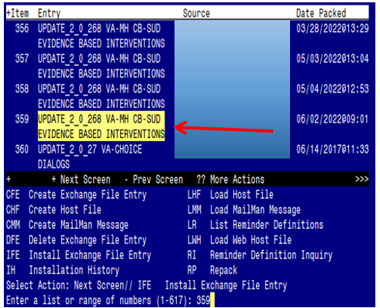

At the Select Action prompt, enter IFE for Install Exchange File Entry
Enter the number that corresponds with your entry titled
UPDATE_2_0_268 VA-MH CB-SUD EVIDENCE BASED INTERVENTIONS
(in this example it is entry 359, it will vary by site). The date of the exchange file is 06/02/2022.

***There is a new reminder sponsor associated with this install. You will need to do an IS to selectively install reminder sponsor OFFICE OF HEALTHCARE INNOVATION AND LEARNING. If you don’t install this first, you will receive errors when installing the health factors. Please do this step prior continuing!

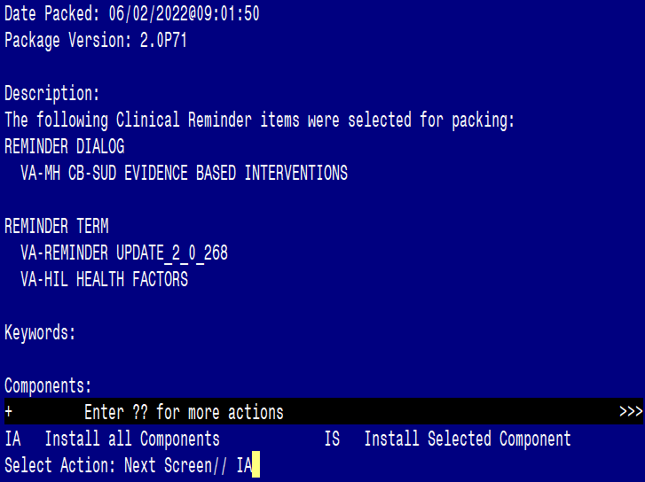

At the Select Action prompt, type IA for Install all Components and hit enter.
Select Action: Next Screen// IA Install all Components

During the installation, you will see several prompts:
Install all new components, Skip any existing components

You will be promped to install the dialog component:

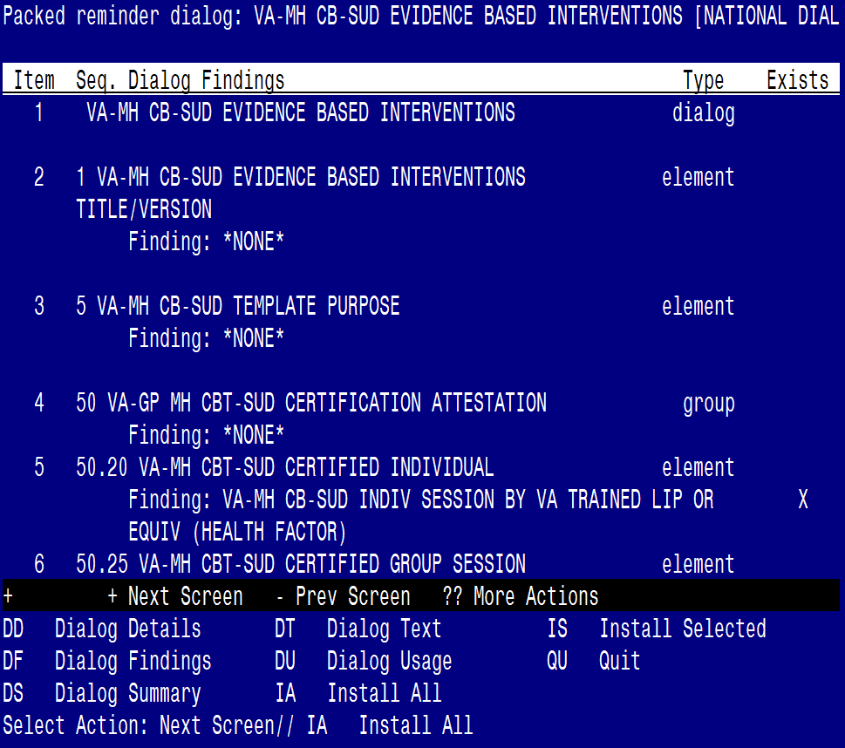

At the Select Action prompt, type IA to install the dialog – VA-MH CB-SUD EVIDNECE BASED INTERVENTIONS
Select Action: Next Screen// IA Install All
Install reminder dialog and all components with no further changes: Y// ES

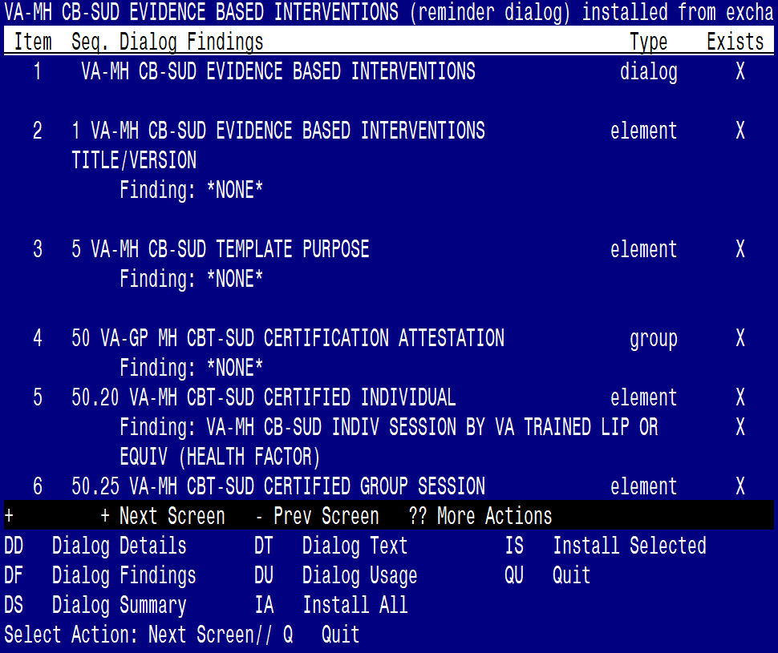

When the dialog has completed installation, you will then be returned to this screen. At the Select Action prompt, type Q.

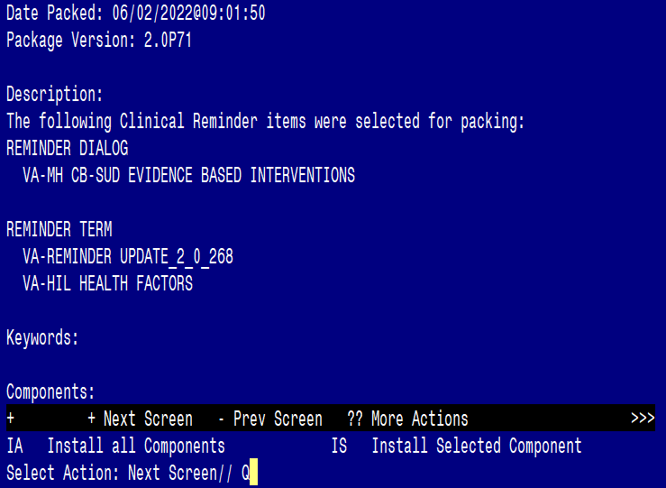

You will be returned to this screen. Type Q to quit.
Install Completed

Post Installation

- Make the Dialog templates available to be attached to a Personal or Shared template or to be able to attach the dialog to a progress note title.
From the Reminders Manager Menu:
Select Reminder Managers Menu Option: CP CPRS Reminder Configuration
CA Add/Edit Reminder Categories
CL CPRS Lookup Categories
CS CPRS Cover Sheet Reminder List
MH Mental Health Dialogs Active
PN Progress Note Headers
RA Reminder GUI Resolution Active
TIU TIU Template Reminder Dialog Parameter
DL Default Outside Location
PT Position Reminder Text at Cursor
Select CPRS Reminder Configuration Option: TIU TIU Template Reminder Dialog
Parameter
Reminder Dialogs allowed as Templates may be set for the following:
1 User USR [choose from NEW PERSON]
3 Service SRV [choose from SERVICE/SECTION]
4 Division DIV [choose from INSTITUTION]
5 System SYS [NATREM.FO-SLC.MED.VA.GOV]
Enter selection: 5 Choose the appropriate number for your site. Your site may do
this by System or other levels. The example below uses SYSTEM level
Setting Reminder Dialogs allowed as Templates for System:
Select Display Sequence: ?

148 VA-VETERANS CHOICE NOTE
149 VA-TBI SCREENING
151 VACO TRANSPLANT REFERRAL (D)
When you type a question mark above, you will see the list of #’s (with dialogs) that
are already taken. Choose a number NOT on this list. For this example, looking
above I see the number 150 is not present, so I will use 150.

Select Display Sequence: 150
Are you adding 150 as a new Display Sequence? Yes// Y YES
Display Sequence: 150// <Enter>
Clinical Reminder Dialog: VA-MH CB-SUD EVIDENCE BASED INTERVENTIONS
<Enter>
OK? Yes// <Enter> (Yes)

- Setup of Note title
The new note title that needs to be created is:
SUD COGNITIVE BEHAVIORAL INTERVENTIONS. This note title is to be mapped to the following VHA Enterprise Standard Title:
MENTAL HEALTH NOTE

Comprehensive information on Creating Document Definitions can be found beginning on page 47 of the TIU/ASU Implementation Guide

- Associate the reminder dialog with the note title in CPRS
To do this, go to Template Editor, then Document Titles, select the appropriate folder (if applicable), and choose New Template (top right-hand corner).
Type in the following information:
Name: SUD COGNITIVE BEHAVIORAL INTERVENTIONS
Template Type: Reminder Dialog
Reminder Dialog: VA-MH CB-SUD EVIDENCE BASED INTERVENTIONS

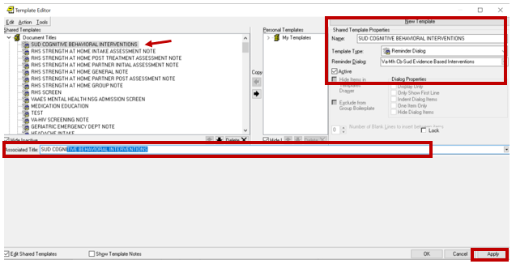

Next, type in the Associated Title, which in this case is SUD COGNITIVE BEHAVIORAL INTERVENTIONS and hit Apply.

- Add the dialog to a shared template in CPRS.
To do this, go to Template Editor, then Shared Templates, select the appropriate folder (if applicable), and choose New Template (top right-hand corner).
Type in the following information:
Name: SUD COGNITIVE BEHAVIORAL INTERVENTIONS
Template Type: Reminder Dialog
Reminder Dialog: VA-MH CB-SUD EVIDENCE BASED INTERVENTIONS

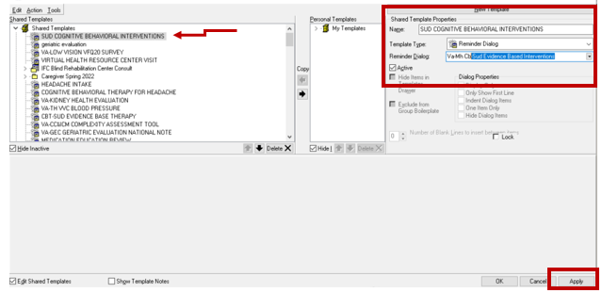

Hit Apply.

- Review the pre-install dialog content and add back any local content that existed from the pre-install.
In Reminder Dialog Manager > Reminder Dialogs > Change your view to Dialog Elements.
  - VAL-MH OUD PDMP LINK - If you previously added a hyperlink TXML field to this element, you will need to edit the element and add it back to the dialog text.

  - VAL-MH OUD ASSESS NALOXONE ORDERED. If you previously added a Naloxone quick order to this element, will need to edit the element add it as an additional finding.

