Update _2_0_269

Clinical Reminders

VA-INITIAL FIVE ELEMENT MENTALHEALTH SCREEN

Install Guide

December 2022

Product Development
Office of Information Technology
Department of Veterans Affairs

Table of Contents
Introduction 1
Install Details 3
Install Example 3
Post Installation 6

Introduction
VHA policy requires that all Veterans new to mental health must complete an INITIAL FIVE ELEMENT MENTAL HEALTH (MH) screen, which includes 5 specific elements. Compliance reviews have shown that the elements are not always completed, either in practice or in documentation. These results are reported periodically to Congress and other stakeholders. In addition, reviews have revealed marked variation in how sites document these screens. The new template will provide a nationally standard documentation process for initial MH screens that will, by design, include the completion of all 5 of the required elements. Mandatory use of the template will reduce variation in practice and documentation across all VHA sites of care, leading to more consistent review of MH care needs and provision of care as well as better alignment with agency policy and its intent.
Any VA LIP or RN who completes an initial MH screen with Veterans can use this template. Most of the time, users will be LIPs or RNs from mental health or primary care.
Strengthening compliance with policy by providing a National template to the field will ensure Veteran’s clinical needs are addressed in a timely manner and that they have resources to support engagement in care.
VHA requires same-day screening of MH concerns when these are raised. This often happens in two ways:
Scenario 1: Veteran is being seen by PCP and reports a mental health concern. The PCP either personally completes the initial MH screen as part of the assessment or provides a warm handoff to a PCMHI provider, who completes the screen as part of their assessment.
Scenario 2: Veteran contacts a clinic and asks to be seen by mental health. The responding MH LIP or RN completes the initial MH screen to assess urgency of needs, arrange for timely clinical care based on urgency, provide resources and address questions/concerns to ensure Veteran engagement in care.

UPDATE_2_0_269 contains 1 Reminder Exchange entry:
UPDATE_2_0_269 VA-INITIAL FIVE ELEMENT MENTAL HEALTH SCREEN

The exchange file contains the following components:

REMINDER DIALOG LINK TYPE
VA-MH INITIAL PERFORM C-SSRS POSITIVE NEW

TIU TEMPLATE FIELD
VA-MH SAME DAY CLINIC PHONE
VA-WORD
VA-MH STAFF GUIDE

HEALTH FACTORS
VA-REMINDER UPDATES [C]
VA-UPDATE_2_0_269
VA-MH INITIAL 5 ELEMENT MENTAL HEALTH SCREEN [C]
VA-MH INIT MH SCREEN-URG-WARM HANDOFF
VA-MH INIT MH SCREEN-URG-OTHER
VA-MH-INIT MH SCRN URGENT
VA-MH INIT MH SCREEN-ROUTINE-OTHER
VA-MH INIT MH SCREEN-ROUTINE-FOLLOWUP
VA-MH-INIT MH SCRN ROUTINE
VA-MH-INIT MH SCRN EMERGENT
VA-SUICIDE RISK ASSESSMENT [C]
VA-SUICIDE RISK CHRONIC LOW
VA-SUICIDE RISK CHRONIC INTERMEDIATE
VA-SUICIDE RISK CHRONIC HIGH
VA-SUICIDE RISK ACUTE LOW
VA-SUICIDE RISK ACUTE INTERMEDIATE
VA-SUICIDE RISK ACUTE HIGH

REMINDER SPONSOR
OFFICE OF MENTAL HEALTH SERVICES

REMINDER TERM
VA-REMINDER UPDATE_2_0_269
VA-BL PRIOR SUCIDE RISK
VA-BL C-SSRS DONE TODAY
VA-C-SSRS DONE TODAY POSITIVE QUESTION 8
VA-C-SSRS DONE TODAY POSITIVE QUESTION 5
VA-C-SSRS DONE TODAY POSITIVE QUESTION 4
VA-C-SSRS DONE TODAY POSITIVE QUESTION 3
VA-C-SSRS DONE SAME DAY POSITIVE QUESTION 8
VA-C-SSRS DONE SAME DAY POSITIVE QUESTION 5
VA-C-SSRS DONE SAME DAY POSITIVE QUESTION 4
VA-C-SSRS DONE SAME DAY POSITIVE QUESTION 3
VA-BL C-SSRS DONE SAME DAY POSITIVE

REMINDER DEFINITION
VA-BL C-SSRS DONE TODAY POSITIVE
VA-BL C-SSRS DONE SAME DAY POSITIVE

HEALTH SUMMARY TYPE
VA-CSRE RISK 24 HOURS

HEALTH SUMARY OBJECTS
VA-CSRE RISK 24 HOURS (TIU)

TIU DOCUMENT DEFINITION
VA-CSRE RISK 24 HOURS

REMINDER DIALOG
VA-MH INITIAL FIVE ELEMENT MENTAL HEALTH SCREEN

Install Details

This update is being distributed as a web host file. The address for the host file is: https://REDACTED/UPDATE_2_0_269.PRD

The file will be installed using Reminder Exchange, programmer access is not required.

Installation:
=============
This update can be loaded with users on the system. Installation will take less than 5 minutes.

Install Example

To Load the exchange file, use LWH. The URL is https://REDACTED /UPDATE_2_0_269.PRD

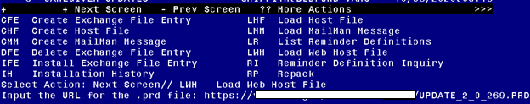

If you use LWH and it works, you will see something like this message. Make sure the file was loaded successfully.
Search and locate an entry titled UPDATE_2_0_269 VA-INITIAL FIVE ELEMENT MENTAL HEALTH SCREEN in reminder exchange.
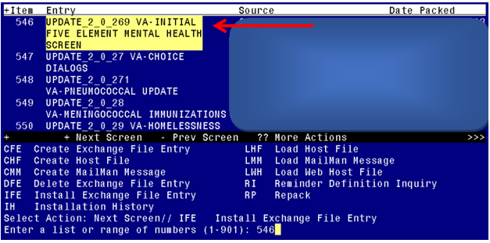

At the Select Action prompt, enter IFE for Install Exchange File Entry
Enter the number that corresponds with your entry titled UPDATE_2_0_269 VA-INITIAL FIVE ELEMENT MENTAL HEALTH SCREEN (in this example it is entry 546, it will vary by site) that is dated 09/30/2022.

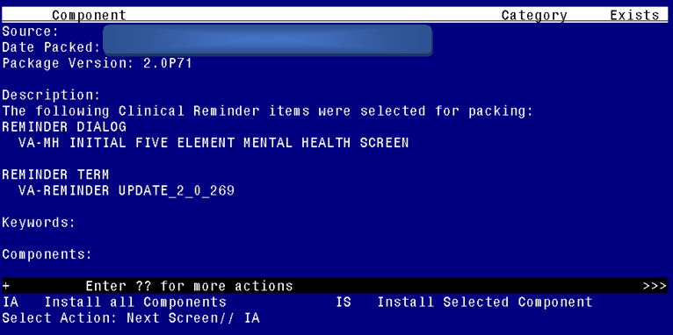
At the Select Action prompt, type IA for Install all Components and hit enter.
For all new entries in any category you will choose I to Install
Skip any items you are prompted to overwrite.
You will then be prompted to install the first dialog component. You will choose IA to install all even though some items will already have an X to indicate they exist.
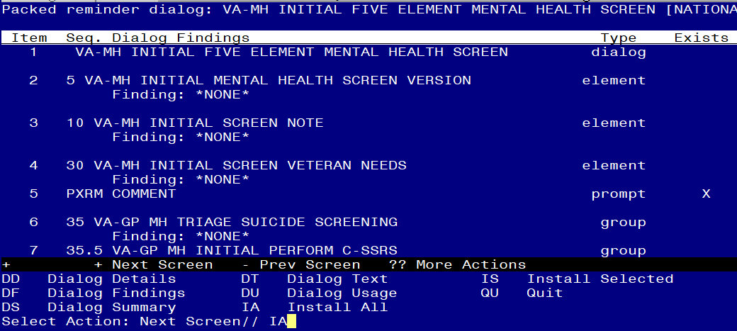
At the Select Action prompt, type IA to install the dialog – VA-MH INITIAL FIVE ELEMENT MENTAL HEALTH SCREEN
Install reminder dialog and all components with no further changes: Y//ES

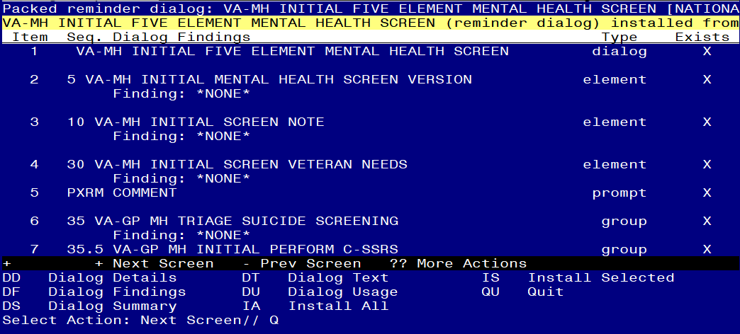
When the dialog has completed installation, you will then be returned to this screen. At the Select Action prompt, type Q.

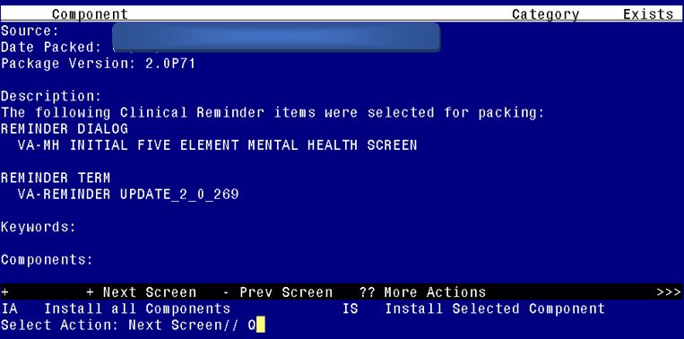
You will then be returned to this screen. At the Select Action prompt, type Q.

Install complete.

Post Installation

- Setup of Note Title.

The note title to create to associate with this template is:
INITIAL FIVE ELEMENT MENTAL HEALTH SCREEN

VHA Enterprise Standard Title: MENTAL HEALTH NOTE

You can add these to your document class where mental health progress notes are located.

Note: Comprehensive information on Creating new Document Classes and Titles can be found beginning on page 54 of the TIU/ASU Implementation Guide at the following link: http://www.va.gov/vdl/documents/Clinical/CPRS-Text_Integration_Utility_(TIU)/tiuim.pdf

- Make the Dialog templates available to be attached to a Personal or Shared templates or to be able to attach the dialog to a progress note title.
Select Reminder Managers Menu <TEST ACCOUNT> Option: CP CPRS Reminder Configuration
CA Add/Edit Reminder Categories
CL CPRS Lookup Categories
CS CPRS Cover Sheet Reminder List
MH Mental Health Dialogs Active
PN Progress Note Headers
RA Reminder GUI Resolution Active
TIU TIU Template Reminder Dialog Parameter
DEVL Evaluate Coversheet List on Dialog Finish
DL Default Outside Location
PT Position Reminder Text at Cursor
LINK Link Reminder Dialog to Template
TEST CPRS Coversheet Time Test
NP New Reminder Parameters
GEC GEC Status Check Active
WH WH Print Now Active
Select CPRS Reminder Configuration <TEST ACCOUNT> Option: TIU TIU Template Reminder Dialog Parameter
Reminder Dialogs allowed as Templates may be set for the following:
1 User USR [choose from NEW PERSON]
3 Service SRV [choose from SERVICE/SECTION]
4 Division DIV [SALT LAKE CITY]
5 System SYS [NATREM.FO-SLC.MED.VA.GOV]
Enter selection: 5 Choose the appropriate number for your site. Your site may do this by System or other levels. The example below uses SYSTEM level.
Setting Reminder Dialogs allowed as Templates for System: NATREM.FO-SLC.MED.VA.GOV
Select Display Sequence: ?
388 VA-COVID-19 TELEPHONE FOLLOW-UP
389 VA-SRA-CONSULT RESPONSE (D)
When you type a question mark above, you will see the list of #’s (with dialogs) that are already taken. Choose a number NOT on this list. For this example, 390 is not present so I will use 490.
Select Display Sequence: 490
Are you adding 490 as a new Display Sequence? Yes// YES

Display Sequence: 490// <Enter> 490
Clinical Reminder Dialog: VA-MH INITIAL FIVE ELEMENT MENTAL HEALTH SCREEN reminder dialog NATIONAL
...OK? Yes// <Enter> (Yes)

- Associate the reminder dialogs with the note title in CPRS
- In CPRS, open the Template Editor, expand Document Titles, select the appropriate folder (if applicable), then click New Template (top right-hand corner).

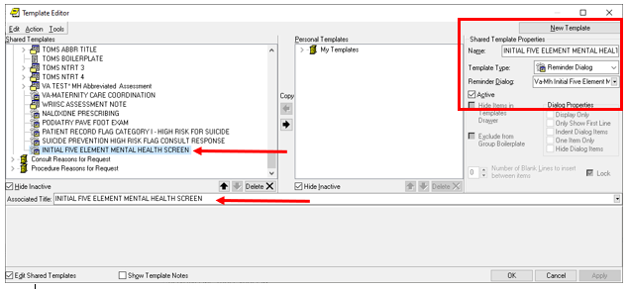
Type in the following information:
Name: INITIAL FIVE ELEMENT MENTAL HEALTH SCREEN
Template Type: Reminder Dialog
Reminder Dialog: VA-MH INITIAL FIVE ELEMENT MENTAL HEALTH SCREEN
Next, type in the Associated Title name – INITIAL FIVE ELEMENT MENTAL HEALTH SCREEN – then click Apply.

- In addition to setting up the document title, you can also add this template to your shared templates folder to make it easy for your staff to incorporate into their existing notes/processes. Review with your MH staff to identify the best place within shared templates to add it.
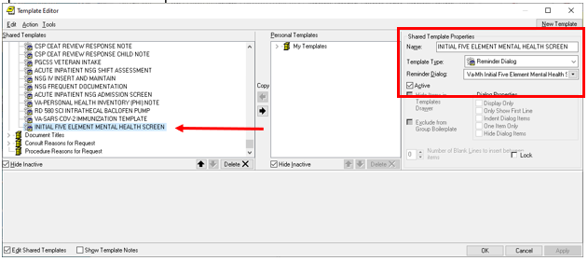

Type in the following information:
Name: INITIAL-FIVE ELEMENT MENTAL HEALTH SCREEN
Template Type: Reminder Dialog
Reminder Dialog: VA-MH INITIAL FIVE ELEMENT MENTAL HEALTH SCREEN

- UPDATE TIU TEMPLATE FIELD:
Using the Template field editor in CPRS, edit the template field names VA-MH SAME DAY CLINIC PHONE.
Replace the characters “(***)***-**** EXT XXXX” with the phone number for your facility’s mental health services number.

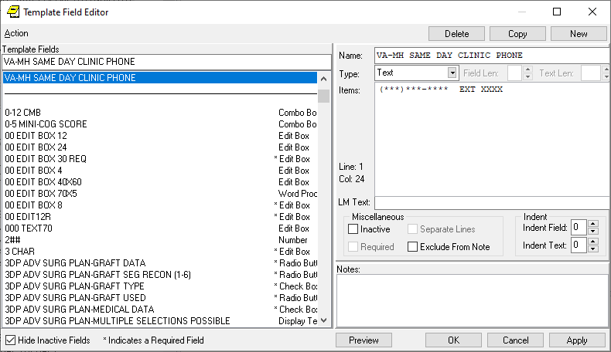

If your site is integrated, you can change the type to a combo, check box or radio buttons and add multuple lines of phone numbers.

- Add local referral order/menu for Mental Health to the reminder dialog element, using the Reminder Dialog Manager Menu, DI Reminder Dialogs, Change View to Element and then search for and edit the following reminder dialog element VA-MH INITIAL NEEDS FOLLOW UP ARRANGED and add your quick order or menu as an additional finding.

