Update _2_0_272

Clinical Reminders

VA-ATHLETES MEDICAL INFORMATION TEMPLATE UPDATE
Install Guide

March 2022

Product Development
Office of Information Technology
Department of Veterans Affairs

Table of Contents
Introduction 1
Install Details 2
Install Example 2
Post Installation 6

Introduction
Description-
This updated reminder dialog template will be used to address identified needs of the National Veterans Golden Age Games and capture medical data to clear Veterans to participate in the Games at the time of screening.
- The annual National Veterans Golden Age Games (NVGAG) provides Veterans opportunities to engage in rehabilitative sport and recreation opportunities. It serves Veterans ages 55 years and older who are enrolled in the VA Health Care System.

- Participants learn to use the therapeutic value of sports, fitness and recreation through an active, healthy lifestyle by competing in sporting competitions for example air rifle, horseshoes, pickleball, track and field.

- By participating in NVGAG, Veterans reach their full potential, improve their independence, achieve a healthier lifestyle and enjoy a higher quality of life.

- This reminder template allows the VA provider to electronically capture medical data to determine participation in the National Veterans Golden Age Games.

- This will facilitate communication to health care providers at the Host Site Facility to ensure continuity of care while participation in the National Veterans Golden Age Games away from the Veteran’s primary site of care.

Summary of Changes:

1. Version number changed to 2.1.
2. Introduction updated to remove specific number of sports.
3. Long jump added to field event description.
4. Kickball added to event options.

UPDATE_2_0_272 contains 1 Reminder Exchange entry:
UPDATE_2_0_272 VA-ATHLETES MED INFO TEMPLATE UPDATE

The exchange file contains the following components:

TIU TEMPLATE FIELD
GOLDEN GAMES HL

HEALTH FACTORS
VA-REMINDER UPDATES [C]
VA-UPDATE_2_0_272

REMINDER TERM
VA-REMINDER UPDATE_2_0_272

REMINDER DIALOG
VA-ATHLETES MEDICAL INFO UPDATE FEB 2022

Install Details

This update is being distributed as a web host file. The address for the host file is: https://REDACTED /UPDATE_2_0_272.PRD
The file will be installed using Reminder Exchange, programmer access is not required.

Installation:
=============
This update can be loaded with users on the system. Installation will take less than 5 minutes.

Pre-Install

- You should have installed update 55 prior to installing this update.
REDACTED

Install Example
To Load the Web Host File. Navigate to Reminder exchange in Vista
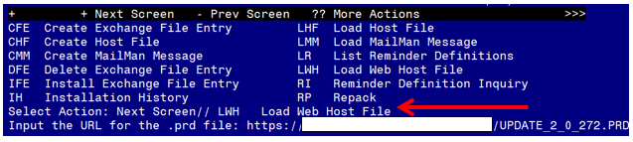
At the Select Action: prompt, enter LWH for Load Web Host File
At the Input the url for the .prd file: prompt, type the following web address:
https://REDACTED/UPDATE_2_0_272.PRD
You should see a message at the top of your screen that the file successfully loaded.

Search and locate an entry titled UPDATE_2_0_272 VA-ATHLETES MED INFO TEMPLATE UPDATE in reminder exchange.

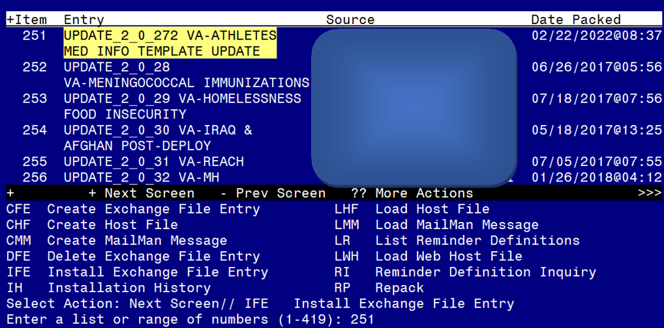

At the Select Action prompt, enter IFE for Install Exchange File Entry
Enter the number that corresponds with your entry UPDATE_2_0_272 VA-ATHLETES MED INFO TEMPLATE UPDATE (in this example it is entry 251. It will vary by site). The date of the exchange file should be 02/22/2022.

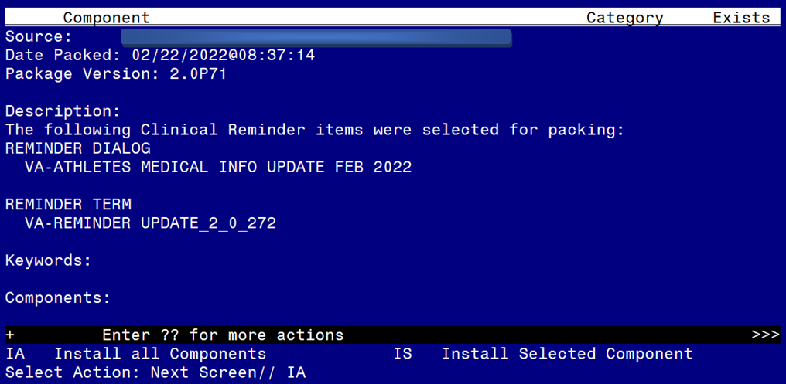

At the Select Action prompt, type IA for Install all Components and hit enter.
Select Action: Next Screen// IA Install all Components
You will see several prompts:
For all new entries you will choose I to Install
If you are prompted to overwrite any components, choose S to Skip.
You will be promped to install the reminder dialog component (VA-ATHLETES MEDICAL INFO UPDATE FEB 2022). You will choose to install all even though some components may have an X to indicate that they exist.
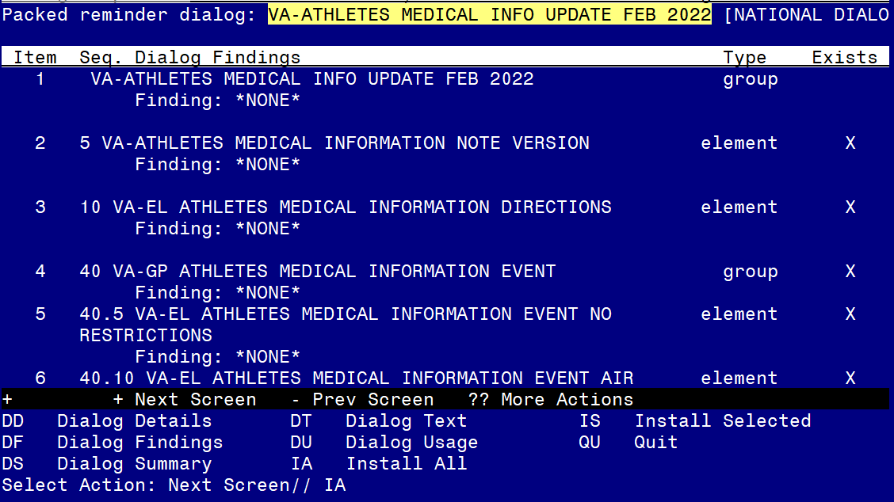

At the Select Action prompt, type IA to install the dialog: VA-ATHLETES MEDICAL INFO UPDATE FEB 2022
Select Action: Next Screen// IA Install All
Install reminder dialog and all components with no further changes: Y// Yes

After completing this dialog install, you will type Q.
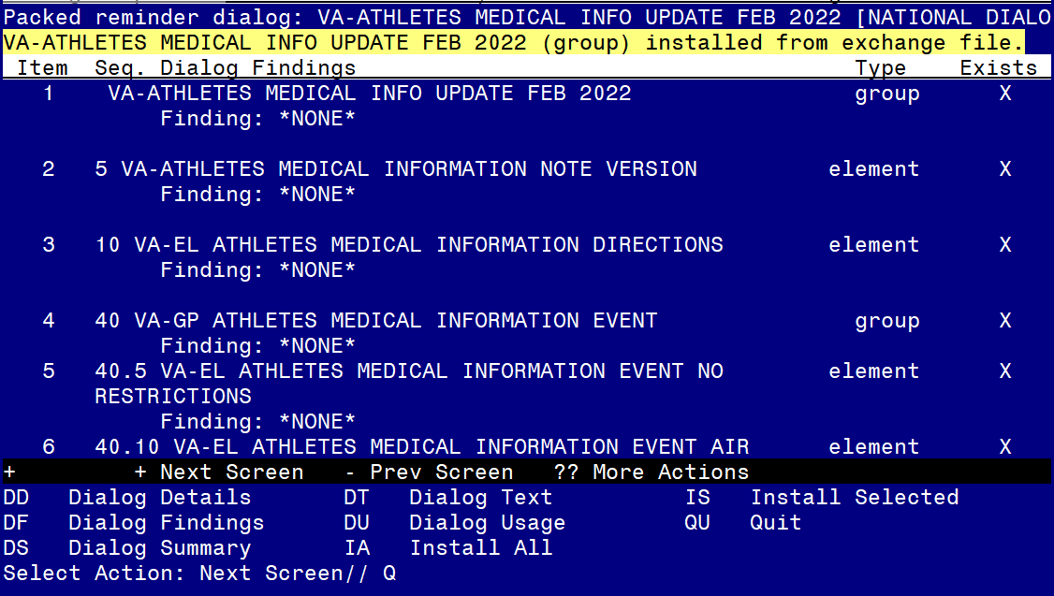

Select Action: Next Screen// Q

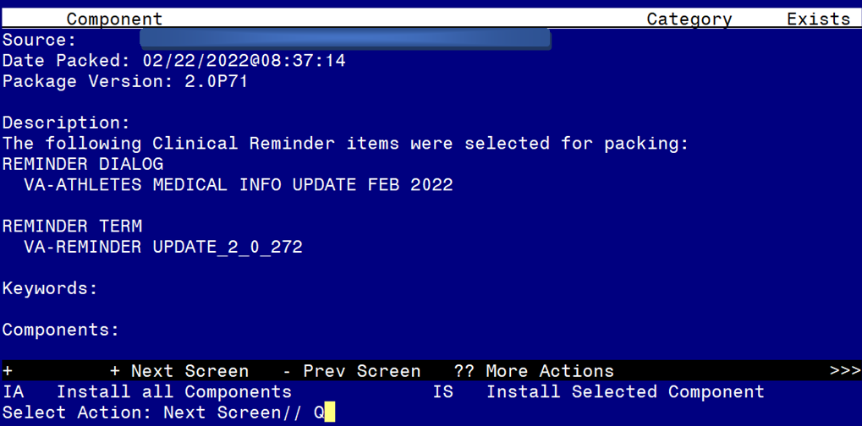
You will then be returned to this screen. At the Select Action prompt, type Q.

Install complete.

Post Installation

Open the note titled NATIONAL VETERANS GOLDEN AGE GAMES MEDICAL CLEARANCE FORM and confirm the version that displays is 2.1.

