Update_2_0_273

Clinical Reminders

VA-PERSONAL HEALTH INVENTORY (PHI) NOTE UPDATE

Install Guide

April 2022

Product Development
Office of Information Technology
Department of Veterans Affairs

Table of Contents
Introduction 1
Install Details 3
Install Example 3
Post Installation 7

Introduction

The Personal Health Inventory (PHI) is a tool providers may use to explore with their patients what matters to them, and assess where they are and where they want to be in eight areas of self-care from the Circle of Health. VHA Office of Patient-Centered Care and Cultural Transformation has partnered with the National Template Workgroup to update the national reminder dialogue template for the PHI, for use with Veterans as a part of the Whole Health approach to care. For a more in-depth explanation of the Circle of Health, please visit https://www.va.gov/WHOLEHEALTH/circle-of-health/index.asp

Below are the items that have wording changes:
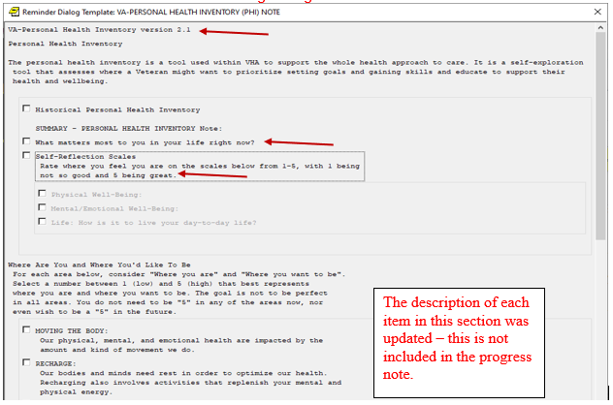

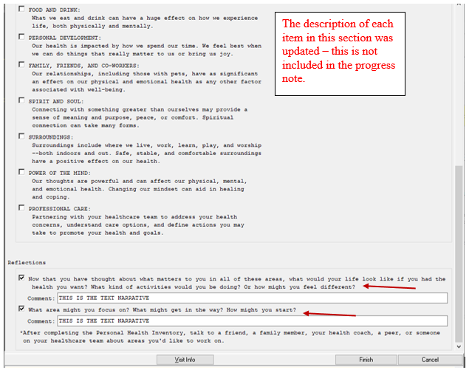
10 not in PN

UPDATE_2_0_273 contains 1 Reminder Exchange entry:
UPDATE_2_0_273 VA-PERSONAL HEALTH INVENTORY (PHI) NOTE UPDATE

The exchange file contains the following components:

HEALTH FACTORS
VA-REMINDER UPDATES [C]
VA-UPDATE_2_0_273
VA-PERSONAL HEALTH INVENTORY [C]
VA-PHI REFLECTIONS AREAS TO WORK ON
VA-PHI REFLECTIONS VISION BEST SELF
VA-PHI PROFESSIONAL CARE TO BE
VA-PHI PROFESSIONAL CARE NOW
VA-PHI POWER OF MIND TO BE
VA-PHI POWER OF MIND NOW
VA-PHI SURROUNDINGS TO BE
VA-PHI SURROUNDINGS NOW
VA-PHI SPIRIT AND SOUL TO BE
VA-PHI SPIRIT AND SOUL NOW
VA-PHI FAMILY AND FRIENDS TO BE
VA-PHI FAMILY AND FRIENDS NOW
VA-PHI PERSONAL DEVELOPMENT TO BE
VA-PHI PERSONAL DEVELOPMENT NOW
VA-PHI FOOD AND DRINK TO BE
VA-PHI FOOD AND DRINK NOW
VA-PHI RECHARGE TO BE
VA-PHI RECHARGE NOW
VA-PHI WORKING THE BODY TO BE
VA-PHI WORKING THE BODY NOW
VA-PHI DAY TO DAY LIFE WHY
VA-PHI DAY TO DAY LIFE
VA-PHI PHYSICAL WELL BEING WHY
VA-PHI PHYSICAL WELL BEING
VA-PHI MENTAL/EMOTIONAL WELL BEING WHY
VA-PHI MENTAL/EMOTIONAL WELL BEING
VA-PHP [C]
VA-PHP MAP

REMINDER SPONSOR
OFFICE OF PATIENT CENTERED CARE AND CULTURAL TRANSFORMATION

REMINDER TERM
VA-REMINDER UPDATE_2_0_273

REMINDER DIALOG
VA-PERSONAL HEALTH INVENTORY (PHI) NOTE

Install Details

This update is being distributed as a web host file. The address for the host file is: https://REDACTED /UPDATE_2_0_273_1.PRD

The file will be installed using Reminder Exchange, programmer access is not required.

Installation:
=============
This update can be loaded with users on the system. Installation will take less than 2 minutes.

Install Example
To Load the Web Host File. Navigate to Reminder exchange in Vista
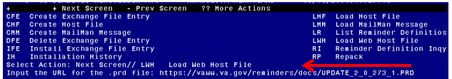
At the Select Action: prompt, enter LWH for Load Web Host File
At the Input the url for the .prd file: prompt, type the following web address:
https://REDACTED/UPDATE_2_0_273_1.PRD
You should see a message at the top of your screen that the file successfully loaded.

Search and locate an entry titled UPDATE_2_0_273 VA-PERSONAL HEALTH INVENTORY (PHI) NOTE UPDATE in reminder exchange
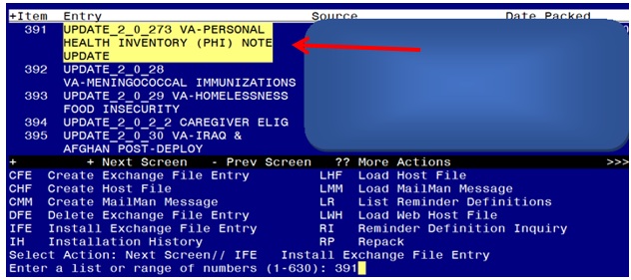

At the Select Action prompt, enter IFE for Install Exchange File Entry
Enter the number that corresponds with your entry titled UPDATE_2_0_273 VA-PERSONAL HEALTH INVENTORY (PHI) NOTE UPDATE (in this example it is entry 391, it will vary by site) The exchange file date should be 03/18/2022.

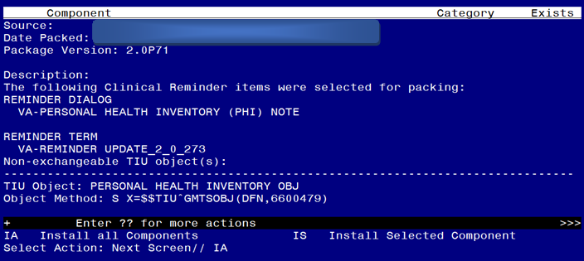
At the Select Action prompt, type IA for Install all Components and hit enter.
Select Action: Next Screen// IA Install all Components

During the installation, you will see several prompts: *Note that you will Install all new components* If you are prompted to overwrite any items, choose SKIP.
You will be promped to install the dialog component, you should Install All even though all components will have an X in the “Exists” column:
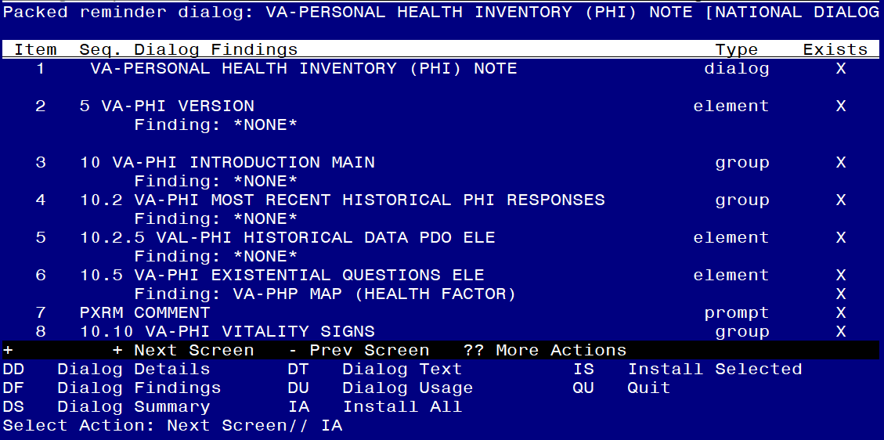
At the Select Action prompt, type IA to install the dialog – VA-PERSONAL HEALTH INVENTORY (PHI) NOTE
Select Action: Next Screen// IA Install All
Install reminder dialog and all components with no further changes: Y// ES

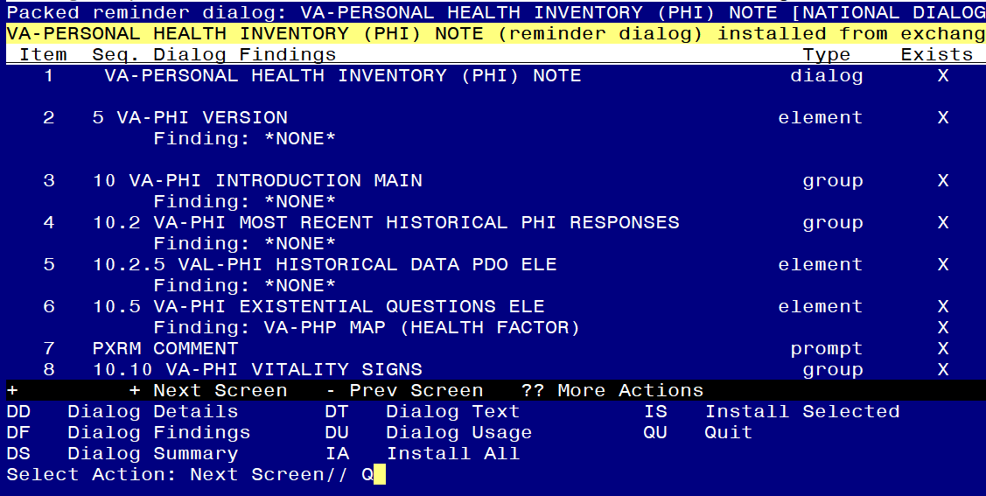
When the dialog has completed installation, you will then be returned to this screen. At the Select Action prompt, type Q.

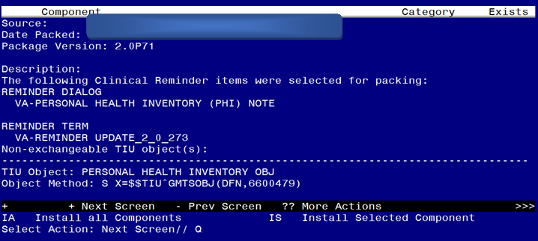
You will be returned to this screen. Type Q to quit.

Install Completed

Post Installation

- Open the note titled PERSONAL HEALTH INVENTORY NOTE (Reminder dialog VA-PERSONAL HEALTH INVENTORY (PHI) NOTE) and confirm the version is 2.1.

