Update_2_0_281

Clinical Reminders

VA-MISC Update 18

Install Guide

August 2022

Product Development
Office of Information Technology
Department of Veterans Affairs

Table of Contents
Introduction 1
Pre-Installation 3
Install Details 3
Install Example 4
Post Installation 9

Introduction

This update contains minor spelling corrections and other changes/edits to existing clinical reminder content, a full list of the changes can be found here:

REDACTED URL

UPDATE_2_0_281 contains 1 Reminder Exchange entry:
UPDATE_2_0_281 VA-MISC UPDATE 18

The exchange file contains the following components:

REMINDER GENERAL FINDINGS
VIEW PROGRESS NOTE TEXT

TIU TEMPLATE FIELD
DISPLAY TEXT SP THOGHTS DESCRIPTION
VA-NSG CDC TRAVELERS HEALTH WEBSITE
VA-OSP COUPLES COACH
VA-OSP SAFE OPIOID USE
VA-OSP OUD MED
VA-RAI SCORE TEXT
WWW RAI FRAILTY
VA SP 3 LINES
VA-OTHER TEXT
VA-OSP VHB URL

HEALTH FACTORS
VA-REMINDER UPDATES [C]
VA-UPDATE_2_0_281
VA-RAI FRAILTY TOOL [C]
VA-RAI FRAILTY SCORE
VA-RAI FRAILTY SCORE WITHOUT CANCER
VA-MIMTF EDU TYPE OF EDUCATION PROVIDED [C]
VA-MIMTF VERBAL EDUCATION AND UNDERSTANDING
VA-SUICIDE RISK ASSESSMENT [C]
VA-SUICIDE RISK CHRONIC INTERMEDIATE
CARE COORDINATION AND INTEGRATED CASE MANAGEMENT [C]
VA-CCRT PREVIOUS DOM SW
VA-CCRT PREVIOUS DOM RN
VA-PAVE PODIATRY FOOT EXAM [C]
VA-PAVE NO DIFFICULTY EXAMING FEET
VA-PAVE DOES NOT KNOW HOW TO EXAMINE FEET
VA-PAVE DIFFICULTY REACHING FEET
VA-PAVE DIFFICULTY SEEING FEET
VA-PAVE PATIENT HAS DIFFICULTY EXAMINING FEET
ONCOLOGY (ONC) COLORECTAL (CRC) WORKUP [C]
ONC CRC BRAF WILD TYPE
ONC CRC NRAS WILD TYPE
ONC CRC KRAS WILD TYPE
ONCOLOGY (ONC) LUNG CANCER DIAGNOSES [C]
ONC LUNG EGFR TEST-WILD TYPE
HYPERTENSION [C]
VA-HTN REFERRED OTHER
VA-HTN REFERRED TO TELEHEALTH
HTN REFERRED TO MOVE
HTN REFERRED TO DIETICIAN
HTN REFERRED TO PACT PHARMACIST

REMINDER SPONSOR
MENTAL HEALTH SERVICES
VHA ONCOLOGY

REMINDER LOCATION LIST
VA-PODIATRY VISITS (OP)

REMINDER TERM
VA-PAVE SEEN BY PODIATRY
VA-REMINDER UPDATE_2_0_281

REMINDER DIALOG
VA-GP MISC UPDATE 18

Pre-Installation

Prior to installing this Update:

- Check Reminder Exchange Install History (IH) and ensure your facility has installed the following (previously released) Updates:

  - UPDATE_2_0_106 VA-ONCOLOGY DIALOG UPDATES
  - UPDATE_2_0_198 VA-MH HIGH RISK FOR SUICIDE PATIENT RECORD FLAG
  - UPDATE_2_0_221 VA-RAI FRAILTY TEMPLATE
  - UPDATE_2_0_226 VA-VA VIDEO CONNECT (VVC) BLOOD PRESSURE UPDATE
  - UPDATE_2_0_240 VA-PAVE REMINDER AND TEMPLATE
  - UPDATE_2_0_256 VA-MEDICATION EDUCATION REVIEW TEMPLATE
  - UPDATE_2_0_260 VA-CPAP/BIPAP/HMV PHILIPS RESPIRONICS RECALL DIAOG

- From the Reminder Dialog Management menu, Inquire/Print (INQ) and capture/save the following ELEMENTS:

Identify any orders that you have as additional findings on the following elements, there are elements with the same referrals in this dialog. Re-mapping steps of these orders are outlined in the Post-Installation steps.

- Element: VA-TH VVC HTN REFERRAL PHARM
- Element: VA-TH VVC HTN REFERRAL DIETITIAN
- Element: VA-TH VVC HTN REFERRAL MOVE
- Element: VA-TH VVC HTN REFERRAL HT
- Element: VAL-TH VVC HTN REFERRAL OTHER

NOTE: The Element name(s) in your system may begin with prefix “VAL-“ vs. “VA-“

- From the Reminder Term Management menu, inquire on the following Reminder Term and capture/save the output, so you can remap any locally map Finding Items during the Post Installation steps:

  - REMINDER TERM: VA-PAVE SEEN BY PODIATRY

Install Details

This update is being distributed as a web host file. The address for the host file is: https://REDACTED/UPDATE_2_0_281.PRD

The file will be installed using Reminder Exchange, programmer access is not required.

Installation:
=============
This update can be loaded with users on the system. Installation will take less than 15 minutes.

Install Example
To Load the Web Host File. Navigate to Reminder exchange in Vista

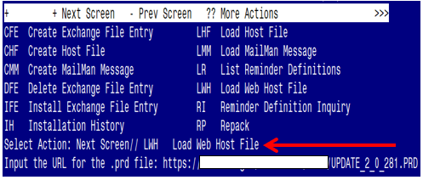

At the Select Action: prompt, enter LWH for Load Web Host File
At the Input the url for the .prd file: prompt, type the following web address:
https://REDACTED/UPDATE_2_0_281.PRD
You should see a message at the top of your screen that the file successfully loaded.

Search for and locate the reminder exchange entry titled UPDATE_2_0_281 VA-MISC UPDATE 18.

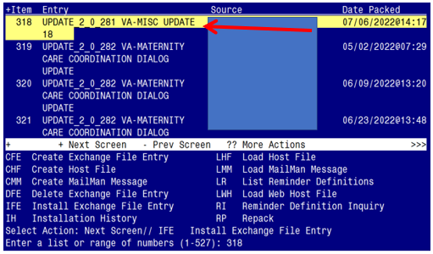

At the Select Action prompt, enter IFE for Install Exchange File Entry
Enter the number that corresponds with your entry titled UPDATE_2_0_281 VA-MISC UPDATE 18 (in this example it is entry 318, it will vary by site). The exchange file date should be 07/06/2022@14:17.
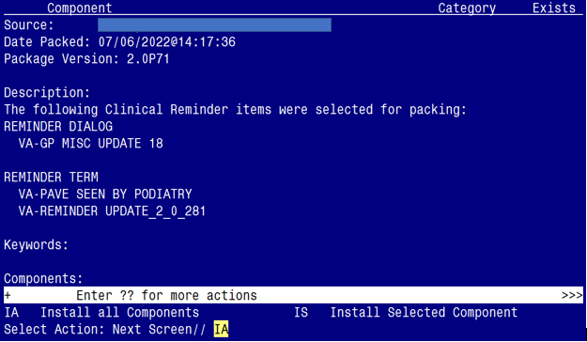

At the Select Action prompt, type IA for Install all Components and hit enter.
Select Action: Next Screen// IA Install all Components

You will see several prompts:

1 - For all new components, choose I to Install
2 - For existing components, choose O to Overwrite.

Individual components for which you may (or may not) be prompted are listed below, along with the response you should provide.

TIU TEMPLATE FIELD entry DISPLAY TEXT SP THOUGHTS DESCRIPTION is NEW,
what do you want to do?

Select one of the following:

C Create a new entry by copying to a new name
I Install
Q Quit the install
S Skip, do not install this entry

Enter response: I// nstall

TIU TEMPLATE FIELD entry VA-OSP COUPLES COACH is NEW,
what do you want to do?

Select one of the following:

C Create a new entry by copying to a new name
I Install
Q Quit the install
S Skip, do not install this entry

Enter response: I// nstall

TIU TEMPLATE FIELD entry VA-OSP OUD MED is NEW,
what do you want to do?

Select one of the following:

C Create a new entry by copying to a new name
I Install
Q Quit the install
S Skip, do not install this entry

Enter response: I// nstall

TIU TEMPLATE FIELD entry VA-OSP VHB URL already exists but
the packed component is different, what do you want to do?

what do you want to do?

Select one of the following:

C Create a new entry by copying to a new name
O Overwrite the current entry
U Update
Q Quit the install
S Skip, do not install this entry

Enter response: O// verwrite the current entry

HEALTH FACTORS entry VA-UPDATE_2_0_281 is NEW,
what do you want to do?

Select one of the following:

C Create a new entry by copying to a new name
I Install
Q Quit the install
S Skip, do not install this entry

Enter response: I// nstall

HEALTH FACTORS entry VA-MIMTF VERBAL EDUCATION AND UNDERSTANDING is NEW,
what do you want to do?

Select one of the following:

C Create a new entry by copying to a new name
I Install
Q Quit the install
S Skip, do not install this entry

Enter response: I// nstall

REMINDER TERM entry VA-REMINDER UPDATE_2_0_281 is NEW,
what do you want to do?

Select one of the following:

C Create a new entry by copying to a new name
I Install
Q Quit the install
S Skip, do not install this entry

Enter response: I// nstall

REMINDER TERM entry named VA-PAVE SEEN BY PODIATRY already exists but
the packed component is different, what do you want to do?

Select one of the following:

C Create a new entry by copying to a new name
M Merge findings
O Overwrite the current entry
U Update
Q Quit the install
S Skip, do not install this entry

Enter response: O// Overwrite the current entry
Are you sure you want to overwrite? N// y YES

You will be promped to install the dialog component:

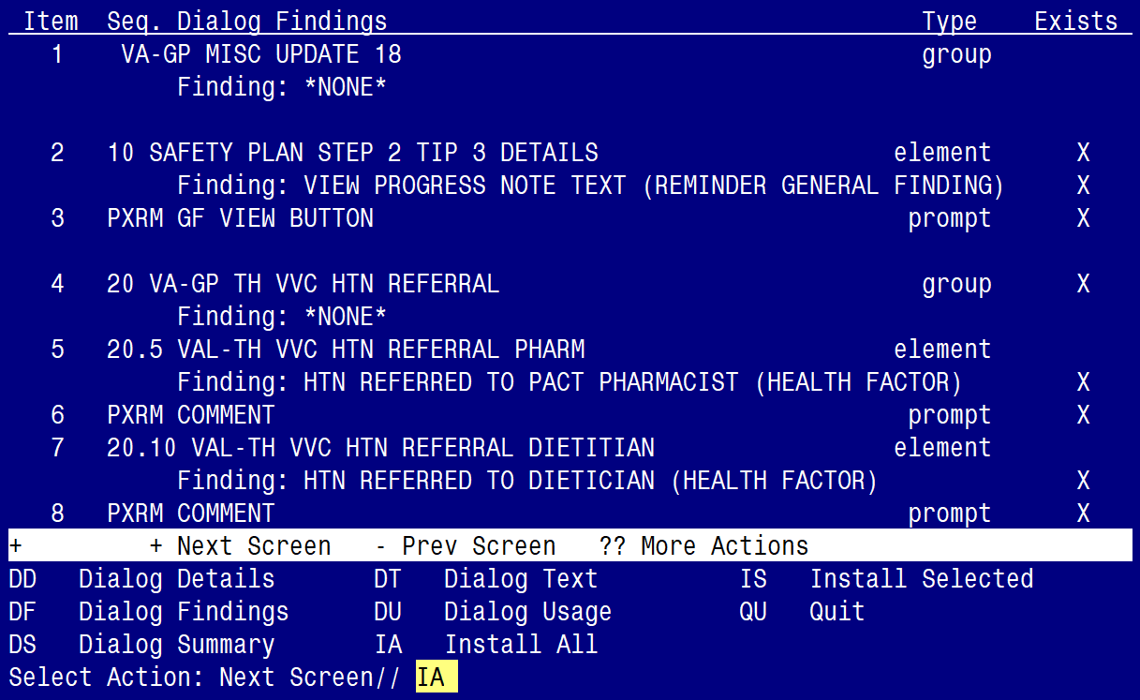

At the Select Action prompt, type IA to install the dialog – VA-GP MISC UPDATE 18
Select Action: Next Screen// IA Install All
Install reminder dialog and all components with no further changes: Y// ES

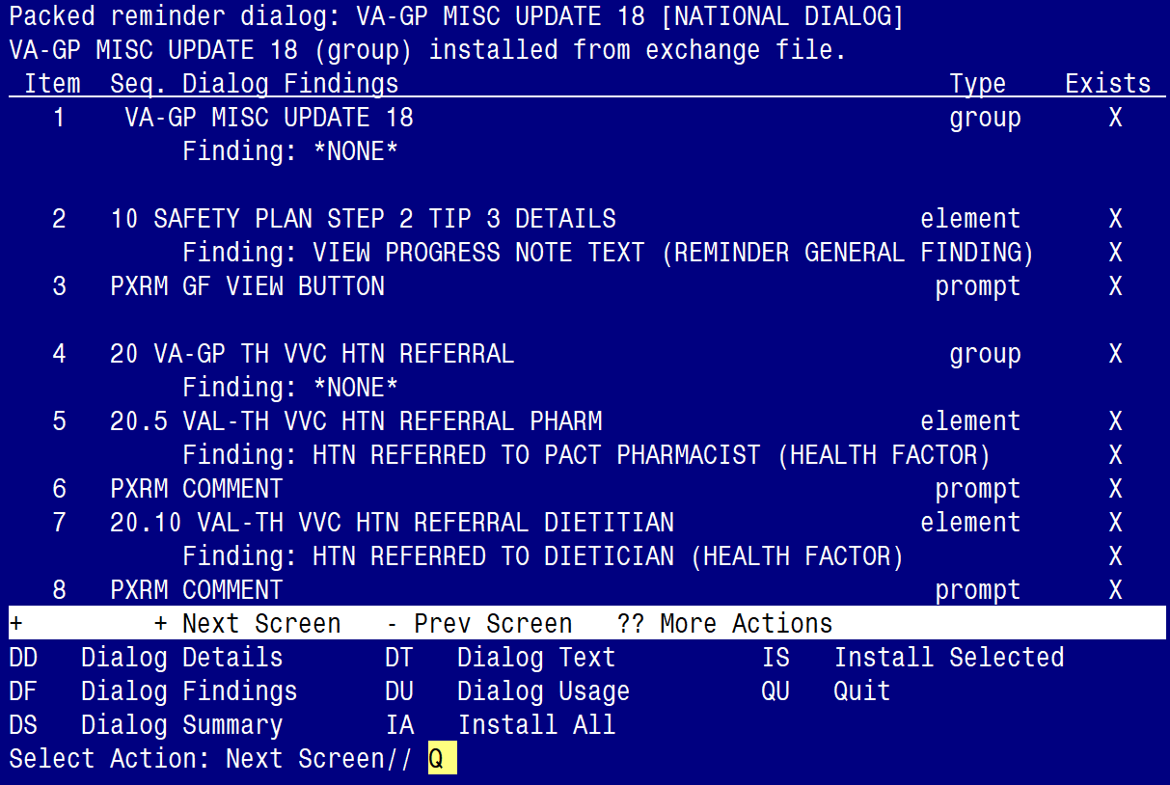

When the dialog has completed installation, you will then be returned to this screen. At the Select Action prompt, type Q.

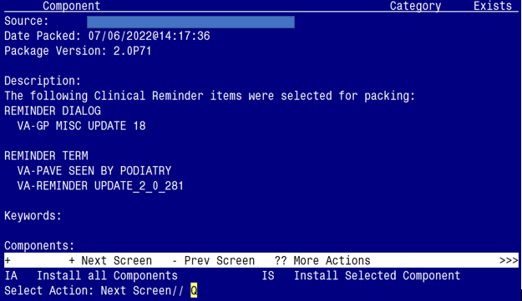

You will be returned to this screen. Type Q to quit.

Install Completed

Post Installation

- Refer to the Inquire/Print (INQ) you saved during the Pre-Installation steps for the following ELEMENTS:

Re-map any orders you captured in the INQ from the Pre-Install step to the additional findings on the following elements. (Take Note: four of the element prefixes changed from “VA-“ to “VAL-“, and are now set to local class)

Element: VAL-TH VVC HTN REFERRAL PHARM
Element: VAL-TH VVC HTN REFERRAL DIETITIAN
Element: VAL-TH VVC HTN REFERRAL MOVE
Element: VAL-TH VVC HTN REFERRAL HT
Element: VAL-TH VVC HTN REFERRAL OTHER

- From the Reminder Term Management menu, inquire on the following Reminder Term and capture/save the output, so you can remap any locally map Finding Items during the Post Installation steps:

Reminder Term: VA-PAVE SEEN BY PODIATRY

