Update _2_0_282

Clinical Reminders

VA-MATERNITY CARE COORDINATION DIALOG UPDATE
Install Guide

July 2022

Product Development
Office of Information Technology
Department of Veterans Affairs

Table of Contents
Introduction 1
Pre-Installation 10
Install Details 10
Install Example 11
Post Installation 19

Introduction
The Maternity Care Coordinator (MCC) reminder dialog was updated to embed the pregnancy/intentions/contraception dialog and remove duplicated information from the dialog. These change allow MCCs to complete their work in a single dialog as opposed to the current two, with increases in efficiencies. This version of the pregnancy dialog includes an expanded medication review for those not/unknown to be pregnant with expanded documentation options.

This dialog is sponsored by the Women Veterans Health Program.

The Pregnancy/Intentions/Contraception dialog edits are as follows:
- Yes, PREGNANT - and veteran patient has potentially harmful medications on file, the options below will show; otherwise the option is suppressed.
Before:

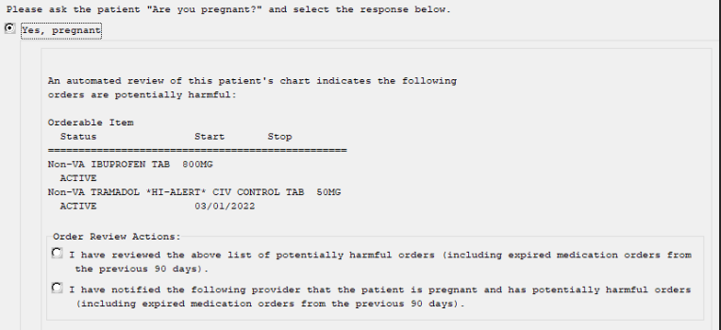

After:

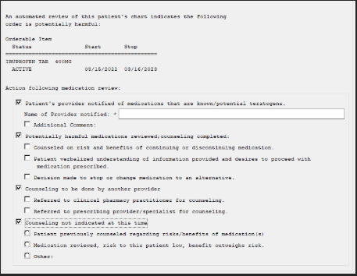
- No, NOT PREGNANT – The same items appear if NOT pregnant or unknown, but counseling options differ.
Before: << no counseling options existed previously >>

After (only if medications exist that fit the criteria):

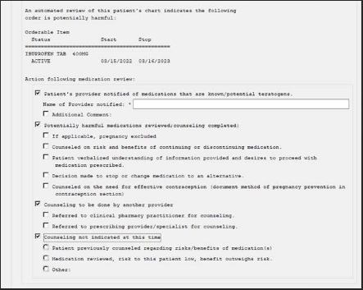
- Yes, LACTATING – Because there are options in the Pregnancy dialog to indicate the patient is lactating, the counseling options in the Lactating reminder were also updated.
Before:

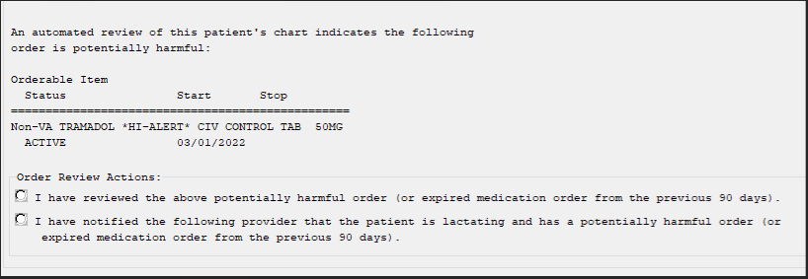

After:

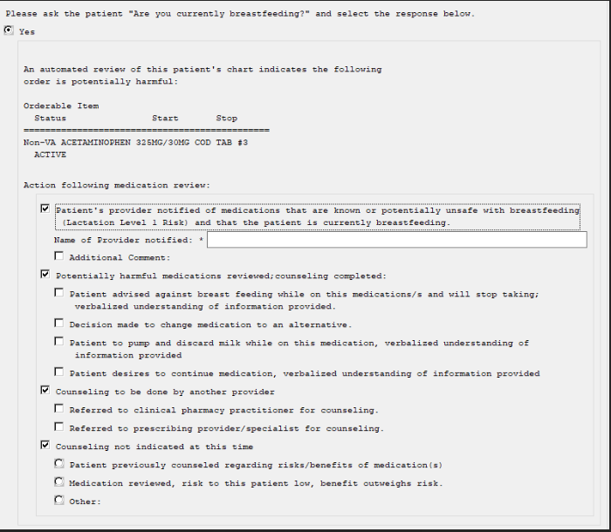
UPDATE_2_0_282 contains 1 Reminder Exchange entry:
UPDATE_2_0_282 VA-MATERNITY CARE COORDINATION DIALOG UPDATE

The exchange file contains the following components:

ROUTINE:
PXRMCALT
PXRMCDEF
PXRMCWH1
PXRMDATE
PXRMPDEM

MH TESTS AND SURVEYS
PHQ-2

REMINDER GENERAL FINDINGS:
LACTATION END DATE
PATIENT IS NOT LACTATING
PATIENT IS LACTATING
WH-LACTATION DATA SOURCE
PREGNANCY ENDED REASON MATERNAL MORTALITY
PREGNANCY ENDED REASON VAGINAL DELIVERY AND CSECTION
PREGNANCY ENDED REASON ECTOPIC
PREGNANCY ENDED REASON TERMINATION
PREGNANCY ENDED REASON MISCARRIAGE
PREGNANCY ENDED REASON STILLBIRTH
PREGNANCY ENDED REASON C SECTION
PREGNANCY ENDED REASON VAGINAL DELIVERY
PREGNANCY END DATE
HYSTEROSCOPIC STERILIZATION
LAPAROSCOPIC STERILIZATION
NO CURRENT PARTNER
WITHDRAWAL
EMERGENCY CONTRACEPTION
NATURAL FAMILY PLANNING
SPERMICIDE ALONE
CONTRACEPTIVE SPONGE
CERVICAL CAP WITH SPERMICIDE
DIAPHRAGM WITH SPERMICIDE
FEMALE CONDOM
MALE CONDOM
CONTRACEPTIVE PILL, RING OR PATCH
CONTRACEPTIVE SHOT
CURRENT PARTNER
CONTRACEPTIVE IMPLANT
IUD
NOTHING
PATIENT IS UNSURE ABOUT BECOMING PREGNANT
PATIENT DOES NOT WANT TO BECOME PREGNANT
PATIENT WANTS TO BECOME PREGNANT
PATIENT DOES NOT KNOW PREGNANCY STATUS
PATIENT IS NOT PREGNANT
OVERRIDE CALCULATED EDD REASON
EXPECTED DUE DATE
LAST MENSTRUAL PERIOD DATE
PATIENT IS PREGNANT
PATIENT MEDICALLY ABLE TO CONCEIVE
MEDICAL REASON
PATIENT MEDICALLY UNABLE TO CONCEIVE
WH-PREGNANCY DATA SOURCE
CLEAR ALL FOR ALL USER
PREGNANCY CLEAR SMART DATA
PREGNANCY ALERT ID
WH-TD PREGNANCY EDIT RECORD
WH-TD LACTATION EDIT RECORD
VIEW PROGRESS NOTE TEXT
TICKLER REMINDER COMMENT
TICKLER REMINDER

REMINDER DIALOG FUNCTION FILE
DATE_HIST
DATE_DIFF
DATE_OFFSET

REMINDER DIALOG LINK TYPE
VA-WH UPDATE HISTORICAL FV
VA-WH HIDE CONTRA OTHER
VA-WH SUPPRESS EDD OVERRIDE PROMPT
VA-WH SET EDD FROM LMPD

TIU TEMPLATE FIELD
WH US SPR LINK
WH US MEC LINK
TEXT NO LIMIT
NUM
TEXT (1-40 CHAR)
VA-MCC BABY SEX
TEXT - ONE LINE ONLY
MCC GESTATE AGE
TEXT (1-60 CHAR)1
DATE
VA-MCC SHAREPOINT SITE
HEALTH FACTORS
VA-REMINDER UPDATES [C]
VA-UPDATE_2_0_282
VA-WH MEDICATION REVIEW [C]
VA-WH MED REVIEW HARMFUL MEDS COUNSELING BY ANOTHER
VA-WH MED REVIEW HARMFUL MEDS COUNSELING NOT INDICATED
VA-WH MED REVIEW HARMFUL MEDS COUNSELING COMPLETED
VA-WH MED REVIEW HARMFUL MEDS NOTIFIED PROVIDER
WH PAP SMEAR [C]
WH HYSTERECTOMY W/CERVIX REMOVED
VA-MCC DELIVERY INFORMATION (C) [C]
VA-MCC COMPLICATION GEST DIABETES
VA-MCC COMPLICATION DVT/PE
VA-MCC COMPLICATION POSTPARTUM DEPR
VA-MCC COMPLICATION NONE
VA-MCC COMPLICATION INFECTIONS
VA-MCC COMPLICATION HEMORRHAGE
VA-MCC COMPLICATION ECLAMPSIA
VA-MCC COMPLICATION PREECLAMPSIA
VA-MCC COMPLICATION GEST HYPERTENSION
VA-MCC BABY #3 WT ABOVE NORMAL
VA-MCC BABY #3 WT NORMAL
VA-MCC BABY #3 WT BELOW NORMAL
VA-MCC BABY #2 WT ABOVE NORMAL
VA-MCC BABY #2 WT NORMAL
VA-MCC BABY #2 WT BELOW NORMAL
VA-MCC BABY #1 WT ABOVE NORMAL
VA-MCC BABY #1 WT NORMAL
VA-MCC BABY #1 WT BELOW NORMAL
VA-MCC BIRTH MULTIPLES
VA-MCC BIRTH TWINS
VA-MCC BIRTH SINGLETON
VA-MCC LIVE BIRTH
VA-MCC CALLS (C) [C]
VA-MCC UNABLE TO CONTACT
VA-MCC BREASTFEEDING [C]
VA-MCC BREASTFEED PLANS TO
VA-MCC BREASTFEED ISSUES
VA-MCC BREASTFEED NO ISSUES
VA-MCC BREASTFEED PT NOT INTERESTED
VA-MCC BREASTFEED SUPPLIES RECEIVED
VA-MCC BREASTFEED SUPPLIES ORDERED
VA-MCC INTIMATE PARTNER VIOLENCE (C) [C]
VA-MCC IPV DISCUSSED
VA-MCC DEPRESSION (C) [C]
VA-MCC DEPRESSION SCREEN POSITIVE
VA-MCC DEPRESSION SCREEN INTERMEDIATE
VA-MCC DEPRESSION SCREEN NEGATIVE
VA-MCC ALCOHOL USE (C) [C]
VA-MCC ALCOHOL DOES CONSUME
VA-MCC ALCOHOL DOES NOT CONSUME
VA-MCC TOBACCO USE (C) [C]
VA-MCC TOBACCO SMOKES RECENTLY QUIT
VA-MCC TOBACCO SMOKES CONTEMPLATE QUIT
VA-MCC TOBACCO SMOKES YES
VA-MCC TOBACCO SMOKES DOES NOT
VA-MCC HISTORY OF HEALTH PROBLEMS (C) [C]
VA-MCC HISTORY OF PTSD
VA-MCC HISTORY OF MH NOT SPECIFIED
VA-MCC HISTORY OF DEPRESSION/MH DISORDER
VA-MCC HISTORY OF BIPOLAR DISORDER
VA-MCC HISTORY OF ANXIETY
VA-MCC HISTORY OF SUBSTANCE ABUSE
VA-MCC HISTORY OF OBESITY
VA-MCC HISTORY OF THYROID
VA-MCC HISTORY OF STI
VA-MCC HISTORY OF SEIZURE DISORDER
VA-MCC HISTORY OF RENAL DISEASE
VA-MCC HISTORY OF LUPUS
VA-MCC HISTORY OF HYPERTENSION
VA-MCC HISTORY OF HYPERCOAGULABLE
VA-MCC HISTORY OF HIV
VA-MCC HISTORY OF DIABETES
VA-MCC HISTORY OF CHRONIC PAIN
VA-MCC HISTORY OF ASTHMA
VA-MCC WIC BENEFITS
VA-MCC ADDITIONAL CONTACT
VA-MCC 4TH TRIMESTER CONTACT
VA-MCC 3RD TRIMESTER CONTACT
VA-MCC 2ND TRIMESTER CONTACT
VA-MCC 1ST TRIMESTER CONTACT

REMINDER SPONSOR
WOMEN VETERANS HEALTH PROGRAM
OFFICE OF NURSING INFORMATICS
WOMEN VETERANS HEALTH PROGRAM AND NATIONAL CENTER FOR HEALTH PROMOTION AND DISEASE PREVENTION (NCP)
VHA NATIONAL CENTER FOR HEALTH PROMOTION AND DISEASE PREVENTION (NCP) AND VHA OFFICE OF WOMEN'S HEALTH
MENTAL HEALTH SERVICES

REMINDER COMPUTED FINDING
VA-DATE OF DEATH
VA-SEX
VA-WH PATIENT IS PREGNANT/LACTATING
VA-WH PATIENT DOCUMENTATION
VA-WH UNSAFE ORDER COUNT
VA-SMART PATIENT HAS ALERT
VA-FILEMAN DATE
VA-REMINDER DEFINITION

REMINDER TAXONOMY
VA-WH RECENTLY PREGNANT
VA-WH CURRENTLY PREGNANT
VA-WH TUBAL REANASTOMOSIS (TAXONOMY)
VA-WH TUBAL LIGATION CODES (TAXONOMY)
VA-WH HYSTERECTOMY W/CERVIX REMOVED
VA-WH TERATOGENIC MEDICATIONS EXCLUSIONS TAXONOMY

REMINDER TERM
VA-REMINDER UPDATE_2_0_282
VA-WH BL PREGNANCY CURRENT
VA-WH PREGNANCY ALERT
VA-WH TUBAL REANASTOMOSIS (TERM)
VA-WH TUBAL LIGATION CODES (TERM)
VA-WH PREGNANCY TEST ORDERED
VA-WH BL TD INCOMPLETE MUC
VA-WH BL TD INCOMPLETE DON'T KNOW
VA-WH BL TD INCOMPLETE NOT PREGNANT
VA-WH BL PREGNANCY EDIT END DOCUMENTATION

REMINDER DEFINITION
VA-WH PREGNANCY AND LACTATION DATA ENTRY ALLOWED
VA-WH BL LACTATION ADD END DATE
VA-WH BL POTENTIALLY UNSAFE ORDERS
VA-WH BL POTENTIALLY TERATOGENIC ORDERS
VA-WH MEDICALLY UNABLE TO CONCEIVE
VA-WH UPDATE PREGNANCY STATUS
VA-WH BL PREGNANCY STATUS DOCUMENTATION
VA-WH BL PREGNANCY EDIT END DOCUMENTATION
VA-WH BL LACTATION EDIT END DATE

HEALTH SUMMARY COMPONENT
WH PREGNANCY DOCUMENTATION
PROGRESS NOTES SELECTED

HEALTH SUMMARY TYPE
VA-WH PREGNANCY STATUS
VA-MCC (TIU)

HEALTH SUMMARY OBJECTS
VA-WH PREGANCY STATUS (TIU)
VA-MCC (TIU) (TIU)

TIU DOCUMENT DEFINTION
VA-WH RECENT LACTATION STATUS
VA-WH POTENTIAL UNSAFE ORDERS
VA-WH RECENT PREGNANT STATUS
VA-WH POTENTIAL TERATOGENIC ORDERS
VA-WH PREGNANCY STATUS
VA-WH SRN TEXT PREGNANCY
VA-WH RECENT LABORATORY PREGNANCY TEST
VA-MCC (TIU)
ACTIVE MEDS COMBINED
VA-WRIISC ACTIVE PROBLEMS

REMINDER DIALOG
VA-WH UPDATE PREGANCY STATUS
VA-MATERNITY CARE COORDINATION

Pre-Installation

Prior to installing this Update:

- Check Reminder Exchange Install History (IH) and ensure your facility has installed the following (previously released) Update:

  - UPDATE_2_0_190 VA-MATERNITY CARE COORDINATION UPDATE

- From the Reminder Dialog Management menu, Inquire/Print (INQ) and capture/save the following ELEMENTS:

  - VA-WH TD PREGNANCY ORDER PREGNANCY TEST
  - VA-WH TD PREGNANCY ORDER EMERGENCY CONTRACEPTIVE

Install Details

This update is being distributed as a web host file. The address for the host file is: https://REDACTED/UPDATE_2_0_282.PRD

The file will be installed using Reminder Exchange, programmer access is not required.

Installation:
=============
This update can be loaded with users on the system. Installation will take less than 15 minutes.

Install Example
To Load the Web Host File. Navigate to Reminder exchange in Vista

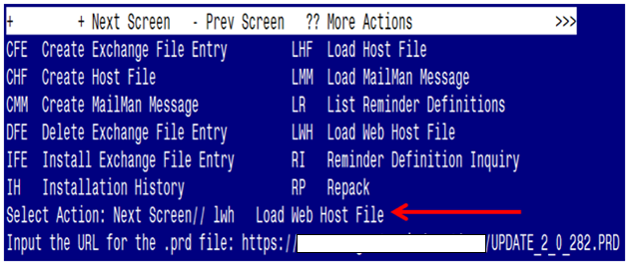

At the Select Action: prompt, enter LWH for Load Web Host File

At the Input the url for the .prd file: prompt, type the following web address:
You should see a message at the top of your screen that the file successfully loaded.
https://REDACTED/UPDATE_2_0_282.PRD

Search reminder exchange and locate an entry titled:
UPDATE_2_0_282 VA-MATERNITY CARE COORDINATION DIALOG UPDATE

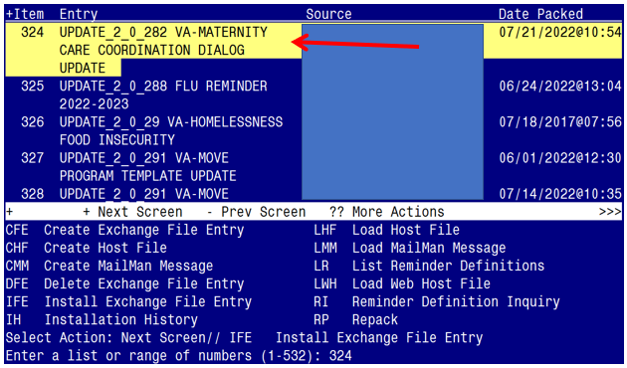

At the Select Action prompt, enter IFE for Install Exchange File Entry
Enter the number that corresponds with your entry:
UPDATE_2_0_282 VA-MATERNITY CARE COORDINATION DIALOG UPDATE
(in this example it is entry 324. It will vary by site). The date of the exchange file should be 07/21/2022@10:54.

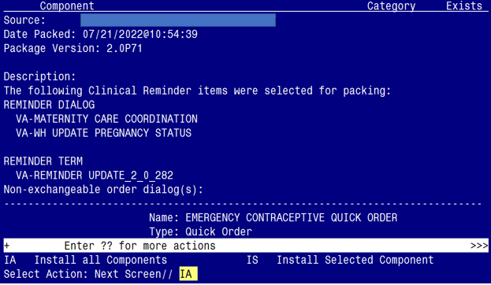

At the Select Action prompt, type IA for Install all Components and hit enter.
Select Action: Next Screen// IA Install all Components
You will see several prompts:

- For all new entries you will choose I to Install
- For (most) components that exist but packed component is different, choose O to Overwrite.
  - Five Exceptions (listed below) – There are five components that exist but packed component is different for which you will need to choose S to Skip.

For the specific components below, make sure you select the responses highlighted for each

- For REMINDER TAXONOMY entry named VA-WH TUBAL LIGATION CODES (TAXONOMY) already exists but the packed component is different, what do you want to do?

Select one of the following:
C Create a new entry by copying to a new name
O Overwrite the current entry
U Update
Q Quit the install
S Skip, do not install this entry

Enter response: O// s Skip, do not install this entry..

- For REMINDER TAXONOMY entry named VA-WH TERATOGENIC MEDICATIONS EXCLUSIONS TAXONOMY already exists but the packed component is different, what do you want to do?

Select one of the following:
C Create a new entry by copying to a new name
O Overwrite the current entry
U Update
Q Quit the install
S Skip, do not install this entry

Enter response: O// s Skip, do not install this entry..

- For REMINDER TERM entry named VA-WH PREGNANCY TEST ORDERED already exists but the packed component is different, what do you want to do?

Select one of the following:
C Create a new entry by copying to a new name
M Merge findings
O Overwrite the current entry
U Update
Q Quit the install
S Skip, do not install this entry
Enter response: O// s Skip, do not install this entry..

- For REMINDER DEFINITION entry named VA-WH UPDATE PREGNANCY STATUS already exists but the packed component is different, what do you want to do?

Select one of the following:
C Create a new entry by copying to a new name
O Overwrite the current entry
U Update
Q Quit the install
S Skip, do not install this entry

Enter response: O// s Skip, do not install this entry..

- For HEALTH SUMMARY TYPE entry named VA-WH PREGNANCY STATUS already exists but the packed component is different, what do you want to do?

Select one of the following:

C Create a new entry by copying to a new name
O Overwrite the current entry
U Update
Q Quit the install
S Skip, do not install this entry

Enter response: O// s Skip, do not install this entry..

You will be promped to install the 1st reminder dialog component
(VA-WH UPDATE PREGNANCY STATUS)

- You will choose to install all even though some components may have an X to indicate that they exist.

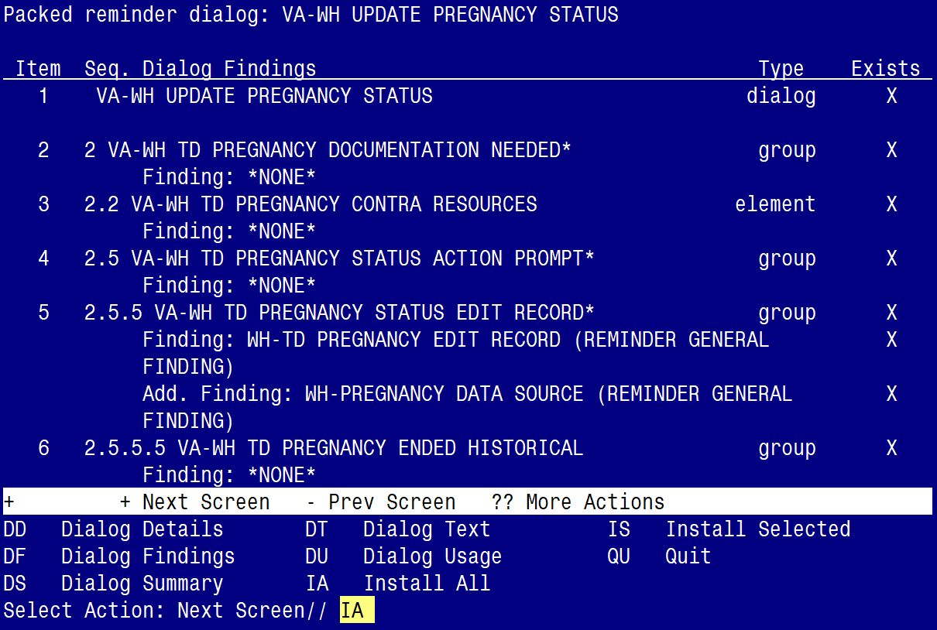

At the Select Action prompt, type IA to install the dialog:
VA-WH UPDATE PREGNANCY STATUS

Select Action: Next Screen// IA Install All
Install reminder dialog and all components with no further changes: Y// Yes

YOU WILL SEE THE FOLLOWING TWO PROMPTS:
(refer to the INQ you saved during the Pre-Installation Steps)

FINDING entry Q.EMERGENCY CONTRACEPTIVE QUICK ORDER does not exist.

Select one of the following:

D Delete
P Replace with an existing entry
Q Quit the install

Enter response: P
Select ORDER DIALOG NAME: enter your local order dialog for emergency contraceptive here
FINDING entry Q.PREGNANCY TEST QUICK ORDER does not exist.

Select one of the following:

D Delete
P Replace with an existing entry
Q Quit the install

Enter response: P
Select ORDER DIALOG NAME: enter your local order dialog for pregnancy test here

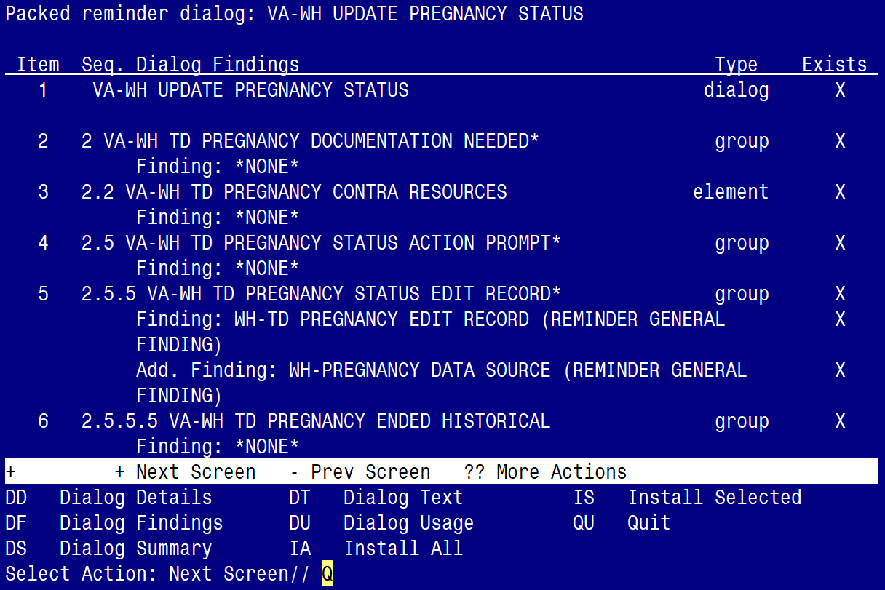

After completing this dialog install, you will type Q.

You will be promped to install the 2nd reminder dialog component
(VA-MATERNITY CARE COORDINATION)

- You will choose to install all even though some components may have an X to indicate that they exist.

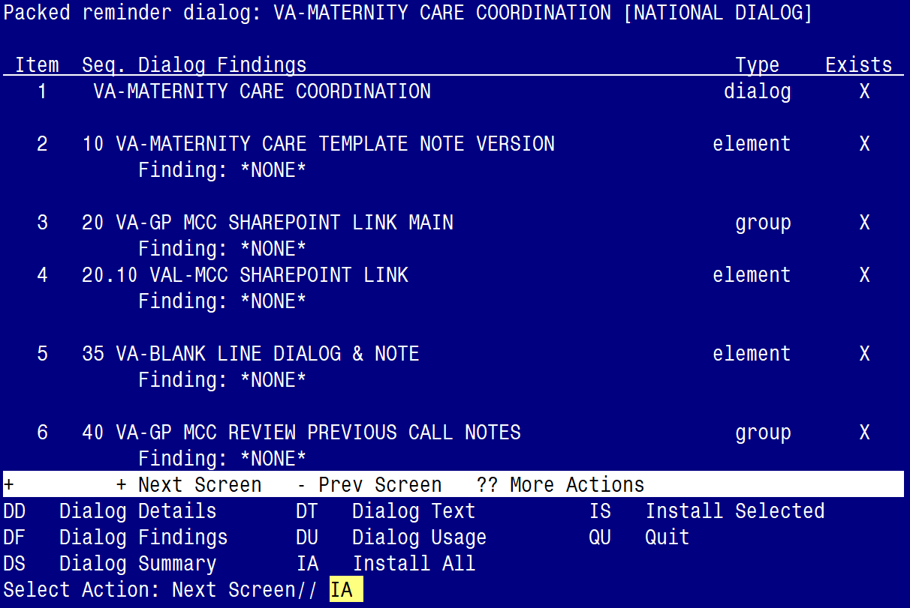

At the Select Action prompt, type IA to install the dialog:
VA-MATERNITY CARE COORDINATION

Select Action: Next Screen// IA Install All
Install reminder dialog and all components with no further changes: Y// Yes

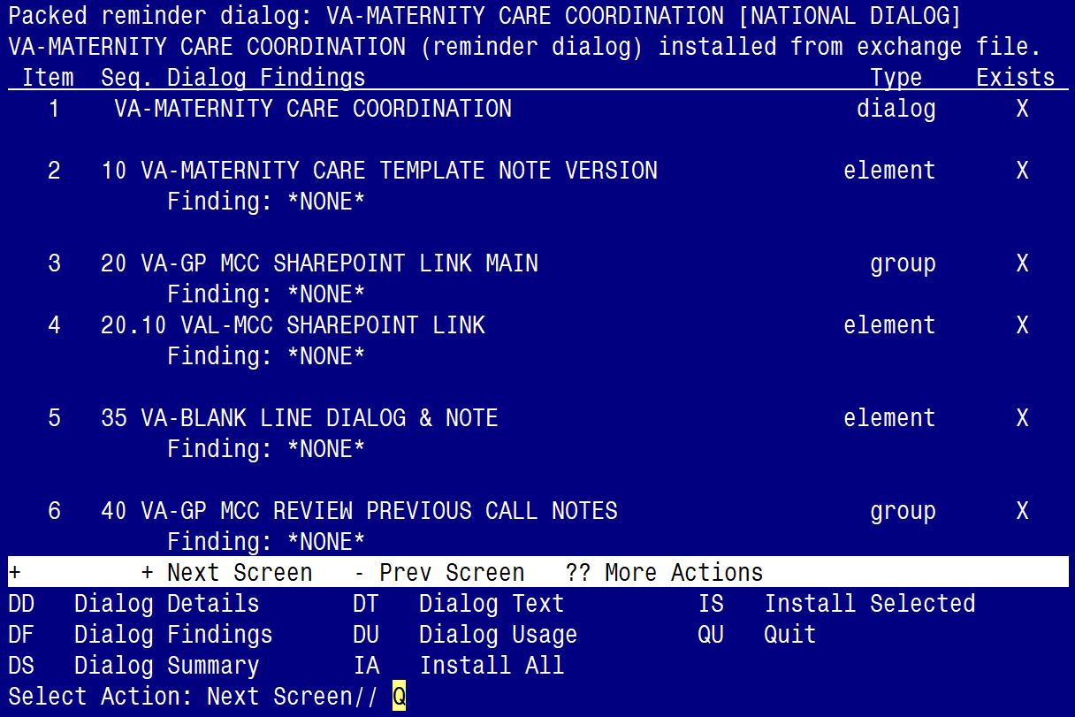

After completing this dialog install, you will type Q.

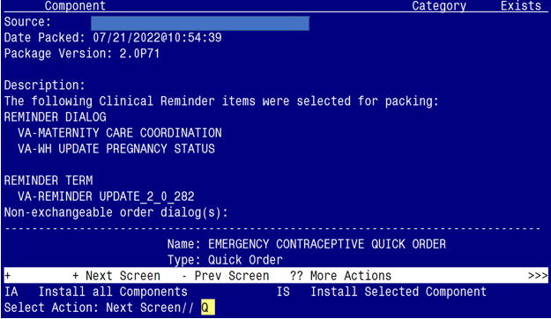

You will then be returned to this screen. At the Select Action prompt, type Q.

Install complete.

Post Installation

- Launch the VA-MATERNITY CARE COORDINATION dialog and confirm the version number is 3.5 (displayed at the top of the dialog). See screenshot below.

  - Launch the dialog using note title: VA-MATERNITY CARE COORDINATION

  - If your site does not have the note title established, refer to the original install guide and the post-installation step instructions for note title creation. The install guide is UPDATE_2_0_190_IG (remainder of location is redacted)

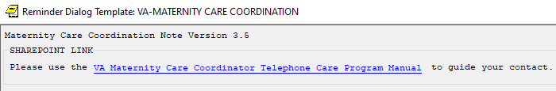

- Confirm the ACTIVE MEDS COMBINED object is added in the Element: VA-MCC MEDS ACTIVE. If not, add your site’s objects for ACTIVE MEDS COMBINED.

Element: VA-MCC MEDS ACTIVE
VA Health Record: |ACTIVE MEDS COMBINED|

- Confirm the VA-WRIISC ACTIVE PROBLEMS object is added in the Element: VA-MCC HEALTH PROBLEM LIST. If not, add your site’s objects for ACTIVE PROBLEMS.

Element: VA-MCC HEALTH PROBLEM LIST
Active Problems: |VA-WRIISC ACTIVE PROBLEMS|

- Confirm quick orders are re-mapped. Refer to the Inquire/Print (INQ) you saved from the pre-installation instructions to confirm the quick orders are mapped to the Finding Items of the two ELEMENT below:

  - VA-WH TD PREGNANCY ORDER PREGNANCY TEST

  - VA-WH TD PREGNANCY ORDER EMERGENCY CONTRACEPTIVE

- Confirm the VA-MCC (TIU) Health Summary Type is set with the SPN component and the VA-MATERNITY CARE COORDINATION title is mapped as a selection (see screenshot below)

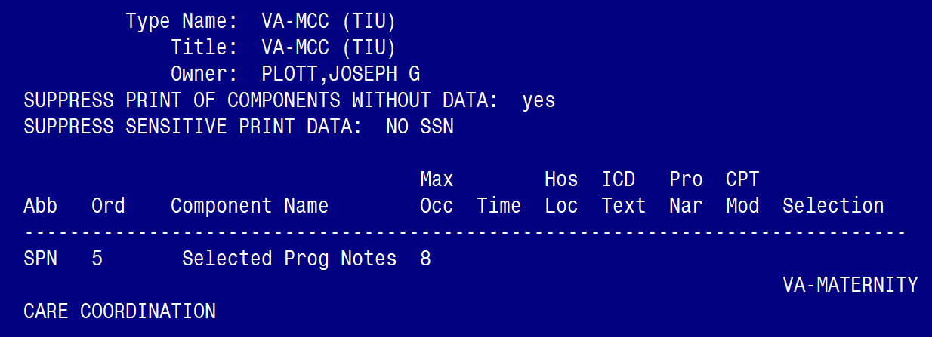

If not, complete the action below to add the SPN component to the VA-MCC (TIU) Health Summary Type:

Select Health Summary Maintenance Menu <TEST ACCOUNT> Option: 6 Create/Modify Health Summary Type

Select Health Summary Type: VA-MCC (TIU)

VA-Mcc (TIU)
OK? YES//

WARNING: You are about to edit a Health Summary Type that is being used
by a Health Summary Object. Changing the structure of this Health Summary
Type will alter how the Object will display.

Do want to continue? NO// y YES
NAME: VA-MCC (TIU)//
TITLE: VA-MCC (TIU)//
SUPPRESS PRINT OF COMPONENTS WITHOUT DATA: yes//
SUPPRESS SENSITIVE PRINT DATA: NO SSN//
LOCK:
OWNER: << your name here >>

Do you wish to copy COMPONENTS from an existing Health Summary Type? YES// NO
Select COMPONENT: SPN PROGRESS NOTES SELECTED SPN
SUMMARY ORDER: 5// 5
OCCURRENCE LIMIT: 8
TIME LIMIT:
HEADER NAME: Selected Prog Notes//

No selection items chosen.
Select new items one at a time in the sequence you want them displayed.
You may select any number of items.
Select SELECTION ITEM: VA-MATERNITY CARE COORDINATION

Searching for a TIU DOCUMENT DEFINITION, (pointed-to by SELECTION ITEM)

Searching for a TIU DOCUMENT DEFINITION
VA-MATERNITY CARE COORDINATION TITLE
Std Title: WOMENS HEALTH PROGRESS NOTE
...OK? Yes// (Yes)

Select SELECTION ITEM:
Select COMPONENT:
Do you wish to review the Summary Type structure before continuing? NO//

