

**Update _2_0_284**

Clinical Reminders

TERATOGENIC MEDICATIONS UPDATE 2022_02

Install Guide

**October 2022**

Product Development

Office of Information Technology

Department of Veterans Affairs

Table of Contents

Introduction 1

Install Details 6

Pre-Installation 10

Installation 10

Install Example 10

Post-Install Set-up Instructions 15

# Introduction

UPDATE_2_0_284 contains 1 Reminder Exchange entry: **UPDATE_2_0_284 VA-TERATOGENIC MEDS ORDER CHECKSUPDATE 2022_02**

The Teratogenic Medications Order Check Interim Solution was originally released as VistA patch PXRM*2*22 in July 2012. The interim solution is intended to have regular updates for clinical content, primarily to add newly approved medications that have a noted risk during pregnancy and that warrant an order check. This update, UPDATE_2_0_284 represents the second update in 2022.

Below are the changes:

1. These reminder order check rules were updated to include a statement that “Such counseling must be documented in the medical record by the  prescriber”.

VA-WH HIRISK MEDS (LACT 1) EXPIRED DOC RULE

VA-WH HIRISK MEDS (LACT 1) RULE

VA-WH HIRISK MEDS (LACT 2) EXPIRED DOC RULE

VA-WH HIRISK MEDS (LACT 2) RULE

1. These reminder order check rules were updated to replace the word “mother” with “pregnant patient”.

VA-WH HIRISK MEDS (MODERATE/HIGH RISK) NO PREG DOC RULE

VA-WH HIRISK MEDS (MODERATE/HIGH RISK) NOT PREG RULE

VA-WH HIRISK MEDS (MODERATE/HIGH RISK) PREG RULE

1. These reminder order check rules were updated to have the OUTPUT TEXT set to ORDER CHECK TEXT ONLY and the following text was added to the end of the Order Check text:

****************************************************************

The 'High Risk Items' order check will display for birth sex=female patients between the ages of 10 and 47 except those with a known exclusion criterion (e.g., hysterectomy), those with a documented tubal ligation that is more recent than a documented tubal reanastomosis or those documented as medically unable to conceive.

VA-WH HIRISK MEDS (EXTREME RISK) NO PREG DOC RULE

VA-WH HIRISK MEDS (EXTREME RISK) NOT PREG RULE

VA-WH HIRISK MEDS (EXTREME RISK) PREG RULE

VA-WH HIRISK MEDS (MODERATE/HIGH RISK) NO PREG DOC RULE

VA-WH HIRISK MEDS (MODERATE/HIGH RISK) NOT PREG RULE

VA-WH HIRISK MEDS (MODERATE/HIGH RISK) PREG RULE

1. The reminder definitions below were updated to change the baseline frequency and General Patient Cohort Found Text:

VA-WH HIRISK ORDER CHECK - NO PREG DOC

VA-WH HIRISK ORDER CHECK - NOT PREGNANT

Before:

Frequency included ages 10 to 52

After:

Frequency includes ages 10 to 47

1. The reminder definitions below were updated to change the baseline frequency:

VA-WH NO PREGNANCY END DOC RPT

Before:

Frequency included ages 10 to 52

After:

Frequency includes ages 10 to 47

1. The reminder definition VA-WH HIRISK ORDER CHECK – PREGNANT was updated – the general cohort found text was updated to indicate the updated age range
2. The reminder definition VA-WH UPDATE PREGNANCY STATUS was updated

Below are the changes to the definition:

VA-WH UPDATE PREGNANCY STATUS

* updated description to indicate new age range
* update baseline frequency age

Before:

Frequency included ages 10 to 52

After:

Frequency included 1 year for ages 10 to 47

* Updated FF7 to indicate new age range

1. VA-WH HIRISK MEDICATIONS (MODERATE/HIGH RISK) GROUP was updated to add the following medications:

**DG.SEMAGLUTIDE  
DG.DULAGLUTIDE**

**DG.APIXABAN**

**DG.EDOXABAN**

**DG.RIVAROXABAN**

**DG.TRAMADOL/CELECOXIB**

**DG.ALPELISIB**

**DG.BEVACIZUMAB-MALY**

**DG.BROLUCIZUMAB-DBLL**

**DG.CILTACABTAGENE AUTOLEUCEL**

**DG.EDARAVONE**

**DG.FARICIMAB-SVOA**

**DG.LUTETIUM DOTATATE,LU-177**

**DG.MAVACAMTEN**

**DG.NIVOLUMAB/RELATLIMAB-RMBW**

**DG.PACRITINIB**

**DG.SIPONIMOD**

**DG.TALAZOPARIB**

**DG.TEBENTAFUSP-TEBN**

**DG.TRALOKINUMAB-LDRM**

**DG.UPADACITINIB**

1. VA-WH HIRISK MEDICATIONS (MOD/HIGH RISK DURING PREGNANCY) GROUP was updated to add the following medications:

**DG.SEMAGLUTIDE  
DG.DULAGLUTIDE**

**DG.APIXABAN**

**DG.EDOXABAN**

**DG.RIVAROXABAN**

**DG.CLONIDINE/KETOROLAC/ROPIVACAINE**

**DG.INCLISIRAN**

**DG.TRAMADOL/CELECOXIB**

**DG.ALPELISIB**

**DG.BEVACIZUMAB-MALY**

**DG.BROLUCIZUMAB-DBLL**

**DG.CILTACABTAGENE AUTOLEUCEL**

**DG.EDARAVONE**

**DG.FARICIMAB-SVOA**

**DG.LUTETIUM DOTATATE,LU-177**

**DG.MAVACAMTEN**

**DG.NIVOLUMAB/RELATLIMAB-RMBW**

**DG.PACRITINIB**

**DG.SIPONIMOD**

**DG.TALAZOPARIB**

**DG.TEBENTAFUSP-TEBN**

**DG.TRALOKINUMAB-LDRM**

**DG.UPADACITINIB**

1. VA-WH HIRISK MEDICATIONS (MODERATE/HIGH RISK) GROUP was updated to remove the following medications:

DG.NICOTINE

DG.NICOTINE POLACRILEX

They remain in the VA-WH HIRISK MEDICATIONS (MOD/HIGH RISK DURING PREGNANCY) GROUP

1. A new reminder dialog template is available for use that can be added to your shared template folder and used to document teratogenic counseling.

The appropriate option will automatically check based on the information in the patient record but the user, can change the selection if needed:

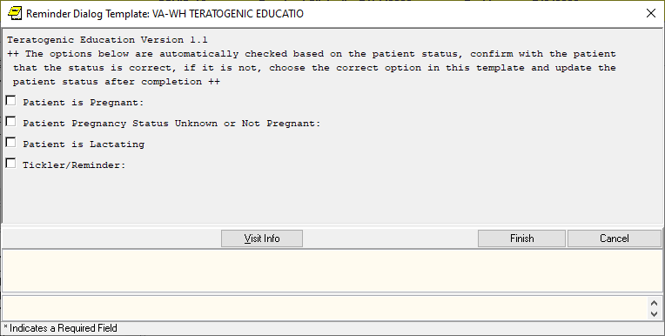

Expanded:

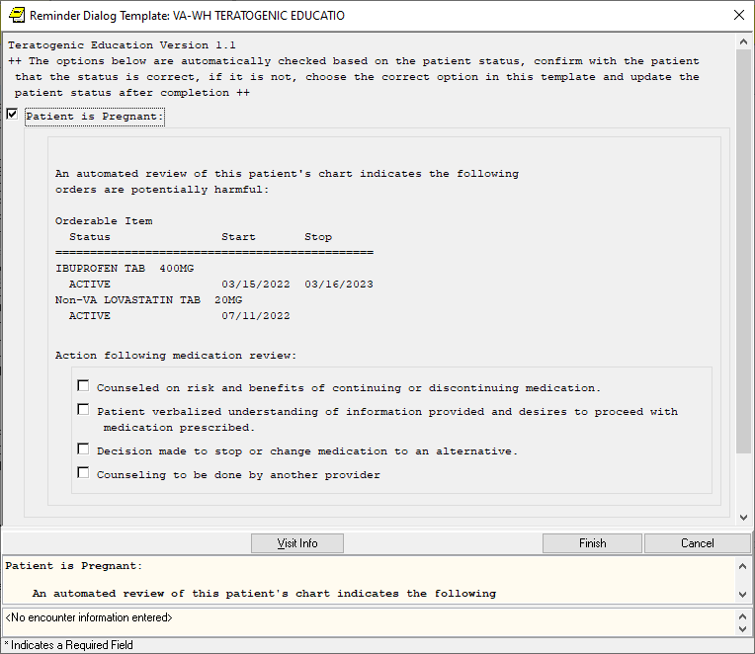

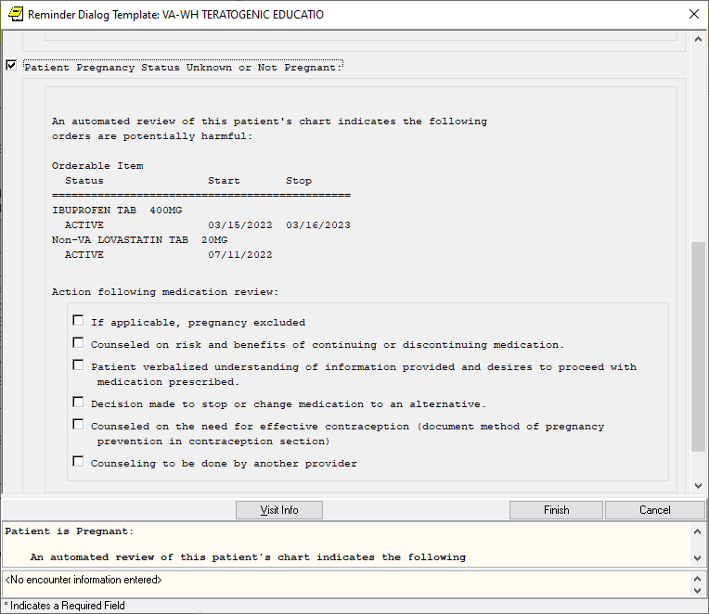

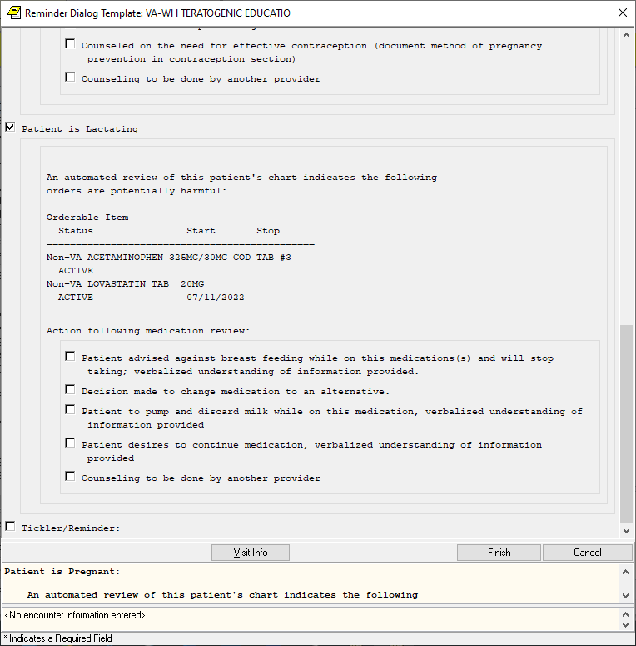

If there are no orders that have potential teratogens, the template options would reflect that:

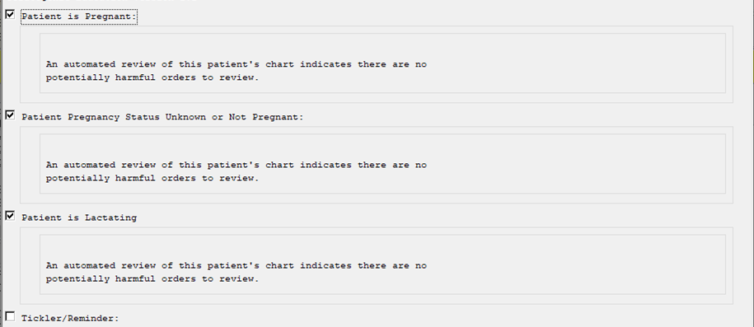

# Install Details

This update is being distributed as a web host file. The address for the host file is: **Redacted as the URL is inside the VA.**

The following reminder content is included in this UPDATE:

**REMINDER GENERAL FINDINGS**

TICKLER REMINDER COMMENT

TICKLER REMINDER

LACTATION END DATE

PATIENT IS NOT LACTATING

PATIENT IS LACTATING

WH-LACTATION DATA SOURCE

PREGNANCY ENDED REASON MATERNAL MORTALITY

PREGNANCY ENDED REASON VAGINAL DELIVERY AND CSECTION

PREGNANCY ENDED REASON ECTOPIC

PREGNANCY ENDED REASON TERMINATION

PREGNANCY ENDED REASON MISCARRIAGE

PREGNANCY ENDED REASON STILLBIRTH

PREGNANCY ENDED REASON C SECTION

PREGNANCY ENDED REASON VAGINAL DELIVERY

PREGNANCY END DATE

HYSTEROSCOPIC STERILIZATION

LAPAROSCOPIC STERILIZATION

NO CURRENT PARTNER

WITHDRAWAL

EMERGENCY CONTRACEPTION

NATURAL FAMILY PLANNING

SPERMICIDE ALONE

CONTRACEPTIVE SPONGE

CERVICAL CAP WITH SPERMICIDE

DIAPHRAGM WITH SPERMICIDE

FEMALE CONDOM

MALE CONDOM

CONTRACEPTIVE PILL, RING OR PATCH

CONTRACEPTIVE SHOT

CURRENT PARTNER

CONTRACEPTIVE IMPLANT

IUD

NOTHING

PATIENT IS UNSURE ABOUT BECOMING PREGNANT

PATIENT DOES NOT WANT TO BECOME PREGNANT

PATIENT WANTS TO BECOME PREGNANT

PATIENT DOES NOT KNOW PREGNANCY STATUS

PATIENT IS NOT PREGNANT

OVERRIDE CALCULATED EDD REASON

EXPECTED DUE DATE

LAST MENSTRUAL PERIOD DATE

PATIENT IS PREGNANT

PATIENT MEDICALLY ABLE TO CONCEIVE

MEDICAL REASON

PATIENT MEDICALLY UNABLE TO CONCEIVE

WH-PREGNANCY DATA SOURCE

CLEAR ALL FOR ALL USER

PREGNANCY CLEAR SMART DATA

PREGNANCY ALERT ID

WH-TD PREGNANCY EDIT RECORD

WH-TD LACTATION EDIT RECORD

**REMINDER DIALOG LINK TYPE**

VA-WH UPDATE HISTORICAL FV

VA-WH HIDE CONTRA OTHER

VA-WH SUPPRESS EDD OVERRIDE PROMPT

VA-WH SET EDD FROM LMPD

**TIU TEMPLATE FIELD**

WH US SPR LINK

WH US MEC LINK

**HEALTH FACTORS**

WH PAP SMEAR [C]

WH HYSTERECTOMY W/CERVIX REMOVED

VA-REMINDER UPDATES [C]

VA-UPDATE_2_0_284

VA-WH MEDICATION REVIEW [C]

VA-WH MED REVIEW HARMFUL MEDS COUNSELING BY ANOTHER

VA-WH MED REVIEW HARMFUL MEDS COUNSELING NOT INDICATED

VA-WH MED REVIEW HARMFUL MEDS COUNSELING COMPLETED

VA-WH MED REVIEW HARMFUL MEDS NOTIFIED PROVIDER

**REMINDER SPONSOR**

OFFICE OF NURSING INFORMATICS

WOMEN VETERANS HEALTH PROGRAM

VHA NATIONAL CENTER FOR HEALTH PROMOTION AND DISEASE PREVENTION (NCP) AND VHA OFFICE OF WOMEN'S HEALTH

WOMEN VETERANS HEALTH PROGRAM AND NATIONAL CENTER FOR HEALTH PROMOTION AND DISEASE PREVENTION (NCP)

**REMINDER TAXONOMY**

VA-WH TUBAL REANASTOMOSIS (TAXONOMY)

VA-WH TUBAL LIGATION CODES (TAXONOMY)

VA-WH HYSTERECTOMY W/CERVIX REMOVED

VA-WH TERATOGENIC MEDICATIONS EXCLUSIONS TAXONOMY

VA-WH RECENTLY PREGNANT

VA-WH CURRENTLY PREGNANT

**REMINDER TERM**

VA-WH TUBAL REANASTOMOSIS (TERM)

VA-WH TUBAL LIGATION CODES (TERM)

VA-WH HIRISK LACTATING CURRENT DOC

VA-WH HIRISK LACTATING EXPIRED DOC

VA-REMINDER UPDATE_2_0_284

VA-BL PREGNANT PATIENT

VA-BL LACTATING PATIENT

VA-WH BL PREGNANCY CURRENT

VA-WH PREGNANCY ALERT

VA-WH PREGNANCY TEST ORDERED

VA-WH BL TD INCOMPLETE MUC

VA-WH BL TD INCOMPLETE DON'T KNOW

VA-WH BL TD INCOMPLETE NOT PREGNANT

VA-WH BL PREGNANCY EDIT END DOCUMENTATION

**REMINDER DEFINITION**

VA-WH MEDICALLY UNABLE TO CONCEIVE

VA-WH HIRISK ORDER CHECK - NOT PREGNANT

VA-WH HIRISK ORDER CHECK - PREGNANT

VA-WH HIRISK ORDER CHECK - NO PREG DOC

VA-WH UPDATE LACTATION STATUS

VA-WH HIRISK ORDER CHECK - LACTATING

VA-WH BL POTENTIALLY TERATOGENIC ORDERS

VA-WH BL POTENTIALLY UNSAFE ORDERS

VA-WH NO PREGNANCY END DOC RPT

VA-WH PREGNANCY AND LACTATION DATA ENTRY ALLOWED

VA-WH BL LACTATION ADD END DATE

VA-WH UPDATE PREGNANCY STATUS

VA-WH BL PREGNANCY STATUS DOCUMENTATION

VA-WH BL PREGNANCY EDIT END DOCUMENTATION

VA-WH BL LACTATION EDIT END DATE

**HEALTH SUMMARY TYPE**

VA-WH PREGNANCY STATUS

**HEALTH SUMMARY OBJECTS**

VA-WH PREGNANCY STATUS (TIU)

**TIU DOCUMENT DEFINITION**

VA-WH PREGNANCY STATUS

**REMINDER ORDER CHECK RULES**

VA-WH HIRISK MEDS (EXTREME RISK) NOT PREG RULE

VA-WH HIRISK MEDS (EXTREME RISK) NO PREG DOC RULE

VA-WH HIRISK MEDS (LACT 1) RULE

VA-WH HIRISK MEDS (LACT 1) EXPIRED DOC RULE

VA-WH HIRISK MEDS (LACT 2) RULE

VA-WH HIRISK MEDS (MODERATE/HIGH RISK) PREG RULE

VA-WH HIRISK MEDS (EXTREME RISK) PREG RULE

VA-WH HIRISK MEDS (LACT 2) EXPIRED DOC RULE

VA-WH HIRISK MEDS (MODERATE/HIGH RISK) NOT PREG RULE

VA-WH HIRISK MEDS (MODERATE/HIGH RISK) NO PREG DOC RULE

**REMINDER ORDER CHECK ITEMS GROUP**

VA-WH HIRISK MEDICATIONS (MOD/HIGH RISK DURING PREGNANCY) GROUP

VA-WH HIRISK MEDICATIONS (MODERATE/HIGH RISK) GROUP

**REMINDER DIALOG**

VA-WH TERATOGENIC EDUCATION

VA-WH UPDATE PREGNANCY STATUS

# Pre-Installation

Prior to installing this Update:

1. From the Reminder Dialog Management menu, Inquire/Print (INQ) and capture/save the following ELEMENTS, you will need to know what quick order is used as a finding item for reference during the installation:
   * VA-WH TD PREGNANCY ORDER PREGNANCY TEST
   * VA-WH TD PREGNANCY ORDER EMERGENCY CONTRACEPTIVE

If you follow the install instruction closely and skip the pregnancy dialog, you should not need to enter these items but they are useful to have in case you accidentally install it.

# Installation:

This update can be loaded with users on the system. Installation will take less than five minutes.

The file will be installed using Reminder Exchange, programmer access is not required.

# Install Example

To Load the Web Host File. Navigate to Reminder exchange in Vista

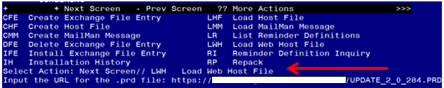

At the **Select Action:** prompt, enter **LWH** for Load Web Host File

At the **Input the url for the .prd file:** prompt, type the following web address:

**https://REDACTED /UPDATE_2_0_284.PRD**

You should see a message at the top of your screen that the file successfully loaded.

Navigate to the exchange entry named UPDATE_2_0_284 VA-TERATOGENIC MEDS ORDER CHECKSUPDATE 2022_02

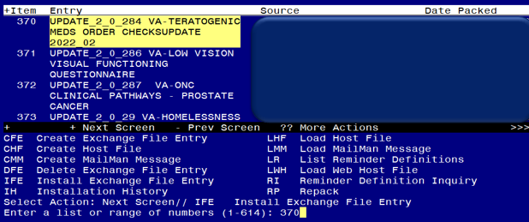

At the **Select Action** prompt, enter **IFE** for Install Exchange File Entry

Enter the number that corresponds with your entry **UPDATE_2_0_284 VA-TERATOGENIC MEDS ORDER CHECKS UPDATE 2022_02** *(in this example it is entry 370, it will vary by site, The exchange date should be 10/13/2022).*

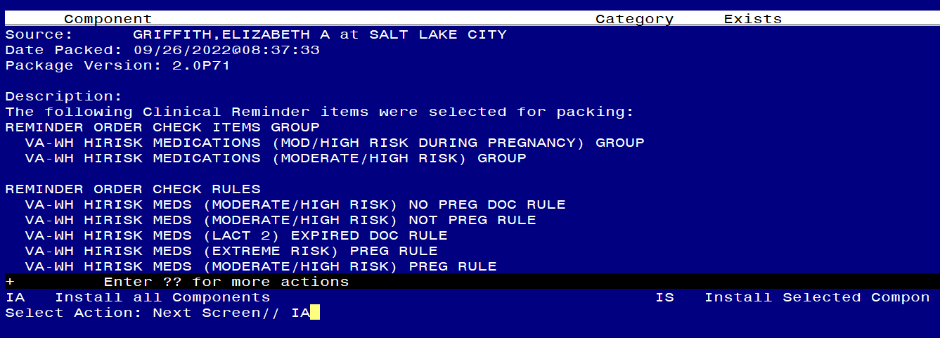

At the **Select Action** prompt, type **IA** for Install all Components and hit enter.

Any items that are NEW in any categories, you should INSTALL

If you are prompted to overwrite any reminder general findings, you should choose SKIP – you will install the new ones

If you are prompted to overwrite any reminder dialog link types, you should choose Overwrite

If you are prompted to overwrite any TIU TEMPLATE FIELDs, you should choose Overwrite

If you are prompted to overwrite any health factors, you should choose SKIP - You will install the new ones

If you are prompted to overwrite any reminder sponsor, you should choose SKIP

If you are prompted to overwrite any reminder taxonomies, you should choose SKIP

If you are prompted to overwrite any reminder terms, you should choose SKIP – You will install the new terms

If you are prompted to overwrite any reminder definitions, you should choose Overwrite

If you are prompted to overwrite any health summary types, you should choose SKIP

If you are prompted to overwrite any health summary objects, you should choose SKIP

If you are prompted to overwrite any TIU DOCUMENT DEFINITIONS, you should choose SKIP

If you are prompted to overwrite any REMINDER ORDER CHECK RULES, you should choose Overwrite

If you are prompted to overwrite any REMINDER ORDER CHECK ITEMS GROUP, you should choose Overwrite

** In your test account, when overwriting the reminder order check groups, some drugs (DG findings) may not exist, choose Delete if prompted to replace an entry**

You will be prompted to install the reminder dialog component VA-WH TERATOGENIC EDUCATION.

* You will choose to install all even though some components may have an X to indicate that they exist.

Regarding the VA-WH TERATOGENIC EDUCATION dialog:
Shows IA for Install All entered at the Select Action: prompt.


Select Action: Next Screen// IA Install All

Install reminder dialog and all components with no further changes: Y// Yes

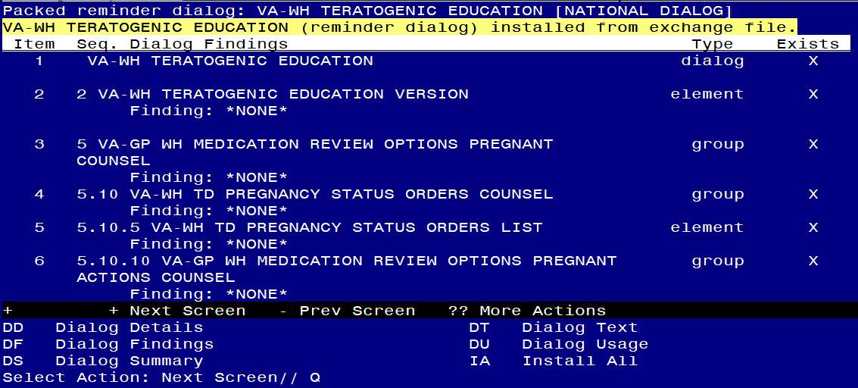

Select Action: Next Screen// Q

You will be prompted to install the reminder dialog component VA-WH UPDATE PREGNANCY STATUS

* **You do not need to install this dialog – choose Q to quit**

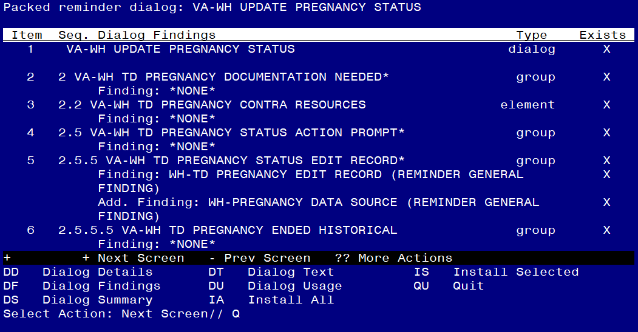At the **Select Action** prompt, type **Q.**

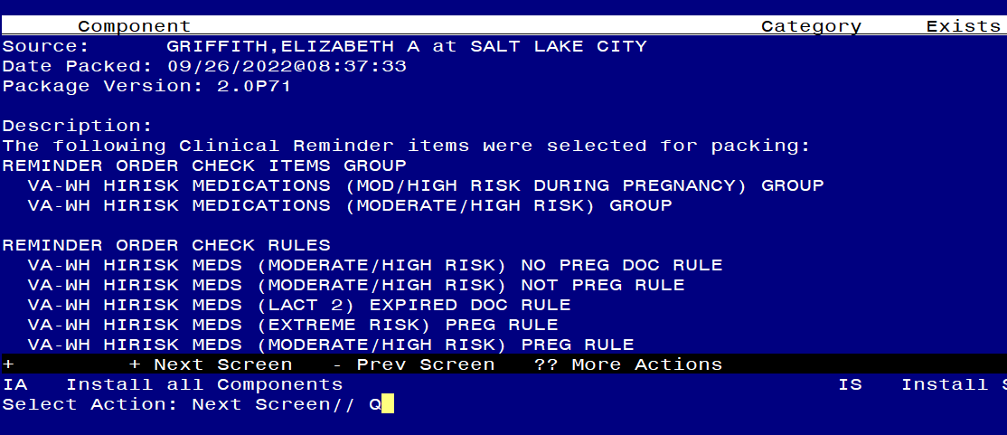

You will then be returned to this screen. At the **Select Action** prompt, type **Q.**

Install Complete

# Post-Install Set-up Instructions

## *Activate the Reminder Order Check Rules*

The installation of CLINICAL REMINDER UPDATE_2_0_284 will require the STATUS of the following Reminder Order Check Rules shown below be changed to PROD.   Shown below are the steps to make this change if yours does not show that PROD status.

**VA-WH HIRISK MEDS (MODERATE/HIGH RISK) PREG RULE**

**VA-WH HIRISK MEDS (MODERATE/HIGH RISK) NO PREG DOC RULE**

**VA-WH HIRISK MEDS (MODERATE/HIGH RISK) NOT PREG RULE**

**VA-WH HIRISK MEDS (EXTREME RISK) PREG RULE**

**VA-WH HIRISK MEDS (EXTREME RISK) NO PREG DOC RULE**

**VA-WH HIRISK MEDS (EXTREME RISK) NOT PREG RULE**

**VA-WH HIRISK MEDS (LACT 1) EXPIRED DOC RULE**

**VA-WH HIRISK MEDS (LACT 1) RULE**

**VA-WH HIRISK MEDS (LACT 2) EXPIRED DOC RULE**

**VA-WH HIRISK MEDS (LACT 2) RULE**

The option represented here is **Add/Edit Reminder Order Check Rule [PXRM ORDER CHECK RULE EDIT].**

Select Reminder Order Check Menu <TEST ACCOUNT> Option: **RE** Add/Edit Reminder Order Check Rule

Select Reminder Order Check Rule by one of the following:

N: ORDER CHECK RULE NAME

R: REMINDER DEFINITION

T: REMINDER TERM

Q: QUIT

Select Reminder Order Check Rule by: (N/R/T/Q): N// <ENTER>

ORDER CHECK RULE NAME

Select Reminder Order Check Rule: **VA-WH HIRISK MEDS (EXTREME RISK) NOT PREG RULE**

**RULE NAME:** **VA-WH HIRISK MEDS (EXTREME RISK) NOT PREG RULE**

**DISPLAY NAME**: **Known or Potential Teratogen (EXTREME Risk-to-Benefit Ratio)**

**STATUS**: **PROD**

**CLASS**: **NATIONAL**

SPONSOR: **WOMEN VETERANS HEALTH PROGRAM**

REVIEW DATE:

_____________________________________________________________

I=INACTIVE, P=PRODUCTION, T=TESTING

**Repeat for all the listed Reminder Order Check Rules –**

\*\***All 10 order checks need to be changed to a status of PROD post install.**

1. CONFIRM *** Refer to the Inquire/Print (INQ) you saved from the pre-installation instructions to confirm quick orders are mapped to the Finding Items of the two ELEMENT below:
   * VA-WH TD PREGNANCY ORDER PREGNANCY TEST
   * VA-WH TD PREGNANCY ORDER EMERGENCY CONTRACEPTIVE
2. **Make the Dialog template available to be attached to a Personal or Shared templates or to be able to attach the dialog to a progress note title.**

Select Reminder Managers Menu <TEST ACCOUNT> Option: **CP** CPRS Reminder Configuration

CA Add/Edit Reminder Categories

CL CPRS Lookup Categories

CS CPRS Cover Sheet Reminder List

MH Mental Health Dialogs Active

PN Progress Note Headers

RA Reminder GUI Resolution Active

TIU TIU Template Reminder Dialog Parameter

DEVL Evaluate Coversheet List on Dialog Finish

DL Default Outside Location

PT Position Reminder Text at Cursor

LINK Link Reminder Dialog to Template

TEST CPRS Coversheet Time Test

NP New Reminder Parameters

GEC GEC Status Check Active

WH WH Print Now Active

Select CPRS Reminder Configuration <TEST ACCOUNT> Option: **TIU** TIU Template Reminder Dialog Parameter

Reminder Dialogs allowed as Templates may be set for the following:

1 User USR [choose from NEW PERSON]

3 Service SRV [choose from SERVICE/SECTION]

4 Division DIV [SALT LAKE CITY]

5 System SYS [NATREM.FO-SLC.MED.VA.GOV]

Enter selection: **5** *Choose the appropriate number for your site. Your site may do this by System or other levels. The example below uses SYSTEM level.*

Setting Reminder Dialogs allowed as Templates for System: NATREM.FO-SLC.MED.VA.GOV

Select Display Sequence: **?**

388 VA-COVID-19 TELEPHONE FOLLOW-UP

389 VA-SRA-CONSULT RESPONSE (D)

*When you type a question mark above, you will see the list of #’s (with dialogs) that are already taken. Choose a number* ***NOT*** *on this list. For this example, 390 is not present so I will use 390.*

Select Display Sequence: **390**

Are you adding 390 as a new Display Sequence? Yes// **YES**

Display Sequence: 390// <Enter> 390

Clinical Reminder Dialog: **VA-WH TERATOGENIC EDUCATION** reminder dialog NATIONAL

...OK? Yes// <Enter> (Yes)

1. **Associate the reminder dialogs with the shared template in CPRS**
2. In CPRS, open the Template Editor, expand the shared template folder, select the appropriate folder (if applicable), then click New Template (top right-hand corner).

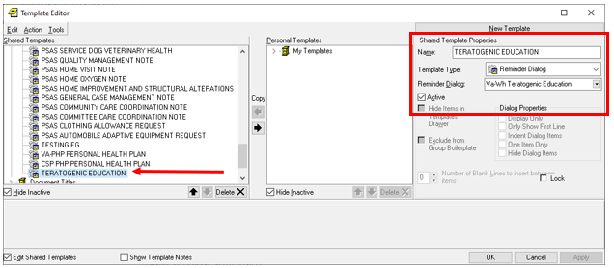

Type in the following information:

Name: **TERATOGENIC EDUCATION**

Template Type: **Reminder Dialog**

Reminder Dialog: **VA-WH TERATOGENIC EDUCATION**

–– then click Apply.