Update _2_0_285

Clinical Reminders

VA-AGING SURGICAL WELLNESS
Install Guide

September 2022

Product Development
Office of Information Technology
Department of Veterans Affairs

Table of Contents
Introduction 1
Install Details 4
Install Example 5
Post Installation 10

Introduction
The Aging Veteran Surgery Wellness program utilizes evidence-based screening tools that are standardized for the aging surgical patient population to evaluate and assess vulnerabilities to prevent adverse outcomes during the perioperative experience. Consults for the Aging Veteran Surgical Wellness program, nutrition, PT/OT, pharmacy, social work, and others are recommended to make this program successful.

The Aging Veteran Surgical Wellness program tracks the perioperative process via the four reminder dialogs outlined for this install: 1) VA-AGING VETERAN SURGICAL WELLNESS PRE-OPERATIVE EVALUATION; 2) VA-AGING VETERAN SURGICAL WELLNESS DAILY ROUNDING NOTE; 3) VA-AGING VETERAN SURGICAL WELLNESS DISCHARGE NOTE; and 4) VA-AGING VETERAN SURGICAL WELLNESS POST DISCHARGE ASSESSMENT. The Aging Veteran Surgical Wellness program follows and complies with the Standards of Care set by the Geriatric Site Verification program.

UPDATE_2_0_285 contains 1 Reminder Exchange entry:
UPDATE_2_0_285 VA-CCRT CARE COORDINATION REVIEW TEAM NOTIFICATION

The exchange file contains the following components:

TIU TEMPLATE FIELD
CALENDAR REQUIRED
WORD 2 LINES RQ
WORD PROCESSING 66/4 REQ
WORD 2 LINES INDENT 2 REQ
NUMBER 0-10 REQ
TEXT (1-50 CHAR) REQ
ASW DISCHARGE CONTACT
NUM 0-200 (R)
TEXT (1-15 CHAR)REQ
TEXT (1-30 CHAR) REQ
ASW BEERS MEDICATIONS LINK
WORD 2 LINES

HEALTH FACTORS
VA-AGING SURGICAL WELLNESS [C]
VA-ASW 10LB OR MORE WEIGHT LOSS IN PAST 6MO NO
VA-ASW 10LB OR MORE WEIGHT LOSS IN PAST 6MO YES
VA-ASW 6CIT SCORE 0-7
VA-ASW 6CIT SCORE 10-28
VA-ASW 6CIT SCORE 8-9
VA-ASW 6CIT SCORE PATIENT DECLINES
VA-ASW ADVANCE DIRECTIVE CURRENT NO
VA-ASW ADVANCE DIRECTIVE CURRENT YES
VA-ASW ADVANCE DIRECTIVE WITHIN LAST YEAR NO
VA-ASW ADVANCE DIRECTIVE WITHIN LAST YEAR YES
VA-ASW AGING VETERAN SURGICAL WELLNESS DAILY ROUNDING
VA-ASW AGING VETERAN SURGICAL WELLNESS DISCHARGE NOTE
VA-ASW AGING VETERAN SURGICAL WELLNESS POST-DISCHARGE ASSE
VA-ASW AGING VETERAN SURGICAL WELLNESS PRE-OPERATIVE NOTE
VA-ASW ASSISTIVE DEVICE CANE DISCHARGE
VA-ASW ASSISTIVE DEVICE CANE POST-DISCHARGE
VA-ASW ASSISTIVE DEVICE NONE DISCHARGE
VA-ASW ASSISTIVE DEVICE NONE POST-DISCHARGE
VA-ASW ASSISTIVE DEVICE OTHER DISCHARGE
VA-ASW ASSISTIVE DEVICE OTHER POST-DISCHARGE
VA-ASW ASSISTIVE DEVICE WALKER DISCHARGE
VA-ASW ASSISTIVE DEVICE WALKER POST-DISCHARGE
VA-ASW ASSISTIVE DEVICE WHEELCHAIR DISCHARGE
VA-ASW ASSISTIVE DEVICE WHEELCHAIR POST-DISCHARGE
VA-ASW ASSISTIVE DEVICES CANE PRE-OPERATIVE
VA-ASW ASSISTIVE DEVICES NONE PRE-OPERATIVE
VA-ASW ASSISTIVE DEVICES OTHER PRE-OPERATIVE
VA-ASW ASSISTIVE DEVICES WALKER PRE-OPERATIVE
VA-ASW ASSISTIVE DEVICES WHEELCHAIR PRE-OPERATIVE
VA-ASW DELIRIUM 4AT SCORE >4 NO
VA-ASW DELIRIUM 4AT SCORE >4 YES
VA-ASW DELIRIUM DURING ADMISSION NO
VA-ASW DELIRIUM DURING ADMISSION YES
VA-ASW DELIRIUM PREVENTION ORDER SET ACTIVE NO
VA-ASW DELIRIUM PREVENTION ORDER SET ACTIVE YES
VA-ASW ELECTIVE SURGERY NO
VA-ASW ELECTIVE SURGERY YES
VA-ASW EXERCISED TO PREVENT FUNCTIONAL DECLINE NO
VA-ASW EXERCISED TO PREVENT FUNCTIONAL DECLINE YES
VA-ASW FALL DURING ADMISSION NO
VA-ASW FALL DURING ADMISSION YES
VA-ASW FALLS >5 POST-DISCHARGE
VA-ASW FALLS 0 POST-DISCHARGE
VA-ASW FALLS 1 POST-DISCHARGE
VA-ASW FALLS 2 POST-DISCHARGE
VA-ASW FALLS 3 POST-DISCHARGE
VA-ASW FALLS 4 POST-DISCHARGE
VA-ASW FALLS 5 POST-DISCHARGE
VA-ASW FALLS LAST 6MO >5 PRE-OPERATIVE
VA-ASW FALLS LAST 6MO 0 PRE-OPERATIVE
VA-ASW FALLS LAST 6MO 1 PRE-OPERATIVE
VA-ASW FALLS LAST 6MO 2 PRE-OPERATIVE
VA-ASW FALLS LAST 6MO 3 PRE-OPERATIVE
VA-ASW FALLS LAST 6MO 4 PRE-OPERATIVE
VA-ASW FALLS LAST 6MO 5 PRE-OPERATIVE
VA-ASW HIGH RISK (BEERS) MEDICATIONS NO
VA-ASW HIGH RISK (BEERS) MEDICATIONS YES
VA-ASW LST OR ADVANCE DIRECTIVE CHANGE NO DISCHARGE
VA-ASW LST OR ADVANCE DIRECTIVE CHANGE YES DISCHARGE
VA-ASW NUMBER OF MEDS D
VA-ASW NUTRITION CONCERNS AT DISCHARGE NO
VA-ASW NUTRITION CONCERNS AT DISCHARGE YES
VA-ASW NUTRITION CONCERNS POST-DISCHARGE NO
VA-ASW NUTRITION CONCERNS POST-DISCHARGE YES
VA-ASW PRESSURE ULCER DURING ADMISSION NO
VA-ASW PRESSURE ULCER DURING ADMISSION YES
VA-ASW PT/OT NO
VA-ASW PT/OT YES
VA-ASW READMISSION NO P
VA-ASW READMISSION YES P
VA-ASW RESTRAINTS DURING ADMISSION NO
VA-ASW RESTRAINTS DURING ADMISSION YES
VA-ASW SWALLOWING CHANGES IN PAST 3MO NO PRE-OPERATIVELY
VA-ASW SWALLOWING CHANGES IN PAST 3MO YES PRE-OPERATIVELY
VA-ASW SWALLOWING CONCERNS AT DISCHARGE NO
VA-ASW SWALLOWING CONCERNS AT DISCHARGE YES
VA-ASW TETHERS ARTERIAL LINE
VA-ASW TETHERS CENTRAL LINE
VA-ASW TETHERS CHEST TUBE
VA-ASW TETHERS FEEDING TUBE
VA-ASW TETHERS FOLEY CATHETER
VA-ASW TETHERS NASOGASTRIC TUBE
VA-ASW TETHERS NONE
VA-ASW TETHERS OXYGEN
VA-ASW TETHERS PERIPHERAL IV
VA-ASW TETHERS RESTRAINTS
VA-ASW TREATING SPECIALTY CARDIAC
VA-ASW TREATING SPECIALTY COLORECTAL
VA-ASW TREATING SPECIALTY EAR NOSE THROAT
VA-ASW TREATING SPECIALTY GENERAL SURGERY
VA-ASW TREATING SPECIALTY GYNECOLOGY
VA-ASW TREATING SPECIALTY NEUROSURGERY
VA-ASW TREATING SPECIALTY ORTHOPAEDIC
VA-ASW TREATING SPECIALTY PLASTIC
VA-ASW TREATING SPECIALTY SPINE
VA-ASW TREATING SPECIALTY SURGICAL ONCOLOGY
VA-ASW TREATING SPECIALTY THORACIC
VA-ASW TREATING SPECIALTY UROLOGY
VA-ASW TREATING SPECIALTY VASCULAR
VA-ASW GP BEERS MEDICATION POST-DISCHARGE
VA-ASW GP BEERS YES POST-DISCHARGE HF
VA-ASW BEERS NO POST-DISCHARGE HF
VA-ASW HIGH RISK (BEERS) MEDICATIONS POST-DISCHARGE NO
VA-ASW HIGH RISK (BEERS) MEDICATIONS POST-DISCHARGE YES

VA-REMINDER UPDATES [C]
VA-UPDATE_2_0_285

REMINDER SPONSOR
OFFICE OF SURGICAL SERVICES
MENTAL HEALTH SERVICES
OFFICE OF NURSING SERVICE
SURGERY

REMINDER TERM
VA-REMINDER UPDATE_2_0_285

REMINDER DIALOG
VA-AGING VETERAN SURGICAL WELLNESS POST DISCHARGE ASSESSMENT
VA-AGING VETERAN SURGICAL WELLNESS DISCHARGE NOTE
VA-AGING VETERAN SURGICAL WELLNESS PRE-OPERATIVE EVALUATION
VA-AGING VETERAN SURGICAL WELLNESS DAILY ROUNDING NOTE

Pre-Installation

- Coordinate with local surgery staff about participating in the Aging Veteran Surgery Wellness program. If your site is not participating, the update should be installed, but completing the post-installation steps is optional.

- Coordinate with local staff to identify the following consult quick orders. These will be mapped to elements and groups in the post installation steps.
  - Outpatient Physical Therapy/Occupational Therapy (PT/OT)
  - Inpatient Physical Therapy/Occupational Therapy (PT/OT)
  - Outpatient Nutrition
  - Need for Advance Directive
  - Outpatient wound care
  - Discharge planning (typically social work or utilization management staff)
  - Inpatient pharmacy
  - Outpatient pharmacy
  - Geriatrician or primary care consult order

Install Details
This update is being distributed as a web host file. The address for the host file is: https://Redacted/UPDATE_2_0_285.PRD
The file will be installed using Reminder Exchange, programmer access is not required.
Installation:
=============
This update can be loaded with users on the system. Installation will take less than 5 minutes.

Install Example
To Load the Web Host File. Navigate to Reminder exchange in Vista
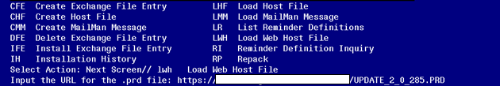

At the Select Action: prompt, enter LWH for Load Web Host File
At the Input the url for the .prd file: prompt, type the following web address:
https://Redacted/UPDATE_2_0_285.PRD

You should see a message at the top of your screen that the file successfully loaded.

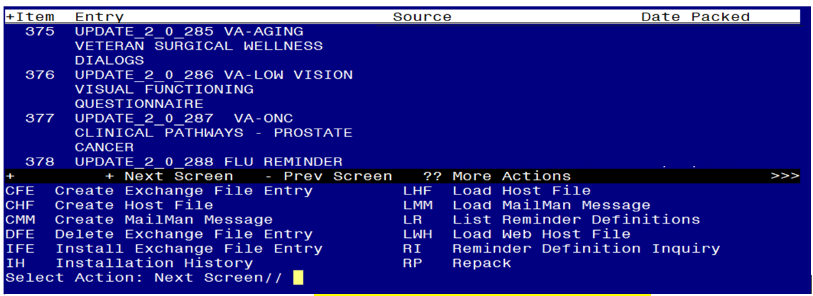 Search and locate an entry titled UPDATE_2_0_285 VA-AGING VETERAN SURGICAL WELLNESS DIALOGS in reminder exchange.

At the Select Action prompt, enter IFE for Install Exchange File Entry
Enter the number that corresponds with your entry UPDATE_2_0_285 VA-AGING VETERAN SURGICAL WELLNESS DIALOGS
(In this example it is entry 383. It will vary by site). The date of the exchange file should be 9/01/2022.

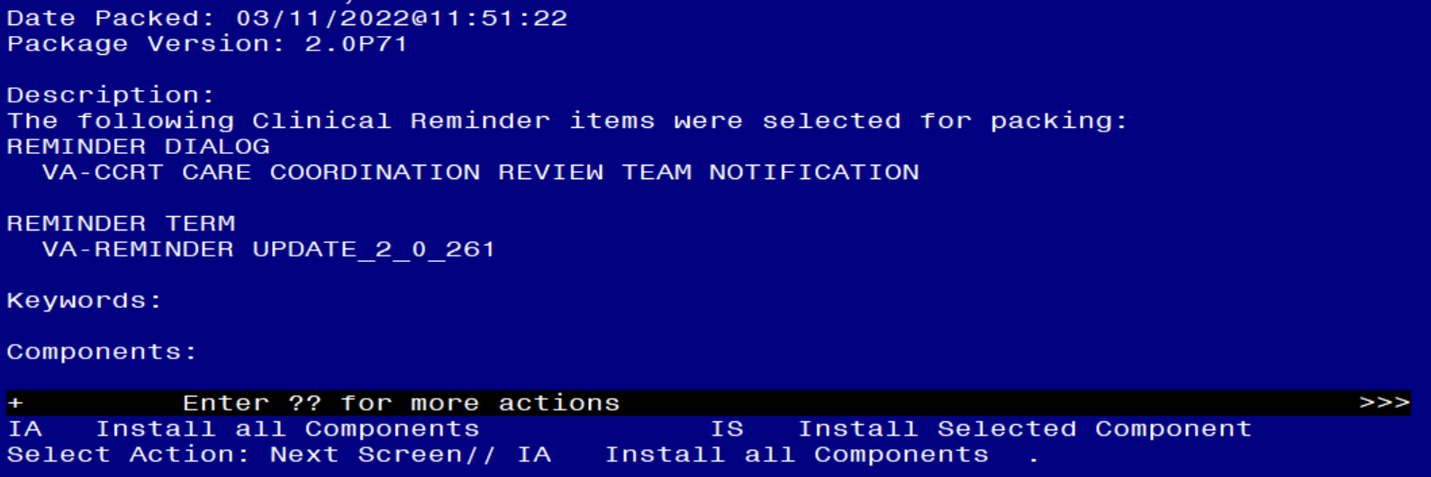

At the Select Action prompt, type IA for Install all Components and hit enter.
Select Action: Next Screen// IA Install all Components

You will see several prompts, for all new entries you will choose I to Install
For components that already exists but the packed component is different, choose O to Overwrite.

Dialog #1 of 4: You will be promped to install the reminder dialog component (VA-AGING VETERAN SURGICAL WELLNESS POST DISCHARGE ASSESSMENT). You will choose to install all even though some components may have an X to indicate that they exist.
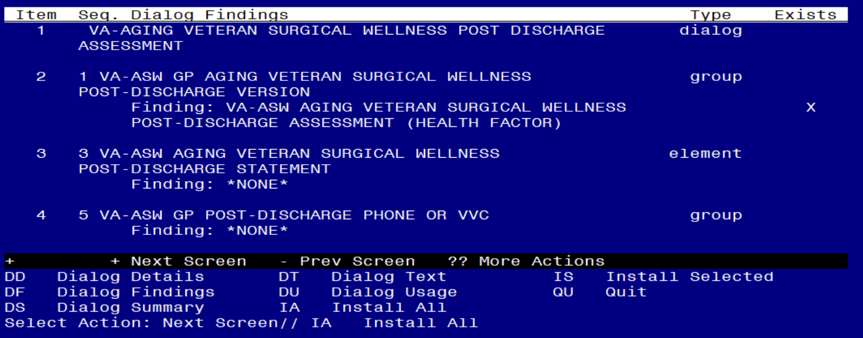

At the Select Action prompt, type IA to install the dialog: VA-AGING VETERAN SURGICAL WELLNESS POST DISCHARGE ASSESSMENT
Select Action: Next Screen// IA Install All

Install reminder dialog and all components with no further changes: Y// Yes
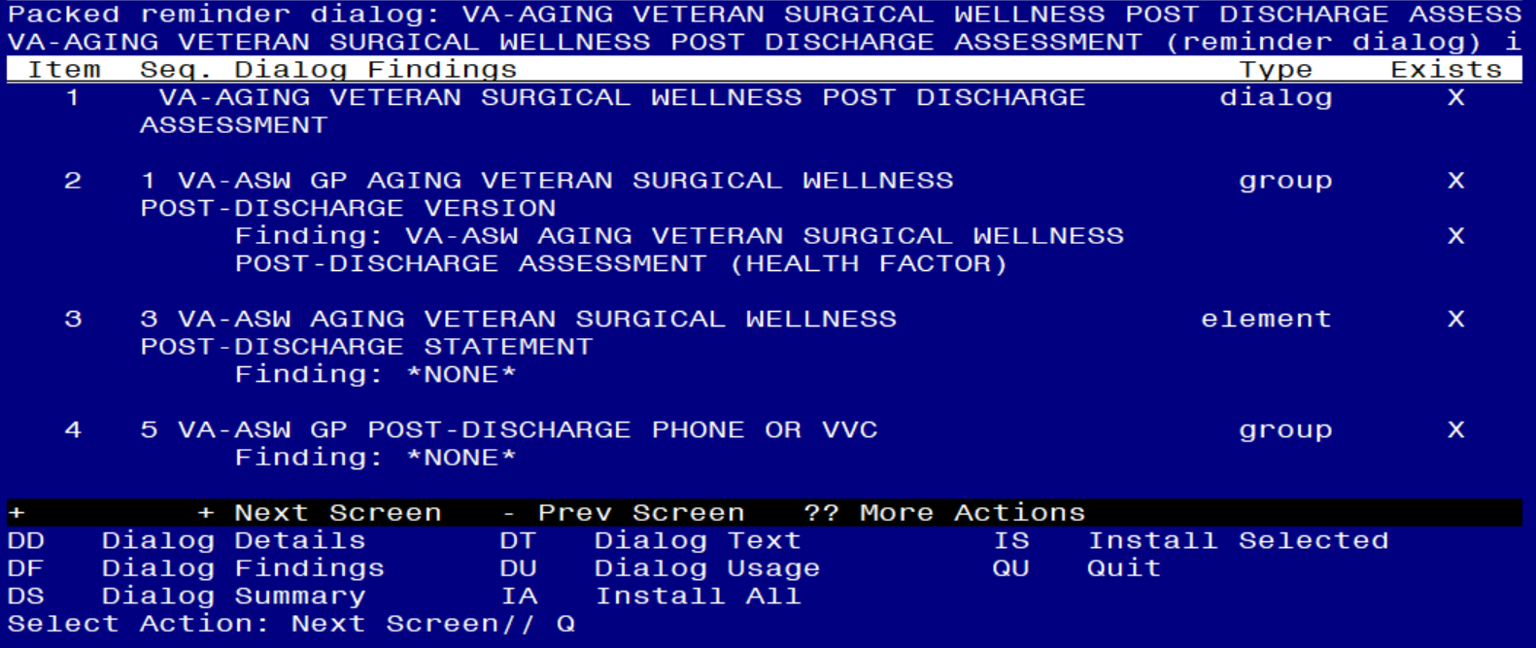

After completing this dialog install, you will type Q.

Dialog #2 of 4: You will be promped to install the reminder dialog component (VA-AGING VETERAN SURGICAL WELLNESS DISCHARGE NOTE). You will choose to install all even though some components may have an X to indicate that they exist.
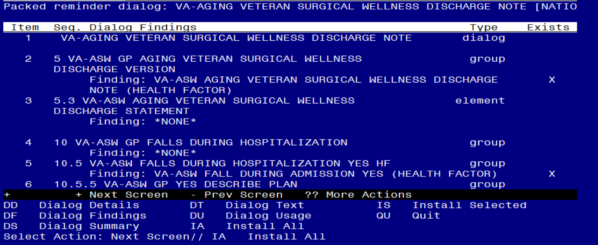

At the Select Action prompt, type IA to install the dialog: VA-AGING VETERAN SURGICAL WELLNESS DISCHARGE NOTE
Select Action: Next Screen// IA Install All

Install reminder dialog and all components with no further changes: Y// Yes
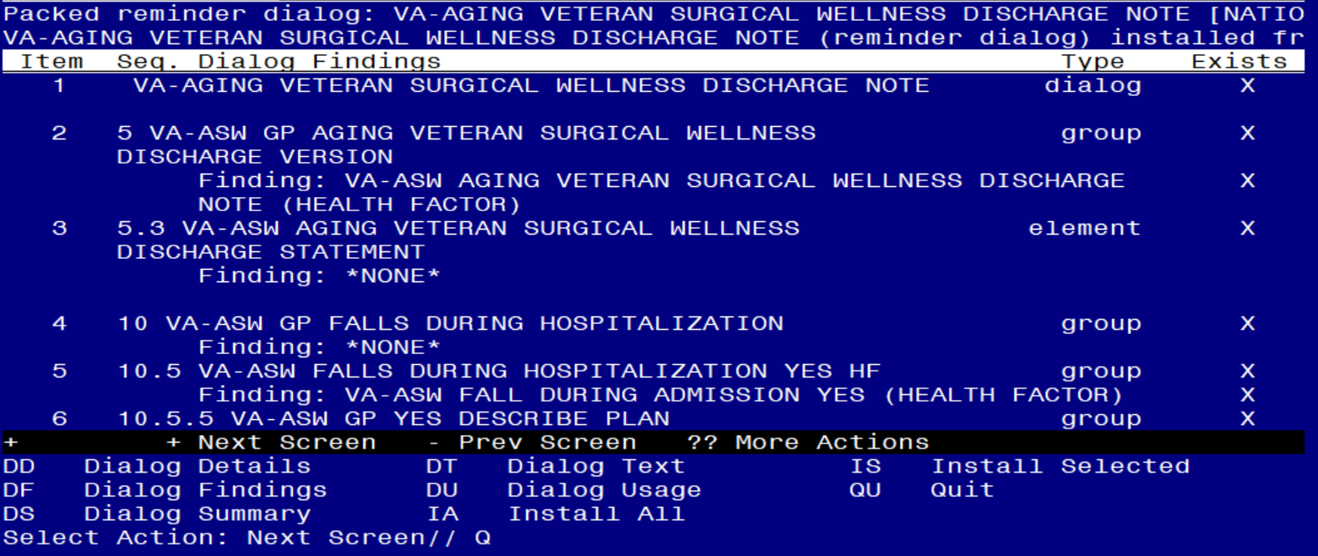

After completing this dialog install, you will type Q.

Dialog #3 of 4: You will be promped to install the reminder dialog component (VA-AGING VETERAN SURGICAL WELLNESS DAILY ROUNDING NOTE). You will choose to install all even though some components may have an X to indicate that they exist.
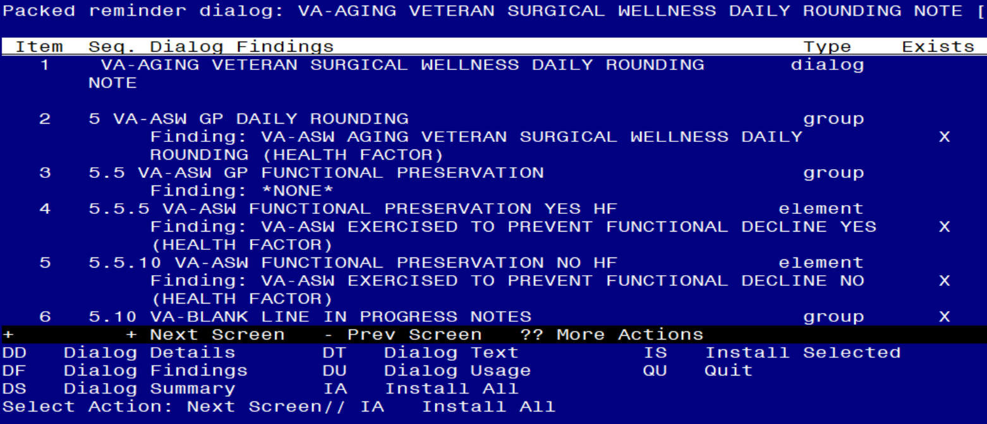

At the Select Action prompt, type IA to install the dialog: VA-AGING VETERAN SURGICAL WELLNESS DAILY ROUNDING NOTE
Select Action: Next Screen// IA Install All

Install reminder dialog and all components with no further changes: Y// Yes
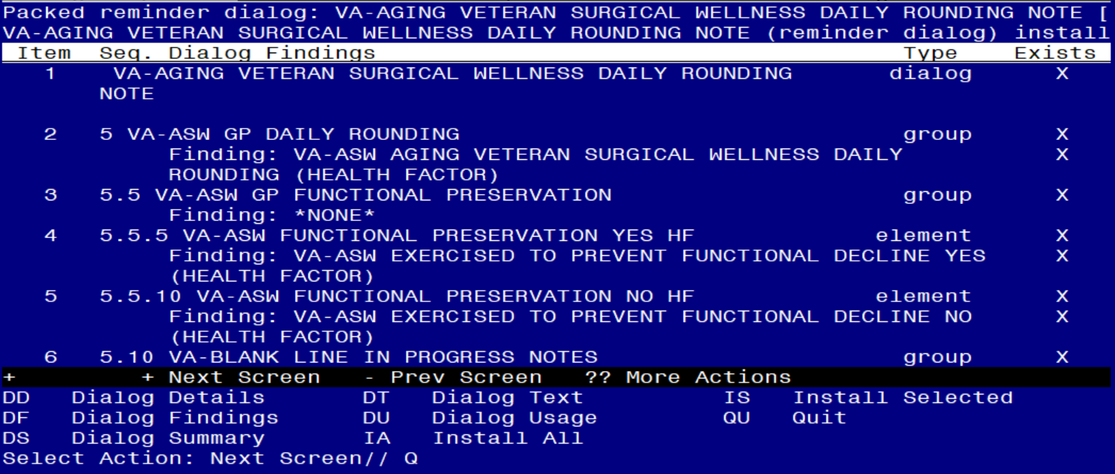

After completing this dialog install, you will type Q.

Dialog #4 of 4: You will be promped to install the reminder dialog component (VA-AGING VETERAN SURGICAL WELLNESS PRE-OPERATIVE EVALUATION). You will choose to install all even though some components may have an X to indicate that they exist.
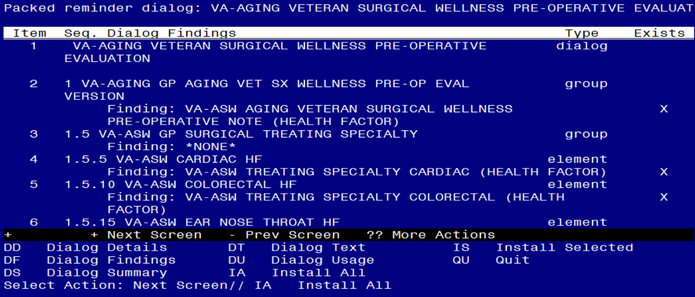

At the Select Action prompt, type IA to install the dialog: VA-AGING VETERAN SURGICAL WELLNESS PRE-OPERATIVE EVALUATION
Select Action: Next Screen// IA Install All

Install reminder dialog and all components with no further changes: Y// Yes
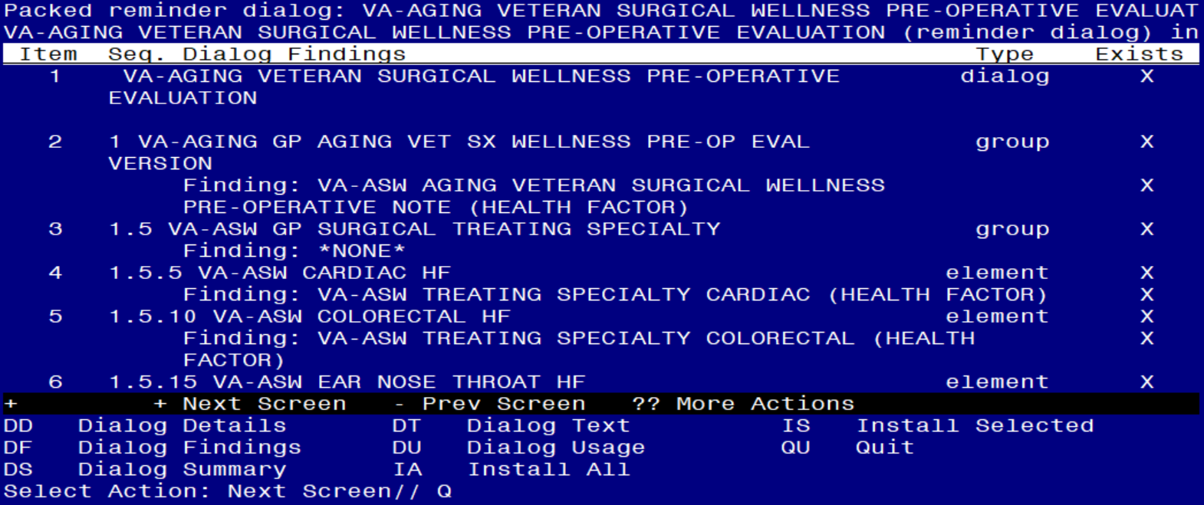

After completing this dialog install, you will type Q.

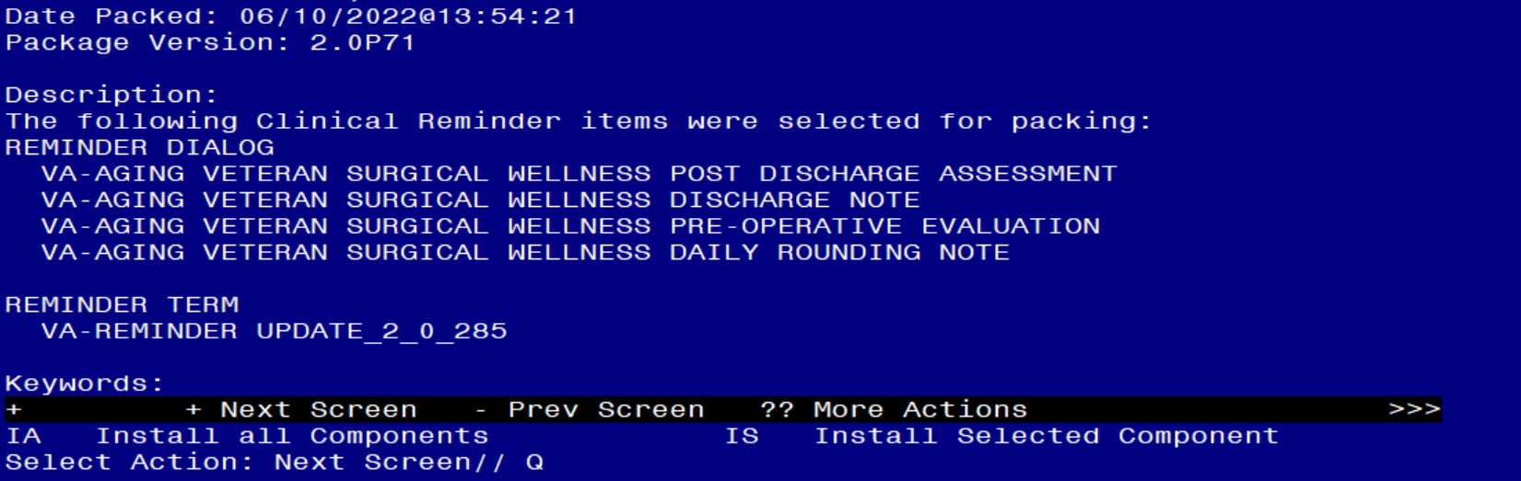
You will then be returned to this screen. At the Select Action prompt, type Q.

Install complete.

Post Installation

- Add local consult quick orders to the following elements/groups.
  - Element: VA-ASW FALLS 1 HF

Current dialog element/group name: VA-ASW FALLS 1 HF
Used by: VA-ASW GP FALLS IN 6 MONTHS (Dialog Group)

FINDING ITEM: VA-ASW FALLS LAST 6MO 1 PRE-OPERATIVE
//
Select ADDITIONAL FINDINGS: Enter “Q.”, then name of local consult quick order for outpatient PT/OT

  - Repeat mapping for remaining groups/elements in the table below.

GROUP/ELEMENT | GROUP/ELEMENT NAME | CONSULT QUICK ORDER TO MAP | PROMPT MAPING LOCATION
Element | VA-ASW FALLS 2 HF | outpatient PT/OT | ADDITIONAL FINDING
Element | VA-ASW FALLS 3 HF | outpatient PT/OT | ADDITIONAL FINDING
Element | VA-ASW FALLS 4 HF | outpatient PT/OT | ADDITIONAL FINDING
Element | VA-ASW FALLS 5 HF | outpatient PT/OT | ADDITIONAL FINDING
Element | VA-ASW FALLS >5 HF | outpatient PT/OT | ADDITIONAL FINDING
Group | VA-ASW GP 10LB WEIGHT LOSS OR MORE IN PAST 6MO YES HF | outpatient nutrition | ADDITIONAL FINDING
Group | VA-ASW GP SWALLOWING CHANGES YES HF | outpatient nutrition | FINDING ITEM
Element | VA-ASW ADVANCE DIRECTIVE WITHIN LAST YEAR NO HF | advance directive | FINDING ITEM
Element | VA-ASW 6CIT SCORE 10-28 HF | geriatric or primary care | ADDITIONAL FINDING
Group | VA-ASW GP PATIENT BACK TO NORMAL MOBILITY NO | outpatient PT/OT | ADDITIONAL FINDING
Element | VA-ASW FALLS 1 POST DISCHARGE ASSESSMENT HF | outpatient PT/OT | ADDITIONAL FINDING
Element | VA-ASW FALLS 2 POST DISCHARGE ASSESSMENT HF | outpatient PT/OT | ADDITIONAL FINDING
Element | VA-ASW FALLS 3 POST DISCHARGE ASSESSMENT HF | outpatient PT/OT | ADDITIONAL FINDING
Element | VA-ASW FALLS 4 POST DISCHARGE ASSESSMENT HF | outpatient PT/OT | ADDITIONAL FINDING
Element | VA-ASW FALLS 5 POST DISCHARGE ASSESSMENT HF | outpatient PT/OT | ADDITIONAL FINDING
Element | VA-ASW FALLS >5 POST DISCHARGE ASSESSMENT HF | outpatient PT/OT | ADDITIONAL FINDING
Group | VA-ASW GP NUTRITIONAL CONCERNS POST DISCHARGE ASSESSMENT YES HF | outpatient nutrition | ADDITIONAL FINDING
Group | VA-ASW GP MEDICATION UNDERSTANDING NO | outpatient pharmacy | FINDING ITEM
Group | VA-ASW GP BEERS YES HF | inpatient pharmacy | ADDITIONAL FINDING
Group | VA-ASW FALLS DURING HOSPITALIZATION YES HF | outpatient PT/OT | ADDITIONAL FINDING
Element | VA-ASW ASSISTIVE DEVICE CANE AT DISCHARGE HF | outpatient PT/OT | ADDITIONAL FINDING
Element | VA-ASW ASSISTIVE DEVICE WALKER AT DISCHARGE HF | outpatient PT/OT | ADDITIONAL FINDING
Element | VA-ASW ASSISTIVE DEVICE WHEELCHAIR AT DISCHARGE HF | outpatient PT/OT | ADDITIONAL FINDING
Element | VA-ASW ASSISTIVE DEVICE OTHER AT DISCHARGE HF | outpatient PT/OT | ADDITIONAL FINDING
Group | VA-ASW NUTRITIONAL CONCERNS YES HF | outpatient nutrition | ADDITIONAL FINDING
Group | VA-ASW SWALLOWING ISSUES DISCHARGE YES HF | outpatient nutrition | ADDITIONAL FINDING
Group | VA-ASW GP LST OR ADVANCE DIRECTIVE CHANGE AT DISCHARGE YES HF | advance directive | ADDITIONAL FINDING
Group | VA-ASW PRESSURE ULCER DURING HOSPITALIZATION YES HF | outpatient wound care | ADDITIONAL FINDING
Element | VA-ASW PT/OT NO HF | inpatient PT/OT | ADDITIONAL FINDING
Group | VA-ASW GP ADVANCE DIRECTIVE CURRENT NO HF | advance directive | ADDITIONAL FINDING
Group | VA-ASW GP DISCHARGE PLANNING BEING ADDRESSED NO | discharge planning | ADDITIONAL FINDING
Group | VA-ASW GP BEERS YES POST-DISCHARGE HF | outpatient pharmacy | ADDITIONAL FINDING

- Insert local TIU object to list outpatient medications in the VAL-ASW GP OUTPATIENT MEDICATIONS AT DISCHARGE group.

NAME: VAL-ASW GP OUTPATIENT MEDICATIONS AT DISCHARGE
DISABLE:
CLASS: LOCAL
SPONSOR: OFFICE OF SURGICAL SERVICES
REVIEW DATE:
RESOLUTION TYPE:
ORDERABLE ITEM:
FINDING ITEM:

Additional findings: none
Select ADDITIONAL FINDING:
GROUP CAPTION:
PUT A BOX AROUND THE GROUP:
SHARE COMMON PROMPTS:
MULTIPLE SELECTION:
HIDE/SHOW GROUP:
GROUP HEADER DIALOG TEXT:
Insert local data object for outpatient medications.

Edit? NO// YES

==[ WRAP ]==[INSERT ]=======< GROUP HEADER DIALOG TEX[Press <PF1>H for
Insert local data object for outpatient medications.

Replace highlighted text with local TIU object to display outpatient medications.

<=======T=======T=======T=======T=======T=======T=======T=======T=======T>=

- Insert local TIU object to list active medications in the VAL-ASW ACTIVE MEDICATIONS element.

Current dialog element/group name: VAL-ASW ACTIVE MEDICATIONS
Used by: VA-ASW GP HIGH RISK/BEERS MEDS (Dialog Group)

NAME: VAL-ASW ACTIVE MEDICATIONS
DISABLE:
CLASS: LOCAL
SPONSOR: OFFICE OF SURGICAL SERVICES
REVIEW DATE:
RESOLUTION TYPE: DONE AT ENCOUNTER
ORDERABLE ITEM:
FINDING ITEM:

Additional findings: none
Select ADDITIONAL FINDING:
DIALOG/PROGRESS NOTE TEXT:
INSERT OBJECT FOR ACTIVE MEDICATIONS
{FLD:WORD 2 LINES}\\
Edit? NO// YES

==[ WRAP ]==[INSERT ]=======< DIALOG/PROGRESS NOTE TE[Press <PF1>H for
INSERT OBJECT FOR ACTIVE MEDICATIONS Replace highlighted text with local TIU
object to display active medications.
{FLD:WORD 2 LINES}\\
\\

<=======T=======T=======T=======T=======T=======T=======T=======T=======T>====

- Make the dialog templates available to be attached to a Personal or Shared template or to be able to attach the dialog to a progress note title.

Select Reminder Managers Menu <TEST ACCOUNT> Option: CP CPRS Reminder Configuration
CA Add/Edit Reminder Categories
CL CPRS Lookup Categories
CS CPRS Cover Sheet Reminder List
MH Mental Health Dialogs Active
PN Progress Note Headers
RA Reminder GUI Resolution Active
TIU TIU Template Reminder Dialog Parameter
DEVL Evaluate Coversheet List on Dialog Finish
DL Default Outside Location
PT Position Reminder Text at Cursor
LINK Link Reminder Dialog to Template
TEST CPRS Coversheet Time Test
NP New Reminder Parameters
GEC GEC Status Check Active
WH WH Print Now Active
Select CPRS Reminder Configuration <TEST ACCOUNT> Option: TIU TIU Template Reminder Dialog Parameter

Reminder Dialogs allowed as Templates may be set for the following:

1 User USR [choose from NEW PERSON]
3 Service SRV [choose from SERVICE/SECTION]
4 Division DIV [SALT LAKE CITY]
5 System SYS [NATREM.FO-SLC.MED.VA.GOV]

Enter selection: 5 Choose the appropriate number for your site. Your site may do this by System or other levels. The example below uses SYSTEM level.

Setting Reminder Dialogs allowed as Templates for System: NATREM.FO-SLC.MED.VA.GOV
Select Display Sequence: ?

388 VA-COVID-19 TELEPHONE FOLLOW-UP
389 VA-SRA-CONSULT RESPONSE (D)

When you type a question mark above, you will see the list of #’s (with dialogs) that are already taken. Choose a number NOT on this list. For this example, 390 is not present so I will use 390.

Select Display Sequence: 390
Are you adding 390 as a new Display Sequence? Yes// YES

Display Sequence: 390// <Enter>
Clinical Reminder Dialog: VA-AGING VETERAN SURGICAL WELLNESS POST DISCHARGE ASSESSMENT
...OK? Yes// <Enter> (Yes)

Select Display Sequence: 391
Are you adding 391 as a new Display Sequence? Yes// YES

Display Sequence: 391// <Enter>
Clinical Reminder Dialog: VA-AGING VETERAN SURGICAL WELLNESS DISCHARGE
NOTE
...OK? Yes// <Enter> (Yes)

Select Display Sequence: 392
Are you adding 392 as a new Display Sequence? Yes// YES

Display Sequence: 392// <Enter>
Clinical Reminder Dialog: VA-AGING VETERAN SURGICAL WELLNESS PRE-OPERATIVE EVALUATION
...OK? Yes// <Enter> (Yes)

Select Display Sequence: 393
Are you adding 393 as a new Display Sequence? Yes// YES

Display Sequence: 393// <Enter>
Clinical Reminder Dialog: VA-AGING VETERAN SURGICAL WELLNESS DAILY ROUNDING NOTE
...OK? Yes// <Enter> (Yes)

- Setup of note titles.

The four note titles to create to associate with these templates are:

AGING VETERAN SURGICAL WELLNESS POST DISCHARGE ASSESSMENT
AGING VETERAN SURGICAL WELLNESS DISCHARGE NOTE
AGING VETERAN SURGICAL WELLNESS PRE-OPERATIVE EVALUATION
AGING VETERAN SURGICAL WELLNESS DAILY ROUNDING NOTE
VHA Enterprise Standard Title: SURGERY NOTE

You can add this to the appropriate document class.

Note: Comprehensive information on Creating new Document Classes and Titles can be found beginning on page 54 of the TIU/ASU Implementation Guide at the following link: http://www.va.gov/vdl/documents/Clinical/CPRS-Text_Integration_Utility_(TIU)/tiuim.pdf

- Associate the reminder dialogs with the note titles in CPRS

In CPRS, open the Template Editor, expand Document Titles, select the appropriate folder (if applicable), then click New Template (top right-hand corner).

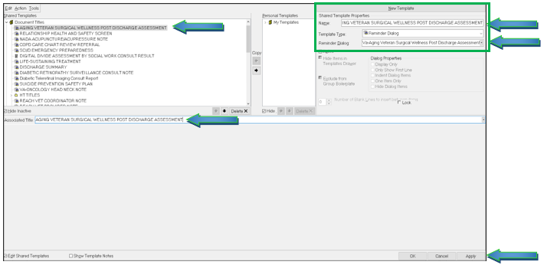

Type in the following information:
Name: AGING VETERAN SURGICAL WELLNESS POST DISCHARGE ASSESSMENT
Template Type: Reminder Dialog
Reminder Dialog: VA-AGING VETERAN SURGICAL WELLNESS POST DISCHARGE ASSESSMENT

Next, type in the Associated Title name –– then click Apply.

Repeat step 3 for the remaining three reminder dialogs and titles.

