Update _2_0_286

Clinical Reminders

VA-LOW VISION VISUAL FUNCTIONING QUESTIONNAIRE

Install Guide

October 2022

Product Development
Office of Information Technology
Department of Veterans Affairs

Table of Contents
Introduction 1
Install Details 2
Install Example 2
Post Installation 7

Introduction
Blind Rehabilitation Service (BRS) is implementing a standardized functional outcome measure to be used by all BRS programs. The VA Visual Functioning Questionnaire (VFQ) will be the standardized functional outcome measure. The VFQ is a 20-question questionnaire that captures the difficulty adults with visual impairment have performing daily activities. The questionnaire is utilized to gather information on visual function both pre and post rehabilitation.

UPDATE_2_0_286 contains 1 Reminder Exchange entry:

UPDATE_2_0_286 VA-LOW VISION VISUAL FUNCTIONING QUESTIONNAIRE

The exchange file contains the following components:

REMINDER GENERAL FINDINGS
VIEW PROGRESS NOTE TEXT

TIU TEMPLATE FIELD
WP 4/60

HEALTH FACTORS
VA-REMINDER UPDATES [C]
VA-UPDATE_2_0_286

REMINDER SPONSOR
BLIND REHAB SERVICE

REMINDER TERM
VA-REMINDER UPDATE_2_0_286

HEALTH SUMMARY TYPE
VA-VFQ20
VA-LOW VISION LAST NOTE

HEALTH SUMARY OBJECTS
VA-VFQ20 (TIU)
VA-LOW VISION VFQ TOTAL

TIU DOCUMENT DEFINITION
VA-VFQ20
VA-BRS VFQ LAST NOTE

REMINDER DIALOG
VA-LOW VISION VFQ20 SURVEY

Install Details

This update is being distributed as a web host file. The address for the host file is: https://REDACTED /UPDATE_2_0_286.PRD

The file will be installed using Reminder Exchange, programmer access is not required.

The mental health instrument will be distributed as a host file. The address for the instrument is: REDACTED

Installation:
=============
This update can be loaded with users on the system. Installation will take less than 5 minutes.

Install Example
Step 1 – (must be completed first) Load the Mental Health Instrument
You will first load the instrument using the INSTRUMENT EXCHANGE Menu (YTQ INSTRUMENT EXCHANGE) in Vista. If you do not have access to this menu, you will need to go through your facility process to request a new Vista menu.
THIS IS NOT REMINDER EXCHANGE.

To Load the exchange file, use LH Load Host File. The URL is REDACTED/VFQ20.JSON

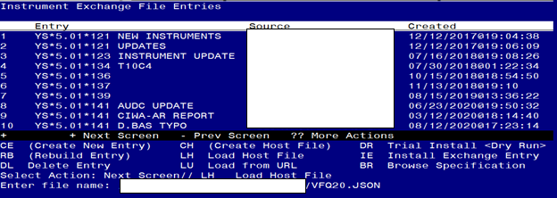
You will see this prompt:
This will load: VFQ20-READY-FOR-REMINDER
created on: 07/29/2022@14:26:44
source: REDACTED@CAMP MASTER
Description ---
(no description)
Do you want to continue? Yes// Y
Search and locate an entry titled VFQ20-READY-FOR-REMINDER in instrument exchange.
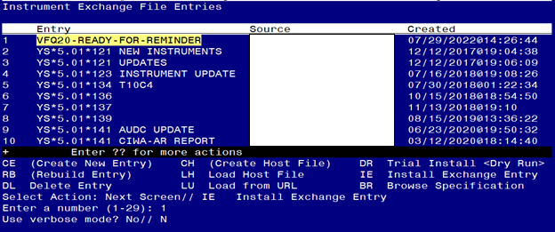
At the Select Action prompt, type IE for Install all Components and hit enter.
Enter the number that corresponds with your entry titled VFQ20-READY-FOR-REMINDER (in this example it is entry 1 it will vary by site) that is dated 07/29/2022.
At the Use verbose mode prompt enter: N
You should see the following:

Select Action: Next Screen// IE Install Exchange Entry
Enter a number (1-29): 1
Use verbose mode? No// NO

Installing VFQ20-READY-FOR-REMINDER
Gathering installed instruments............................
Installing VFQ20................................................................
.......................................................................
.......................................................................
.......................................................................
........
156 records added.
0 records updated.
0 records deleted.
0 errors.
Installation complete.
Press return to continue...
Instrument installation is complete.

Step 2. Load the reminder exchange file.
Go to Reminder exchange in Vista.
To Load the exchange file, use LWH. The URL is https://REDACTED /UPDATE_2_0_286.PRD

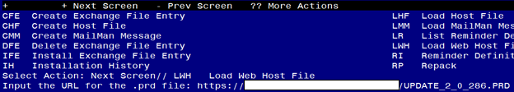
You will see a message indicating the file was loaded successfully.
Search and locate an entry titled UPDATE_2_0_286 VA-LOW VISION VISUAL FUNCTIONING QUESTIONNAIRE in reminder exchange.

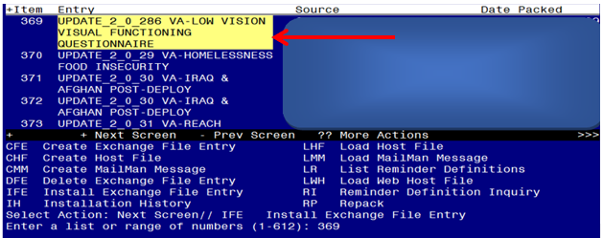

At the Select Action prompt, enter IFE for Install Exchange File Entry
Enter the number that corresponds with your entry titled UPDATE_2_0_286 VA-LOW VISION VISUAL FUNCTIONING QUESTIONNAIRE (in this example it is entry 369, it will vary by site) that is dated 08/04/2022.
THIS NEXT STEP IS NEW – PLEASE PAY CLOSE ATTENTION BEFORE YOU INSTALL ALL COMPONENTS, YOU NEED TO INSTALL SELECT THE NEW REMINDER SPONSOR ENTRY ONLY (ITEM 5):
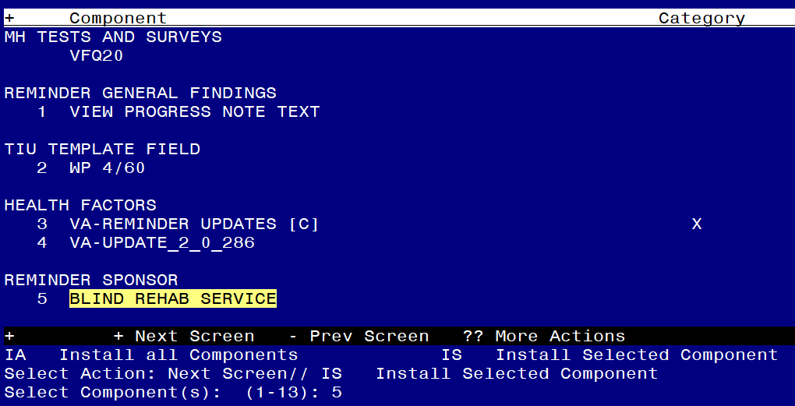
Select Action: Quit// IS Install Selected Component
Select Component(s): (1-13): 5
REMINDER SPONSOR entry BLIND REHAB SERVICE is NEW,
what do you want to do?
Select one of the following:
C Create a new entry by copying to a new name
I Install
Q Quit the install
S Skip, do not install this entry
Enter response: I//nstall
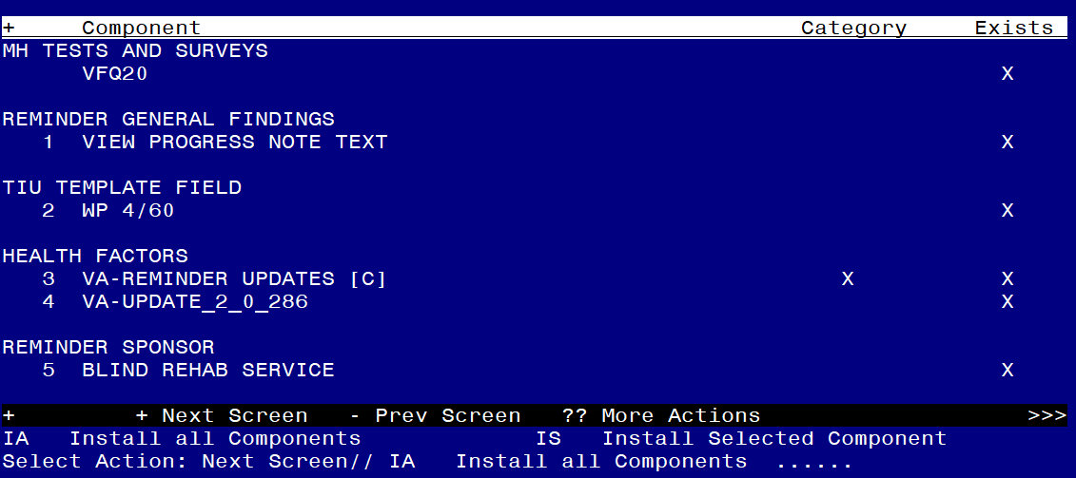
At the Select Action prompt, type IA for Install all Components and hit enter.
For all new entries in any category you will choose I to Install
Skip any items in any category you are prompted to overwrite

You will then be prompted to install the dialog component.
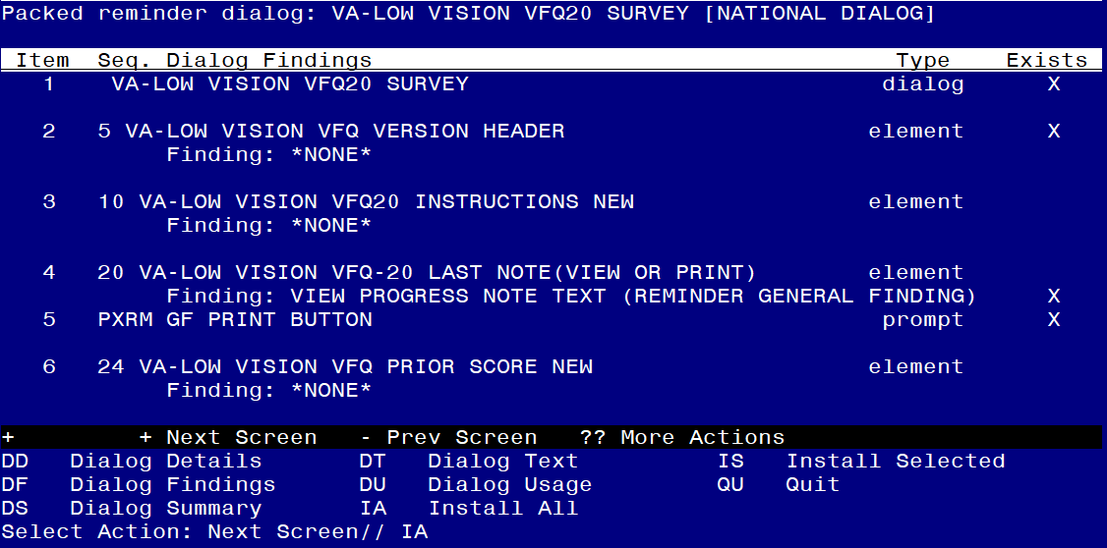
At the Select Action prompt, type IA to install the dialog – VA-LOW VISION RECENT VFQ TOTAL
Install reminder dialog and all components with no further changes: Y//ES

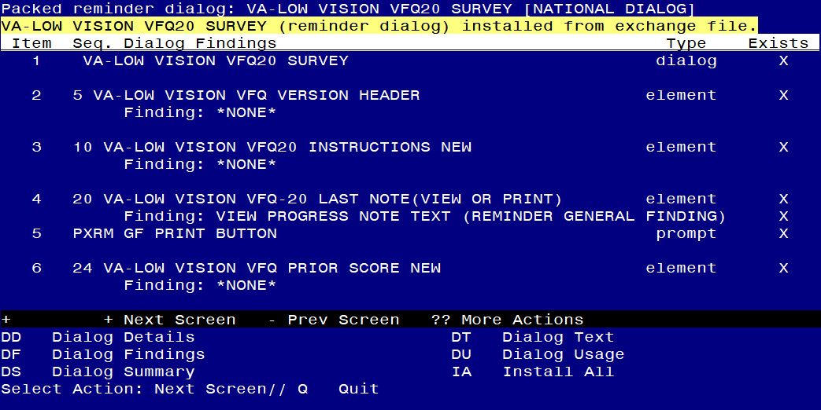
When the dialog has completed installation, you will then be returned to this screen. At the Select Action prompt, type Q.

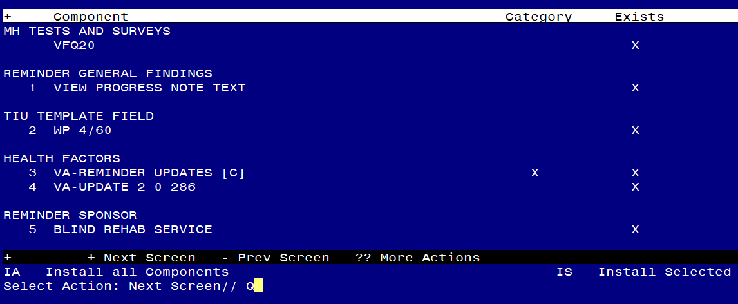
You will then be returned to this screen. At the Select Action prompt, type Q.

Install complete.

Post Installation

- Setup of Note Title.

The note title to create to associate with this template is:
BRS VFQ-20 VISUAL FUNCTIONING QUESTIONNAIRE

VHA Enterprise Standard Title: BLIND REHABILITATION NOTE

You can add these to your document class where blind rehab progress notes are located.

- Make the Dialog templates available to be attached to a Personal or Shared templates or to be able to attach the dialog to a progress note title.
Select Reminder Managers Menu <TEST ACCOUNT> Option: CP CPRS Reminder Configuration
CA Add/Edit Reminder Categories
CL CPRS Lookup Categories
CS CPRS Cover Sheet Reminder List
MH Mental Health Dialogs Active
PN Progress Note Headers
RA Reminder GUI Resolution Active
TIU TIU Template Reminder Dialog Parameter
DEVL Evaluate Coversheet List on Dialog Finish
DL Default Outside Location
PT Position Reminder Text at Cursor
LINK Link Reminder Dialog to Template
TEST CPRS Coversheet Time Test
NP New Reminder Parameters
GEC GEC Status Check Active
WH WH Print Now Active
Select CPRS Reminder Configuration <TEST ACCOUNT> Option: TIU TIU Template Reminder Dialog Parameter
Reminder Dialogs allowed as Templates may be set for the following:
1 User USR [choose from NEW PERSON]
3 Service SRV [choose from SERVICE/SECTION]
4 Division DIV [SALT LAKE CITY]
5 System SYS [NATREM.FO-SLC.MED.VA.GOV]
Enter selection: 5 Choose the appropriate number for your site. Your site may do this by System or other levels. The example below uses SYSTEM level.
Setting Reminder Dialogs allowed as Templates for System: NATREM.FO-SLC.MED.VA.GOV
Select Display Sequence: ?
388 VA-COVID-19 TELEPHONE FOLLOW-UP
389 VA-SRA-CONSULT RESPONSE (D)
When you type a question mark above, you will see the list of #’s (with dialogs) that are already taken. Choose a number NOT on this list. For this example, 390 is not present so I will use 390.
Select Display Sequence: 390
Are you adding 390 as a new Display Sequence? Yes// YES
Display Sequence: 390// <Enter> 390
Clinical Reminder Dialog: VA-LOW VISION VFQ20 SURVEY reminder dialog NATIONAL
...OK? Yes// <Enter> (Yes)

- Associate the reminder dialogs with the note title in CPRS
- In CPRS, open the Template Editor, expand Document Titles, select the appropriate folder (if applicable), then click New Template (top right-hand corner).
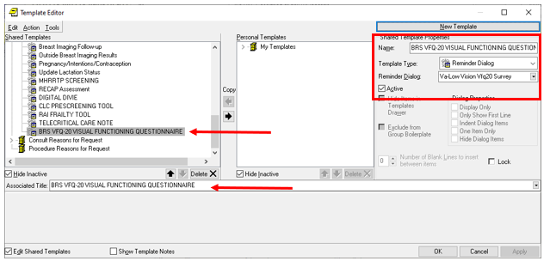

Type in the following information:
Name: BRS VFQ-20 VISUAL FUNCTIONING QUESTIONNAIRE
Template Type: Reminder Dialog
Reminder Dialog: VA-LOW VISION VFQ20 SURVEY
Next, type in the Associated Title name BRS VFQ-20 VISUAL FUNCTIONING QUESTIONNAIRE
–– then click Apply.

- Edit the Health Summary Type VA-LOW VISION LAST NOTE.
Edit the component SPN, at the Select Selection Item prompt, add your local progress note created earlier BRS VFQ-20 VISUAL FUNCTIONING QUESTIONNAIRE.

1 Create/Modify Health Summary Type
2 Delete Health Summary Type
3 Health Summary Objects Menu ...
4 Information Menu ...
5 Print Health Summary Menu ...

Select Build Health Summary Type Menu <TEST ACCOUNT> Option: 1 Create/Modify Health Summary Type

Select Health Summary Type: VA-low Vision Last note (most Recent Vfq note)

WARNING: You are about to edit a Health Summary Type that is being used
by a Health Summary Object. Changing the structure of this Health Summary
Type will alter how the Object will display.

Do want to continue? NO// y YES
NAME: VA-LOW VISION LAST NOTE Replace
TITLE: Most Recent VFQ Note Replace
SUPPRESS PRINT OF COMPONENTS WITHOUT DATA: no// <<HIT ENTER KEY>>
SUPPRESS SENSITIVE PRINT DATA: NO SSN// <<HIT ENTER KEY>>
LOCK: <<HIT ENTER KEY>>
OWNER: <<HIT ENTER KEY>>

Do you wish to copy COMPONENTS from an existing Health Summary Type? YES// NO
Select COMPONENT: SPN PROGRESS NOTES SELECTED SPN
PROGRESS NOTES SELECTED is already a component of this summary.

Select one of the following:

E Edit component parameters
D Delete component from summary

Select Action: Edit component parameters
SUMMARY ORDER: 5// 5
OCCURRENCE LIMIT: 1
TIME LIMIT: <<HIT ENTER KEY>>
HEADER NAME: <<HIT ENTER KEY>>
No selection items chosen.

Select new items one at a time in the sequence you want them displayed.
You may select any number of items.

Select SELECTION ITEM: BRS VFQ-20 VISUAL FUNCTIONING QUESTIONNAIRE
TITLE
Std Title: BLIND REHABILITATION NOTE
...OK? Yes// (Yes)
Select SELECTION ITEM: <<HIT ENTER KEY>>
Select COMPONENT: <<HIT ENTER KEY>>
Do you wish to review the Summary Type structure before continuing? NO// <<HIT ENTER KEY>>

Please hold on while I resequence the summary order.

