Update _2_0_295

Clinical Reminders

VA-DIAGNOSTIC IMAGING ORDER/EXAMINATION REVIEW

Install Guide

July 2022

Product Development
Office of Information Technology
Department of Veterans Affairs

Table of Contents
Introduction 1
Install Details 1
Install Example 2
Post Installation 5

Introduction
Description:
The template will be used by clinical radiology staff to document a diagnostic imaging order or examination review. This review will include determining if an imaging order/examination will be placed in the hold status, cancelled, or changed to another imaging modality. An example of when this note would be used is the current national shortage of iodinated contrast.

UPDATE_2_0_295 contains 1 Reminder Exchange entry:
UPDATE_2_0_295 VA-DIAGNOSTIC IMAGING ORDER REVIEW

The exchange file contains the following components:

TIU TEMPLATE FIELD
TEXT (1-60 CHAR)REQUIRED
VA-DIAGNOSTIC IMAGING TXT (1-50)R
VA-BLANK

HEALTH FACTORS
VA-REMINDER UPDATES [C]
VA-UPDATE_2_0_295
VA-DIAGNOSTIC IMAGE ORDER REVIEW [C]
VA-RAD DX IMAG ORDER REV ASSESS POT HARM NO
VA-RAD DX IMAG ORDER REV ASSESS POT HARM YES REC INSTIT DISCLOS
VA-RAD DX IMAG ORDER REV ASSESS POT HARM YES REC CLIN DISCLOS
VA-RAD DX IMAG ORDER REV REASON OTHER
VA-RAD DX IMAG ORDER REV REASON GLOBAL CONTRAST SHORTAGE
VA-RAD DX IMAG ORDER REV REASON COMPANION CT SAFETY LOOKBACK
VA-RAD DX IMAG ORDER REV REASON SERVICE CURTAILMENT
VA-RAD DX IMAG ORDER REV ACTION REC ALT IMAG MODALITY
VA-RAD DX IMAG ORDER REV ACTION OTHER
VA-RAD DX IMAG ORDER REV ACTION CANCELLED
VA-RAD DX IMAG ORDER REV ACTION PLACED ON HOLD

REMINDER SPONSOR
RADIOLOGY

REMINDER TERM
VA-REMINDER UPDATE_2_0_295

REMINDER DIALOG
VA-DIAGNOSTIC IMAGING ORDER REVIEW

Install Details

This update is being distributed as a web host file. The address for the host file is: https://REDACTED/UPDATE_2_0_295.PRD

The file will be installed using Reminder Exchange, programmer access is not required.

Installation:
=============
This update can be loaded with users on the system. Installation will take less than 5 minutes.

Install Example
To Load the exchange file, use LWH. The URL is https://REDACTED/UPDATE_2_0_295.PRD
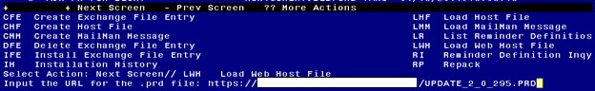

If you use LWH and it works, you will see something like this message. Make sure the file was loaded successfully.
Search and locate an entry titled UPDATE_2_0_295 VA-DIAGNOSTIC IMAGING ORDER REVIEW in reminder exchange.

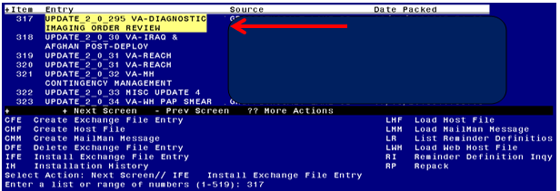

At the Select Action prompt, enter IFE for Install Exchange File Entry
Enter the number that corresponds with your entry titled UPDATE_2_0_295 VA-DIAGNOSTIC IMAGING ORDER REVIEW (in this example it is entry 317, it will vary by site) that is dated 07/05/2022.

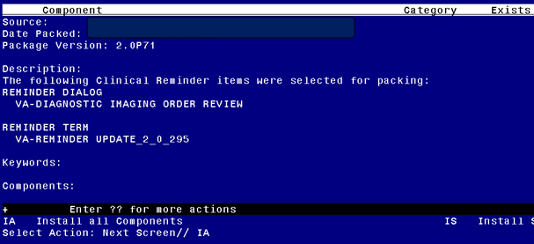
At the Select Action prompt, type IA for Install all Components and hit enter.
For all new entries in any category you will choose I to Install
Skip any items in any category you are prompted to overwrite

You will then be prompted to install the dialog component.
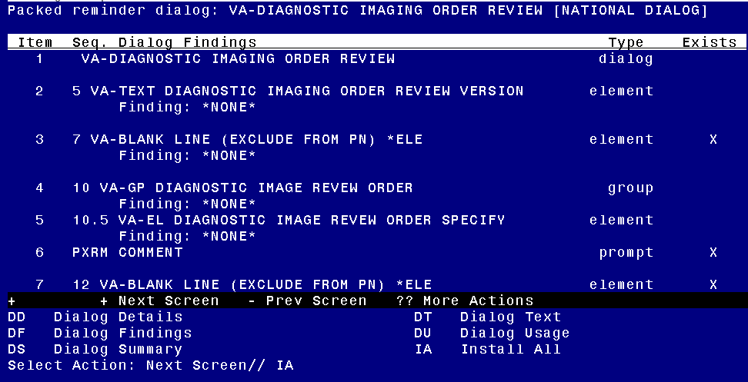
At the Select Action prompt, type IA to install the dialog – VA-DIAGNOSTIC IMAGING ORDER REVIEW
Install reminder dialog and all components with no further changes: Y//ES

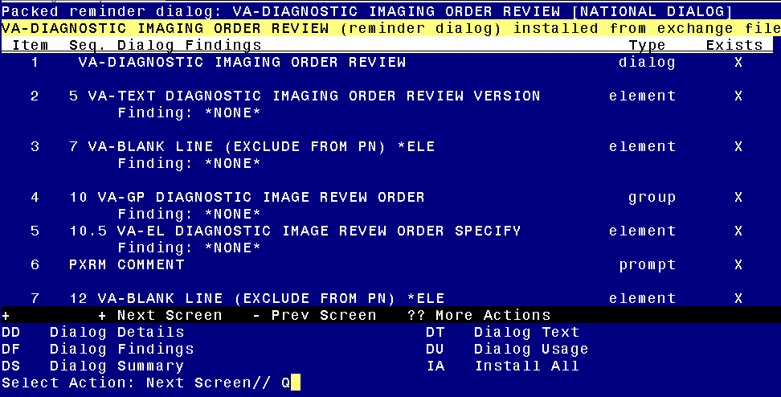
When the dialog has completed installation, you will then be returned to this screen. At the Select Action prompt, type Q.

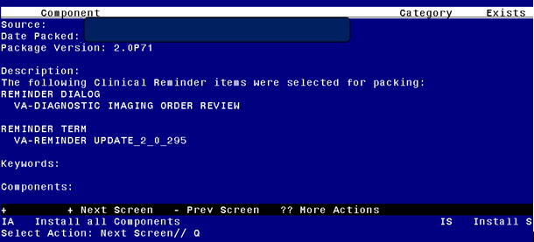
You will then be returned to this screen. At the Select Action prompt, type Q.

Install complete.

Post Installation

- Setup of Note Title.

The note title to create to associate with this template is:

DIAGNOSTIC IMAGING ORDER EXAMINATION REVIEW

VHA Enterprise Standard Title: RADIOLOGY NOTE

You can add these to your document class where IMAGING progress notes are located.

Note: Comprehensive information on Creating new Document Classes and Titles can be found beginning on page 54 of the TIU/ASU Implementation Guide at the following link: http://www.va.gov/vdl/documents/Clinical/CPRS-Text_Integration_Utility_(TIU)/tiuim.pdf

- Make the Dialog templates available to be attached to a Personal or Shared templates or to be able to attach the dialog to a progress note title.
Select Reminder Managers Menu <TEST ACCOUNT> Option: CP CPRS Reminder Configuration
CA Add/Edit Reminder Categories
CL CPRS Lookup Categories
CS CPRS Cover Sheet Reminder List
MH Mental Health Dialogs Active
PN Progress Note Headers
RA Reminder GUI Resolution Active
TIU TIU Template Reminder Dialog Parameter
DEVL Evaluate Coversheet List on Dialog Finish
DL Default Outside Location
PT Position Reminder Text at Cursor
LINK Link Reminder Dialog to Template
TEST CPRS Coversheet Time Test
NP New Reminder Parameters
GEC GEC Status Check Active
WH WH Print Now Active
Select CPRS Reminder Configuration <TEST ACCOUNT> Option: TIU TIU Template Reminder Dialog Parameter
Reminder Dialogs allowed as Templates may be set for the following:
1 User USR [choose from NEW PERSON]
3 Service SRV [choose from SERVICE/SECTION]
4 Division DIV [SALT LAKE CITY]
5 System SYS [NATREM.FO-SLC.MED.VA.GOV]
Enter selection: 5 Choose the appropriate number for your site. Your site may do this by System or other levels. The example below uses SYSTEM level.
Setting Reminder Dialogs allowed as Templates for System: NATREM.FO-SLC.MED.VA.GOV
Select Display Sequence: ?
388 VA-COVID-19 TELEPHONE FOLLOW-UP
389 VA-SRA-CONSULT RESPONSE (D)
When you type a question mark above, you will see the list of #’s (with dialogs) that are already taken. Choose a number NOT on this list. For this example, 390 is not present so I will use 390.

Select Display Sequence: 390

Are you adding 390 as a new Display Sequence? Yes// YES

Display Sequence: 390// <Enter> 390

Clinical Reminder Dialog: VA-DIAGNOSTIC IMAGING ORDER REVIEW reminder dialog NATIONAL

...OK? Yes// <Enter> (Yes)

- Associate the reminder dialogs with the note title in CPRS
- In CPRS, open the Template Editor, expand Document Titles, select the appropriate folder (if applicable), then click New Template (top right-hand corner).
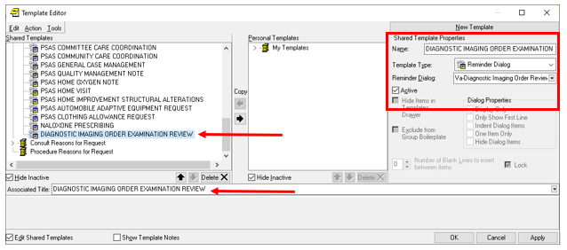

Type in the following information:
Name: DIAGNOSTIC IMAGING ORDER EXAMINATION REVIEW
Template Type: Reminder Dialog
Reminder Dialog: VA-DIAGNOSTIC IMAGING ORDER REVIEW
Next, type in the Associated Title name DIAGNOSTIC IMAGING ORDER EXAMINATION REVIEW
–– then click Apply.

- UPDATE TIU TEMPLATE FIELD:
Using the Template field editor in CPRS, edit the template field names VA-DIAGNOSTIC IMAGING TXT (1-50)R

Replace the characters “(xxx)xxx-xxxx Ext xxxx” with the phone number for your facility’s Imaging Department number.

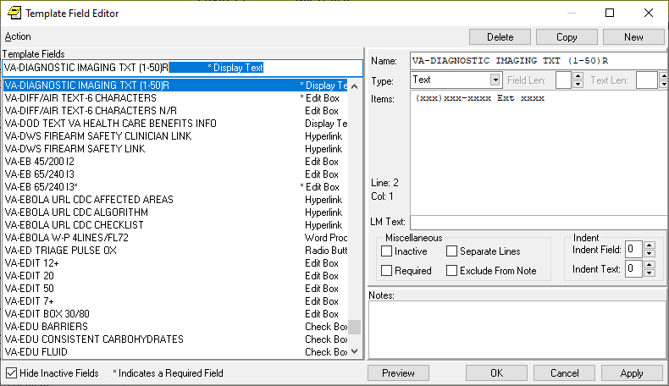

If your site has an integrated Vista database or you want to provide multiple phone number options, you can change the type to a combo, check box or radio buttons and add multuple lines of phone numbers.

