

**Update _2_0_296**

Clinical Reminders

VA-COVID-19 TEMPLATE UPDATES

Install Guide

**July 2022**

Product Development

Office of Information Technology

Department of Veterans Affairs

Table of Contents

Introduction 1

Install Details 4

Install Example 5

Post Installation 7

# Introduction

Description:

COVID-19 Telephone Follow Up note:

* Updates to display the symptom onset date and/or exposure date from screening template (last two weeks) This will assist the user completing the template when reviewing isolation criteria.
* Update to change Infection Control discussion from referral to review.
* Update to vaccine guidance in plan
* New option for offering treatment in plan (local section)
* Updates to more clearly reflect guidance for isolation

COVID-19 Discharge template (also embedded in COVID-19 provider screen note)

* Updates to more clearly reflect guidance for isolation

COVID-19 Immunization reminder and template

* Added links for Novavax EAU fact sheets for providers and patients.

1. Update to telephone note – symptom onset and exposure date entered on covid screen template now display above the care disposition section, isolation information updated to include mask wearing and separate symptomatic into mild and moderate:

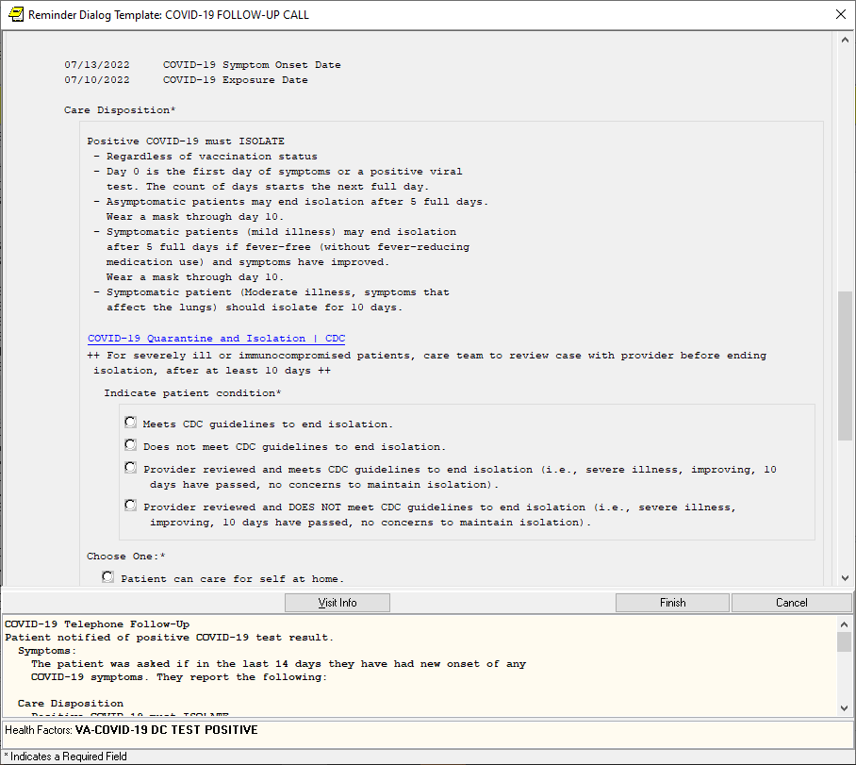

1. Telephone Note – Plan section – Immunocompromised condition and Vaccine Guidance section updated

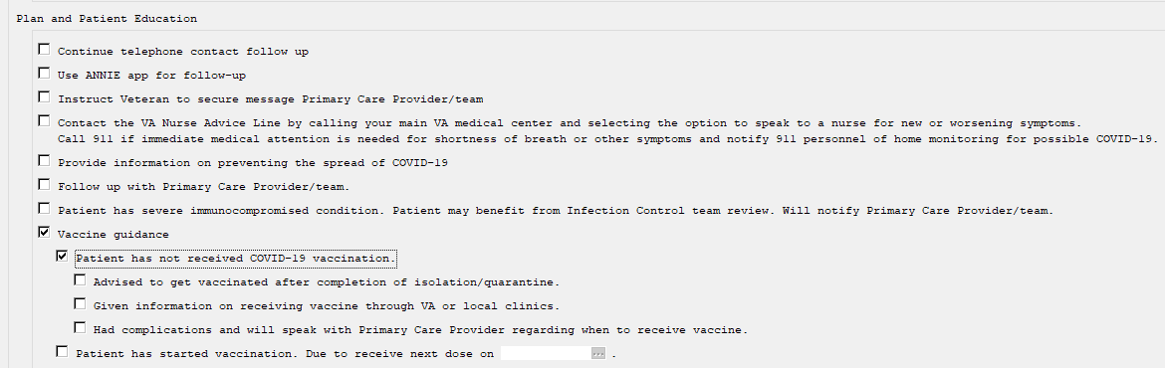

1. Telephone Note - New group available for sites to include/add to the plan section if they would like to. All the specific treatment options install disabled and you can choose which options to enable based on what treatment options are available for your patients, this dialog group is also locally editable, you can add additional elements that represent other treatment options if needed:

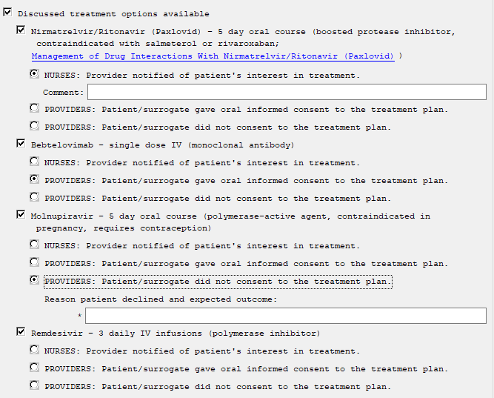

1. Discharge note – suspected and positive Isolation criteria updated to include mask wearing and separate symptomatic into mild and moderate, these items are also in the provider screen discharge instructions as well

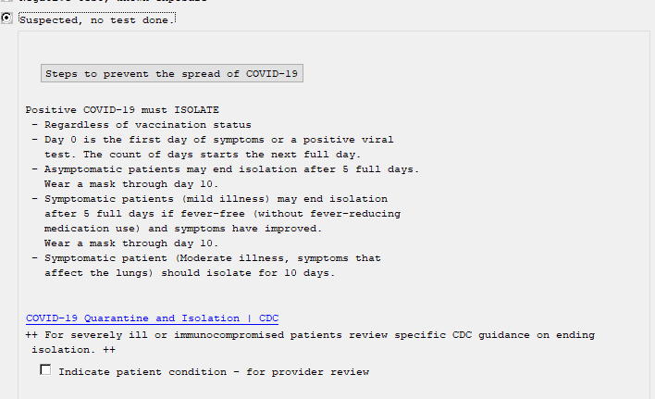

1. The hyperlink in the field HYPERLINK COVID-19 HOW TO PROTECT SELF was updated to the correct CDC page.
2. NOVAVAX information added to detailed information section in COVID-19 reminder dialog.

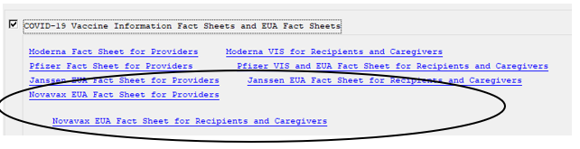

UPDATE_2_0_296 contains 1 Reminder Exchange entry:

**UPDATE_2_0_296 VA-COVID-19 TEMPLATE UPDATES**

**The exchange file contains the following components:**

**REMINDER GENERAL FINDINGS**

VIEW PROGRESS NOTE TEXT

**TIU TEMPLATE FIELD**

HYPERLINK COVID-19 PREVENT SPREAD

HYPERLINK COVID-19 HOW TO PROTECT SELF

VA-CDC QUARANTINE ISOLATION

DATE

VA-COVID PAXLOVID LINK

**HEALTH FACTORS**

VA-REMINDER UPDATES [C]

VA-UPDATE_2_0_296

VA-COVID-19 [C]

VA-COVID-19 UNABLE TO CARE FOR SELF HOME

VA-COVID-19 CAN CARE FOR SELF AT HOME

VA-COVID-19 EXPOSURE DATE

VA-COVID-19 SYMPTOM ONSET DATE

VA-COVID-19 PLAN DISCUSS TREATMENT REMDESIVIR

VA-COVID-19 PLAN DISCUSS TREATMENT MOLNUPIRAVIR

VA-COVID-19 PLAN DISCUSS TREATMENT BEBTELOVIM

VA-COVID-19 PLAN DISCUSS TREATMENT PAXLOVID

**REMINDER TERM**

VA-REMINDER UPDATE_2_0_296

**HEALTH SUMMARY TYPE**

VA-COVID-19 EXPO SYMP DATE

**HEALTH SUMMARY OBJECTS**

VA-COVID-19 EXPOSURE SYMPTOM DATE (TIU)

**TIU DOCUMENT DEFINITION**

VA-COVID-19 EXPOSURE SYMPTOM DATE

**REMINDER DIALOG**

VA-GP COVID-19 UPDATE JUNE 2022

# Install Details

Installation:

=============

This update can be loaded with users on the system. Installation will take less than 5 minutes.

This update is being distributed as a web host file. The address for the host file is:

https://REDACTED/UPDATE_2_0_296.PRD

The file will be installed using Reminder Exchange, programmer access is not required.

# Install Example

To Load the Web Host File. Navigate to Reminder exchange in Vista

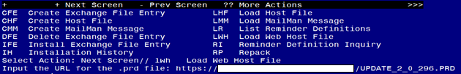

At the **Select Action:** prompt, enter **LWH** for Load Web Host File

At the **Input the url for the .prd file:** prompt, type the following web address:

https://REDACTED/UPDATE_2_0_296.PRD

You should see a message at the top of your screen that the file loaded successfully

Terminal window screen shot of the message displaying the URL of the file that was successfully loaded.  Part of the URL has been redacted as it is a VA only internal web site URL.

Search and locate an entry titled **UPDATE_2_0_296 VA-COVID-19 TEMPLATE UPDATES** in reminder exchange. 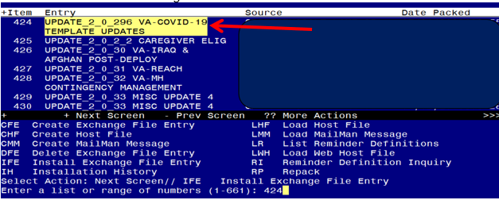

At the **Select Action** prompt, enter **IFE** for Install Exchange File Entry

Enter the number that corresponds with your entry **UPDATE_2_0_296 VA-COVID-19 TEMPLATE UPDATES** *(in this example it is entry 424 it will vary by site).* The date of the exchange file should be 07/26/2022.

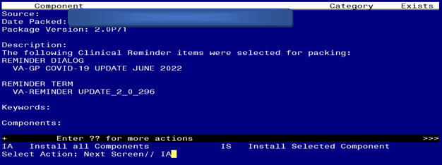

At the **Select Action** prompt, type **IA** for Install all Components and hit enter.

Select Action: Next Screen// IA Install all Components

You will see several prompts, for all new entries you will choose **I to Install**

*For components that already exists but the packed component is different, you will choose* ***O to Overwrite.***

**You will be prompted to install the reminder dialog component – You will choose to install all even though some components may have an X to indicate that they exist.**

For VA-GP COVID-19 UPDATE JUNE 2022:
Screen shot of the terminal window showing a list of elements, groups and dialogs with the text with IA for "Install All" entered at the "Select Action:" Prompt.  The correct entries are described in the text of this document.


At the **Select Action** prompt, type **IA** to install the dialog – **VA-GP COVID-19 UPDATE JUNE 2022**

Select Action: Next Screen// IA Install All

Install reminder dialog and all components with no further changes: Y// Yes

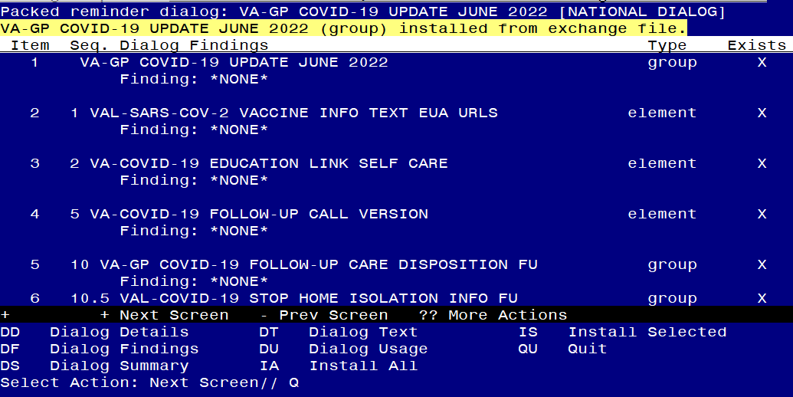

After completing this dialog install, you will type Q.

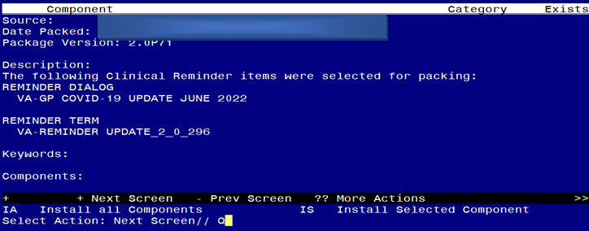

You will then be returned to this screen. At the **Select Action** prompt, type **Q.**

Install complete.

# Post Installation

1. **Open the COVID-19 Telephone Follow-Up (VA-COVID-19 TELEPHONE FOLLOW-UP) and confirm the version is 9.2**
2. **Open the COVID-19 Discharge Template (VA-COVID-19 DISCHARGE INSTRUCTIONS) and confirm the version is 6.2**
3. **(OPTIONAL) Add “Discussed treatment options available” to the plan section of the VA-COVID-19 TELEPHONE FOLLOW UP note if your facility would like these to be discussed and documented when calling the patient for follow up. (optional)**

In VistA, using the menu Reminder Dialog Manager, Reminder Dialog, change view to Group view, edit the reminder dialog groups **VAL-GP COVID-19 FOLLOW-UP PLAN EDUCATION** and **VAL-GP COVID-19 FOLLOW-UP PLAN EDUCATION POS**, add SEQUENCE 58, **VAL-GP COVID-19 DISCUSSED TREATMENT OPTIONS**.

Within that group are several treatment options that are disabled, you can enable the options that your site would like to display in the template. If you are not sure what options to add, ask your Infectious disease service.

VAL-COVID-19 DISCUSSED TREATMENT PAXLOVID

VAL-COVID-19 DISCUSSED TREATMENT BEBTELOVIMAB

VAL-COVID-19 DISCUSSED TREATMENT MOLNUPIRAVIR

VAL-COVID-19 DISCUSSED TREATMENT REMDESIVIR

This is what that section would look like with all options enabled:

